Asymmetric responses of global grain production potential to future climate adaption
Yansui Liu^{1,3,4}, Zongfeng Chen^{1,3}, Xueqi Liu^{2,4,}*, Guy Robinson^{5,6}

1 Faculty of Geographical Science and Engineering, Henan University, Zhengzhou 450046, China
2 Agricultural Information Institute, Chinese Academy of Agricultural Sciences, Beijing 100086, China
3 Institute of Geographic Sciences and Natural Resources Research, Chinese Academy of Sciences, Beijing 100101, China
4 Key Laboratory of Geospatial Technology for the Middle and Lower Yellow River Regions, Ministry of Education, Henan University, Kaifeng, 475004, China
5 Department of Geography, Environment and Population, School of Social Sciences, University of Adelaide, South Australia 5005, Australia
6 Lab of Interdisciplinary Spatial Analysis (LISA), Department of Land Economy, University of Cambridge, Cambridge CB3 9EP, United Kingdom

* Corresponding author:
Xueqi Liu, liuxueqi02@caas.cn

The Supplementary Information contains supplementary GAEZ file, supplementary Tables 1-8 and Figures 1-3.

Supplementary GAEZ file: the calculation progress of future potential yields by GAEZ model
To estimate future potential attainable yields, this study utilized the Global Agro-Ecological Zones (GAEZ v5) framework, specifically focusing on the integration of edaphic, terrain, and climatic variables. The simulation employed a highly resolved ‘pixelated’ approach. The foundational evaluation was conducted at a 30 arc-second grid resolution using the spatial soil association layer from the Harmonized World Soil Database (HWSD). Within each 30 arc-second cell, specific land units were delineated based on unique combinations of climate data, soil types and slope classes, ensuring that the agronomic constraints of each sub-grid environment were independently assessed.
The calculation of attainable yield for each specific land unit followed a robust, multi-step algorithm.
Step 1. Future climate data acquisition and agro-climatic indicators preparation.
Future climate data, including average monthly maximum and minimum air temperatures, precipitation, relative humidity and solar radiation, generated from five different models were used to calculate the future thermal regimes and moisture regime. The agro-climatic indicators, including thermal zones, different crop calendars, accumulated temperature sums, permafrost zone and multiple cropping zones, are obtained from GAEZ v5 model.
Step 2. Future agro-climatic yields under irrigation and rainfed conditions calculation.
The main purpose of step 2 is to calculate the future agro-climatic yields for a wide range of land utilization types (LUTs) under rainfed and irrigated conditions. The future agro-climatic yields estimation at irrigation condition consider only solar radiation and temperature conditions required for specific crop growth. The agro-climatic yields estimation at rainfed condition consider solar radiation, temperature conditions and water stress required for specific crop growth. The input data of step 2 include LUTs data, 2015 irrigated area map, future climate data at various SSP scenarios in different future periods and agro-climatic indicators. The output data include future agro-climatic yields under irrigation and rainfed conditions for four different crops (rice, maize, wheat and soybean) at three SSPs (SSP1-2.6, SSP 3-7.0 and SSP 5-8.5) in the 2030s, 2050s and 2070s.
Step 3. Future attainable yield calculation considering agro-climatic constraints and agro-edaphic constraints.
The main purpose of step 3 is to determine the future attainable yield under possible agro-climatic constraints and agro-edaphic constraints in specific crop growth. The agro-climatic constraints mainly consider the water-stress constraints on crop growth (e.g., rainfall variability) and the occurrence of early and late frost. Because agricultural activities significantly influence topsoil erosion, terrain suitability was evaluated utilizing grid-cell-specific slope classes and location-specific rainfall concentration characteristics. The agro-edaphic constraints mainly conside soil suitability and terrain suitability. Based on the analysis of agro-climatic constraints and agro-edaphic constraints, to modify the agro-climatic yield and obtain the future attainable yield for each crop.
Step 4. Impact of atmospheric CO₂ concentrations on future attainable potential yield.
The future attainable yield calculated in the above steps mainly consider the restriction of temperature, water, solar radiation and soil suitability, without considering the CO₂ fertilization effect. The “fertilization” effect of increasing atmospheric CO₂ on crop yields is accounted in GAEZ by the CO₂ yield-adjustment factor ($f_{{CO}_{2}}$).
Crop species respond differently to CO₂ depending on physiological characteristics such as photosynthetic pathway (e.g., C₃ or C₄ plants). These crop specific responses are accounted in the parameterization of $f_{{CO}_{2}}$:
$$f_{{CO}_{2}}=1+\left(a×{\left[{CO}_{2}\right]}^{2}+b×\left[{CO}_{2}\right]+c×f_{{sui_CO}_{2}}\right)$$
Where a, b and c are parameters (by broad crop groups) used to capture the different CO₂ responses of four broad crop groups (Table 1). The factor $f_{{sui_CO}_{2}}$is an empirical correction factor accounting for land suitability (Table 2). $\left[{CO}_{2}\right]$ is the atmospheric CO₂ concentrations (ppm) (Table 3).
Following these comprehensive sub-grid evaluations, the individual 30 arc-second results were spatially aggregated. One hundred 30 arc-second sub-grids were compiled to produce the final edaphic characterization and attainable yield distributions at a 5 arc-minute grid resolution.

Table 1. Crop-specific coefficients for the calculation of CO₂ fertilization effect
Coefficients | Crop Group
Coefficients | Wheat | rice | maize | soybean
a | -0.0003500 | -0.0003325 | -0.0002800 | -0.0003850
b | 0.10636 | 0.10104 | 0.057888 | 0.11700
c | -31.2870 | -29.7227 | -16.0540 | -34.4157
Table 2. Adjustment factors for CO₂ fertilization effect according to land suitability class
 | Very Suitable | Suitable | Moderately  Suitable | Marginally  Suitable
$$f_{{sui_CO}_{2}}$$ | 0.850 | 0.667 | 0.500 | 0.333
Table 3. Atmospheric CO₂ concentrations (ppm) used to model the fertilization effect in GAEZ for different SSP scenarios and time points
Scenario | Year
Scenario | 2030s | 2050s | 2070s
SSP1-2.6 | 422.5 | 442.5 | 428.9
SSP3-7.0 | 422.7 | 498.5 | 531.5
SSP5-8.5 | 431.5 | 570.5 | 801.0

Supplementary Tables

Supplementary Tab. 1 | The rice production growth rate, 2020 rice production, the rice increased production and the proportion of rice production in the top 10 countries during 1980-2020
Country | Incremental slope of rice production (million tons/yr) | 2020 rice production (million tons) | Rice increased production (million tons) | Proportion of rice increased production (%)
China | 1.77 | 213.61 | 70.73 | 18.87%
India | 2.56 | 182.70 | 102.39 | 27.31%
Bangladesh | 0.88 | 56.06 | 35.24 | 9.40%
Indonesia | 0.62 | 54.65 | 25.00 | 6.67%
Vietnam | 0.78 | 42.76 | 31.12 | 8.30%
Thailand | 0.34 | 30.98 | 13.61 | 3.63%
Myanmar | 0.33 | 26.40 | 13.08 | 3.49%
Philippines | 0.29 | 19.29 | 11.65 | 3.11%
Pakistan | 0.20 | 12.63 | 7.94 | 2.12%
Brazil | 0.03 | 11.09 | 1.32 | 0.35%

Supplementary Tab. 2 | The maize production growth rate, 2020 maize production, the maize increased production and the proportion of maize production in the top 10 countries during 1980-2020
Country | Incremental slope of maize production (million tons/yr) | 2020 maize production (million tons) | Maize increased production (million tons) | Proportion of maize increased production (%)
United States | 4.75 | 358.45 | 189.80 | 25.26%
China | 4.95 | 260.88 | 198.16 | 26.37%
Brazil | 2.09 | 103.99 | 83.62 | 11.13%
Argentina | 1.30 | 58.40 | 52.00 | 6.92%
India | 0.60 | 30.89 | 23.93 | 3.19%
Ukraine | 0.55 | 30.29 | 21.89 | 2.91%
Mexico | 0.38 | 27.42 | 15.05 | 2.00%
South Africa | 0.12 | 15.84 | 4.80 | 0.64%
Russia | 0.14 | 13.88 | 5.48 | 0.73%
France | 0.11 | 13.73 | 4.40 | 0.59%

Supplementary Tab. 3 | The wheat production growth rate, 2020 wheat production, the wheat increased production and the proportion of wheat production in the top 10 countries during 1980-2020
Country | Incremental slope of wheat production (million tons/yr) | 2020 wheat production (million tons) | Wheat increased production (million tons) | Proportion of wheat increased production (%)
China | 1.98 | 134.26 | 79.04 | 24.88%
India | 1.90 | 107.86 | 76.03 | 23.93%
Russia | 1.57 | 85.90 | 62.89 | 17.08%
United States | -0.38 | 49.75 | -15.05 | -4.74%
Canada | 0.40 | 35.44 | 16.15 | 5.08%
Australia | 0.53 | 31.92 | 21.07 | 6.63%
France | 0.16 | 30.18 | 6.40 | 2.01%
Pakistan | 0.36 | 25.25 | 14.39 | 4.53%
Ukraine | 0.17 | 24.91 | 6.91 | 2.18%
Germany | 0.27 | 22.17 | 10.92 | 3.44%

Supplementary Tab. 4 | The soybean production growth rate, 2020 soybean production, the soybean increased production and the proportion of soybean production in the top 10 countries during 1980-2020
Country | Incremental slope of soybean production (million tons/yr) | 2020 soybean production (million tons) | Soybean increased production(million tons) | Proportion of soybean increased production (%)
Brazil | 2.67 | 121.82 | 106.67 | 39.45%
United States | 1.65 | 114.75 | 65.83 | 24.35%
Argentina | 1.13 | 48.78 | 45.28 | 16.75%
China | 0.29 | 19.60 | 11.64 | 4.30%
India | 0.30 | 12.61 | 12.17 | 4.50%
Paraguay | 0.26 | 11.02 | 10.49 | 3.88%
Canada | 0.14 | 6.36 | 5.67 | 2.10%
Russia | 0.02 | 4.31 | 0.81 | 0.30%
Bolivia | 0.07 | 2.83 | 2.78 | 1.03%
Ukraine | 0.01 | 2.80 | 0.30 | 0.11%

Supplementary Tab. 5 | The potential production and future climate gaps of rice across different continents under three scenarios in 2030s, 2050s and 2070s.
Variables | Future scenarios | Global | Asia | Africa | Europe | Oceania | North America | South America
2030s future potential production(Mt） | ssp1-2.6 | 874.88 | 773.54 | 54.72 | 4.30 | 0.17 | 13.61 | 28.55
2030s future potential production(Mt） | ssp3-7.0 | 865.77 | 764.80 | 54.62 | 4.26 | 0.17 | 13.52 | 28.40
2030s future potential production(Mt） | ssp5-8.5 | 872.32 | 770.55 | 55.27 | 4.27 | 0.17 | 13.54 | 28.53
2030s future climate gap (Mt） | ssp1-2.6 | 81.08 | 66.39 | 9.95 | 0.47 | 0.01 | 1.10 | 3.16
2030s future climate gap (Mt） | ssp3-7.0 | 71.97 | 57.64 | 9.86 | 0.44 | 0.01 | 1.01 | 3.02
2030s future climate gap (Mt） | ssp5-8.5 | 78.52 | 63.40 | 10.50 | 0.44 | 0.01 | 1.03 | 3.14
2050s future potential production(Mt） | ssp1-2.6 | 884.30 | 783.13 | 54.64 | 4.34 | 0.17 | 13.55 | 28.48
2050s future potential production(Mt） | ssp3-7.0 | 839.22 | 739.93 | 53.46 | 4.30 | 0.17 | 13.31 | 28.04
2050s future potential production(Mt） | ssp5-8.5 | 854.87 | 755.20 | 53.92 | 4.31 | 0.17 | 13.32 | 27.94
2050s future climate gap (Mt） | ssp1-2.6 | 90.49 | 75.97 | 9.88 | 0.51 | 0.01 | 1.03 | 3.09
2050s future climate gap (Mt） | ssp3-7.0 | 45.41 | 32.78 | 8.70 | 0.47 | 0.01 | 0.80 | 2.65
2050s future climate gap (Mt） | ssp5-8.5 | 61.07 | 48.05 | 9.16 | 0.49 | 0.01 | 0.81 | 2.55
2070s future potential production(Mt） | ssp1-2.6 | 878.98 | 779.17 | 53.36 | 4.34 | 0.17 | 13.53 | 28.41
2070s future potential production(Mt） | ssp3-7.0 | 824.04 | 727.76 | 51.50 | 4.30 | 0.17 | 13.04 | 27.27
2070s future potential production(Mt） | ssp5-8.5 | 819.47 | 724.96 | 50.31 | 4.28 | 0.17 | 12.90 | 26.85
2070s future climate gap (Mt） | ssp1-2.6 | 85.17 | 72.01 | 8.60 | 0.51 | 0.01 | 1.02 | 3.02
2070s future climate gap (Mt） | ssp3-7.0 | 30.24 | 20.61 | 6.74 | 0.47 | 0.00 | 0.53 | 1.88
2070s future climate gap (Mt） | ssp5-8.5 | 25.67 | 17.81 | 5.55 | 0.46 | 0.00 | 0.39 | 1.46

Supplementary Tab. 6 | The potential production and future climate gaps of maize across different continents under three scenarios in 2030s, 2050s and 2070s.
Variables | Future scenarios | Global | Asia | Africa | Europe | Oceania | North America | South America
2030s future potential production(Mt） | ssp1-2.6 | 1533.70 | 500.99 | 252.32 | 143.17 | 0.52 | 416.93 | 219.78
2030s future potential production(Mt） | ssp3-7.0 | 1516.30 | 489.46 | 251.27 | 143.35 | 0.51 | 413.55 | 218.15
2030s future potential production(Mt） | ssp5-8.5 | 1536.24 | 500.89 | 252.32 | 145.58 | 0.52 | 413.43 | 223.50
2030s future climate gap (Mt） | ssp1-2.6 | 220.13 | 82.09 | 40.73 | 21.37 | 0.11 | 56.74 | 19.09
2030s future climate gap (Mt） | ssp3-7.0 | 202.73 | 70.56 | 39.67 | 21.56 | 0.10 | 53.37 | 17.46
2030s future climate gap (Mt） | ssp5-8.5 | 222.68 | 81.99 | 40.72 | 23.79 | 0.11 | 53.25 | 22.81
2050s future potential production(Mt） | ssp1-2.6 | 1553.88 | 514.02 | 253.53 | 144.02 | 0.53 | 423.68 | 218.10
2050s future potential production(Mt） | ssp3-7.0 | 1511.25 | 489.43 | 249.94 | 143.57 | 0.54 | 409.20 | 218.57
2050s future potential production(Mt） | ssp5-8.5 | 1526.41 | 506.38 | 250.57 | 133.98 | 0.55 | 412.32 | 222.61
2050s future climate gap (Mt） | ssp1-2.6 | 240.31 | 95.12 | 41.94 | 22.22 | 0.12 | 63.50 | 17.41
2050s future climate gap (Mt） | ssp3-7.0 | 197.68 | 70.53 | 38.35 | 21.78 | 0.13 | 49.02 | 17.88
2050s future climate gap (Mt） | ssp5-8.5 | 212.84 | 87.48 | 38.98 | 12.19 | 0.13 | 52.14 | 21.92
2070s future potential production(Mt） | ssp1-2.6 | 1550.87 | 517.78 | 249.74 | 145.26 | 0.53 | 421.75 | 215.80
2070s future potential production(Mt） | ssp3-7.0 | 1507.22 | 501.70 | 247.69 | 133.64 | 0.56 | 403.10 | 220.52
2070s future potential production(Mt） | ssp5-8.5 | 1518.08 | 514.04 | 246.84 | 123.60 | 0.55 | 410.88 | 222.17
2070s future climate gap (Mt） | ssp1-2.6 | 237.30 | 98.89 | 38.14 | 23.47 | 0.12 | 61.57 | 15.12
2070s future climate gap (Mt） | ssp3-7.0 | 193.66 | 82.81 | 36.09 | 11.84 | 0.15 | 42.92 | 19.83
2070s future climate gap (Mt） | ssp5-8.5 | 204.51 | 95.15 | 35.24 | 1.80 | 0.13 | 50.70 | 21.48

Supplementary Tab. 7 | The potential production and future climate gaps of wheat across different continents under three scenarios in 2030s, 2050s and 2070s.
Variables | Future scenarios | Global | Asia | Africa | Europe | Oceania | North America | South America
2030s future potential production(Mt） | ssp1-2.6 | 1076.23 | 446.19 | 35.07 | 366.95 | 39.11 | 138.19 | 50.71
2030s future potential production(Mt） | ssp3-7.0 | 1060.07 | 437.54 | 33.57 | 364.46 | 37.44 | 136.61 | 50.44
2030s future potential production(Mt） | ssp5-8.5 | 1069.55 | 442.76 | 33.99 | 365.38 | 37.25 | 139.79 | 50.38
2030s future climate gap (Mt） | ssp1-2.6 | 280.39 | 77.83 | 8.30 | 84.55 | 38.75 | 25.32 | 45.65
2030s future climate gap (Mt） | ssp3-7.0 | 264.23 | 69.18 | 6.80 | 82.06 | 37.08 | 23.74 | 45.38
2030s future climate gap (Mt） | ssp5-8.5 | 273.71 | 74.39 | 7.22 | 82.97 | 36.89 | 26.92 | 45.32
2050s future potential production(Mt） | ssp1-2.6 | 1052.65 | 436.82 | 33.37 | 356.31 | 36.59 | 140.39 | 49.18
2050s future potential production(Mt） | ssp3-7.0 | 1023.16 | 415.35 | 31.04 | 355.88 | 35.31 | 137.28 | 48.30
2050s future potential production(Mt） | ssp5-8.5 | 1006.08 | 412.04 | 28.60 | 346.90 | 36.02 | 134.65 | 47.87
2050s future climate gap (Mt） | ssp1-2.6 | 256.81 | 68.45 | 6.60 | 73.90 | 36.23 | 27.51 | 44.12
2050s future climate gap (Mt） | ssp3-7.0 | 227.32 | 46.99 | 4.26 | 73.47 | 34.96 | 24.40 | 43.24
2050s future climate gap (Mt） | ssp5-8.5 | 210.24 | 43.68 | 1.83 | 64.50 | 35.66 | 21.77 | 42.81
2070s future potential production(Mt） | ssp1-2.6 | 1060.82 | 435.94 | 32.40 | 364.98 | 36.31 | 141.41 | 49.79
2070s future potential production(Mt） | ssp3-7.0 | 976.90 | 395.79 | 27.45 | 341.79 | 34.37 | 131.70 | 45.80
2070s future potential production(Mt） | ssp5-8.5 | 930.95 | 377.48 | 25.62 | 320.10 | 32.78 | 132.02 | 42.95
2070s future climate gap (Mt） | ssp1-2.6 | 264.98 | 67.57 | 5.63 | 82.58 | 35.95 | 28.53 | 44.73
2070s future climate gap (Mt） | ssp3-7.0 | 181.06 | 27.43 | 0.68 | 59.39 | 34.01 | 18.82 | 40.74
2070s future climate gap (Mt） | ssp5-8.5 | 135.11 | 9.11 | -1.16 | 37.69 | 32.42 | 19.15 | 37.89

Supplementary Tab. 8 | The potential production and future climate gaps of soybean across different continents under three scenarios in 2030s, 2050s and 2070s.
Variables | Future scenarios | Global | Asia | Africa | Europe | Oceania | North America | South America
2030s future potential production(Mt） | ssp1-2.6 | 370.50 | 55.56 | 9.06 | 13.42 | 0.02 | 124.54 | 167.90
2030s future potential production(Mt） | ssp3-7.0 | 365.53 | 54.61 | 9.03 | 13.34 | 0.02 | 121.22 | 167.31
2030s future potential production(Mt） | ssp5-8.5 | 370.89 | 55.54 | 9.10 | 13.62 | 0.02 | 122.83 | 169.79
2030s future climate gap (Mt） | ssp1-2.6 | 29.69 | 3.94 | 1.15 | 2.67 | 0.02 | 9.90 | 12.01
2030s future climate gap (Mt） | ssp3-7.0 | 24.73 | 3.00 | 1.13 | 2.59 | 0.01 | 6.58 | 11.42
2030s future climate gap (Mt） | ssp5-8.5 | 30.08 | 3.92 | 1.19 | 2.87 | 0.01 | 8.19 | 13.90
2050s future potential production(Mt） | ssp1-2.6 | 370.72 | 57.06 | 9.02 | 13.42 | 0.02 | 124.26 | 166.94
2050s future potential production(Mt） | ssp3-7.0 | 360.10 | 53.70 | 8.96 | 13.33 | 0.02 | 120.24 | 163.84
2050s future potential production(Mt） | ssp5-8.5 | 358.75 | 54.68 | 8.89 | 12.69 | 0.02 | 118.61 | 163.87
2050s future climate gap (Mt） | ssp1-2.6 | 29.91 | 5.44 | 1.11 | 2.67 | 0.01 | 9.62 | 11.05
2050s future climate gap (Mt） | ssp3-7.0 | 19.29 | 2.09 | 1.05 | 2.59 | 0.01 | 5.61 | 7.94
2050s future climate gap (Mt） | ssp5-8.5 | 17.94 | 3.06 | 0.98 | 1.94 | 0.01 | 3.97 | 7.97
2070s future potential production(Mt） | ssp1-2.6 | 367.62 | 56.62 | 8.90 | 13.58 | 0.02 | 123.20 | 165.31
2070s future potential production(Mt） | ssp3-7.0 | 353.89 | 54.01 | 8.63 | 12.38 | 0.02 | 118.65 | 160.19
2070s future potential production(Mt） | ssp5-8.5 | 352.18 | 54.13 | 8.38 | 11.74 | 0.02 | 118.76 | 159.15
2070s future climate gap (Mt） | ssp1-2.6 | 26.81 | 5.00 | 0.99 | 2.83 | 0.01 | 8.56 | 9.42
2070s future climate gap (Mt） | ssp3-7.0 | 13.08 | 2.39 | 0.72 | 1.63 | 0.02 | 4.01 | 4.30
2070s future climate gap (Mt） | ssp5-8.5 | 11.37 | 2.52 | 0.47 | 0.99 | 0.01 | 4.13 | 3.26

Supplementary Figures
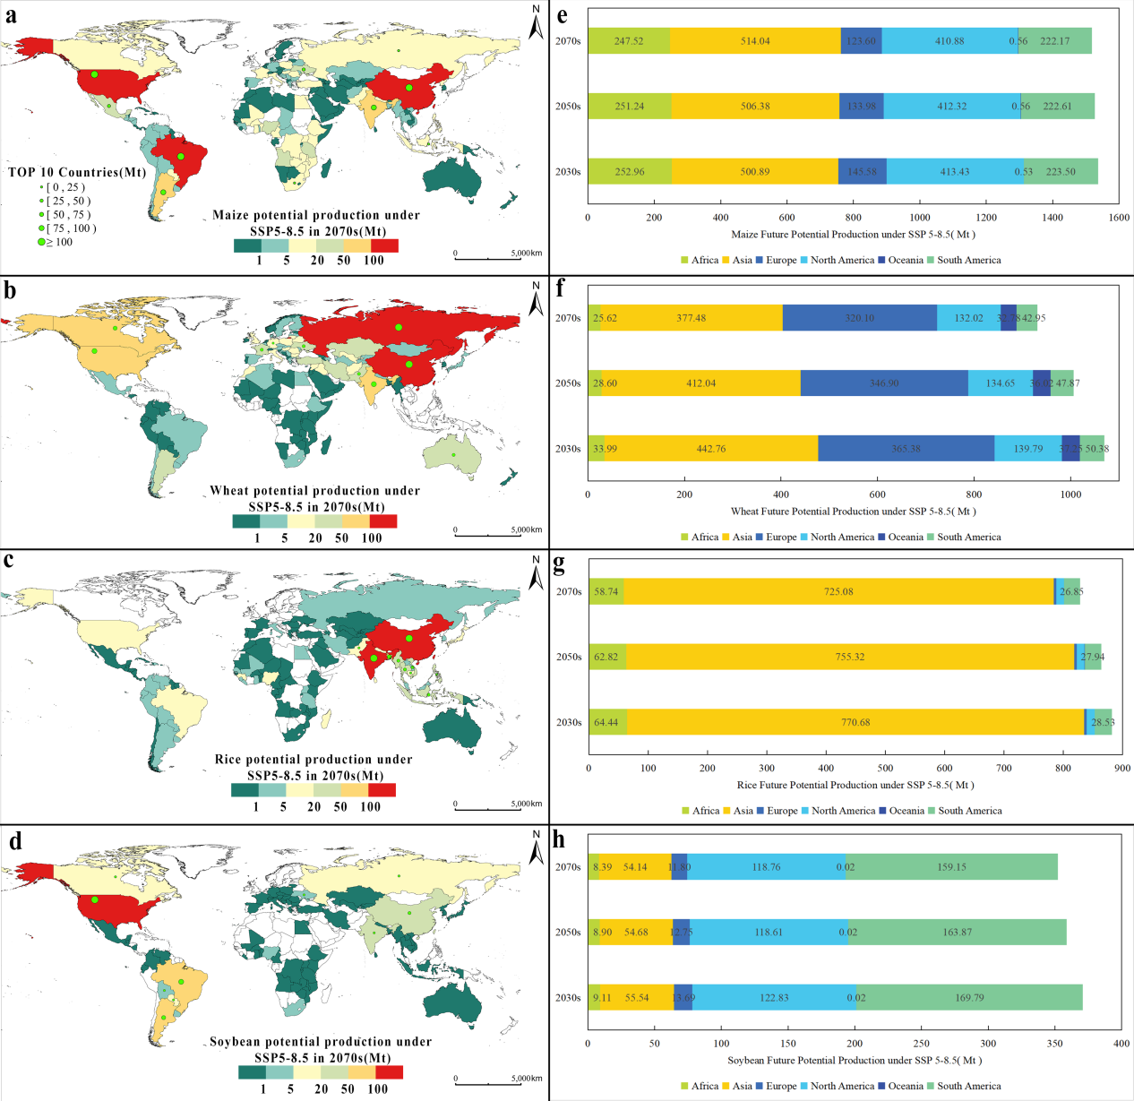
Supplementary Fig. 1 | Global distribution of future potential production for four staple crops under SSP5-8.5 in 2070s. Panels (a)-(d) display the spatial patterns of future potential production for maize, wheat, rice and soybean under SSP5-8.5. The green points in each panel highlight the top 10 countries with the highest potential production for the corresponding crop. Panels (e)-(h) present the future potential production of each continent for each crop under SSP5-8.5 in 2030s, 2050s and 2070s, respectively.

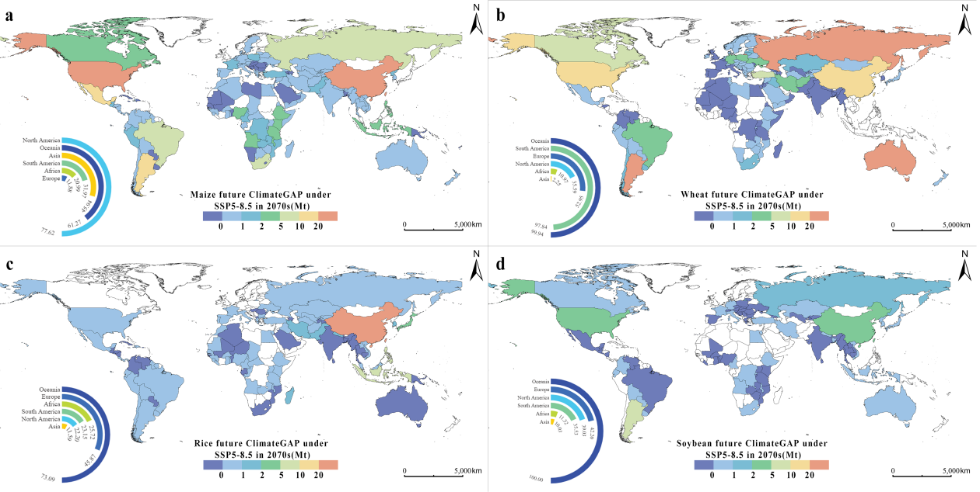
Supplementary Fig. 2 | Global distribution future climate gap for four staple crops under SSP5-8.5 in 2070s. Panels (a)-(d) display the spatial patterns of future climate gap for maize, wheat, rice and soybean under SSP5-8.5. The ring graphs in each panel represent the contributions of the future climate gap on future crop yield gap in each continent.

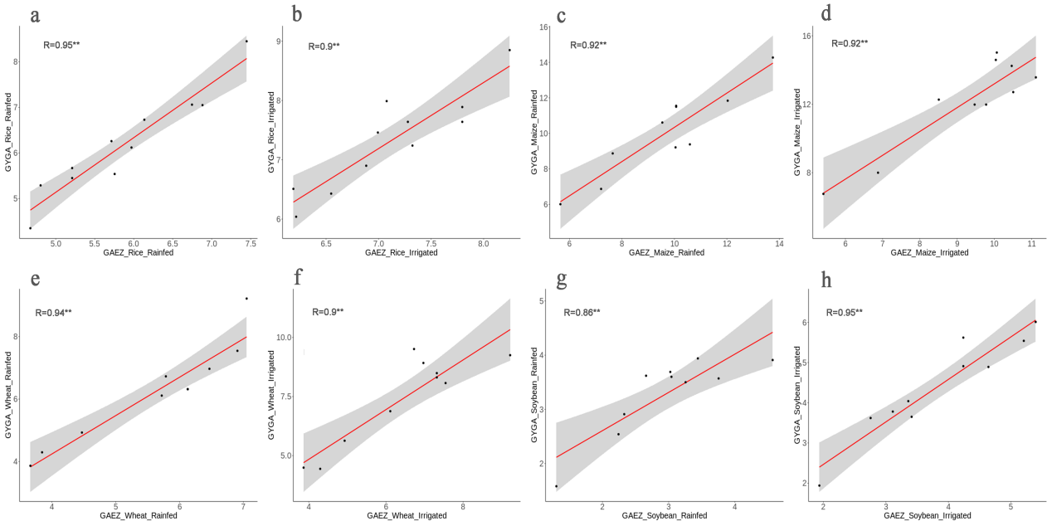
Supplementary Fig. 3 | The validation scatter plot of 2010s potential attainable yields derived from GAEZ model and GYGA model in top 10 countries for each crop. Panels (a)-(b) display the validation scatter plots for rice under rainfed and irrigated condition, panels (c)-(d) display the validation scatter plots for maize under rainfed and irrigated condition, panels (e)-(f) display the validation scatter plots for wheat under rainfed and irrigated condition, panels (g)-(h) display the validation scatter plots for soybean under rainfed and irrigated condition.

