Online Resource 1: PGC-1α WB
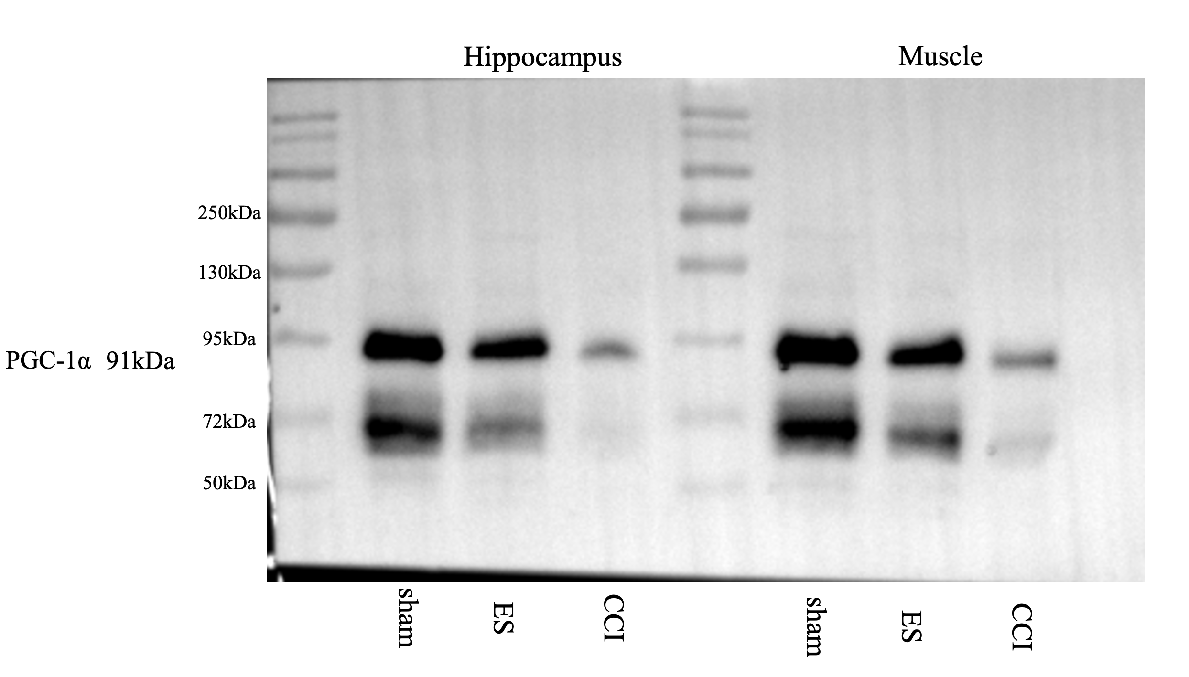
Online Resource 1: Original uncropped Western blot membrane strip for PGC-1α (theoretical molecular weight 91kDa). Samples were from one biological replicate of sham, ES, and CCI groups in both hippocampus and skeletal muscle tissues. The molecular weight marker is included in the strip to confirm the specificity of the target band at ~91kDa.
Online Resource 2: GAPDH WB
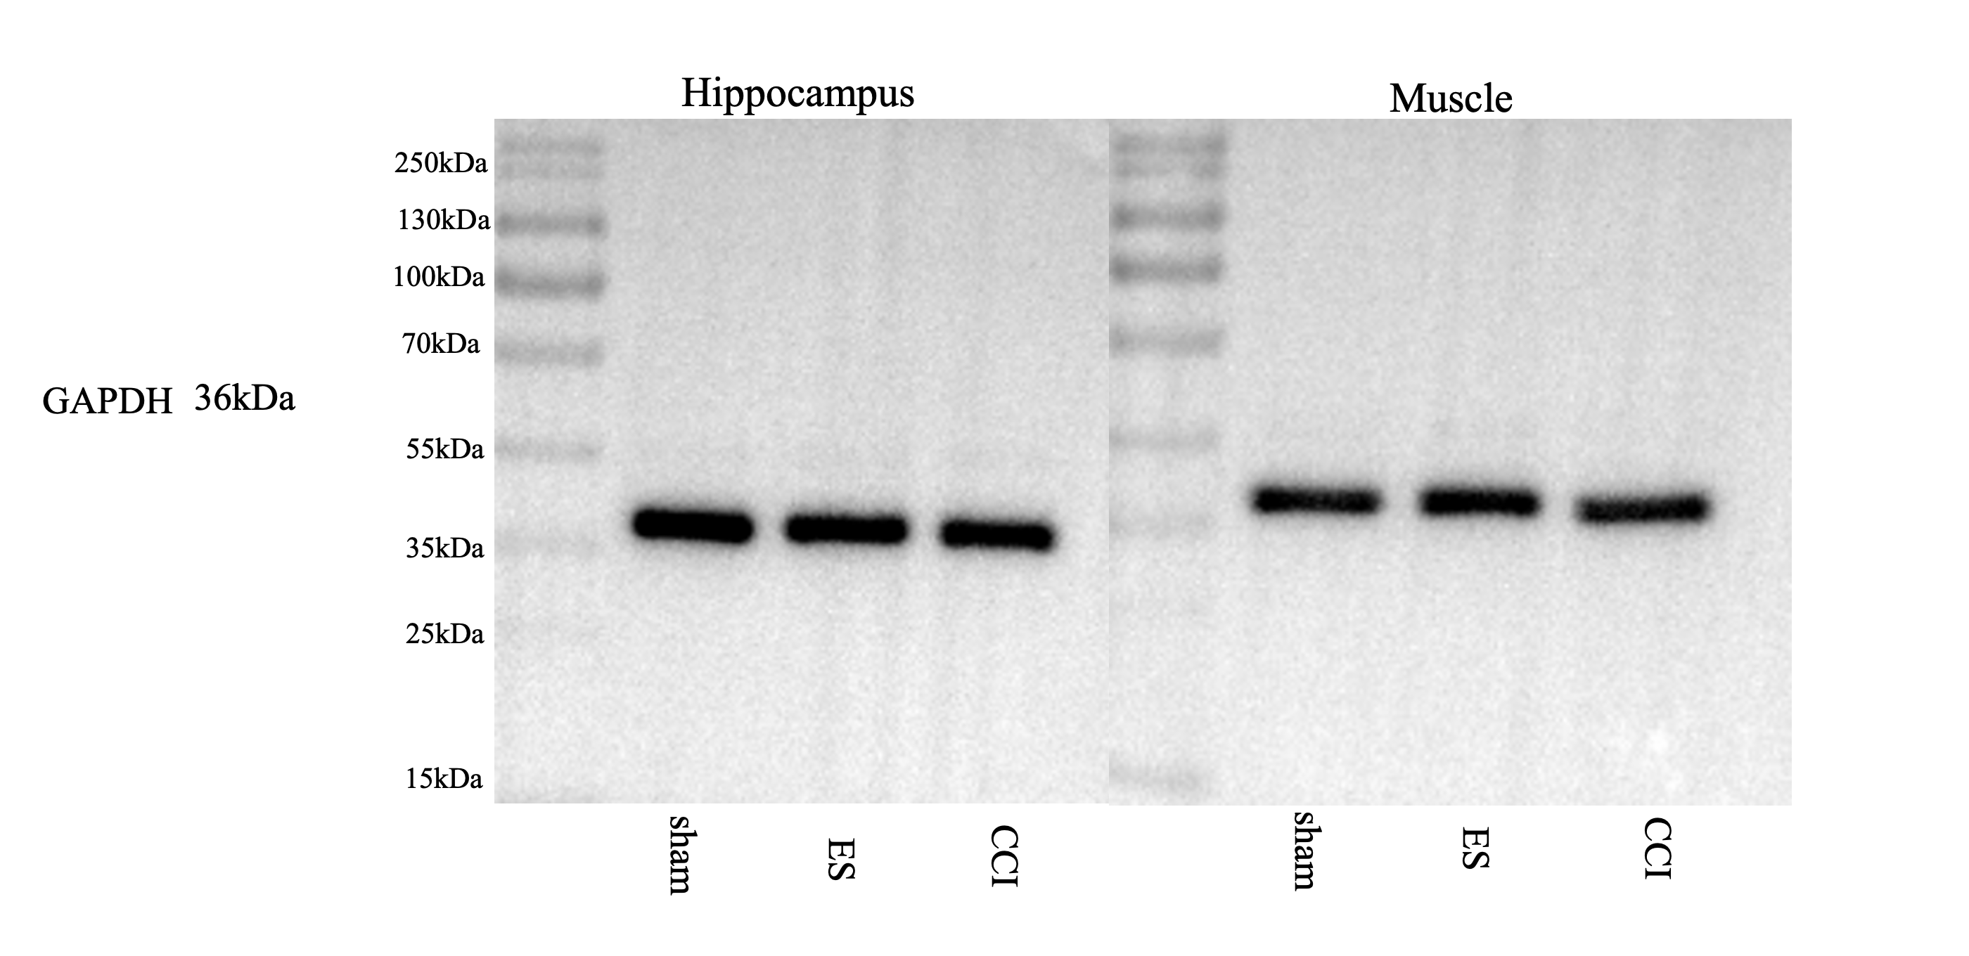
Online Resource 2: Original uncropped Western blot membrane strip for GAPDH (theoretical molecular weight 36kDa, loading control). Samples were from one biological replicate of sham, ES, and CCI groups in both hippocampus and skeletal muscle tissues. The molecular weight marker is included in the strip to confirm the specificity of the target band at ~36kDa.

Online Resource 3: FNDC5 WB
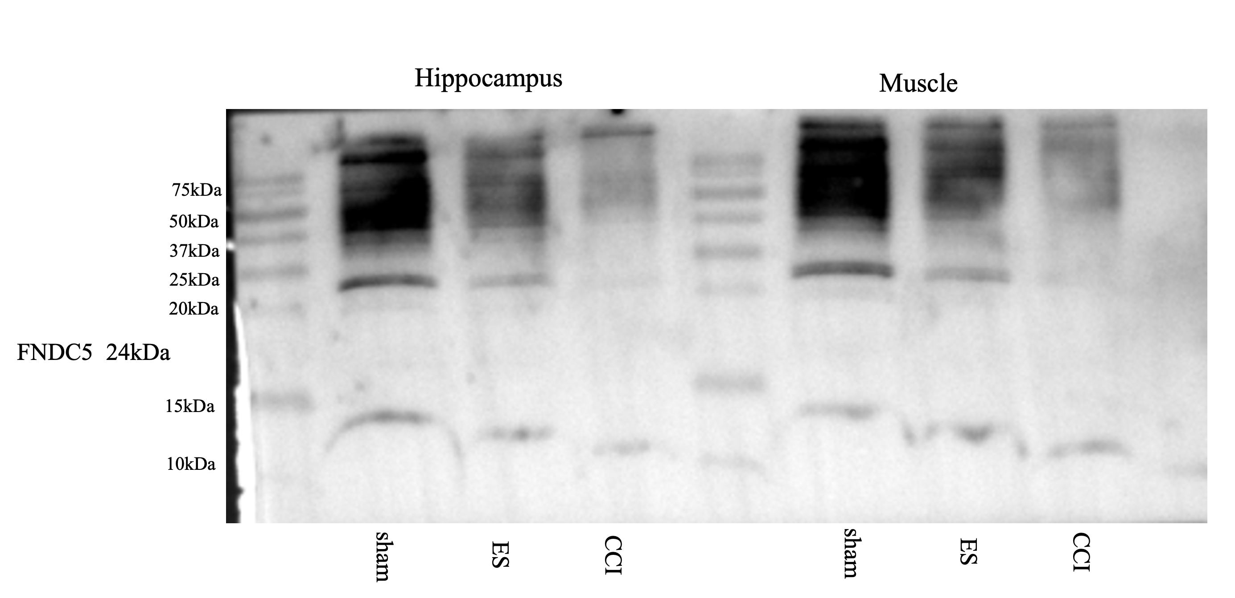
Online Resource 3: Original uncropped Western blot membrane strip for FNDC5 (theoretical molecular weight 24kDa). Samples were from one biological replicate of sham, ES, and CCI groups in both hippocampus and skeletal muscle tissues. The molecular weight marker is included in the strip to confirm the specificity of the target band at ~24kDa.

Online Resource 4: BDNF WB
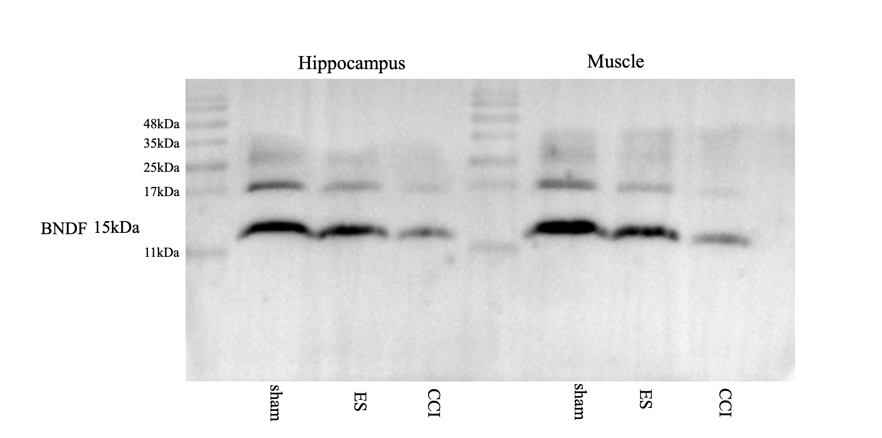
Online Resource 4: Original uncropped Western blot membrane strip for BDNF (theoretical molecular weight 15kDa). Samples were from one biological replicate of sham, ES, and CCI groups in both hippocampus and skeletal muscle tissues. The molecular weight marker is included in the strip to confirm the specificity of the target band at ~15kDa.

