Supporting Information

Dimensionality and Composition Controlled Microwave Absorption in Ti₃C₂T_{x} MXenes-Polymer Hybrids

G.Chandana¹, Anupma Thakur^{2*}, Nithin Chandran BS³, Praveen C Ramamurthy^{1,2*}
¹Interdisciplinary Center for Energy Research (ICER), Indian Institute of Science, Bangalore, Karnataka 560012, India
²Department of Materials Engineering, Indian Institute of Science, Bangalore, Karnataka 560012, India
³Department of Metallurgical and Materials Engineering, Indian Institute of Technology Madras, Chennai 600036, India

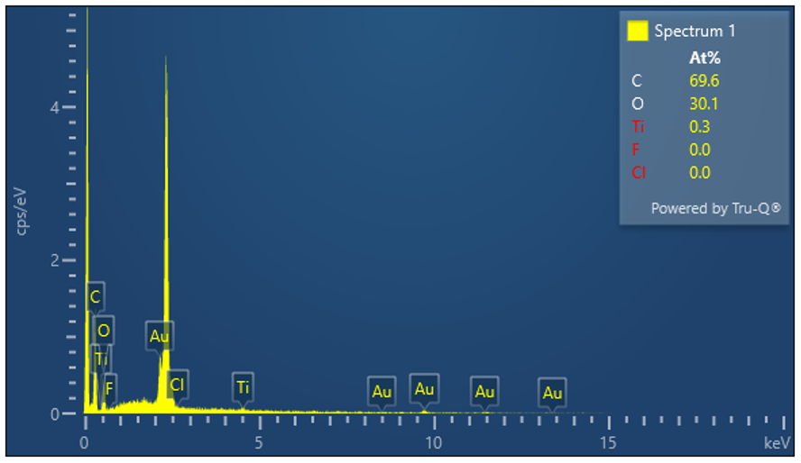

Figure S1: EDS spectrum of Ti₃C₂T_{x}-XPVB composite

Figure S2: Schematic of Ti₃C₂T_{x} MXene-XPVB hybrid preparation

Figure S3: Electromagnetic properties of Ti₃AlC₂-XPVB composite: Real part of Permittivity (ε’)

Figure S4: Electromagnetic properties of Ti₃AlC₂-XPVB composite: Imaginary part (ε″) of permittivity

Figure S5: Electromagnetic properties of Ti₃AlC₂-XPVB composite: Real part (μ′) of Permeability

Figure S6: Electromagnetic properties of Ti₃AlC₂-XPVB composite: Imaginary part (μ″) of permeability

Figure S7: Contour of Thickness dependent RL of multilayered Ti₃C₂T_{x} MXene

Figure S8: Microwave absorbing parameters: Attenuation constant

Figure S9: Microwave absorbing parameters: Impedance matching ability of different hybrids

Figure S10: Cole-Cole analysis of Dielectric Relaxation of Ti₃C₂T_{x} MXene/XPVB composite

Figure S11: Cole-Cole analysis of Dielectric Relaxation Ti₃(C_{2-y}O_{y})T_{x} MXene/XPVB composite

Figure S12: Cole-Cole analysis of Dielectric Relaxation Ti₃AlC₂ MAX/XPVB composite

Figure S13: Cole-Cole analysis of Dielectric Relaxation single flake Ti₃C₂T_{x} MXene/XPVB composite

Figure S14: Cole-Cole analysis of Dielectric Relaxation single flake Ti₃(C_{2-y}O_{y})T_{x} MXene/XPVB composite

Figure S15: Microwave absorbing parameters: Eddy current loss coefficient

Table 1: Comparison of microwave absorption properties of various MXene-based composites
Matrix | Filler | Filler loading (wt%) | Thickness (mm) | Optimal RL (dB) | Absorption Peak Position Frequency (GHz) | RL ≤ -10 dB bandwidth (GHz) | Reference
PVB/PANI | Ti₃C₂T_{x} | 23.5 | 1.5 | -58.1 | 9.7 | 2.3 | ¹
PVB | Ti₃C₂T_{x} | 30 | 2 | -14.4 | 14.8 | 0.8 | ²
PVB | Ti₃C₂T_{x}/ Co₂Z | 30 | 2.8 | -46.3 | 5.8 | 1.6 | ²
Epoxy | Ti₃C₂T_{x} | 50 | 1.4 | -17 | 14.6 | 5.6 | ³
TEP, PVB, GL, DOP | Ti₃C₂T_{x} | 5 | 1.05 | -42.39 | 10.2 | 4.2 | ⁴
Wax | Ti₃C₂T_{x}/Co₃O₄ | 50 | 2 | -55.4 | 12.2 | 6.2 | ⁵
PANI | Fe₃O₄/Ti₃C₂T_{x} | 30 | 1.9 | -40.3 | 15.3 | 5.2 | ⁶
PANI | Ti₃C₂T_{x} | 50 | 1.8-2.6 | -56.3 | 13.8 | 10 | ⁷
PANI | Ti₃C₂T_{x} | 10 | 1.33 | -53.79 | 12.67 | 2.74 | ⁸
PANI | TiO₂/Ti₃C₂T_{x} | 25 | 2.18 | -65.61 | 13.92 | 5.92 | ⁹
PVDF | Ti₃C₂T_{x}/Co | 6 | 4 | -45.6 | 25.2 | 2 | ¹⁰
rGO aerogel | Ti₃C₂T_{x}/TiO₂ | 10 | 2.5 | -65.3 | 13.74 | 4.3 | ¹¹
PANI | CNZFO/Ti₃C₂T_{x} | 60 | 2.2 | -37.1 | 10.2 | 4.1 | ¹²
PPy Hybrids/Paraffin | Ti₃C₂T_{x} | 25 | 3.2 | -49.2 | 8.5 | 4.9 | ¹³
Cellulose Aerogel | Ti₃C₂T_{x} | 24 | 2 | -43.4 | 11.2 | 4.5 | ¹⁴
GO | Ti₃C₂T_{x} | 10 | 1.2 | -49.1 | 14.2 | 2.9 | ¹⁵
rGO | Ti₃C₂T_{x} | 15 | 2.05 | -31.2 | 8.2 | 5.1 | ¹⁶
CNT microspheres | Ti₃C₂T_{x} | 30 | 2.7 | -45 | 10 | 4.9 | ¹⁷
Ni | Ti₃C₂T_{x} | 60 | 1.9 | -52.7 | 12.8 | 3.9 | ¹⁸
wax | Ti₃C₂T_{x} | 50 | 1.7 | -48.4 | 11.6 | 7.2 | ¹⁹
Wax | Ti₃C₂T_{x}/Fe₃O₄ | 25 | 3.6 | -57.2 | 15.7 | 1.4 | ²⁰
Epoxy | Ti₃C₂T_{x}/FCl | 20 | 1 | -15.52 | 13 | 8.16 | ²¹
Wax | Ti₃C₂T_{x}/Ni | 50 | 1.75 | -49.9 | 11.9 | 2.1 | ²²
FeCo | Ti₃C₂T_{x} | 70 | 1.6 | -17.86 | 17.6 | 8.8 | ²³
Wax | Ti₃C₂T_{x}/CNT | 35 | 2.65 | -52.9 | 7.15 | 4.46 | ²⁴
Wax | PPy/Ti₃C₂T_{x} | 10 | 3.6 | -49.5 | 7.6 | 5.14 | ²⁵
Wax | C Spheres/Ti₃C₂T_{x} | 50 | 4.8 | -54.67 | 3.97 | 1.4 | ²⁶
TiO₂/Fe₃O₄ | Ti₃C₂T_{x} | 30 | 1.9 | -57.3 | 10.1 | 2 | ²⁷
Ni_{0.5}Zn_{0.5}Fe₂O₄ | Ti₃C₂T_{x} | 5 | 6.5 | -42.5 | 13.5 | 3 | ²⁸
XPVB | Ti₃(C_{2-y}O_{y})T_{x y=0.3} | 2.5 | 2.1 | -49.9 | 14.2 | 4.5 | This work
XPVB | Ti₃C₂T_{x} | 2.5 | 2.2 | -59.3 | 12.6 | 5.5 | This work

References

1. Bora, P. J., Mahanta, B., Anil, A. G., Tan, D. Q. & Ramamurthy, P. C. Electromagnetic Data-Driven Approach to Realize the Best Microwave Absorption Characteristics of MXene-Based Nanocomposites. ACS Appl. Electron. Mater. 3, 4558–4567 (2021).
2. Yang, H. et al. Layered PVB/Ba3Co2Fe24O41/Ti3C2 Mxene composite: Enhanced electromagnetic wave absorption properties with high impedance match in a wide frequency range. Mater. Chem. Phys. 200, 179–186 (2017).
3. Qing, Y., Zhou, W., Luo, F. & Zhu, D. Titanium carbide (MXene) nanosheets as promising microwave absorbers. Ceram. Int. 42, 16412–16416 (2016).
4. Ji, B. et al. Microwave absorption properties of multilayer impedance gradient absorber consisting of Ti3C2TX MXene/polymer films. Carbon N. Y. 181, 130–142 (2021).
5. Deng, R. et al. MXene/Co3O4 composite material: Stable synthesis and its enhanced broadband microwave absorption. Appl. Surf. Sci. 488, 921–930 (2019).
6. Wang, Y. et al. Synthesis of Ti 3 C 2 /Fe 3 O 4 /PANI hierarchical architecture composite as an efficient wide-band electromagnetic absorber. Appl. Surf. Sci. 480, 830–838 (2019).
7. Wei, H. et al. Ti3C2Tx MXene/polyaniline (PANI) sandwich intercalation structure composites constructed for microwave absorption. Compos. Sci. Technol. 169, 52–59 (2019).
8. Shi, Y. et al. Self-assembled lightweight three-dimensional hierarchically porous Ti3C2Tx MXene@polyaniline hybrids for superior microwave absorption. J. Alloys Compd. 892, 162194 (2022).
9. Gao, X. et al. Design of Ti3C2Tx/TiO2/PANI multi-layer composites for excellent electromagnetic wave absorption performance. J. Colloid Interface Sci. 583, 510–521 (2021).
10. Li, R. et al. Lightweight, multifunctional MXene/polymer composites with enhanced electromagnetic wave absorption and high-performance thermal conductivity. Carbon N. Y. 183, 301–312 (2021).
11. Tong, Y. et al. Three-Dimensional Hierarchical Architecture of the TiO 2 /Ti 3 C 2 T x /RGO Ternary Composite Aerogel for Enhanced Electromagnetic Wave Absorption. ACS Sustain. Chem. Eng. 6, 8212–8222 (2018).
12. Lei, Y. et al. Broadband high-performance electromagnetic wave absorption of Co-doped NiZn ferrite/polyaniline on MXenes. Ceram. Int. 46, 10006–10015 (2020).
13. Tong, Y. et al. Hybridizing polypyrrole chains with laminated and two-dimensional Ti 3 C 2 T x toward high-performance electromagnetic wave absorption. Appl. Surf. Sci. 434, 283–293 (2018).
14. Jiang, Y. et al. Hierarchically structured cellulose aerogels with interconnected MXene networks and their enhanced microwave absorption properties. J. Mater. Chem. C Mater. 6, 8679–8687 (2018).
15. Li, Y. et al. Electrospun generation of Ti3C2Tx MXene@graphene oxide hybrid aerogel microspheres for tunable high-performance microwave absorption. Chemical Engineering Journal 391, 123512 (2020).
16. Wang, L., Liu, H., Lv, X., Cui, G. & Gu, G. Facile synthesis 3D porous MXene Ti3C2Tx@RGO composite aerogel with excellent dielectric loss and electromagnetic wave absorption. J. Alloys Compd. 828, 154251 (2020).
17. Cui, Y. et al. Three dimensional porous MXene/CNTs microspheres: Preparation, characterization and microwave absorbing properties. Compos. Part A Appl. Sci. Manuf. 145, 106378 (2021).
18. Cui, Y. et al. Wrinkled three-dimensional porous MXene/Ni composite microspheres for efficient broadband microwave absorption. Carbon N. Y. 181, 58–68 (2021).
19. Han, M. et al. Ti 3 C 2 MXenes with Modified Surface for High-Performance Electromagnetic Absorption and Shielding in the X-Band. ACS Appl. Mater. Interfaces 8, 21011–21019 (2016).
20. Zhang, X. et al. Novel solvothermal preparation and enhanced microwave absorption properties of Ti3C2Tx MXene modified by in situ coated Fe3O4 nanoparticles. Appl. Surf. Sci. 484, 383–391 (2019).
21. Yan, S., Cao, C., He, J., He, L. & Qu, Z. Investigation on the electromagnetic and broadband microwave absorption properties of Ti 3 C 2 Mxene/flaky carbonyl iron composites. Journal of Materials Science: Materials in Electronics 30, 6537–6543 (2019).
22. Liang, L. et al. Promising Ti 3 C 2 T x MXene/Ni Chain Hybrid with Excellent Electromagnetic Wave Absorption and Shielding Capacity. ACS Appl. Mater. Interfaces 11, 25399–25409 (2019).
23. He, J. et al. Magnetic FeCo nanoparticles-decorated Ti3C2 MXene with enhanced microwave absorption performance. J. Magn. Magn. Mater. 492, 165639 (2019).
24. Li, X. et al. Ti 3 C 2 MXenes modified with in situ grown carbon nanotubes for enhanced electromagnetic wave absorption properties. J. Mater. Chem. C Mater. 5, 4068–4074 (2017).
25. Liu, T. et al. Designed construction of Ti3C2Tx@PPY composites with enhanced microwave absorption performance. J. Alloys Compd. 802, 445–457 (2019).
26. Dai, B. et al. Novel two-dimensional Ti 3 C 2 T x MXenes/nano-carbon sphere hybrids for high-performance microwave absorption. J. Mater. Chem. C Mater. 6, 5690–5697 (2018).
27. Liu, P. et al. Facile synthesis of ultrasmall Fe3O4 nanoparticles on MXenes for high microwave absorption performance. Compos. Part A Appl. Sci. Manuf. 115, 371–382 (2018).
28. Li, Y. et al. Facile preparation of in situ coated Ti 3 C 2 T x /Ni 0.5 Zn 0.5 Fe 2 O 4 composites and their electromagnetic performance. RSC Adv. 7, 24698–24708 (2017).

