Online Resource 1 Representative image of Pd3D spheroids captured at the end of culture (day 7).
Online Resource 2 Representative images of SSTR2 immunocytochemistry and corresponding digital analysis markup.
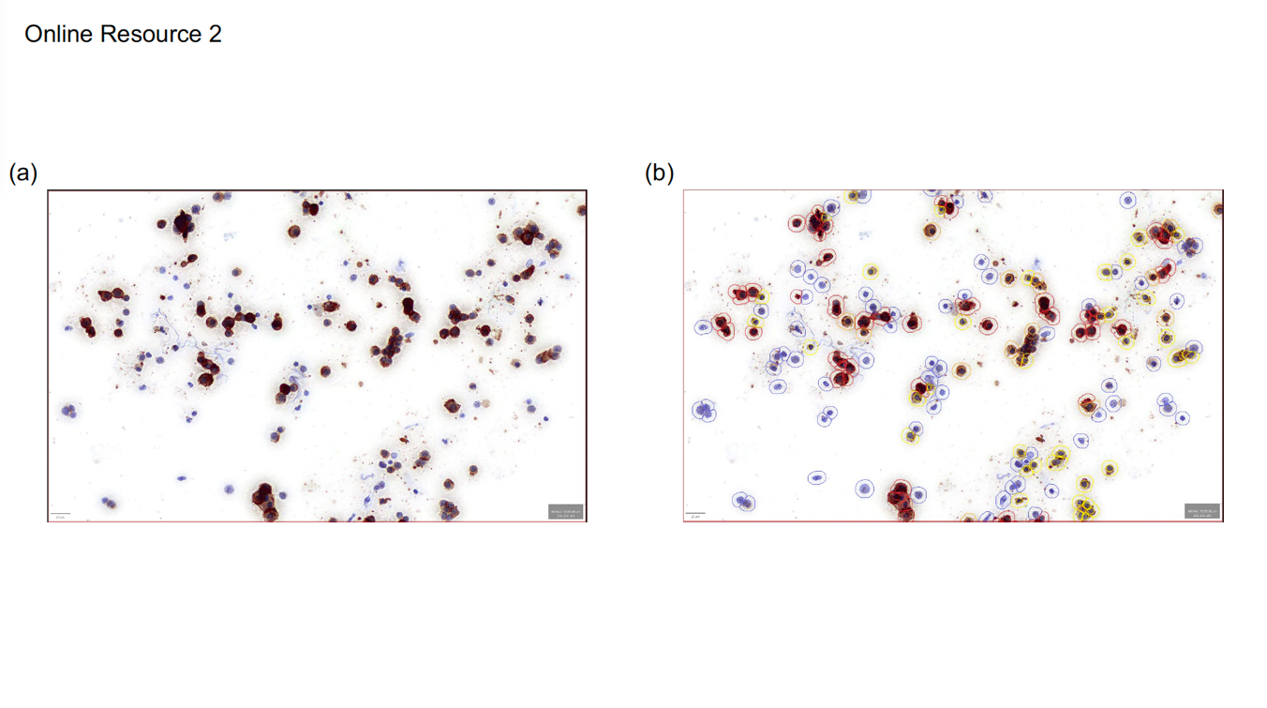 a. Original immunocytochemical staining of an LBC specimen derived from Pd3D spheroids.
b. Digital analysis markup of the same field. Cells are detected and color-coded based on DAB staining intensity (blue: negative, yellow: 1+, orange: 2+, and red: 3+) for automated H-score calculation.

Online Resource 3 The viability of control cultures over the experimental period.
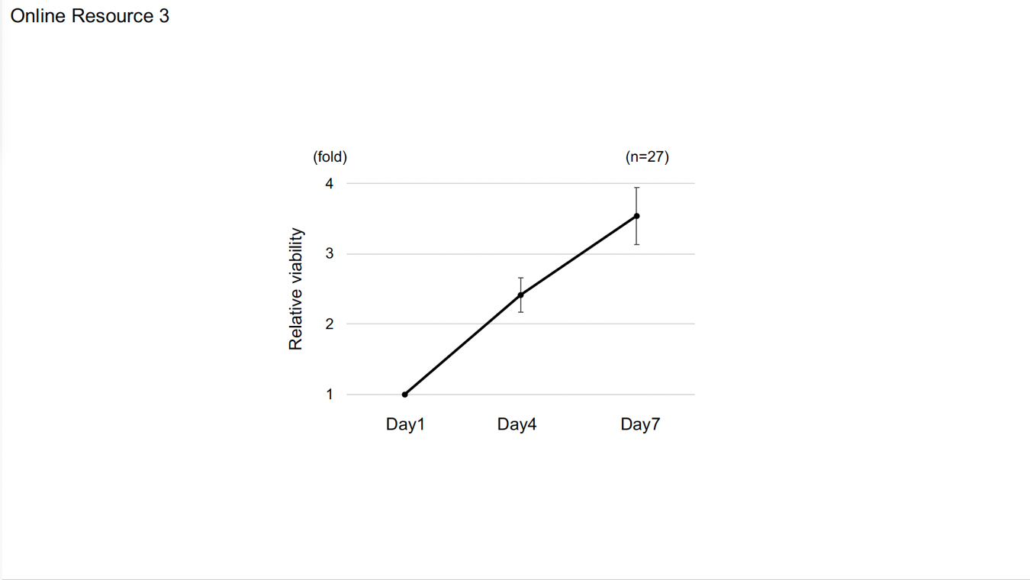
Cell viability of control cultures was tracked from baseline to the experimental endpoint. All 27 samples maintained robust viability throughout the culture duration. Data are presented as mean ± SE.

