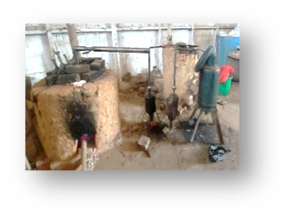
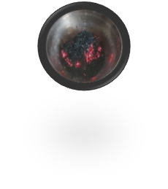
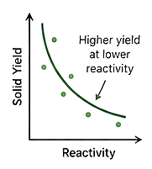
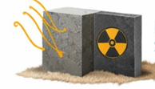
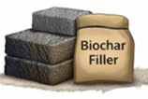
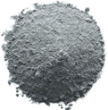

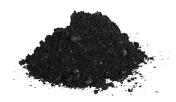
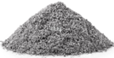
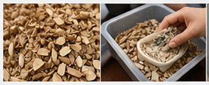
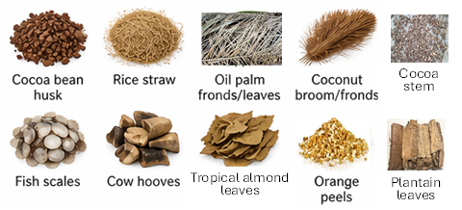
PYROLYSIS OF AGRICULTURAL WASTE MATERIALS
From Agricultural Waste to Potential Radiation Shielding Materials: Linking Thermochemical Reactivity and Solid Product Availability

- Onset temperature (T_{onset}): Decomposition starts
- Heating Rate: 2.7 – 8.3 ºCmin⁻¹
- Residence Time
- Final Temperature (T_{f})
- Thermal Reactivity Index (TRI)
$$TRI= \frac{T_{f}- T_{o}}{t_{f}-t_{o}}$$
$TRI Range: 0.7 - 7.0$ºCmin⁻¹
THERMOCHEMICAL REACTIVITY INDICATORS

THERMOCHEMICAL CONVERSION
COMBUSTION OF AWM
(Ash production)
- Temperature: 400 – 700OC
- Product: Mineral-Rich bio-ash

PYROLYSIS OF AWMs
(Oxygen-limited)
- Temperature: Ambient to 800^{O}C
- Residence time: Controlled
- Product: Biochar + Volatiles

- Low-moderate reactivity
Higher solid yields
- High reactivity
Faster decomposition
Lower char yield
- Energy demand inversely proportional to reactivity
(SGC: 0.29 – 1.22 kg kg⁻¹)
PERFORMANCE AND ENERGY INSIGHT

ENGINEERING APPLICATIONS

SUPPLEMENTARY CEMENT REPLACEMENT
Pozzolanic ash

CONCRETE FILLERS
(Lightweight aggregates)

RADIATION SHIELDING MATERIAL
Biochar and Ashes Composites

SUSTAINABLE CONSTRUCTION MATERIALS

SOLID RESIDUES (PRODUCTS)

BIOCHAR
YIELD: 10 – 34%

Highest yield:
- Fisch Scale (~33.8%)
- Cocoa bean husk (~30.3%)
- Cow Hooves (~21.5%)

ASH
YIELD: 0 – 12%

Highest yield:
- Tropical Almond leaves (~11.5%)
- Plantain leaves (~9.1%)
- Rice straw (~6.8%)

- Cutting larger samples – size reduction
- Cleaning Samples - impurity removal
- Drying Samples – moisture control
FEEDSTOCK PREPARATION

FEEDSTOCK
(Agricultural Waste Materials)

