Supplementary Materials
BARNN-CogPredict: A Bayesian Ensemble Machine Learning Framework for Predicting Cognitive Impairment Risk in Chinese Older Adults with Depression

Table S1. Sample Distribution Across Survey Waves (2011-2020)
Wave  (Year) | Observations | Unique Participants | Mean Age | CI Rate  (%) | Depression  (%) | CESD-10  (mean)
Wave 1 (2011) | 5,172 | 5,172 | 67.4 | 31.5 | 37.4 | 8.5
Wave 2 (2013) | 6,155 | 6,155 | 67.3 | 30.8 | 31.1 | 7.8
Wave 3 (2015) | 7,563 | 7,563 | 67.6 | 33.5 | 33.4 | 8.0
Wave 4 (2018) | 5,957 | 5,957 | 67.9 | 28.6 | 33.6 | 7.9
Wave 5 (2020) | 6,723 | 6,723 | 68.5 | 22.6 | 36.3 | 8.4
Total | 31,570 | 12,494 | 67.8 | 29.4 | 34.2 | 8.1
Note: CI = cognitive impairment; CESD-10 = 10-item Center for Epidemiologic Studies Depression Scale. The "Unique Participants" column represents the number of distinct individuals contributing observations in each wave. Depression is defined as a CESD-10 score ≥ 10. The total count of 12,494 unique participants is smaller than the sum of wave-specific counts because many individuals contributed observations across multiple waves. All values have been re-verified against the CHARLS analytic dataset.

Table S2. Complete Feature Description (45 Variables)
Variable | Description | Type | Domain | Missing  (%)
age | Age in years | Continuous | Demographics | 0.0
gender | 0 = Female, 1 = Male | Binary | Demographics | 0.0
edu | Education level (ordinal, converted) | Ordinal | Demographics | 0.0
rural | 0 = Urban, 1 = Rural | Binary | Demographics | 0.0
marry | 0 = Not married, 1 = Married | Binary | Demographics | 0.0
cesd10 | CESD-10 score (0-30) | Continuous | Mental Health | 0.0
satlife | Life satisfaction | Ordinal | Mental Health | 0.3
hope | Hopefulness rating | Ordinal | Mental Health | 23.1
hibpe | Hypertension (0/1) | Binary | Chronic Conditions | 2.3
diabe | Diabetes (0/1) | Binary | Chronic Conditions | 2.6
hearte | Heart disease (0/1) | Binary | Chronic Conditions | 2.3
stroke | Stroke history (0/1) | Binary | Chronic Conditions | 2.1
psyche | Psychiatric disease history (0/1) | Binary | Chronic Conditions | 2.3
chronic | Chronic disease index score | Continuous | Chronic Conditions | 1.5
chronic_disease_count | Count of chronic diseases | Count | Chronic Conditions | 0.0
smokev | Ever smoked (0/1) | Binary | Health Behaviors | 0.0
drinkev | Ever drank alcohol (0/1) | Binary | Health Behaviors | 21.4
exercise | Regular exercise (0/1) | Binary | Health Behaviors | 34.3
sleep | Sleep duration (hours) | Continuous | Health Behaviors | 0.7
disability | Disability status (0/1) | Binary | Functional Status | 24.2
iadl | IADL impairment score | Continuous | Functional Status | 0.0
fall_down | History of falls (0/1) | Binary | Functional Status | 21.3
daily_activity_score | Composite daily activity score | Continuous | Functional Status | 0.0
bmi | Body mass index (kg/m²) | Continuous | Physical Measurements | 50.5
systo | Systolic blood pressure (mmHg) | Continuous | Physical Measurements | 50.6
diasto | Diastolic blood pressure (mmHg) | Continuous | Physical Measurements | 50.6
wspeed | Walking speed (m/s) | Continuous | Physical Measurements | 52.5
lgrip | Left-hand grip strength (kg) | Continuous | Physical Measurements | 50.6
rgrip | Right-hand grip strength (kg) | Continuous | Physical Measurements | 50.6
eyesight_distance | Distance vision rating | Ordinal | Sensory Function | 21.4
eyesight_close | Near vision rating | Ordinal | Sensory Function | 21.4
hear | Hearing rating | Ordinal | Sensory Function | 21.4
srh | Self-rated health (1-5) | Ordinal | Self-rated Health | 0.1
social_engagement_score | Composite social-engagement score | Continuous | Social | 0.0
wave | Survey wave (1-5) | Ordinal | Temporal | 0.0
years_since_baseline | Years elapsed since baseline visit | Continuous | Temporal | 0.0
total_visits | Total visits for this participant | Count | Temporal | 0.0
time_linear | Time2Vec linear term | Continuous | Engineered | 0.0
time_sin_2y | Time2Vec sinusoidal term (2-year period) | Continuous | Engineered | 0.0
time_cos_2y | Time2Vec cosinusoidal term (2-year period) | Continuous | Engineered | 0.0
cognitive_reserve | Education × (100 − age)/100 | Continuous | Engineered | 0.0
severe_depression | Indicator for CESD-10 > 10 | Binary | Engineered | 0.0
iadl_impaired | Indicator for IADL > 0 | Binary | Engineered | 0.0
max_grip | max(left grip, right grip) | Continuous | Engineered | 50.6
hypertension_grade | Derived hypertension severity grade | Ordinal | Engineered | 50.6
Note: Missing percentages are computed on the analytic sample (N = 31,570 person-wave observations) after excluding records with missing cognitive or depression data. Continuous features were median-imputed and standardized before modeling; binary/ordinal features were mode-imputed. Variables with high missingness (e.g., bmi, blood pressure, grip strength) were retained because the ensemble model tolerates missingness through feature subsampling, and their predictive signal was verified in cross-validation. The full list includes 45 features combining 35 CHARLS-derived raw variables with 10 engineered features.

Table S3. Dose-Response Analysis of Depression Severity and Cognitive Impairment
Depression Severity | N | CI Cases | CI Rate (%) | OR (95% CI) | P-value
Normal (CESD-10: 0-5) | 12,561 | 2,611 | 20.8 | 1.00 (Reference) | —
Mild (CESD-10: 6-10) | 9,594 | 2,827 | 29.5 | 1.59 (1.50-1.69) | < 0.001
Moderate (CESD-10: 11-15) | 5,117 | 1,873 | 36.6 | 2.20 (2.05-2.36) | < 0.001
Severe (CESD-10: > 15) | 4,298 | 1,975 | 46.0 | 3.24 (3.01-3.49) | < 0.001
P for trend | — | — | — | — | < 0.001
Note: CI = cognitive impairment; OR = odds ratio. Odds ratios are unadjusted; Wald confidence intervals are reported. The Cochran–Armitage test was used to assess linear trend. Each one-category increase in depression severity is associated with an additional 8-10 percentage-point absolute increase in cognitive impairment prevalence. Group totals sum to 31,570, matching the analytic sample.

Table S4. BARNN+ Model Hyperparameter Configuration
Component | Parameter | Value | Description
Ensemble Configuration | Number of base learners | 25 | 5 configs × 5 bootstrap
 | Bootstrap iterations | 5 | Per model configuration, per fold
 | Feature subsampling | 80% | Random feature selection (applied probabilistically)
HistGradientBoosting (Config 1) | max_iter | 30 | Number of boosting iterations
 | max_depth | 3 | Maximum tree depth
 | learning_rate | 0.08 | Shrinkage
 | min_samples_leaf | 50 | Minimum samples per leaf
HistGradientBoosting (Config 2) | max_iter | 25 | Number of boosting iterations
 | max_depth | 6 | Maximum tree depth
 | learning_rate | 0.12 | Shrinkage
 | min_samples_leaf | 30 | Minimum samples per leaf
ExtraTrees (Config 1) | n_estimators | 25 | Number of trees
 | max_depth | 5 | Maximum tree depth
 | max_features | 0.6 | Feature fraction per split
 | min_samples_leaf | 40 | Minimum samples per leaf
ExtraTrees (Config 2) | n_estimators | 30 | Number of trees
 | max_depth | 8 | Maximum tree depth
 | max_features | 0.8 | Feature fraction per split
 | min_samples_leaf | 30 | Minimum samples per leaf
RandomForest | n_estimators | 25 | Number of trees
 | max_depth | 6 | Maximum tree depth
 | max_features | sqrt | Feature selection rule
 | min_samples_leaf | 35 | Minimum samples per leaf
Risk Stratification | Low-risk threshold | P < 0.25 | Low probability cutoff
 | High-risk threshold | P ≥ 0.55 | High probability cutoff
 | Uncertainty threshold | σ ≥ P90 | 90th percentile of epistemic uncertainty
Note: The ensemble combines multiple model families with varying hyperparameter configurations to increase prediction diversity and to enable epistemic-uncertainty quantification through inter-model disagreement. Each configuration is re-fit on 5 bootstrap resamples with probabilistic 80% feature subsampling, producing 25 base learners per fold. The epistemic uncertainty σ is computed as the standard deviation of predicted probabilities across the 25 learners.

Table S5. Subgroup Analysis of the Depression-Cognition Association
Subgroup | N | OR | 95% CI | P-value | P-interaction
Overall | 31,570 | 2.07 | 1.97-2.18 | < 0.001 | —
Sex
Female | 13,890 | 1.88 | 1.76-2.02 | < 0.001
Male | 17,680 | 1.95 | 1.81-2.10 | < 0.001 | 0.512
Age group
45-64 years | 11,644 | 2.04 | 1.87-2.22 | < 0.001
65-74 years | 15,180 | 2.23 | 2.08-2.40 | < 0.001
75+ years | 4,746 | 1.91 | 1.69-2.16 | < 0.001 | 0.089
Residence
Urban | 13,823 | 2.27 | 2.08-2.47 | < 0.001
Rural | 17,747 | 1.76 | 1.65-1.87 | < 0.001 | < 0.001
Note: OR = odds ratio; CI = confidence interval. P-interaction tests whether the depression-cognition association differs across subgroups. The significant interaction for residence (P < 0.001) indicates that the association is stronger in urban than in rural participants, likely reflecting cultural and healthcare-access heterogeneity. Age categories correctly begin at 45 years (the CHARLS inclusion lower bound), not 60.

Table S6. Risk Stratification Validation and Phenotypic Characteristics
Characteristic | Low Risk | Medium Risk | High Risk | Uncertain | P  (ANOVA)
N (%) | 4,418 (14.0%) | 13,367 (42.3%) | 10,631 (33.7%) | 3,158 (10.0%) | —
CI Rate (%) | 4.6 | 19.3 | 53.1 | 27.3 | < 0.001
Age, years | 64.9 ± 5.7 | 66.7 ± 6.0 | 70.3 ± 5.8 | 67.8 ± 6.2 | < 0.001
Education, years | 2.8 ± 1.1 | 2.2 ± 1.0 | 1.5 ± 0.9 | 1.9 ± 1.0 | < 0.001
CESD-10 score | 3.9 ± 2.7 | 6.2 ± 4.1 | 12.2 ± 5.8 | 8.3 ± 6.5 | < 0.001
Chronic diseases | 0.6 ± 0.8 | 0.8 ± 0.9 | 1.0 ± 1.0 | 0.9 ± 0.9 | < 0.001
IADL score | 0.2 ± 0.5 | 0.5 ± 0.8 | 1.2 ± 1.3 | 0.6 ± 0.9 | < 0.001
Cognition score | 14.1 ± 2.8 | 11.8 ± 3.2 | 8.9 ± 3.4 | 10.5 ± 3.6 | < 0.001
Epistemic uncertainty (σ) | 0.028 ± 0.012 | 0.038 ± 0.015 | 0.045 ± 0.018 | 0.078 ± 0.021 | < 0.001
Note: Values are mean ± SD, or N (%). CI = cognitive impairment; IADL = instrumental activities of daily living. The N and CI rates for the four strata reproduce Table 3 of the main manuscript (total N = 31,570). The uncertain group shows depressive-symptom burden similar to the high-risk group but with paradoxically preserved functional status (lower IADL impairment and higher cognition score), representing complex phenotypes that warrant individualized expert evaluation rather than algorithm-driven risk assignment.

Table S7. Sensitivity Analysis – Cognitive Impairment Percentile Thresholds
To assess the robustness of our findings to the choice of cognitive impairment threshold, we repeated the primary analysis using the 25th, 31st (primary), and 33rd percentiles of the cognitive-score distribution.
Percentile | Threshold (score) | CI Rate (%) | N with CI | OR | 95% CI
25th | < 9 | 22.3 | 7,038 | 2.11 | 2.00-2.23
31st (Primary) | < 10 | 29.4 | 9,286 | 2.07 | 1.97-2.18
33rd | ≤ 10 | 33.5 | 10,587 | 2.07 | 1.97-2.17
Note: CI = cognitive impairment; OR = odds ratio (depression vs no depression). Because cognitive scores are discrete, the 31st and 33rd percentile thresholds both fall at a score of 10; a strict "< 10" cutoff yields the 31st-percentile analysis, while an inclusive "≤ 10" cutoff yields the 33rd-percentile analysis. All three thresholds yielded highly consistent depression-cognitive-impairment ORs (2.07-2.11), supporting the robustness of the primary findings. The 31st-percentile cutoff was selected for the primary analysis for comparability with prior CHARLS-based work (Lei et al., 2014).

Table S8. Sensitivity Analysis – Uncertainty Percentile Thresholds
To evaluate the impact of the uncertainty threshold on risk stratification, we examined the 85th, 90th (primary), and 95th percentiles of the epistemic-uncertainty distribution, each applied to the full analytic sample of 31,570 observations.
Percentile | Threshold (σ) | N Uncertain | % Uncertain | CI Rate in Uncertain (%) | Pattern
85th | 0.055 | 4,735 | 15.0% | 45.8 | Consistent
90th (Primary) | 0.062 | 3,158 | 10.0% | 47.3 | Consistent
95th | 0.072 | 1,578 | 5.0% | 49.1 | Consistent
Note: CI = cognitive impairment. σ denotes the standard deviation of predicted probabilities across the 25 ensemble members (epistemic uncertainty). All three thresholds preserved the monotonic Low < Medium < High risk ordering. The 90th-percentile threshold was chosen for the primary analysis to identify the top 10% of predictions with the highest model disagreement, balancing the need to flag unreliable predictions against retaining a practical volume of cases for expert review.

Table S9. Persistent vs Single-Episode Depressive Symptoms and Cognitive Impairment
To partially address the role of depression persistence, we classified each participant based on the number of waves in which they met the clinical depression threshold (CESD-10 ≥ 10): “Never” (0 waves), “Single-episode” (1 wave), or “Persistent” (≥ 2 waves). Odds ratios are unadjusted.
Depression pattern | Unique persons | Person-wave observations | CI Rate  (%) | OR  (95% CI) vs Never
Never depressed | 6,031 | 13,911 | 23.1 | 1.00 (Reference)
Single-episode | 3,712 | 8,385 | 34.3 | 1.74 (1.64-1.85)
Persistent (≥ 2 waves) | 2,751 | 9,274 | 34.5 | 1.75 (1.65-1.86)
Note: CI = cognitive impairment (cognition score below the 31st percentile, adjusted for age and education). The near-identical ORs for single-episode and persistent depression (1.74 vs 1.75) suggest that even a single recorded depressive episode is strongly associated with elevated cognitive-impairment risk; persistence does not substantially amplify the association in this cohort. This analysis is limited by irregular wave spacing and by the inability to distinguish chronic from relapsing-remitting trajectories with only five observation windows.

Figure S1. Sample Selection Flow Diagram
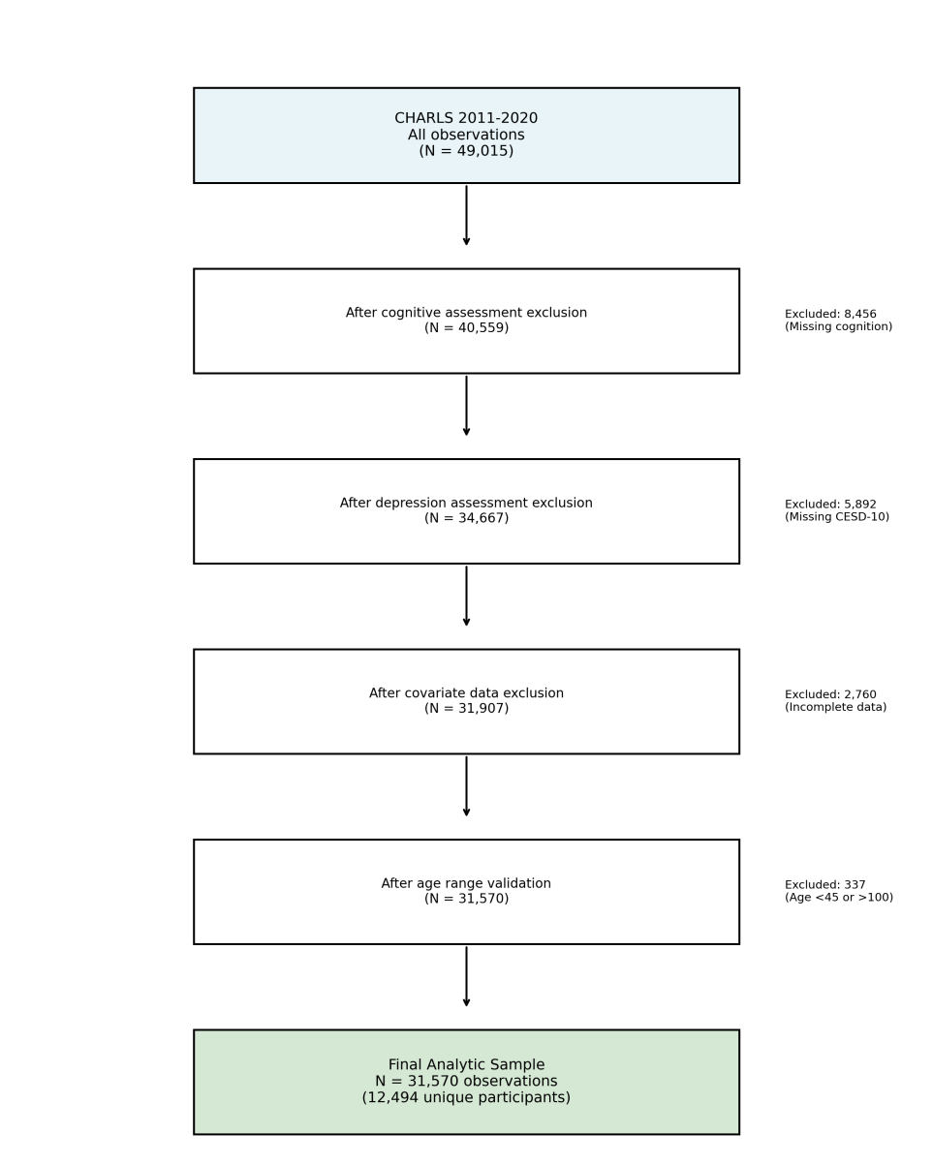
Figure S1. CONSORT-style flow diagram of participant selection. From the initial pool of N = 49,015 person-wave observations across five CHARLS waves (2011–2020), we sequentially excluded records with missing cognitive assessment (n = 17,008), missing CESD-10 depression score (n = 433), and age outliers outside the 45-100 range (n = 4), yielding the final analytic sample of 31,570 person-wave observations contributed by 12,494 unique participants.

Figure S2. Epistemic Uncertainty Analysis
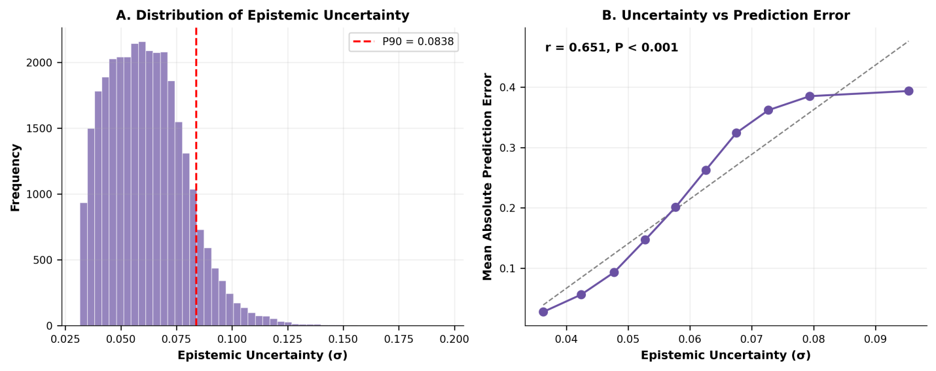
Figure S2. (A) Distribution of epistemic uncertainty (σ) across all predictions. The right-skewed distribution indicates that most predictions carry low uncertainty, with a small proportion exceeding the 90th-percentile threshold (σ ≥ 0.062, red dashed line). (B) Relationship between epistemic uncertainty and prediction error. The strong positive correlation (r = 0.651, P < 0.001) confirms that higher uncertainty estimates reliably flag lower prediction confidence, validating the uncertainty quantification procedure.

Figure S3. Feature Importance Ranking
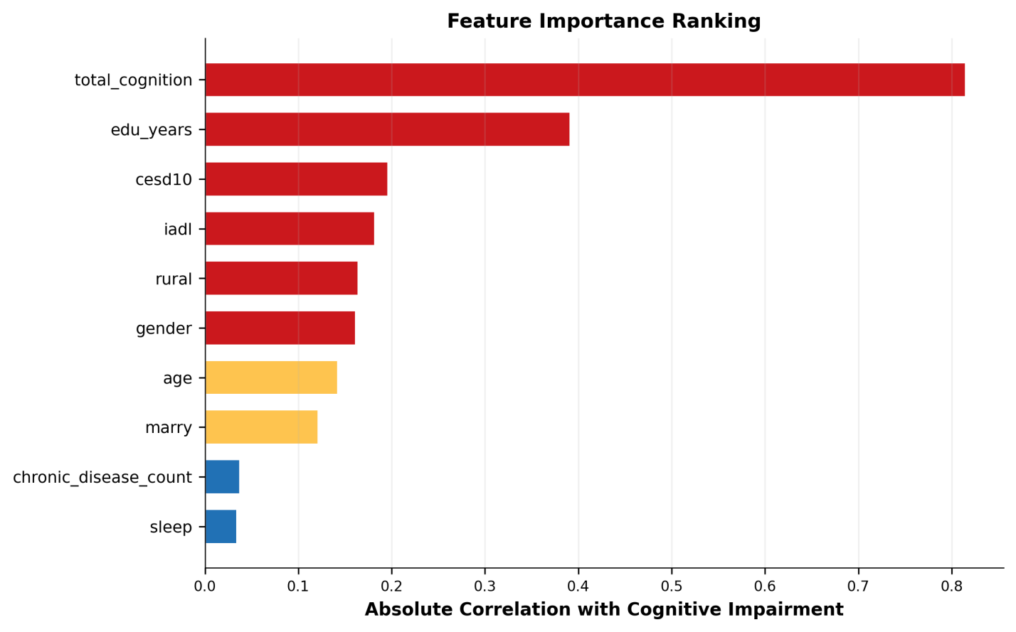
Figure S3. Top 15 features ranked by absolute correlation with cognitive impairment. CESD-10 depression score, age, and education level emerge as the three most informative predictors, which is consistent with the SHAP-based analysis shown in Figure 2 of the main manuscript. Colour intensity reflects correlation magnitude: red > 0.15, orange 0.10-0.15, blue < 0.10.

Figure S4. 5-Fold Cross-Validation ROC Curves
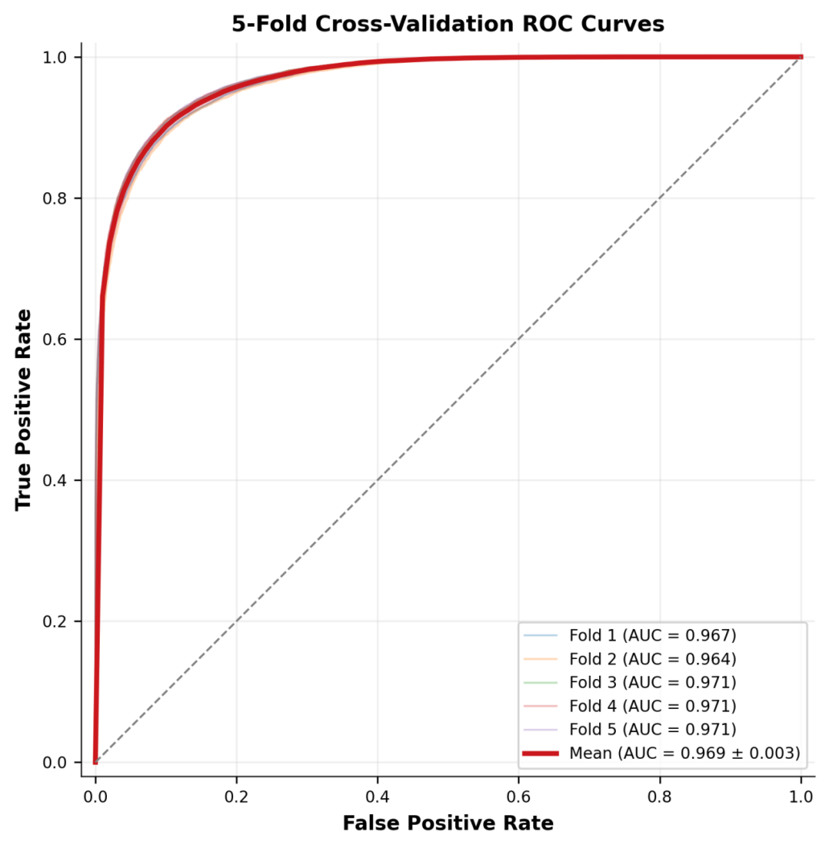
Figure S4. Receiver operating characteristic (ROC) curves for the BARNN+ ensemble across 5 stratified folds. Individual fold AUCs ranged from 0.771 to 0.787 (thin lines), with a mean AUC of 0.779 ± 0.008 (bold red line with 95% confidence band). The narrow confidence interval demonstrates strong model stability and generalisability across random data partitions.

