Multi-omics reveals divergent regulation of anthocyanin glycosylation and gibberellin biosynthesis underlying leaf variegation in Saxifraga stolonifera
Supplementary Figure 1-13

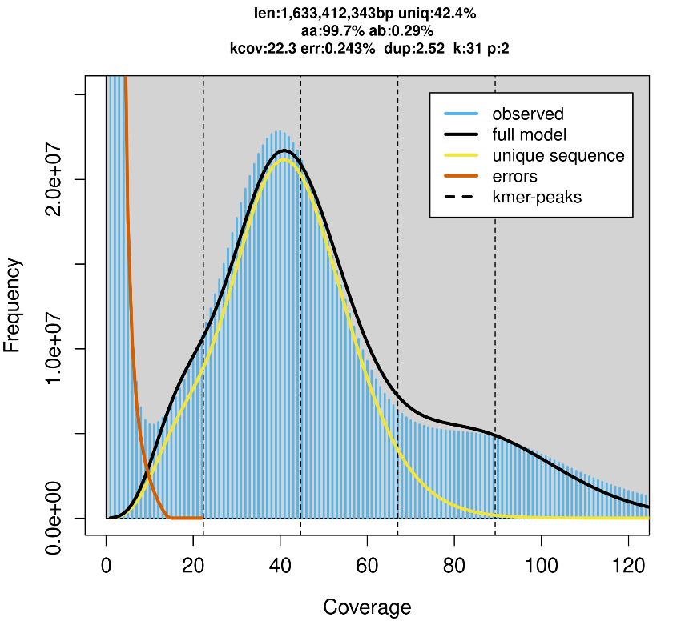
Fig. S1. Frequency distribution of k-mer number and species number when K-mer = 31 in the S. stolonifera genome.

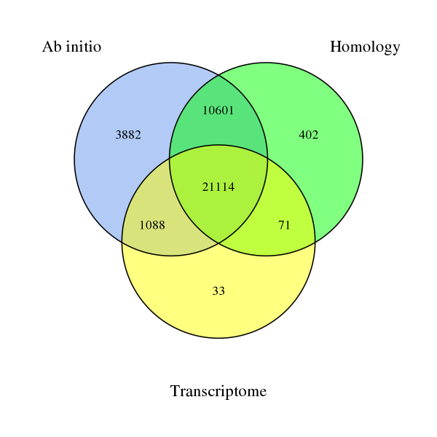
Fig. S2. Venn diagram of genes annotated by ab initio, homology-based, and transcription-based approaches.

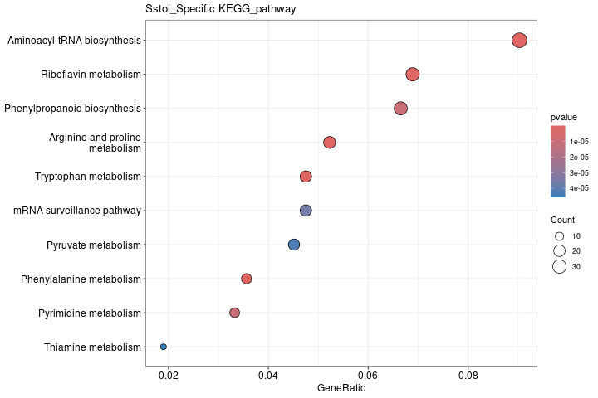
Fig. S3. KEGG pathway of gene families specific to S. stolonifera.

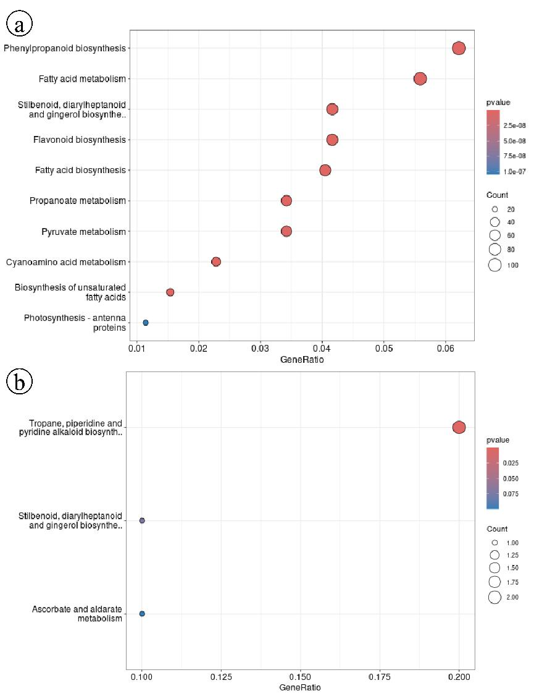
Fig. S4. KEGG enrichment analysis of expanded (a) and contracted (b) genes in the S. stolonifera.

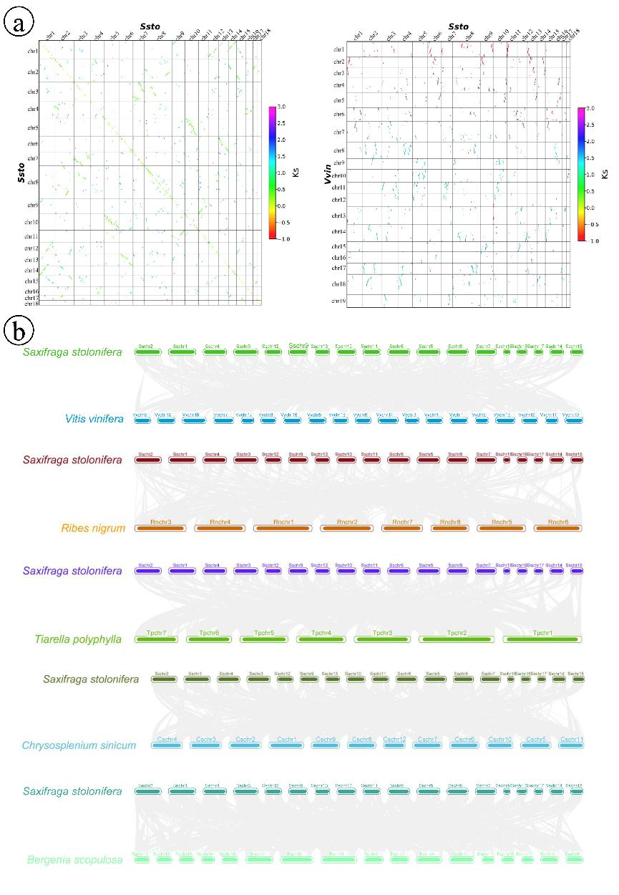
Fig. S5. Syntenic dot-plot and chromosome collinearity analysis. (a) Syntenic dot-plot of intra-genomic comparison in the Saxifraga stolonifera genome and between the S. stolonifera and V. vinifera genome. (b) Chromosome collinearity analysis between S. stolonifera and Vitis vinifera, Ribes nigrum, Tiarella polyphylla, Bergenia scopulosa, and Chrysosplenium sinicum.
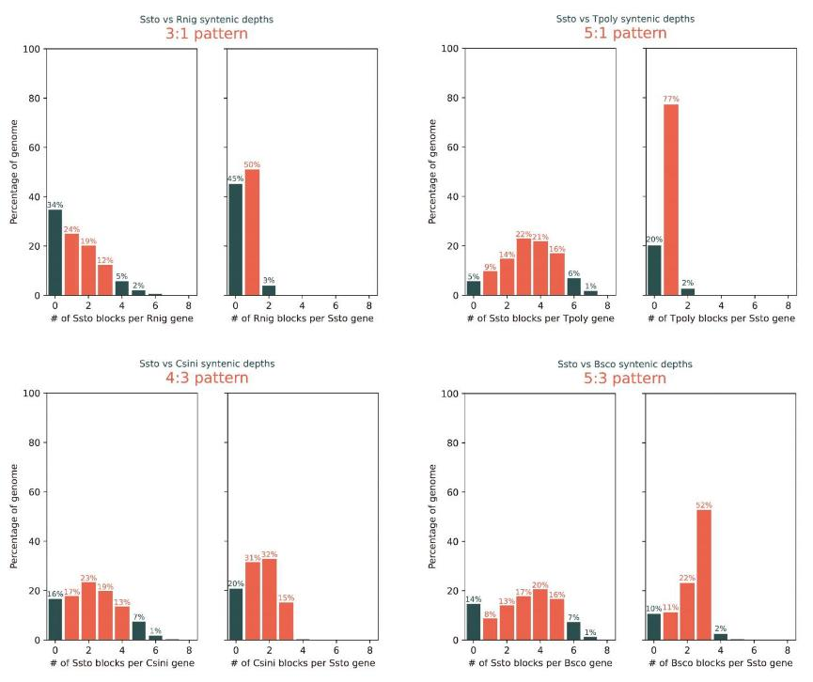
Fig. S6. Syntenic depth ratio analyses of S. stolonifera vs. Ribes nigrum, S. stolonifera vs. Tiarella polyphylla, S. stolonifera vs. Chrysosplenium sinicum, and S. stolonifera vs. Bergenia scopulosa.

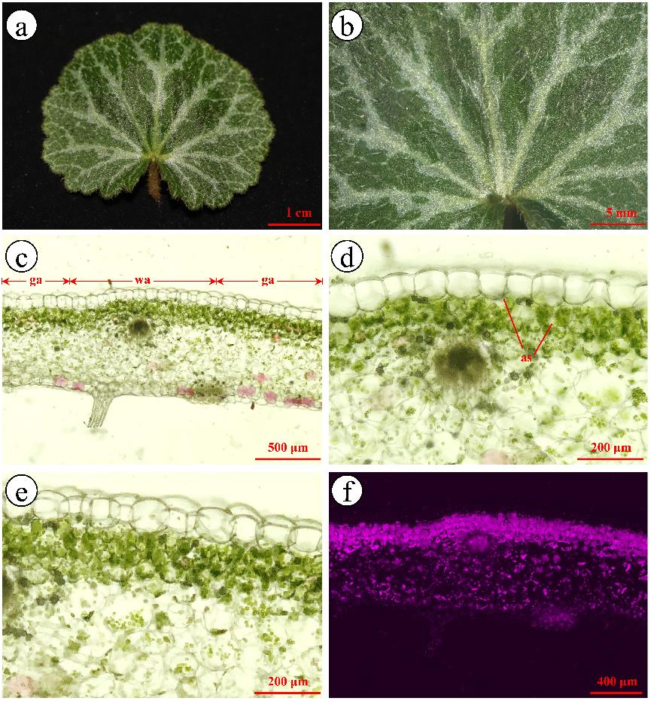
Fig. S7. Leaf structure of the white-variegated type Saxifraga stolonifera. (a) adaxial surface of leaf; (b) the enlargement of adaxial surface of leaf; (c-e) leaf transverse sections, obvious air spaces are observed between palisade tissue cells and upper epidermal cells and among palisade tissue cells above vascular bundle; (f) autofluorescence of chloroplast in leaf transverse section; ga, green area; wa, white area; as, air space.

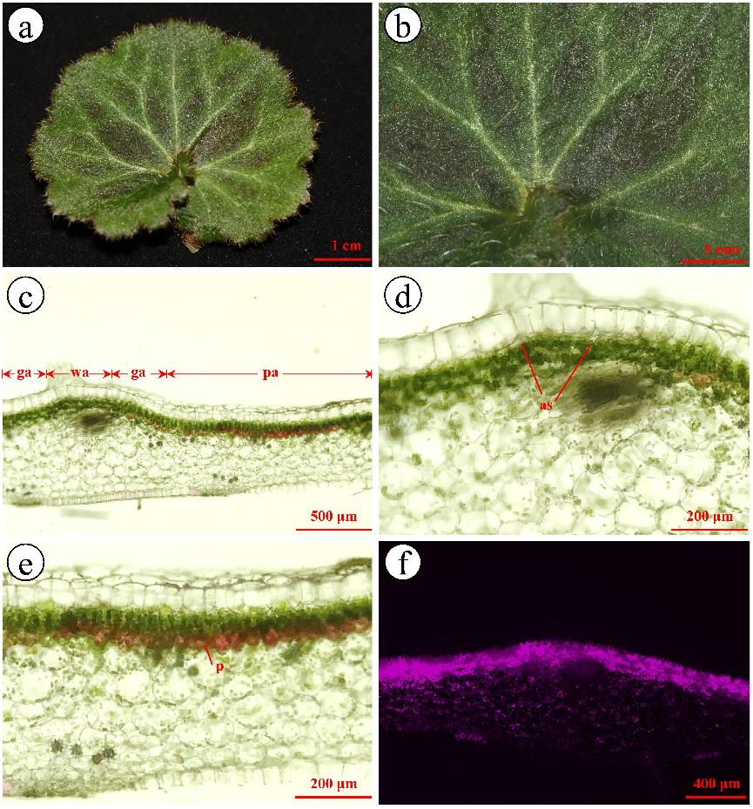
Fig. S8. Leaf structure of the purple-variegated type Saxifraga stolonifera. (a) adaxial surface of leaf; (b) the enlargement of adaxial surface of leaf; (c-e) leaf transverse sections, obvious air spaces are observed between palisade tissue cells and upper epidermal cells above vascular bundle, purple pigment cells can be seen below the palisade tissue between veins; (f) autofluorescence of chloroplast in leaf transverse section; ga, green area; wa, white area; pa, purple area; as, air space; p, pigment cell.

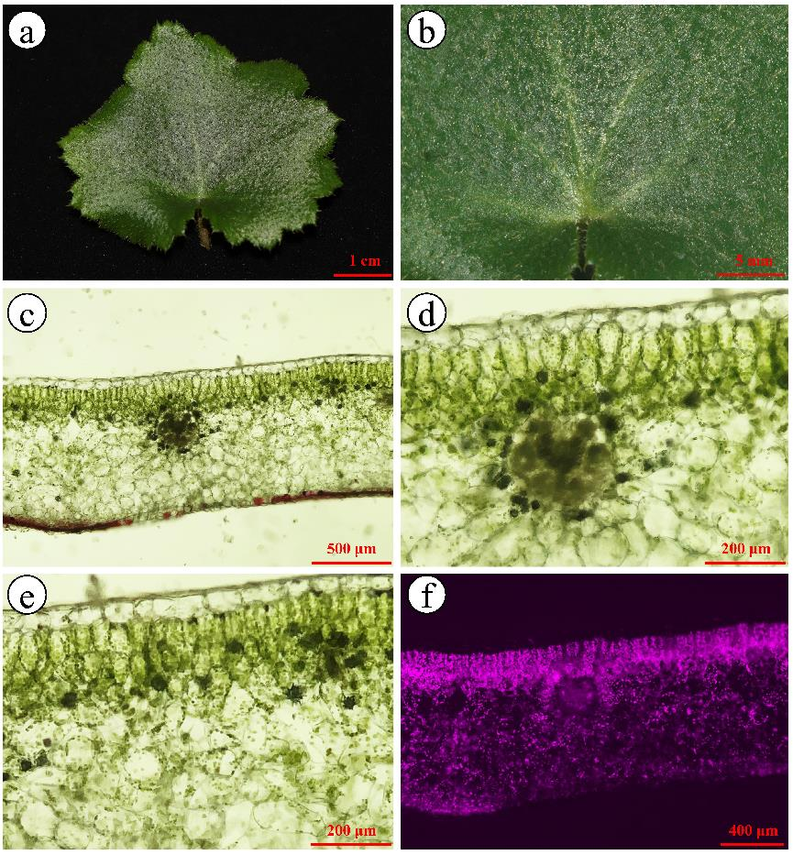
Fig S9. Leaf structure of the green leaf type Saxifraga stolonifera. (a) adaxial surface of leaf; (b) the enlargement of adaxial surface of leaf; (c-e) leaf transverse sections, there was no obvious air space between palisade tissue cells and upper epidermal cells and among palisade tissue cells; (f) autofluorescence of chloroplast in leaf transverse section.

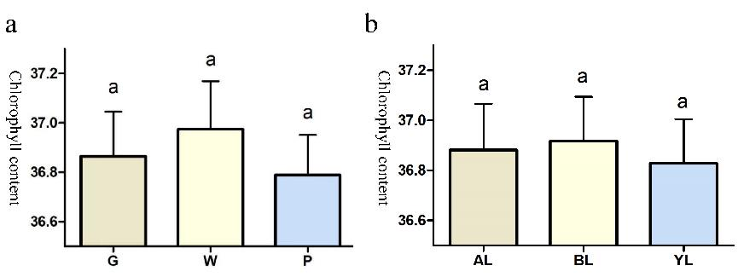
Fig. S10. Results of chlorophyll content of the three phenotypes of Saxifraga stolonifera. (a) differences in chlorophyll content among the three phenotypes; (b) differences in chlorophyll content among different positions or maturity of leaves; G, green leaf type; P, purple-variegated type; W, white-variegated type; AL, along leaf vein; BL, between leaf veins; YL, young leaves.

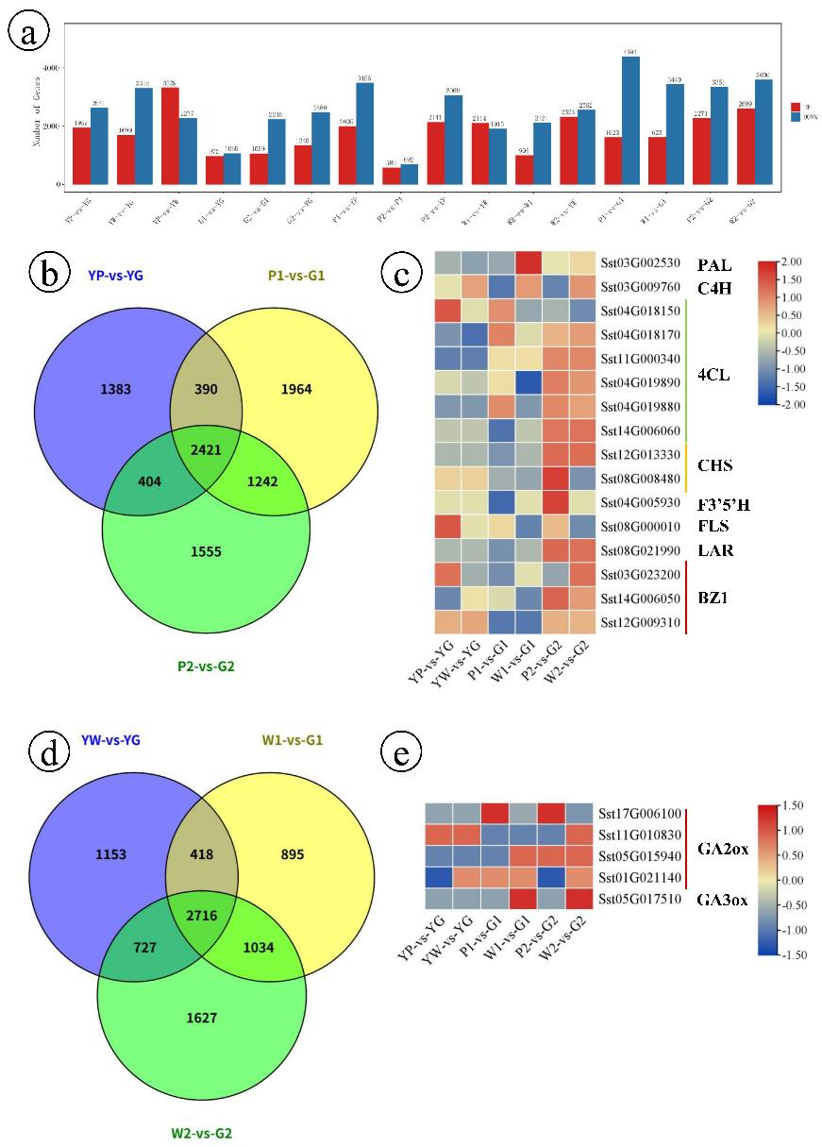
Fig. S11. Overview of the differentially expressed genes (DEGs) between the three phenotypes. (a) the number of up and down regulated DEGs in 6 comparisons. (b) venn analysis of the three stage comparison experiments between the purple-variegated type and the green-leaf type. (c) heatmaps of DEGs related to key enzyme genes in the anthocyanins biosynthetic pathways. (d) venn analysis of the three stage comparison experiments between the white-variegated type and the green-leaf type. (e) heatmaps of DEGs related to key enzyme genes in the gibberellins biosynthesis pathway.

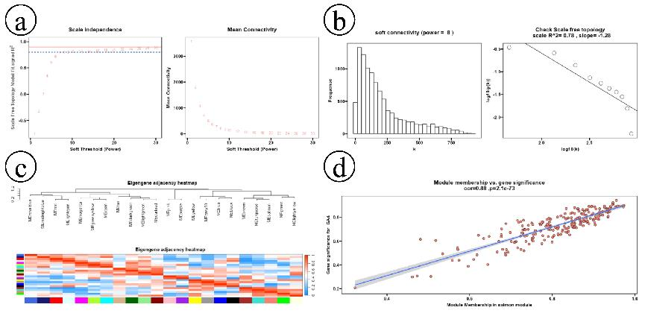

Fig. S12. Wgcna analysis process for the three leaf phenotypes (a-d).

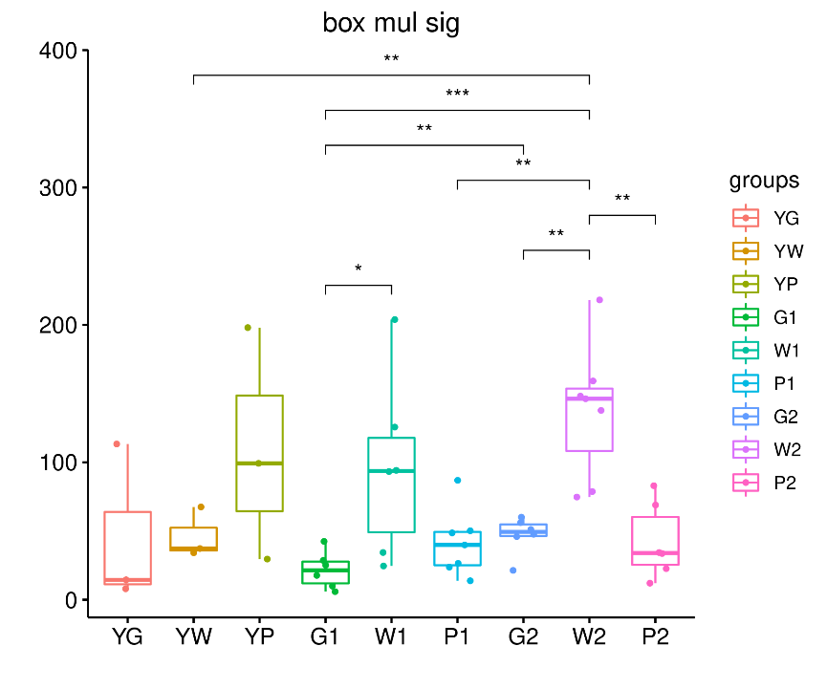
Fig. S13. T-test analysis of SsGA3ox (Sst05G017510) expression in the two groups of samples. *, p-value ＜0.05. **, p-value ＜0.01. ***, p-value＜0.001.

