Imbalance dataset results
Table1: models comparison of all ML models of Imbalance dataset
Model | Accuracy | Precision | Sensitivity | Specificity | F1-score
DT | 0.5771$±$0.029 | 0.375$±$0.036 | 0.382$±$0.088 | 0.677$±$0.063 | 0.375$±$0.054
RF | 0.654$±$0.008 | 0.217$±$0.004 | 0.012$±$0.016 | 0.985$±$0.007 | 0.022$±$0.031
GBM | 0.643$±$ 0.025 | 0.403$±$0.112 | 0.110$±$0.030 | 0.914$±$0.029 | 0.173$±$0.047
XGBM | 0.622$±$0.029 | 0.385$±$0.078 | 0.200$±$0.045 | 0.837$±$0.032 | 0.262$±$0.055
LGBM | 0.626$±$0.030 | 0.382$±$0.093 | 0.174$±$0.045 | 0.856$±$0.034 | 0.239$±$0.059
DNM | 0.575$±$0.054 | 0.576$±$0.055 | 0.569$±$0.056 | 0.581$±$0.051 | 0.572$±$0.054
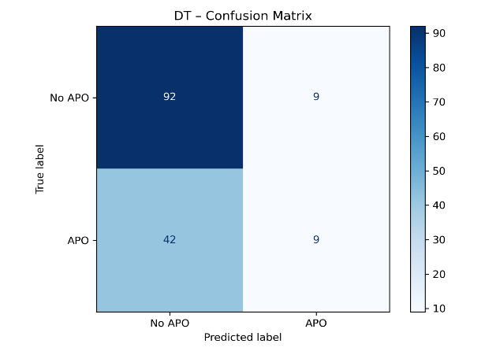
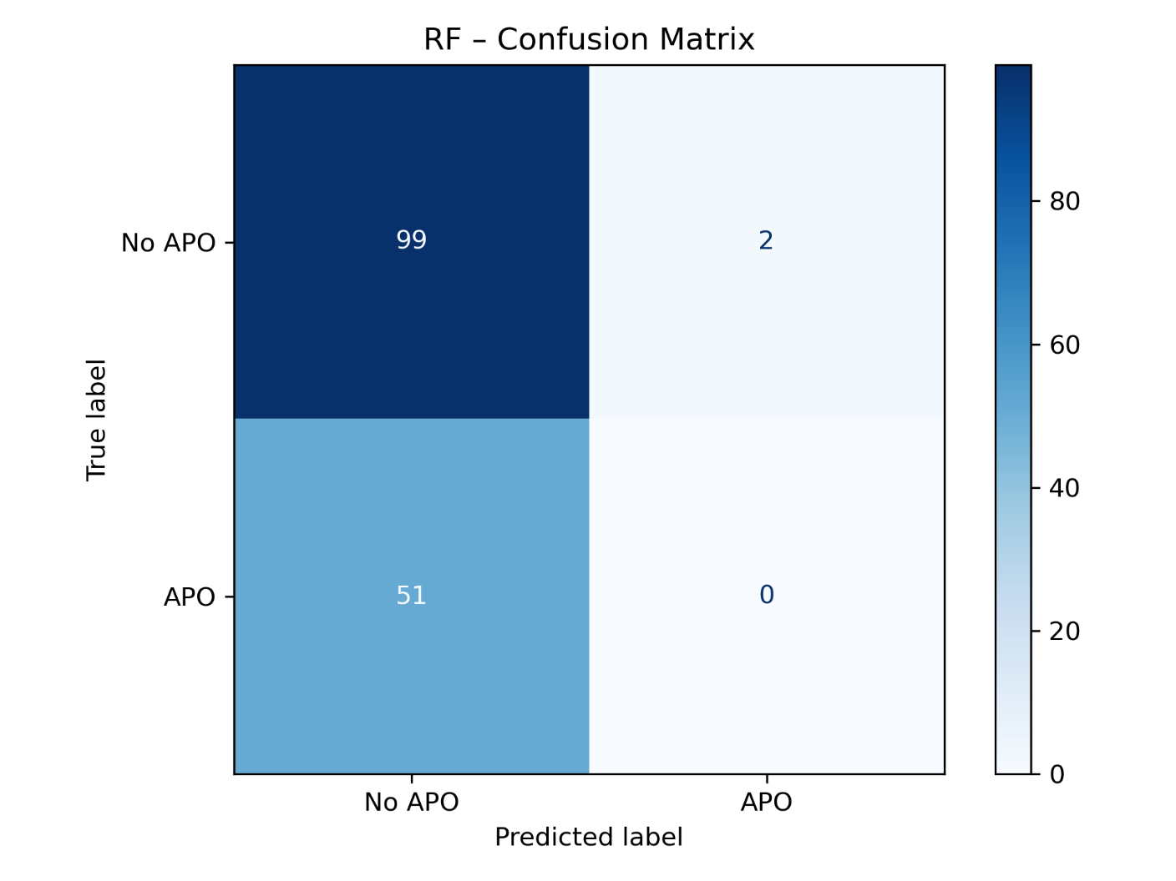
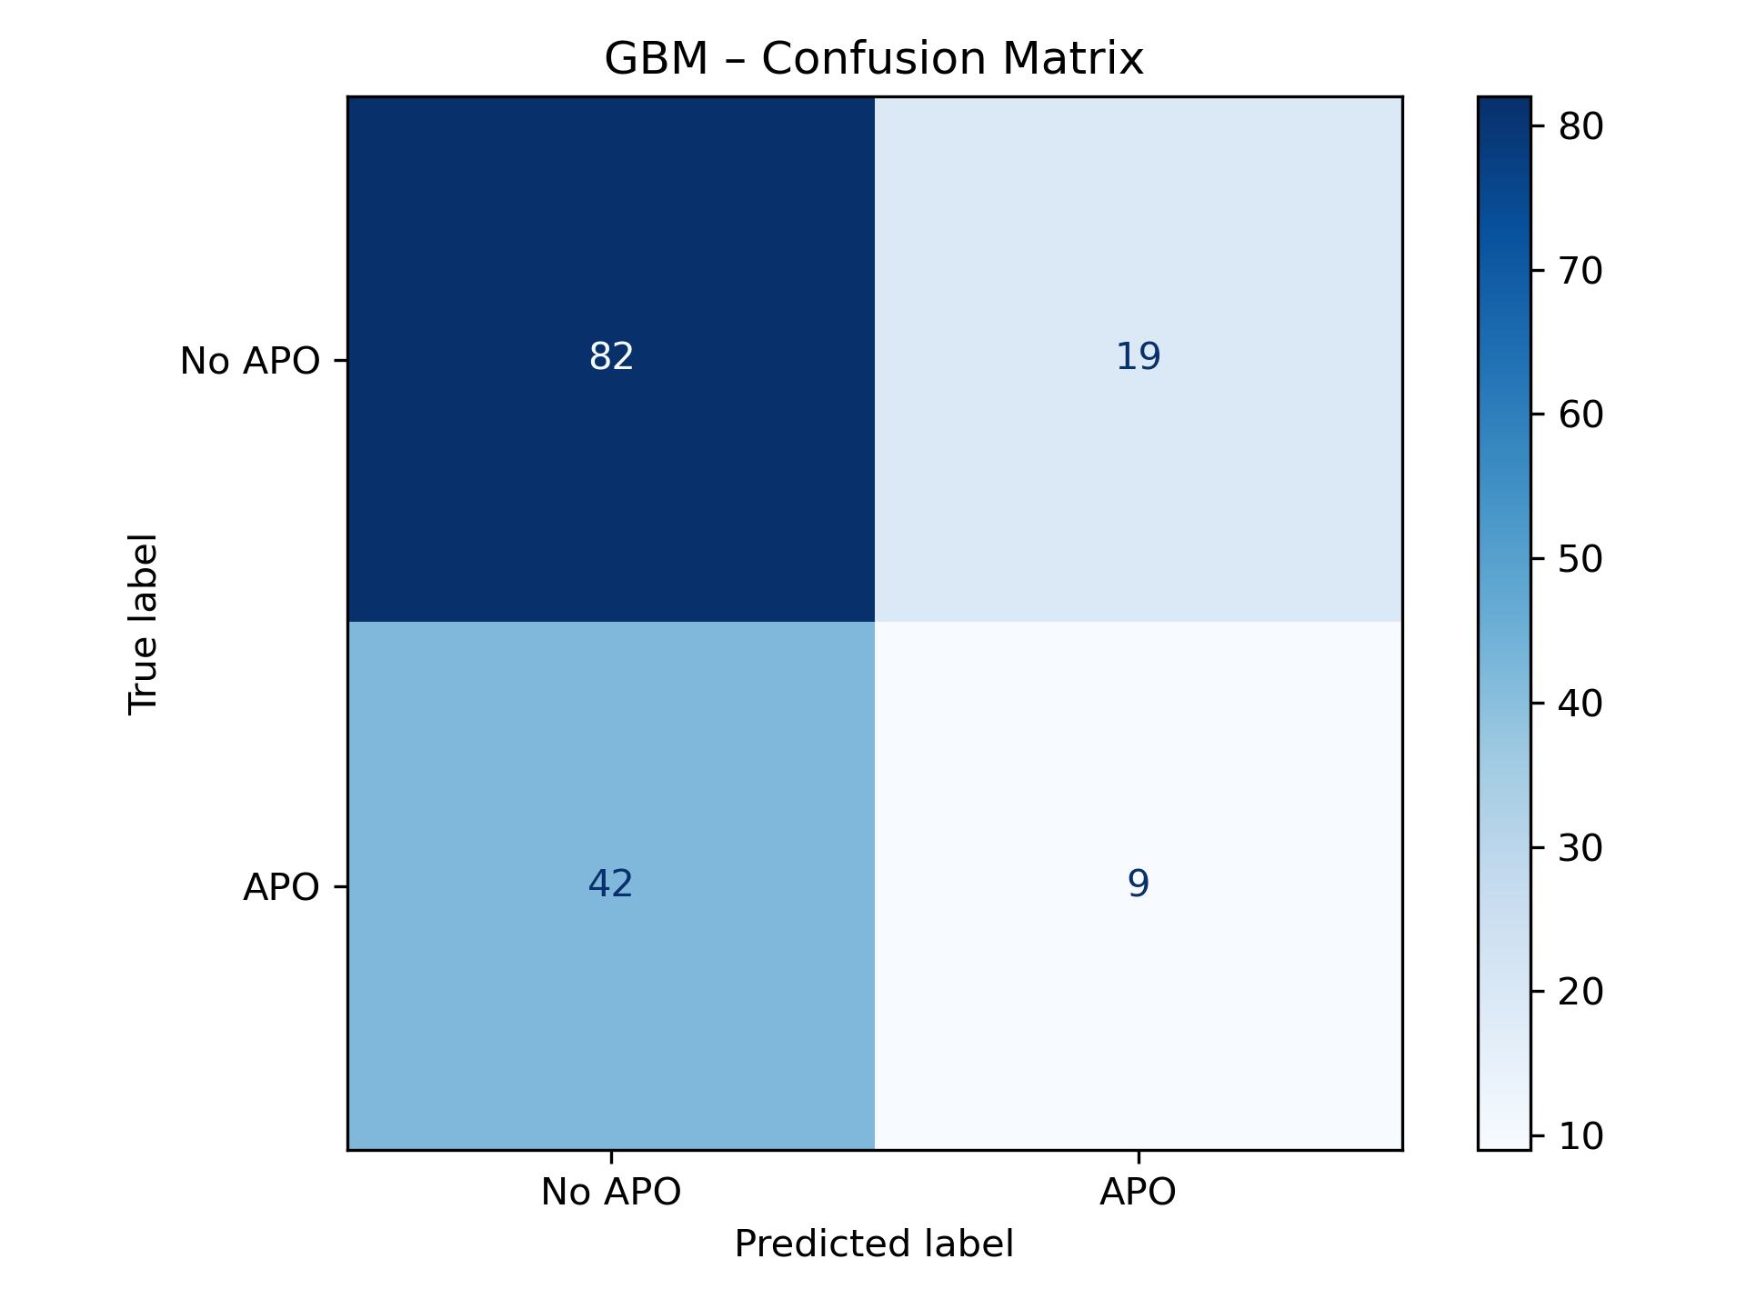
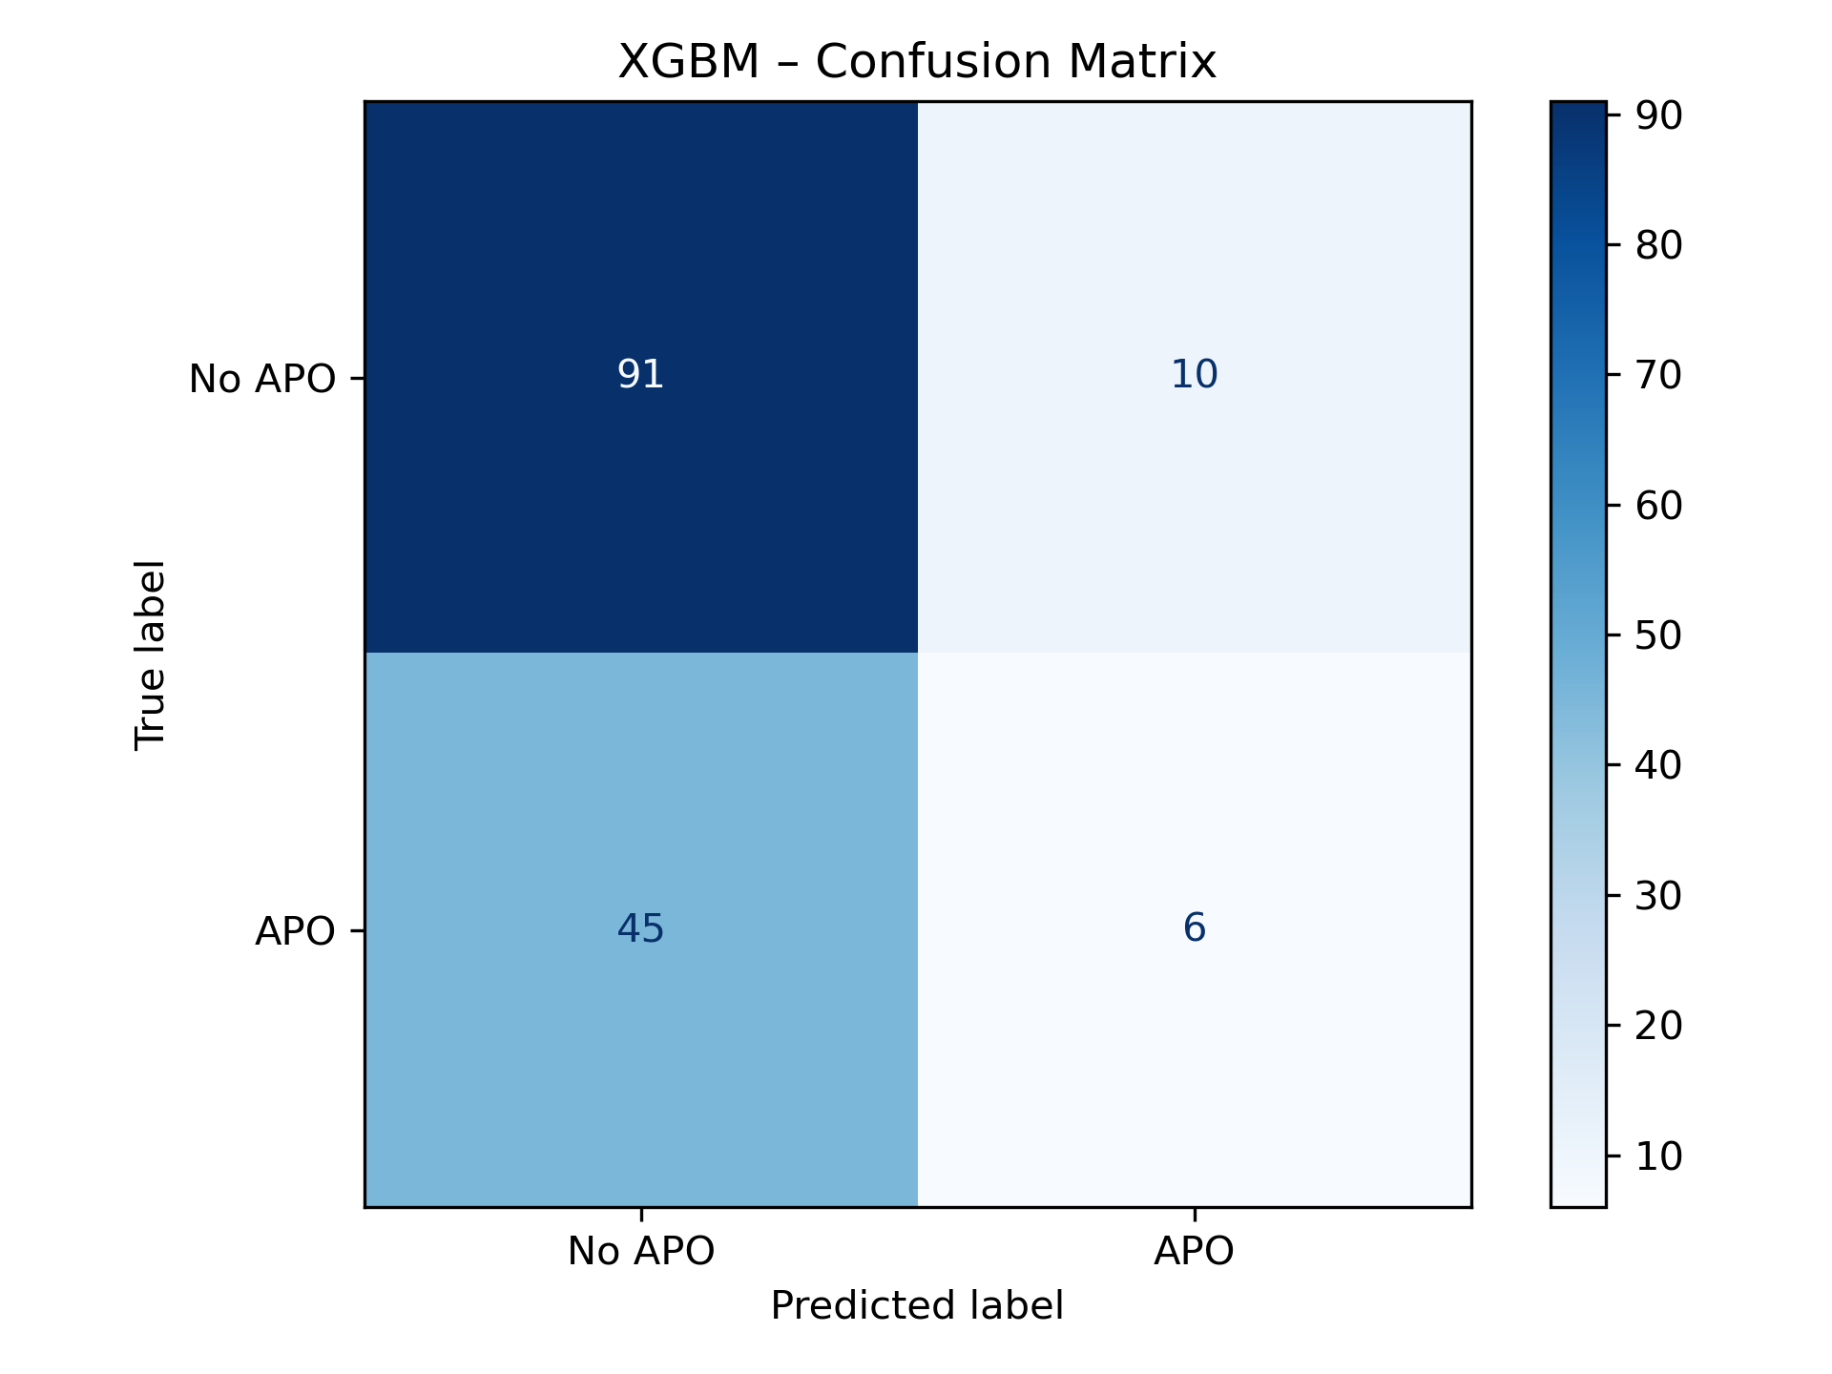
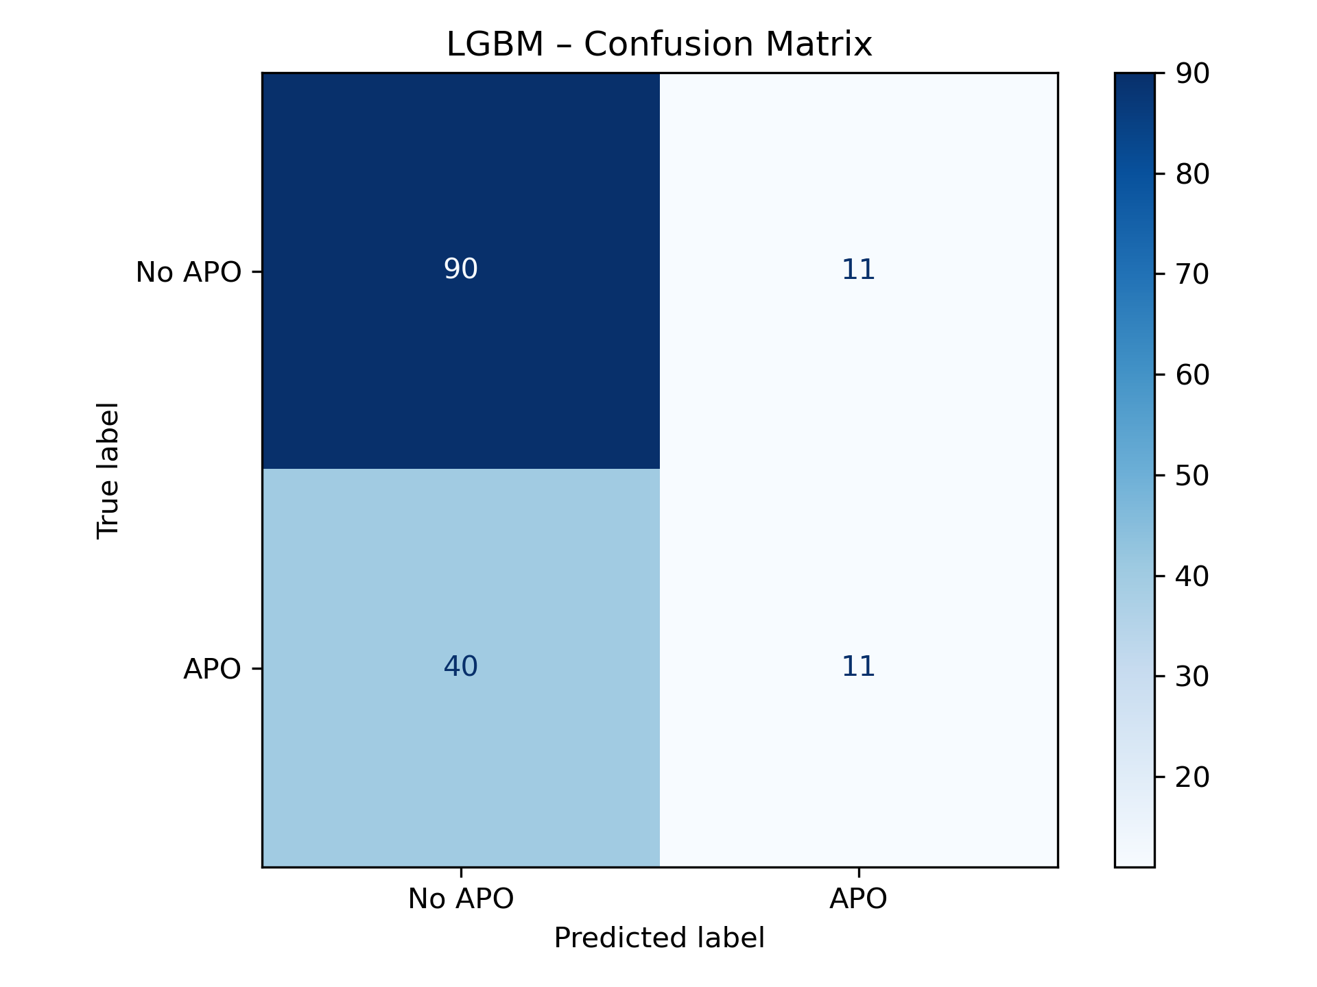
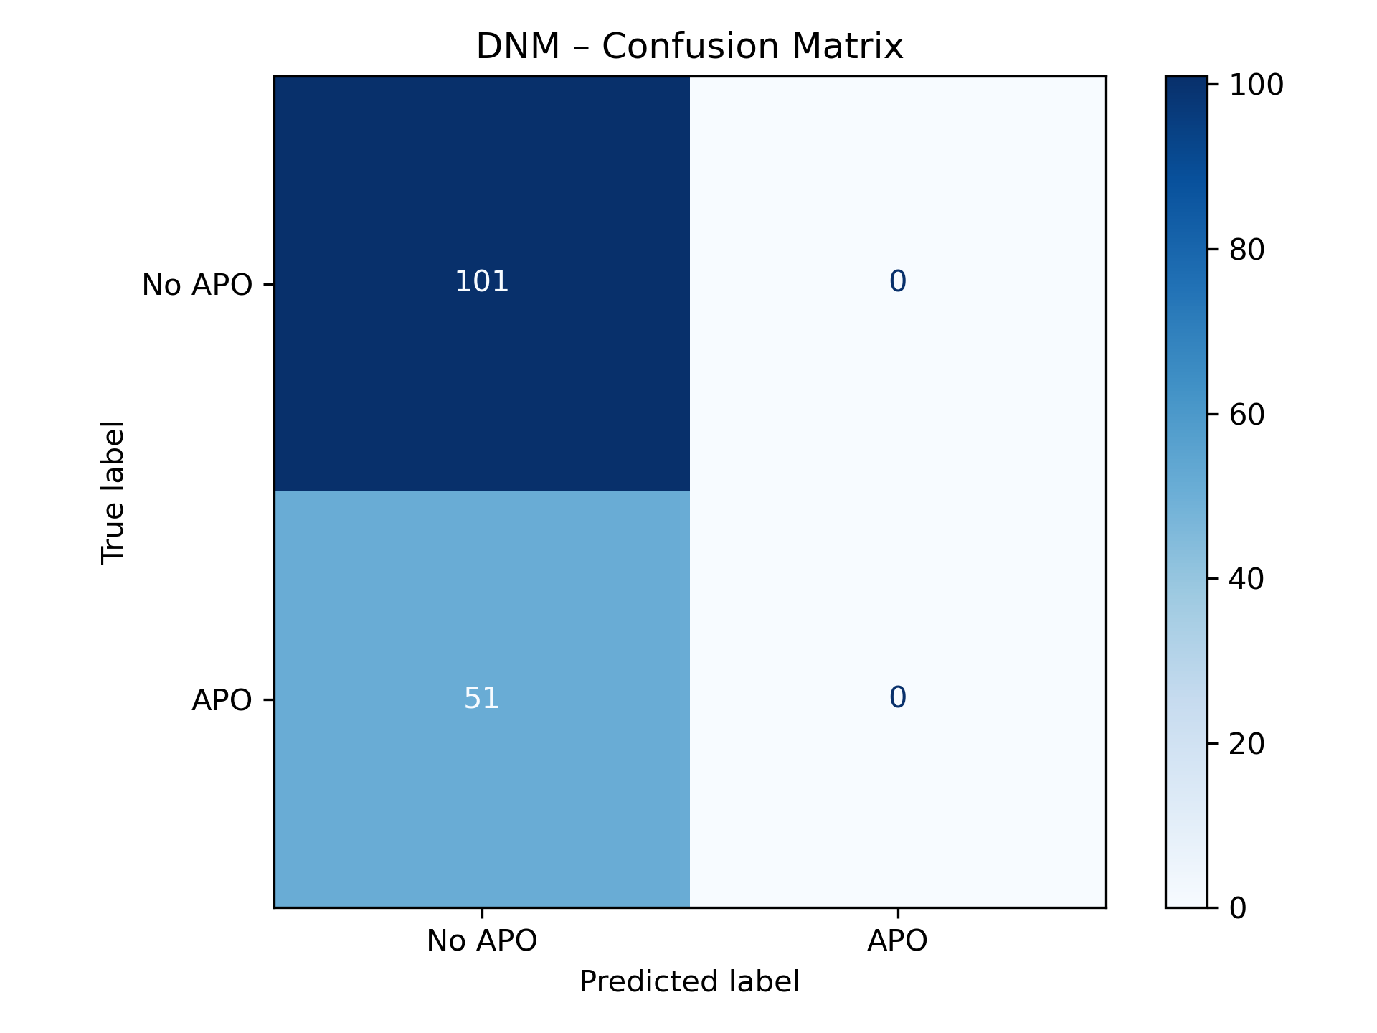
Imbalance Confusion Matrix

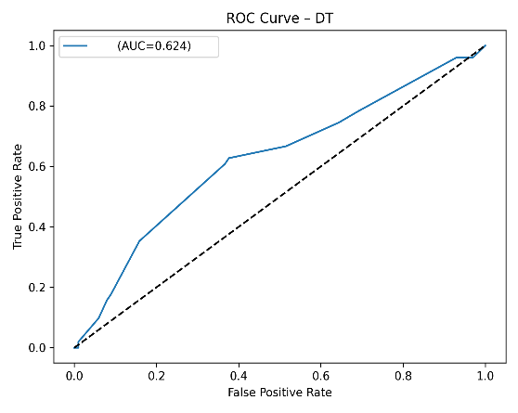
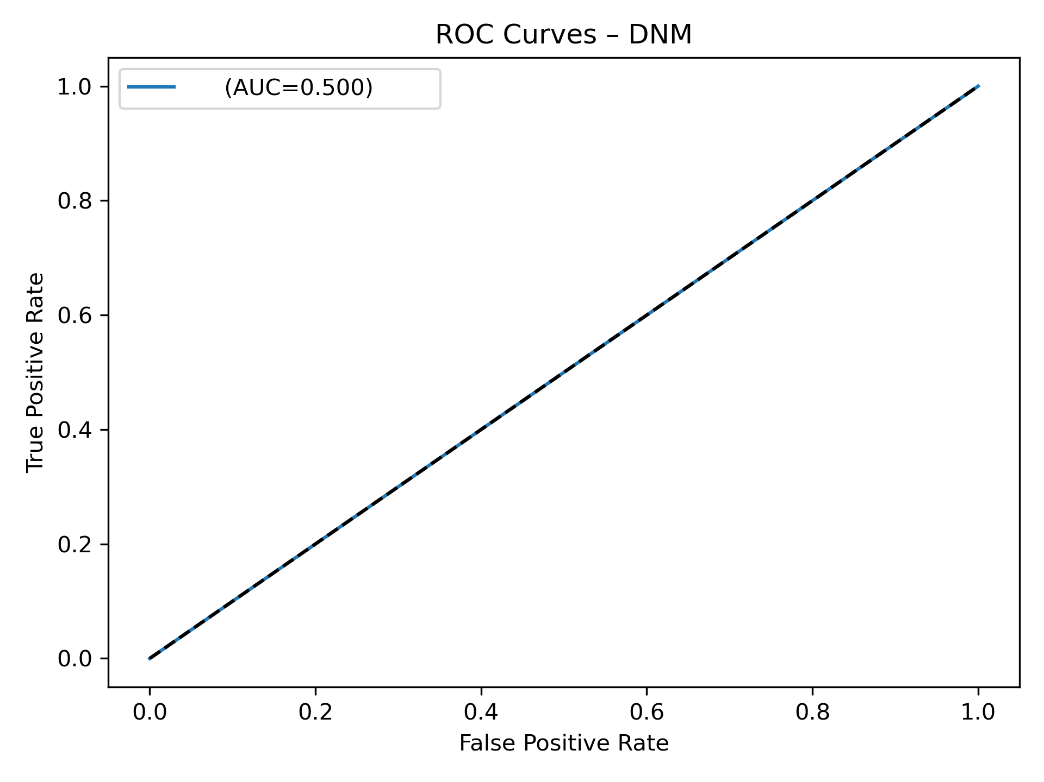
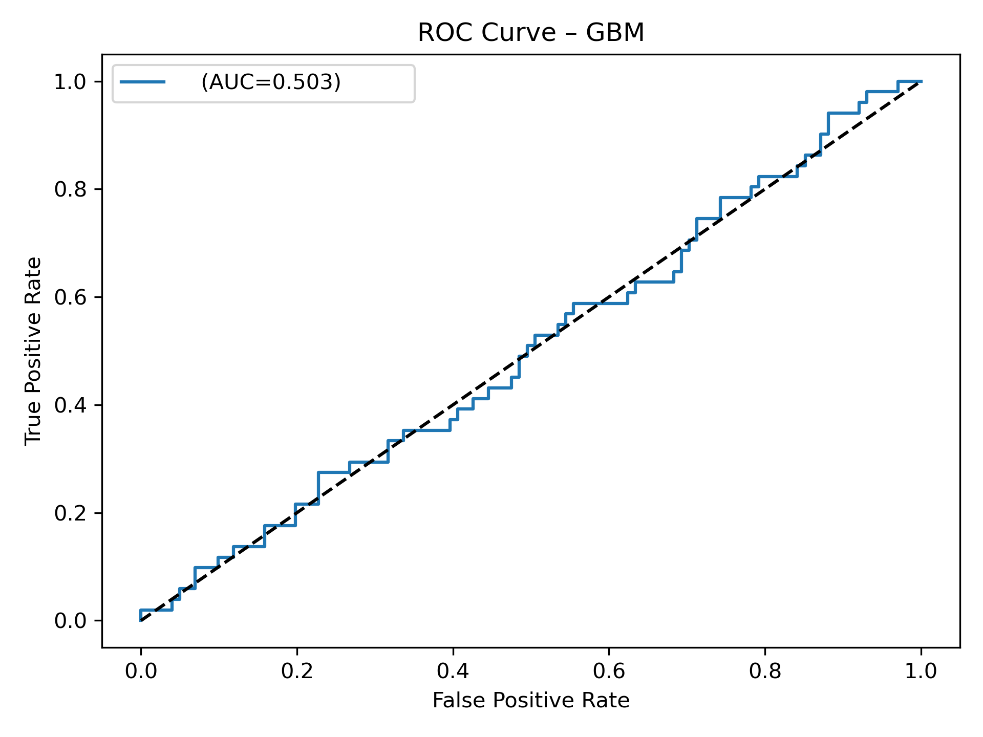
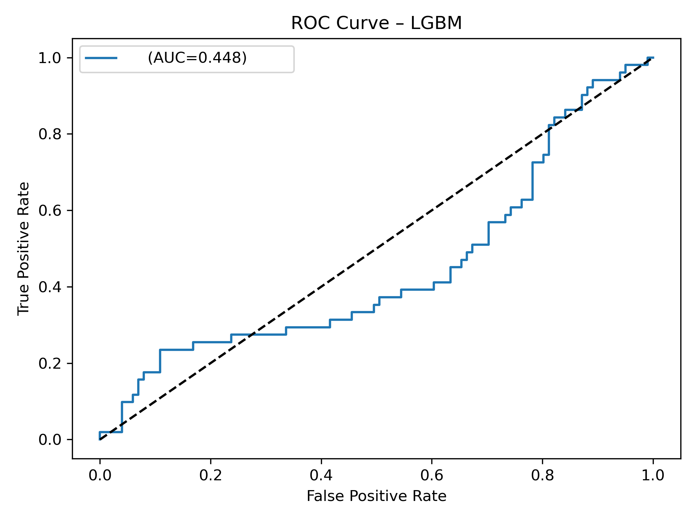
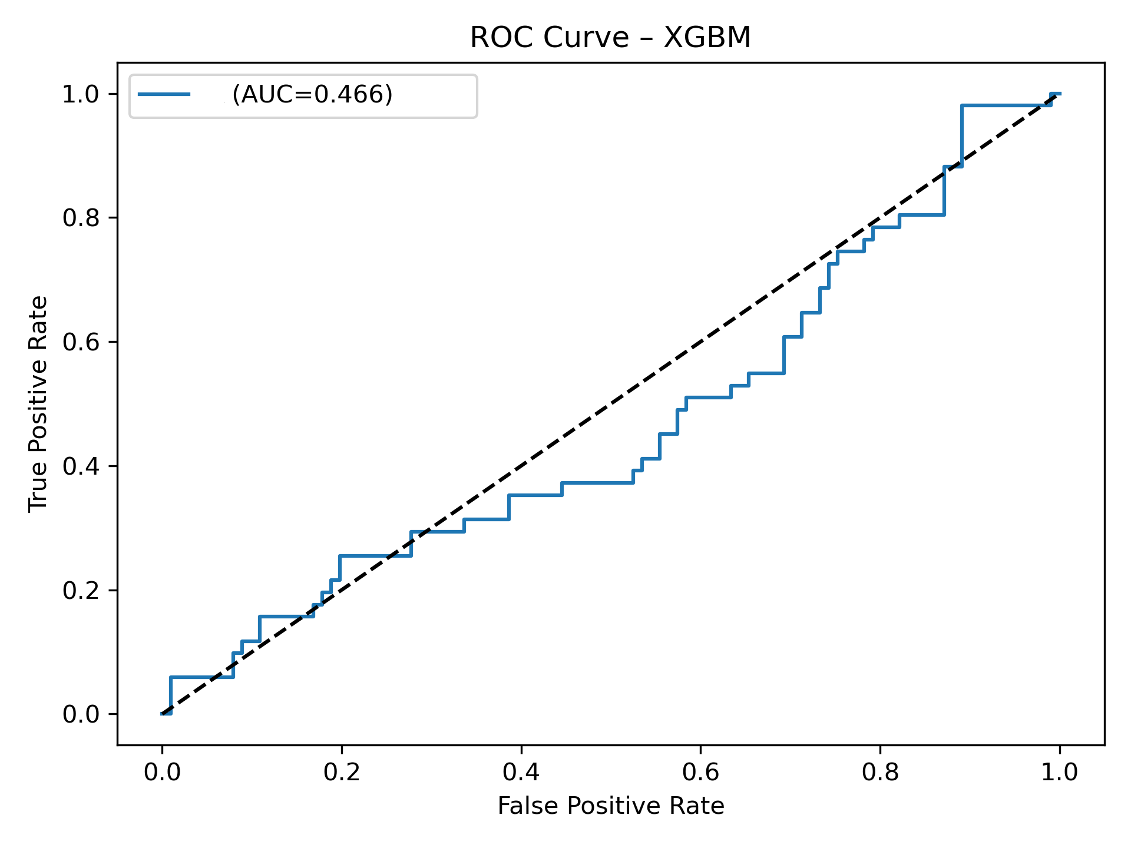
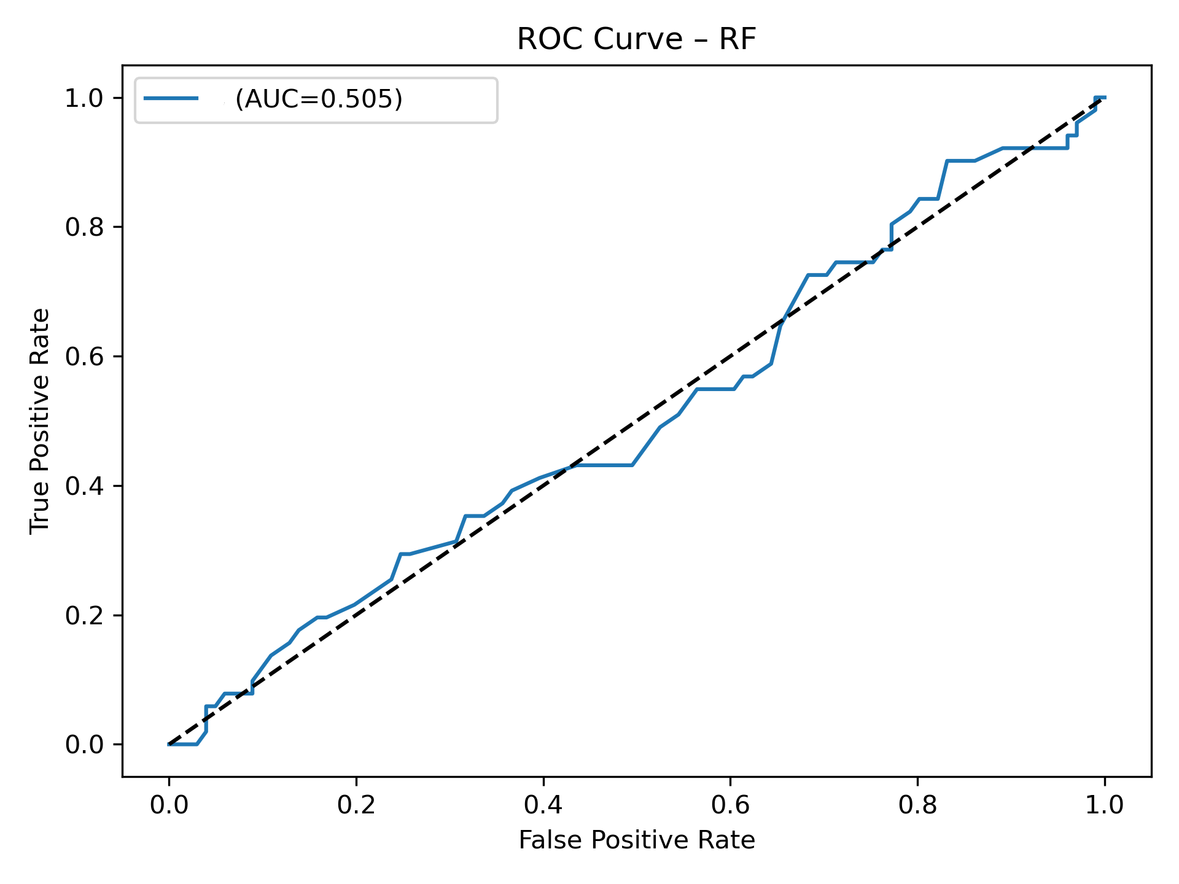
Imbalance Roc Curve

