Supplementary Methods

Anchor baseline window selection
Because the inertial state-space formulation relies on cumulative integration of observations over time, estimates derived from the earliest frames of each scan are inherently unstable and sensitive to transient effects. In particular, early time points provide too few samples to establish a reliable cumulative reference and are more susceptible to scanner settling and magnetization equilibration effects. To address this, we define an anchor baseline window at the beginning of each scan that serves as a stable reference configuration for subsequent cumulative evaluation.
For resting-state fMRI data, meaningful low-frequency BOLD fluctuations occur on the order of tens of seconds due to the application of a low-pass filter at 0.01 Hz. The corresponding −3 dB cutoff of this filter occurs at approximately 88 s, indicating the minimum temporal window required to capture a representative baseline of intrinsic fluctuations¹⁻⁵. Accordingly, after discarding the initial 10 s of data to allow scanner magnetization to reach equilibrium, we define the anchor baseline using the subsequent 88 s of data. This window provides sufficient temporal support to establish a stable reference configuration while minimizing contamination from early transient effects.
Importantly, the anchor baseline does not imply the existence of a shared resting task, cognitive state, or baseline across individuals. Rather, it functions solely as a within-subject reference against which later observations are evaluated. Subsequent deviations are therefore interpreted relative to each subject’s own initial configuration, allowing the cumulative framework to assess whether new fluctuations reinforce or overcome the running configuration implied by prior activity.
All dynamic time warping parameters, filtering procedures, and numerical choices associated with the anchor construction are held constant across subjects and groups.
DTW-based observation trajectory for the ISSM
In this work, dynamic time warping (DTW) is used to define the observed trajectory within the inertial state-space model (ISSM), providing a time-resolved measure of deviation between evolving interregional BOLD amplitude profiles. DTW serves as an observational instantiation of the ISSM, supplying the displacement-like signal from which latent state evolution and functional inertia are subsequently derived.
For each subject, DTW was applied to pairs of post-equilibrium BOLD amplitude time series $x(t)$ and $y(t)$, each of length $N$. DTW distances were computed using a Sakoe–Chiba constraint window with half-width $w$⁶, selected to match the duration of the anchor baseline window (see Supplementary Methods: Anchor baseline window). This constraint limits temporal alignment to physiologically plausible lags while preserving sensitivity to low-frequency fluctuations characteristic of resting-state dynamics⁷.
The local cost function was defined as
$λ_{γ}\left(x_{i}, y_{j}\right)= {\left|x_{i}-y_{j}\right|}^{γ}$, | (S1)
where $γ=1.5$. This exponent was chosen based on prior work demonstrating optimal test–retest reliability and sensitivity to clinical relevance using this value⁸.
The cumulative cost matrix ${CM}_{(i,j)}$ for indices satisfying $∣i-j∣≤w$was constructed recursively as
${CM}_{(i,j)ϵ\left\{\left|i-j\right| ≤ w\right\}}= λ_{γ}\left(x_{i}, y_{j}\right)+min\left\{\begin{aligned}{CM}_{DTW\left(i-1,j-1\right)} \\ {CM}_{DTW\left(i-1,j\right)} \\ {CM}_{DTW\left(i,j-1\right)}\end{aligned}\right.$. | (S2)
After completion of the cumulative cost matrix, the optimal warping path $\left(φ_{x}(τ),φ_{y}(τ)\right)$, with length $\left|τ\right|≥N$, was obtained by standard backtracking. From this path, a time-resolved DTW distance was defined as
$D_{tr}(τ)={\left|x\left(φ_{x}\left(τ\right)\right)-y\left(φ_{y}\left(τ\right)\right)\right|}^{γ}$. | (S3)
To obtain a uniformly sampled distance trajectory, $D_{tr}(τ)$was resampled at integer time indices $i=1,…,N$ using a piecewise cubic Hermite interpolating polynomial (PCHIP), yielding $D_{tr}^{pchip}(i)$ ⁸.
Finally, for each time point $t≥t_{a}$, where $t_{a}$ denotes the end of the anchor baseline window, the cumulative trajectory was defined as the running cumulative average
$$c\left(t\right)=\frac{1}{t}\sum_{i=1}^{t}{D_{tr}^{pchip}\left(i\right)}.$$ | (S4)
This cumulative DTW trajectory constitutes the observed signal $y(t)$ in the inertial state-space model. Latent state evolution and functional inertia measures were then derived from this trajectory as described in the main Methods.
Estimation of the FII using DTW
For each cumulative DTW trajectory $c(t)$, the FII was estimated as the temporal derivative of the latent trajectory. Because direct differencing amplifies high-frequency noise, temporal smoothing was applied before differentiation to obtain a robust estimate of moment-to-moment reconfiguration. Specifically, a Gaussian filter was applied to each cumulative trajectory to obtain a smoothed trajectory $\tilde{c}(t)$. The filter bandwidth was selected in a data-driven manner based on the frequency content of $c(t)$. The mean power spectral density (PSD) of the cumulative trajectories was computed across subjects, and the frequency $f_{p}$ at the elbow of the power log of the PSD was identified. This frequency was used as the −3 dB (half-power) cutoff of the Gaussian filter.
The frequency response of the Gaussian filter is given by
$${\left|H\left(f\right)\right|}^{2}=e^{-4{\left(πfσ_{t}\right)}^{2}},$$ | (S5)
where $σ_{t}$denotes the temporal standard deviation of the filter. Setting $∣H(f_{p})∣^{2}=1/2$ yields
$$σ_{t}=\sqrt{\frac{\ln{2}}{4π^{2}f_{p}^{2}}} .$$ | (S6)
The corresponding full width at half maximum (FWHM) in the time domain was computed as
$$FWHM=2\sqrt{2\ln{2}}σ_{t} ,$$ | (S7)
and converted to samples based on the repetition time (TR) of the acquisition. The smoothed cumulative trajectory $\tilde{c}(t)$ was then differentiated using first differences,
$$\dot{c}\left(t\right)= \tilde{c}\left(t\right)-\tilde{c}\left(t-1\right) ,$$ | (S8)
to obtain the FII. For the present dataset (TR = 2 s), this procedure yielded a Gaussian filter with FWHM of 4 samples (Supplementary Fig. 1).
Because DTW distances are accumulated over time, the sign of the discrete derivative reflects whether the cumulative deformation cost is increasing or decreasing, corresponding to divergence from or convergence toward the running configuration, respectively. For interpretability, the discrete derivative was multiplied by −1 so that positive values correspond to convergence and negative values to divergence, without altering the magnitude of the effect. Temporal smoothing suppresses high-frequency noise while preserving meaningful reconfiguration events, yielding a stable estimate of functional inertia.
Time-averaged FIIM and Mediation Analysis
To summarize the overall strength of inertia across the scan, we quantify the time-averaged functional inertia index magnitude by averaging it across time for each participant. Specifically, time-averaged whole-brain FIIM was computed as the temporal mean of the absolute value of the discrete derivative of the cumulative trajectory:
$$FIIM_{wb}=\frac{1}{N-t_{a}}\sum_{t=t_{a}+1}^{N}{\left|\dot{c}\left(t\right)\right|}$$ | (S9)
where $\dot{c}(t)$ denotes the temporally smoothed discrete derivative of the cumulative trajectory, $t_{a}$ is the anchor time point, and $N$ is the total number of time points. This summary measure captures the overall strength with which past configurations constrain ongoing state evolution across the scan, independent of direction, with lower values indicating stronger functional inertia.
To test whether overall whole-brain functional inertia mediates the relationship between state-level dynamic metrics and clinical symptom severity, we implemented a single-mediator model in which a state metric $X$ (e.g., mean dwell time or fraction rate) influences symptom severity $Y$ through time-averaged whole-brain FIIM $M$. The analytic framework corresponds to the causal chain $X→M→Y$, with adjustment for age, sex, mean framewise displacement, and scanning site. Ordinary least-squares regression was used to estimate the following paths:
a-path:  b-and c$'$-paths:  c-path(total):  indirect effect: | $M=β_{a}X+Cγ_{a}+ε_{a},$  $Y=β_{b}M+B_{c'}X+Cγ_{b}+ε_{b},$  $Y=β_{c}X+Cγ_{c}+ε_{c},$  $β_{indirect}= β_{a}×β_{b}$ | (S10)
where $C$ denotes the covariate matrix, $β$ are regression coefficients, and $ε$ are residual terms. Statistical significance of the indirect effect was assessed using 5,000 nonparametric bootstrap resamples. Mediation was considered significant when the 95% percentile bootstrap confidence interval excluded zero.
Regime assignment based on the Functional Inertia Index
To characterize recurrent dynamical regimes of state evolution, we assigned each time point to a functional inertia regime based on the sign and magnitude of the functional inertia index (FII). As described in the main Methods, the FII reflects the temporally smoothed discrete derivative of the cumulative DTW trajectory and quantifies moment-to-moment reconfiguration of the latent state. Because the FII naturally separates into three qualitatively distinct regimes corresponding to near-zero change, directed convergence toward lower-disparity configurations, and directed divergence away from lower-disparity configurations, k-means clustering with k = 3 was applied to the FII time series concatenated across subjects and interregional pairs. The choice of three clusters was supported by the elbow criterion, which indicated a clear inflection at k = 3 (Supplementary Fig. 2). These regimes are referred to throughout as locked, stabilizing, and shifting.
Latent-state context across functional inertia regimes
Regime-conditioned Latent-state Magnitude
To characterize the latent-state context in which each functional inertia regime is expressed, we examined the magnitude of the cumulative latent trajectory $x_{t}$ conditional on regime membership. Within the inertial state-space formulation, the latent state at time $t$reflects a weighted accumulation of prior observations. Accordingly, given that DTW was used as the representational axis, the magnitude of $x_{t}$ provides a direct measure of interregional disparity encoded in the current system configuration, with higher values indicating greater disequilibrium.
For each subject, the latent trajectory was partitioned according to functional inertia regime labels derived from the Functional Inertia Index. Regime-conditioned latent-state magnitude was computed by averaging $x_{t}$ across all time points assigned to each regime, yielding a three-element vector corresponding to the stabilizing, locked, and shifting regimes. These values summarize the typical latent-state context in which each regime occurs, independently of the duration or frequency of regime engagement. Where specified, latent-state magnitudes were standardized using z-scoring relative to the control group distribution to facilitate cross-subject and cross-group comparisons.
Group differences in latent-state context across regimes
Across all three functional inertia regimes, individuals with schizophrenia exhibited elevated latent-state magnitude relative to healthy controls, indicating greater interregional disparity regardless of whether the system was locked, stabilizing, or shifting (Supplementary Table S1). This elevation was consistent across regimes, with no evidence that stabilizing dynamics in schizophrenia occurred within a latent-state context comparable to that observed in controls. Importantly, this pattern indicates that engagement in a stabilizing regime does not imply proximity to a normative, low-disparity configuration. Rather, stabilizing dynamics in schizophrenia reflect directed convergence occurring at an elevated baseline of disparity, highlighting a dissociation between the direction of reconfiguration and the absolute latent-state context in which that reconfiguration unfolds.
Within-group regime ordering and cross-regime comparisons
Within-group comparisons revealed systematic ordering of latent-state magnitude across regimes in both diagnostic groups (Supplementary Table S2). In schizophrenia and controls, shifting regimes were associated with higher latent-state magnitude than locked regimes, consistent with directed divergence from the running configuration. However, the relative positioning of stabilizing regimes differed between groups. In controls, stabilizing regimes occurred at latent-state magnitudes comparable to locked regimes, whereas in schizophrenia, stabilizing regimes remained elevated relative to locked regimes, indicating convergence toward reduced disparity without reaching a low-disparity configuration.
Cross-group, cross-regime comparisons further demonstrated that latent-state magnitude in schizophrenia exceeded that of controls for every regime pairing examined (Supplementary Table S3). Notably, latent-state magnitude during stabilizing regimes in schizophrenia remained significantly higher than that observed during locked regimes in controls, indicating that directed convergence in schizophrenia does not approach the latent-state context characteristic of stable configurations in healthy individuals. Together, these findings demonstrate that functional inertia regimes capture the direction of state evolution, while latent-state magnitude captures the location in state space, and that these two aspects are systematically dissociated in schizophrenia.
Alternative Representational Axis: Correlation-Based Instantiation of the ISSM
To test whether the regime structure and clinical associations observed in the main analysis depend on the dynamic time warping representational axis, we implemented an alternative instantiation of the inertial state-space model using sliding-window Pearson correlation as the observational trajectory⁹. Time-resolved interregional correlation matrices were treated as the evolving observations and accumulated within the same ISSM framework to generate cumulative latent trajectories and corresponding functional inertia indices. All accumulation, smoothing, and clustering procedures were identical to the DTW-based analysis.
Clustering of the correlation-derived functional inertia index again revealed three recurrent regimes organized along a low–mid–high inertia hierarchy (Supplementary Fig. 3a). As expected given the correlational representational axis, the spatial patterns of each regime reflected network-specific covariance structure rather than whole-brain distance structure. Because correlation emphasizes instantaneous interregional coupling strength, regimes in this instantiation manifest as distinct patterns of coordinated network configuration rather than global displacement in trajectory space. This difference in spatial expression reflects the observational axis used to describe state, not a change in the underlying inertial principle.
Despite these representational differences, regime dynamics showed significant group differences in fraction rate, mean dwell time, and transition probabilities (Supplementary Fig. 3b), and regime engagement metrics were associated with symptom severity and cognitive performance (Supplementary Fig. 3c). Together, these findings demonstrate that the emergence of hierarchical inertia regimes and their behavioral and clinical relevance are not specific to the DTW instantiation, but reflect a representation-agnostic property of accumulated state evolution captured by the ISSM.
Ablation of Accumulation Reveals Loss of System-Level Inertial Structure
To determine whether the observed system-level and mediation-level effects depend specifically on cumulative state integration, we performed an ablation analysis in which the accumulation step of the inertial state-space model was removed while all other components of the pipeline were held constant (Supplementary Fig. 4a). In this no-accumulation formulation, DTW-derived disparity was subjected to identical smoothing and differentiation procedures, yielding an instantaneous functional inertia estimate without cumulative context. This design isolates the contribution of accumulation itself, ensuring that any downstream differences cannot be attributed to preprocessing, smoothing, clustering, or derivative computation.
Under the ablated formulation, tri-modal regime structure was preserved, and several regime-level group differences remained statistically significant (Supplementary Fig. 4b–c). Specifically, locked and stabilizing mean dwell time and fraction rate differences between groups were largely retained. However, critical system-level effects were lost. Whole-brain FIIM no longer showed significant associations with positive symptom severity and was no longer associated with negative symptoms as observed under the full ISSM. Most importantly, mediation pathways linking locked-regime persistence to symptom severity through whole-brain FIIM were lost in the no-accumulation model. Indirect effects that were significant in the full ISSM, including locked-regime to FIIM to symptom pathways, were no longer significant when accumulation was removed (Supplementary Fig. 4c). These results demonstrate that while instantaneous disparity can reproduce aspects of regime segmentation and some group-level contrasts, the cumulative context integration is required to recover global inertial magnitude and the coherent mediation architecture that links regime dynamics to clinical expression.
Supplementary Figure 1 | Spectral knee selection across the subject-averaged PSD
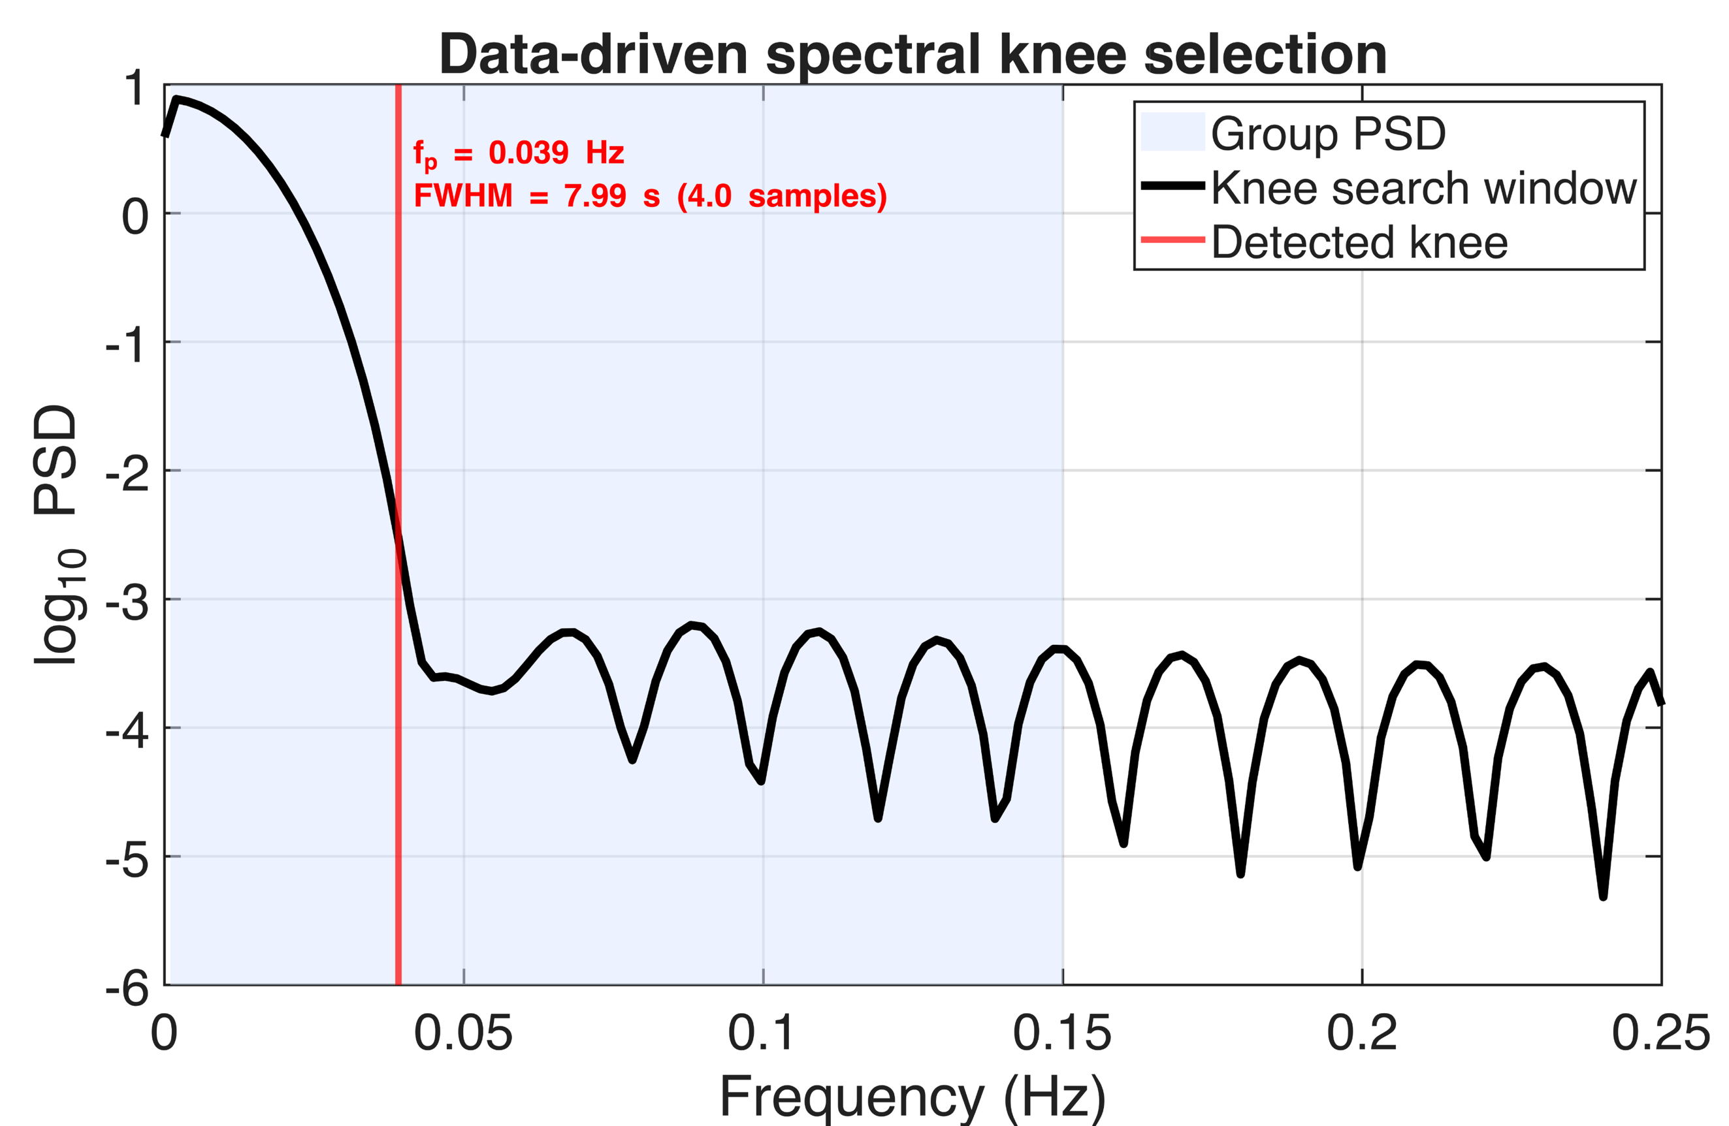
Supplementary Figure 1 Spectral knee selection across subject-averaged PSD of the cumulative DTW trajectory. The power spectral density (PSD) of the cumulative DTW trajectory was averaged across all subjects and brain region pairs and plotted on a logarithmic scale. The shaded band denotes the frequency window used for knee detection. The vertical line marks the detected spectral knee frequency $f_{p}$, representing the transition from signal-dominated low-frequency structure to higher-frequency fluctuations. This knee was used to define the −3 dB cutoff of a Gaussian smoothing filter, yielding a data-driven full width at half maximum (FWHM) used in subsequent temporal smoothing.

Supplementary Figure 2 | Determination of the number of functional inertia regimes
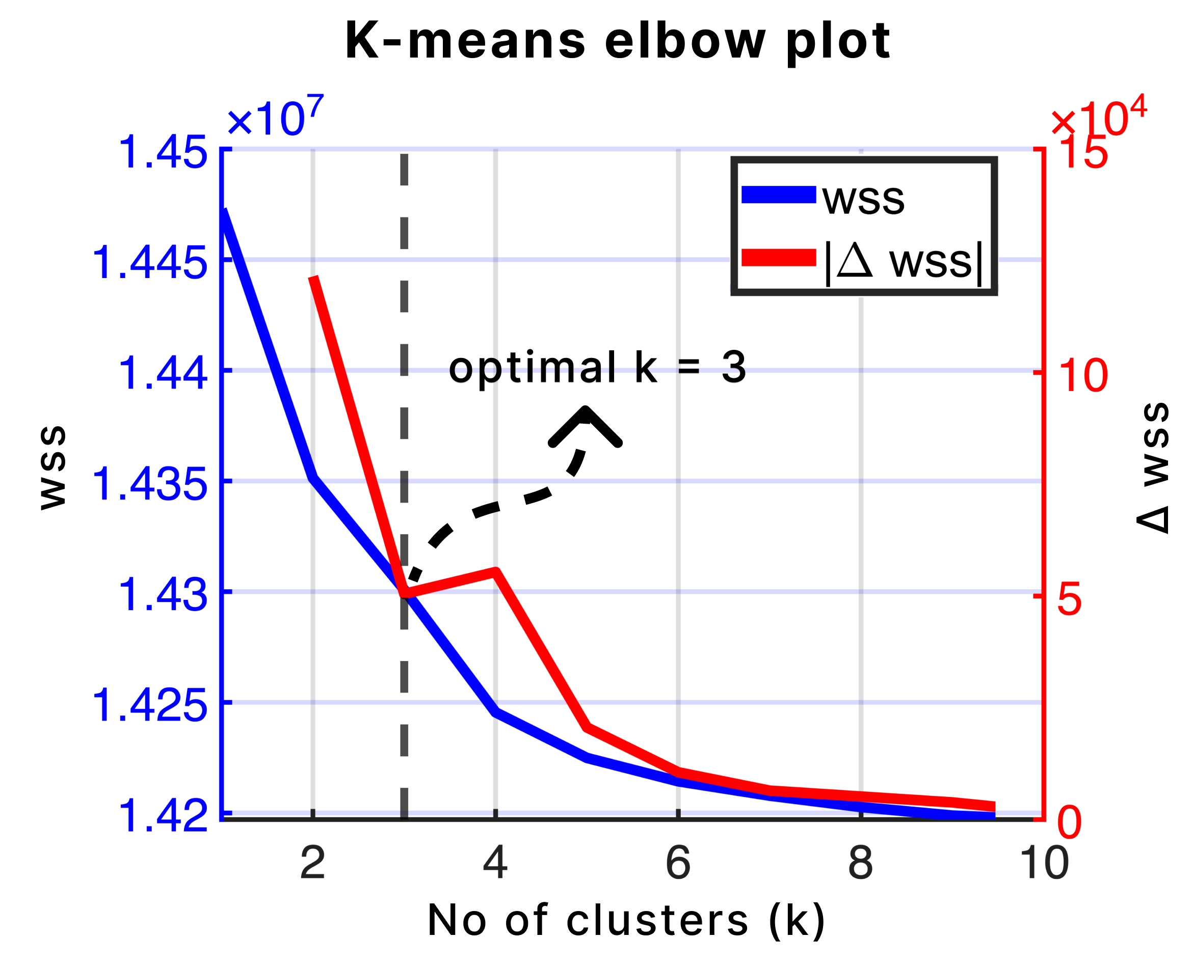
Supplementary Figure 2 Elbow analysis for k-means clustering of the Functional Inertia Index (FII) time series concatenated across subjects and interregional pairs. The within-cluster sum of squares (WSS; blue) decreases monotonically with increasing cluster number, while the change in WSS between successive solutions (|ΔWSS|; red) exhibits a clear inflection at k = 3, indicating diminishing returns beyond this point. This pattern supports the selection of three clusters, corresponding to the locked, stabilizing, and shifting functional inertia regimes used throughout the study.

Supplementary Figure 3 | ISSM instantiation through correlation
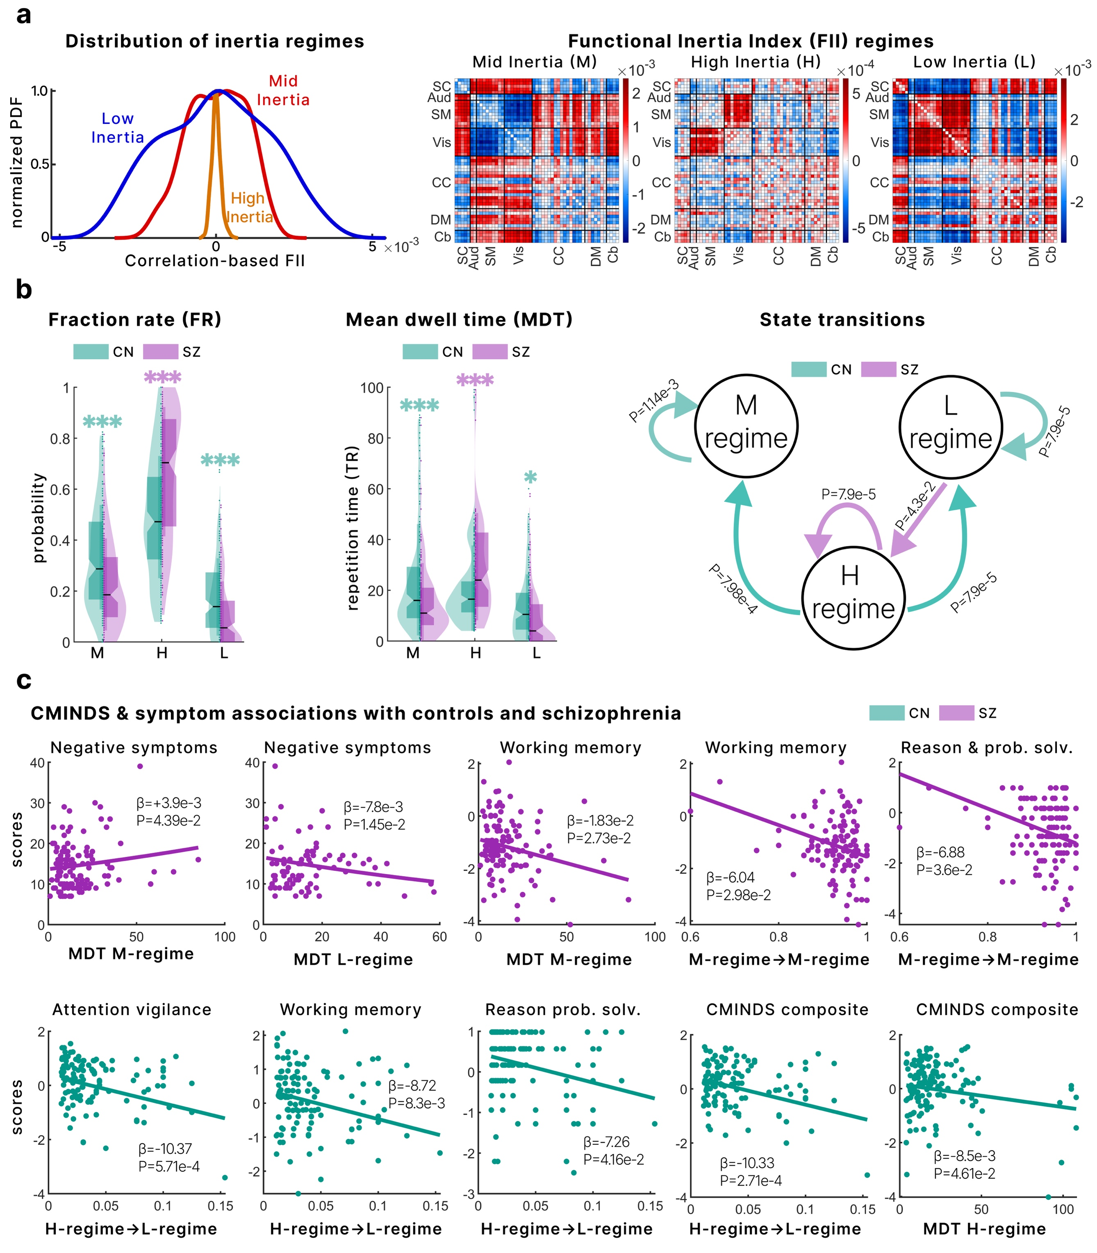
Supplementary Figure 3 ISSM under correlation instantiation. (a) Distribution of correlation-based Functional Inertia Index (FII) regimes derived from the inertial state-space model (ISSM). Clustering of the accumulated correlation trajectories revealed three regimes organized along a low–mid–high inertia hierarchy. Heatmaps depict the corresponding correlation configuration patterns within each regime. (b) Group differences in regime dynamics. Fraction rate (FR) and mean dwell time (MDT) show significant alterations in schizophrenia (SZ) relative to controls (CN). Transition probability analysis reveals distinct regime transition structures between groups. (c) Clinical and cognitive associations. Regime engagement metrics and transition probabilities are associated with symptom severity and cognitive performance, demonstrating that the clinical relevance of functional inertia is preserved under a correlation-based representational axis. Together, these results demonstrate that the emergence of hierarchical inertia regimes and their behavioral and clinical associations are not specific to the dynamic time warping instantiation but reflect a representation-agnostic property of accumulated state evolution captured by the ISSM.

Supplementary Figure 4 | Accumulation is necessary for system-level and mediation-level effects
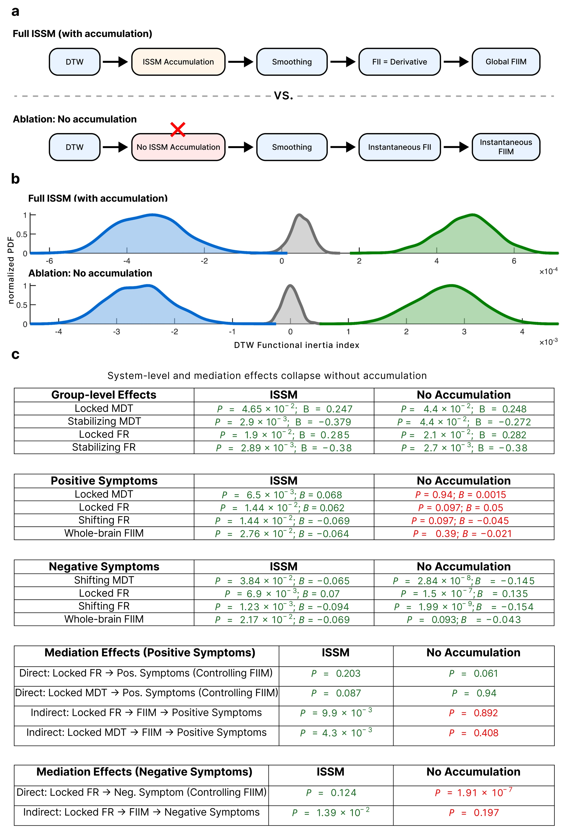
Supplementary Figure 4: Necessity of accumulation context. a) Schematic comparison of the full inertial state-space model (ISSM) and an ablated pipeline in which the accumulation step is removed. Both pipelines include DTW, identical smoothing, and derivative computation. The ablation isolates the role of cumulative context in generating functional inertia and whole-brain FIIM. b) Distribution of FII states under the full ISSM and the no-accumulation pipeline. Both formulations yield a comparable tri-modal organization consisting of negative, near-zero, and positive regimes, indicating that regime segmentation does not depend on accumulation. c) Statistical comparison of group differences, symptom associations, and mediation effects. While regime-level group differences are largely preserved without accumulation, system-level and mediation-level effects collapse (shown in red). In the full ISSM, whole-brain FIIM significantly associates with positive and negative symptom severity and mediates relationships between locked-regime persistence and symptoms. These effects are lost under the no-accumulation formulation, demonstrating that cumulative state integration, rather than instantaneous disparity, is required to recover global inertial magnitude and the mediation architecture linking regime dynamics to symptom expression.

Supplementary Table 1 | Group differences in latent-state magnitude within each functional inertia regime
Regime | Δ (Schizo. – Control) | Std. Error | 95% CI | p-value | pFDR
Locked | 0.0148 | 0.002714 | [0.0094, 0.0201] | $$4.80 × 10⁻⁸$$ | $$4.80 × 10⁻⁸$$
Stabilizing | 0.0159 | 0.002759 | [0.0105, 0.0212] | $$9.02 × 10⁻⁹$$ | 1.35 × 10⁻⁸
Shifting | 0.0155 | 0.002688 | [0.0103, 0.0208] | 7.22 × 10⁻⁹ | 1.35 × 10⁻⁸
Table 1 Group differences in regime-conditioned latent-state magnitude between individuals with schizophrenia and healthy controls. Values represent estimated marginal mean differences (Schizophrenia minus Control) in the magnitude of the cumulative latent state within each functional inertia regime, adjusted for age, sex, scanning site, and head motion. Positive values indicate greater interregional disparity in schizophrenia. Statistical significance was assessed using a repeated-measures ANCOVA framework, with false discovery rate (FDR) correction applied across regimes
Supplementary Table 2 | Ordering of latent-state magnitude across functional inertia regimes within each diagnostic group
Schizophrenia
Regime Comparison | Difference | Std. Error | 95% CI | p-value | pFDR
Shifting - Locked | 0.002343 | 0.000552 | [0.001049, 0.003637] | 6.56 × 10⁻⁵ | $$1.97×{10}^{-4}$$
Shifting - Stabilizing | 0.001025 | 0.000326 | [0.000260, 0.001790] | 4.79 × 10⁻³ | $$7.2 × {10}^{-3}$$
Stabilizing - Shifting | $$0.001318$$ | 0.000563 | [−1.07 × 10⁻⁶, 0.002637] | 5.02 × 10⁻² | $$6.02 × {10}^{-2}$$
Controls
Regime Comparison | Difference | Std. Error | 95% CI | p-value | pFDR
Shifting - Locked | $$0.001600$$ | $$0.000491$$ | $$[0.000449, 0.002751]$$ | $$3.23 × 10⁻³$$ | $$6.5×{10}^{-3}$$
Shifting - Stabilizing | $$0.001329$$ | $$0.000290$$ | $$[0.000649, 0.002009]$$ | $$1.38 × 10⁻⁵$$ | $$8.28 × {10}^{-5}$$
Stabilizing - Shifting | $$0.000270$$ | $$0.000500$$ | $$[-0.000903, 0.001443]$$ | $$0.851$$ | $$0.851$$
Table 2 Within-group pairwise comparisons of regime-conditioned latent-state magnitude for schizophrenia and control participants. Differences reflect contrasts between functional inertia regimes within the same diagnostic group, estimated from a repeated-measures ANCOVA model with covariate adjustment. Positive differences indicate higher latent-state magnitude in the first-listed regime. False discovery rate (FDR) correction was applied separately within each group to account for multiple regime comparisons.
Supplementary Table 3 | Cross-group, cross-regime comparisons of latent-state magnitude
Schizophrenia Regime | Control Regime | Δ (Schizo. – Control) | 95% CI | p-value | pFDR
Stabilizing | Locked | 0.01608 | [0.01073, 0.02143] | 1.1 × 10⁻⁸ | 1.1 × 10⁻⁸
Stabilizing | Stabilizing | 0.01586 | [0.01046, 0.02127] | 9.0 × 10⁻⁹ | 1.35 × 10⁻⁸
Stabilizing | Shifting | 0.01453 | [0.00921, 0.01985] | 2.4 × 10⁻⁷ | 2.9 × 10⁻⁷
Locked | Locked | 0.01482 | [0.00950, 0.02014] | 4.8 × 10⁻⁸ | 4.8 × 10⁻⁸
Locked | Stabilizing | 0.01455 | [0.00918, 0.01992] | 6.1 × 10⁻⁸ | 6.8 × 10⁻⁸
Locked | Shifting | 0.01322 | [0.00794, 0.01850] | 1.7 × 10⁻⁶ | 2.1 × 10⁻⁶
Shifting | Locked | 0.01716 | [0.01183, 0.02249] | 3.5 × 10⁻⁹ | 5.4 × 10⁻⁹
Shifting | Stabilizing | 0.01583 | [0.01058, 0.02109] | 8.9 × 10⁻⁹ | 1.35 × 10⁻⁸
Shifting | Shifting | 0.01556 | [0.01029, 0.02083] | 7.2 × 10⁻⁹ | 1.35 × 10⁻⁸
Table 3 Cross-group comparisons of regime-conditioned latent-state magnitude between schizophrenia and control participants across all combinations of functional inertia regimes. Differences represent estimated marginal mean contrasts (Schizophrenia minus Control) derived from the repeated-measures ANCOVA model, adjusted for age, sex, scanning site, and head motion. Positive values indicate higher interregional disparity in schizophrenia. False discovery rate (FDR) correction was applied across all cross-regime comparisons.
References
1. Faghiri A, Iraji A, Damaraju E, Turner J, Calhoun VD. A unified approach for characterizing static/dynamic connectivity frequency profiles using filter banks. Network Neuroscience. 2021;5(1):56-82.
2. Faghiri A, Yang K, Ishizuka K, Sawa A, Adali T, Calhoun V. Frequency modulation increases the specificity of time-resolved connectivity: A resting-state fMRI study. 2023.
3. Wiafe S-L, Asante NO, Calhoun VD, Faghiri A. Studying time-resolved functional connectivity via communication theory: on the complementary nature of phase synchronization and sliding window Pearson correlation. bioRxiv. 2024:2024.2006. 2012.598720.
4. Wiafe S-L, Faghiri A, Fu Z, Miller R, Calhoun V. Capturing Stretching and Shrinking of Inter-Network Temporal Coupling in FMRI Via WARP Elasticity. 2024.
5. Wiafe S-L, Faghiri A, Fu Z, Miller R, Preda A, Calhoun VD. The dynamics of dynamic time warping in fMRI data: a method to capture inter-network stretching and shrinking via warp elasticity. Imaging Neuroscience. 2024.
6. Paliwal KK, Agarwal A, Sinha SS. A modification over Sakoe and Chiba's dynamic time warping algorithm for isolated word recognition. Signal Processing. 1982;4(4):329-333.
7. Meszlényi RJ, Hermann P, Buza K, Gál V, Vidnyánszky Z. Resting state fMRI functional connectivity analysis using dynamic time warping. Frontiers in neuroscience. 2017;11:75.
8. Wiafe S-L, Kinsey S, Soleimani N, et al. Mapping Dynamic Metabolic Energy Distribution in Brain Networks using fMRI: A Novel Dynamic Time Warping Framework. bioRxiv. 2025:2025.2003. 2020.644399.
9. Allen EA, Damaraju E, Plis SM, Erhardt EB, Eichele T, Calhoun VD. Tracking whole-brain connectivity dynamics in the resting state. Cereb Cortex. 2014;24(3):663-676.

