Table S1. Partial Mantel correlations between microbiome composition (Bray-Curtis dissimilarity) and ecological trait distances, controlling for seasonal variation
Trait | Oral r | p | Skin r | p | Stool r | p
Colony size (log) | +0.324 | 0.100 | +0.290* | 0.050 | −0.797 | 0.942
Human proximity | +0.179 | 0.379 | +0.143 | 0.246 | −0.071 | 0.801
Aquatic foraging | −0.198 | 0.753 | −0.226 | 1.000 | +0.078 | 0.602
Body mass (log) | +0.475* | 0.032 | +0.112 | 0.266 | −0.026 | 0.612
Roost substrate | +0.174 | 0.236 | +0.072 | 0.319 | +0.042 | 0.545
Ectoparasite load | +0.366 | 0.058 | +0.331* | 0.043 | −0.544 | 0.889
Combined ecological | +0.462* | 0.035 | +0.216 | 0.124 | −0.364 | 0.807
Phylogenetic distance | +0.701** | 0.005 | +0.284 | 0.051 | −0.364 | 0.767
9,999 permutations; species-level Bray-Curtis centroids. *p < 0.05, **p < 0.01. Variance partitioning (ecology unique / phylogeny unique / shared / unexplained): oral 5.2% / 18.9% / 23.6% / 52.3%; skin 6.5% / 0.4% / 5.1% / 88.1%; stool 3.5% / 5.9% / 4.3% / 86.3%

Table S2. Seasonal variation in alpha diversity (Shannon index) within each species and body site.

Species | Oral |  |  | Skin |  |  | Stool
Species | F | p | Peak | F | p | Peak | F | p | Peak
M. fuliginosus | 17.09 | *** | Summer | 18.24 | *** | Spring | 1.15 | ns | —
R. ferrumequinum | 10.45 | *** | Spring† | 47.31 | *** | Fall | — | — | —
M. macrodactylus | 14.14 | *** | Summer | 6.65 | *** | Fall | — | — | —
M. bombinus | — | — | — | 7.32 | *** | Fall | 4.69 | * | Spring
P. abramus | — | — | — | — | — | — | — | — | —
M. petax | 4.73 | * | Winter | 3.44 | * | Fall | — | — | —
M. aurascens | 5.56 | ** | Summer | — | — | — | — | — | —
M. hilgendorfi | — | — | — | — | — | — | — | — | —
ANOVA on Shannon diversity index across seasons within each species. *p < 0.05, **p < 0.01, ***p < 0.001, ns = not significant. — = not significant, insufficient seasonal coverage, or excluded (see Methods).
† R. ferrumequinum oral: spring, summer, and winter were all significantly higher than fall (all p < 0.001); listed as spring (highest mean). Peak = season with the highest mean Shannon diversity.

Table S3 Top 5 differentially abundant metabolic pathways between hibernation and active periods per body site
Body site | Enriched in | Pathway | Coefficient (×10⁻³) | q-value
Oral | Hibernation | Fatty acid β-oxidation I | +1.28 | 1.88 × 10⁻¹³
Oral | Hibernation | Sucrose degradation II | +1.27 | 7.55 × 10⁻¹³
Oral | Hibernation | Ergothioneine biosynthesis II | +1.20 | 3.92 × 10⁻¹⁶
Oral | Hibernation | Stearate biosynthesis I | +1.16 | 2.36 × 10⁻¹⁷
Oral | Hibernation | Fatty acid β-oxidation II | +1.14 | 1.09 × 10⁻⁹
Oral | Active | Peptidoglycan biosynthesis V | −1.56 | 3.99 × 10⁻³⁰
Oral | Active | L-lysine biosynthesis II | −1.52 | 1.44 × 10⁻³¹
Oral | Active | Glucose-1-phosphate metabolism | −1.29 | 6.34 × 10⁻¹⁴
Oral | Active | Peptidoglycan biosynthesis IV | −1.19 | 4.44 × 10⁻²²
Oral | Active | cis-vaccenate biosynthesis | −1.09 | 3.87 × 10⁻¹⁰
Skin | Hibernation | Chitin derivatives degradation | +1.31 | 1.02 × 10⁻¹³
Skin | Hibernation | Guanosine nucleotides degradation II | +0.97 | 2.97 × 10⁻³²
Skin | Hibernation | Protocatechuate degradation | +0.96 | 3.11 × 10⁻¹²
Skin | Hibernation | Inositol degradation | +0.90 | 4.15 × 10⁻¹⁹
Skin | Hibernation | Phytol degradation | +0.84 | 1.87 × 10⁻³
Skin | Active | Petroselinate biosynthesis | −1.17 | 2.11 × 10⁻¹⁹
Skin | Active | Cardiolipin biosynthesis II | −0.94 | 7.88 × 10⁻¹⁹
Skin | Active | Superpathway of dTDP-glucose biosynthesis | −0.92 | 8.16 × 10⁻³³
Skin | Active | cis-vaccenate biosynthesis | −0.91 | 8.99 × 10⁻¹⁷
Skin | Active | Gondoate biosynthesis | −0.91 | 1.47 × 10⁻¹⁴
Stool | Hibernation | tRNA charging | +8.35 | 7.21 × 10⁻⁵
Stool | Hibernation | Glucose-1-phosphate metabolism | +6.96 | 1.33 × 10⁻⁴
Stool | Hibernation | Inositol degradation | +5.88 | 2.06 × 10⁻⁴
Stool | Hibernation | Glycolysis IV | +5.61 | 1.09 × 10⁻⁶
Stool | Hibernation | D-glucuronate degradation I | +5.46 | 1.33 × 10⁻⁴
Stool | Active | Lipid A biosynthesis | −1.91 | 2.09 × 10⁻³
Stool | Active | Ethanolamine utilization | −1.47 | 1.05 × 10⁻²
Stool | Active | Polyprenol biosynthesis | −1.41 | 5.17 × 10⁻⁵
Stool | Active | Pentose phosphate pathway | −1.31 | 1.00 × 10⁻⁶
Stool | Active | C4 photosynthetic carbon assimilation | −1.25 | 2.48 × 10⁻⁸
All coefficients are on the same (×10⁻³) scale. Stool hibernation-enriched coefficients are substantially larger in magnitude than oral or skin coefficients because hibernating bats cease feeding entirely, producing a dramatic shift in gut substrate availability and therefore larger effect sizes in the linear models for stool. Coefficients are from linear models controlling for species and activity mode, with Benjamini–Hochberg FDR correction (q < 0.05).

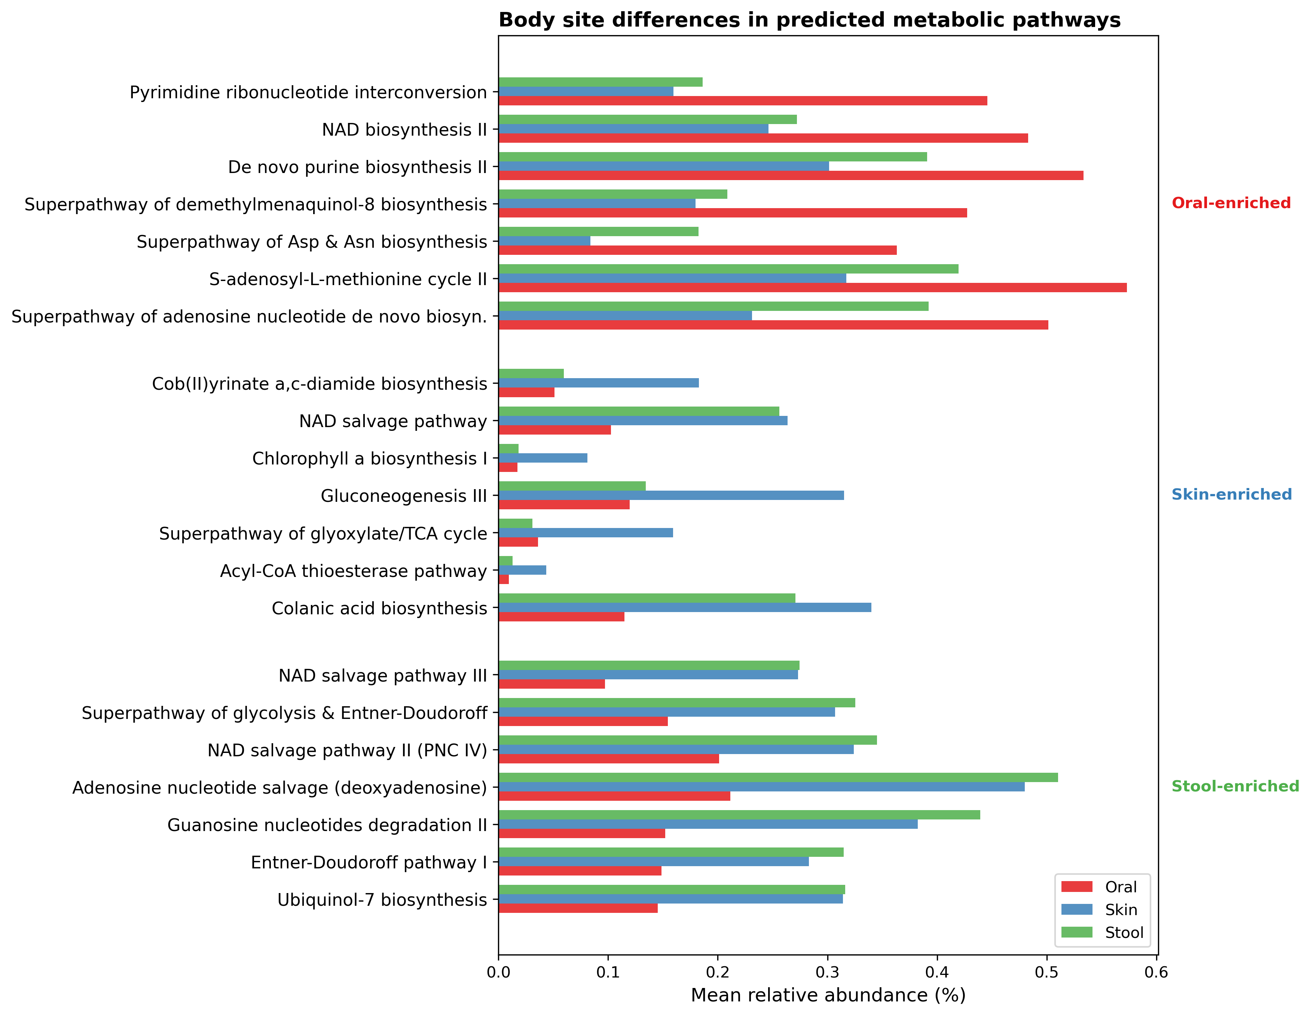

Fig. S1 Predicted metabolic pathways differing across body sites (PICRUSt2). Top 7 pathways enriched in each body site (21 total; linear model controlling for species and activity mode); grouped bars show mean relative abundance (%) for oral (red), skin (blue), and stool (green). All displayed pathways are significant at q < 0.05.

