Table S1. Sensitivity Analysis of UHR and Cardiorenal Syndrome in the discovery cohort (NHANES 2011–2018) .
 | Model 1 |  | Model 2 |  | Model 3
 | OR (95% CI) | P-value | OR (95% CI) | P-value | OR (95% CI) | P-value
UHR | 1.116 (1.087, 1.146) | <0.001 | 1.137 (1.102, 1.174) | <0.001 | 1.136 (1.094, 1.180) | <0.001
Categories
Q 1 | Reference | / | Reference | / | Reference | /
Q 2 | 1.896 (0.965, 3.725) | 0.069 | 1.974 (0.936, 4.166) | 0.082 | 2.008 (0.913, 4.415) | 0.093
Q 3 | 3.170 (1.678, 5.986) | <0.001 | 3.617 (1.627, 8.042) | 0.003 | 3.623 (1.534, 8.559) | 0.006
Q 4 | 4.953 (2.759, 8.890) | <0.001 | 7.182 (3.290, 15.680) | <0.001 | 7.114 (2.943, 17.199) | <0.001
P for trend | / | <0.001 | / | <0.001 | / | <0.001
Model 1: unadjusted; Model 2: adjusted for age, gender, race, education level, smoking status, alcohol use, BMI; Model 3: adjusted for age, gender, race, education level, smoking status, alcohol use, BMI, hypertension, diabetes, triglyceride, LDL-C, total bilirubin, SII, NLR, PLR.
Abbreviations: UHR: uric acid to high-density lipoprotein cholesterol ratio; CRS: Cardiorenal syndrome; BMI: body mass index; LDL-C: low-density lipoprotein cholesterol; HDL-C: high-density lipoprotein cholesterol; SII: Systemic Immune Inflammation Index; NLR: neutrophil-to-lymphocyte ratio; PLR: platelet-to-lymphocyte ratio; OR: odds ratio; CI: confidence interval.

Table S2. Sensitivity Analysis of UHR and Cardiorenal Syndrome in the external cohort (Affiliated Lihuili Hospital of Ningbo University 2015-2017).
 | Model 1 |  | Model 2 |  | Model 3
 | OR (95% CI) | P-value | OR (95% CI) | P-value | OR (95% CI) | P-value
UHR | 1.042 (1.037, 1.047) | <0.001 | 1.042 (1.037, 1.048) | <0.001 | 1.035 (1.029, 1.041) | <0.001
Categories
Q 1 | Reference | / | Reference | / | Reference | /
Q 2 | 1.979 (1.414, 2.77) | <0.001 | 1.829 (1.3, 2.574) | <0.001 | 1.866 (1.311, 2.656) | <0.001
Q 3 | 4.482 (3.308, 6.072) | <0.001 | 3.664 (2.68, 5.008) | <0.001 | 3.702 (2.664, 5.143) | <0.001
Q 4 | 12.555 (9.432, 16.712) | <0.001 | 9.192 (6.809, 12.409) | <0.001 | 8.117 (5.856, 11.251) | <0.001
P for trend | / | <0.001 | / | <0.001 | / | <0.001
Model 1: unadjusted; Model 2: adjusted for age, gender, education level, smoking status, alcohol use, BMI; Model 3: adjusted for age, gender, education level, smoking status, alcohol use, BMI, hypertension, diabetes, triglyceride, LDL-C, total bilirubin, SII, NLR, PLR.
Abbreviations: UHR: uric acid to high-density lipoprotein cholesterol ratio; CRS: Cardiorenal syndrome; BMI: body mass index; LDL-C: low-density lipoprotein cholesterol; HDL-C: high-density lipoprotein cholesterol; SII: Systemic Immune Inflammation Index; NLR: neutrophil-to-lymphocyte ratio; PLR: platelet-to-lymphocyte ratio; OR: odds ratio; CI: confidence interval.

Table S3. Performance of supplementary machine learning models in external validation.

Model | Feature set | External AUC | External Brier score
Logistic regression | Base | 0.850 | 0.036
Logistic regression | Base + UHR | 0.800 | 0.040
LASSO logistic regression | Base | 0.851 | 0.036
LASSO logistic regression | Base + UHR | 0.809 | 0.040
XGBoost | Base | 0.896 | 0.034
XGBoost | Base + UHR | 0.914 | 0.036
The base feature set included age, sex/gender, education level, smoking status, alcohol use, BMI, hypertension, diabetes, triglycerides, LDL-C, total bilirubin, SII, NLR, and PLR. The extended feature set additionally included UHR. Performance was evaluated in the independent hospital-based cohort. Abbreviations: AUC: area under the receiver operating characteristic curve; UHR: uric acid to high-density lipoprotein cholesterol ratio
Table S4. SHAP-based variable importance ranking in XGBoost.
Rank | Variable | MeanAbsSHAP
1 | age | 0.023848
2 | UHR | 0.019794
3 | Hypertension | 0.017047
4 | NLR | 0.012582
5 | Total bilirubin | 0.011315
6 | SII | 0.004251
7 | LDL-C | 0.004180
8 | diabetes | 0.003293
9 | PLR | 0.002963
10 | gender | 0.002697
11 | education- level | 0.002284
12 | BMI | 0.001697
13 | Triglyceride | 0.001239
14 | Alcohol use | 0.000209
15 | Smoking status | 0.000075
Categorical variables that were encoded before model fitting were recombined at the original-variable level for presentation.
Abbreviations: UHR: uric acid to high-density lipoprotein cholesterol ratio; BMI: body mass index; LDL-C: low-density lipoprotein cholesterol; SII: Systemic Immune Inflammation Index; NLR: neutrophil-to-lymphocyte ratio; PLR: platelet-to-lymphocyte ratio.

Table S5. Calibration metrics of extended supplementary machine learning models in the external validation cohort.
Extended model | Calibration intercept | Calibration slope | Brier score
Logistic + UHR | 0.642 | 0.569 | 0.040
LASSO + UHR | 0.717 | 0.627 | 0.040
XGBoost + UHR | 1.836 | 1.193 | 0.036

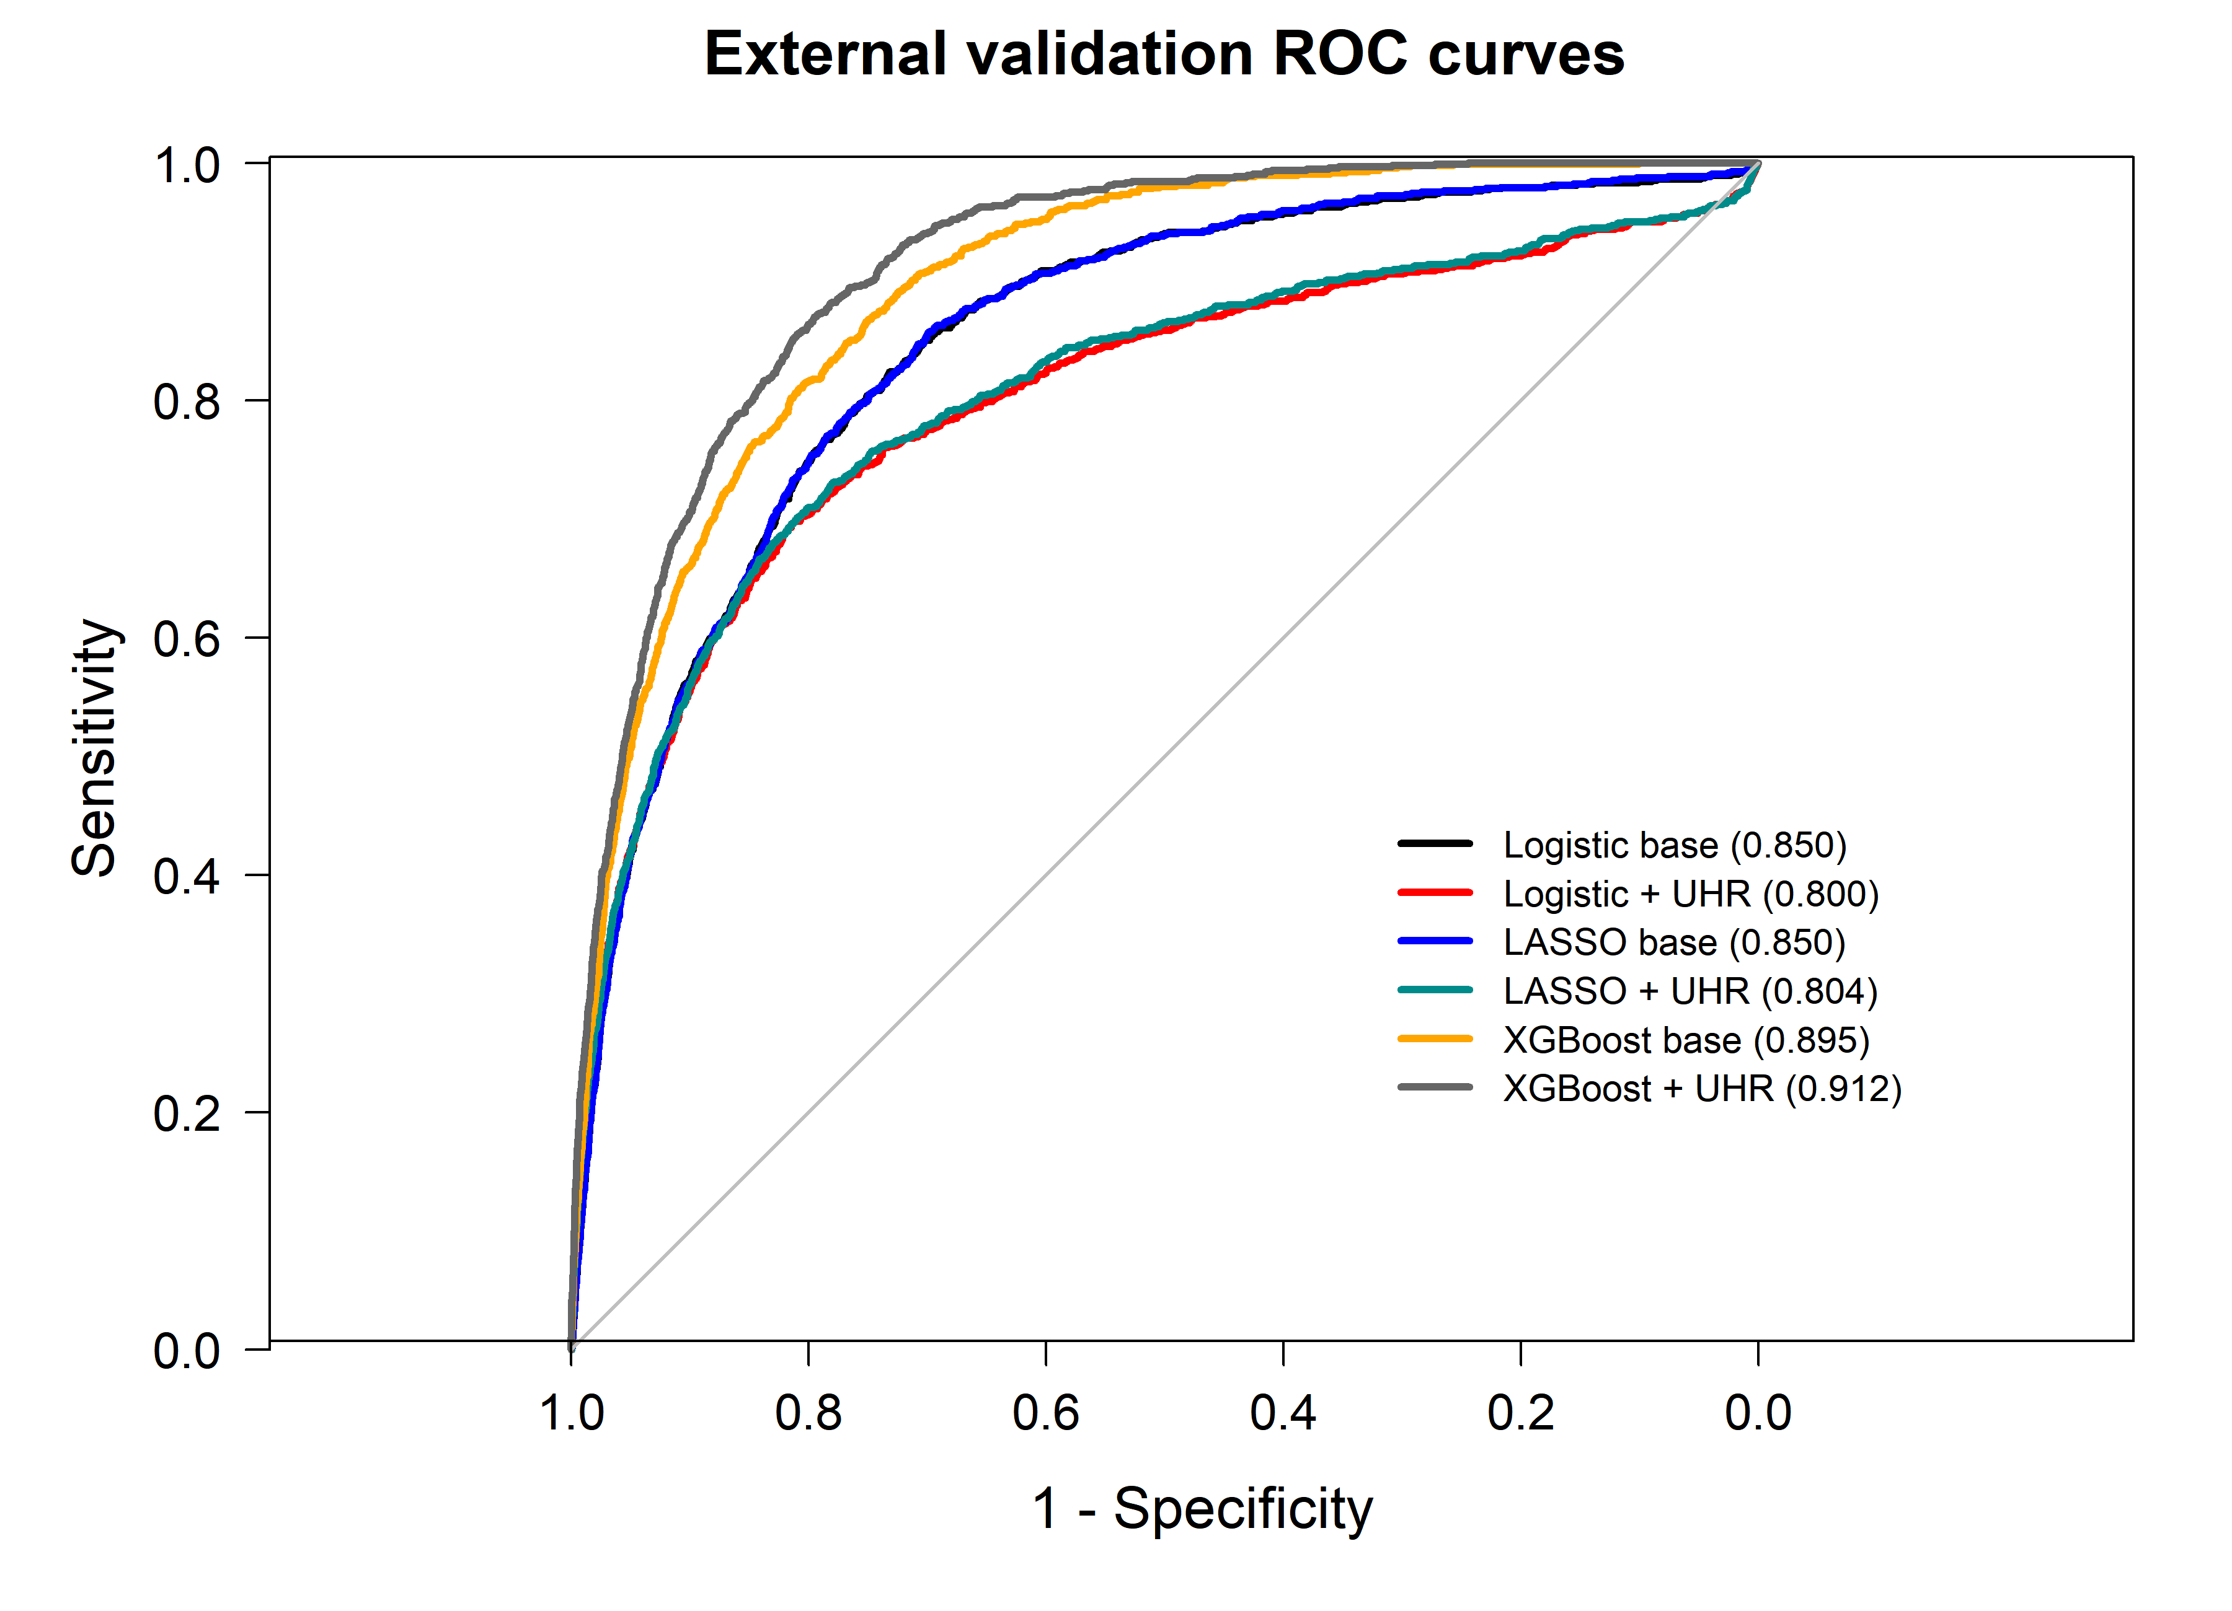
Figure S1. ROC curves of supplementary machine learning models in the external validation cohort.

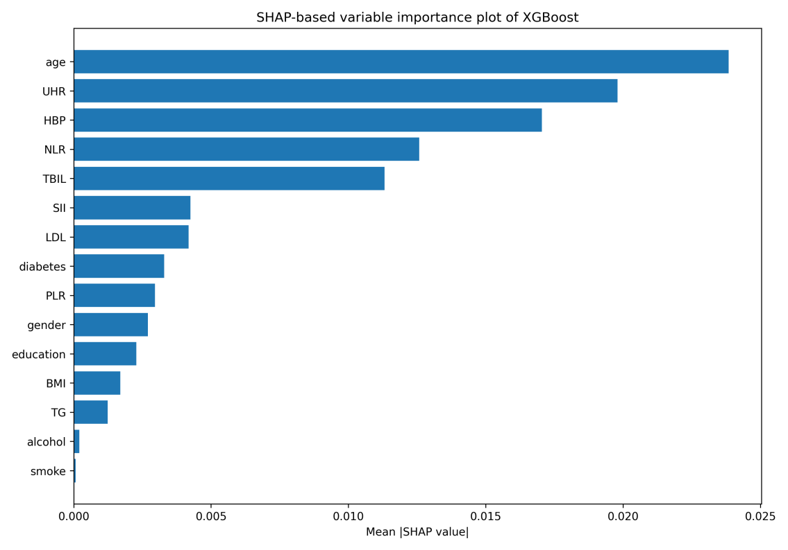
Figure S2. SHAP-based variable importance plot of XGBoost.
The figure shows the relative contribution of each predictor to the XGBoost model based on mean absolute SHAP values.
Abbreviations: UHR: uric acid to high-density lipoprotein cholesterol ratio; BMI: body mass index; LDL: low-density lipoprotein cholesterol; SII: Systemic Immune Inflammation Index; NLR: neutrophil-to-lymphocyte ratio; PLR: platelet-to-lymphocyte ratio; TG: Triglyceride.

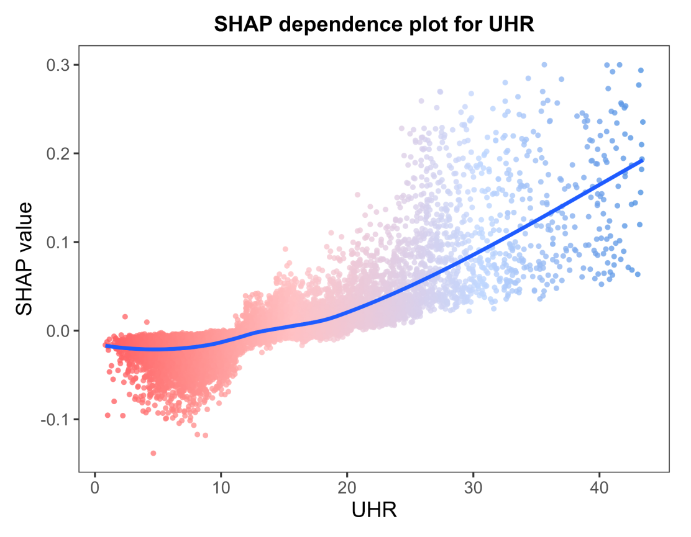
Figure S3. SHAP dependence plot for UHR in XGBoost.
The SHAP dependence plot illustrates the relationship between UHR values and their contribution to model-predicted CRS probability, showing a non-linear contribution pattern.
Points represent individual observations and are colored according to UHR level, and the solid blue curve represents the LOESS-smoothed trend. The x-axis was restricted to the main distribution range of UHR for visualization clarity.

