Pilot Study: Validation of McGurk Stimuli for Infant Audiovisual Integration Research
This pilot study employs the McGurk effect to assess audiovisual integration abilities in infants. To ensure that the observed responses in infants truly reflect audiovisual integration rather than perceptual or attentional confounds, it is critical to first establish that the McGurk stimuli used in the main experiment reliably induce the effect. Thus, this pilot study aims to (1) verify the occurrence of the McGurk effect in adult participants and (2) investigate potential gender-based differences in the McGurk effect when using male versus female stimulus speakers.

METHOD

Participants
A total of 31 participants (14 male, 17 female) with a mean age of 29.6 years (range: 19-45 years, SD = 6.28) were recruited for this study. All participants were right-handed and reported normal or corrected-to-normal vision.
An a priori power analysis was conducted using G*Power 3.1 to determine the required sample size. Using a repeated-measures ANOVA (within factors) design with parameters set to effect size f = 0.25, α = 0.05, power (1-β) = 0.8, Number of groups = 1, and Number of measures = 4, the analysis indicated that a minimum sample size of 24 participants was required to achieve adequate statistical power. Our final sample of 31 participants exceeded this requirement.

Stimuli
Two native Mandarin-speaking adults (1 female, 1 male; aged 25-26 years) were recruited for audiovisual stimulus recording. Both speakers articulated the syllables /ka/, /pa/, and /ta/ in a sound-attenuated booth. Recordings were captured using an iPhone XR (1080p resolution at 60 fps) to ensure synchronous audio and video acquisition.
Using Adobe Premiere Pro 2018, we generated three categories of experimental stimuli for each speaker: (1) audio-only (/ka/, /pa/, and /ta/) and video-only (/ka/, /pa/, and /ta); (2) Congruent bimodal stimuli: audio-visual matched pairs (A/ka/-V/ka/, A/pa/-V/pa/, A/ta/-V/ta/); (3) Incongruent bimodal stimuli: classic McGurk combination (A/pa/-V/ka/) and non-McGurk combination (A/ka/-V/pa/). This yielded a total of 22 unique stimuli (11 per speaker), comprising both McGurk and non-McGurk combinations for investigating audiovisual integration effects.

Design and Procedure
This study employed a within-subjects design with two independent variables: model gender (male vs. female) and stimulus type (11 categories, including McGurk and non-McGurk combination). The experiment was administered through the Credamo online platform, with participants instructed to complete the task in a quiet environment while maintaining their computer volume at 50%.
The experimental procedure consisted of three randomly ordered blocks corresponding to the pure auditory, silent visual, and audiovisual conditions. Each stimulus was presented three times across 66 trials. The experimental trial began with a 500 ms fixation followed by stimulus presentation. Response options (/ka/, /pa/, /ta/) were displayed beneath the stimulus. For auditory and audiovisual trials, participants identified the perceived auditory syllable, while for silent lip-movement trials, they reported the visually presented syllable.

RESULTS
The McGurk effect elicits a distinct perceptual fusion phenomenon where visual articulatory cues override auditory input, creating an emergent percept. Specifically, when participants are presented with auditory /pa/ synchronized with visual /ka/ articulation, this audiovisual mismatch consistently produces the fused percept /ta/ - a phenomenon not observed with reversed stimulus pairings (auditory /ka/ + visual /pa/). Our data demonstrate this critical dissociation: McGurk stimuli (auditory /pa/-visual /ka/) elicited significantly higher /ta/ response rates compared to non-McGurk control pairings (auditory /ka/-visual /pa/), confirming the robust efficacy of our McGurk paradigm.
Initial analyses employed sex-specific one-sample t-tests to evaluate identification accuracy on audio-only, video-only, and congruent audio-video conditions. For both male and female stimulus sets, mean accuracy significantly exceeded the chance level (33.3%) across all nine stimulus types (male voices: Ms > 0.49, ps < 0.008; female voices: Ms > 0.46, ps < 0.025), confirming robust syllable discrimination capabilities in all experimental conditions.
We subsequently performed a 2 (model gender: male vs. female) × 2 (audiovisual type: McGurk vs. non-McGurk) repeated-measures ANOVA on /ta/ response proportion. This analysis yielded two key findings: First, a robust main effect of audiovisual type, F (1, 30) = 613.13, p < 0.001, η_{p}² = 0.95, demonstrating significantly greater /ta/ responses to McGurk stimuli (auditory /pa/-visual /ka/) compared to non-McGurk stimuli (auditory /ka/- visual /pa/). Second, we observed a significant though smaller main effect of model gender, F (1, 30) = 5.48, p = 0.026, η_{p}² = 0.15, with higher /ta/ response rates for male versus female models.
The analysis revealed a statistically significant interaction between model gender and audiovisual type, F (1, 30) = 6.09, p =0.020, η_{p}² = 0.17, indicating differential gender effects across McGurk and non-McGurk conditions. Post hoc simple effects analyses (Figure 1) showed three key patterns: (1) For McGurk stimuli, adults produced significantly more /ta/ responses to male models (M_{male} = 97.8%, SE_{male} = 1.5%) than female models (M_{female} = 81.7%, SE_{female} = 6.3%), F (1, 30) = 6.86, p = 0.014, η_{p}² = 0.19. (2) No gender difference emerged for non-McGurk stimuli (M_{male} = 2.2%, SE_{male} = 1.5%; M_{female} = 2.2%, SE_{female} = 2.2%), F (1, 30) < 0.001, p = 1.0, η_{p}² < 0.001. (3) Furthermore, McGurk stimuli elicited substantially higher /ta/ responses than non-McGurk stimuli for both male models [F (1, 30) =2200.28, p < 0.001, η_{p}² = 0.99] and female models [F (1, 30) =149.89, p < 0.001, η_{p}² = 0.83], with large effect sizes in both cases.
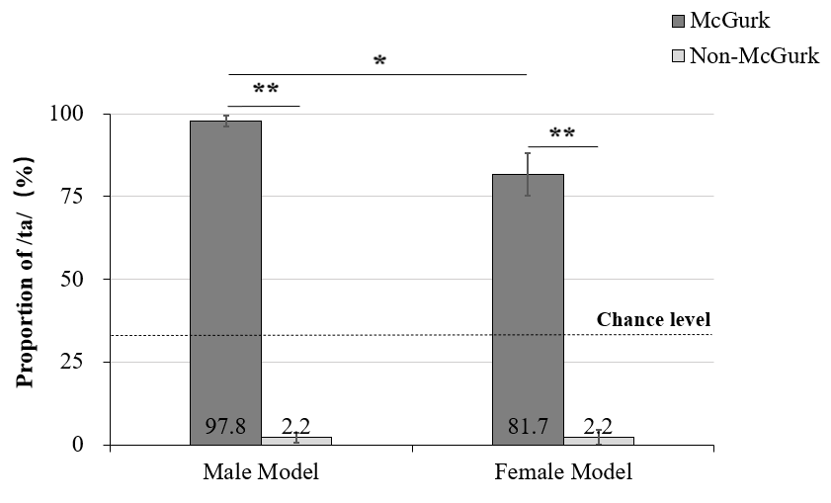
FIGURE 1 Differential response patterns for /ta/ perception across experimental conditions. The bar graph compares mean /ta/ proportions between McGurk (auditory /pa/-visual /ka/) and non-McGurk (auditory /ka/-visual /pa/) stimulus pairs, separately for male and female model presentations. Error bars represent standard error of the mean, demonstrating significantly enhanced /ta/ responses to McGurk stimuli (**p < 0.01) and a selective gender effect for McGurk combinations (p < 0.05). The dashed line indicates chance-level responding (33.3%).
The results demonstrate robust audiovisual integration across both genders, as participants consistently perceived the McGurk illusion regardless of model gender. Notably, the strength of this integration effect showed significant gender modulation, with male faces eliciting a more pronounced McGurk effect compared to female faces. This finding provides compelling evidence that our stimulus successfully induced the classic McGurk effect, while simultaneously revealing an unexpected gender-based asymmetry in integration strength.

