Supplementary materials
Supplementary Tables
Supplementary Table 1 International Classification of Diseases, Ninth & Tenth Revision Clinical Modification codes used to identify cerebrovascular diseases.
Cerebrovascular Diseases | ICD-10-CM | ICD-9-CM
Ischemic Stroke | I65.1, I63.22, I65.29, I63.139, I63.239, I65.09, I63.019, I63.119, I63.219, I63.20, I65.9, I63.59, I65.8, I63.50, I66.9, I63.40, I66.09, I66.19, I66.29, I63.30, I63.032, I63.033, I63.039, I63.031, I63.131, I63.132, I63.133, I63.231, I63.232, I63.233, I63.311, I63.312, I63.313, I63.319, I63.321, I63.322, I63.323, I63.329, I63.331, I63.332, I63.333, I63.339, I63.341, I63.342, I63.343, I63.349, I63.411, I63.412, I63.413, I63.419, I63.421, I63.422, I63.423, I63.429, I63.431, I63.432, I63.433, I63.439, I63.441, I63.442, I63.443, I63.449, I63.511, I63.512, I63.513, I63.519, I63.521, I63.522, I63.523, I63.529, I63.531, I63.532, I63.533, I63.539, I63.541, I63.542, I63.543, I63.549, I63.9, I65.21, I65.22, I65.23, I66.11, I66.12, I66.13, I66.21, I66.22, I66.23, I66.3, I66.8, I66.9, I63.011, I63.012, I63.013, I63.02, I63.12, I63.111, I63.112, I63.113, I63.211, I63.212, I63.213, I65.01, I65.02, I65.03, I63.00, I63.09, I63.19, I63.10, I63.29, I63.39, I63.49, I63.89, I63.8, I63.81 | 433.0, 433.01, 433.10, 433.11, 433.20, 433.21, 433.30, 433.31, 433.80, 433.81, 433.90, 433.91, 434.0, 434.01, 434.10, 434.11, 434.90, 434.91, 433.11, 434.01, 434.11, 434.91, 433.10, 434.00, 434.10, 434.90, 433.21, 433.01, 433.21, 433.20, 433.91, 433.81, 433.91, 434.01, 434.11
Intracerebral Hemorrhage | I61.0, I61.1, I61.2, I61.3, I61.4, I61.5, I61.6, I61.8, I61.9 | 431
Non-traumatic Subarachnoid Hemorrhage | I60.00, I60.01, I60.02, I60.10, I60.11, I60.12, I60.2, I60.30, I60.31, I60.32, I60.4, I60.50, I60.51, I60.52, I60.6, I60.7, I60.8, I60.9 | 430
Cerebral Venous Sinus Thrombosis | I67.6 | 437.6
Unspecified Cerebrovascular Diseases | I67.89, I67.2, I67.81, I67.82, I67.89, I67.9, G45.9, I67.848, G45.1, G45.8, G45.0, G45.8, G46.1, G46.0, G45.2, G45.1, G45.8, G45.0, G46.2, G45.2, I67.81, I67.82, I67.89, I67.89, I68.0, I67.9, G46.5, G46.6, G46.7, G46.3, G46.4, G46.8, G45.8, G45.9, G45.3, H34.00 | 435.0, 435.1, 435.3, 435.8, 437.1, 436, 437.8, 437.9, 435.8, 435.2, 435.9, 362.34, 435.8
ICD-10-CM=International Classification of Diseases, Tenth Revision, Clinical Modification, Coding System. ICD-9-CM=International Classification of Disease, Ninth Revision, Clinical Modification, Coding System.

Supplementary Table 2 All Variables extracted from the MIMIC-IV Database.
Category | Variables Included
Demographics | Age, Gender, and Race.
Vital parameters | HR, RR, NBPM, Temperature, and Spo2.
Underlying comorbid conditions | AF, HF, COPD, MI, Diabetes, and Hypertension.
Laboratory indicators | Hb, Plt, RBC, WBC, Potassium, Sodium, Cr, BUN, PT, HbA1c, Glu.
Medication usage | VP, HA, and IA.
Clinical interventions | Ventilation.
Severity scores | SOFA, GCS, APS - III, and SAPS - II.
Clinical outcomes | 28-day Mortality.
HR Heart Rate; RR Respiratory Rate; SpO2 O2 saturation pulseoxymetry; NBPM Non Invasive Blood Pressure mean; Hb hemoglobin; Plt platelet; RBC red blood cell; WBC white blood cell; Cr creatinine; BUN blood urea nitrogen; PT prothrombin time; HbA1c glycated hemoglobin; Glu glucose; AF atrial fibrillation; HF heart failure; MI myocardial infarction; COPD chronic obstructive pulmonary disease; VP Vasopressor; HA Hypoglycemic Agents; IA Insulin Therapy; APS-III acute physiology score III; SAPS-II simplified acute physiology score II; GCS Glasgow coma scale; SOFA sequential organ failure assessment.

Supplementary Table 3 Univariate Cox regression results for 28-day mortality
Characteristics | Number (%) | Hazard Ratio (HR) | 95% CI Lower | 95% CI Upper | P value
AF
No (reference) | 2935 (66.1)
Yes | 1506 (33.9) | 1.697 | 1.433 | 2.009 | <0.001
APSIII | 39.48 (17.03) | 1.025 | 1.021 | 1.029 | <0.001
Age | 68.99 (15.02) | 1.019 | 1.012 | 1.025 | <0.001
BUN | 22.55 (17.65) | 1.013 | 1.01 | 1.016 | <0.001
COPD
No (reference) | 4010 (90.3)
Yes | 431 (9.7) | 0.996 | 0.75 | 1.322 | 0.977
Cr | 1.29 (1.48) | 1.102 | 1.064 | 1.141 | <0.001
Diabetes
No (reference) | 2862 (64.4)
Yes | 1579 (35.6) | 1.114 | 0.936 | 1.324 | 0.224
GCS | 13.02 (2.63) | 0.97 | 0.941 | 1 | 0.048
GV | 21.96 (16.50) | 1.011 | 1.007 | 1.014 | <0.001
GV tertiles
1 | 1481 (33.3)
2 | 1480 (33.3) | 1.125 | 0.892 | 1.418 | 0.321
3 | 1480 (33.3) | 1.96 | 1.592 | 2.415 | <0.001
Gender
No (reference) | 2060 (46.4)
Yes | 2381 (53.6) | 0.898 | 0.759 | 1.063 | 0.212
Glu | 145.82 (69.92) | 1.002 | 1.002 | 1.003 | <0.001
HA
No (reference) | 4178 (94.1)
Yes | 263 (5.9) | 0.111 | 0.041 | 0.296 | <0.001
HF
No (reference) | 3344 (75.3)
Yes | 1097 (24.7) | 1.399 | 1.167 | 1.678 | <0.001
HR | 84.31 (18.65) | 1.009 | 1.005 | 1.014 | <0.001
Hb | 11.91 (2.19) | 0.88 | 0.848 | 0.913 | <0.001
HbA1c | 6.29 (1.56) | 1.016 | 0.964 | 1.07 | 0.555
Hypertension
No (reference) | 1985 (44.7)
Yes | 2456 (55.3) | 0.878 | 0.742 | 1.039 | 0.13
IA
No (reference) | 946 (21.3)
Yes | 3495 (78.7) | 1.504 | 1.192 | 1.898 | <0.001
MI
No (reference) | 4040 (91.0)
Yes | 401 (9.0) | 1.764 | 1.39 | 2.24 | <0.001
NBPM | 119.19 (1801.36) | 0.991 | 0.987 | 0.996 | <0.001
PT | 13.97 (4.37) | 1.03 | 1.017 | 1.042 | <0.001
Plt | 218.46 (91.61) | 0.999 | 0.998 | 1 | 0.023
Potassium | 4.09 (0.70) | 1.318 | 1.194 | 1.455 | <0.001
RBC | 4.01 (0.73) | 0.677 | 0.604 | 0.758 | <0.001
RR | 19.15 (5.33) | 1.025 | 1.01 | 1.041 | <0.001
Race
1 (reference) | 2515 (56.6)
2 | 504 (11.3) | 1.069 | 0.792 | 1.443 | 0.662
3 | 1422 (32.0) | 1.907 | 1.598 | 2.276 | <0.001
SAPS - II | 33.33 (11.81) | 1.044 | 1.038 | 1.051 | <0.001
SHR | 1.11 (0.42) | 1.347 | 1.252 | 1.449 | <0.001
Group (SHR + GV)
Group 1 (low SHR + low GV) | 2144 (48.3)
Group 2 (low SHR + high GV) | 816 (18.4) | 1.953 | 1.545 | 2.469 | <0.001
Group 3 (high SHR + low GV) | 817 (18.4) | 1.967 | 1.556 | 2.487 | <0.001
Group 4 (high SHR + high GV) | 664 (15.0) | 2.79 | 2.225 | 3.499 | <0.001
SHR tertiles
1 | 1482 (33.4)
2 | 1478 (33.3) | 1.099 | 0.872 | 1.385 | 0.426
3 | 1481 (33.3) | 1.947 | 1.583 | 2.395 | <0.001
SOFA | 3.63 (2.85) | 1.134 | 1.108 | 1.161 | <0.001
Sodium | 138.98 (4.65) | 0.99 | 0.972 | 1.008 | 0.252
SpO2 | 97.08 (2.95) | 1.018 | 0.987 | 1.049 | 0.254
Temperature | 98.19 (2.97) | 1.024 | 0.976 | 1.074 | 0.341
VP
No (reference) | 2959 (66.6)
Yes | 1482 (33.4) | 2.93 | 2.471 | 3.474 | <0.001
Ventilation
No (reference) | 1435 (32.3)
Yes | 3006 (67.7) | 2.214 | 1.78 | 2.752 | <0.001
WBC | 11.43 (9.11) | 1.013 | 1.01 | 1.016 | <0.001
Glucose metabolism state
DM (reference) | 1699 (38.3)
NGR | 1632 (36.7) | 0.749 | 0.616 | 0.912 | 0.004
PreDM | 1110 (25.0) | 0.85 | 0.688 | 1.052 | 0.135
HR Heart Rate; RR Respiratory Rate; SpO2 O2 saturation pulseoxymetry; NBPM Non Invasive Blood Pressure mean; Hb hemoglobin; Plt platelet; RBC red blood cell; WBC white blood cell; Cr creatinine; BUN blood urea nitrogen; PT prothrombin time; HbA1c glycated hemoglobin; Glu glucose; AF atrial fibrillation; HF heart failure; MI myocardial infarction; COPD chronic obstructive pulmonary disease; VP Vasopressor; HA Hypoglycemic Agents; IA Insulin Therapy; APS-III acute physiology score III; SAPS-II simplified acute physiology score II; GCS Glasgow coma scale; SOFA sequential organ failure assessment.

Supplementary Table 4 Variance inflation factor between variables.
Characteristic | GVIF | Df | GVIF^(1/(2*Df))
Group (SHR + GV) | 2.62152793093825 | 3 | 1.17424597858959
AF | 1.277725786 | 1 | 1.13036533296718
APS - III | 4.07666048935559 | 1 | 2.01907416638309
Age | 1.76108646410983 | 1 | 1.32705932953649
BUN | 2.69099378100221 | 1 | 1.64042487819534
COPD | 1.05089025896896 | 1 | 1.02512938645273
Cr | 2.57458469929949 | 1 | 1.60455124545758
Diabetes | 1.7107943215872 | 1 | 1.3079733642499
GCS | 1.50378481988175 | 1 | 1.22628904418239
Gender | 1.15446474228919 | 1 | 1.07446020972821
Glu | 2.53105861513851 | 1 | 1.59093011007351
HA | 1.01751051272029 | 1 | 1.00871726104013
HF | 1.44363337803412 | 1 | 1.20151295375211
HR | 1.37843542004416 | 1 | 1.17406789413737
Hb | 6.1901962955214 | 1 | 2.48801050952792
HbA1c | 2.14475552163891 | 1 | 1.46449838567303
Hypertension | 1.35903307692104 | 1 | 1.16577574040681
IA | 1.14898727036433 | 1 | 1.07190823784703
MI | 1.17402283512194 | 1 | 1.08352334313661
NBPM | 1.00148334514275 | 1 | 1.00074139773607
PT | 1.24658550133003 | 1 | 1.1165059343013
Plt | 1.22859548527125 | 1 | 1.1084202656354
Potassium | 1.25550738561578 | 1 | 1.12049425951933
RBC | 6.06516650506342 | 1 | 2.46275587605906
RR | 1.20057501072052 | 1 | 1.09570753886268
Race | 1.23921997274311 | 2 | 1.05508415535948
SAPSII | 3.91022480775783 | 1 | 1.97742883759639
SOFA | 3.05106570026529 | 1 | 1.74673000210831
Sodium | 1.28209114181441 | 1 | 1.13229463560259
SpO2 | 1.12977679757077 | 1 | 1.06290959049713
Temperature | 1.09682071833253 | 1 | 1.04729208835574
VP | 1.50075888761417 | 1 | 1.2250546467869
Ventilation | 1.18126642169743 | 1 | 1.0868608106365
WBC | 1.13798182498861 | 1 | 1.06676230950883
HR Heart Rate; RR Respiratory Rate; SpO2 O2 saturation pulseoxymetry; NBPM Non Invasive Blood Pressure mean; Hb hemoglobin; Plt platelet; RBC red blood cell; WBC white blood cell; Cr creatinine; BUN blood urea nitrogen; PT prothrombin time; HbA1c glycated hemoglobin; Glu glucose; AF atrial fibrillation; HF heart failure; MI myocardial infarction; COPD chronic obstructive pulmonary disease; VP Vasopressor; HA Hypoglycemic Agents; IA Insulin Therapy; APS-III acute physiology score III; SAPS-II simplified acute physiology score II; GCS Glasgow coma scale; SOFA sequential organ failure assessment.

Supplementary Table 5 The association of the SHR and GV with 28-day mortality
Variables | Model 1 |  |  | Model 2 |  |  | Model 3
Variables | HR (95%CI) | P |  | HR (95%CI) | P |  | HR (95%CI) | P
Overall
SHR
T1 | 1.00 (Reference) |  |  | 1.00 (Reference) |  |  | 1.00 (Reference)
T2 | 1.10 (0.87–1.38) | 0.426 |  | 1.13 (0.90–1.43) | 0.294 |  | 1.06 (0.84–1.34) | 0.616
T3 | 1.95 (1.58–2.40) | <0.001 |  | 1.93 (1.57–2.38) | <0.001 |  | 1.41 (1.14–1.75) | 0.002
P for trend |  | <0.001 |  |  | <0.001 |  |  | <0.001
GV
T1 | 1.00 (Reference) |  |  | 1.00 (Reference) |  |  | 1.00 (Reference)
T2 | 1.12 (0.89–1.42) | 0.321 |  | 1.10 (0.87–1.39) | 0.413 |  | 0.88 (0.69–1.11) | 0.280
T3 | 1.96 (1.59–2.41) | <0.001 |  | 1.91 (1.55–2.36) | <0.001 |  | 1.32 (1.04–1.66) | 0.020
P for trend |  | <0.001 |  |  | <0.001 |  |  | 0.007
Patients with NGR
SHR
T1 | 1.00 (Reference) |  |  | 1.00 (Reference) |  |  | 1.00 (Reference)
T2 | 1.27 (0.77–2.11) | 0.349 |  | 1.34 (0.81–2.23) | 0.257 |  | 1.19 (0.71–1.99) | 0.505
T3 | 3.34 (2.11–5.29) | <0.001 |  | 3.26 (2.05–5.18) | <0.001 |  | 2.07 (1.27–3.38) | 0.004
P for trend |  | <0.001 |  |  | <0.001 |  |  | <0.001
GV
T1 | 1.00 (Reference) |  |  | 1.00 (Reference) |  |  | 1.00 (Reference)
T2 | 1.18 (0.82–1.71) | 0.373 |  | 1.16 (0.80–1.67) | 0.437 |  | 0.80 (0.55–1.18) | 0.267
T3 | 2.96 (2.05–4.26) | <0.001 |  | 2.88 (1.99–4.15) | <0.001 |  | 1.47 (0.97–2.22) | 0.071
P for trend |  | <0.001 |  |  | <0.001 |  |  | 0.087
Patients with Pre-DM
SHR
T1 | 1.00 (Reference) |  |  | 1.00 (Reference) |  |  | 1.00 (Reference)
T2 | 1.29 (0.85–1.96) | 0.232 |  | 1.27 (0.83–1.93) | 0.267 |  | 1.16 (0.76–1.78) | 0.489
T3 | 2.03 (1.33–3.08) | <0.001 |  | 2.02 (1.33–3.07) | 0.001 |  | 1.38 (0.88–2.15) | 0.163
P for trend |  | 0.001 |  |  | 0.001 |  |  | 0.163
GV
T1 | 1.00 (Reference) |  |  | 1.00 (Reference) |  |  | 1.00 (Reference)
T2 | 0.94 (0.62–1.43) | 0.766 |  | 0.92 (0.60–1.41) | 0.706 |  | 0.80 (0.51–1.24) | 0.311
T3 | 1.87 (1.24–2.81) | 0.003 |  | 1.81 (1.20–2.72) | 0.005 |  | 1.36 (0.86–2.16) | 0.187
P for trend |  | 0.005 |  |  | 0.008 |  |  | 0.199
P for trend |  | <0.001 |  |  | <0.001 |  |  | 0.044
Patients with DM
SHR
T1 | 1.00 (Reference) |  |  | 1.00 (Reference) |  |  | 1.00 (Reference)
T2 | 1.16 (0.82–1.64) | 0.393 |  | 1.18 (0.83–1.67) | 0.347 |  | 1.12 (0.79–1.59) | 0.528
T3 | 1.48 (1.10–1.99) | 0.010 |  | 1.47 (1.09–1.99) | 0.011 |  | 1.17 (0.86–1.60) | 0.321
P for trend |  | 0.009 |  |  | 0.010 |  |  | 0.327
GV
T1 | 1.00 (Reference) |  |  | 1.00 (Reference) |  |  | 1.00 (Reference)
T2 | 1.17 (0.76–1.81) | 0.468 |  | 1.16 (0.75–1.79) | 0.509 |  | 0.99 (0.63–1.55) | 0.969
T3 | 1.51 (1.04–2.20) | 0.031 |  | 1.54 (1.06–2.25) | 0.024 |  | 1.22 (0.82–1.83) | 0.330
P for trend |  | 0.016 |  |  | 0.010 |  |  | 0.219
Model 1: unadjusted;
Model 2: adjusted for age , gender and race
Model 3 was further adjusted for APS - III, GCS, HR, RR, SpO2, Temperature, Cr, WBC, Platelet, AF, HF, Hypertension, MI, COPD, and Ventilation.

Supplementary Table 6 Discrimination of each predictive model for outcomes
Models | AUC(95% CI) | Sensitivity | Specificity | P
DM
SHR+GV | 0.567(0.527-0.607) | 0.776 | 0.341 | 1.00 (Reference)
SHR | 0.557(0.515-0.599) | 0.194 | 0.923 | 0.158
GV | 0.544(0.506-0.583) | 0.603 | 0.49 | 0.341
GCS | 0.521(0.480-0.562) | 0.511 | 0.596 | 0.125
SOFA | 0.618(0.579-0.656) | 0.654 | 0.541 | 0.048
APS - III | 0.645(0.607-0.682) | 0.616 | 0.637 | 0.001
NGR
SHR+GV | 0.686(0.642-0.731) | 0.601 | 0.696 | 1.00 (Reference)
SHR | 0.670(0.624-0.717) | 0.601 | 0.682 | 0.061
GV | 0.626(0.579-0.672) | 0.509 | 0.731 | 0.01
GCS | 0.503(0.454-0.553) | 0.503 | 0.605 | <0.001
SOFA | 0.657(0.611-0.702) | 0.514 | 0.766 | 0.338
APS - III | 0.689(0.644-0.733) | 0.561 | 0.731 | 0.933
PreDM
SHR+GV | 0.628(0.581-0.676) | 0.857 | 0.369 | 1.00 (Reference)
SHR | 0.580(0.527-0.632) | 0.729 | 0.416 | 0.004
GV | 0.583(0.529-0.637) | 0.308 | 0.865 | 0.096
GCS | 0.557(0.504-0.611) | 0.556 | 0.608 | 0.058
SOFA | 0.615(0.566-0.665) | 0.519 | 0.659 | 0.679
APS - III | 0.616(0.566-0.667) | 0.594 | 0.629 | 0.678
SHR, Stress hyperglycemia ratio; GV, glycemic variability; GCS, Glasgow Coma Scale; SOFA, Sequential Organ Failure Assessment; APS - III, Acute Physiology Score III.

Supplementary Table 7 Results of the proportional hazards test (Cox model) in the NGR population

Variable Name | P
Group (SHR + GV) | 0.509507
Age | 0.129634
Gender | 0.006637
GCS | 0.298997
APSIII | 0.689849
SpO2 | 0.734736
Cr | 0.438474
BUN | 0.177755
PT | 0.164446
Hb | 0.53465
AF | <0.001
Hypertension | 0.276396
MI | 0.021757
COPD | 0.165399
Ventilation | 0.13784
VP | 0.074061
HA | 0.999942
GLOBAL | 0.003644

Supplementary Table 8 Results of the proportional hazards test (Cox model) in the DM population
Variable Name | P
Group (SHR + GV) | 0.01528
Age | 0.017834
Gender | 0.064284
GCS | 0.178908
APSIII | 0.195344
SpO2 | 0.890048
Cr | 0.259186
BUN | 0.547718
PT | 0.409903
Hb | 0.026428
AF | 0.319311
Diabetes | 0.552501
Hypertension | 0.031796
MI | 0.040148
COPD | 0.182098
Ventilation | 0.015965
VP | <0.001
HA | 0.433887
GLOBAL | 0.001266

Supplementary Table 9 Results of the proportional hazards test (Cox model) in the Pre-DM population
Variable Name | p
Group (SHR + GV) | 0.08131
Age | 0.134121
Gender | 0.115821
GCS | 0.164176
APSIII | 0.286895
SpO2 | 0.082482
Cr | 0.984895
BUN | 0.459848
PT | 0.246746
Hb | 0.275121
AF | 0.710571
Hypertension | 0.709754
MI | 0.473301
COPD | 0.533939
Ventilation | 0.02117
VP | 0.101261
HA | 0.999976
GLOBAL | 0.058674

Supplementary Table 10 The association of the combination of SHR and GV with all-cause mortality after excluding hypoglycemic agents.
Variables | Model 1 |  | Model 2 |  | Model 3
Variables | HR (95%CI) | P | HR (95%CI) | P | HR (95%CI) | P
Overall
Group 1 | 1.00 (Reference) |  | 1.00 (Reference) |  | 1.00 (Reference)
Group 2 | 2.11 (1.66 ~ 2.67) | <0.001 | 2.11 (1.66 ~ 2.67) | <0.001 | 1.51 (1.18 ~ 1.95) | 0.001
Group 3 | 1.99 (1.58 ~ 2.52) | <0.001 | 2.02 (1.60 ~ 2.56) | <0.001 | 1.49 (1.17 ~ 1.89) | 0.001
Group 4 | 3.09 (2.46 ~ 3.88) | <0.001 | 3.16 (2.52 ~ 3.96) | <0.001 | 1.86 (1.44 ~ 2.40) | <0.001
P for trend | 1.42 (1.32 ~ 1.52) | <0.001 | 1.43 (1.33 ~ 1.53) | <0.001 | 1.20 (1.11 ~ 1.30) | <0.001
Patients with NGR
Group 1 | 1.00 (Reference) |  | 1.00 (Reference) |  | 1.00 (Reference)
Group 2 | 2.36 (1.36 ~ 4.08) | 0.002 | 2.30 (1.33 ~ 3.98) | 0.003 | 1.57 (0.89 ~ 2.77) | 0.117
Group 3 | 2.58 (1.79 ~ 3.73) | <0.001 | 2.62 (1.81 ~ 3.79) | <0.001 | 1.94 (1.31 ~ 2.86) | <0.001
Group 4 | 5.81 (3.87 ~ 8.73) | <0.001 | 5.92 (3.94 ~ 8.90) | <0.001 | 2.77 (1.76 ~ 4.35) | <0.001
P for trend | 1.73 (1.51 ~ 1.97) | <0.001 | 1.74 (1.53 ~ 1.99) | <0.001 | 1.39 (1.21 ~ 1.61) | <0.001
Patients with Pre-DM
Group 1 | 1.00 (Reference) |  | 1.00 (Reference) |  | 1.00 (Reference)
Group 2 | 2.53 (1.63 ~ 3.92) | <0.001 | 2.47 (1.60 ~ 3.83) | <0.001 | 1.94 (1.21 ~ 3.10) | 0.006
Group 3 | 2.35 (1.51 ~ 3.66) | <0.001 | 2.34 (1.50 ~ 3.64) | <0.001 | 1.45 (0.90 ~ 2.34) | 0.122
Group 4 | 2.16 (1.22 ~ 3.81) | 0.008 | 2.17 (1.23 ~ 3.83) | 0.008 | 1.39 (0.75 ~ 2.56) | 0.29
P for trend | 1.37 (1.18 ~ 1.59) | <0.001 | 1.37 (1.18 ~ 1.59) | <0.001 | 1.14 (0.96 ~ 1.35) | 0.132
Patients with DM
Group 1 | 1.00 (Reference) |  | 1.00 (Reference) |  | 1.00 (Reference)
Group 2 | 1.31 (0.92 ~ 1.87) | 0.128 | 1.36 (0.95 ~ 1.93) | 0.09 | 1.11 (0.77 ~ 1.60) | 0.57
Group 3 | 1.29 (0.82 ~ 2.04) | 0.265 | 1.31 (0.83 ~ 2.07) | 0.24 | 1.15 (0.72 ~ 1.82) | 0.561
Group 4 | 1.86 (1.32 ~ 2.62) | <0.001 | 1.94 (1.37 ~ 2.73) | <0.001 | 1.45 (1.00 ~ 2.10) | 0.051
P for trend | 1.21 (1.09 ~ 1.35) | <0.001 | 1.23 (1.10 ~ 1.37) | <0.001 | 1.13 (1.00 ~ 1.27) | 0.046
Group 1: Low SHR and Low GV (SHR < 1.17 and GV < 23.40); Group 2: Low SHR and High GV (SHR < 1.17 and GV ≥ 23.40); Group 3: High SHR and Low GV (SHR ≥ 1.17 and GV < 23.40); Group 4: High SHR and High GV (SHR ≥ 1.17 and GV ≥ 23.40).
Model 1: unadjusted;
Model 2: adjusted for age , gender and race
Model 3 was further adjusted for APS - III, GCS, HR, RR, SpO2, Temperature, Cr, WBC, Platelet, AF, HF, Hypertension, MI, COPD, and Ventilation.
Group 1: Low SHR and Low GV (SHR < 1.17 and GV < 23.40); Group 2: Low SHR and High GV (SHR < 1.17 and GV ≥ 23.40); Group 3: High SHR and Low GV (SHR ≥ 1.17 and GV < 23.40); Group 4: High SHR and High GV (SHR ≥ 1.17 and GV ≥ 23.40).

Supplementary Table 11 The association of the combination of SHR and GV with all-cause mortality after excluding extreme SHR/GV (1%-99%).
Variables | Model 1 |  | Model 2 |  | Model 3
Variables | HR (95%CI) | P | HR (95%CI) | P | HR (95%CI) | P
Overall
Group 1 | 1.00 (Reference) |  | 1.00 (Reference) |  | 1.00 (Reference)
Group 2 | 1.88 (1.48 ~ 2.40) | <0.001 | 1.91 (1.50 ~ 2.43) | <0.001 | 1.50 (1.16 ~ 1.95) | 0.002
Group 3 | 1.93 (1.53 ~ 2.45) | <0.001 | 1.98 (1.56 ~ 2.50) | <0.001 | 1.47 (1.15 ~ 1.87) | 0.002
Group 4 | 2.58 (2.03 ~ 3.27) | <0.001 | 2.64 (2.08 ~ 3.34) | <0.001 | 1.78 (1.37 ~ 2.33) | <0.001
P for trend | 1.35 (1.26 ~ 1.46) | <0.001 | 1.36 (1.27 ~ 1.47) | <0.001 | 1.19 (1.10 ~ 1.29) | <0.001
Patients with NGR
Group 1 | 1.00 (Reference) |  | 1.00 (Reference) |  | 1.00 (Reference)
Group 2 | 2.43 (1.40 ~ 4.20) | 0.001 | 2.35 (1.36 ~ 4.07) | 0.002 | 1.65 (0.94 ~ 2.91) | 0.083
Group 3 | 2.48 (1.72 ~ 3.60) | <0.001 | 2.52 (1.74 ~ 3.64) | <0.001 | 1.89 (1.28 ~ 2.79) | 0.001
Group 4 | 5.02 (3.23 ~ 7.80) | <0.001 | 5.10 (3.28 ~ 7.93) | <0.001 | 2.62 (1.61 ~ 4.26) | <0.001
P for trend | 1.65 (1.44 ~ 1.89) | <0.001 | 1.66 (1.45 ~ 1.90) | <0.001 | 1.37 (1.18 ~ 1.58) | <0.001
Patients with Pre-DM
Group 1 | 1.00 (Reference) |  | 1.00 (Reference) |  | 1.00 (Reference)
Group 2 | 2.55 (1.63 ~ 3.99) | <0.001 | 2.50 (1.59 ~ 3.92) | <0.001 | 2.01 (1.24 ~ 3.26) | 0.005
Group 3 | 2.34 (1.50 ~ 3.64) | <0.001 | 2.32 (1.49 ~ 3.62) | <0.001 | 1.47 (0.92 ~ 2.37) | 0.109
Group 4 | 2.24 (1.25 ~ 4.02) | 0.007 | 2.24 (1.25 ~ 4.03) | 0.007 | 1.42 (0.76 ~ 2.65) | 0.276
P for trend | 1.38 (1.19 ~ 1.61) | <0.001 | 1.38 (1.19 ~ 1.61) | <0.001 | 1.15 (0.97 ~ 1.37) | 0.11
Patients with DM
Group 1 | 1.00 (Reference) |  | 1.00 (Reference) |  | 1.00 (Reference)
Group 2 | 1.19 (0.83 ~ 1.70) | 0.349 | 1.25 (0.87 ~ 1.79) | 0.223 | 1.08 (0.74 ~ 1.57) | 0.702
Group 3 | 1.25 (0.80 ~ 1.97) | 0.328 | 1.30 (0.83 ~ 2.04) | 0.258 | 1.14 (0.72 ~ 1.80) | 0.587
Group 4 | 1.63 (1.15 ~ 2.31) | 0.006 | 1.71 (1.21 ~ 2.43) | 0.003 | 1.45 (0.99 ~ 2.12) | 0.054
P for trend | 1.17 (1.05 ~ 1.31) | 0.006 | 1.19 (1.06 ~ 1.33) | 0.003 | 1.13 (1.00 ~ 1.28) | 0.046
Model 1: unadjusted;
Model 2: adjusted for age , gender and race
Model 3 was further adjusted for APS - III, GCS, HR, RR, SpO2, Temperature, Cr, WBC, Platelet, AF, HF, Hypertension, MI, COPD, and Ventilation.
Group 1: Low SHR and Low GV (SHR < 1.17 and GV < 23.40); Group 2: Low SHR and High GV (SHR < 1.17 and GV ≥ 23.40); Group 3: High SHR and Low GV (SHR ≥ 1.17 and GV < 23.40); Group 4: High SHR and High GV (SHR ≥ 1.17 and GV ≥ 23.40).

Supplementary Figures
Supplementary Figure 1 The trends of the proportional - hazards assumption test based on the COX regression model
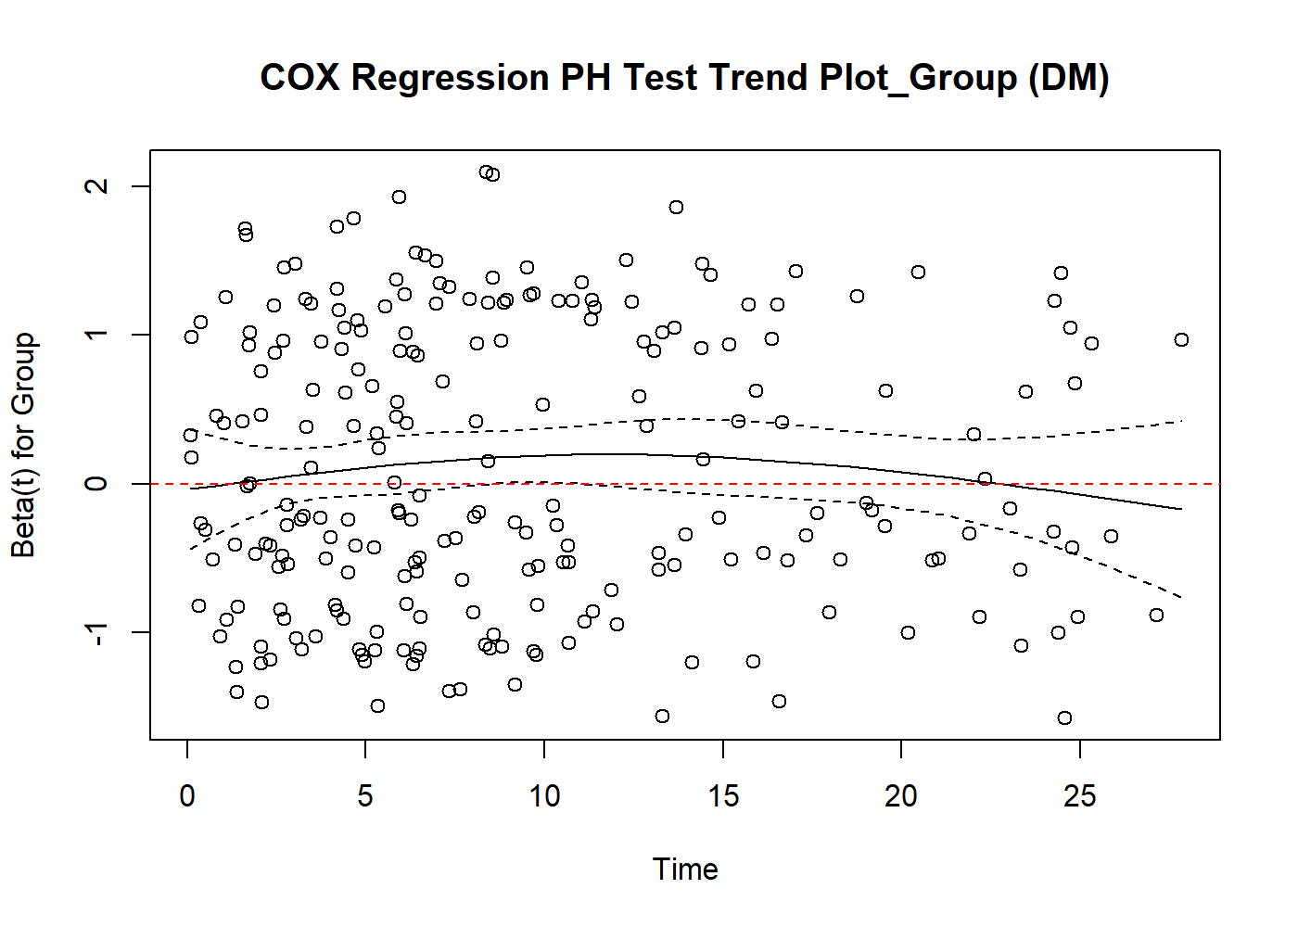

Supplementary Figure 2 The Boruta algorithm ranks the importance of potential risk factors for 28-day mortality in overall patients.

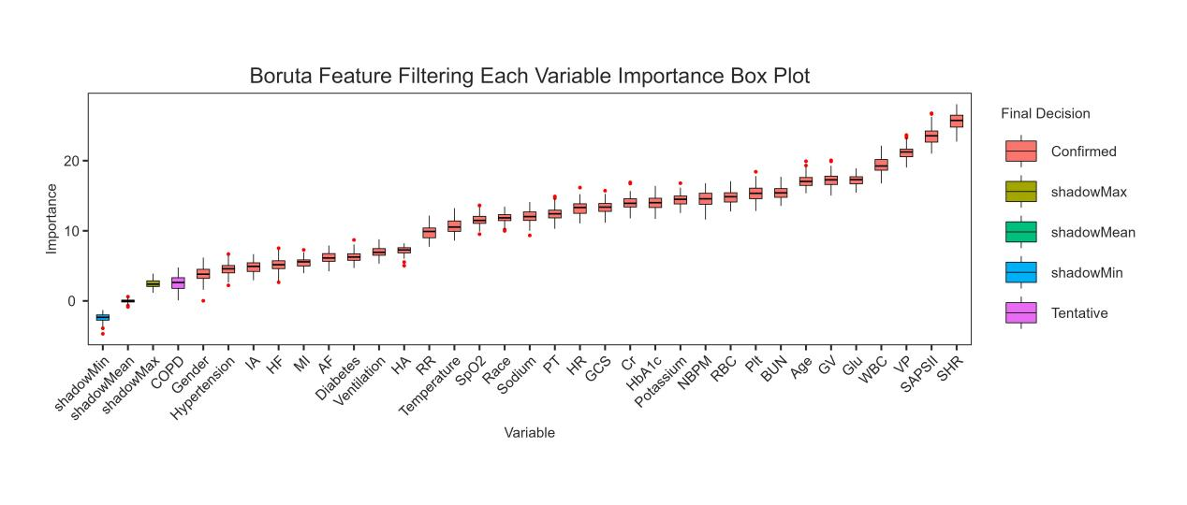

Supplementary Figure 3 Receiver operating characteristic curve of six ML models for predicting 28-day mortality in overall patients.

Supplementary Figure 4 Explanation of the 28-day mortality prediction model in overall patients.

