Supplementary Materials For

Applied Biochemistry and Biotechnology

Highly-Expressed Aspartic Protease from Aspergillus fumigatus-Mediated Enzymolysis of Silkworm (Bombyx mori) Pupae Protein

Running title: Protease expression and protein hydrolysis

Richard A. Herman ª, Chen Xie ª, Zi-Qian Zha ª, Zong-Nan Li ª, Jin-Zheng Wang ª, Shuai You ^{a, b}, Jun Wang ^{a, b *}

ª Jiangsu Key Laboratory of Sericultural Biology and Biotechnology, School of Biotechnology, Jiangsu University of Science and Technology, Zhenjiang, Jiangsu 212100, China;
^{b} Key Laboratory of Silkworm and Mulberry Genetic Improvement, Ministry of Agricultural and Rural Affairs, Sericultural Research Institute, Chinese Academy of Agricultural Sciences, Zhenjiang, Jiangsu 212100, China;

To whom all correspondence should be addressed.

* Corresponding author. Phone: +86-511-84448290, Fax: +86-511-84448290.
E-mail: wangjun@just.edu.cn (Prof. Dr. Jun Wang)

Supplementary materials:
Fig. S1. Peptide alignment of recombinant Af293 aspartic protease of Aspergillus fumigatus; (1) Amino acid sequence of aspartic protease from Aspergillopepesin-1 (pepA), (2) Amino acid sequence of recombinant aspartic protease from Aspergillus fumigatus (This study). The peptides obtained a 73.04% sequence similarity with the reported Aspergillopepsin-1 aspartic protease (Aspergillus fumigatus CBS 101355). The missing amino acid sequence are marked in red color, and a boxed D (102,284) active residue in brown color.
Fig. S2. The standard curve generated for determining the kinetic parameters of the aspartic protease from A. fumigatus Af293-ap.
Table S1 Primer sequence used for the PCR assay
Table S2 Kinetic profiling of the recombinant aspartic protease A. fumigatus Af293.

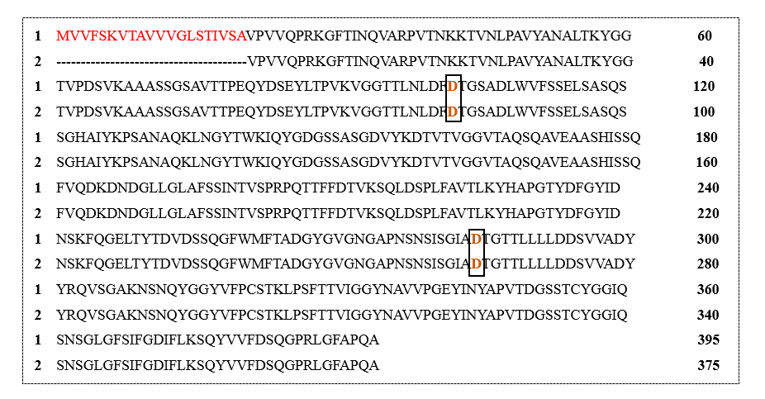
Fig. S1. Peptide alignment of recombinant Af293 aspartic protease of Aspergillus fumigatus; (1) Amino acid sequence of aspartic protease from Aspergillopepesin-1 (pepA), (2) Amino acid sequence of recombinant aspartic protease from Aspergillus fumigatus (This study). The peptides obtained a 73.04% sequence similarity with the reported Aspergillopepsin-1 aspartic protease (Aspergillus fumigatus CBS 101355). The missing amino acid sequence are marked in red color, and a boxed D (102,284) active residue in brown color.

Fig. S2. The standard curve generated for determining the kinetic parameters of the aspartic protease from A. fumigatus Af293-ap.

Table S1 Primer sequence used for the PCR assay
Gene | Direction | Sequence (5’-3’)
Af293-ap 1 | F | TTGTCTGCCTCCCAATCTTC
Af293-ap 1 | R | CTCCGTTACCAACACCGTATC
Af293-ap 2 | F | CCAGTTGTTCAGCCAAGAAAG
Af293-ap 2 | R | CACCGTATCCATCAGCAGTAAG
Af293-ap 3 | F | CTGATGGATACGGTGTTGGTAA
Af293-ap 3 | R | CCAATCTAGGACCTTGGGAATC
Af293-ap 4 | F | CCGGTTCTGCTGTTACTACTC
Af293-ap 4 | R | GCCAATCCCAACAAACCATC
Af293-ap 5 | F | GGTGATGGTTCTTCTGCTTCT
Af293-ap 5 | R | CAGTATCAGCGATACCGGAAAT

Table S2 Kinetic profiling of the recombinant aspartic protease A. fumigatus Af293
Kinetic parameters | Values
Total activity (U/mL) | 1009 ± 36.6
Specific activity (U/mg) | 8408.9 ± 305.6
K_{m} (mg/mL) | 2.0
V_{max} (µmoL/min/mg) | 765.3
K_{cat} (/s) | 573.9
K_{cat}/K_{m} (mL/s/mg) | 285.9
T₅₀ (°C) | 65

