Supplementary Materials for
Ultralow-power field-free magnetization switching via oxide interfacial Quasi-two-dimensional electron gas
Yongcheng Deng^{1#}, Zhaoqing Li^{2#}, Hui Wen^{1,3}, Qilin Guan², Qiyuan Feng⁴, Chuanying Xi⁴, Xionghua Liu^{1,3}, Xuan Qian^{1,3}, Wenkai Zhu¹, Li Pi⁴, Dingfu Shao⁵, Zhe Yuan^{2*}, Kaiyou Wang^{1,3*}
¹State Key Laboratory of Semiconductor Physics and Chip Technologies, Institute of Semiconductors, Chinese Academy of Sciences, Beijing, 100083, China
²State Key Laboratory of Surface Physics and Interdisciplinary Center for Theoretical Physics and Information Sciences, Fudan University, Shanghai 200433, China
³Center of Materials Science and Optoelectronics Engineering, University of Chinese Academy of Sciences, Beijing, 100049, China
⁴Anhui Key Laboratory of Low-Energy Quantum Materials and Devices, High Magnetic Field Laboratory, HFIPS, Chinese Academy of Sciences, Hefei, Anhui 230031, China
⁵Key Laboratory of Materials Physics, Institute of Solid State Physics, HFIPS, Chinese Academy of Sciences, Hefei, 230031, China

#These authors contributed equally to this work.
*Correspondence and requests for materials should be addressed to Z.Y. or K.W.
*Email: yuanz@fudan.edu.cn, kywang@semi.ac.cn

Table of Contents
Note 1: Structural characterization of Q-2DEG
Note 2: Transport characterization of Q-2DEG
Note 3: The contact characteristics of 2DEG with metals
Note 4: Characterization of magnetoelectric transport properties of magnetic Q-2DEG/CoGd
Note 5: Critical current density with the parallel current model
Note 6: Current-induced magnetization switching of Q-2DEG(m)/CoGd samples
Note 7: Current-induced magnetization switching of Q-2DEG/CoGd samples
Note 8: Current-induced magnetization switching of STO/CoGd, STO/LAO/CoGd and STO/CoGd/Pt samples
Note 9: SOT switching of Q-2DEG(m)/[Co/Ni]₅ reference samples
Note 10: ST-FMR analysis
Note 11: Charge-spin conversion efficiency determined by harmonic measurement
Note 12: Micromagnetic simulation of current-induced magnetization switching
Note 13: SOT switching of Q-2DEG(m)/CoGd samples with different bombardment powers and different miscut angles
Note 14: Data description for the comparison plot of $ξ_{DL}^{Z}$ and $ξ_{DL}^{y}$
Note 15: Data description for the comparison plot of power dissipation density and critical current density
Note 16: Theoretical modeling of miscut-induced spin polarization

Note 1: Structural characterization of Q-2DEG
X-ray diffraction and HAADF-STEM image confirmed the lattice structure and high crystalline quality of the commercial SrTiO₃ (001) substrate (Figs. S1a-S1c). Subsequently, an atomically stepped surface of non-miscut SrTiO₃ (001) substrate was obtained (Fig. S1d) through BOE etching and annealing. Finally, the samples were bombarded for 10 minutes with a Kaufman-type Ar⁺ beam while being continuously rotated and positioned within the uniform ion-flux region. After Ar⁺ bombardment, the surface remains flat with a surface roughness (R_{q}) ranging from 0.16 to 0.32 nm (Fig. S1e). By adjusting the bombardment power from 200 eV to 450 eV in 50 eV intervals, a series of Q-2DEG samples with different thicknesses and resistivity can be obtained. The thickness of the Q-2DEG can be obtained via the formula¹ $T=1.1{E^{2/3}W}/{ρ{(Z_{i}^{1/4}+Z_{t}^{1/4})}^{2}}$ (unit: Å), where E is the energy in eV, W is the atomic weight of the target (expressed in atomic mass units), and ρ is the target density, Z_{i,t} are the atomic numbers of the ion and target, respectively. By simplification, we obtain the formula T = 0.47E^{2/3}. The Q-2DEG thicknesses bombarded at 300 eV and 250 eV were calibrated to be 2.07 nm and 1.88 nm by HRTEM (Fig. 2a and S2b), in good agreement with the calculated values of 2.1 nm and 1.9 nm derived from the above equation. Figure S2b depicts the relationship between resistivity and bombardment power. With the bombardment power increasing from 250 eV to 450 eV, the resistivity first decreases and then increases, reaching the minimum value at 300 eV, consistent with the literature¹. In the subsequent characterization of Q-2DEGs, we will take the samples fabricated under bombardment powers of 300 eV as the primary research objects.
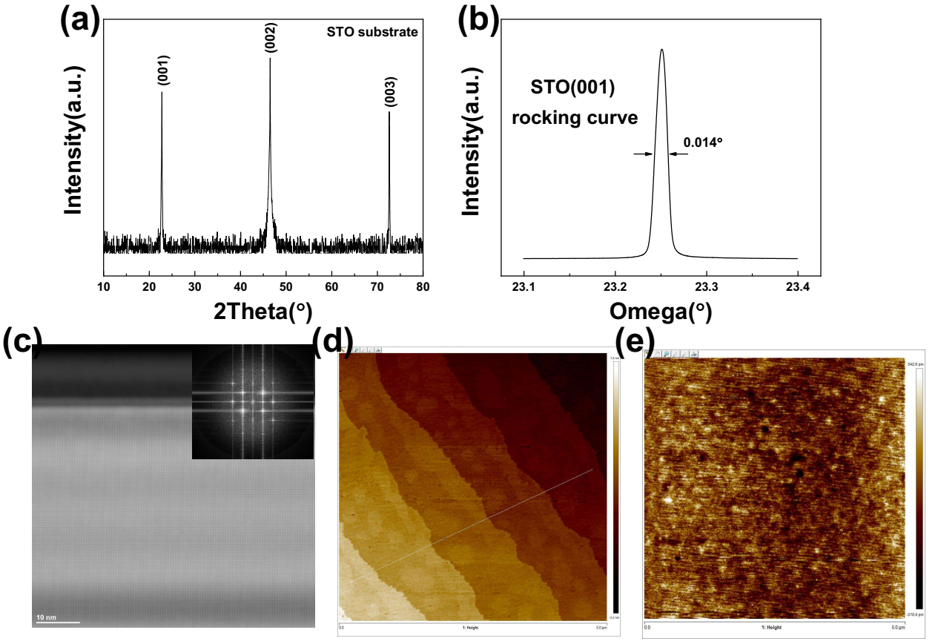
Fig. S1. Structural and morphological characterization during the Q-2DEG preparation process. (a) XRD characterization of the STO (001) substrate. (b) Rocking curve of the (002) peak of the STO (001) substrate. (c) Cross-sectional HAADF-STEM image of the sample fabricated under a bombardment power of 300 eV, with the inset showing the Fast Fourier Transform (FFT) result of the HAADF image. (d) Surface atomic step terrace formed on the STO (001) substrate after acid cleaning and annealing. (e) Surface morphology of the STO (001) substrate after Ar⁺ bombardment.
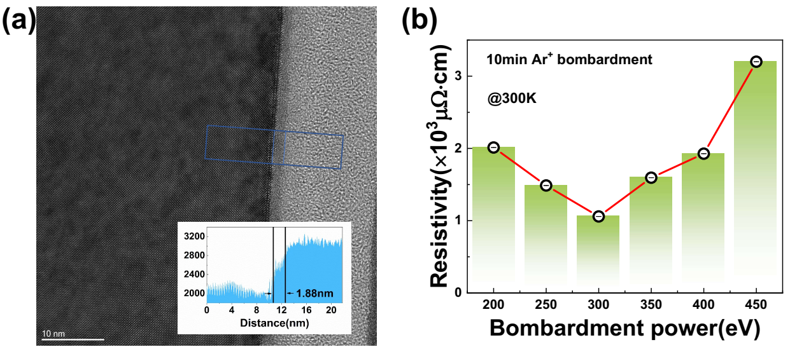
Fig. S2. Characterization of Thickness and Resistivity of Q-2DEG. (a) The HR-TEM of Q-2DEG fabricated under 250 eV bombardment power. The inset shows the profile of the blue box. (b) resistivity of samples prepared at different bombardment powers.
Note 2: Transport characterization of Q-2DEG
We characterized the transport properties of Q-2DEG using the van der Pauw measurement method. The sample was bonded to a chip carrier with silver paste to ensure small contact areas and peripheral positioning. The four contacts are labeled 1 to 4, respectively. The resistance R_{12,34} is defined as $R_{12,34}={V_{34}}/{I_{12}}$, where the current I₁₂ flows from contact 1 to 2, $V_{34}=V_{3}-V_{4}$ denotes the potential difference between contacts 3 and 4. R_{23,41} is defined analogously, and the resistivity is given by $ρ=\frac{πt}{ln2}\frac{(R_{12,34}+R_{23,41})}{2}F$, where t is the sample thickness, F is a function of the ratio $R_{r}=R_{12,34}/R_{23,41}$, satisfying $\frac{R_{r}-1}{R_{r}+1}=\frac{F}{ln2}arccosh\frac{e^{{ln2}/F}}{2}$. Using the van der Pauw technique, we measured the temperature-dependent resistivity of Q-2DEG samples. Figs. 2a and S3a present ρ–T for samples bombarded at 300 eV and 250 eV, with residual resistance ratios RRR = R(300 K)/R(2 K) of 558.5 and 1435.8, respectively. In both cases, the resistivity decreases with temperature and follows a power law $ρ∝T^{α}$ with α > 2, in full agreement with literature¹. Figure 2c presents the temperature dependence of the carrier concentration n for 300 eV Ar⁺ bombardment Q-2DEG. Upon cooling, n decreases slowly at first and then rises sharply to 3.8 × 10²¹ cm⁻³ at 50 K, consistent with literature across the entire temperature range. This tendency is likely due to the activation of extra conductive channels. As shown in Fig. S3b, the n–T curve for the 250 eV bombardment sample follows the same trend, but with a carrier concentration 2–3 times lower. We conducted high-field and low-temperature measurements on the 300 eV-bombarded sample. As depicted in Fig. 2d, distinct SdH oscillations were observed at temperatures below 1 K after subtracting the background magnetoresistance, which gradually faded as the temperature increased to 3.4 K.
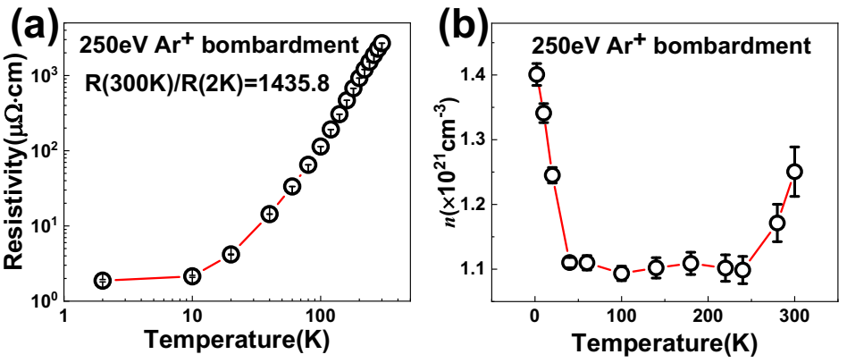
Fig. S3. Transport properties of Q-2DEG fabricated by 250 eV Ar⁺ bombardment. (a) Temperature-dependent resistance curve of Q-2DEG fabricated by 250 eV Ar⁺ bombardment. (b) Temperature-dependent carrier concentration curve of Q-2DEG fabricated by 250 eV Ar⁺ bombardment.
Note 3: The contact characteristics of 2DEG with metals
The conduction type of metal-oxide (metal-2DEG-metal structures) was investigated via IV measurements. For surface-conducting Q-2DEG, Pt, and Co electrodes all exhibit ohmic contacts (Fig. S4a). In contrast, for STO/LAO-formed 2DEG with a surface potential barrier (Fig. S4b), the Pt and Co electrodes exhibit symmetric Schottky contacts. These results indicate that the Ar⁺-bombarded Q-2DEG surface readily forms an ohmic contact with the adjacent metal layer, whereas “buried” 2DEG tends to form Schottky contacts².
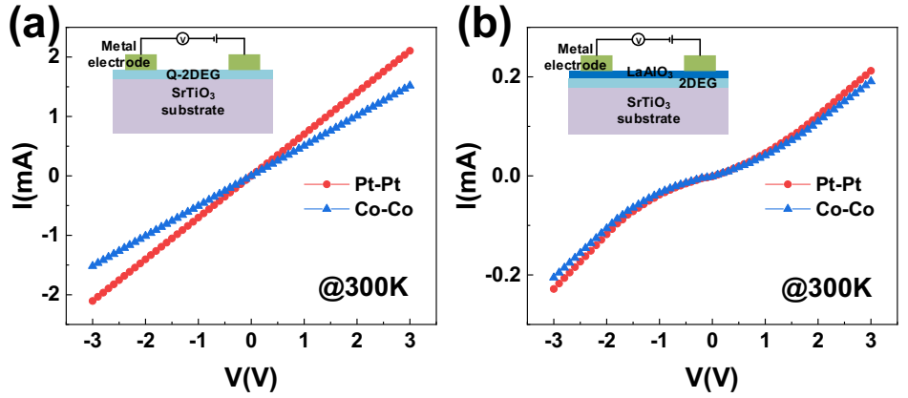
Fig. S4. The contact characteristics of 2DEG with metals. (a) IV characteristic curves of metal-Q-2DEG-metal structures, where the metallic electrodes are Co and Pt respectively. (b) IV characteristic curves of metal-STO/LAO-metal structures, where the metallic electrodes are Co and Pt respectively.
Note 4: Characterization of magnetoelectric transport properties of magnetic Q-2DEG/CoGd
Both Q-2DEG/CoGd and CoGd samples exhibit perpendicular magnetic anisotropy. Figure S5a presents temperature-dependent Hall measurements of the Q-2DEG/CoGd sample. As the temperature decreases, the coercivity first increases and then decreases, while the slope of the linear background gradually increases. The extracted temperature-dependent coercive fields H_{C} and anomalous Hall resistances ΔR_{H} are summarized in Figs. S5b and S5c, respectively. Both the coercive fields and anomalous Hall resistances diverge in the 40–60 K range, indicating that the sample’s compensation temperature lies within this range. Additionally, room-temperature anomalous Hall hysteresis chirality confirms that Co dominates the magnetic behavior of CoGd at room temperature.
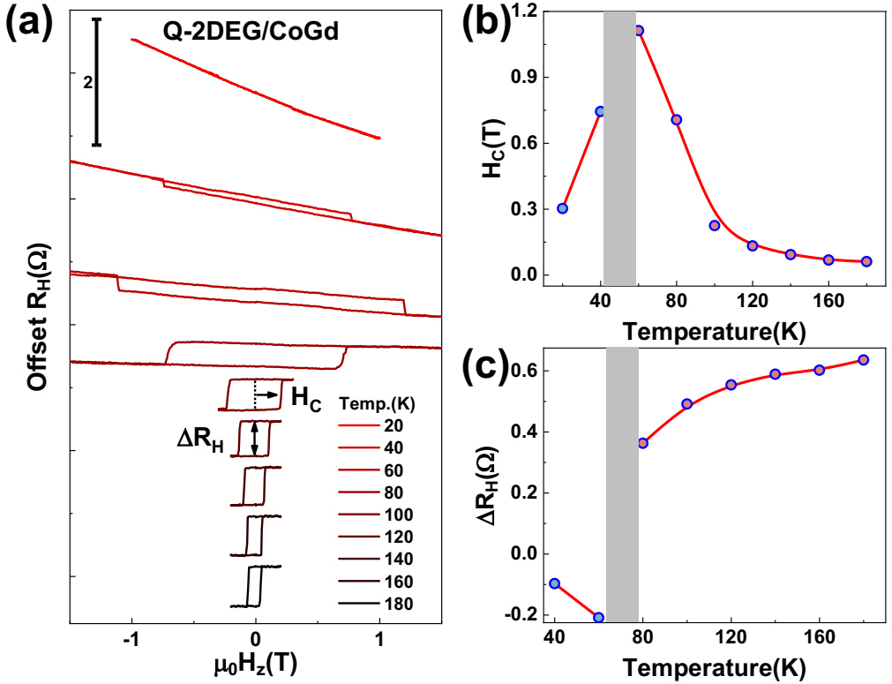
Fig. S5. Magnetic and transport characterizations of the perpendicular magnetized ferrimagnetic multilayer CoGd. (a) Temperature-dependent anomalous Hall hysteresis of the Q-2DEG/CoGd sample (b) Temperature-dependent coercive field of the Q-2DEG/CoGd samples. (c) Temperature-dependent anomalous Hall resistance ΔR_{H} of the Q-2DEG/CoGd sample.
Note 5: Critical current density with the parallel current model
The parallel current model was used to calculate the Q-2DEG current density, treating the spin source layer and the magnetic layer as two parallel resistors. For the 300 eV- bombarded sample, the resistivity of Q-2DEG is determined to 1057.79 μΩ·cm, while perpendicular magnetic anisotropy (PMA) multilayer Ti (2 nm)/CoGd (4 nm)/Cu (4 nm) had a resistivity of 32.16 μΩ·cm. The current density J_{c} by considering the parallel circuit model can be estimated as
$$\begin{aligned}J_{c}=I_{c}\frac{\frac{ρ_{PMA}}{t_{PMA}}}{\frac{ρ_{PMA}}{t_{PMA}}+\frac{ρ_{2DEG}}{t_{2DEG}}}×\frac{1}{w∙t_{2DEG}}\#\left(S1\right)\end{aligned}$$
where I_{c} represents the critical switching current, ρ_{PMA} and ρ_{2DEG} denote the resistivities of the PMA layer and the 2DEG layer, respectively; t_{PMA} and t_{2DEG} represent the thicknesses of the PMA layer and the 2DEG layer, respectively; and w stands for the Hall device width (20 μm).
Note 6: Current-induced magnetization switching of Q-2DEG(m)/CoGd samples
Figure S6 presents the current-induced magnetization switching in the miscut Q-2DEG(m)/CoGd samples. As shown in Fig. S6a, the magnitude of anomalous Hall resistance for both [010] and [100]-oriented samples is ~0.6 Ω. [010]-oriented devices exhibit stable field-free magnetization switching, with polarity consistent with that of a negative external magnetic field (Fig. S6b). Reversing the applied magnetic field μ₀H_{x} from 10 mT to -10 mT reverses the switching polarity. The extracted critical current density J_{c} and anomalous Hall resistance ΔR_{H} are summarized in Fig. S6c. With increasing the magnitude of the external magnetic field, the amplitude of J_{c} decreases, while the amplitude of ΔR_{H} increases. For comparison, [100]-oriented devices (Fig. S6d) do not exhibit field-free magnetization switching, and their field-assisted switching polarity matches that of [010] samples.
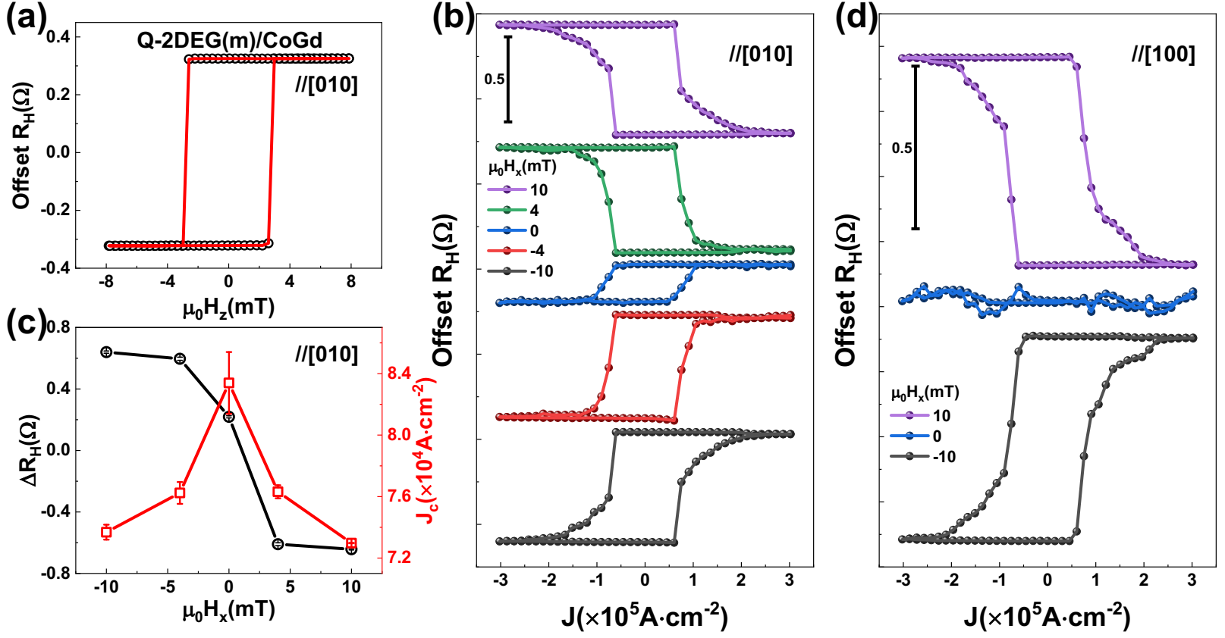
Fig. S6. Current-induced perpendicular magnetization switching of the Q-2DEG(m)/CoGd samples. (a) Anomalous Hall hysteresis of the device along the [010] direction of the Q-2DEG(m)/CoGd sample. (b) Current-induced magnetization switching in [010]-oriented Q-2DEG(m)/CoGd devices under different applied in-plane magnetic fields μ₀H_{x}. (c). Extracted dependence of anomalous Hall resistance ΔR_{H} and critical current density J_{c} on the in-plane magnetic field μ₀H_{x}. (d) Current-induced magnetization switching in [100]-oriented Q-2DEG(m)/CoGd devices under different applied in-plane magnetic fields μ₀H_{x}.
Note 7: Current-induced magnetization switching of Q-2DEG/CoGd samples
Figure S7 presents current-induced magnetization switching in non-miscut Q-2DEG/CoGd samples. As shown in Fig. S7a, [010]-oriented devices exhibit anomalous Hall resistance similar to that of the miscut samples, but with slightly larger H_{C}. Neither the [010] nor the [100]-oriented devices achieve field-free magnetization switching (Figs. S7b and S7d), though their field-assisted switching behavior is consistent with that of the miscut samples. It suggests that the presence of conventional spin polarization but without anomalous spin polarization in this system. Among them, the J_{c} of [010]-oriented non-beveled samples (Fig. S7c) are higher than that of the miscut samples, while their ΔR_{H} are similar.
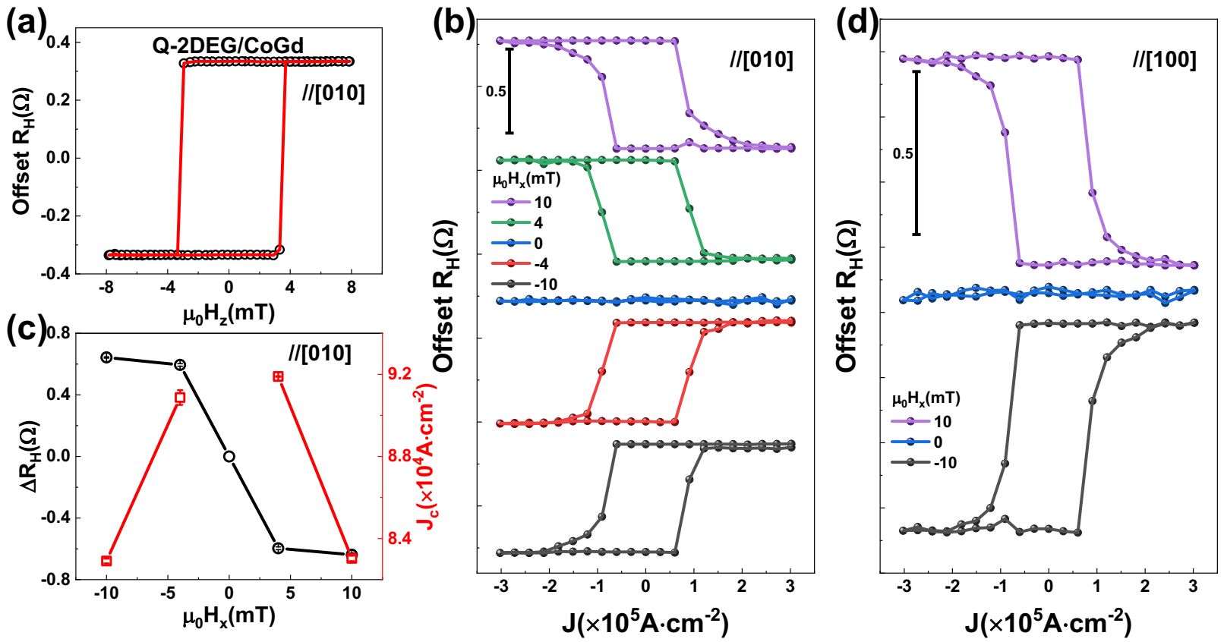
Fig. S7. Current-induced perpendicular magnetization switching of the Q-2DEG/CoGd samples. (a) Anomalous Hall hysteresis of the device along the [010] direction of the Q-2DEG/CoGd sample. (b) Current-induced magnetization switching in [010]-oriented Q-2DEG/CoGd devices under different applied in-plane magnetic fields μ₀H_{x}. (c). Extracted dependence of anomalous Hall resistance ΔR_{H} and critical current density J_{c} on the in-plane magnetic field μ₀H_{x}. (d) Current-induced magnetization switching in [100]-oriented Q-2DEG/CoGd devices under different applied in-plane magnetic fields μ₀H_{x}.
Note 8: Current-induced magnetization switching of STO/CoGd, STO/LAO/CoGd and STO/CoGd/Pt samples
In Fig. S8a, the STO/CoGd sample cannot achieve magnetization switching either under field-assisted or field-free conditions. In contrast, the miscut Q-2DEG(m)/CoGd sample exhibits deterministic magnetization switching regardless of the presence of external magnetic field, while the non-miscut Q-2DEG/CoGd samples only switch under field assistance. These results indicate that high charge-spin conversion efficiency of ion-bombarded Q-2DEG and symmetry breaking induced by miscutting. “Buried-type” 2DEG (STO/LAO/CoGd, Fig. S8b) cannot switch under any conditions, demonstrating that the oxide barrier weakens the injection of spin-polarized current. STO/CoGd/Pt samples (Fig. S8c) only switch with external magnetic field assistance, with polarity consistent with that induced by Q-2DEG, indicating negative conventional spin polarization generated by 2DEG. The absence of field-free magnetization switching in CoGd/Pt samples also confirms no CoGd component gradient to break symmetry.
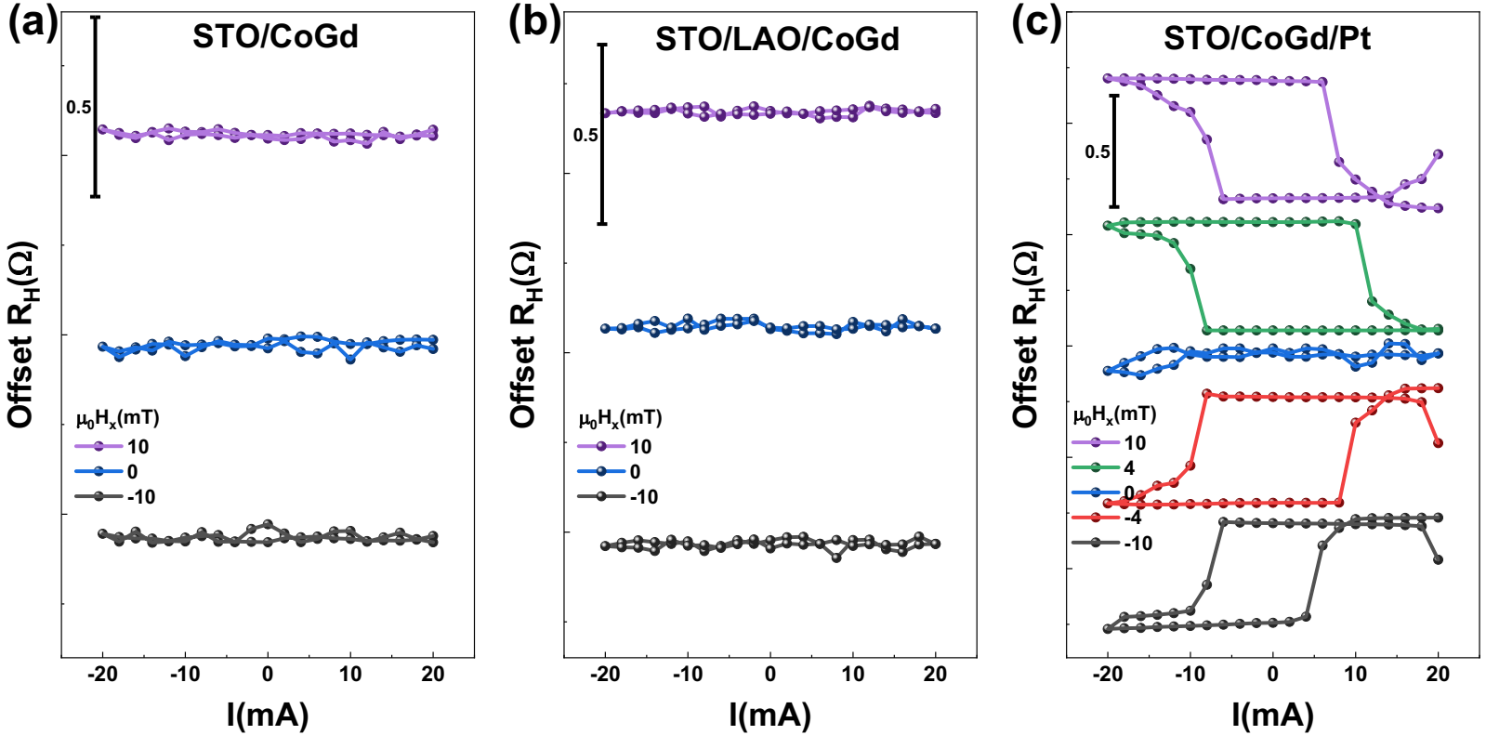
Fig. S8. Current-induced perpendicular magnetization switching of STO/CoGd STO/LAO/CoGd and STO/CoGd/Pt samples.
Note 9: SOT switching of Q-2DEG(m)/[Co/Ni]₅ reference samples
To confirm that the low critical switching current density originates from the high charge-spin conversion efficiency of Q-2DEG(m), we used a [Co/Ni]₅ (4.25 nm) perpendicular magnetic layer (thickness close to CoGd), with saturation magnetization (M_{S}) and uniaxial magnetic anisotropy field (H_{k}) 2–3 times to those of CoGd. For Q-2DEG(m)/[Co/Ni]₅, the anomalous Hall hysteresis loop is shown in Fig. S9a, and current-induced magnetization switching results in Fig. S9b. The critical current density for field-free switching is 1.32×10⁵A·cm⁻², which is slightly higher than that of CoGd but much lower than typical [Co/Ni]-based systems³.
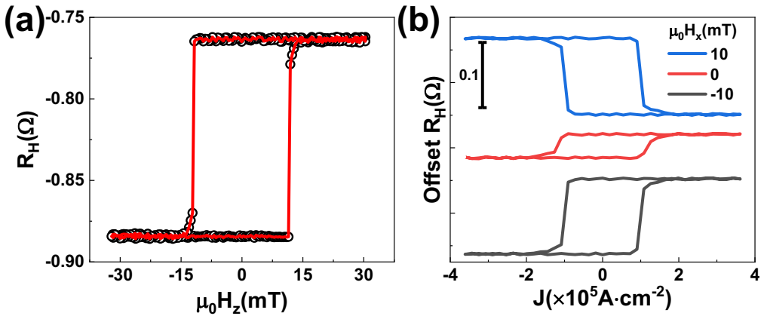
Fig. S9. Current-induced magnetization switching in Q-2DEG(m)/[Co/Ni]₅ samples with [Co/Ni]₅ as the magnetic layer.
Note 10: ST-FMR analysis
When an RF current (I_{RF}) is applied to the ST-FMR device, an RF spin current is generated in the Q-2DEG and subsequently injected into the adjacent NiFe layer. This produces oscillating SOTs acting on the magnetic moments of NiFe. Due to the anisotropic magnetoresistance (AMR) effect of NiFe, the torque-induced precession of the magnetic moments modulates the resistance of the NiFe-based bilayer. Upon application of an in-plane external magnetic field, the mixing of the RF current and oscillating resistance can be detected as a direct current (DC) voltage signal (V_{mix}) via a lock-in amplifier. The V_{mix} signal from ST-FMR measurements can be decomposed into symmetric and antisymmetric components, as described below:
$$\begin{aligned}V_{mix}=V_{S}F_{S}\left(H\right)+V_{A}F_{A}\left(H\right)\#\left(S2\right)\end{aligned}$$
$$\begin{aligned}F_{S}\left(H\right)=\frac{{∆H}^{2}}{{∆H}^{2}+{\left(H-H_{0}\right)}^{2}}\#\left(S3\right)\end{aligned}$$
$$\begin{aligned}F_{A}\left(H\right)=\frac{∆H\left(H-H_{0}\right)}{{∆H}^{2}+{\left(H-H_{0}\right)}^{2}}\#\left(S4\right)\end{aligned}$$
Here, F_{S} and F_{A} denote the symmetric and antisymmetric Lorentzian functions, respectively. The amplitudes of the symmetric (V_{S}) and antisymmetric (V_{A}) components are proportional to the current-induced in-plane and out-of-plane torques, respectively. H₀ represents the resonance magnetic field, ΔH is the resonance linewidth, and H corresponds to the external magnetic field magnitude. The ST-FMR measurement setup and device schematic are illustrated in Figs. 3a and 3b. Figure S10a shows a representative ST-FMR spectrum of the [010]-oriented sample measured at 10 GHz. Fitting to Eqs. S2–S4 allows extraction F_{S}, F_{A}, H₀, and ΔH. Figure S10b summarizes the ST-FMR spectra at varying frequencies in a contour plot, revealing that the magnetic field at the resonance peak increases nonlinearly with frequency. The Kittel formula, given by:
$$\begin{aligned}f=\frac{γ}{2π}\sqrt{H_{0}\left(H_{0}+4πM_{eff}\right)}\#\left(S5\right)\end{aligned}$$
can be employed to extract the gyromagnetic ratio γ and effective magnetization 4πM_{eff}. Additionally, the damping factor α and inhomogeneous linewidth broadening ΔH₀ can be extracted from the linewidth relation:
$$\begin{aligned}∆H=\left(\frac{2π}{γ}\right)αf+{ΔH}_{0}\#\left(S6\right)\end{aligned}$$
Figures S10c and S10d show the representative Kittel fitting (Eq. S5) and linewidth fitting (Eq. S6), respectively.
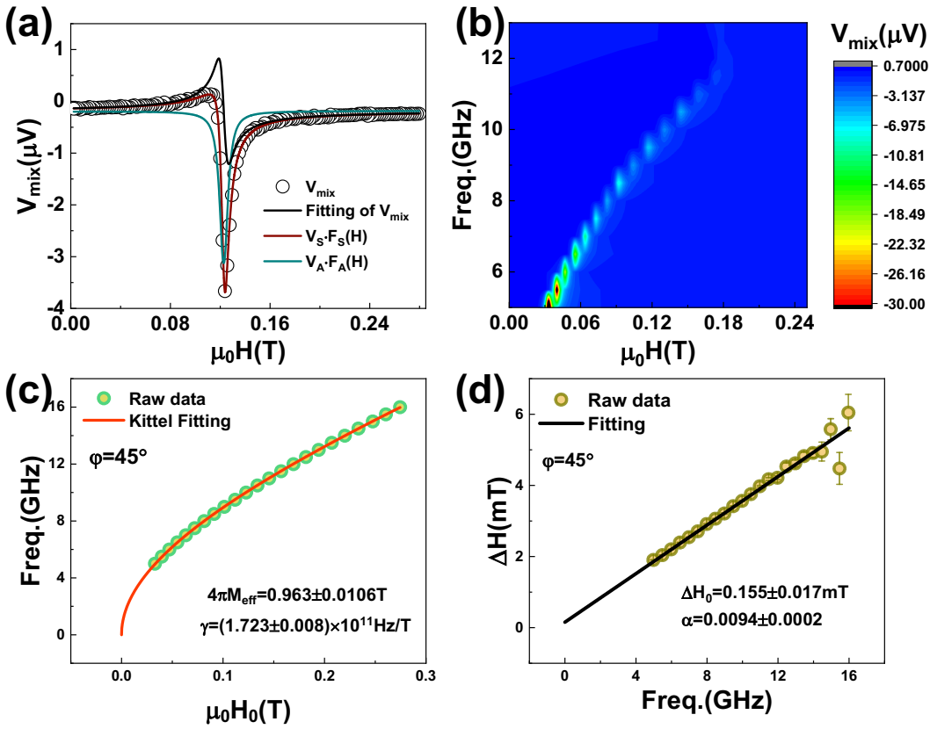
Fig. S10. Frequency-dependent ST-FMR spectra of [010]-oriented Q-2DEG(m)/NiFe devices. (a) Representative ST-FMR spectra from the frequency-dependent measurements, which can be fitted by the Lorentzian V_{S}·F_{S}(H) and anti-Lorentzian V_{A}·F_{A}(H) functions. (b) Contour plot of ST-FMR spectral dependence on magnetic field μ₀H and RF frequency. (c) Resonance frequency versus resonance magnetic field μ₀H₀, with the fitted curves from the Kittel formula. (d) Frequency dependence of resonance linewidth ΔH and its linear fitting curves.
Angle-dependent ST-FMR measurements allow us to determine the charge-spin conversion efficiency $ξ_{DL}^{i=x,y,z}$. The SOTs consist of symmetric and antisymmetric components, corresponding to damping-like and field-like torques, respectively. The symmetric components arise from: the damping-like torque M × (M × y) induced by y-polarized spins (σ_{y}); the damping-like torque M × (M × x) induced by x-polarized spins (σ_{x}); and the field-like torque z × M induced by z-polarized spins (σ_{z}). The antisymmetric components arise from: the field-like torque y × M induced by y-polarized spins (σ_{y}); the field-like torque x × M induced by x-polarized spins (σ_{x}); and the damping-like torque M × (M × z) induced by z-polarized spins (σ_{z}). These torques contribute to the symmetric (V_{S}) and antisymmetric (V_{A}) coefficients with distinct angle dependencies, which can be expressed as follows:
$$\begin{aligned}V_{S}=S_{DL}^{y}\cos\left(φ\right)\sin\left(2φ\right)+S_{DL}^{x}\sin\left(φ\right)\sin\left(2φ\right)+S_{FL}^{z}sin\left(2φ\right)\#\left(S7\right)\end{aligned}$$
$$\begin{aligned}V_{A}=A_{FL}^{y}\cos\left(φ\right)\sin\left(2φ\right)+A_{FL}^{x}\sin\left(φ\right)\sin\left(2φ\right)+A_{DL}^{z}sin\left(2φ\right)\#\left(S8\right)\end{aligned}$$
Here, $S_{DL}^{y}$ and $S_{DL}^{x}$ denote the symmetric coefficients associated with the damping-like SOT driven by σ_{y} and σ_{x}, respectively, while $S_{FL}^{z}$ represents the symmetric coefficient for field-like SOT driven by σ_{z}. Conversely, $A_{FL}^{y}$ and $A_{FL}^{x}$ are the antisymmetric coefficients for the field-like SOT driven by σ_{y} and σ_{x}, respectively, and $A_{DL}^{z}$ corresponds to the antisymmetric coefficient for damping-like SOT driven by σ_{z}.
Fitting Eqs. S7–S8 yields the damping-like and field-like torque induced by the conventional spin polarization σ_{y}, and the anomalous spin polarization σ_{z}. The charge-spin conversion efficiency $ξ_{DL}^{i=x,y,z}$ can then be determined via:
$$\begin{aligned}ξ_{DL}^{y}=\frac{S_{DL}^{y}}{A_{FL}^{y}}\frac{eμ_{0}M_{S}t_{HM}t_{FM}}{ℏ}\sqrt{1+\frac{M_{eff}}{H_{0}}}\#\left(S9\right)\end{aligned}$$
$$\begin{aligned}ξ_{DL}^{x}=\frac{S_{DL}^{x}}{A_{FL}^{y}}\frac{eμ_{0}M_{S}t_{HM}t_{FM}}{ℏ}\sqrt{1+\frac{M_{eff}}{H_{0}}}\#\left(S10\right)\end{aligned}$$
$$\begin{aligned}ξ_{DL}^{z}=\frac{A_{DL}^{z}}{A_{FL}^{y}}\frac{eμ_{0}M_{S}t_{HM}t_{FM}}{ℏ}\#\left(S11\right)\end{aligned}$$
Here, e, μ₀, ħ, M_{S}, t_{HM}, t_{FM}, and M_{eff} represent the elementary charge, the vacuum permeability, the reduced Planck constant, the saturation magnetization of the ferromagnetic layer, the thicknesses of the heavy metal and the ferromagnetic layer, and the effective magnetization, respectively. Figure S11a shows representative ST‑FMR spectra measured at different azimuthal angles φ for a device stripe aligned along the [010] direction. At ϕ = 0°, 90°, 180°, 270°, the resonance signals are weak due to the AMR readout term proportional to sin(2ϕ) and the symmetry suppression of the excitation torque. The full set of angle‑dependent data is summarized in the contour plot (Fig. S11b), where two maxima and two minima emerge successively as ϕ varies from 0° to 360°. The angle-dependent symmetric and asymmetric components are extracted using Eqs. S2–S4. Subsequently, the damping-like and field-like coefficients are derived by fitting to Eqs. S7–S8 (Figs. S11c and S11d). Notably, the damping-like antisymmetric coefficient $A_{DL}^{z}$ contributed by σ_{z} is pronounced, indicating the presence of symmetry breaking in the [010]‑oriented device.
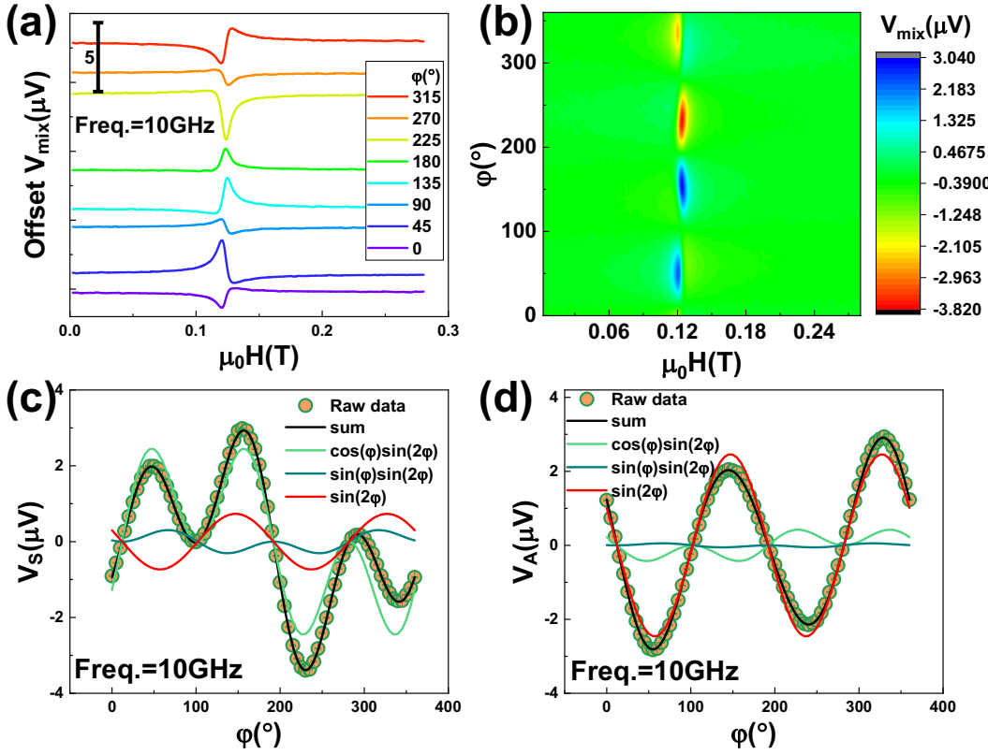
Fig. S11. Angle-dependent ST-FMR spectra of [010]-oriented Q-2DEG(m)/NiFe devices. (a) Representative ST-FMR spectra from the angle-dependent measurements. (b) Contour plot of ST-FMR spectral dependence on magnetic field μ₀H and azimuthal angle ϕ of magnetic field. (c) and (d) Azimuthal angle φ dependent symmetric V_{S} and antisymmetric V_{A} components of the ST-FMR spectra.
Figure S12 presents the ST-FMR results for devices oriented along the [100] direction. Figure S12a shows a contour plot of the frequency-dependent ST-FMR response, with the corresponding Kittel and linewidth fits displayed in Figs. S12b and S12c, respectively. Figure S12d depicts a contour plot of the angle-dependent ST-FMR spectrum, with the fits to the angle-dependent symmetric and asymmetric components are shown in Figs. S12e and S12f, respectively. Notably, the damping-like antisymmetric coefficient $A_{DL}^{z}$ contributed by σ_{z} is negligible, indicating the symmetry protection of this system.
Additionally, we characterized the charge-spin conversion efficiency of non-miscut Q-2DEG/NiFe samples along both the [010] and [100] directions. All charge-spin conversion efficiencies deduced from the aforementioned ST-FMR measurements are summarized in Table S2. All devices exhibit a large conventional charge-spin conversion efficiency, ranging from 0.21 to 0.44. The [010]-oriented device of miscut sample exhibits the highest anomalous charge-spin conversion efficiency of 0.087, whereas that of the [100]-oriented devices are nearly zero. Notably, only [010]-oriented Q-2DEG(m)/NiFe devices yield an anomalous spin polarization angle ($θ=arcsin⁡({ξ_{DL}^{Z}}/{\sqrt{{(ξ_{DL}^{Z})}^{2}+{(ξ_{DL}^{y})}^{2}}})$) exceeding 5°, with a measured value of 14.57°. The non-miscut samples also show a finite anomalous charge-spin conversion efficiency of approximately 0.012–0.015, which may be associated with the spin swapping effect in this system⁴.
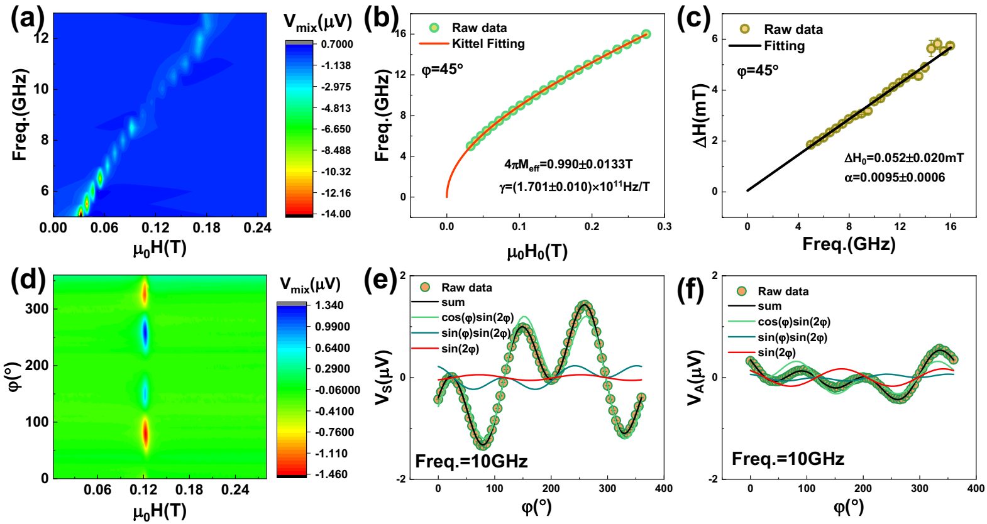
Fig. S12. ST-FMR spectra of [100]-oriented Q-2DEG(m)/NiFe devices. (a) Contour plot of ST-FMR spectral dependence on magnetic field μ₀H and RF frequency. (b) Resonance frequency versus resonance magnetic field μ₀H₀, with the fitted curves from the Kittel formula. (c) Frequency dependence of resonance linewidth ΔH and its linear fitting curves. (d) Contour plot of ST-FMR spectral dependence on magnetic field μ₀H and azimuthal angle ϕ of magnetic field. (e) and (f) Azimuthal angle φ dependent symmetric V_{S} and antisymmetric V_{A} components of the ST-FMR spectra.
Note 11: Charge-spin conversion efficiency determined by harmonic measurement
Although the ST-FMR yielded a relatively high conventional charge-spin conversion efficiency for our SrTiO₃ based Q-2DEG, the Q-2DEG/CoGd heterostructure may possess an interfacial barrier different from that of the Q-2DEG/NiFe. Meanwhile, previous literature⁵ have suggested that the high dielectric constant of SrTiO₃ may induce artifacts in the extracted charge-spin conversion efficiency. To further verify the result, we independently determined the conventional charge-spin conversion efficiency of the perpendicularly magnetized Q-2DEG/CoGd sample using low-frequency second-harmonic Hall measurements. A low-frequency alternating current (1327 Hz) was applied along the x direction through the current channel of the Hall device. An in-plane magnetic field was applied along x direction and swept while simultaneously recording the first harmonic Hall voltage (V_{ω}) and the second harmonic Hall voltage (V_{2ω}) (Fig. S13a). The effective damping-like field was extracted using⁶ $H_{DL}=-2(∂V_{2ω}/H_{x})/(∂^{2}V_{ω}/∂H_{x}^{2})$(Fig. S13b). The charge-spin conversion efficiency (spin Hall angle) was then determined from⁷ $ξ_{DL}=\frac{∂H_{DL}/∂J_{x}γeM_{s}t_{FM}}{μ_{B}}$, where γ is the gyromagnetic ratio, M_{S} is the saturation magnetization, μ_{B} is the Bohr magneton and t_{FM} is the ferromagnetic layer thickness. The calculated charge-spin efficiency is ξ_{DL} = 0.560 ± 0.018, which exceeds the range of 0.21–0.44 obtained from ST-FMR measurements.
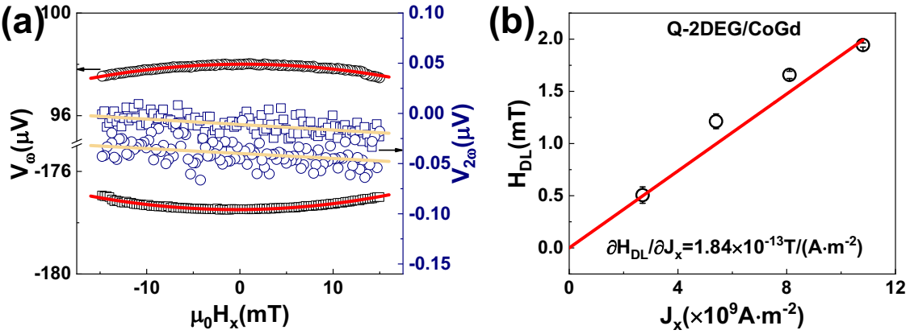
Fig. S13. Harmonic measurement of the perpendicular magnetized Q-2DEG/CoGd. (a) The μ₀H_{x} dependence of the first and second harmonic Hall voltage. (b) The current density dependence of the damping-like effective field.
Note 12: Micromagnetic simulation of current-induced magnetization switching
We employed the open-source micromagnetic simulation software mumax3⁸ to investigate the current-induced magnetization switching based on miscut Q-2DEG(m) and non-miscut Q-2DEG samples. The magnetization was first relaxed to its zero‑field, zero‑current ground state. A current pulse of 5 ns duration was then applied, and the magnetization was subsequently recorded after pulse termination. The current-induced magnetization switching was simulated by sweeping the current density from 0 to 1 × 10⁸ A·cm⁻², backwards to -1 × 10⁸ A·cm⁻², and finally returning to 1 × 10⁸ A·cm⁻². Simulations were performed using a six-terminal Hall device geometry with a 50-nm-wide main channel (Fig. S14a). The magnetic layer consisted of a 0.9-nm CoFeB film. Spin injection from the spin‑source layer was modeled using the Slonczewski formalism for spin polarization We adopted the vector charge-spin conversion efficiencies of Q-2DEG(m) and Q-2DEG along the [010] and [100] directions, as obtained from the aforementioned ST-FMR measurements. The electrical current polarization (Pol) was quantified by the modulus of the vector charge-spin conversion efficiency ($\sqrt{{(ξ_{DL}^{Z})}^{2}+{(ξ_{DL}^{y})}^{2}}$), while the spin polarization direction of the fixed layer was defined by the measured vector orientation of conversion efficiency. Key micromagnetic simulation parameters^{9,10} are listed in Table S3.
The simulated current-induced magnetization switching induced by Q-2DEG(m) and Q-2DEG as spin sources are presented in Fig. S14b. Deterministic field-free magnetization switching is only achieved in Q-2DEG(m)-based devices along the [010] direction. While Q-2DEG devices along the [100] direction exhibit the largest conventional spin polarization, they possess the smallest anomalous spin polarization angle and fail to enable field-free magnetization switching. With an increasing anomalous spin polarization angle, the magnetic moment difference ΔM_{z}(J = 0) at zero current gradually increases, indicating a positive correlation between the field-free switching amplitude and the anomalous spin polarization angle.
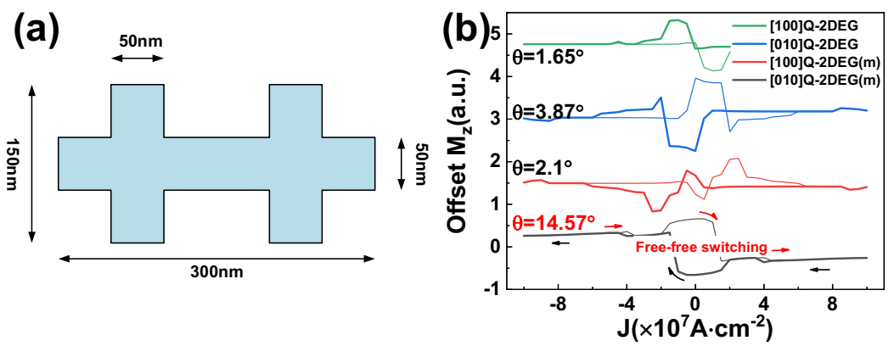
Fig. S14. Micromagnetic simulation of current-induced magnetization switching. (a) Shape and size of the model used in micromagnetic simulation. (b) Current-induced magnetization switching simulated from the spin polarization data of Q-2DEG(m) and Q-2DEG samples along the [010] and [100] directions.
Note 13: SOT switching of Q-2DEG(m)/CoGd samples with different bombardment powers and different miscut angles
We sought to tune the conductivity, Rashba spin-orbit coupling, and symmetry of Q-2DEG(m) by varying the Ar⁺ bombardment power and substrate miscut angle, with the goal of controlling the power consumption of Q-2DEG(m)/CoGd.
Figure S15 illustrates current-induced magnetization switching in Q-2DEG(m)/CoGd samples prepared at different bombardment powers, with the substrate miscut angle fixed at 0.3°. While the bombardment power has little effect on the critical current density, the corresponding variation in resistivity (Fig. S2b) leads to a similar trend in power consumption (Fig. 4a). Figure S16 presents current-induced magnetization switching in Q-2DEG(m)/CoGd samples prepared with different substrate miscut angles, under a fixed Ar⁺ bombardment power of 300 eV. An increased miscut enhances the symmetry breaking, and the switching amplitude first rises, then gradually decreases and eventually saturates.
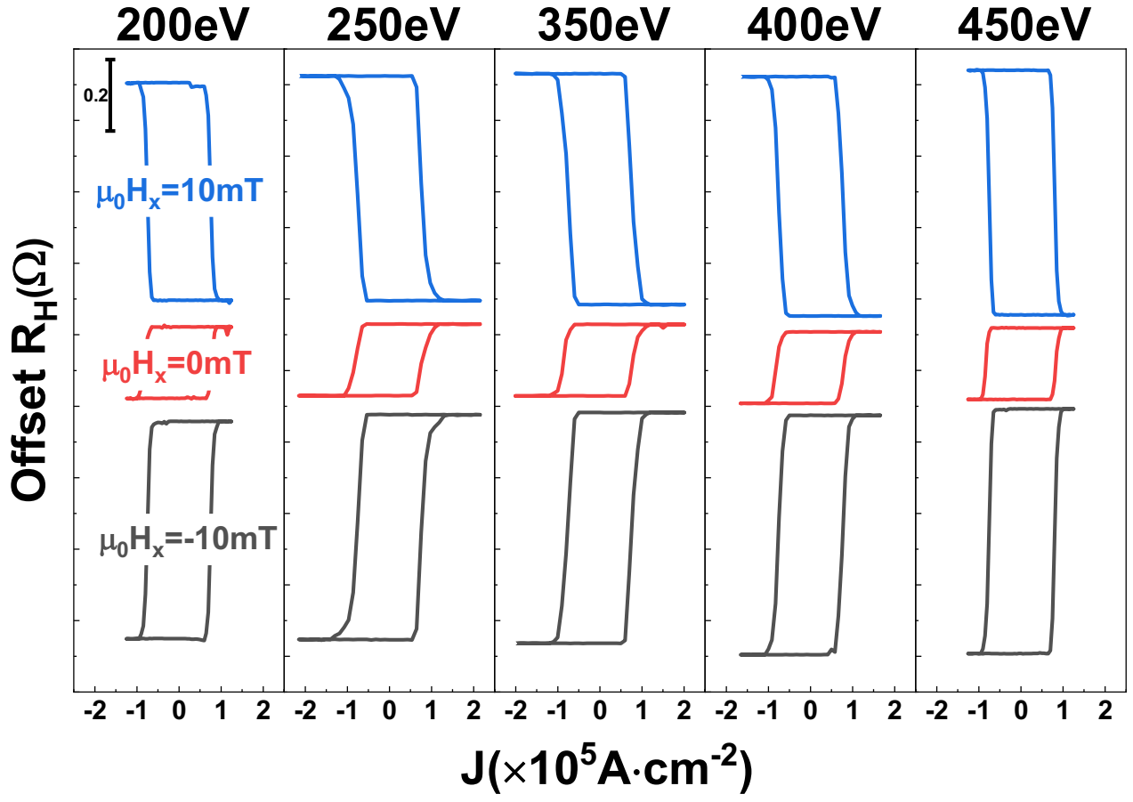
Fig. S15. Current-induced magnetization switching in Q-2DEG(m)/CoGd samples with different bombardment powers.
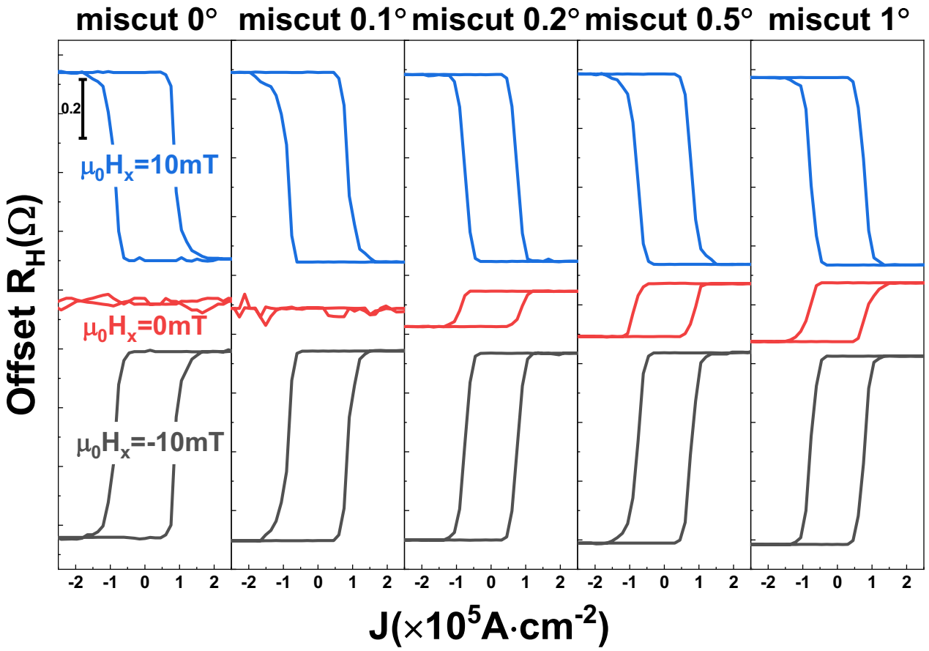
Fig. S16. Current-induced magnetization switching in Q-2DEG(m)/CoGd samples with different miscut angles.
Note 14: Data description for the comparison plot of $ξ_{DL}^{Z}$ and $ξ_{DL}^{y}$
Figure 4c summarizes the conventional and anomalous charge-spin conversion efficiencies across a range of material systems, including the Weyl semimetals TaIrTe₄, WTe₂, and MoTe₂, the noncollinear antiferromagnet Mn₃GaN, and the altermagnet RuO₂. The corresponding raw data for Fig. 4c are listed in Table S4.
Note 15: Data description for the comparison plot of power dissipation density and critical current density
Figure 4d presents a comparative summary of the power dissipation density and critical current density for field-free switching of perpendicular magnetization induced by conventional heavy metals (HMs), emerging symmetry-broken semimetals, oxides, topological insulators (TIs), and the Q-2DEG investigated in this work. TIs achieve the field-free magnetization switching of perpendicular magnetization by simultaneously utilizing both the spin transfer torque (STT) effect and the SOT effect. The power dissipation density for TIs accounts for contributions from both the STT effect (with a junction diameter of 800 nm, a thickness of 1.6 nm for the MgO tunneling layer, and a junction resistance of 2100 Ω) and the SOT effect. All parameters employed in these calculations are summarized in Table S5.
Note 16: Theoretical modeling of miscut-induced spin polarization
To elucidate the microscopic origin of the out-of-plane spin polarization observed in the vicinal SrTiO₃(001) 2DEG, we construct a minimal effective Hamiltonian grounded in symmetry analysis. For an ideal (001) interface, the system exhibits $C_{4v}$ point group symmetry, which hosts the Rashba spin-orbit coupling (SOC) with the standard form $H_{0}=α_{R}({k_{y}σ_{x}-k}_{x}σ_{y})$, confining the effective magnetic field and the resulting spin texture at the interface. In this high-symmetry limit, any out-of-plane spin accumulation is strictly forbidden. However, the introduction of a miscut angle $θ$ along the [100] direction breaks this symmetry by geometrically tilting the macroscopic confining potential. We model this effect by rotating the effective surface normal vector $\hat{n}$ around the [010] axis, resulting in a tilted normal $\hat{n}'=(sinθ, 0, cosθ)$. Substituting this tilted vector into the general Rashba expression $H_{R}=α_{R}σ∙(k×{\hat{n}}^{'})$, we derive a symmetry-breaking term $H_{miscut}≈-α_{R}{θk}_{y}σ_{z}$ valid in the small-angle approximation. This term explicitly couples the in-plane momentum component parallel to the step edges ($k_{y}$) with the out-of-plane spin operator ($σ_{z}$), providing the fundamental mechanism for the generation of $s_{z}$ that is otherwise forbidden in highly symmetric system.
Numerical simulations based on this effective Hamiltonian and the semiclassical Boltzmann transport theory further confirm the validity of this mechanism. The spin response tensor is directly calculated via
$$\begin{aligned}s_{i}∝\sum_{k,n}{δ\left(E_{k,n}-E_{F}\right)\left(v_{k,n}∙{\hat{n}}_{E}\right){\left\langle σ_{i}\right\rangle }_{k,n}}\#\text{(S12)}\end{aligned}$$
where ${\hat{n}}_{E}=(cosψ,sinψ,0)$ is the unit vector defining the direction of the applied electric field, and ${\left\langle σ_{i}\right\rangle }_{k,n}$ is the spin expectation value of a state with wave vector k in the n-th band at the Fermi energy $E_{F}$. For the ideal surface without miscut ($θ=0°$), the out-of-plane spin accumulation $s_{z}$ vanishes for all electric field directions, consistent with the $C_{4v}$ symmetry analysis (see main text). Upon introducing a finite miscut, a distinct sinusoidal oscillation of $s_{z}$ emerges with respect to the electric field angle $ψ$, as shown in Fig. S17. The simulation results demonstrate that the magnitude of the induced $s_{z}$ scales linearly with the miscut angle $θ$ within the perturbative regime. It is important to note that this linear scaling represents an idealized behavior valid for small miscut angles. In realistic experimental scenarios, larger miscut angles may induce complex surface reconstructions or enhanced scattering that is beyond this perturbative regime. Nevertheless, for the small vicinal angles investigated in this work, the geometric tilt model provides a robust and sufficient explanation for the observed out-of-plane spin polarization.
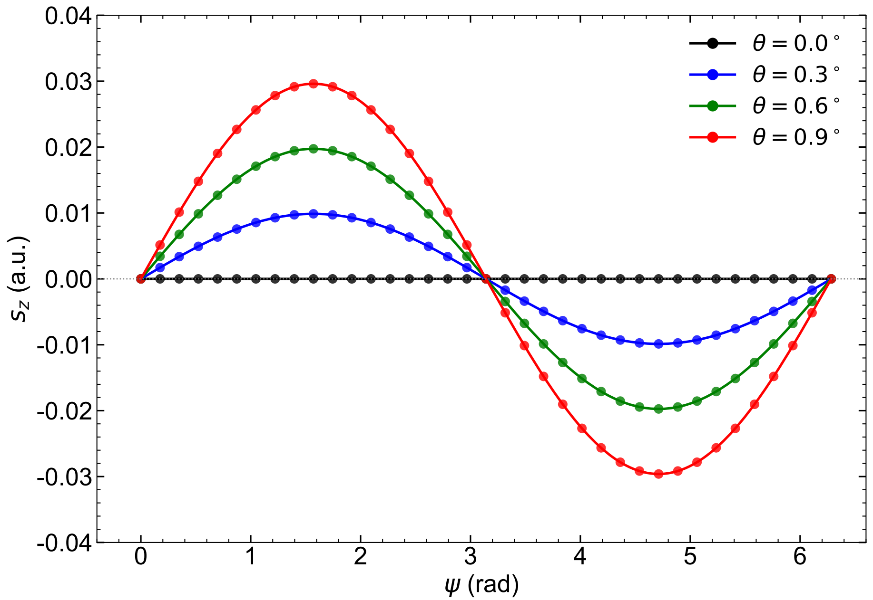
Fig. S17. Calculated angular dependence of the out-of-plane spin accumulation. The out-of-plane spin component $s_{z}$ is plotted as a function of the in-plane electric field angle $ψ$ for various vicinal miscut angles $θ$. The black line ($θ=0°$) corresponds to the ideal (001) surface without miscut. Solid dots represent the numerical data points derived from the semiclassical Boltzmann transport theory using the effective Hamiltonian, while the solid lines are sinusoidal fits.

Table S1 Summary of the abbreviations, stacking structures, fabricated devices and their functional characteristics for all samples in this work
No. | Samples | Devices | Functions | Description
1 | Q-2DEG (m)/CoGd | [010] & [100] Hall | SOT switching | Q-2DEG(m) (2.1)/Ti (2)/CoGd (4)/Cu (4), m = 0.3°, and bombardment power is 300 eV.
2 | Q-2DEG/CoGd | [010] & [100] Hall | SOT switching | Q-2DEG (2.1)/Ti (2)/CoGd (4)/Cu (4)
3 | Q-2DEG(m)/NiFe | [010] & [100] GSG | ST-FMR | Q-2DEG(m) (2.1)/NiFe (8)/MgO (1.5)/Ta (2), and m = 0.3°
4 | Q-2DEG/NiFe | [010] & [100] GSG | ST-FMR | Q-2DEG (2.1)/NiFe (8)/MgO (1.5)/Ta (2)
5 | STO/CoGd | Hall | SOT switching & Electric transport | SrTiO₃ sub./Ti (2)/CoGd (4)/Cu (4)
6 | STO/CoGd/Pt | Hall | SOT switching | SrTiO₃ sub./Ti (2)/CoGd (4)/Pt (4)
7 | CoGd | Hall | Electric transport | SiO₂ sub./Ti (2)/CoGd (4)/Pt (4)
8 | STO/LAO/CoGd | Hall | SOT switching | SrTiO₃/LaAlO₃/Ti (2)/CoGd (4)/Cu (4)
9 | STO/LAO/m (m is Co or Pt) | Two-terminal | IV curve | SrTiO₃/LaAlO₃/m (10), (m is Co or Pt)
10 | Q-2DEG/m (m is Co or Pt) | Two-terminal | IV curve | Q-2DEG (2.1)/m (10), (m is Co or Pt)
11 | Pt/NiFe | GSG | ST-FMR | SiO₂ sub./NiFe (8)/MgO (1.5)/Ta (2)
12 | Q-2DEG (m)/CoGd | [010] Hall | SOT switching | Q-2DEG(m) (2.1)/Ti (2)/CoGd (4)/Cu (4), m = 0.3°, the bombardment power is 200 eV, 250 eV, 350 eV, 400 eV and 450 eV.
13 | Q-2DEG (m)/CoGd | [010] Hall | SOT switching | Q-2DEG(m) (2.1)/Ti (2)/CoGd (4)/Cu (4), m = 0.1°, 0.2°, 0.5°, 1°, and bombardment power is 300 eV.

Table S2 Anisotropic charge-spin conversion efficiency of Q-2DEG(m)/NiFe and Q-2DEG/NiFe.
Samples | Device orientation | $$ξ_{DL}^{y}$$ | $$ξ_{DL}^{z}$$ | θ
Q-2DEG(m)/NiFe | [010] | -0.3332±0.0056 | -0.0866±0.0015 | 14.57°
Q-2DEG(m)/NiFe | [100] | -0.2185±0.0031 | 0.0080±0.0001 | 2.10°
Q-2DEG/NiFe | [010] | -0.2261±0.0087 | 0.0153±0.0008 | 3.87°
Q-2DEG/NiFe | [100] | -0.4413±0.0372 | -0.0127±0.0015 | 1.65°

Table S3 Key parameters in micromagnetic simulation.
Parameters | value
Saturation magnetization (M_{sat}) | 1.2×10⁶ A/m
Perpendicular magnetic anisotropy (Ku₁) | 9×10⁵ J/m³
Interfacial Dzyaloshinskii-Moriya strength (D_{ind}) | 5×10⁻⁴ J/m³
Exchange stiffness (A_{ex}) | 2×10⁻¹¹ J/m³
Damping constant | 0.02
Spin polarization
for Q-2DEG(m) [010] | sqrt((-0.3332)²+(-0.0866)²)
for Q-2DEG(m) [100] | sqrt((-0.2185)²+(0.0080)²)
for Q-2DEG [010] | sqrt((-0.2261)²+(0.0153)²)
for Q-2DEG [100] | sqrt((-0.4413)²+(-0.0127)²)
Fixed layer polarization vector
for Q-2DEG(m) [010] | (0, -0.3332, -0.0866)
for Q-2DEG(m) [100] | (0, -0.2185, 0.0080)
for Q-2DEG [010] | (0, -0.2261, 0.0153)
for Q-2DEG [100] | (0, -0.4413, -0.0127)

Table S4. Summary of conventional charge-spin conversion efficiency ($ξ_{DL}^{y}$) and anomalous charge-spin conversion efficiency ($ξ_{DL}^{z}$).
System | $$ξ_{DL}^{y}$$ | $$ξ_{DL}^{z}$$ | Refs.
TaIrTe₄ (a-axis) 120 nm | 0.08 | 0.11 | ¹¹
TaIrTe₄ (a-axis) | 0.05 | 0.05 | ¹²
TaIrTe₄ (a-axis) 40 nm | 0.062 | 0.014 | ¹³
TaIrTe₄ (a-axis) 30 nm | 0.119 | 0.027 | ¹³
TaIrTe₄ (a-axis) 25 nm | 0.113 | 0.043 | ¹³
TaIrTe₄ (a-axis) 20 nm | 0.160 | 0.046 | ¹³
WTe₂ | 0.029 | 0.013 | ¹⁴
WTe₂ (a-axis) 5 nm | 0.011 | 0.029 | ¹²
WTe₂ (a-axis) 10 nm | 0.012 | 0.02 | ¹²
MoTe₂ | 0.032 | 0.006 | ¹⁵
PtTe/WTe₂ | 0.15 | 0.034 | ¹⁶
Mn₃GaN | 0.025 | 0.019 | ¹⁷
RuO₂(101) | 0.052 | 0.010 | ¹⁸
RuO₂(101) | 0.048 | 0.008 | ¹⁸
RuO₂(101) | 0.044 | 0.007 | ¹⁸
RuO₂(101) | 0.041 | 0.006 | ¹⁸
Q-2DEG(m)([010]) | 0.3332 | 0.0866 | Our work
Q-2DEG(m)([100]) | 0.2185 | 0.008 | Our work

Table S5. Summary of critical current density (J_{c}), resistivity (ρ) and power consumption (J_{c}²·ρ).
System | J_{c} | ρ | J_{c}²·ρ | Refs.
System | A/cm² | μΩ·cm | W/m³ | Refs.
NiO/Pt | 3E7 | 10.6 | 9.54E15 | ¹⁹
NiO/Pt | 6E7 | 10.6 | 3.82E16 | ¹⁹
Pt | 2.5E7 | 10.6 | 6.63E15 | ²⁰
Pt | 2.4E7 | 10.6 | 6.11E15 | ⁹
Pt/W | 1.3E7 | 10.6 | 1.79E15 | ²¹
CuPt | 2.4E7 | 120 | 6.91E16 | ^{22,23}
PtMn | 5.28E6 | 145 | 4.04E15 | ^{24,25}
Ta | 5E6 | 50 | 1.25E15 | ²⁶
Ta | 2.5E6 | 50 | 3.13E14 | ²⁶
Ta | 7.03E6 | 50 | 2.47E15 | ^{27,28}
W | 3.06 | 238 | 2.22E17 | ^{10,29}
MnPb₃ | 1.1E7 | 60 | 7.26E15 | ³⁰
MnPb₃ | 2.47E7 | 95 | 5.8E16 | ³⁰
Mn₃Sn | 4.6E6 | 367.5 | 7.78E15 | ³¹
WTe₂@200K | 2.5E6 | 600 | 3.75E15 | ³²
WTe₂@140K | 9.8E6 | 470 | 4.51E16 | ³²
WTe₂ | 2.23E6 | 780 | 3.88E15 | ³³
TaIrTe₄ | 2.35E6 | 203.67 | 1.12E15 | ¹²
TaIrTe₄ | 7.65E6 | 209.73 | 1.23E16 | ¹²
SrRuO₃@70K | 8E6 |  | 5.77E15 | ³⁴
SrIrO₃@40K | 2.7E6 | 3.37E6 | 2.46E19 | ^{35,36}
SrTiO₃@130K | 6E6 | 1057.79 | 3.81E16 | ³⁷
(BiSb)₂Te₃ | 1.19E5 (SOT)  2E3(STT) | 4680(SOT)  6.6E7(junction) | 3.30E14 | ³⁸
(BiSb)₂Te₃ | 9.22E4 (SOT)  4.4E4(STT) | 4680(SOT)  6.6E7(junction) | 1.28E17 | ³⁸
Q-2DEG | 8.06E4 | 1057.79 | 6.87E12 | Our work
Q-2DEG | 8.24E4 | 1594.51 | 1.08E13 | Our work
Q-2DEG | 8.08E4 | 1926.87 | 1.26E13 | Our work
Q-2DEG | 8.32E4 | 3199.81 | 2.21E13 | Our work

References
1. Reagor, D. W. & Butko, V. Y. Highly conductive nanolayers on strontium titanate produced by preferential ion-beam etching. Nat. Mater. 4, 593–596 (2005).
2. Wu, S. et al. Nonvolatile Resistive Switching in Pt/LaAlO3/SrTiO3 Heterostructures. Phys. Rev. X 3, 041027 (2013).
3. Wang, Q. et al. Spin-orbit torque switching in Co/Ni multilayers with strong domain wall pinning. Appl. Phys. Lett. 126, 122405 (2025).
4. Hazra, B. K. et al. Generation of out-of-plane polarized spin current by spin swapping. Nat. Commun. 14, 4549 (2023).
5. Soya, N., Yoshikawa, S., Katase, T. & Ando, K. Spin-torque ferromagnetic resonance in SrTiO3-based systems: impact of out-of-phase Oersted field torque. npj Spintronics 3, 38 (2025).
6. Kim, J. et al. Layer thickness dependence of the current-induced effective field vector in Ta|CoFeB|MgO. Nat. Mater. 12, 240–245 (2013).
7. Yang, M. et al. Spin-orbit torque in Pt/CoNiCo/Pt symmetric devices. Sci. Rep. 6, 20778 (2016).
8. Vansteenkiste, A. et al. The design and verification of MuMax3. AIP Adv. 4, 107133 (2014).
9. Deng, Y. et al. Field-Free Switching of Spin Crossbar Arrays by Asymmetric Spin Current Gradient. Adv. Funct. Mater. 34, 2307612 (2024).
10. Murray, N. et al. Field-free spin-orbit torque switching through domain wall motion. Phys. Rev. B 100, 104441 (2019).
11. Bainsla, L. et al. Large out-of-plane spin–orbit torque in topological Weyl semimetal TaIrTe₄. Nat. Commun. 15, 4649 (2024).
12. Zhang, Y. et al. Room temperature field-free switching of perpendicular magnetization through spin-orbit torque originating from low-symmetry type II Weyl semimetal. Sci. Adv. 9, eadg9819 (2023).
13. Liu, Y. et al. Field-free switching of perpendicular magnetization at room temperature using out-of-plane spins from TaIrTe₄. Nat. Electron. 6, 732–738 (2023).
14. MacNeill, D. et al. Control of spin–orbit torques through crystal symmetry in WTe₂/ferromagnet bilayers. Nat. Phys. 13, 300–305 (2017).
15. Stiehl, G. M. et al. Layer-dependent spin-orbit torques generated by the centrosymmetric transition metal dichalcogenide β−MoTe₂. Phys. Rev. B 100, 184402 (2019).
16. Wang, F. et al. Field-free switching of perpendicular magnetization by two-dimensional PtTe₂/WTe₂ van der Waals heterostructures with high spin Hall conductivity. Nat. Mater. 23, 768–774 (2024).
17. Nan, T. et al. Controlling spin current polarization through non-collinear antiferromagnetism. Nat. Commun. 11, 4671 (2020).
18. Bose, A. et al. Tilted spin current generated by the collinear antiferromagnet ruthenium dioxide. Nat. Electron. 5, 267–274 (2022).
19. Wang, M. et al. Field-free spin-orbit torque switching via out-of-plane spin-polarization induced by an antiferromagnetic insulator/heavy metal interface. Nat. Commun. 14, 2871 (2023).
20. Lau, Y.-C., Betto, D., Rode, K., Coey, J. M. D. & Stamenov, P. Spin–orbit torque switching without an external field using interlayer exchange coupling. Nat. Nanotechnol. 11, 758–762 (2016).
21. Ma, Q. et al. Switching a Perpendicular Ferromagnetic Layer by Competing Spin Currents. Phys. Rev. Lett. 120, 117703 (2018).
22. Liu, L. et al. Symmetry-dependent field-free switching of perpendicular magnetization. Nat. Nanotechnol. 16, 277–282 (2021).
23. Tian, K. & Tiwari, A. CuPt Alloy Thin Films for Application in Spin Thermoelectrics. Sci. Rep. 9, 3133 (2019).
24. Fukami, S., Zhang, C., DuttaGupta, S., Kurenkov, A. & Ohno, H. Magnetization switching by spin–orbit torque in an antiferromagnet–ferromagnet bilayer system. Nat. Mater. 15, 535–541 (2016).
25. Ou, Y., Shi, S., Ralph, D. C. & Buhrman, R. A. Strong spin Hall effect in the antiferromagnet PtMn. Phys. Rev. B 93, 220405 (2016).
26. Yu, G. et al. Switching of perpendicular magnetization by spin–orbit torques in the absence of external magnetic fields. Nat. Nanotechnol. 9, 548–554 (2014).
27. Hao, Q. & Xiao, G. Giant spin Hall effect and magnetotransport in a Ta/CoFeB/MgO layered structure: A temperature dependence study. Phys. Rev. B 91, 224413 (2015).
28. Zhang, Z. et al. Field-Free Spin-Orbit Torque Switching in Perpendicularly Magnetized Ta/CoFeB/MgO/NiO/Ta with a Canted Antiferromagnetic Insulator NiO Interlayer. Adv. Funct. Mater. 35, 2414643 (2025).
29. Takeuchi, Y. et al. Spin-orbit torques in high-resistivity-W/CoFeB/MgO. Appl. Phys. Lett. 112, 192408 (2018).
30. Dc, M. et al. Observation of anti-damping spin–orbit torques generated by in-plane and out-of-plane spin polarizations in MnPd₃. Nat. Mater. 22, 591–598 (2023).
31. Hu, S. et al. Efficient perpendicular magnetization switching by a magnetic spin Hall effect in a noncollinear antiferromagnet. Nat. Commun. 13, 4447 (2022).
32. Kao, I.-H. et al. Deterministic switching of a perpendicularly polarized magnet using unconventional spin–orbit torques in WTe₂. Nat. Mater. 21, 1029–1034 (2022).
33. Kajale, S. N., Nguyen, T., Hung, N. T., Li, M. & Sarkar, D. Field-free deterministic switching of all–van der Waals spin-orbit torque system above room temperature. Sci. Adv. 10, eadk8669 (2024).
34. Jo, Y. et al. Field-Free Spin–Orbit Torque Magnetization Switching in a Single-Phase Ferromagnetic and Spin Hall Oxide. Nano Lett. 24, 7100–7107 (2024).
35. Zheng, D. et al. Field-Free Switching of Magnetization in Oxide Superlattice by Engineering the Interfacial Reconstruction. Adv. Funct. Mater. 34, 2312746 (2024).
36. Wang, H. et al. Pseudosymmetry in Tetragonal Perovskite SrIrO₃ Synthesized under High Pressure. ACS Appl. Electron. Mater. 6, 6820–6825 (2024).
37. Keum, J. et al. Novel Magnetic-Field-Free Switching Behavior in vdW-Magnet/Oxide Heterostructure. Adv. Mater. 37, 2412037 (2025).
38. Cui, B. et al. Low-Power and Field-Free Perpendicular Magnetic Memory Driven by Topological Insulators. Adv. Mater. 35, 2302350 (2023).

