Supplemental Table 1: Classification Performance for Distinguishing PMS from TD Across Feature Sets

Model | Covariates | AUROC | Sensitivity | Specificity | F1 | Precision
TS | None | 0.66 (0.52–0.79) | 0.32 (0.15–0.50) | 0.79 (0.65–0.90) | 0.38 (0.18–0.56) | 0.47 (0.22–0.73)
TS | Age + Sex | 0.64 (0.50–0.77) | 0.32 (0.14–0.50) | 0.76 (0.63–0.89) | 0.37 (0.18–0.54) | 0.44 (0.22–0.68)
ITPC | None | 0.83 (0.72–0.92) | 0.56 (0.35–0.75) | 0.86 (0.74–0.96) | 0.62 (0.42–0.77) | 0.70 (0.50–0.91)
ITPC | Age + Sex | 0.83 (0.72–0.92) | 0.56 (0.35–0.76) | 0.83 (0.71–0.94) | 0.61 (0.42–0.75) | 0.67 (0.45–0.86)
ERSP | None | 0.74 (0.61–0.86) | 0.52 (0.32–0.71) | 0.83 (0.72–0.93) | 0.58 (0.38–0.72) | 0.65 (0.42–0.85)
ERSP | Age + Sex | 0.76 (0.63–0.87) | 0.56 (0.37–0.75) | 0.83 (0.71–0.94) | 0.61 (0.43–0.75) | 0.67 (0.46–0.88)
FOOOF | None | 0.71 (0.57–0.83) | 0.52 (0.33–0.71) | 0.74 (0.60–0.85) | 0.53 (0.33–0.68) | 0.54 (0.35–0.72)
FOOOF | Age + Sex | 0.75 (0.62–0.86) | 0.52 (0.30–0.70) | 0.79 (0.65–0.90) | 0.55 (0.34–0.71) | 0.59 (0.36–0.80)
Combined | None | 0.78 (0.67–0.89) | 0.52 (0.33–0.71) | 0.83 (0.71–0.94) | 0.58 (0.40–0.73) | 0.65 (0.44–0.85)
Combined | Age + Sex | 0.76 (0.63–0.87) | 0.44 (0.26–0.64) | 0.81 (0.68–0.92) | 0.50 (0.31–0.67) | 0.58 (0.33–0.80)
Covariates Only | Age + Sex | 0.70 (0.57–0.83) | 0.60 (0.40–0.78) | 0.79 (0.66–0.90) | 0.61 (0.44–0.75) | 0.62 (0.43–0.80
Performance metrics for XGBoost models trained to classify PMS versus TD participants using time-series (TS), intertrial phase coherence (ITPC), event-related spectral perturbation (ERSP), aperiodic/FOOOF features, or combined feature sets. Models were evaluated with and without age and sex covariates using leave-one-out cross-validation.

Supplemental Figure 1: Schematic Overview of Study Design and Analysis Pipeline: Participants (N=123) included three groups: typically developing controls (TD, n=42, ages 2–30), individuals with idiopathic autism spectrum disorder (iASD, n=56, ages 3–31), and individuals with Phelan-McDermid syndrome (PMS, n=25, ages 2–26). All participants underwent EEG recording during a 40 Hz auditory steady-state response (ASSR) paradigm. Four feature sets were extracted from preprocessed EEG data: time-series (TS) waveforms, event-related spectral perturbation (ERSP), FOOOF-derived aperiodic and periodic spectral features, and intertrial phase coherence (ITPC). These features were entered into XGBoost classifiers under leave-one-out cross-validation (LOOCV) for supervised TD vs. PMS classification. The best-performing model (age/sex-adjusted ITPC) was applied to held-out iASD participants to generate a continuous Synchrony Atypicality Index (SAI), reflecting the degree to which each individual's electrophysiological profile resembles PMS. iASD participants are ranked by SAI from high to low. In parallel, high-dimensional ITPC features were submitted to unsupervised clustering via UMAP, enabling data-driven characterization of electrophysiological heterogeneity across all three groups.

Supplemental Figure 2: Recapitulation of Main Manuscript Figures Using Models Without Age and Sex Covariates: ROC curves and classification performance metrics mirroring the main manuscript analyses, reproduced using models trained without age and sex as covariates. Panels a–b show ROC curves for PMS vs TD classification across all feature sets under leave-one-out cross-validation (a) and the reciprocal analysis in which models trained on iASD participants stratified by SAI tertile are tested on unseen PMS and TD participants (b), analogous to Figure 2. Panels c–e show the distribution of SAI scores across diagnostic groups as boxplots (c), kernel density estimates (d), and rank-ordered bar plots for iASD participants (e), analogous to Figure 3. Panels f–g show ROC curves for iASD vs PMS classification in the full iASD cohort (f) and after excluding high-SAI iASD participants (g), analogous to Figure 4a–b. Panels h–i show ROC curves for iASD vs TD classification in the full iASD cohort (h) and after excluding low-SAI iASD participants (i), analogous to Figure 4c–d. Panels j–k show UMAP embeddings of ITPC features with k-means cluster labels (j) and true diagnostic group labels (k), analogous to Figure 5a–b. Panels l–p show associations between SAI and age (l), IQ (m), ADOS comparison score (n), mean 40 Hz ITPC (o), and distance to cluster centroids in UMAP space (p), analogous to Figure 6a–e. In all panels, results are qualitatively consistent with the covariate-inclusive models presented in the main manuscript, supporting the robustness of the primary findings to the inclusion or exclusion of demographic covariates.
a) 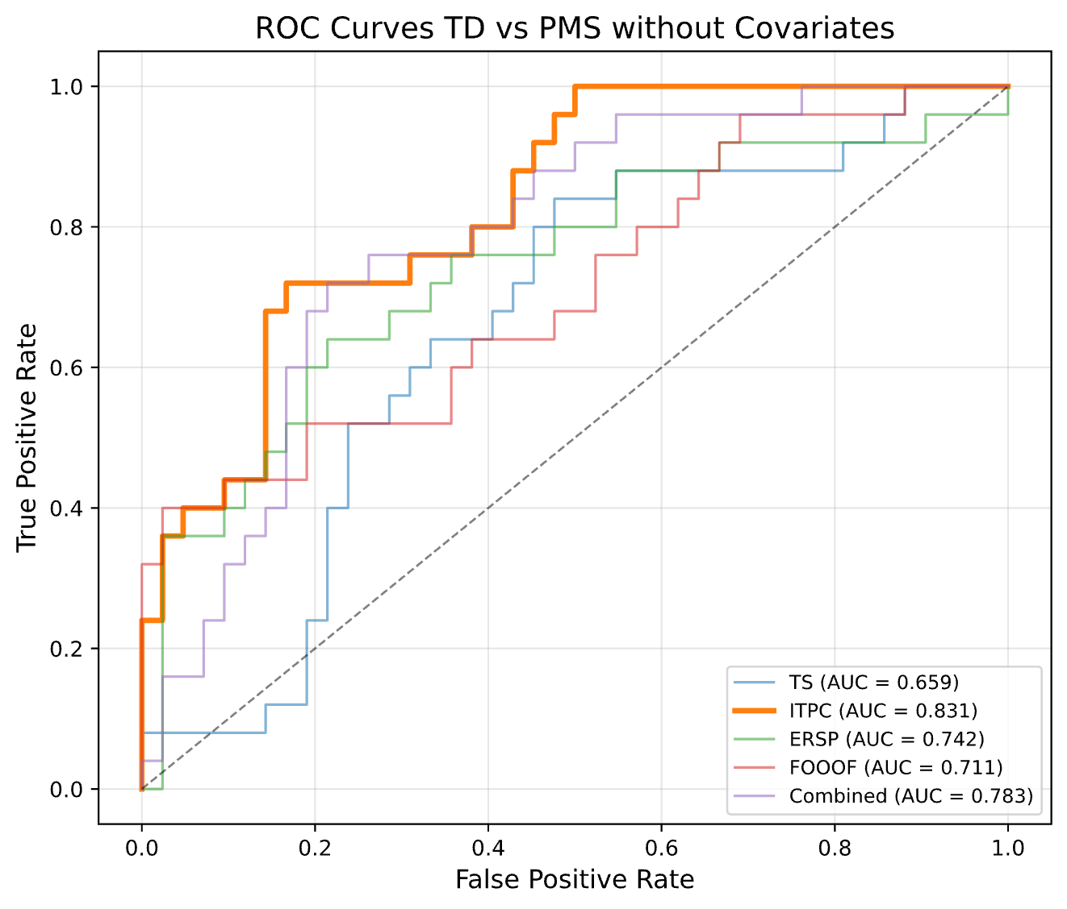 b)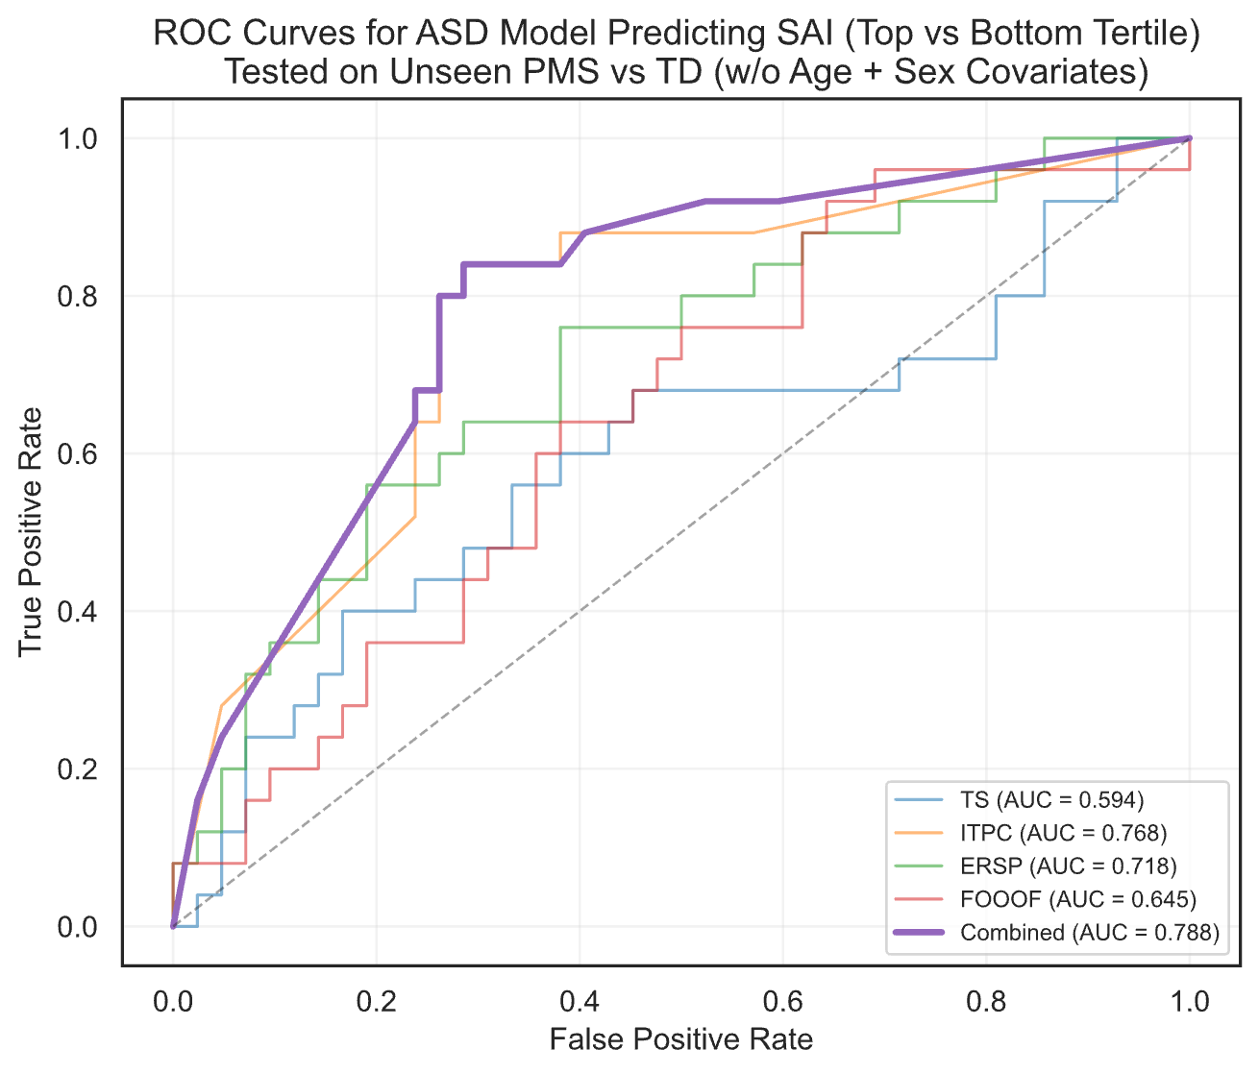
c)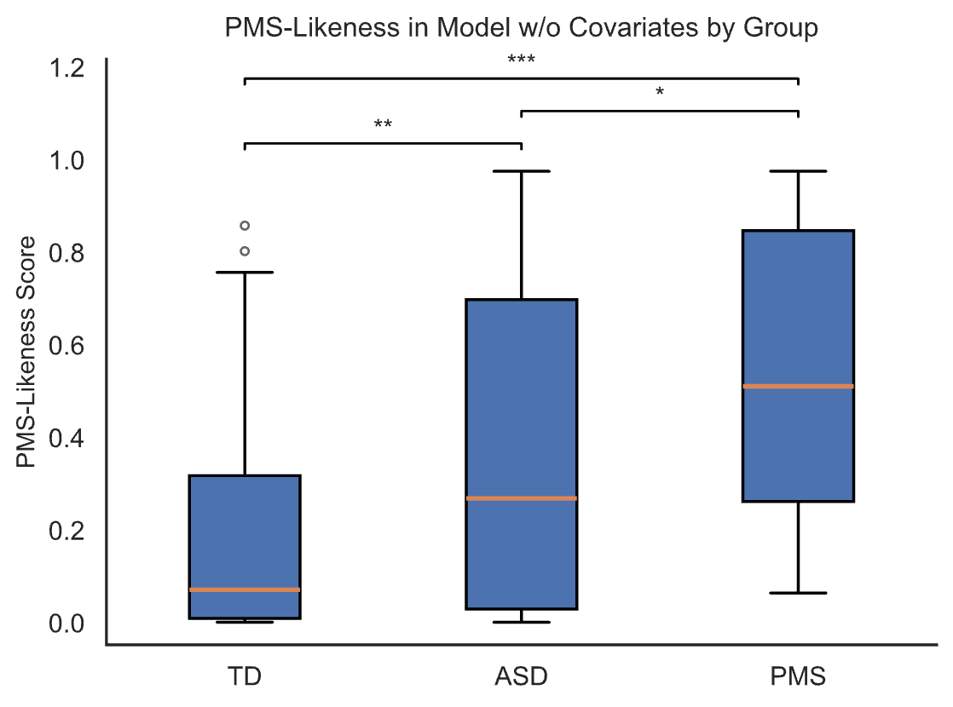d)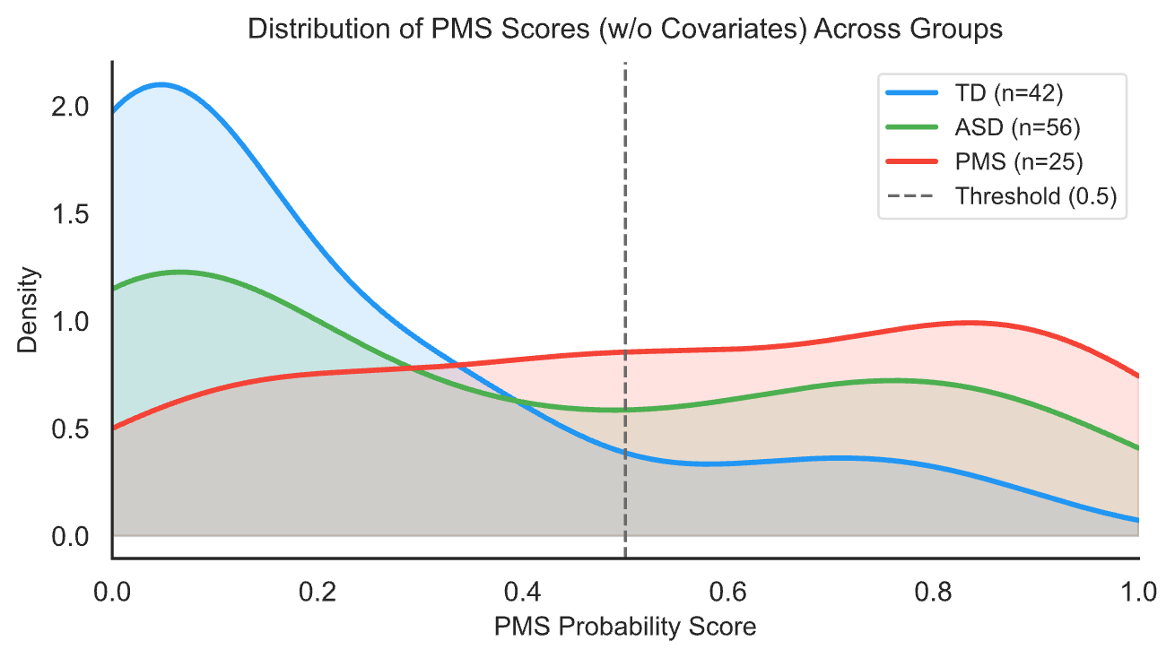
e)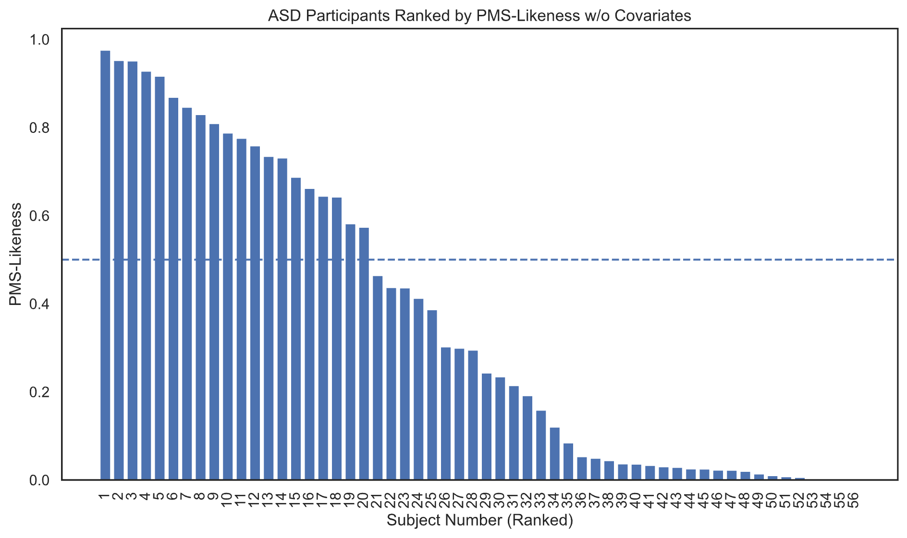
f)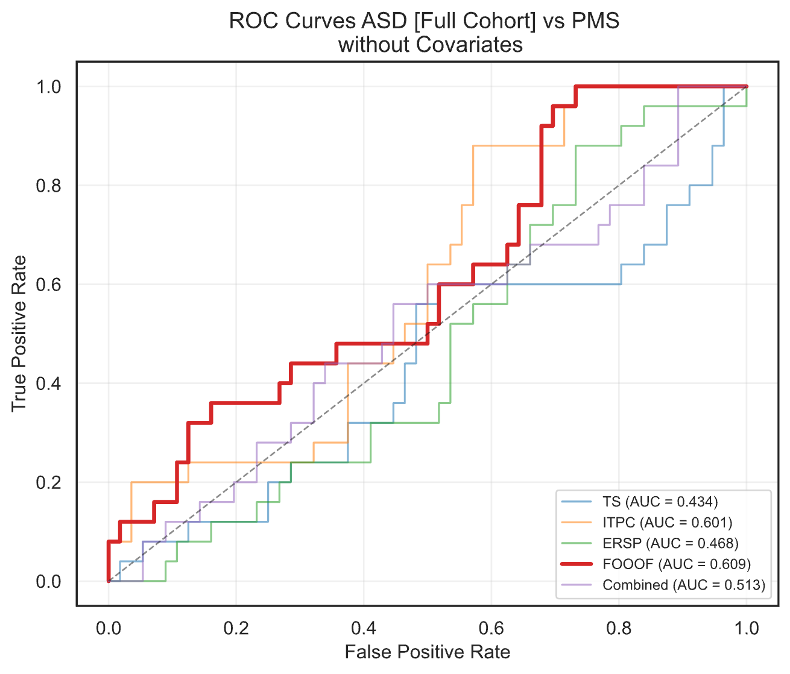g)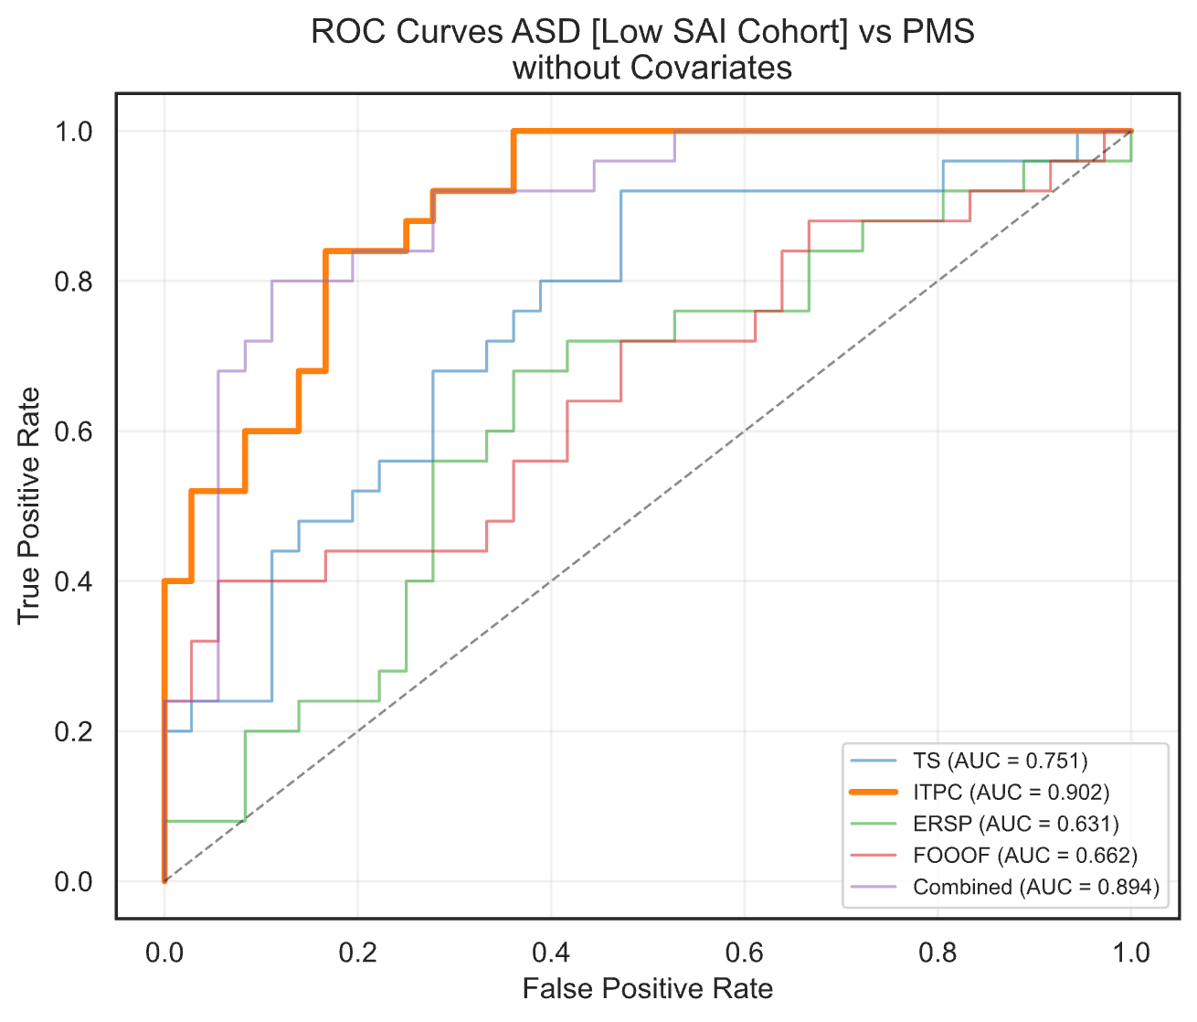
h)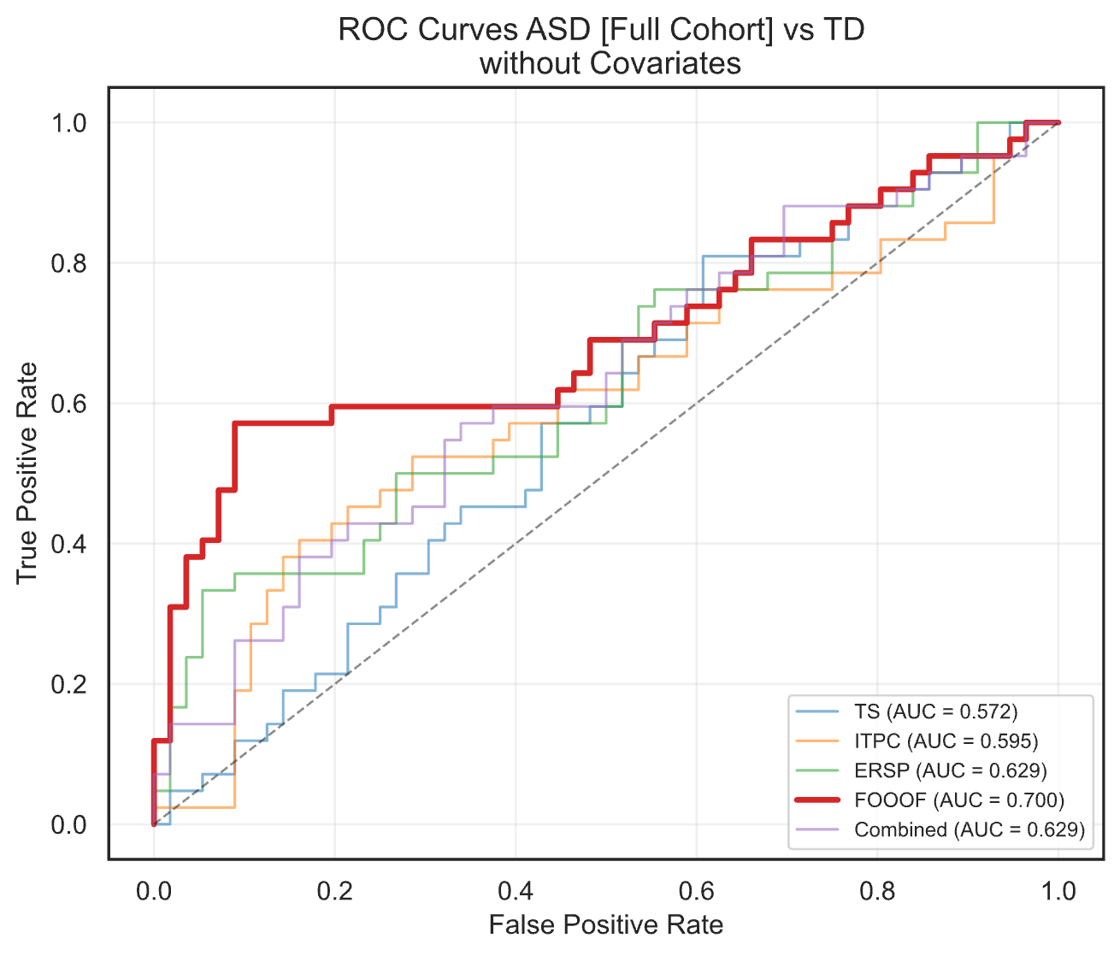i)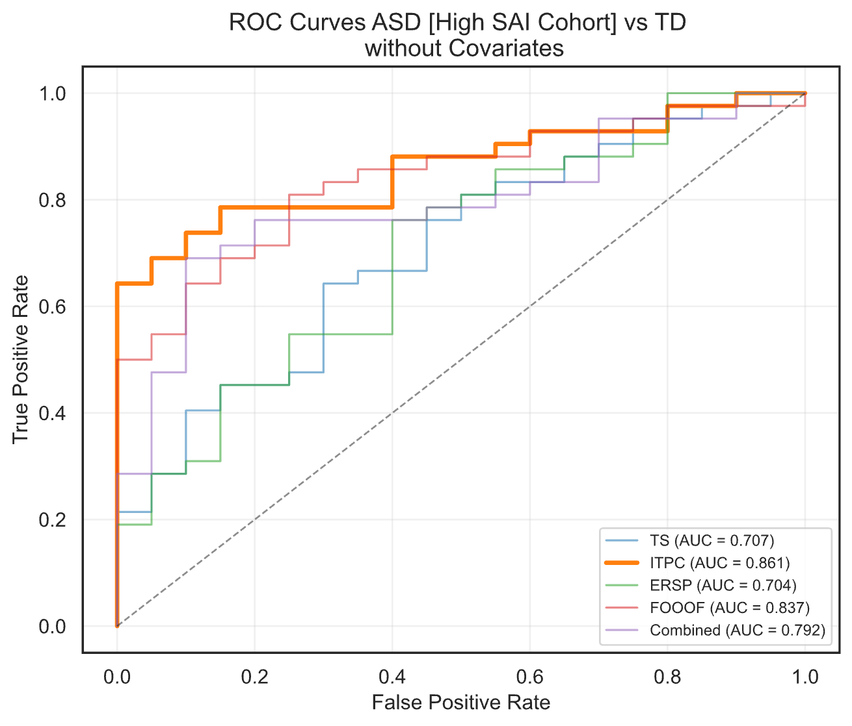
j)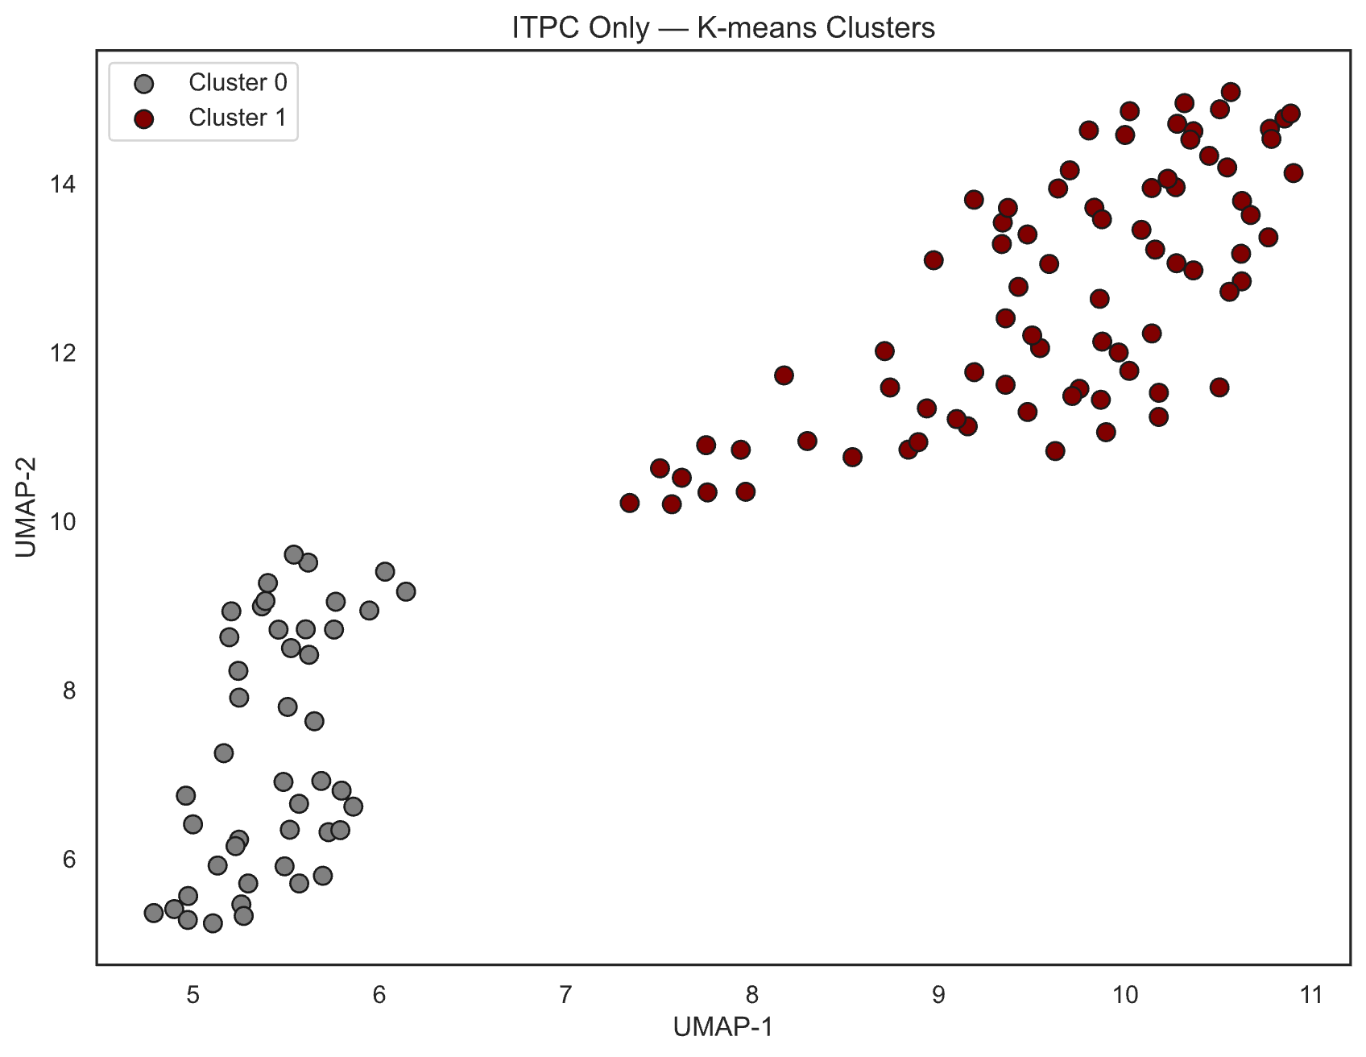k)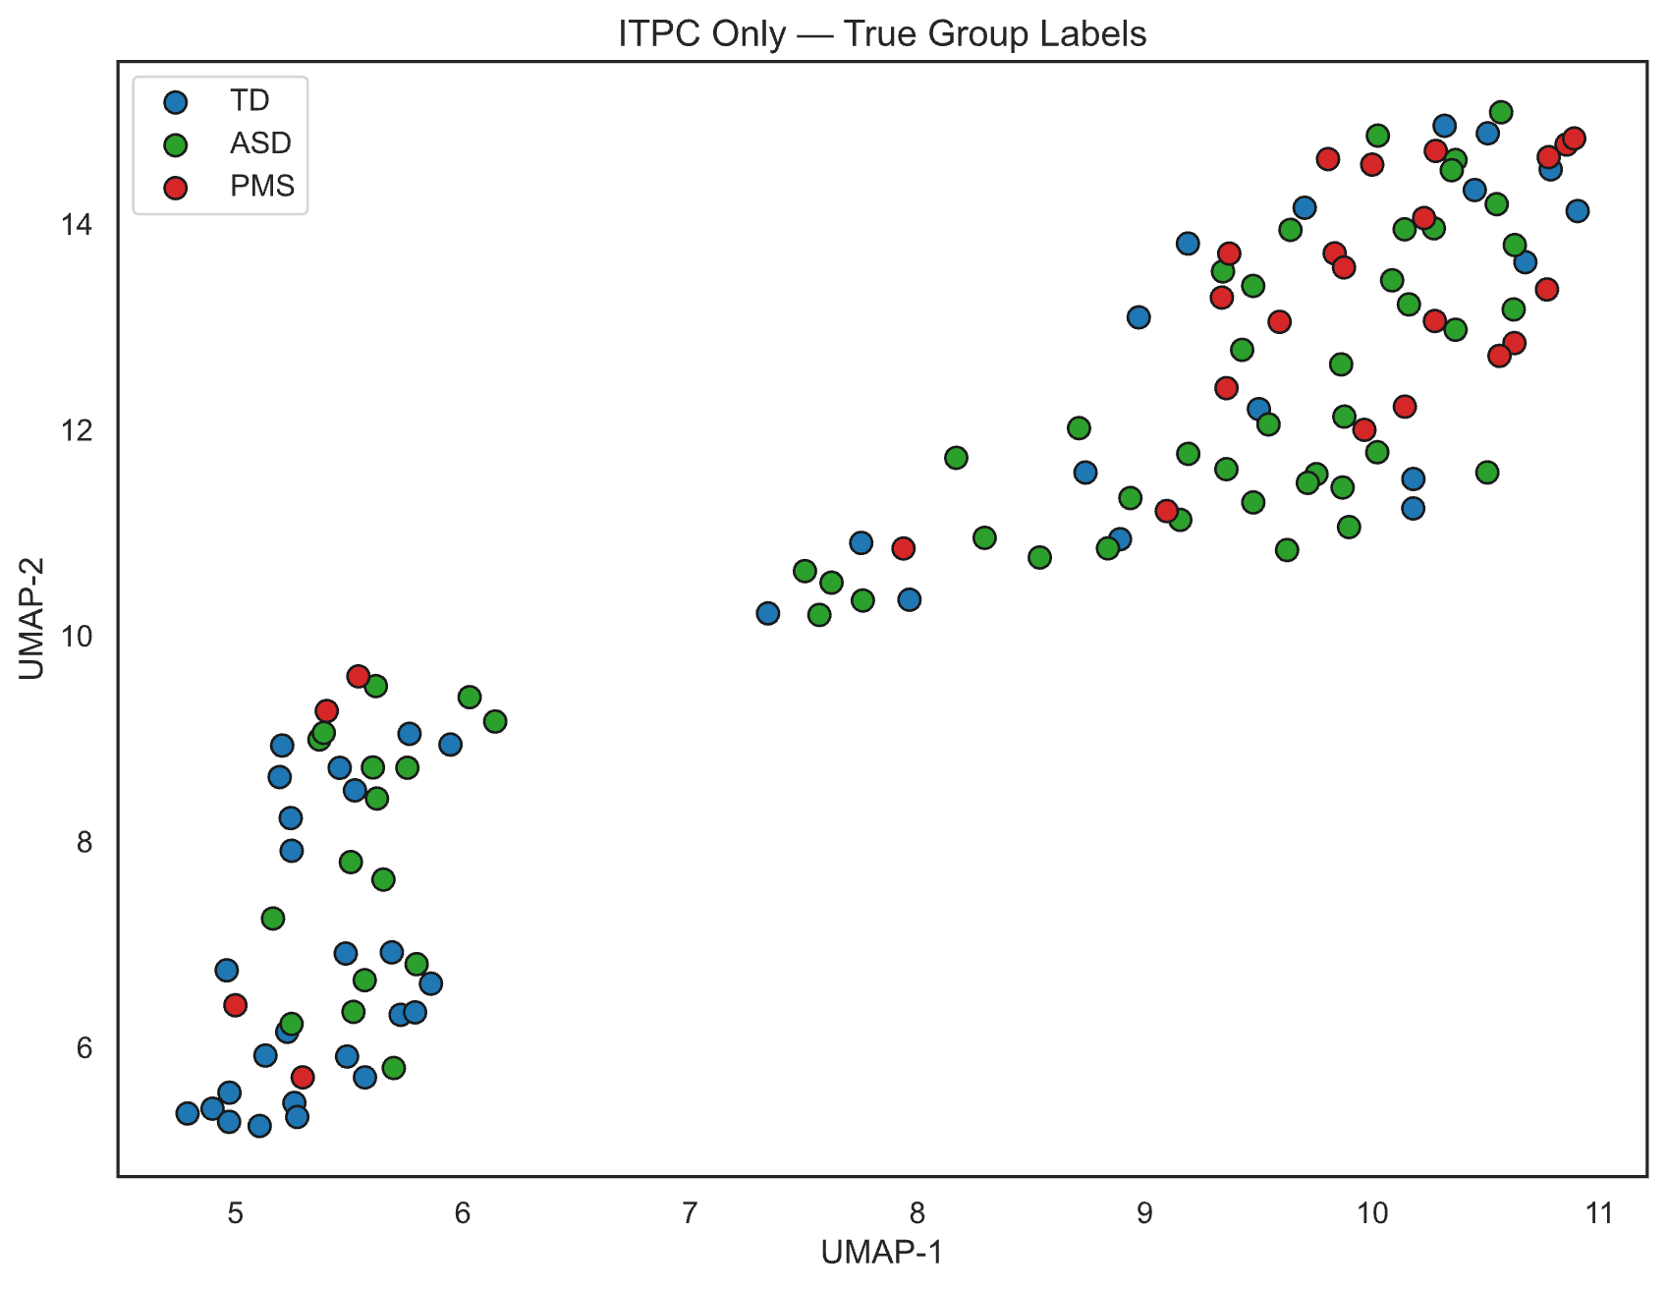
l)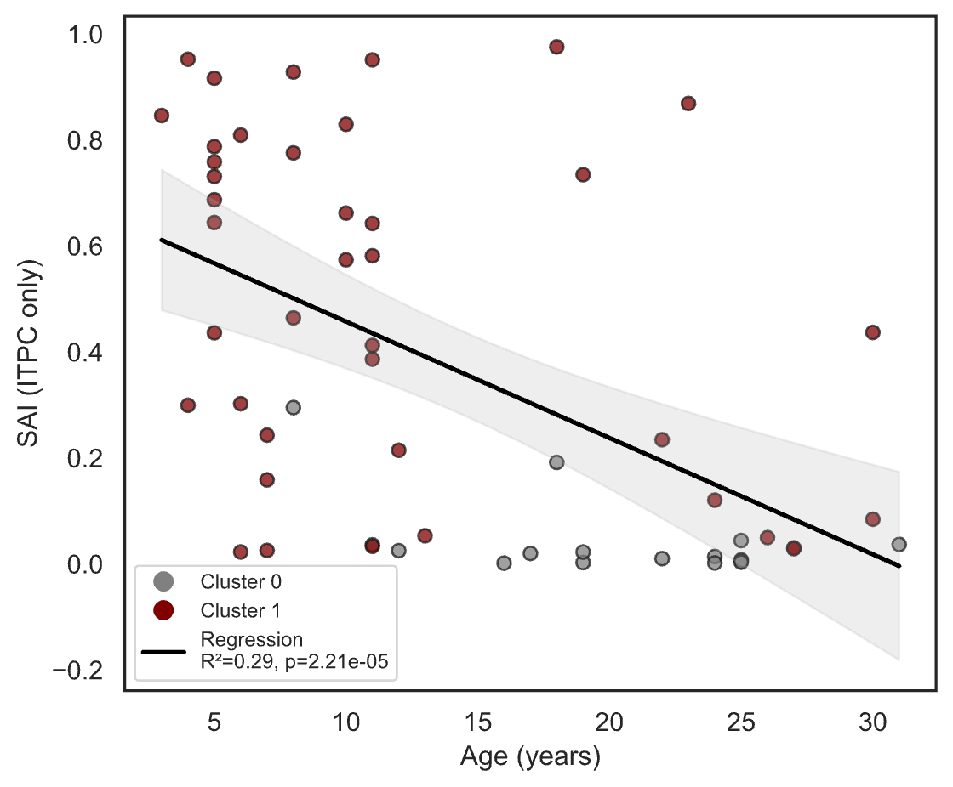m)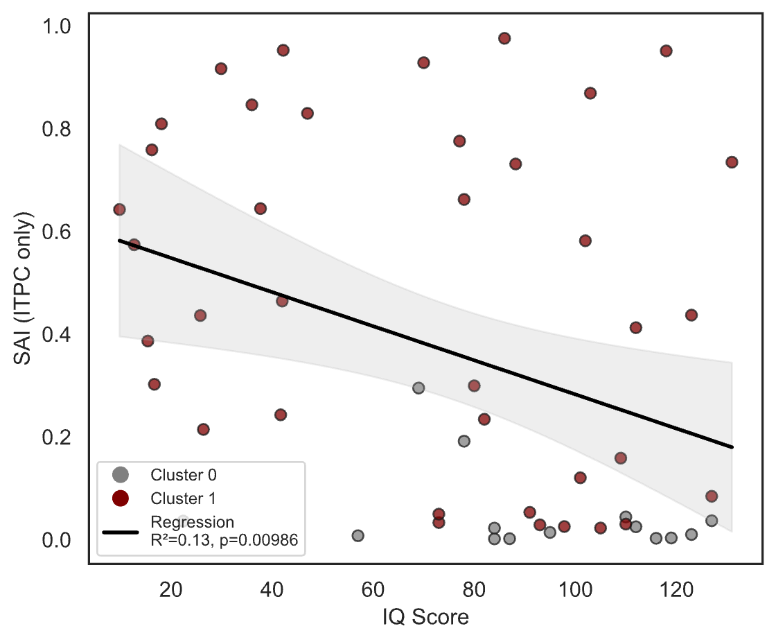
n)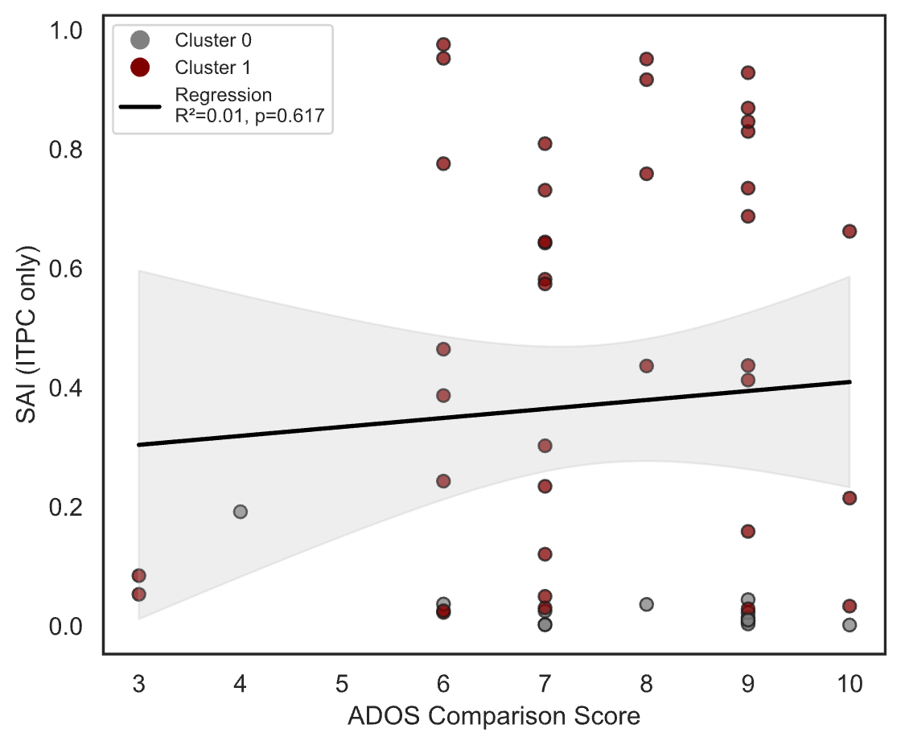o)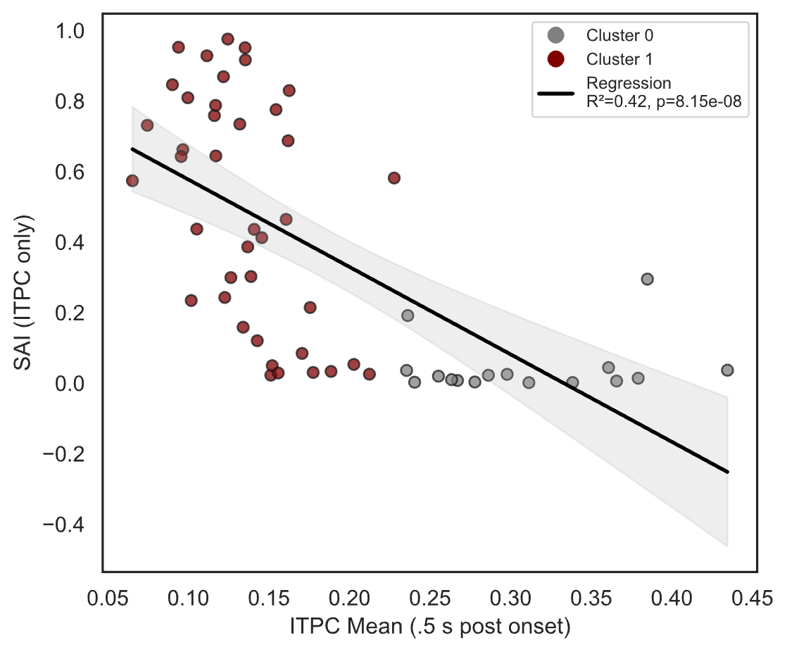
p)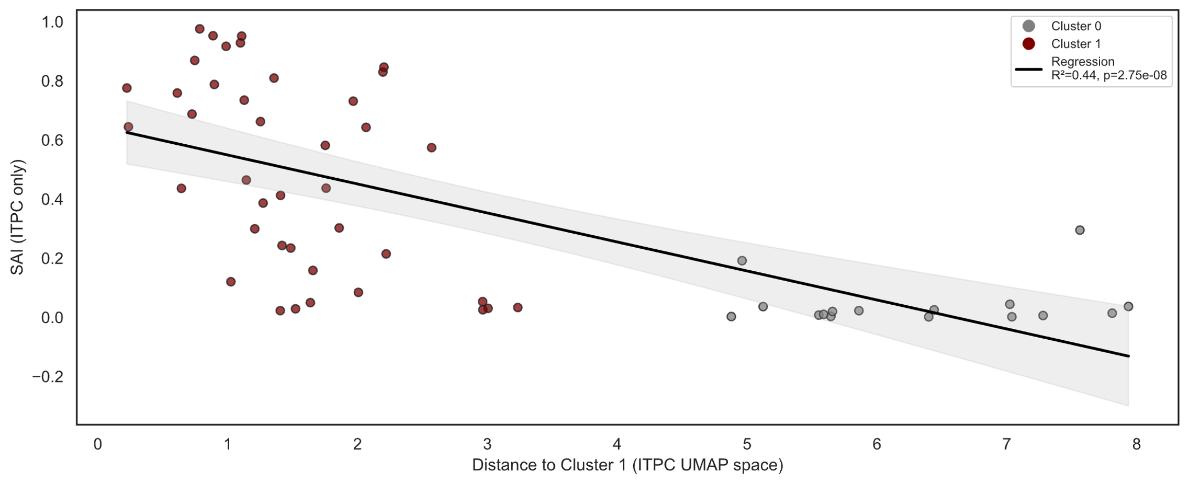

Supplemental Figure 3: Age-Matched Sensitivity Analysis of ITPC-Based Classification: Predicted probabilities from the full LOOCV model and a reduced age-matched model are compared for each participant (PMS: blue; TD: red). In the age-matched model, each participant's classifier was trained on the 24 PMS and 24 TD participants whose ages most closely matched that of the test participant. (A) Scatter plot of full-model versus age-matched predicted probabilities; the dashed line indicates the identity line (slope = 1). (B) Scatter plot of the difference in predicted probabilities between models (Δ probability = age-matched minus full-model) against the mean absolute age gap between the test participant and their age-matched training set.
