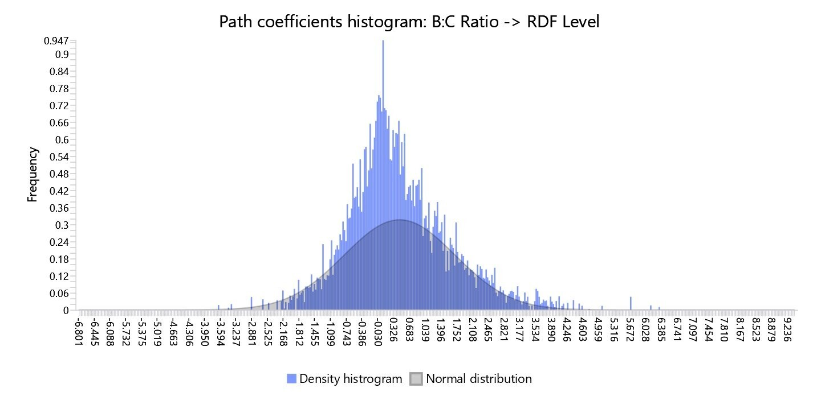

Supplementary Fig. S1: Path coefficients histogram: B:C Ratio → RDF Level

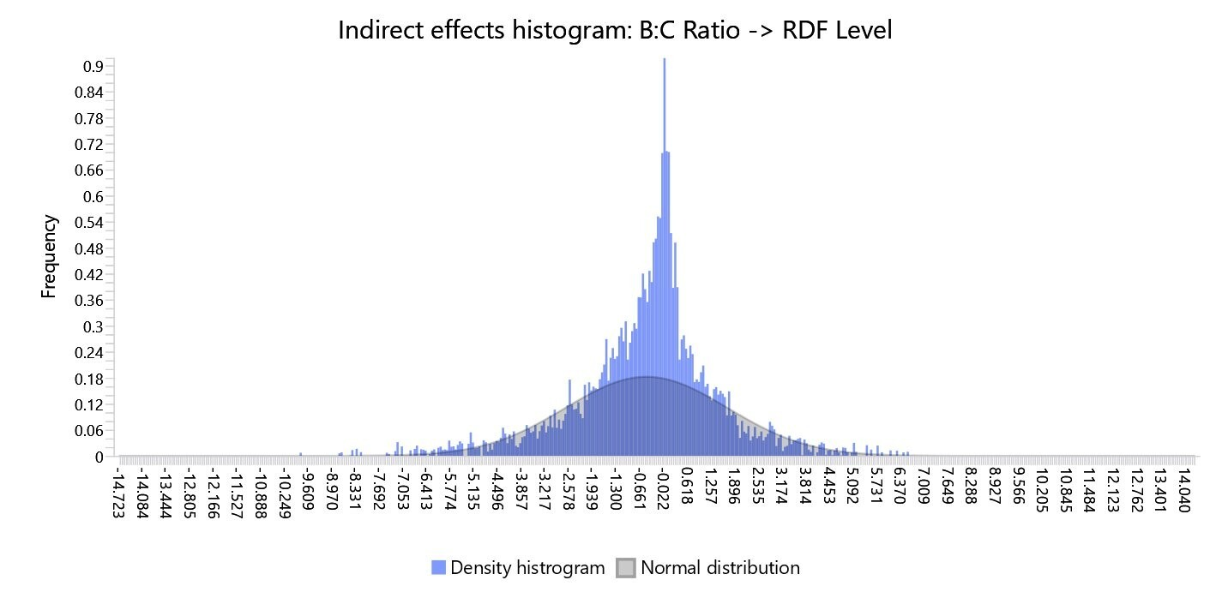

Supplementary Fig. S2: Indirect effects histogram: B:C Ratio → RDF Level

Supplementary Fig. S3: Total effects histogram: B:C Ratio → RDF Level
