Supplementary Figures
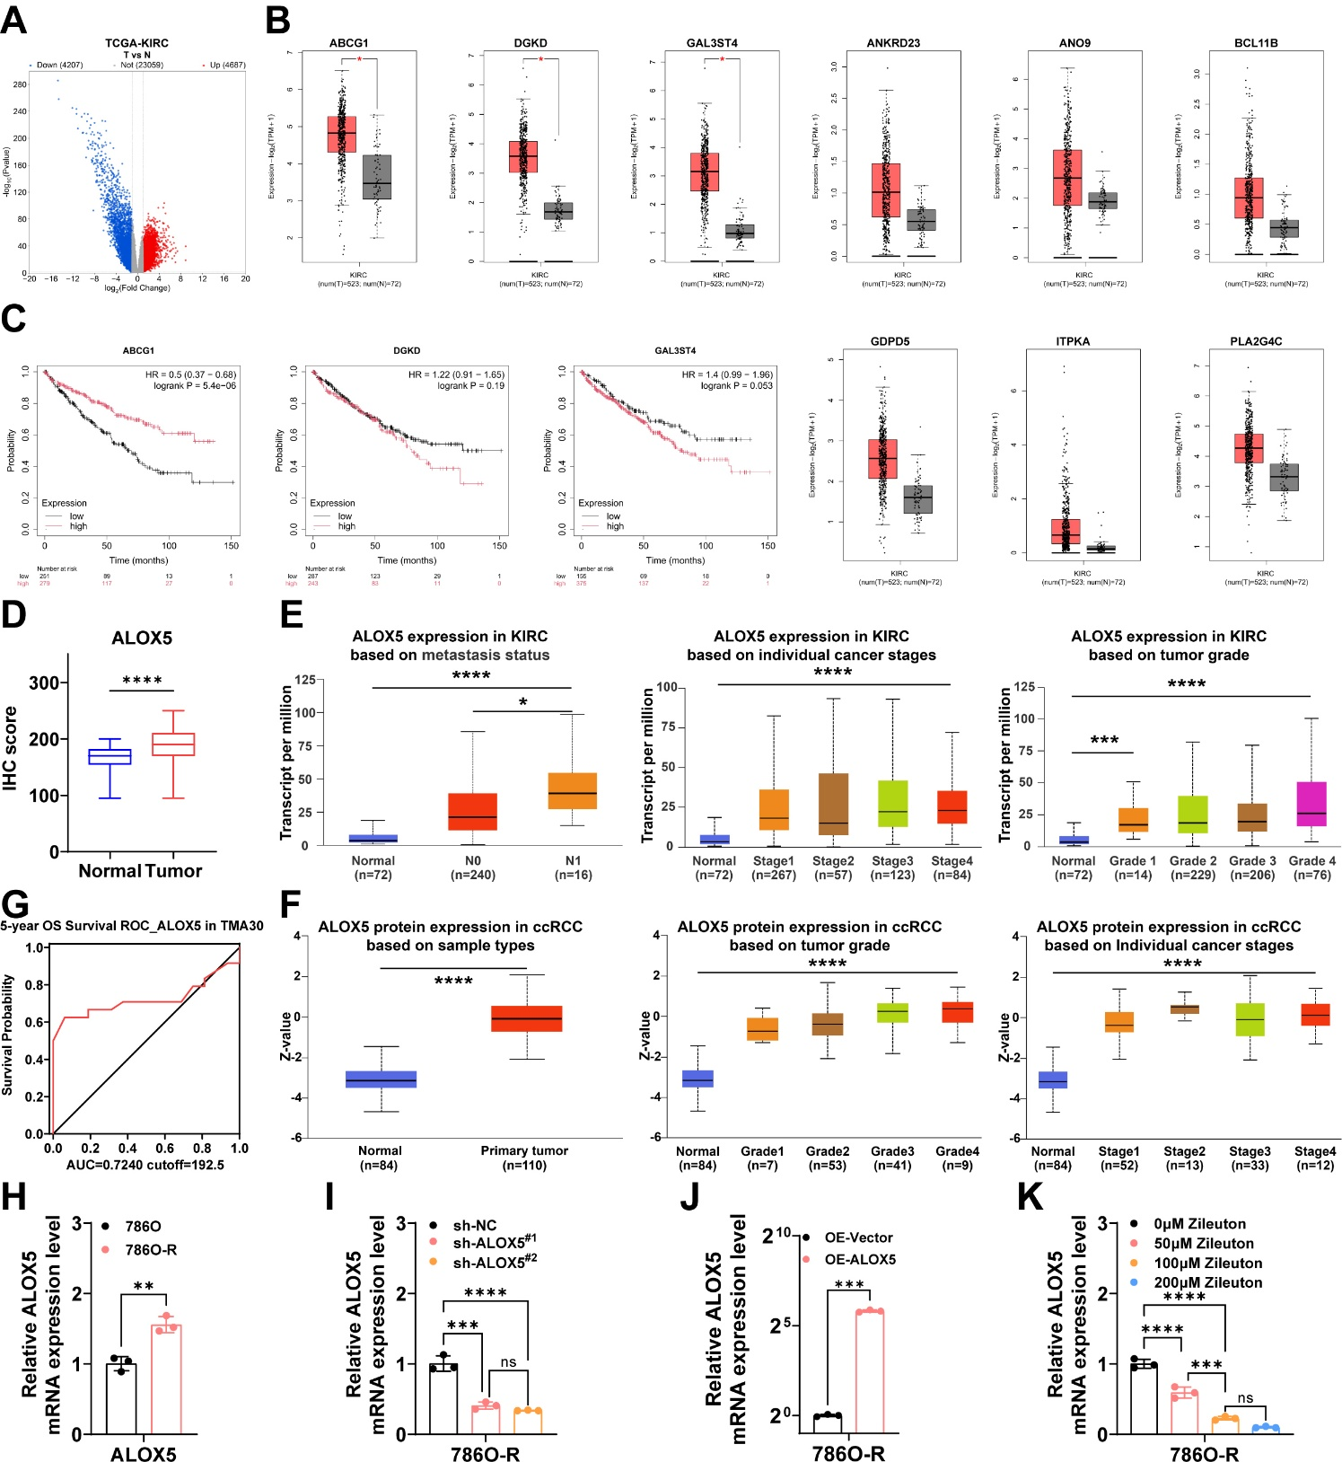

Supplementary Figure 1. (A) Volcano plot, results of differential expression analysis using the TCGA-KIRC dataset. (B) Box plot, differential expression of nine key genes in the GEPIA2 database at the transcript level in KIRC. (C) K-M survival curve, the relationship between the expression levels of the three key genes in the Kaplan-Meier plotter database and OS of KIRC patients. (D) IHC H-scores of ALOX5 expression in paired normal kidney and renal tumor tissues (n = 86). (E) UALCAN-based analyses of ALOX5 transcript-level expression across lymph node metastasis status, clinical stage and tumor grade. (F) UALCAN-based analyses of ALOX5 protein expression in tumor versus normal tissues, across tumor grades and clinical stages. (G) ROC curve of ALOX5 expression and 5-year overall survival in the TMA30 cohort. (H-K) RT-qPCR, ALOX5 mRNA expression levels in 786O and 786O-R cells, ALOX5 mRNA expression levels in 786O-R cells of Sh-NC, Sh-ALOX5^{#1} and Sh-ALOX5^{#2}, ALOX5 mRNA expression levels in 786O-R cells of OE-Vector and OE-ALOX5, ALOX5 mRNA expression levels after co-culture with 786O-R cells using different concentrations of Zileuton. *p < 0.05, ** p < 0.01, *** p < 0.001, **** p < 0.0001.

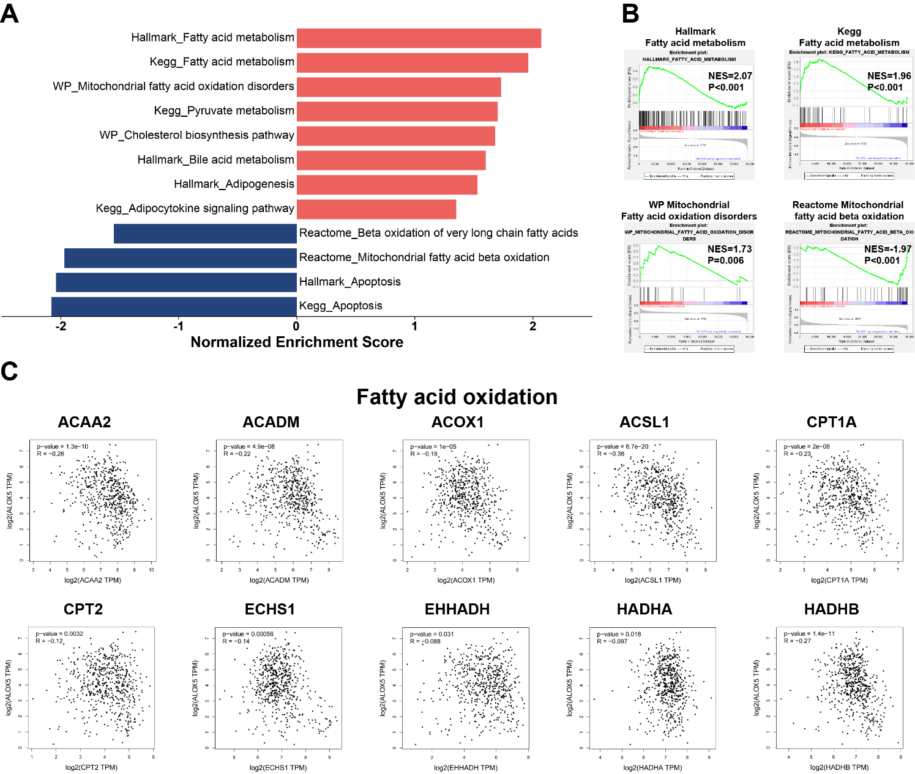
Supplementary Figure 2. (A) GSEA bar graph, the TCGA-KIRC data set was divided into two groups of ALOX5 high expression and low expression for single gene enrichment analysis, red represents up-regulation and blue represents down-regulation. (B) Weight ranking of genes with high versus low ALOX5 expression in GSEA analysis. NES, standardized enrichment score, indicates pathway enrichment level. (C) Scatter plot, correlation analysis of ALOX5 and fatty acid oxidation key genes in KIRC transcript levels in GEPIA2 database. *p < 0.05, ** p < 0.01, *** p < 0.001, **** p < 0.0001.

