Supplementary information

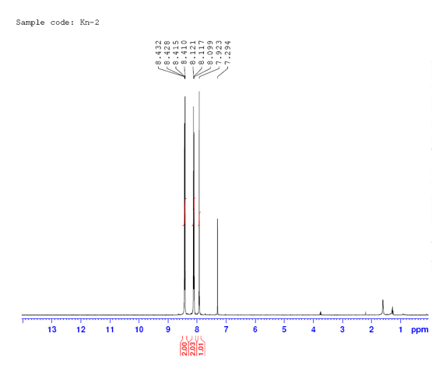
Figure S3. ¹HNMR spectrum of 2-(4-nitrobenzylidene)malononitrile

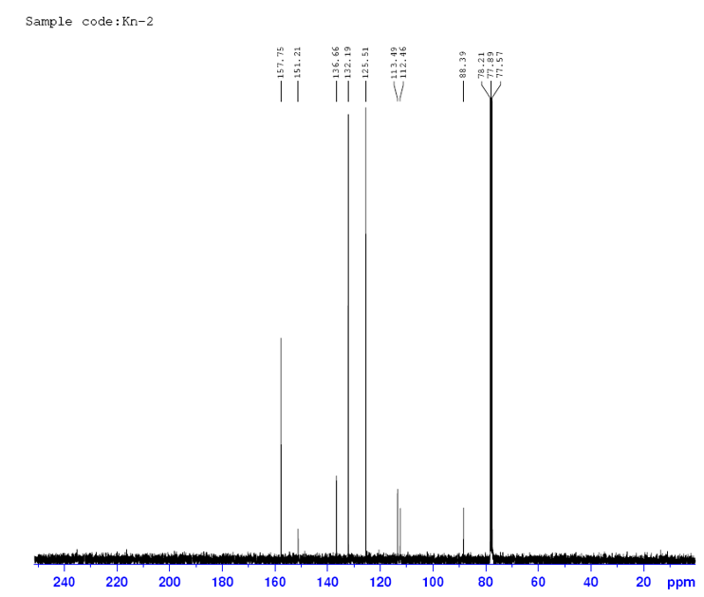

Figure S4. ¹³CNMR spectrum of 2-(4-nitrobenzylidene)malononitrile

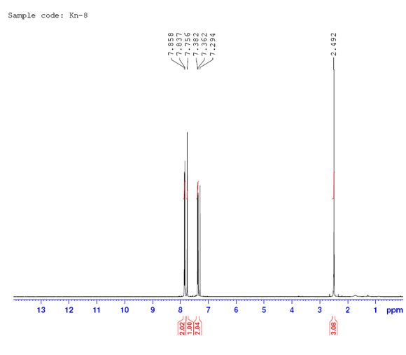
Figure S5. ¹HNMR spectrum of 2-(4-methylbenzylidene)malononitrile

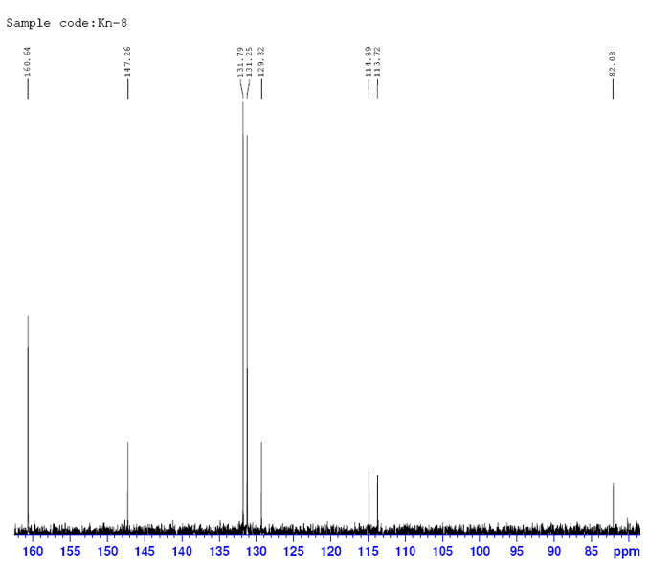
Figure S6. ¹³CNMR spectrum of 2-(4-methylbenzylidene)malononitrile

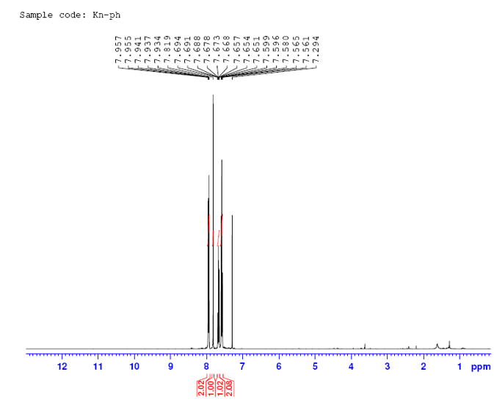
Figure S7. ¹HNMR spectrum of 2-benzylidenemalononitrile

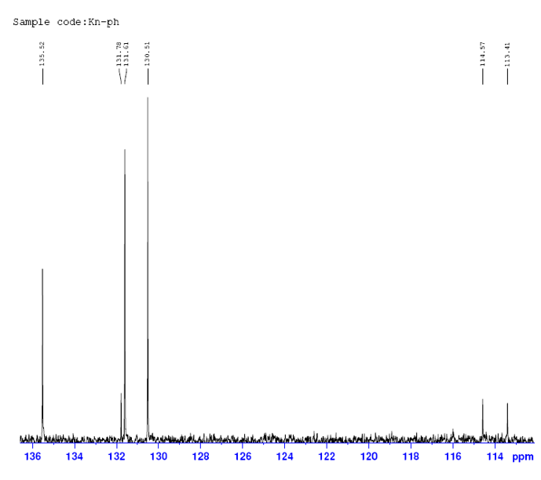
Figure S8. ¹³CNMR spectrum of 2-benzylidenemalononitrile

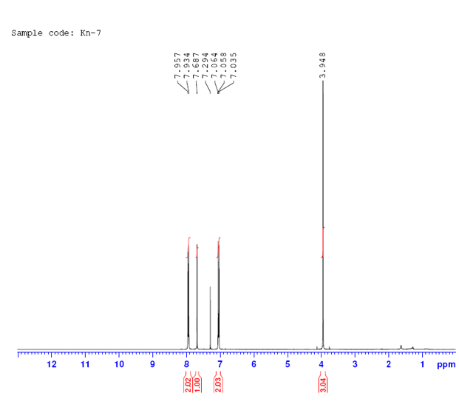
Figure S9. ¹HNMR spectrum of 2-(4-methoxybenzylidene)malononitrile

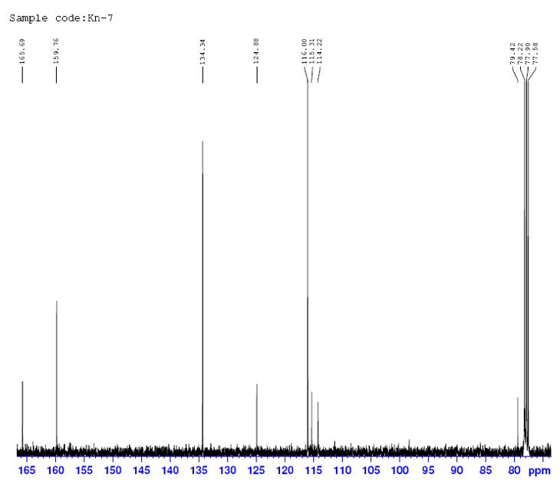
Figure S10. ¹³CNMR spectrum of 2-(4-methoxybenzylidene)malononitrile

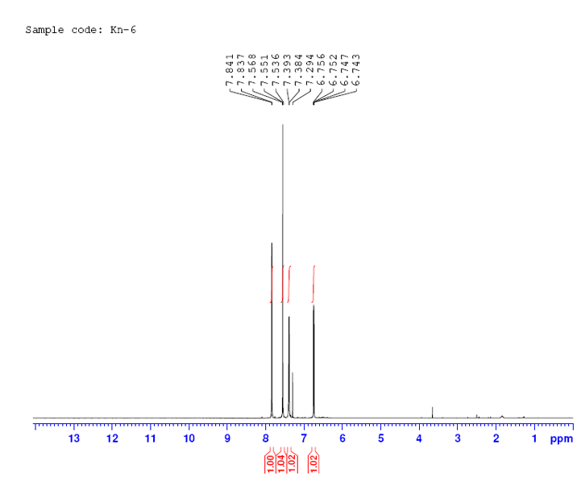
Figure S11. ¹HNMR spectrum of 2-(furan-2-ylmethylene)malononitrile

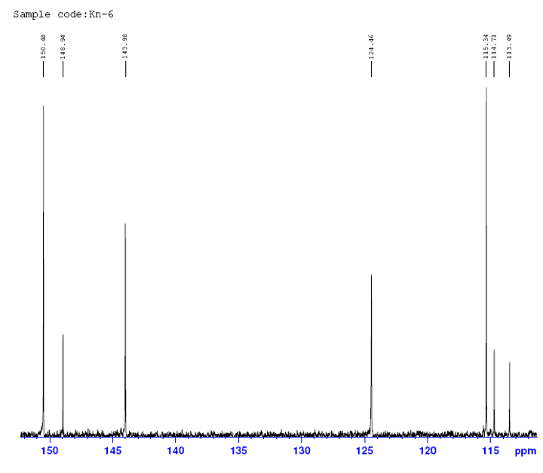
Figure S12. ¹³CNMR spectrum of 2-(furan-2-ylmethylene)malononitrile

