Online Resource 1. Opioid conversion ratios
Name | Route of administration | Equivalent amount in oral morphine 30 mg
Morphine | Oral | 30 mg
 | Injection | 15 mg
 | Rectal | 20 mg
Hydromorphone | Oral | 6 mg
 | Injection | 2 mg
Oxycodone | Oral | 20 mg
 | Injection | 15 mg
Fentanyl | Transdermal | 12.5 μg/h
 | Injection | 0.3 mg
Tapentadol | Oral | 100 mg
Codeine | Oral | 200 mg
Tramadol | Oral, Injection | 150 mg
Methadone | Oral | 4.09 mg (In cases of methadone ≤15 mg/day)  3.27 mg (In cases of methadone >15 mg/day)
Buprenorphine | Rectal, Injection | 0.6 mg
Pentazocine | Injection | 45 mg
 | Oral | 170 mg

Online Resource 2. Daily opioid dose during the last 90 days before death in the two groups, calculated using data from patients in the top 80% of opioid consumption
Data are presented as medians with 95% confidence intervals in morphine milligram equivalents. Between-group comparison was performed using the Mann–Whitney U test.

Online Resource 3. Trends in opioid dose over the last 3 months before death in the two groups, calculated using data from patients in the top 80% of opioid consumption
Data are presented as medians with 95% confidence intervals in morphine milligram equivalents. Between-group comparisons were performed using the Mann–Whitney U test with Bonferroni correction.

Online Resource 4. Unadjusted baseline characteristics by region
 | Hokkaido/Tohoku |  | Kanto |  | Chubu |  | Kansai |  | Chugoku |  | Shikoku |  | Kyusyu/Okinawa
 | Hospital | Home | Hospital | Home | Hospital | Home | Hospital | Home | Hospital | Home | Hospital | Home | Hospital | Home
N | 545 | 41 | 3046 | 542 | 1857 | 183 | 1008 | 164 | 287 | 31 | 141 | 18 | 517 | 49
Proportion of patients receiving home-based care (%) | 7.0 |  | 15.1 |  | 9.0 |  | 14.0 |  | 9.8 |  | 11.3 |  | 8.7
Sex (male, %) | 57.1 | 61.0 | 60.3 | 53.3 | 61.7 | 53.6 | 62.2 | 51.2 | 62.4 | 51.6 | 61.7 | 55.6 | 61.1 | 57.1
Age (mean ± standard deviation) | 58.6  ±10.2 | 59.0  ±11.9 | 59.1  ±9.7 | 57.1  ±10.3 | 57.5  ±10.0 | 55.9  ±10.9 | 59.2  ±9.6 | 56.3  ±10.6 | 56.5  ±10.1 | 52.2  ±12.4 | 59.3  ±10.7 | 55.3  ±9.6 | 57.3  ±9.8 | 53.2  ±12.6
Charlson Comorbidity Inex (mean ± standard deviation) | 9.7±3.1 | 10.2±2.8 | 9.5±3.0 | 9.6±3.3 | 8.8±3.2 | 9.3±3.4 | 9.3±3.0 | 9.2±2.8 | 9.6±3.1 | 9.5±3.4 | 9.2±3.4 | 9.1±4.7 | 9.3±2.7 | 9.3±2.8
Radiation therapy within 6 months before the last chemotherapy (%) | 19.5 | 14.6 | 21.9 | 24.4 | 21.4 | 27.9 | 23.3 | 17.1 | 23.0 | 16.1 | 16.3 | 27.8 | 22.2 | 34.7
Lower gastrointestinal cancer (%) | 30.1 | 29.3 | 25.8 | 24.7 | 27.3 | 24.6 | 27.5 | 25.0 | 25.8 | 29.0 | 18.4 | 5.6 | 27.5 | 22.5
Upper gastrointestinal cancer (%) | 27.2 | 34.2 | 23.4 | 23.1 | 22.7 | 26.2 | 26.1 | 26.8 | 30.3 | 25.8 | 28.4 | 22.2 | 25.9 | 28.6
Lung cancer (%) | 27.7 | 14.6 | 24.9 | 20.1 | 21.6 | 27.3 | 23.0 | 18.9 | 22.0 | 9.7 | 31.2 | 22.2 | 20.9 | 10.2
Pancreatic cancer (%) | 22.2 | 22.0 | 18.3 | 22.0 | 17.8 | 21.3 | 20.7 | 24.4 | 22.7 | 16.1 | 19.9 | 11.1 | 17.4 | 16.3
Hospital, Hospital-based care group; Home, home-based care group.

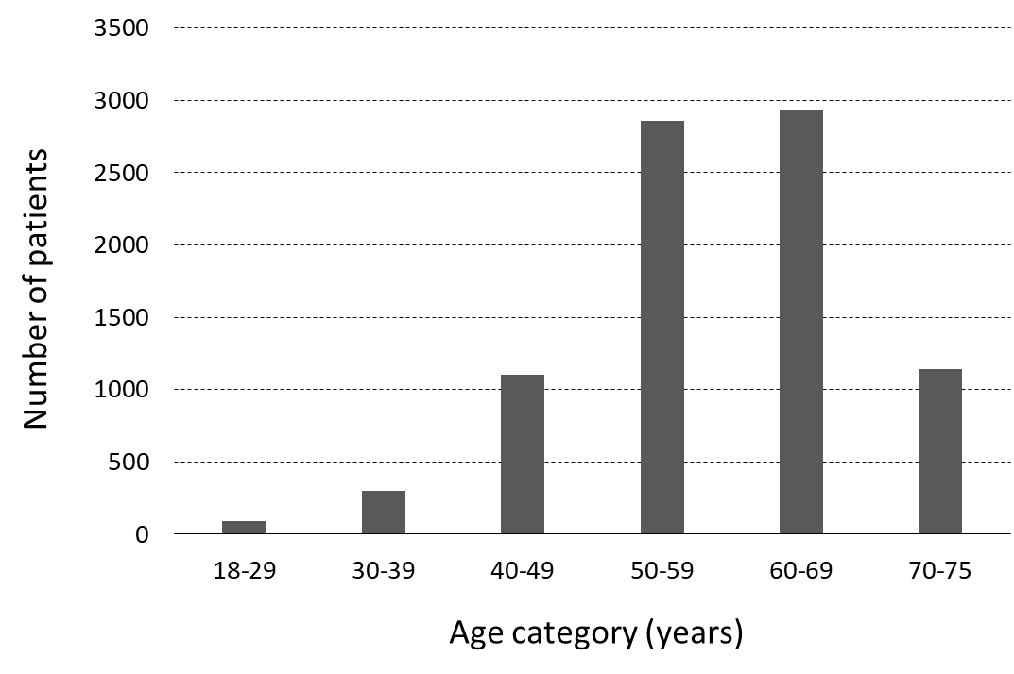
Online Resource 5. Age distribution of study population

