Supporting Information

Effect of copper on bioconcentration of benzotriazole ultraviolet stabilizers (BUVSs) in common carp (Cyprinus carpio)

Dandan Zhaoª, Tadiyose Girma Bekeleª, Hongxia Zhao^{a, *}

ª Key Laboratory of Industrial Ecology and Environmental Engineering (Ministry of Education), School of Environmental Science and Technology, Dalian University of Technology, Linggong Road 2, Dalian, 116024, China

Corresponding Author
*Prof. Hongxia Zhao, phone: +86-411-8470 7965, E-mail: hxzhao@dlut.edu.cn
Contents
Text S1: GC-MS conditions
Text S2: Water sample treatment
Table S1: Abbreviations, names, molecular formulas, and properties of the six BUVSs standards involved in the present study
Table S2: Chemical Structure of the six BUVSs standards involved in the present study
Table S3: Qualitative, quantitative ions and retention time for 6 BUVSs
Table S4: Method detection limits (MDL), method quantification limits (MQLs), spiked average recoveries and relative standard deviations (RSD, n = 6) for each BUVSs
Table S5: Uptake and depuration phase duration, mortality, and hepatosomatic index (HSI) for exposed and control common carp
Table S6: No significant difference in the HSIs was found between the treatment groups and the control group (Paired Student’s t-test; P > 0.05)
Table S7: The concentration of BUVSs in water samples (n=2)
Figure S1: Uptake and depuration curves of BUVSs in tissues of common carp under different Cu concentrations.

Text S1: GC-MS conditions
Analytes were determined by GCMS-QP2010 SE. Separations were carried out in a Agilent DB-5MS type column (30 m × 0.25× 0.25 µm), operated at a constant helium flow of 1.0 ml·min⁻¹. The GC oven was programmed as follows: 180 °C (held for 1 min), rate 10 °C min⁻¹ to 290 °C (held for 10 min). The temperature of the injector was maintained at 290 °C, and samples were injected in the splitless mode. The mass spectrometer was operated in the electron impact (EI) ionization mode (70 eV). The acquisition was performed in the selected ion monitoring mode (SIM) to obtain the highest possible selectivity. Qualitative, quantitative ions and retention time for each analyte were listed in Table S3.

Text S2: Water sample treatment
The BUVSs in the water were extracted by hydrophilic-lipophilic balance solid-phase extraction (C18 SPE) column using an improved procedure described by Kameda et al. (2011). In detail, the C18 column were pre-washed using 10 mL dichloromethane followed by 10 mL methanol and 10 mL ultra-pure water. The surrogate spiked (Allyl-bzt) water sample was transferred to the cartridge with a flow-rate of approximately 1.5 mL/min. Following that, the cartridge was dried and 10 mL dichloromethane was used to elute the target BUVSs. The elutes were evaporated to near dryness under a gentle nitrogen stream and re-dissolved in 1 mL n-hexane before GC-MS analysis.

Chemical Name | Abbreviations | CAS Number | Molecular Formula | logKowª
2-(2-Hydroxy-5-tert-butylphenyl)-2H-benzotriazole | UV-PS | 3147-76-0 | C₁₃H₁₁N₃O |  | 4.36
2-(2'-Hydroxy-3',5'-di-tert-butylphenyl)- benzotriazole | UV-320 | 3846-71-7 | C₂₀H₂₅N₃O |  | 7.21
2-T-butyl-6-(5-chloro-2H-benzotriazol-2-yl)-4-methylphenol | UV-326 | 3896-11-5 | C₁₇H₁₈ClN₃O |  | 5.55
2-(5-chloro-2h-benzotriazol-2-yl)-4,6-bis(1,1-dimethylethyl)-phenol | UV-327 | 3864-99-1 | C₂₀H₂₄ClN₃O |  | 6.91
2-(3,5-Di-tert-amyl-2-hydroxyphenyl)- benzotriazole | UV-328 | 25973-55-1 | C₂₂H₂₉N₃O |  | 7.25
2-(2h-benzotriazol-2-yl)-4-(1,1,3,3-tetramethylbutyl)-phenol | UV-329 | 3147-75-9 | C₂₀H₂₅N₃O |  | 6.21
2-(2H-benzotriazol-2-yl)-4-methyl-6-(2-propenyl)phenol | Allyl-bzt | 2170-39-0 | C₁₆H₁₅N₃O |  | 5.3
Table S1 Abbreviations, names, molecular formulas, and properties of the six BUVSs standards involved in present study
ª Values were obtained from EPI Suite．
Table S2 Chemical Structure of the six BUVSs standards involved in present study
Abbreviation | Chemical Structure | Abbreviation | Chemical Structure
UV-PS | 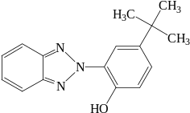 | UV-327 | 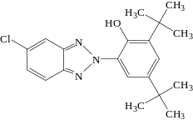
UV-320 | 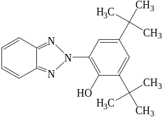 | UV-328 | 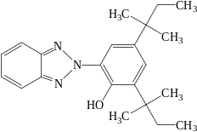
UV-326 | 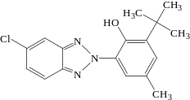 | UV-329 | 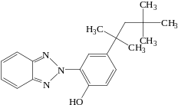
Allyl-bzt | 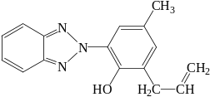

Table S3 Qualitative, quantitative ions and retention time for 6 BUVSs
Compound | Retention time (min) | Qualitative ion (m/z) | Quantitative ion (m/z)
UV-PS | 8.645 | 252.00 | 267.00
UV-320 | 10.250 | 308.00 | 323.00
UV-326 | 10.850 | 300.00 | 315.00
UV-327 | 11.665 | 342.00 | 357.00
UV-328 | 11.605 | 322.00 | 323.00
UV-329 | 11.055 | 252.00 | 253.00
Allyl-bzt | 9.200 | 265.00 | 250.00

Table S4 Method detection limits (MDL), method quantification limits (MQLs), spiked average recoveries and relative standard deviations (RSD, n = 6) for BUVSs
Compound | MDLsª  (ng/g ww) | MQLsª  (ng/g ww) | Spiked levels  (ng/g) | Recovery^{b}  (%) | RSD  (%)
UV-PS | 0.05 | 0.15 | 500 | 104.67 | 13.30
UV-PS | 0.05 | 0.15 | 50 | 97.18 | 23.48
UV-PS | 0.05 | 0.15 | 5 | 86.42 | 14.74
UV-320 | 0.35 | 1.16 | 500 | 92.70 | 6.87
UV-320 | 0.35 | 1.16 | 50 | 91.19 | 13.14
UV-320 | 0.35 | 1.16 | 5 | 85.59 | 16.38
UV-327 | 0.34 | 1.12 | 500 | 99.92 | 7.40
UV-327 | 0.34 | 1.12 | 50 | 106.59 | 15.39
UV-327 | 0.34 | 1.12 | 5 | 105.43 | 16.59
UV-326 | 0.81 | 2.7 | 500 | 109.04 | 12.26
UV-326 | 0.81 | 2.7 | 50 | 103.77 | 13.96
UV-326 | 0.81 | 2.7 | 5 | 96.61 | 18.66
UV-329 | 0.46 | 1.52 | 500 | 111.18 | 19.99
UV-329 | 0.46 | 1.52 | 50 | 100.38 | 22.79
UV-329 | 0.46 | 1.52 | 5 | 98.02 | 15.11
UV-328 | 0.05 | 0.16 | 500 | 97.68 | 8.94
UV-328 | 0.05 | 0.16 | 50 | 97.60 | 13.91
UV-328 | 0.05 | 0.16 | 5 | 89.70 | 15.79
ªThe method detection limit (MDL) was calculated as three times the standard deviation (SD) of the mean procedural blanks (n= 6), while method quantification limit (MQLs) was set as ten times the SD of mean procedural blanks.
^{b}The recovery of each BUVSs was determined by analysis of six replicates of aquarium raised fish (i.e., non-contaminated biotic matrix) spiked with a mixture of BUVSs standards.

Table S5 Uptake and depuration phase duration, mortality, and hepatosomatic index (HSI) for exposed and control common carp
Group | Number of fish |  | Number of dead fish | Uptake period (d) | Depuration period (d) | Mean initial fish mass (g) | Mortality (%) | Average liver weight | HSI (%)
Control | 60 |  | 1 | 28 | 20 | 3.37 ± 0.61 | <2 | 0.060 ± 0.006 | 1.78%±0.05%
Cu-blank |  | 60 | 3 | 28 | 20 | 3.14 ± 0.45 | 5 | 0.041 ± 0.007 | 1.31%±0.16%
Cu-low | 60 |  | 2 | 28 | 20 | 3.43 ± 0.77 | <4 | 0.053 ± 0.009 | 1.58%±0.20%
Cu-high | 60 |  | 2 | 28 | 20 | 3.22 ± 0.87 | <4 | 0.037 ± 0.01 | 1.10%±0.27%

Table S6 No significant difference in the HSIs was found between the treatment groups and the control group (Paired Student’s t-test; P > 0.05)
Group | N | Paired correlation | significance
Control & Cu-blank | 14 | 0.214 | 0.057
Control & Cu-low | 14 | -0.250 | 0.587
Control & Cu- high | 14 | 0.447 | 0.603
Cu-blank & Cu-low | 14 | -0.070 | 0.310
Cu-blank & Cu- high | 14 | 0.451 | 0.175
Cu-low & Cu-high | 14 | 0.053 | 0.339

Table S7 The concentration of BUVSs in water samples (n=2)
Compound | Group | 7 day (μg/L) | 28 day (μg/L)
UV-PS | Cu-blank | 12.339±1.21 | 10.021±0.44
UV-PS | Cu-low | 13.187±2.12 | 12.150±1.39
UV-PS | Cu-high | 15.289±1.22 | 13.722±1.27
UV-320 | Cu-blank | 10.274±1.29 | 15.213±2.33
UV-320 | Cu-low | 12.963±3.28 | 12.764±0.98
UV-320 | Cu-high | 14.134±2.12 | 13.713±0.03
UV-327 | Cu-blank | 15.543±1.10 | 12.829±1.22
UV-327 | Cu-low | 14.739±0.67 | 12.315±0.72
UV-327 | Cu-high | 12.271±2.09 | 14.503±0.57
UV-326 | Cu-blank | 16.287±0.89 | 11.086±1.28
UV-326 | Cu-low | 13.322±2.11 | 10.991±0.97
UV-326 | Cu-high | 15.692±1.73 | 11.124±1.01
UV-329 | Cu-blank | 11.562±2.73 | 11.466±0.77
UV-329 | Cu-low | 13.783±3.23 | 11.223±0.56
UV-329 | Cu-high | 11.562±2.72 | 12.178±1.29
UV-328 | Cu-blank | 12.976±2.13 | 15.642±0.76
UV-328 | Cu-low | 14.231±1.78 | 12.176±1.75
UV-328 | Cu-high | 13.256±3.12 | 14.219±0.22

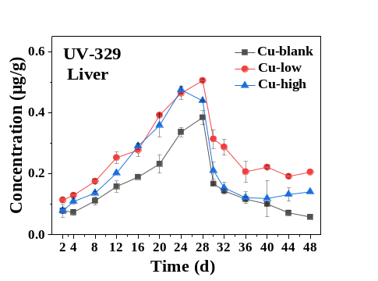
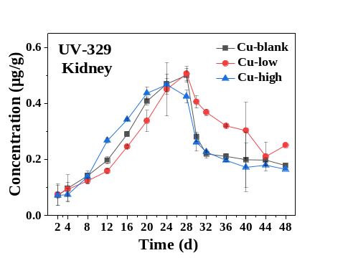
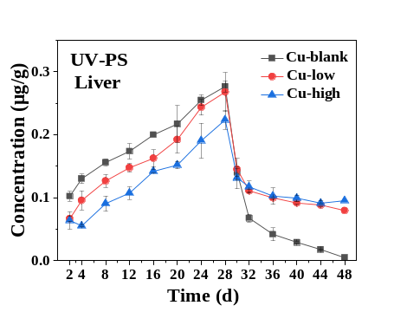
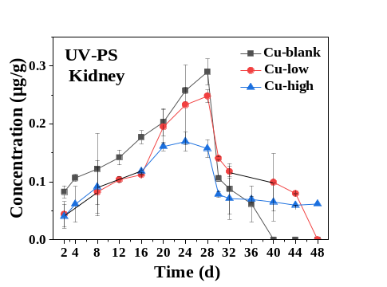
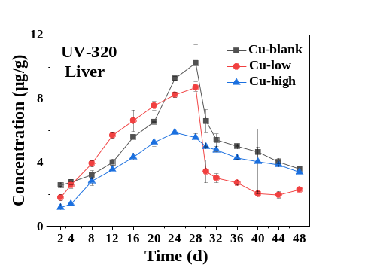
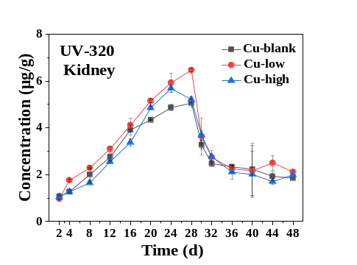
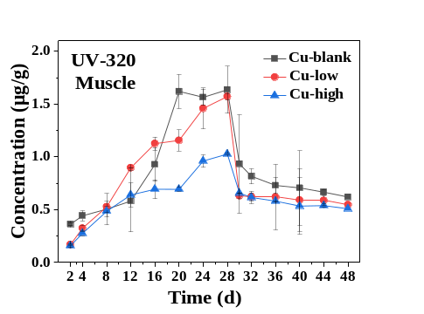
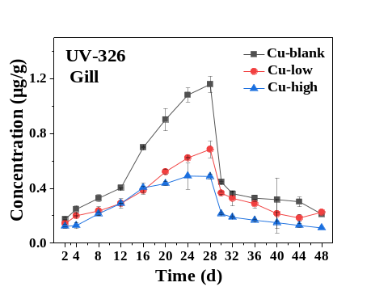
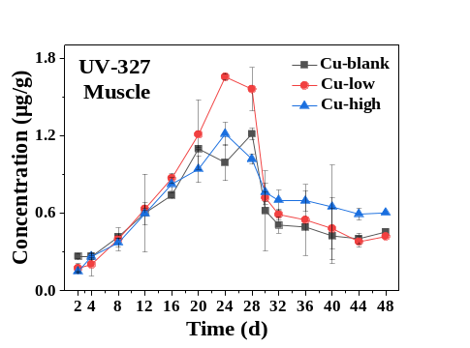
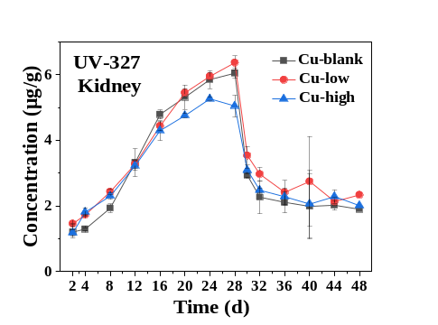
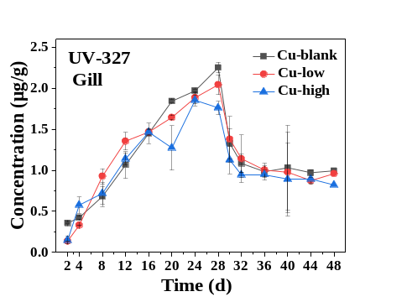
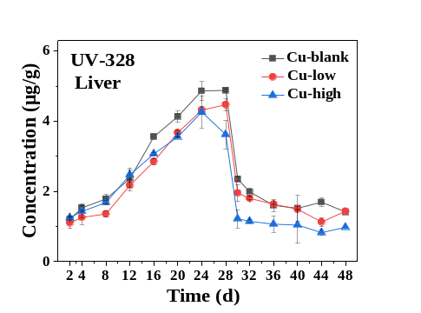
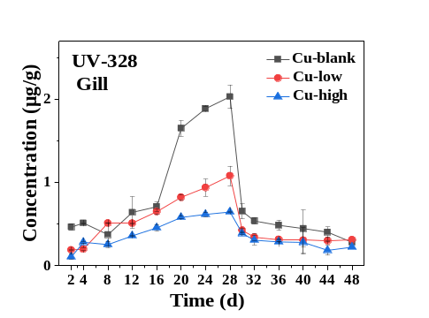
Fig S1 Uptake and depuration curves of BUVSs in tissues of common carp under different Cu concentrations.

References
Kameda Y, Kimura K, Miyazaki M. 2011. Occurrence and profiles of organic sun-blocking agents in surface waters and sediments in japanese rivers and lakes. Environmental Pollution 159:1570-1576. DOI:10.1016/j.envpol.2011.02.055.

