Supplementary Information
Title: Prey availability and fine-scale oceanography drive reef manta ray aggregations at the world’s largest hotspot
Journal name: Journal of Marine Biology
Authors: Hannah M. Moloney, Guy M. W. Stevens, Asia O. Armstrong, Alvise Dabala, Christine L. Dudgeon, Tamaryn J. Sawers, Elspeth M. Strike, Kathy A. Townsend, Anthony J. Richardson
Corresponding author and affiliations: Hannah M. Moloney^{1,2,3,4} - hannah.moloney@research.usc.edu.au
¹University of the Sunshine Coast, School of Science, Technology and Engineering, Hervey Bay, Queensland, Australia
²The Manta Trust, Catemwood House, Norwood Lane, Corscombe, Dorset, DT2 0NT, United Kingdom
³Maldives Manta Conservation Programme, M. Kureli, Buruzu Magu, Maafannu, 20304, Malé, Republic of Maldives
⁴Commonwealth Scientific and Industrial Research Organisation (CSIRO) Environment, BioSciences Precinct (QBP), St Lucia, Queensland, Australia
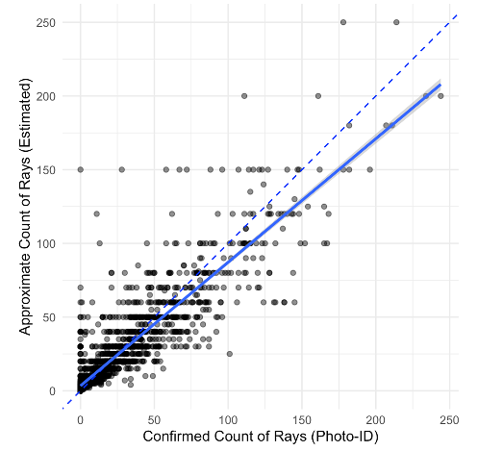
Online Resource. 1 Individual Mobula alfredi sighted during surveys using an “approximate count of sightings” (total individuals observed) and a “confirmed count of sightings” (unique individuals verified via photo-identification (ID)). In this study, for M. alfredi abundance we used the confirmed count of sightings unless it deviated by ≥50% from the estimated count of sightings, in which the estimated count was adopted to avoid under-representation of abundance when there were many manta rays present and photo-ID of all individuals was difficult

