Online Resource 1. STROBE and TARGET Checklist

STROBE Checklist
Strengthening the Reporting of Observational Studies in Epidemiology (von Elm et al., J Clin Epidemiol 2008;61:344–349).
Item | Topic | STROBE recommendation | Reported location
 | Title and abstract
1a | Title/abstract | Indicate the study design with a commonly used term in the title or abstract. | Title: "target trial emulation"; Abstract: "target trial emulation"
1b |  | Provide an informative and balanced summary of what was done and what was found. | Abstract: Purpose, Methods, Results, Conclusions
 | Introduction
2 | Background | Explain the scientific background and rationale for the investigation. | Introduction, paragraphs 1–3
3 | Objectives | State specific objectives, including any prespecified hypotheses. | Introduction, paragraph 3: comparing ultra-early vs early VP initiation timing
 | Methods
4 | Study design | Present key elements of study design early in the paper. | Methods, Study design: target trial emulation with clone-censor-weight approach
5 | Setting | Describe the setting, locations, and relevant dates. | Methods, Data sources: MIMIC-IV (2008–2022, Boston, US); eICU-CRD (2014–2015, multi-center US)
6a | Participants | Give the eligibility criteria, and the sources and methods of selection of participants. | Methods, Eligibility criteria: adults with septic shock, NE-equivalent ≥0.25 µg/kg/min, no prior VP; follow-up to day 28
6b |  | For matched studies, give matching criteria and number of exposed and unexposed. | N/A (clone-censor-weight design; cloning described in Statistical analysis)
7 | Variables | Define all outcomes, exposures, predictors, potential confounders, and effect modifiers. | Methods, Outcomes (primary: 28-day mortality; 6 secondary); Covariates (full list); Online Resource 3
8 | Data sources | For each variable, give sources of data and details of methods of assessment. | Methods, Data sources (ricu package); Online Resource 3 (operational definitions); Online Resource 4 (missing data)
9 | Bias | Describe any efforts to address potential sources of bias. | Methods, Statistical analysis: CCW to address immortal time bias; IPCW for confounding by indication
10 | Study size | Explain how the study size was arrived at. | Results, Cohort characteristics: 5,157 patients from two databases (no a priori sample size calculation; all eligible patients included)
11 | Quantitative variables | Explain how quantitative variables were handled in the analyses. | Methods, Covariates: continuous variables in weight models; subgroup cut points in Online Resource 9
12a | Statistical methods | Describe all statistical methods, including those used to control for confounding. | Methods, Statistical analysis: CCW with IPCW, weighted KM, risk difference, RMST difference, weighted Cox (supplementary); stratified by database, robust SE clustered by patient
12b |  | Describe any methods used to examine subgroups and interactions. | Methods, Secondary outcomes and subgroup analyses: exploratory stratification by lactate, NE dose, ventilation, SOFA
12c |  | Explain how missing data were addressed. | Methods, Missing data; Online Resource 4: LOCF with variable-specific caps
12d |  | If applicable, explain how loss to follow-up was addressed. | Methods, Statistical analysis: artificial censoring at strategy deviation handled by IPCW
12e |  | Describe any sensitivity analyses. | Methods, Sensitivity analyses: 95th-percentile truncation, weighted Cox with covariate adjustment, separate database analyses, 56 alternative time-zero definitions
 | Results
13a | Participants | Report numbers of individuals at each stage of study. | Results, Cohort characteristics (N = 5,157; 10,314 clones); Figure 1 (flow diagram)
13b |  | Give reasons for non-participation at each stage. | Figure 1: eligibility criteria not met (NE threshold, prior VP, no follow-up)
13c |  | Consider use of a flow diagram. | Figure 1
14a | Descriptive data | Give characteristics of study participants and information on exposures and potential confounders. | Table 1: baseline characteristics (overall, N = 5,157)
14b |  | Indicate number of participants with missing data for each variable of interest. | Online Resource 5
14c |  | Summarize follow-up time. | Results, Cohort characteristics
15 | Outcome data | Report numbers of outcome events or summary measures over time. | Table 1 (crude events); Results, Primary and Secondary outcomes; Figure 2 (cumulative incidence curves)
16a | Main results | Give unadjusted estimates and confounder-adjusted estimates and their precision. | Table 1 (crude: 40.7%); Results: RD −5.5 pp (−6.9 to −4.4); RMST +1.49 days (1.18–1.82); HR 0.81 (0.78–0.85)
16b |  | Report category boundaries when continuous variables were categorized. | Results, Subgroup analyses: lactate <2 / 2–<4 / ≥4; NE <0.30 / ≥0.30; SOFA <10 / 10–<14 / ≥14
16c |  | If relevant, consider translating relative risk into absolute risk. | Results, Primary outcome: absolute RD and RMST difference reported alongside HR
17 | Other analyses | Report other analyses done—subgroups, interactions, sensitivity analyses. | Results, Subgroup analyses (Online Resource 9); Sensitivity analyses (Online Resource 10,11)
 | Discussion
18 | Key results | Summarize key results with reference to study objectives. | Discussion, paragraph 1
19 | Limitations | Discuss limitations, considering sources of potential bias or imprecision. | Discussion, Limitations paragraph (residual confounding with specific examples, generalizability, proxy definitions, ischemia, misclassification)
20 | Interpretation | Give a cautious overall interpretation. | Discussion, paragraphs 1–8; Conclusions
21 | Generalizability | Discuss the generalizability of the study results. | Discussion, Limitations: results address timing among users; not generalizable to nonusers or later initiators
 | Other information
22 | Funding | Give the source of funding and the role of the funders. | Declarations, Funding: no specific grant received
CCW, clone-censor-weight; CI, confidence interval; HR, hazard ratio; IPCW, inverse probability of censoring weighting; LOCF, last observation carried forward; NE, norepinephrine; RD, risk difference; RMST, restricted mean survival time; VP, vasopressin.

TARGET Checklist
Transparent Reporting of Observational Studies Emulating a Target Trial (Cashin et al., JAMA 2025;334:1084–1093).

Item | Checklist item | Reported location
 | Abstract
1a | Identify that the study attempts to emulate a target trial. State objectives and summarize the target trial. | Abstract, Purpose and Methods
1b | Report the data sources used for emulation. | Abstract, Methods: "using MIMIC-IV and eICU-CRD"
1c | Summarize key assumptions, statistical methods, findings and conclusions. | Abstract, Methods, Results and Conclusions
 | Introduction
2 | Describe the scientific background and gap in knowledge. | Introduction, paragraphs 1–3
3 | Summarize the causal question. | Introduction, paragraph 3
4 | Describe the rationale for emulating a target trial. Cite informing randomized trials. | Introduction, paragraphs 1–3; VASST and VANISH cited
 | Methods
5 | Cite data sources: purpose, type, geography, setting, period, linkage. | Methods, Data sources (MIMIC-IV 2008–2022; eICU-CRD 2014–2015; ricu harmonization)
6a/7a | Eligibility criteria: specify and describe operationalization. | Methods, Eligibility criteria; Online Resource 2
6b/7b | Treatment strategies: specify and describe operationalization. | Methods, Treatment strategies; Online Resource 2
6c/7c | Assignment procedures: state random assignment in target trial; describe operationalization. | Methods, Treatment strategies (random assignment stated); Statistical analysis (cloning procedure)
6d/7d | Follow-up: confirm start at assignment; specify end; describe operationalization. | Methods, Statistical analysis (time zero to day 28, death, or end of observation; censoring rules; assignment window event handling)
6e/7e | Outcomes: describe and operationalize. | Methods, Outcomes; Online Resource 3
6f/7f | Causal contrasts: describe and operationalize, including effect measures. | Methods, Statistical analysis (risk difference, RMST difference as primary; HR as supplementary); Online Resource 2
6g/7g | Identifying assumptions: describe assumptions for each estimand. | Methods, Covariates: conditional exchangeability assumed; full variable list; Supplementary Methods
6h/7h | Data analysis plan: describe procedures, modelling assumptions, missing data, sensitivity analyses. | Methods, Statistical analysis, Missing data, Sensitivity analyses; Online Resource 4
 | Results
8 | Report numbers assessed, eligible, and assigned. Flow diagram strongly recommended. | Results, Cohort characteristics (N = 5,157; 10,314 clones; 943 ultra-early adherent, 323 early adherent); Figure 1
9 | Describe baseline characteristics by treatment strategy. | Table 1 (overall)
10 | Summarize follow-up length and reasons for end of follow-up. | Results, Cohort characteristics
11 | Describe frequency of missing data. | Online Resource 4
12 | Describe frequency or distribution of each outcome by strategy. | Table 1 (crude events); Results, Primary and Secondary outcomes
13 | Report effect estimates with precision, including absolute and relative measures. | Results: RD −5.5 pp (−6.9 to −4.4); RMST +1.49 days (1.18–1.82); HR 0.81 (0.78–0.85); Figures 2–3
14 | Report results of all sensitivity analyses. | Results, Sensitivity analyses; Online Resource 10-11
 | Discussion
15 | Provide interpretation of key findings. | Discussion, paragraphs 1–4
16 | Discuss limitations considering target trial–emulation differences and plausibility of assumptions. | Discussion, Confounding and Limitations paragraphs
 | Other information
17 | Ethics approval and approval numbers. | Declarations (MIT IRB No. 0403000206; BIDMC 2001-P-001699/14)
18 | State whether the study protocol was registered. | Declarations: not prospectively registered; protocol specified before data extraction
19 | Data, code and materials accessibility. | Declarations, Data availability; Methods, Software and code availability
20 | Funding sources and role of funders. | Declarations, Funding
21 | Conflicts of interest. | Declarations, Competing interests
HR, hazard ratio; IPCW, inverse probability of censoring weighting; RD, risk difference; RMST, restricted mean survival time.

Online Resource 2. Key target trial components and their observational emulation
Target trial component | Target trial | Observational emulation
Eligibility criteria | Adults with septic shock whose norepinephrine-equivalent dose first reaches 0.25 µg/kg/min or higher, who have not received vasopressin before that point, and who are alive and under observation at trial entry. | Adults (aged 18 years or older) in MIMIC-IV (2008–2022) and eICU-CRD (2014–2015) with septic shock (Sepsis-3) whose norepinephrine-equivalent dose reached 0.25 µg/kg/min or higher and who had not received vasopressin before that point.
Treatment strategies | Ultra-early strategy: start vasopressin 0–3 h after time zero; Early strategy: start vasopressin >3–6 h after time zero | Same as target trial.
Assignment | Eligible patients are randomly assigned to one of the two strategies at time zero. | At time zero, each patient was cloned into two identical copies, one assigned to each strategy, thereby mimicking random assignment (cloning step of the clone-censor-weight method).
Follow-up and time zero | Follow-up begins at time zero, defined as the moment when the norepinephrine-equivalent dose first reaches 0.25 µg/kg/min or higher. Follow-up continues until death, 28 days, or loss to follow-up, whichever comes first. Participants are expected to adhere to the assigned strategy throughout the follow-up. | Time zero was operationalized as the first hour at which the norepinephrine-equivalent dose reached the prespecified threshold (default 0.25 µg/kg/min), confirmed by sustained dosing for a minimum of two consecutive hourly recordings. Sensitivity analyses varied the threshold and sustained definition. Follow-up continued until death, end of observable records, or 28 days, whichever came first. Each clone was artificially censored at the time of deviation from the assigned strategy (censoring step): ultra-early clones were censored at 3 h if vasopressin had not been started; early clones were censored if vasopressin was started before 3 h or if it had not been started by 6 h. This artificial censoring corresponds to the per-protocol analysis framework described below and introduces informative censoring, which was addressed by inverse probability of censoring weighting in the analysis step.
Outcome(s) | Primary outcome: all-cause 28-day mortality. Secondary outcomes: incident acute kidney injury, renal replacement therapy, continuous renal replacement therapy, medically treated arrhythmia, and negative cumulative fluid balance by day 28 | Primary outcome derived from time-to-death after time zero. Secondary outcomes were operationalized from derived datasets; incident outcomes excluded patients already meeting the definition at time zero. Full definitions are provided in Online Resource 3.
Causal contrast | Per-protocol effect: the contrast between outcomes that would have been observed had all participants in each arm adhered to their assigned strategy throughout follow-up. | Same as target trial. The per-protocol effect was estimated because the research question concerns the effect of actually initiating vasopressin within the specified time window, not the effect of being assigned to a strategy irrespective of adherence.
Analysis | Intention-to-treat analysis is not applicable because the contrast of interest is the per-protocol effect. The per-protocol effect would be estimated by comparing 28-day risks between the two strategy arms under full adherence. | The clone-censor-weight method was used to estimate the per-protocol effect. Cloning removed baseline confounding by assigning each patient to both arms. Artificial censoring at strategy deviation introduced informative censoring (selection bias), which was corrected by inverse probability of censoring weights estimated at each hour during the 0-to-6-hour assignment window. The censoring model assumed sequential conditional exchangeability given the following measured covariates: baseline variables (age, sex, body mass index, body weight, database source) and hourly time-varying variables (mean arterial pressure, lactate, creatinine, norepinephrine-equivalent dose and its deviation from time-zero value, SOFA score, ventilation status, concurrent vasopressor use, and corticosteroid use). Weighted Kaplan-Meier curves yielded 28-day risk differences and restricted mean survival time differences (with 95% CIs from patient-level bootstrapping). Hazard ratios were estimated using a weighted Cox model with robust standard errors clustered by patient.

Caption:This table specifies the components of the hypothetical target trial and their operationalization using observational data from MIMIC-IV and eICU-CRD. The clone-censor-weight approach was used to emulate the per-protocol effect of initiating vasopressin within 0–3 h versus >3–6 h after the norepinephrine-equivalent dose reached 0.25 µg/kg/min.
Abbreviations:AKI, acute kidney injury; CI, confidence interval; CRRT, continuous renal replacement therapy; eICU-CRD, eICU Collaborative Research Database; IPCW, inverse probability of censoring weighting; MIMIC-IV, Medical Information Mart for Intensive Care IV; NE, norepinephrine; RMST, restricted mean survival time; RRT, renal replacement therapy; SOFA, Sequential Organ Failure Assessment; VP, vasopressin.

Online Resource 3. Operational definitions of secondary outcomes and source variables.

Outcome | Operational definition
AKI KDIGO stage 2 or higher | First time after time zero that Kidney Disease: Improving Global Outcomes stage 2 or higher was reached; patients already meeting the criterion at time zero were excluded from incident-case counting.
AKI KDIGO stage 3 or higher | First time after time zero that Kidney Disease: Improving Global Outcomes stage 3 or higher was reached; patients already meeting the criterion at time zero were excluded from incident-case counting.
RRT initiation | First initiation after time zero of any renal replacement therapy modality, including intermittent or continuous extracorporeal kidney support; patients with renal replacement therapy before time zero were excluded from incident-case counting.
CRRT initiation | First initiation after time zero of continuous renal replacement therapy, analyzed separately because it represents a specific continuous modality of renal replacement therapy commonly used in hemodynamically unstable critically ill patients; patients with continuous renal replacement therapy before time zero were excluded from incident-case counting.
Medically treated arrhythmia | First initiation after time zero of amiodarone, lidocaine, or procainamide; patients treated before time zero were excluded from incident-case counting.
Net negative fluid balance | First time after time zero that cumulative fluid output exceeded cumulative fluid input, such that cumulative net fluid balance (cumulative intake minus cumulative output) became less than zero. This was treated as an exploratory process-of-care outcome reflecting the transition from early resuscitation toward net fluid removal rather than as a direct organ-specific outcome.

Caption:All secondary outcomes were analyzed as time-to-first-event endpoints anchored at time zero. Patients meeting the outcome definition at or before time zero were excluded (incident-case analysis). Source variables and database-specific extraction methods are detailed in the Supplementary Methods.
Abbreviations:AKI, acute kidney injury; KDIGO, Kidney Disease: Improving Global Outcomes; RRT, renal replacement therapy, CRRT, continuous renal replacement therapy.

Online Resource 4. Missingness of variables and imputation method

Category | Variable | Imputation method | Missing (%)
Demographics
 | Age, yr | None required | 0.0
 | Sex | None required | 0.0
 | BMI, kg/m² | LOCF/NOCB within patient | 16.7
 | Weight, kg | LOCF/NOCB within patient | 3.6
Hemodynamics
and severity
 | MAP, mmHg | LOCF, 2-h cap | 2.7
 | Lactate, mmol/L | LOCF, 6-h cap | 9.7
 | SOFA score | LOCF, 24-h cap | 0.0
 | Creatinine, mg/dL | LOCF, 24-h cap | 0.2
 | Systemic corticosteroid | LOCF, 24-h cap | 0
Vasopressors
 | NE-equivalent dose | Zero before first non-zero; LOCF thereafter | 0.0
 | Epinephrine dose | Zero before first non-zero; LOCF thereafter | 0.0
 | Dopamine dose | Zero before first non-zero; LOCF thereafter | 0.0
 | Dobutamine dose | Zero before first non-zero; LOCF thereafter | 0.0
 | Phenylephrine dose | Zero before first non-zero; LOCF thereafter | 0.0
Ventilation
 | Invasive ventilation | Nearest value within 1-h window; default non-invasive | 0.0
 | Prior invasive ventilation | Binary flag | 0.0

Caption:Missingness was assessed at time zero. Imputation rules were prespecified by variable type: LOCF with clinically determined carry-forward caps for hemodynamic and laboratory values, zero-fill before first documentation for vasopressor infusions, and nearest-value within a 1-hour window for ventilation status. Details are shown in the table.
Abbreviations:BMI, body mass index; LOCF, last observation carried forward; MAP, mean arterial pressure; NEE, norepinephrine-equivalent dose; NOCB, next observation carried backward; SOFA, Sequential Organ Failure Assessment.

Online Resource 5. Construction of inverse probability of censoring weights

To account for possibly informative censoring introduced by the artificial censoring according to vasopressin initiation status, we estimated inverse probability of censoring (IPC) weights during the assignment window (0–6 hours after time zero). The weights were estimated in the combined dataset that includes two clones per patient, each of which was assigned to either ultra-early or early vasopressin initiation strategy.

A clone was artificially censored when its observed treatment deviated from the assigned strategy. Because such deviation depends on the patient’s evolving clinical state, we selected these variables as baseline and time-varying covariates for the censoring model.

Time scale and censoring model
The 6-hour assignment window was divided into hourly intervals. At each hour, we determined whether a clone would be censored at the end of that interval because of strategy deviation. We then modeled the probability that a clone remained uncensored at each hour using a pooled logistic regression model. A natural cubic spline of time was included using the ns() function from the R splines package with df = 3 (two internal knots at the 33rd and 67th percentiles of the observed time distribution; boundary knots at 0 and 5 hours; piecewise cubic between knots, linear beyond boundary knots).

Censoring model specification
The censoring model included time and the following covariates, which were assumed to satisfy sequential conditional exchangeability (i.e., no unmeasured confounders affecting both strategy deviation and outcomes, given these variables).

Baseline covariates:
- age
- sex
- body mass index
- body weight
- database indicator (MIMIC-IV or eICU-CRD)
Time-varying covariates (updated hourly during the 0–6 h window):
- mean arterial pressure
- lactate
- creatinine
- norepinephrine-equivalent dose
- Sequential Organ Failure Assessment score
- invasive mechanical ventilation status
- systemic corticosteroid use
- concurrent use of epinephrine, dopamine, dobutamine, and phenylephrine
- deviation of norepinephrine-equivalent dose from the time-zero value
- one-hour change in norepinephrine-equivalent dose

The last two variables were included to capture rapid changes in catecholamine requirement during the assignment window.

Weight construction
At each hour, the predicted probability of remaining uncensored during that interval, conditional on having remained uncensored up to the start of the interval, was obtained from the censoring model. These conditional probabilities were multiplied over time within each clone to obtain the cumulative probability of remaining uncensored up to each time point. The time-varying IPC weight was then defined as the inverse of this cumulative probability. The weight applied to each outcome interval was the cumulative weight estimated in the previous interval.

Missing data handling
For each continuous covariate, a missingness indicator and a zero-filled companion variable were created. This approach allowed the logistic models to be estimated consistently across all intervals without dropping observations. This is a modeling convenience and does not assume that the true missing value was zero. Outcome information was not used in constructing censoring weights.

Weight truncation
Predicted probabilities were clipped away from 0 and 1 to prevent extreme weights. Cumulative weights were truncated at the upper and lower 99th percentiles in the primary analysis. A sensitivity analysis used truncation at the 95th percentiles. The weight distribution is shown in Online Resource 8.

Online Resource 6. Study design diagram illustrating the clone-censor-weight framework.
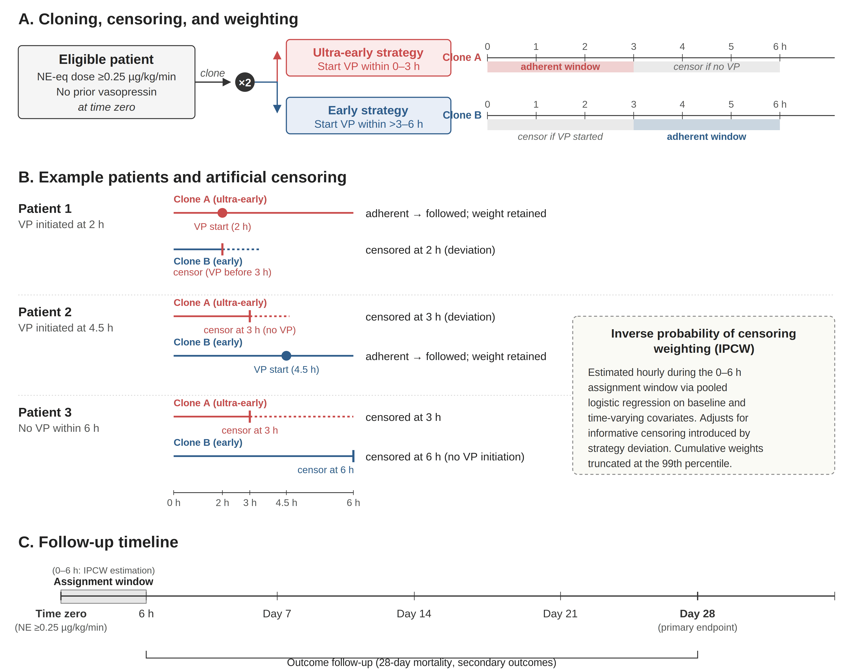

Caption:Schematic of the clone-censor-weight method. Upper panel: each eligible patient (NE-equivalent dose ≥0.25 µg/kg/min, no prior vasopressin) is cloned into two copies at time zero, one assigned to each timing strategy. Copies are censored when actual treatment deviates from the assigned strategy and inverse probability of censoring weights are applied hourly (0–6 h) to the remaining copies. Lower panel: timeline from time zero through day 28.
Abbreviations:h, hours; IPCW, inverse probability of censoring weighting; NE-eq, norepinephrine-equivalent dose; VP, vasopressin.

Online Resource 7 Distribution of time from time zero to first vasopressin initiation among patients who initiated vasopressin within 6 hours

Caption:This figure shows the distribution of elapsed time (hours) from time zero to first vasopressin initiation. Time zero was defined as the first hour at which the norepinephrine requirement reached the prespecified escalation threshold (norepinephrine-equivalent dose ≥0.25 μg/kg/min; operational details in Supplementary Methods). Vasopressin initiation time was defined as the earliest hour with a non-zero vasopressin infusion rate. Only patients who initiated vasopressin within 6 hours after time zero were included in this distribution, consistent with the primary analysis cohort.
The distribution is shown separately for observed initiation timing groups (0–3 h vs >3–6 h).
Online Resource 8. Distribution of inverse probability of censoring weights after truncation at the ninety-ninth percentile

Caption:This figure shows the distribution of stabilized inverse probability of censoring weights used in the clone–censor–weight analysis, after truncation at the 99th percentile to limit the influence of extreme weights. Weights were estimated from hourly logistic regression models of remaining strategy-adherent and uncensored during the assignment window (0–6 hours after time zero), using baseline and time-updated covariates as specified in Supplementary Methods. The displayed weights correspond to the per-clone cumulative weights applied in the weighted Cox models for the primary analysis.
Weights are shown before and after truncation to illustrate the impact of tail trimming.

Online Resource 9. Subgroup analyses for 28-day mortality
Caption::Forest plot of subgroup-specific hazard ratios for 28-day mortality comparing ultra-early (0–3 hours) with early (>3–6 hours) vasopressin initiation. Estimates were derived from the inverse-probability-of-censoring-weighted Cox model used in the primary analysis. Subgroup analyses were prespecified and are presented as exploratory assessments of heterogeneity.
Abbreviations:CI, confidence interval; HR, hazard ratio.

Online Resource 10. Database-specific effect estimates for the primary outcome
Caption:This forest plot shows database-specific hazard ratios for the primary outcome comparing vasopressin initiation at 0–3 hours versus >3–6 hours after time zero among vasopressin initiators within 6 hours. Estimates were obtained using the same clone–censor–weight approach and weighting specification as in the primary analysis, with Cox proportional hazards models fit separately within each database. The dashed vertical line denotes a hazard ratio of 1.0.
Inverse probability of censoring weights were truncated at the 99th percentile for this analysis (consistent with the primary analysis).

Abbreviations:HR, hazard ratio; ICU, intensive care unit.

Online Resource 11. Sensitivity of the primary outcome to alternative time-zero definitions.
Caption:Forest plot showing hazard ratios (95% confidence intervals) for day-28 mortality (ultra-early versus early vasopressin initiation) across 56 combinations of parameters used to define time zero. The left panel uses the norepinephrine-equivalent dose and the right panel uses the norepinephrine infusion rate alone. Seven dose thresholds (0.20, 0.25, 0.30, 0.35, 0.40, 0.45, and 0.50 µg/kg/min), two sustainment durations (2 or 3 consecutive hours above the threshold), and two verification windows (2 or 3 hours after the candidate time zero) were combined, yielding 28 specifications per norepinephrine variable. All estimates are from inverse-probability-of-censoring-weighted Cox models with weights truncated at the 99th percentile. The yellow-highlighted row with a diamond marker denotes the primary analysis specification (norepinephrine-equivalent dose ≥ 0.25 µg/kg/min, 2 consecutive hours above threshold within a 2-hour verification window). Threshold, minimum norepinephrine dose required at the candidate time zero (µg/kg/min); K, required number of consecutive hours above the threshold; W, duration of the verification window after the candidate time zero (hours).
Abbreviations:CI, confidence interval; HR, hazard ratio; IPCW, inverse probability of censoring weighting; NE, norepinephrine.
Online Resource 12. Haemodynamic co-interventions during the first 0–3 hours in the >3–6-hour vasopressin initiation group

Characteristic | Value
Patients, n | 323
MAP at time zero, mmHg | 65.50 (58.38, 74.00)
Minimum MAP during first 3 h, mmHg | 59.75 (54.00, 65.00)
Mean MAP during first 3 h, mmHg | 66.56 (61.84, 72.81)
NE-equivalent dose at time zero | 0.30 (0.27, 0.40)
NE-equivalent dose at end of 0-3 h window | 0.35 (0.30, 0.47)
Maximum NE-equivalent dose during first 3 h | 0.40 (0.31, 0.50)
Increase in NE-equivalent dose to maximum (0-3 h) | 0.03 (0.00, 0.12)
Any epinephrine uses during first 3 h | 13 / 323 (4.0%)
Any dopamine uses during first 3 h | 14 / 323 (4.3%)
Any dobutamine uses during first 3 h | 11 / 323 (3.4%)
Any phenylephrine uses during first 3 h | 105 / 323 (32.5%)
Any invasive ventilation during first 3 h | 157 / 323 (48.6%)

Caption:This table describes the management received by patients assigned to the >3-6-hour strategy during the interval in which vasopressin was not yet initiated. Continuous variables are presented as median (interquartile range); binary variables as n / N (%).
NE-equivalent doses are reported in mcg/kg/min.
Abbreviations:MAP, mean arterial pressure; NE, norepinephrine.

Online Resource 13. Weighted norepinephrine-equivalent dose trajectory from time zero through 72 hours.
Caption: Median (shaded area, interquartile range) norepinephrine-equivalent dose trajectory for the ultra-early (0 to 3 hours, red) and early (>3 to 6 hours, blue) strategies, weighted by stabilized inverse probability of censoring weights truncated at the 99th percentile. Weighting adjusts for baseline confounders so that the two trajectories approximate what would be observed under comparable initial severity. The ultra-early group shows a rapid decline in norepinephrine dose following vasopressin addition, whereas the early group shows continued catecholamine escalation during the deferral period before vasopressin was started. Trajectories converge by approximately 48 to 60 hours.
Abbreviations: NE, norepinephrine

Online Resource 14. Weighted catecholamine exposure and vasopressor-free days by vasopressin initiation timing.

Catecholamine exposure (0–72 hours), weighted
Variable | Ultra early group | Early group
Total catecholamine AUC, µg/kg | 53.6 [14.0, 184.5] | 62.2 [13.4, 198.9]

Vasopressor-free days, weighted
Variable | Ultra early group | Early group | Diff (95% CI)
VFD-7, days, mean (SD) | 0.47 (1.40) | 0.26 (1.01) | 0.20 (0.04, 0.34)
VFD-14, days, mean (SD) | 0.91 (2.81) | 0.48 (1.96) | 0.43 (0.11, 0.71)
VFD-28, days, mean (SD) | 1.34 (4.58) | 0.81 (3.78) | 0.52 (−0.06, 1.07)

Caption: Catecholamine exposure is reported as weighted median [interquartile range] from inverse probability of censoring weighted pseudo-populations after 99th-percentile truncation. Area under the curve (AUC) was calculated as the hourly sum of vasopressor dose from time zero through 72 hours. Total catecholamine AUC includes norepinephrine-equivalent dose, epinephrine, dopamine, dobutamine, and phenylephrine. Vasopressor-free days (VFD) are reported as weighted mean (standard deviation); the difference column shows the mean difference (0 to 3 h minus 3 to 6 h) with bootstrap 95% confidence intervals (1,000 patient-level iterations). VFD is defined as the number of days alive and free of any vasopressor within the specified period; patients who died were assigned zero days.
Abbreviations: AUC, area under the curve; CI, confidence interval; NE, norepinephrine; SD, standard deviation.

Online Resource 15. Baseline distributions of key severity variables at time zero by observed vasopressin initiation timing
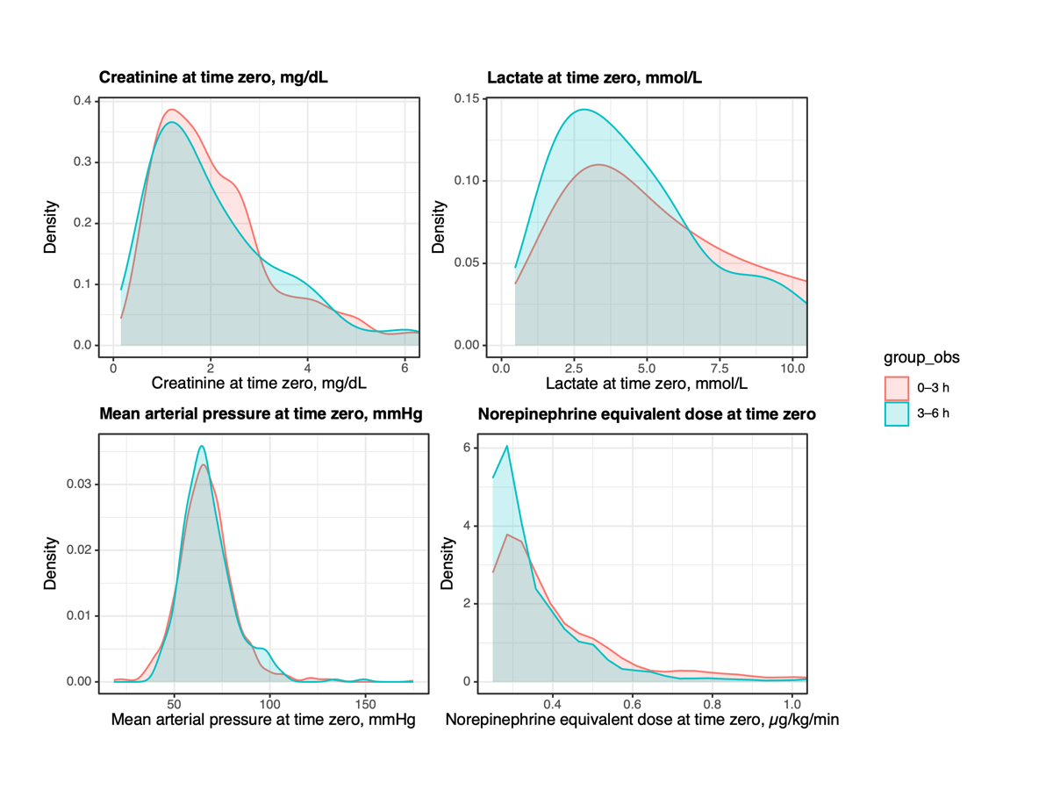

Caption:Kernel density distributions of baseline severity variables measured at time zero are shown by observed vasopressin initiation timing group (0–3 h vs >3–6 h). Time zero was defined as the time point when the norepinephrine requirement reached the prespecified escalation threshold (norepinephrine-equivalent dose ≥0.25 µg/kg/min; operational details in Methods). Panels display creatinine, lactate, mean arterial pressure, and norepinephrine-equivalent dose at time zero. These plots are provided to assess overlap (positivity) and the degree of baseline separation between groups prior to weighting.
Abbreviations:MAP, mean arterial pressure; NEE, norepinephrine-equivalent dose.

Online Resource 16. Hemodynamic trajectories around time zero by observed vasopressin initiation timing

Caption:Observed hemodynamic trajectories are shown for the 6 hours before time zero and the 6 hours after time zero, stratified by observed vasopressin initiation timing group (0–3 h vs >3–6 h). The panels depict mean arterial pressure over time. Lines represent group-level central tendency and shaded bands represent variability (as defined in the analysis code). These trajectories are provided to contextualize early clinical course and co-interventions around the escalation point used to define time zero.
Abbreviations:MAP, mean arterial pressure; NEE, norepinephrine-equivalent dose.

