Supplementary information

Experimental design and ratio
Supplementary Table 1. Formula of agar-pigface Film
Sample | Agar % (w/v) | Pigface % (v/v) | Ratio (A:PF) (w/v)
P1 | 1.5 | 3.8 | 1:2.5
P2 | 2 | 10 | 1:5
P3 | 1 | 10 | 1:10
P4 | 2.2 | 25 | 1:11
P5 | 1.5 | 25 | 1:16
P6 | 2 | 40 | 1:20
P7 | 1.5 | 46.2 | 1:30
P8 | 0.8 | 25 | 1:31
P9 | 1 | 40 | 1:40

Supplementary Table 2. CHNS elements analysis of tested samples
Sample ID | N (%) | C (%) | H (%) | S (%)
Film P5 | 0.64 | 32.17 | 5.71 | 2.22
PF | 23.06 | 29.34 | 4.29 | 0.27
Agar | 5.66 | 36.75 | 5.52 | 1.49

Supplementary Table 3. Water contact angle of Film P5 & P6 in 30s
Film | 0s | 10s | 20s | 30s
P5 | 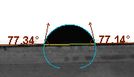 | 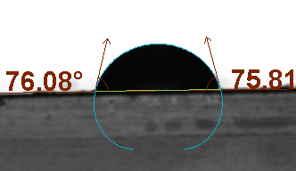 | 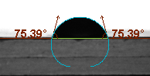
P6 | 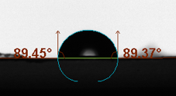 | 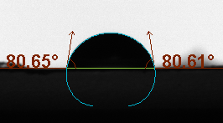 | 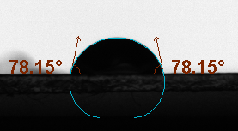 | 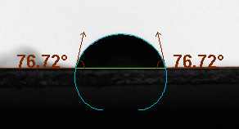

Supplementary Table 4. List of plasticisers and plasticiser-like agents found in pigface using LCMS
Class | Compound
Sugars | fructose, galactose, sucrose, trehalose
Polyols/cyclitols | pinitol, inositol
Sugar acids/lactones | δ-ribono-1,4-lactone
Small organic acids | lactic acid, malic acid, quinic acid, ascorbic acid
Long-chain diacids | azelaic acid, sebacic acid, octadecenedioic acid
Fatty acids | pinolenic acid, octadecatrienoic acid
Oxylipins | jasmonic acid, Oxophytodienoic acid, Hydroxy-octadecadienoic acid/ Dihydroxy-octadecenoic acid
Monoacylglycerols/phospholipid-like amphiphiles | glycerol monooleate, glycerophospho-N-palmitoyl ethanolamine
Fatty acid amides/ethanolamides | oleamide, stearamide, palmitoyl ethanolamide

Supplementary Table 5. Characterisation of Control Agar Film
Measurement | Value
TS (Mpa) | 15.81
EOB (%) | 11.953
WVP (g/m².s.Pa) | 2.91E-11
L* | 92.918
a* | -1.43
b* | 4.288
Opacity (%) | 14.17
Thickness (µm) | 17.2
TPC (mg GAE/g) | 2.47
TEAC (mg/g) | ND

Supplementaty Table 6. As, Cd, Cu, Pb and Hg concentrations in pigface samples
Samples | As (mg/kg) | Cd (mg/kg) | Cu (mg/kg) | Pb (mg/kg) | Hg (mg/kg)
SW | 4.66 | 0.13 | 4.54 | 5.74 | 0.002
PF | 14.35 | 0.07 | 2.52 | 0.2 | 0.007
Optimized Film (P5) | 1.93 | 0.04 | 5.18 | 0.43 | 0.025

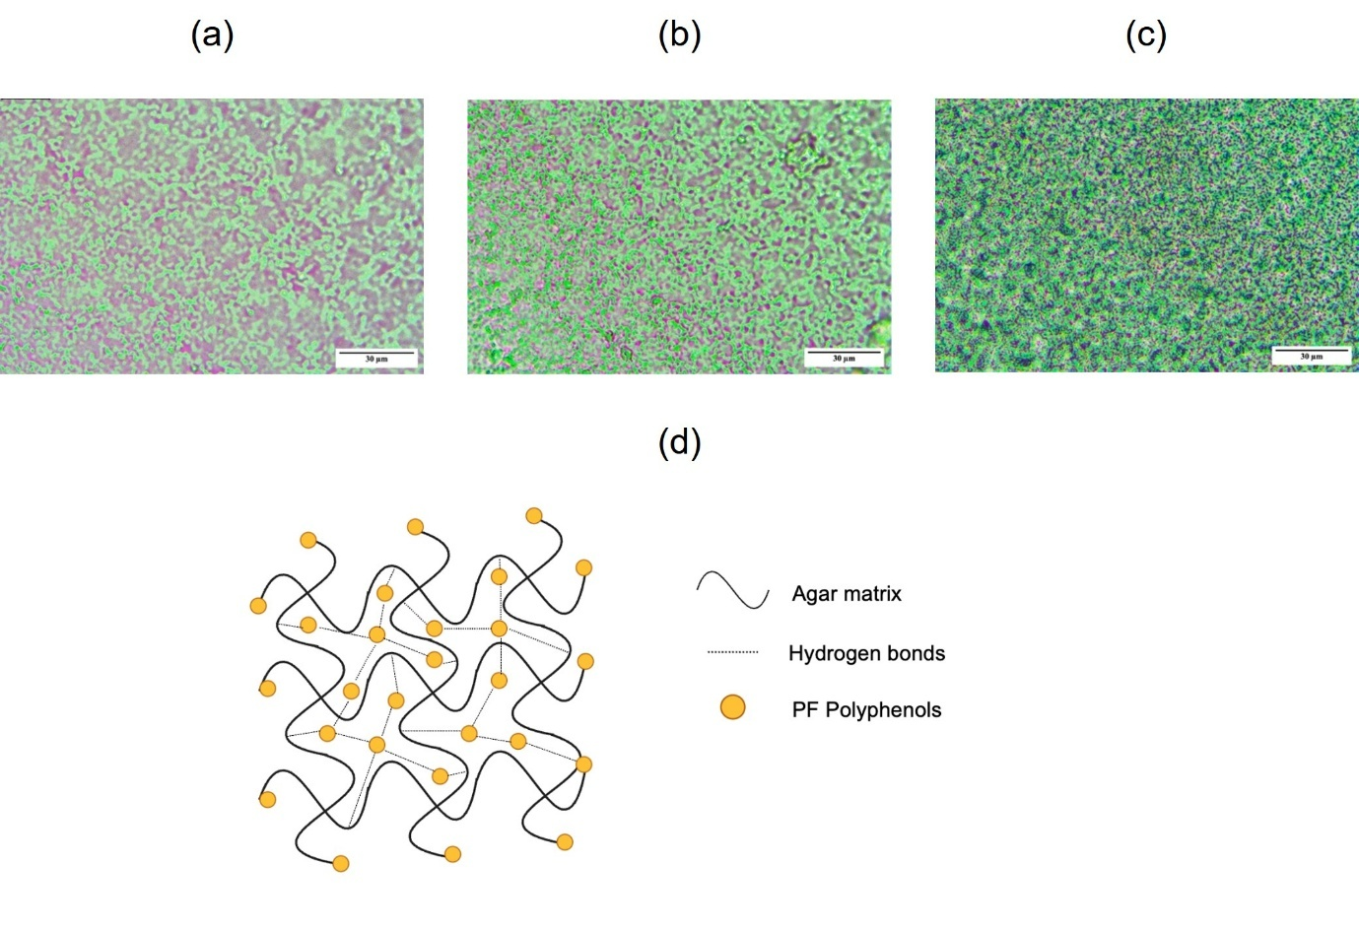
Supplementary Fig. 1 Microstructure of agar-pigface composite films observed under light microscopy (40×): (a) P1 (A:PF 1:2.5); (b) P6 (A:PF 1:20); (c) P9 (A:PF 1:40); (d) agar-polyphenol matrix

