Supplementary Information
Adaptive spatial partitioning under the GeoSOT-3D global grid for efficient low-altitude environment modelling
Qiurong Wang, Zhiyong Liu, and Ningshe Zhao*
*Corresponding author: zhaoningshe@gmail.com

Contents
• Supplementary Figure S1 — GeoSOT-3D conceptual schematic
• Supplementary Figure S2 — Synthetic low-altitude environment
• Supplementary Figure S3 — Xi'an study area DEM
• Supplementary Figure S4 — Local detail comparison
• Supplementary Table S1 — Comparison of 3D modelling approaches
• Supplementary Table S2 — Real-world data sources
• Supplementary Table S3 — Path-planning performance on the synthetic environment

Supplementary Figure S1
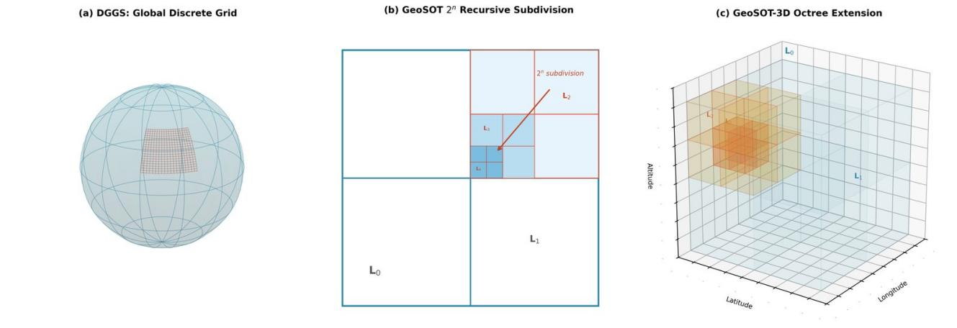
Supplementary Figure S1. Schematic of DGGS models. (a) hierarchical surface cells; (b) GeoSOT 2ⁿ quadtree from L₀ to L₄; (c) GeoSOT-3D octree voxel extension. The TSDP framework operates on the planar quadtree shown in (b); volumetric extension to the octree in (c) is left to future work.

Supplementary Figure S2
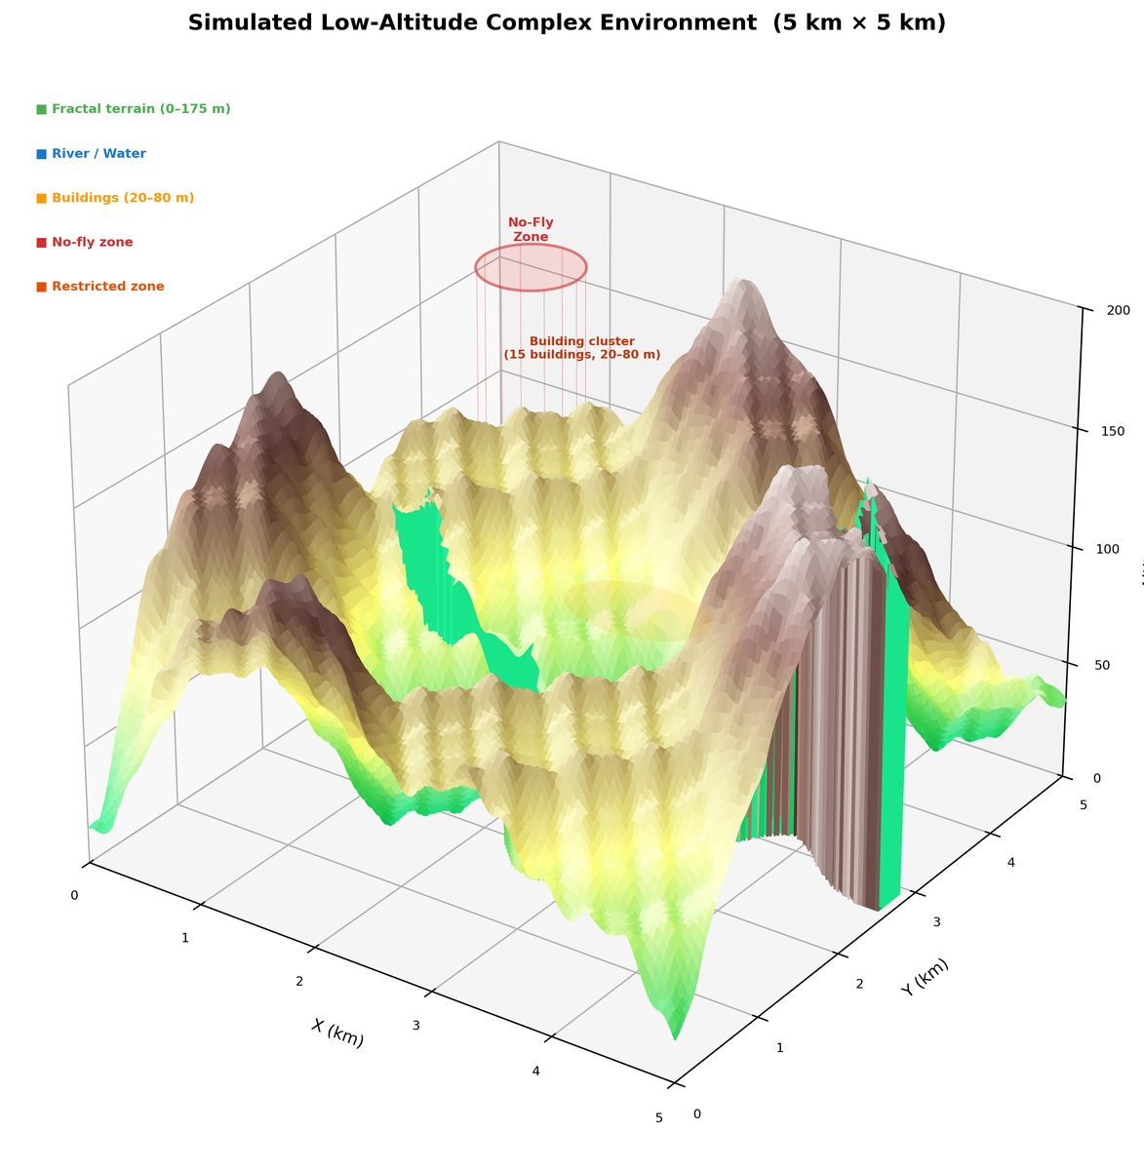
Supplementary Figure S2. Synthetic low-altitude environment used for benchmarking. The scene spans 5 × 5 km horizontally and 0–180 m in altitude, including fractal-noise terrain with 175 m relief, 15 randomly placed buildings (20–80 m), one no-fly zone, one restricted flight zone, and one river.

Supplementary Figure S3
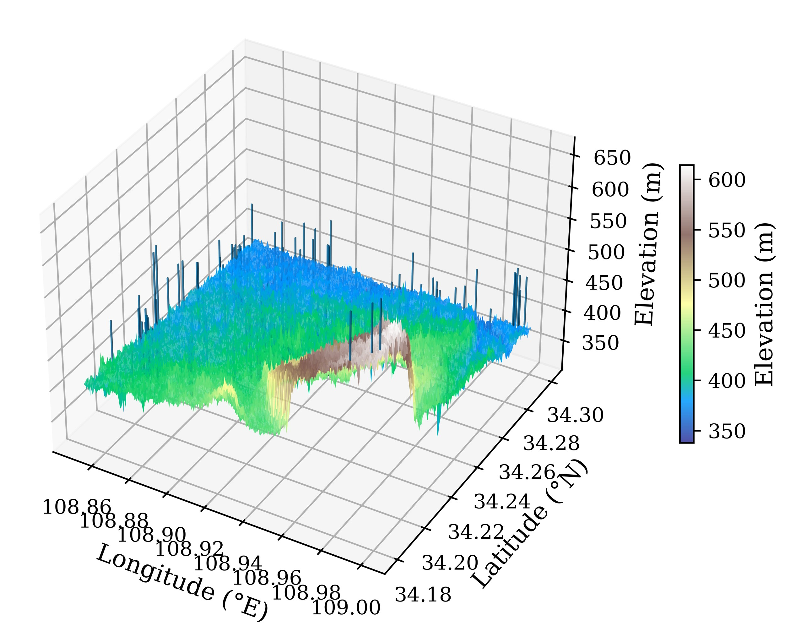
Supplementary Figure S3. 3D terrain visualisation of the Xi'an study area, derived from ASTER GDEM V3. The study extent covers 108.85°–109.00° E and 34.18°–34.30° N. Vertical bars overlaid on the terrain represent buildings (the bar height is the building height plus terrain elevation). Elevations range from approximately 350 m in the central depression to over 600 m in the peripheral elevated regions, providing a typical mixed-relief low-altitude environment.

Supplementary Figure S4
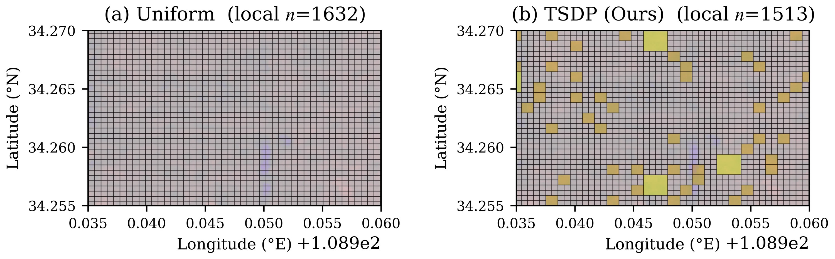
Supplementary Figure S4. Local detail comparison within a sub-area of the Xi'an scene (108.935°–108.960° E, 34.255°–34.270° N). (a) Uniform grid, local count n = 1,632; (b) TSDP, local count n = 1,513. Yellow cells in (b) are coarse merged voxels (L7 or shallower) generated by TSDP's bottom-up merging phase in flat sub-regions. TSDP achieves comparable local representation with fewer voxels by concentrating refinement only where terrain or semantic complexity warrants it.

Supplementary Table S1
Supplementary Table S1. Qualitative comparison of 3D modelling approaches for low-altitude environments. Categorical assessments (Excellent / Good / Moderate / Limited / Poor) reflect the typical performance reported in the cited literature for representative implementations.
Method | Global frame | Geometric adaptivity | Semantic integration | Efficiency | Main limitation
Regular global grid | Excellent | Poor | Limited | Excellent | Fixed resolution
AMR | Limited | Excellent | Limited | Good | Continuous fields only
Reality 3D model | Good | Excellent | Poor | Poor | Large data volume
Point-cloud voxels | Good | Poor | Good | Good | Fixed resolution
Semantic vector | Good | Excellent | Excellent | Poor | Complex topology
CityGML LOD | Good | Good | Excellent | Moderate | No global grid fusion

Supplementary Table S2
Supplementary Table S2. Data sources used in the real-world Xi'an experiment.
Data | Source | Resolution | Access
Elevation | ASTER GDEM V3 | 30 m; RMSE ≈ 8.68 m | NASA Earthdata
Buildings | OpenStreetMap | Vector (~4,200 footprints) | Overpass API
Airspace | eAIP / DJI FlySafe | ≈ 50–100 m | Public + manual
Waterways | OpenStreetMap | Vector | Overpass API

Supplementary Table S3
Supplementary Table S3. Path-planning performance on the synthetic environment, averaged over 30 repetitions with randomised start–goal pairs. Values after ± denote s.d.
Metric | Uniform | Terrain-AMR | TSDP
Time (s) | 2.37 ± 0.19 | 1.65 ± 0.13 | 1.42 ± 0.11
Expanded nodes | 15,832 | 8,945 | 7,590
Path length (m) | 6,842 | 6,715 | 6,698
Min. clearance (m) | 4.2 ± 1.8 | 5.1 ± 2.0 | 8.5 ± 1.4
Clearance violations (<5 m) | 3 | 2 | 0

TSDP reduces planning time by 40.1% relative to the uniform baseline (p = 0.0002), increases minimum obstacle clearance from 4.2 m to 8.5 m, and produces zero clearance violations across all 30 repetitions. Path lengths differ by less than 2% across methods, confirming that the safety improvements do not come at the cost of route efficiency.

