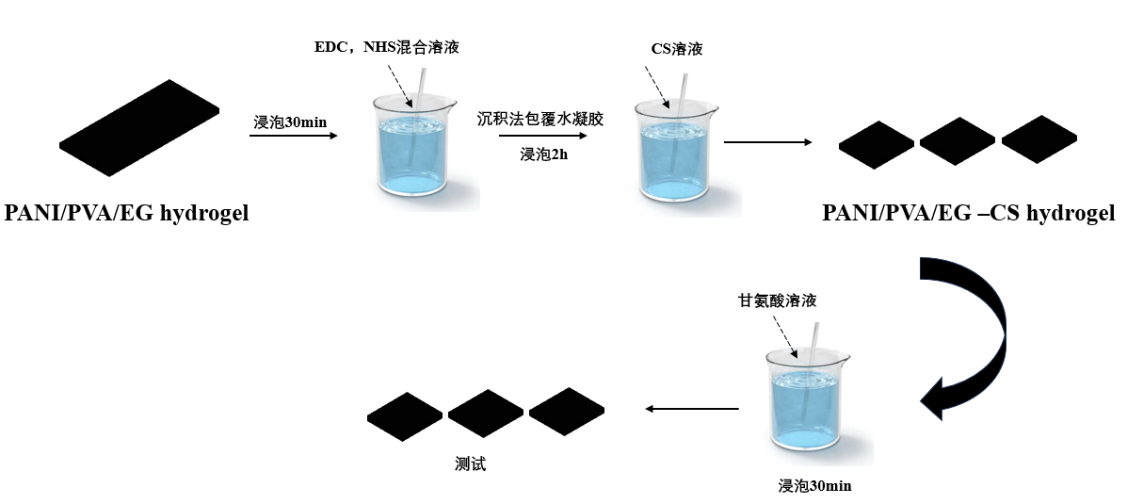
Scheme 1 Preparation and synthesis diagram of hydrogel PANI/PVA/EG-CS

