Table 2. Patient and Disease Characteristics at Study Entry by Treatment Arm 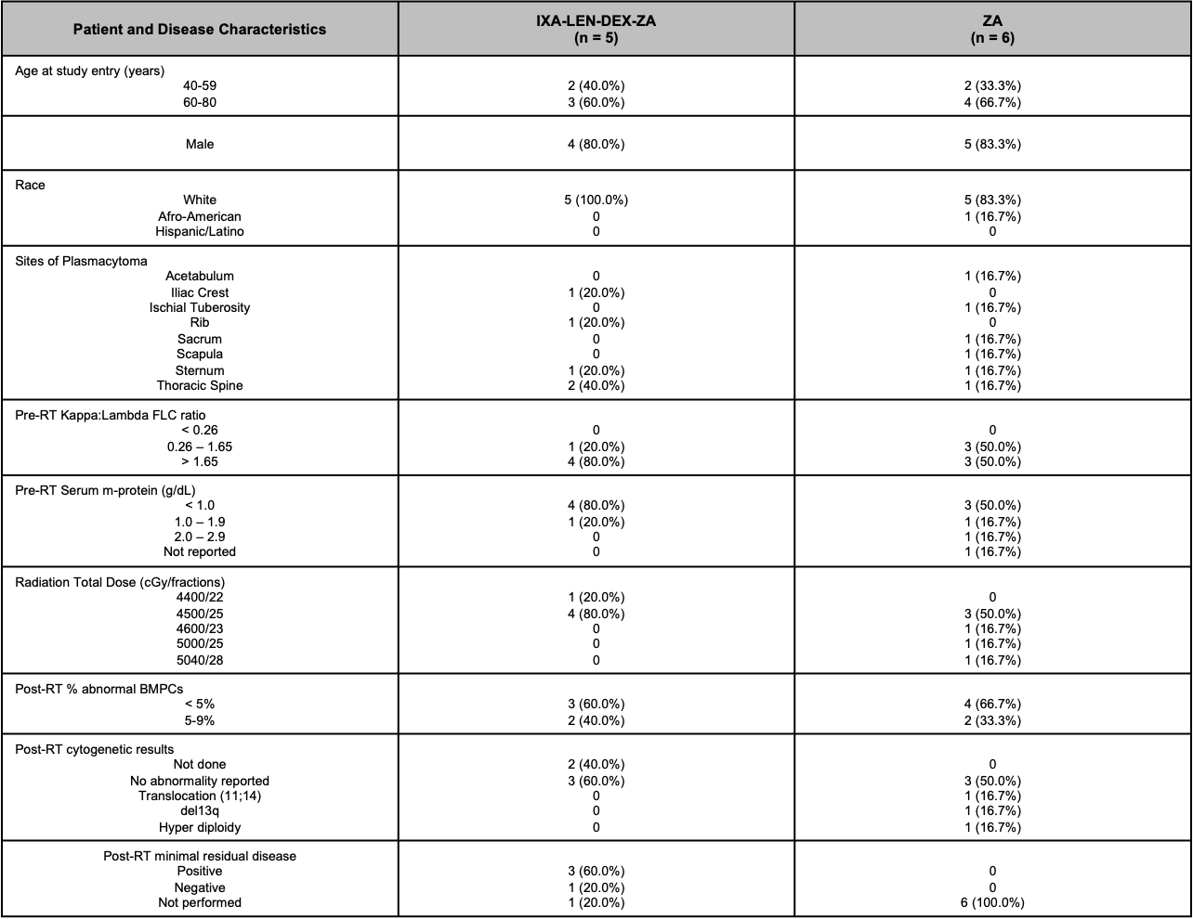
FLC: free light chain; g/dL: grams per deciliter; RT: radiation therapy; del: deletion; t: translocation; BMPC: bone marrow plasma cells; cGy: centigray

