Table 1. Criteria for Adequate Blood Chemistries, Measurable Disease, and Progression to Multiple Myeloma
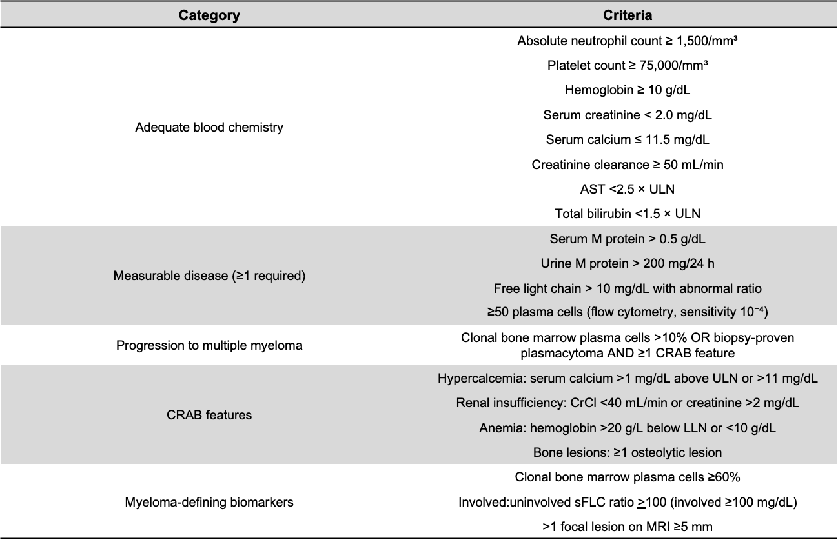
ULN: upper limit of normal; LLN: lower limit of normal; FLC: free light chain; CT: computed tomography; PET: positron emission tomography.

Table 2. Patient and Disease Characteristics at Study Entry by Treatment Arm 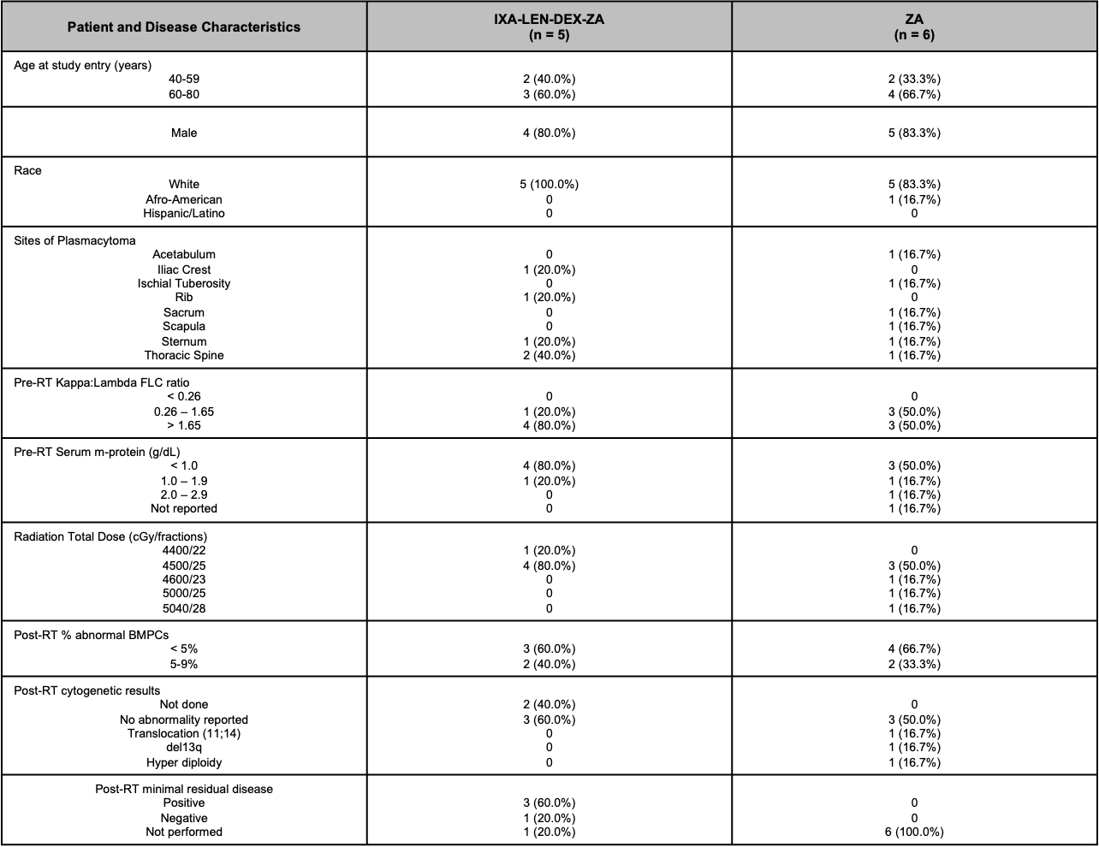

FLC: free light chain; g/dL: grams per deciliter; RT: radiation therapy; del: deletion; t: translocation; BMPC: bone marrow plasma cells; cGy: centigray

Table 3. Adverse Events: Maximum grade per patient regardless of attribution
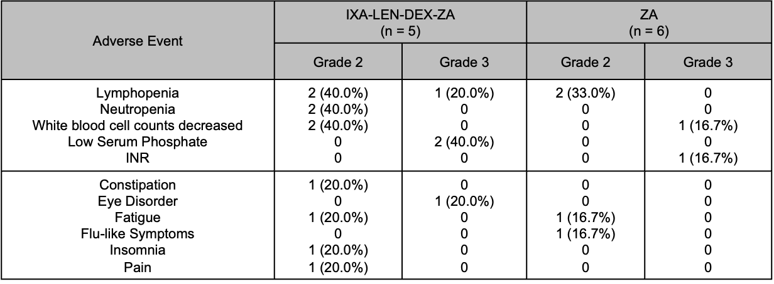
IXA: Ixazomib; LEN: Lenalidomide; DEX: Dexamethasone; ZA: zolendronic acid; n: number; INR: International normalized ratio

FLC: free light chain; g/dL: grams per deciliter; RT: radiation therapy; del: deletion; t: translocation; BMPC: bone marrow plasma cells; cGy: centigray.

