Table 3. Adverse Events: Maximum grade per patient regardless of attribution
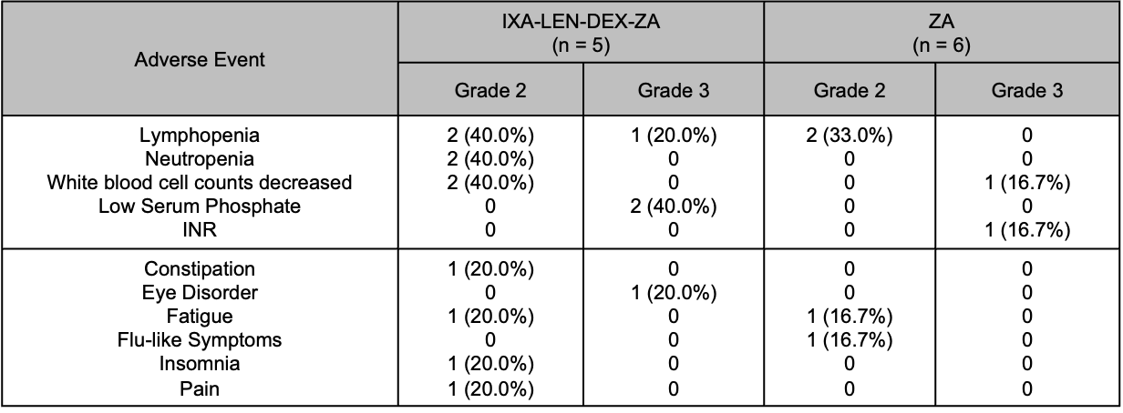
IXA: Ixazomib; LEN: Lenalidomide; DEX: Dexamethasone; ZA: zolendronic acid; n: number; INR: International normalized ratio

