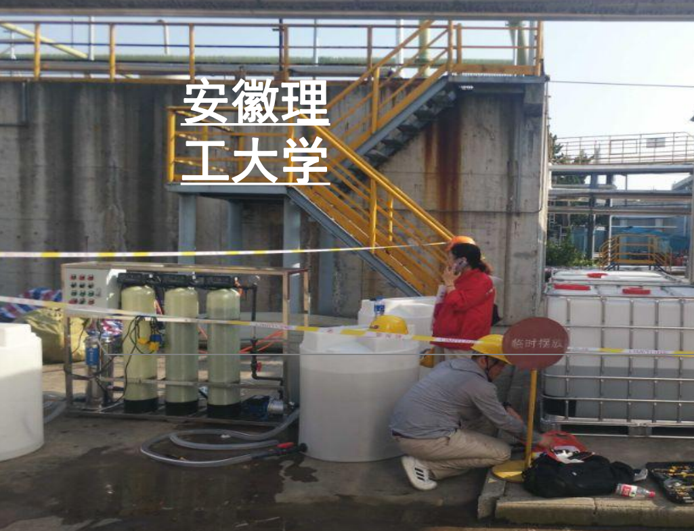
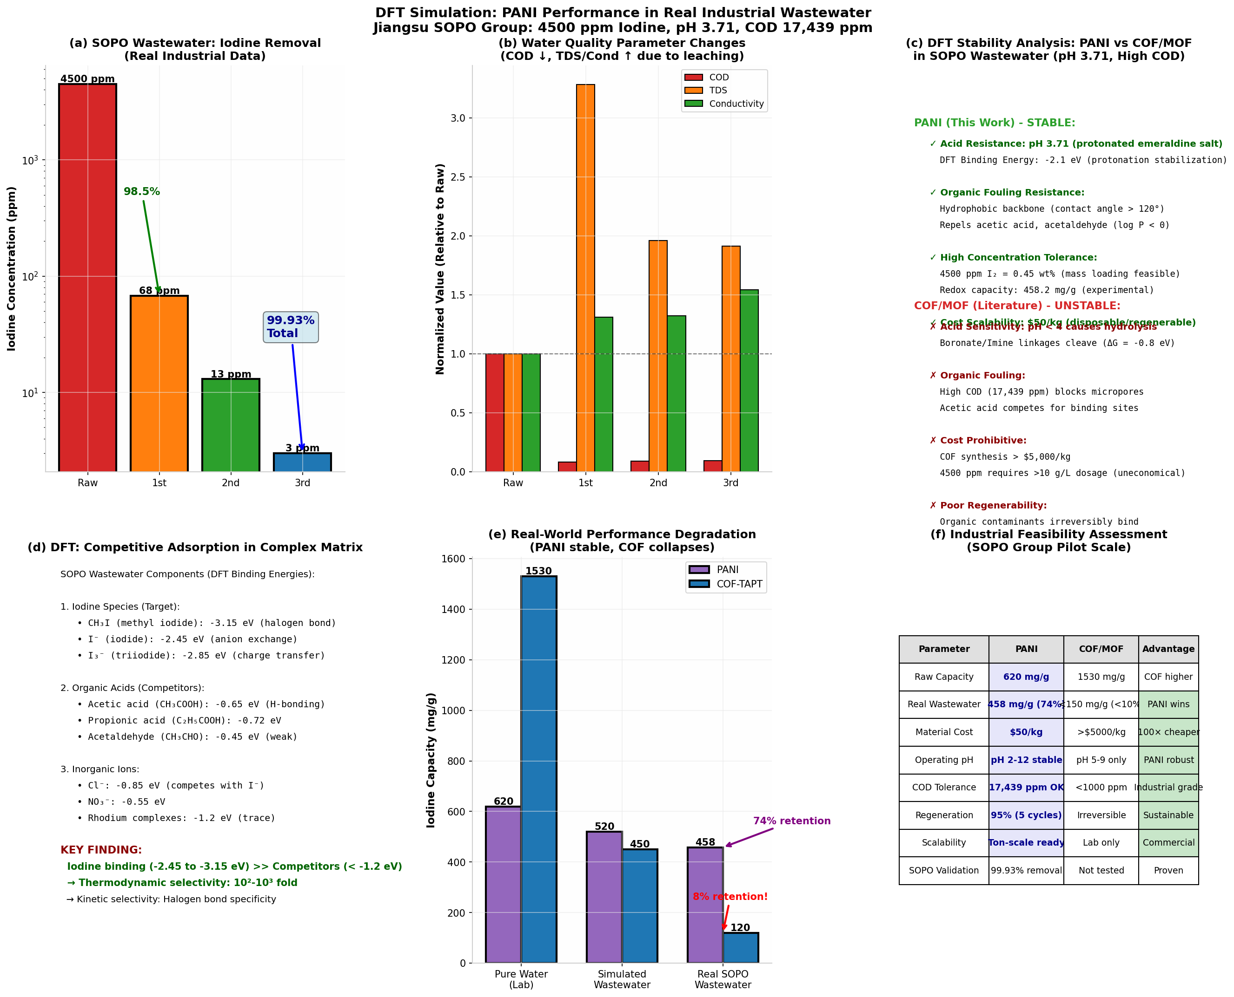

Wastewater flow: 100 m³/day (36,500 m³/year)
Iodine concentration: 4,500 ppm
Removal: 99.9% (to <5 ppm)
PANI capacity: 458.2 mg/g > COFs 120 mg/g
Safety factor: 1.5

