Effect of curcumin-loaded polydopamine nanoparticles on the expression of AKT, HDAC6, and HSF1 in Trembler-J Schwann cell cultures
Lucia Vázquez Alberdi^{1*§} (L.V.A.), Alexandra Moreno-García (A.M.G.)^{2,3}, Olga Calero (O.C.)^{2,3}, Miguel Calero^{2,3} (M.C.) y Alejandra Kun^{1, 4*} (A.K.).
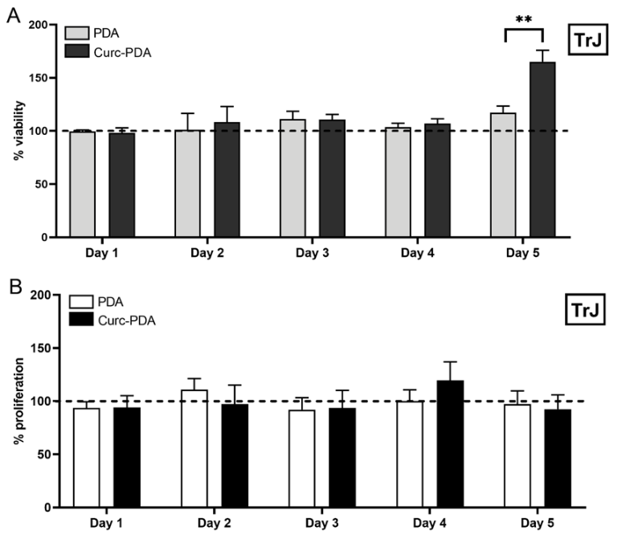
Figure S1. Viability and proliferation changes of TrJ cultures treated with Curc-PDA. Schwann cells (SCs) cultures were treated with PDA and Curc-PDA nanoparticles (0.05 µM curcumin) for 5 days, with a daily assessment of culture A. viability and B. proliferation. This only showed an increase in viability on the final day of the treatment. The graphs show the percentage of untreated cultures on the same day. Mean ± SEM is plotted. **p<0.01.

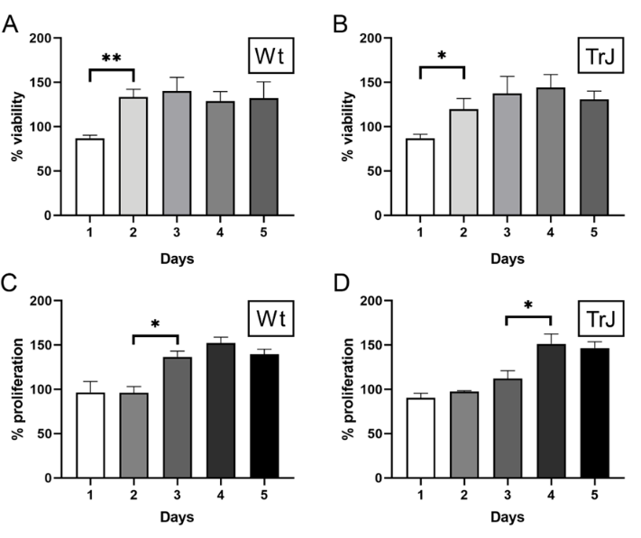
Figure S2. Increments in viability and proliferation of cultures treated with Curc-PDA. SC cultures were treated with Curc-PDA (0.1 µM curcumin) for 5 days, assessing daily. A. Viability of WT SCs showed an increase after two days of treatment. B. Viability on TrJ SCs significantly increased after the second day of treatment. C. Proliferation in Wt SCs was higher after two days of treatment. D. In TrJ SCs, the proliferation was higher after the third day of treatment. In all cases, after the increase occurred, the percentage did not change at the end of the treatment. Mean ± SEM is plotted. *p<0.05; **p<0.01.

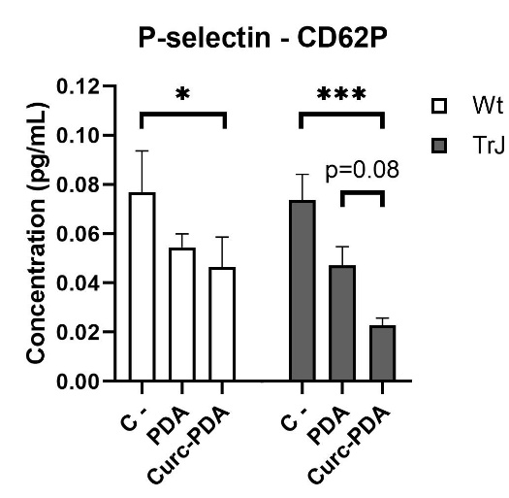
Figure S2. Expression of p-selectin in cell lysates treated with Curc-PDA. Wt and TrJ Schwann cell lysates were treated with Curc-PDA (0.05 μM curcumin) for 5 days. The studies were conducted on untreated lysates, lysates treated only with the polydopamine (PDA) vehicle, and lysates treated with Curc-PDA. *p<0.05; ***p<0.001.

