Supplementary Materials
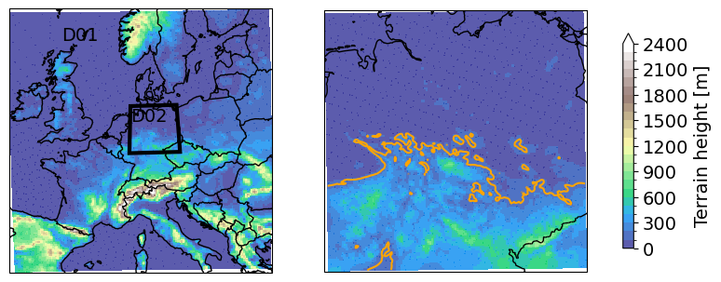
Supplementary Figure 1: The two WRF domains with elevation height in meters. Left, domain 1 15 km resolution with domain 2 shown. Right, domain 2 with orange line where the elevation is 150 meters.
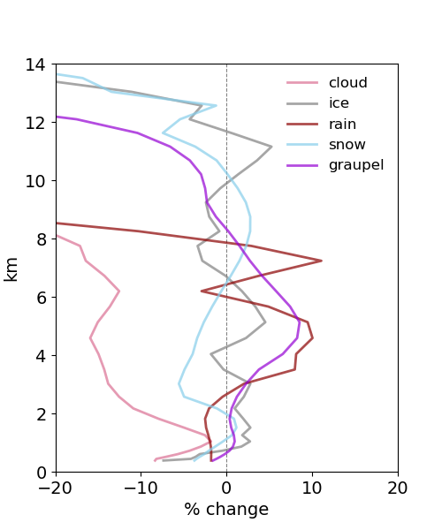
Supplementary Figure 2: The mean daily relative change between the clean and polluted simulation for the Thompson hydrometeors in the mountains for the 99.7 percentile days.

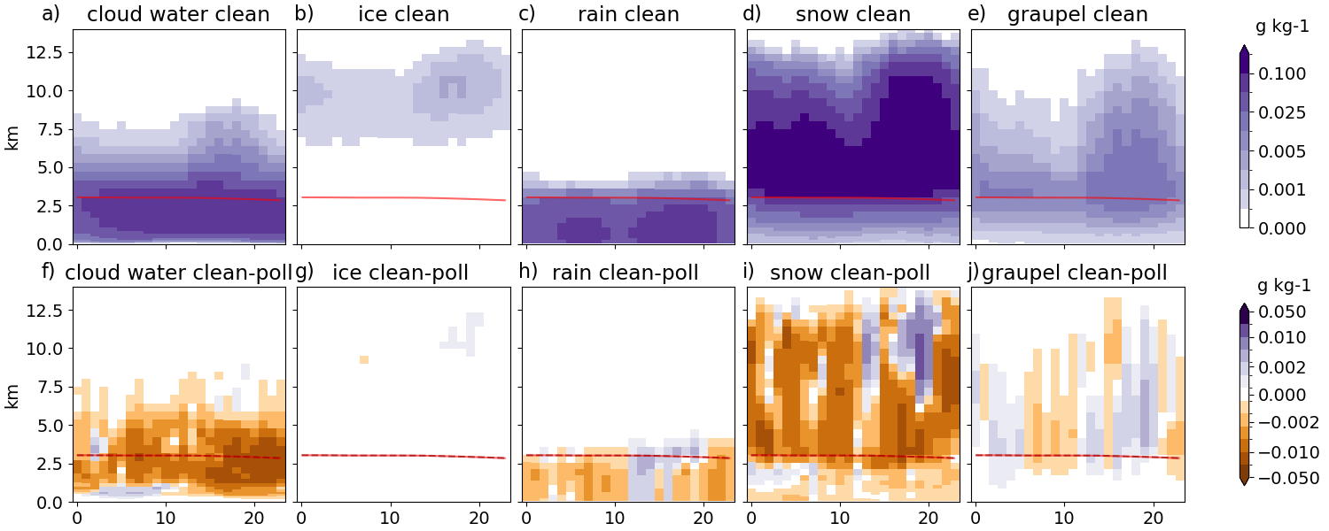
Supplementary Figure 3: Similar to Figure 3, however for lowland grid points.
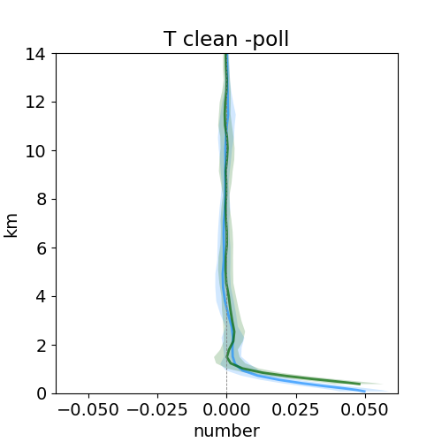
Supplementary Figure 4 Mean temperature difference between clean and polluted simulations over the 20-year simulations, over lowland (blue), and mountain (green) grid cells. Shading represents standard deviation in temperature difference over the years.

Supplementary Table 1: The linear regression trends [mm/year] for German precipitation stations, with 95 % confidence interval and the p value based on the hypothesis is that the slope is nonzero.
Years / elevation | <= 150 m (453 stations) |  | > 150 m (860 stations)
1955-2020 | 0.022 +/- 0.009 | p = 0.0 | 0.020 +/- 0.008 | p = 0.00
1955-1984 | -0.021 +/- 0.028 | p = 0.14 | 0.092 +/- 0.025 | p = 0.15
1991-2020 | 0.023 +/- 0.029 | p = 0.11 | -0.036 +/- 0.025 | p = 0.06

