Breastfeeding Education and Support Program Offering for Expectant Moms!

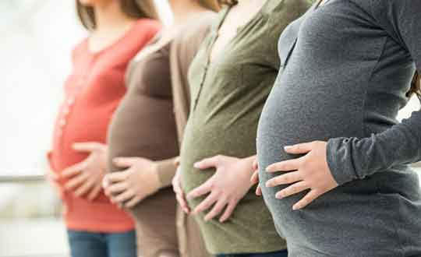

The Maternal Child Health program is offering a six-to-eight-week breastfeeding education and support for maternity women interested in breastfeeding their babies, learning about resources and looking to improve their confidence and intent to breastfeed their bundle of joy.

Program Participation Criteria:

Are you a pregnant woman in your second & third trimester (between 20 weeks and 38 weeks)?

Are you 18 years or older?

Are you interested in breastfeeding your baby?

Are you interested in learning about breastfeeding tips to improve your baby’s feeding success within your first few weeks after delivery?

If yes to the questions above, then you are an ideal candidate to benefit from this program.

If you are interested in participating in this program, please discuss with your nurse and/or call (732) 998-7032 for more information.

You can also email program facilitator at Beverly.kitscha@yahoo.com to indicate your interest.

