Supplementary Information

Table 1- Group Summary of EEG bad channels dropped by “pyprep”.
Group | Total  subjects | Total  dropped | Total Roi  relevant | Median dropped | Min  dropped | Max  dropped | Non-Roi  dropped | Roi relevant share
HC | 11 | 13 | 5 | 1.0 | 0 | 3 | 8 | 0.38
MDD | 11 | 20 | 2 | 2.0 | 0 | 3 | 18 | 0.1

Table 2 - Group Summary of fNIRs bad Pairs dropped based on Scalp Coupling Index.
Healthy Id | Number  Of bad channels | Bad  Pairs | MDD  Id | Number  Of bad channels | Bad  Pairs
205511 | 4 | S5_D7;S7_D7 | pf02 | 0 | -
212942 | 8 | S1_D3;S5_D7;S7_D5;S7_D7 | pf03 | 4 | S1_D3;S3_D1
215602 | 0 | - | pf04 | 6 | S5_D7;S7_D5;S7_D7
215713 | 0 | - | pf05 | 4 | S5_D7;S7_D7
215732 | 0 | - | pf06 | 6 | S5_D7;S5_D8;S8_D5
215735 | 0 | - | pf07 | 2 | S1_D3
215776 | 0 | - | pf08 | 0 | -
215823 | 2 | S7_D7 | pf09 | 14 | S3_D1;S3_D3;S5_D7;  S5_D8;S7_D5;S7_D7;S8_D5
215864 | 0 | - | pf10 | 12 | S1_D2;S2_D1;S2_D4;  S4_D2;S6_D7;S6_D8
215901 | 16 | S1_D1;S1_D3;S3_D1;S5_D5;  S5_D7;S7_D5;S7_D7;S8_D5 | pf11 | 0 | -
216032 | 0 | - | pf12 | 8 | S5_D7;S7_D6;S7_D7;S8_D6

Table 3 – Participant characteristics.
Characteristic | Healthy  controls | MDD  patients | Statistics
N | 11 | 11 | -
Sex (M/F) | 8/3 | 8/3 | -
Age (years) median,  range | 28, (19,55) | 30, (18,54) | Mann–Whitney U = 68.0, p = 0.646
BDI-II score median,  range | 2, (0,11) | 19, (4,38) | Mann–Whitney U = 116.5, p = 0.0002

Table 4 – Alpha band relative EEG power mean, standard deviation and median of healthy controls within the ROIs.
ROI | Mean Healthy  controls | Std Healthy  controls | Median Healthy  controls
LMFC | 0.3873 | 0.1268 | 0.3743
LT | 0.3503 | 0.0968 | 0.2988
PFC | 0.4136 | 0.1296 | 0.4349
PP | 0.5712 | 0.1520 | 0.5613
RMFC | 0.3785 | 0.1182 | 0.4364
RT | 0.3430 | 0.1158 | 0.3543

Table 5- Alpha band relative EEG power mean, standard deviation and median of MDD group within the ROIs.
ROI | Mean MDD | Std MDD | Median MDD
LMFC | 0.2706 | 0.1313 | 0.2655
LT | 0.2595 | 0.1154 | 0.2799
PFC | 0.2628 | 0.1405 | 0.2525
PP | 0.3682 | 0.1719 | 0.3701
RMFC | 0.2836 | 0.1451 | 0.2728
RT | 0.2502 | 0.1179 | 0.2273

Table 6 –EEG Brunner–Munzel test results for group differences between the two groups, together with the corresponding permutation-based Brunner–Munzel p-values.
ROI | BM-stat | BM-p value  uncorrected | BM significance  uncorrected | Permuted  p-value | Permuted  significance
LMFC | -2.0730 | 0.0530 | FALSE | 0.0578 | FALSE
LT | -2.3811 | 0.0311 | TRUE | 0.0344 | TRUE
PFC | -2.8730 | 0.0094 | TRUE | 0.0175 | TRUE
PP | -3.5938 | 0.0018 | TRUE | 0.0064 | TRUE
RMFC | -1.6124 | 0.1229 | FALSE | 0.1229 | FALSE
RT | -1.8922 | 0.0730 | FALSE | 0.0775 | FALSE

Table 7- Descriptive statistics of oxyhemoglobin fALFF values for each channel in the healthy control and MDD groups, including sample size, mean, standard deviation, and median.
channel | n_HC | n_MDD | mean_HC | std_HC | mean_MDD | std_MDD | median_HC | median_MDD
S5_D8 hbo | 11 | 8 | 0.5560 | 0.0879 | 0.6325 | 0.0681 | 0.5537 | 0.6434
S3_D1 hbo | 10 | 10 | 0.5418 | 0.0899 | 0.5884 | 0.1058 | 0.5329 | 0.6122
S8_D5 hbo | 10 | 8 | 0.5417 | 0.1043 | 0.6289 | 0.0944 | 0.5283 | 0.6324
S3_D3 hbo | 11 | 10 | 0.5405 | 0.0875 | 0.5865 | 0.0942 | 0.5618 | 0.6049
S1_D3 hbo | 9 | 10 | 0.5470 | 0.0847 | 0.5934 | 0.0828 | 0.5554 | 0.6168
S2_D4 hbo | 11 | 11 | 0.5209 | 0.0866 | 0.5664 | 0.1209 | 0.53517 | 0.6252
S1_D2 hbo | 11 | 11 | 0.5134 | 0.0952 | 0.5589 | 0.1104 | 0.51249 | 0.5913
S1_D1 hbo | 10 | 10 | 0.5416 | 0.0910 | 0.5951 | 0.0691 | 0.54109 | 0.6099
S3_D4 hbo | 11 | 11 | 0.5532 | 0.0800 | 0.5904 | 0.1242 | 0.56980 | 0.6287
S8_D6 hbo | 11 | 10 | 0.5303 | 0.0950 | 0.5818 | 0.1245 | 0.52632 | 0.5948
S2_D1 hbo | 11 | 11 | 0.5214 | 0.0910 | 0.5577 | 0.1231 | 0.51704 | 0.6099
S6_D8 hbo | 11 | 11 | 0.5518 | 0.0912 | 0.5870 | 0.1015 | 0.53511 | 0.6155
S7_D6 hbo | 11 | 10 | 0.532 | 0.0930 | 0.5936 | 0.1099 | 0.53008 | 0.6041
S7_D5 hbo | 9 | 8 | 0.5457 | 0.1007 | 0.6099 | 0.0739 | 0.53553 | 0.6071
S5_D5 hbo | 10 | 11 | 0.5460 | 0.0973 | 0.5891 | 0.1009 | 0.55829 | 0.6072
S4_D3 hbo | 11 | 11 | 0.5530 | 0.0948 | 0.5824 | 0.0996 | 0.56093 | 0.6109
S4_D2 hbo | 11 | 11 | 0.5318 | 0.1022 | 0.5669 | 0.0993 | 0.52227 | 0.5850
S6_D7 hbo | 11 | 11 | 0.5559 | 0.0969 | 0.5820 | 0.1039 | 0.57717 | 0.54701

Table 8 - Channel-wise Brunner–Munzel test results for group differences in oxyhemoglobin fALFF between the HC and MDD groups, including the BM test statistic, uncorrected p-value, permutation based two-sided p-value, and significance at α = 0.05.
channel | bm_stat | bm_p | perm_p_two_sided | perm_sig_0.05
S5_D8 hbo | 2.3941 | 0.0288 | 0.04062 | TRUE
S3_D1 hbo | 1.5491 | 0.1424 | 0.13938 | FALSE
S8_D5 hbo | 1.5368 | 0.1438 | 0.14302 | FALSE
S3_D3 hbo | 1.4814 | 0.1595 | 0.15030 | FALSE
S1_D3 hbo | 1.4298 | 0.1708 | 0.16547 | FALSE
S2_D4 hbo | 1.3775 | 0.1868 | 0.17851 | FALSE
S1_D2 hbo | 1.2639 | 0.2240 | 0.21233 | FALSE
S1_D1 hbo | 1.2443 | 0.2294 | 0.21942 | FALSE
S3_D4 hbo | 1.1857 | 0.2540 | 0.23819 | FALSE
S8_D6 hbo | 1.1348 | 0.2714 | 0.25615 | FALSE
S2_D1 hbo | 1.1153 | 0.2810 | 0.26375 | FALSE
S6_D8 hbo | 1.0754 | 0.2950 | 0.28273 | FALSE
S7_D6 hbo | 1.0609 | 0.3035 | 0.289754 | FALSE
S7_D5 hbo | 1.0644 | 0.3050 | 0.286274 | FALSE
S5_D5 hbo | 0.9236 | 0.3672 | 0.347033 | FALSE
S4_D3 hbo | 0.7943 | 0.4365 | 0.421911 | FALSE
S4_D2 hbo | 0.7806 | 0.4442 | 0.432411 | FALSE
S6_D7 hbo | 0.2794 | 0.78289 | 0.781024 | FALSE

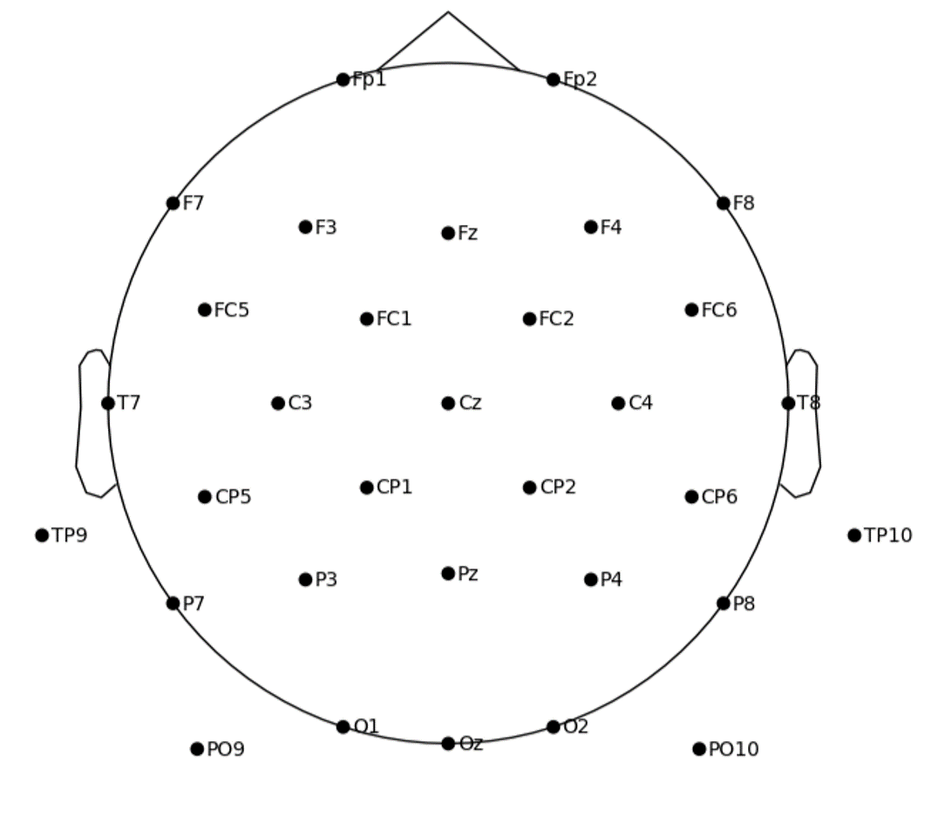
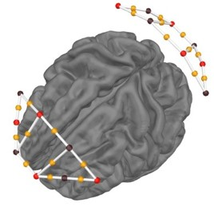
Figure 1- Left: EEG electrodes position. (Source: EEGLAB) , right: §D model of the fNIRS channels (yellow),detectors (purple) and sources (red) (source: MNE Python).

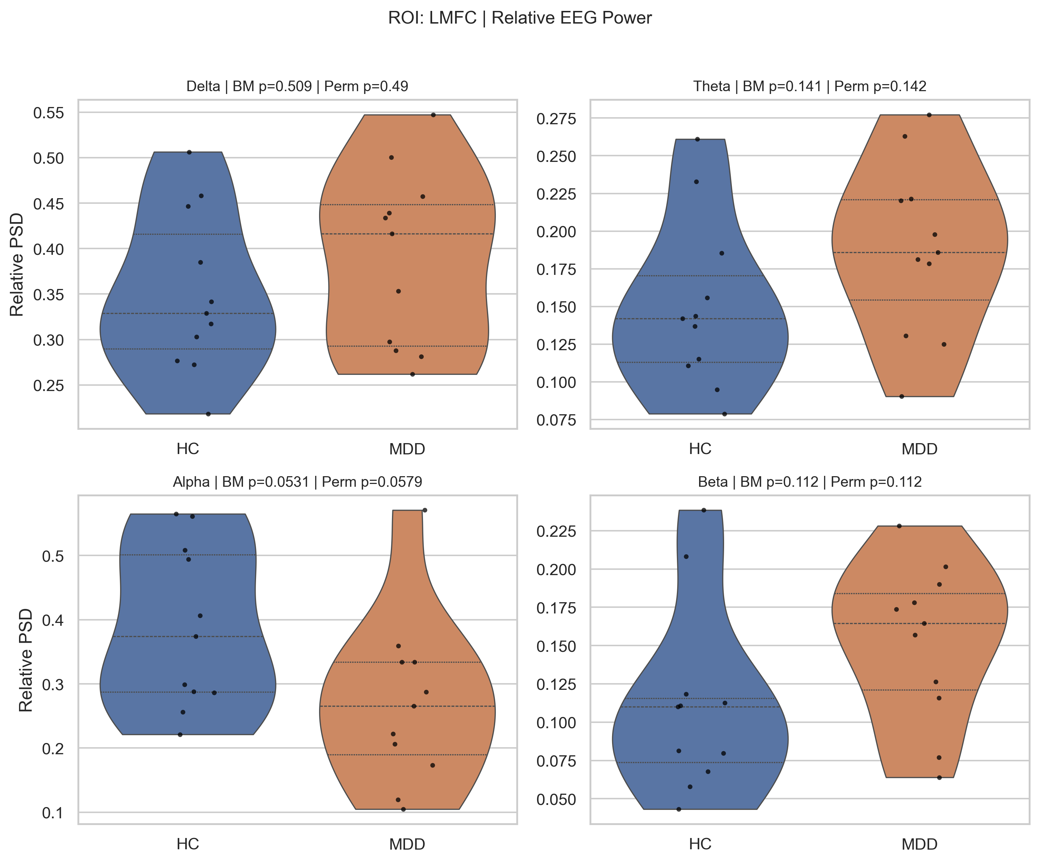
Figure 2- Violin plots of relative EEG power in the LMFC region for the delta, theta, alpha, and beta bands in healthy controls (HC) and patients with major depressive disorder (MDD).

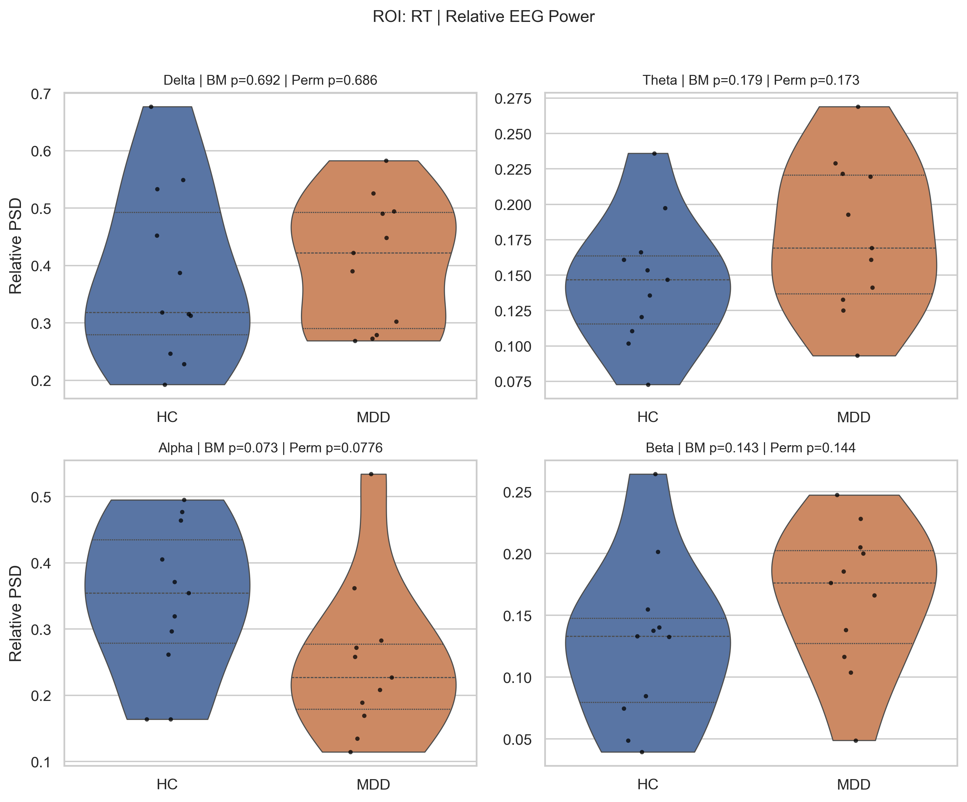

Figure 3- Violin plots of relative EEG power in the RT region for the delta, theta, alpha, and beta bands in healthy controls (HC) and patients with major depressive disorder (MDD).

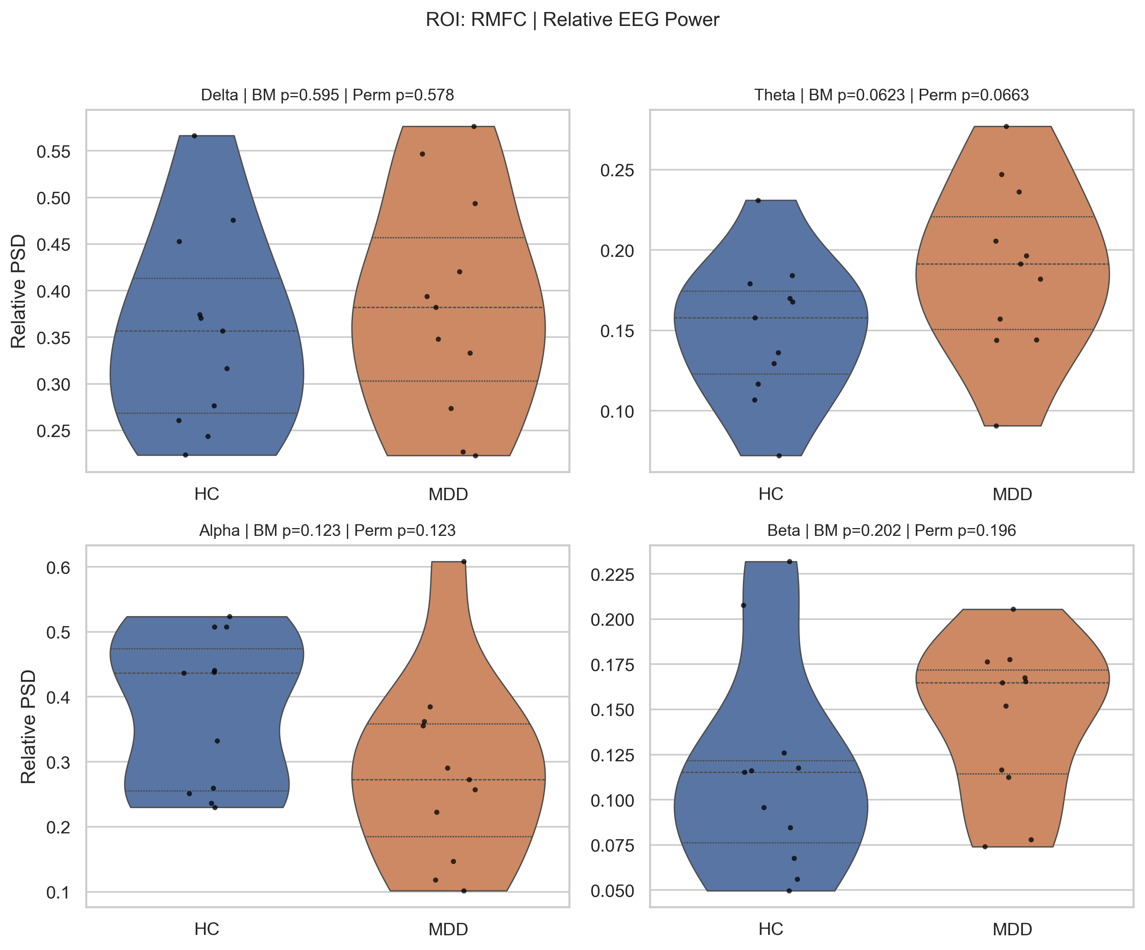
Figure 4- Violin plots of relative EEG power in the RMFC region for the delta, theta, alpha, and beta bands in healthy controls (HC) and patients with major depressive disorder (MDD).

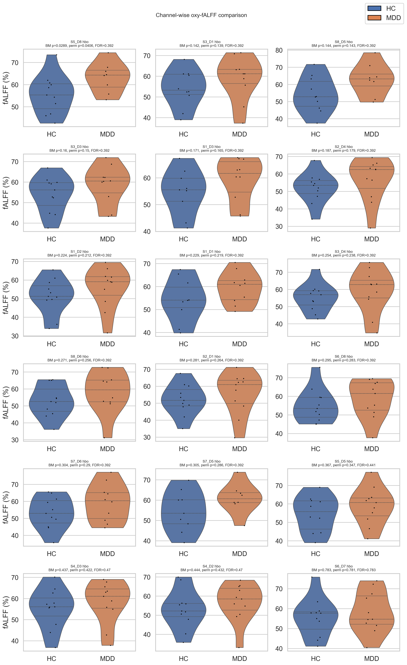

Figure 5- Channel-wise comparison of oxyhemoglobin fALFF (%) between healthy controls and patients with major depressive disorder.

