Table S1. Details of fungal phytopathogens used in this study
Host plant | Scientific name | Isolate | Provider
Tomato | Fusarium oxysporum f. sp. lycopersici | Foly4 | World vegetable center
Tomato | F. oxysporum f. sp. lycopersici | F-01 | Taiwan seed improvement and propagation station (TSIPS)
Watermelon | F. oxysporum f. sp. niveum | Fon-H0103 | Dr. Jenn-Wen Huang
Strawberry | Colletotrichum gloeosporioides | CG8 | Dr. Wen-Hsin Chung
Rice | Magnaporthe oryzae | PT-3 | Dr. Chih-Li Wang

Table S2. Molecular identity of 18 rhizobacterial strains based on sequence analysis of 16S rDNA region
Strain ^{I} | Closest identity ^{II} | Identity (%)
LCKV | Klebsiella variicola F2R9 | 99.93
LCAP | Acinetobacter pittii DSM | 99.86
LCPN-23 | Pseudomonas nitroreducens IAM | 99.35
LCPA | P. aeruginosa DSM | 100.00
NRAP-1 | A. pittii strain LMG | 99.93
NRAP-2 | A. pittii strain LMG | 99.93
NRBC | Burkholderia contaminans J2956 | 99.93
NRBA | B. aenigmatica LMG | 99.71
NRKV | K. variicola F2R9 | 99.85
NRRS | Ralstonia syzygii subsp. indonesiensis UQRS | 99.06
NRAP-3 | A. pittii DSM | 99.86
WRPT | P. taiwanensis DSM 21245 | 100.00
WRSS | Serratia surfactantfaciens YD25 | 99.86
WRPN-1 | P. nitritireducens WZBFD3-5A2 | 99.49
WRAB | A. baumannii ATCC | 100.00
WRPM | P. mosselii CFML | 99.93
WSPN-21 | P. nitroreducens IAM | 99.35
WSPN-22 | P. nitroreducens IAM | 99.35
^{I} The first two alphabets, LC, NR, WR, and WS, of strain represent the source as Linluo cucumber, NPUST rice, Wandan rice, and Wandan sugarcane fields, respectively. The last two alphabets of strain are the initials of their scientific names.
^{II} The closest identity was obtained by aligning the sequence of self-isolated strains to the NCBI BLAST database.

Table S3. List of primers used for qRT-PCR
Gene | Forward Primer (5’ to 3’) | Reverse Primer (3’ to 5’)
β-tubulin (TUB) | CAAGAACTCGTCCTACTTTG | GCTCACTCACCCTTCTAA
WRKY transcription factor 70 (WRKY70) | TGGTAAAGCATAGTGACTCAAC | AGAGGGAGAAGAAGGCATAA
Pathogenesis-related protein 1 (PR1)  1-aminocyclopropane-1-carboxylate synthase 2 (ACS2) | GGTAACTGGAGAGGACAA  GATGGATTTGCGTCCACTTT | GACAATCGATCACTTTATTC  GATCCAGGCGAGACGTTAG
UDP-glycosyltransferase (UDP-G) | GATGAACGCCACCTTCTTAG | CTCCTTCCATAACAATCCTCAC
Ethylene Response Factor 1 (ERF1) | AGACTTGGGAGTTGAATTA | TACATTGCGATCTTGATTA
Allene oxide synthase (AOS) | CCTCTTCCTTCTCTTCACCAAA | GCCGGGTATAGTCCTGGTAGA

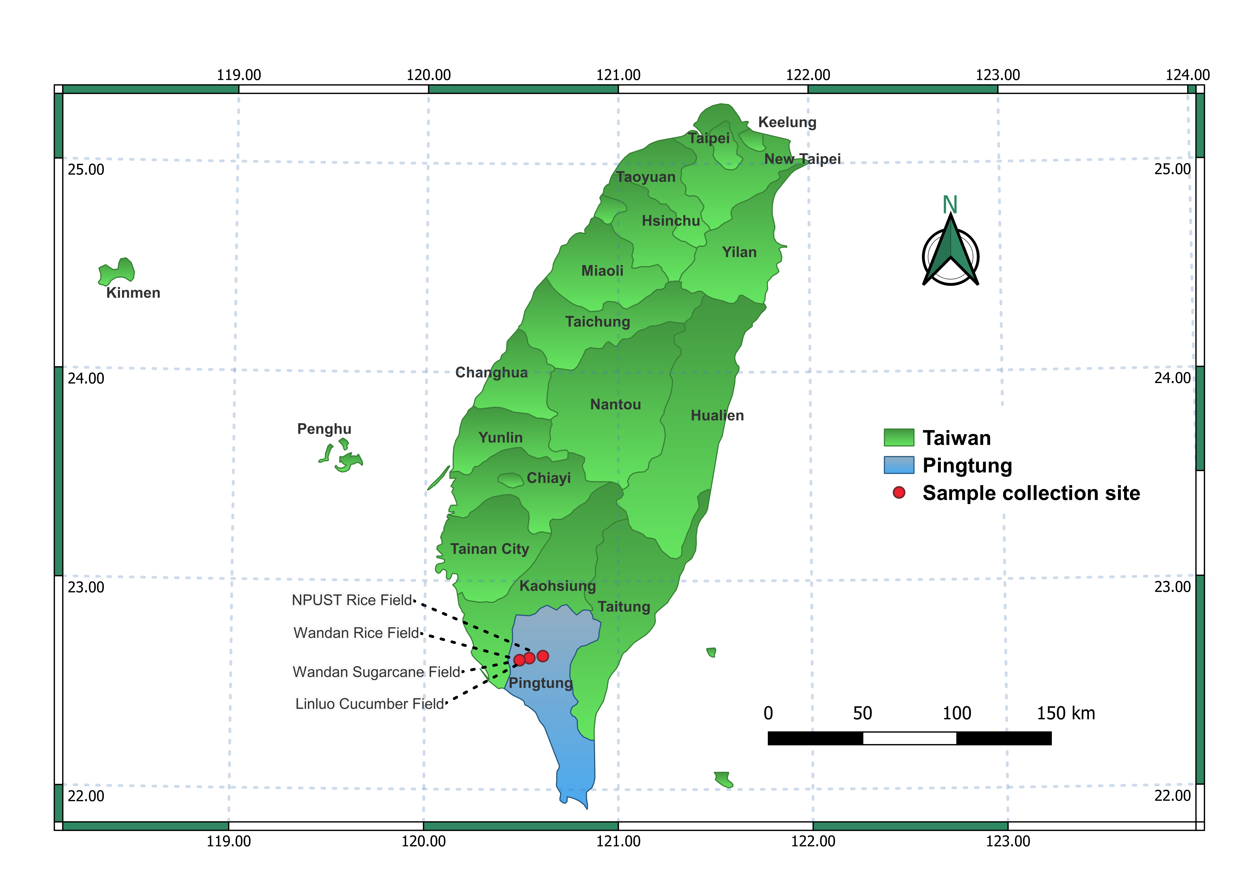
Fig. S1. Map of Taiwan showing the four sampling sites in Pingtung County. Two of the fields were being used for rice cultivation and had been recently harvested, namely, Wandan rice field (GPS coordinate: 22°36'56.3"N 120°29'19.1"E) and NPUST rice field (GPS coordinate: 22°38'38.0"N 120°36'18.2"E). The other two fields were still under cultivation, namely, Linluo cucumber field (GPS coordinate: 22°37'56.2"N 120°32'09.6"E) and Wandan sugarcane field (GPS coordinate: 22°36'57.2"N 120°29'17.2"E).

Fig. S2. In vitro beneficial traits exhibited by representative rhizobacterial strains. The appearance of a halo-zone around the bacterial colony indicates (A) silicate solubilization on silicate medium, (B) phosphate solubilization on Pikovskaya medium, and (C) siderophore production on Chrome Azurol Sulphonate (CAS) agar medium. A scale bar at the bottom right corner represents 1 cm.

