¹⁸F-FDG-PET-guided, pathological complete response-adapted chemotherapy de-escalation in HER2-positive early breast cancer: 5-year outcomes and exploratory ctDNA analyses from the randomized phase 2 PHERGain trial
Pérez-García J. et al.,
Supplementary material
Supplementary methods 1
Inclusion criteria: 1
Exclusion criteria: 2
Randomization and masking 3
Supplementary Fig. 1. PHERGain study design. 4
Supplementary Fig. 2. Consort diagram of plasma sample collection for ctDNA analyses at baseline, the day after cycle 2 (C3D1) and pre-surgery. 5
Supplementary Fig. 3. Association between ctDNA clearance and PET response. 5
Supplementary Fig. 4. Association between ctDNA status and clearance with 5-year DDFS. 5
Supplementary Table 1. 5-year iDFS events by ctDNA status at baseline. 6
Supplementary Table 2. 5-year iDFS events by ctDNA status at C3D1 7
Supplementary Table 3. 5-year iDFS events by ctDNA clearance at C3D1 7

Supplementary methods

Inclusion criteria:
Patients were included in the study only if they meet ALL of the following criteria:
- Written informed consent prior to beginning specific protocol procedures.
- Female or male patients ≥ 18 years of age.
- Eastern Cooperative Oncology Group (ECOG) performance status of 0-1.
- Histologically proven invasive breast cancer.
- Operable breast cancer (cT1-3 and/or cN0-2 tumors).
- Tumor size larger than or equal to 1.5 centimeter (cm) in diameter by magnetic resonance imaging (MRI) or ultrasound with a significant ¹⁸F-FDG uptake defined as maximum standardized uptake value (SUVmax) ≥1.5 x SUVmean liver + 2 SD.
Multicentric/multifocal tumors will be allowed only if:
1. Histological confirmation of at least two lesions.
2. All tumors must be HER2-positive.
3. Largest lesion must be larger than or equal to 1.5 cm in diameter by MRI or ultrasound.
- Centrally confirmed HER2-positive disease according to the 2018 American Society of Clinical Oncology/College of American Pathologists (ASCO/CAP) criteria.
- Patient must have known estrogen receptor (ER) and progesterone receptor (PR) status locally determined prior to study entry.

Patient has adequate bone marrow, liver, and renal function:

- Hematological: White blood cell (WBC) count > 3.0 x 10⁹/L, absolute neutrophil count (ANC) ≥ 1.5 x 10⁹/L, platelet count ≥ 100.0 x10⁹/L, and hemoglobin ≥ 10.0 g/dL (≥ 6.2 mmol/L).
- Hepatic: total bilirubin ≤ institutional upper limit of normal (ULN) (except for Gilbert’s syndrome); alkaline phosphatase (ALP) ≤ 2.5 times ULN; aspartate transaminase (AST) and alanine transaminase (ALT) ≤ 1.5 times ULN.
- Renal: serum creatinine ≤ 1.5 x ULN or creatinine clearance ≥ 50 mL/min/1.73 m² for patients with creatinine levels above institutional normal.
- Patient must be accessible for treatment and follow-up.

Exclusion criteria:
Any patient meeting ANY of the following criteria was excluded from the study:
- Previous treatment with chemotherapy, anti-HER2 therapy, radiation therapy, or endocrine therapy for invasive breast cancer.
- cT4 and/or cN3 tumors.
- Bilateral breast cancer.
- Evidence of metastatic disease by routine clinical assessment [chest x-ray, liver ultrasound, and bone scan; or computed tomography (CT) scan of thorax and and abdomen and bone scan], except patients with subclinical M1 at baseline only according to 18F-fluorodeoxyglucose (18F-FDG) positron emission tomography/computed tomography (PET/CT) that will be allowed to be included into Cohort C.
- Known hypersensitivity reaction to any investigational or therapeutic compound or their incorporated substances.
- History of other malignancy within the last five years prior to first dose of study drug administration, except for curatively treated basal and squamous cell carcinoma of the skin and/or in situ cervical carcinoma.
- Left ventricular ejection fraction (LVEF) below 55% as determined by multiple-gated acquisition (MUGA) scan or echocardiography (ECHO).
- Uncontrolled hypertension (systolic > 150 mm Hg and/or diastolic > 100 mm Hg) despite adequate antihypertensive treatment.
- Clinically significant cardiovascular disease [stroke, unstable angina pectoris, or documented myocardial infarction within six months prior to study entry; history of documented congestive heart failure (CHF) (New York Heart Association II-III-IV); symptomatic pericarditis; documented cardiomyopathy; ventricular arrytmhias with the exception of benign premature ventricular contractions; conduction abnormality requiring a pacemaker; other arrhythmias not controlled with medication].
- Active uncontrolled infection at the time of enrollment.
- Current known infection with HIV, hepatitis B virus, or hepatitis C virus.
- Patients with pulmonary disease requiring continuous oxygen therapy.
- Previous history of bleeding diathesis.
- Patient is currently receiving anti-coagulant therapy, chronic treatment with corticosteroids, or another immunosuppressive agent (standard premedication for chemotherapy and local applications are allowed).
- Major surgical procedure or significant traumatic injury within 14 days prior to randomization or anticipation of need for major surgery within the course of the study treatment.
- Patient has other concurrent severe and/or uncontrolled medical condition that would, in the investigator´s judgment, contraindicate her participation in the clinical study.
- Concurrent participation in other clinical trial, except other translational studies.
- History of receiving any investigational treatment within 28 days prior to randomization.
- Pregnant or breast-feeding women or patients not willing to apply highly effective contraception as defined in the protocol.

Randomization and masking
Patients who underwent baseline 18F-FDG-PET were randomly assigned in a 1:4 ratio to groups A or B. A central randomization procedure was set up with the OpenClinica web-based software. Randomization was stratified by hormone receptor status (positive or negative). Patients with subclinical metastases detected at baseline 18F-FDG-PET, but not previously detected by routine clinical assessment, were included in an exploratory group C (not reported in this article). In this open-label study, patients, Investigators, and the study team were aware of the group assignment. However, Investigators participating in the centralized review of 18F-FDG-PET results were masked to the group assignment.

Supplementary Fig. 1. PHERGain study design.
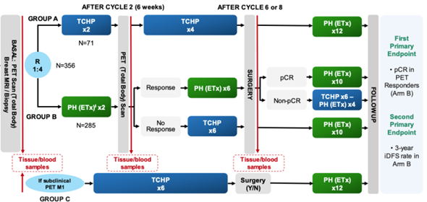
Abbreviations:
C: Carboplatin; D: Docetaxel; EBC: Early breast cancer; ETx: Endocrine therapy (letrozole post-menopausal/tamoxifen pre-menopausal), Adjuvant ETx up to 3 years from surgery; PET: ¹⁸F-fluorodeoxyglucose positron emission tomography/computed tomography; H: Trastuzumab SC; HER2: Human Epidermal Growth Factor Receptor 2; iDFS: Invasive disease-free survival; MRI: Magnetic resonance Imaging; P: Pertuzumab IV; R: Randomization; TCHP: Trastuzumab, pertuzumab, docetaxel, and carboplatin.
ⱡ All hormonal receptor-positive patients received ETx concomitantly with PH (except on chemotherapy).
​​PET RESPONDERS: RECIST responders after cycle 2 with SUVmax reduction ≥40%.​
pCR, Pathological complete response (ypT0/isN0)

Supplementary Fig. 2. Consort diagram of plasma sample collection for ctDNA analyses at baseline, the day after cycle 2 (C3D1) and pre-surgery.
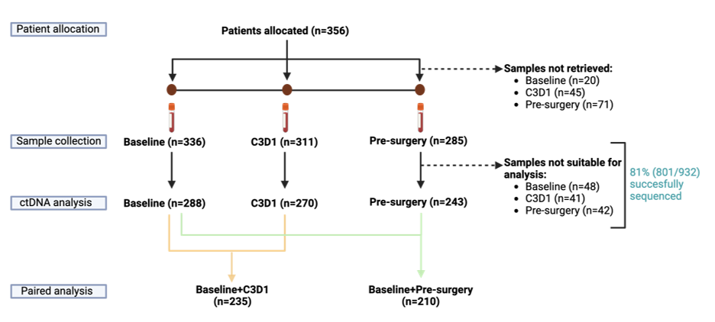

Supplementary Fig. 3. Association between ctDNA clearance and PET response.
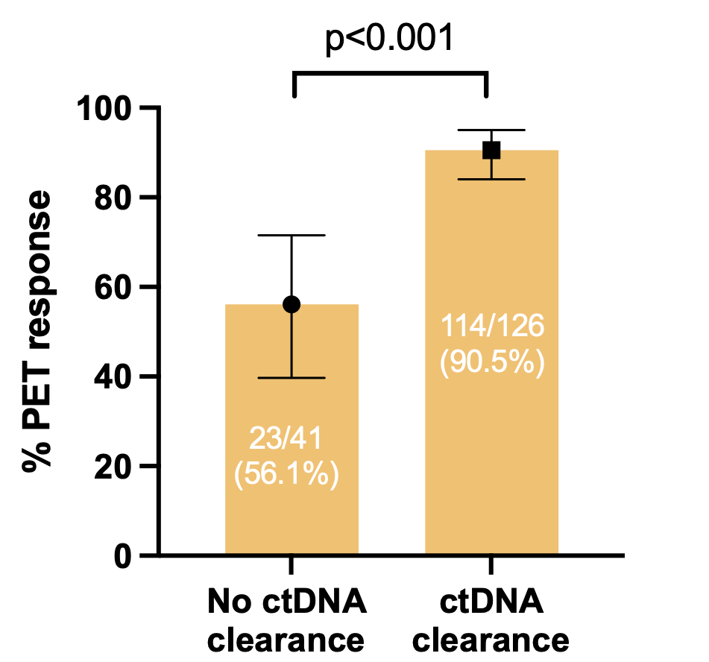
Supplementary Fig. 4. Association between ctDNA status at C3D1 and pre-surgery and clearance with 5-year DDFS. *Cox multivariate model adjusting for disease stage and nodal status. ctDNA clearance (ref) vs no ctDNA clearance.
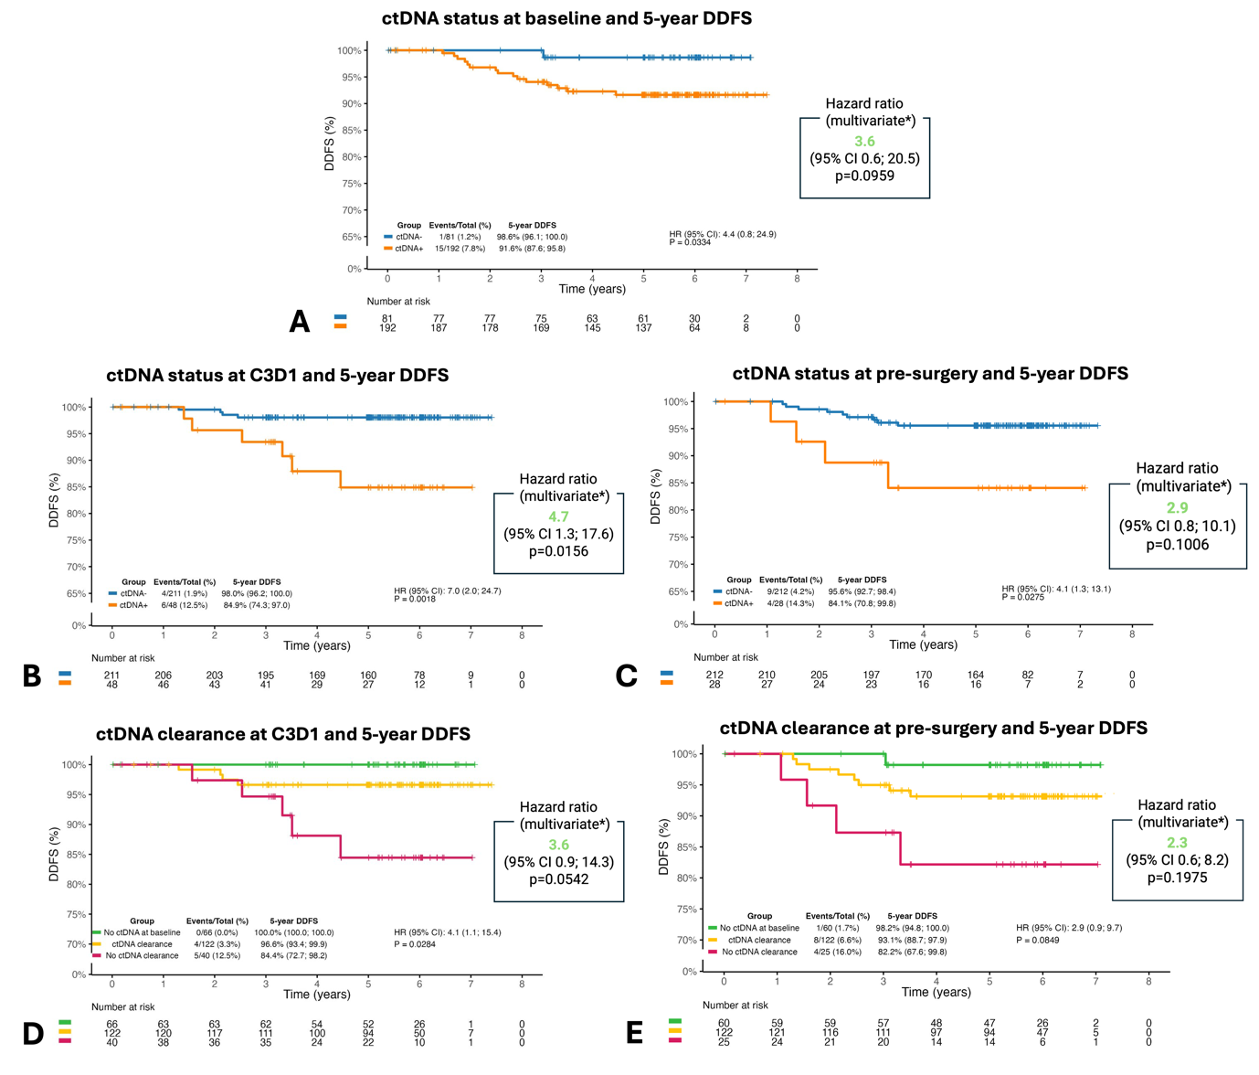

Supplementary Table 1. 5-year iDFS events by ctDNA status at baseline.
 | n
ctDNA-
Contralateral invasive breast cancer | 1
Distant recurrence | 1
ctDNA+
Distant recurrence | 13
Second primary non-breast invasive cancer | 4
Regional invasive breast cancer recurrence | 3
Death | 2
Ipsilateral invasive breast tumor recurrence | 2

Supplementary Table 2. 5-year iDFS events by ctDNA status at C3D1
 | n
ctDNA-
Ipsilateral invasive breast tumor recurrence | 3
Second primary non-breast invasive cancer | 3
Death | 2
Distant recurrence | 2
Contralateral invasive breast cancer | 1
ctDNA+
Distant recurrence | 6
Regional invasive breast cancer recurrence | 2
Second primary non-breast invasive cancer | 1

Supplementary Table 3. 5-year iDFS events by ctDNA clearance at C3D1
 | n
No ctDNA at baseline
Contralateral invasive breast cancer | 1
ctDNA clearance
Second primary non-breast invasive cancer | 3
Death | 2
Distant recurrence | 2
Ipsilateral invasive breast tumor recurrence | 2
No ctDNA clearance
Distant recurrence | 5
Regional invasive breast cancer recurrence | 2
Second primary non-breast invasive cancer | 1

