Table S1. Factor Loadings of Symptom Items by Symptom Clusters
Symptom Cluster/Symptom Item | Factor Loading
Gastrointestinal / Oral
Problems with tasting food | 0.778
Mouth / throat sores | 0.726
Lack of appetite | 0.715
Nausea | 0.679
Vomiting | 0.661
Mucus | 0.660
Swallowing difficulty | 0.654
Dry mouth | 0.616
Constipation | 0.580
Skin symptoms | 0.548
Voice difficulty | 0.483
Emotional / Fatigue
Distress | 0.729
Sleep disturbance | 0.668
Fatigue | 0.621
Shortness of breath | 0.626
Memory difficulty | 0.654
Drowsiness | 0.600
Sadness | 0.653
Function / Quality of Life
Walking | 0.719
Enjoyment of life | 0.710
Relations | 0.699
Work | 0.688
General activity | 0.680
Mood | 0.637

Table S2. Univariate Logistic Regression Analysis of Swallowing Difficulties
Variables | B | SE | Wald | P | OR (95% CI)
Return to Work | -0.928 | 0.229 | 16.447 | ＜0.001 | 0.396 (0.253, 0.619)
Residence
Town/Rural | 0.515 | 0.225 | 5.253 | 0.022 | 1.674 (1.078, 2.601)
Education Level
High school / Vocational school | -0.680 | 0.297 | 5.236 | 0.022 | 0.507 (0.283, 0.907)
College/University or above | -0.961 | 0.251 | 14.622 | ＜0.001 | 0.383 (0.234, 0.626)
Monthly Income
3001–5000 CNY | -0.660 | 0.277 | 5.664 | 0.017 | 0.517 (0.300, 0.890)
5001–10000 CNY | -1.123 | 0.312 | 12.964 | ＜0.001 | 0.325 (0.177, 0.600)
> 10000 CNY | -1.209 | 0.375 | 10.379 | 0.001 | 0.299 (0.143, 0.623)
Age | 0.031 | 0.010 | 9.887 | 0.002 | 1.031 (1.012, 1.051)
AJCC Stage
Stage III | -0.707 | 0.328 | 4.637 | 0.031 | 0.493 (0.259, 0.938)
Stage IV | -1.057 | 0.353 | 8.982 | 0.003 | 0.347 (0.174, 0.694)
Unknown | -1.740 | 0.580 | 9.016 | 0.003 | 0.175 (0.056, 0.546)
N Stage
N1 | -1.078 | 0.432 | 6.221 | 0.013 | 0.340 (0.146, 0.794)
Unknown | -2.381 | 1.137 | 4.387 | 0.036 | 0.092 (0.010, 0.858)
Immunotherapy | -0.516 | 0.221 | 5.434 | 0.020 | 0.597 (0.387, 0.921)
Targeted Therapy | -0.598 | 0.241 | 6.136 | 0.013 | 0.550 (0.342, 0.883)
Voice Index | 0.132 | 0.018 | 55.487 | ＜0.001 | 1.141 (1.102, 1.181)
Depression | 0.137 | 0.023 | 34.817 | ＜0.001 | 1.147 (1.096, 1.200)
Anxiety | 0.114 | 0.026 | 18.675 | ＜0.001 | 1.120 (1.064, 1.180)
Gastrointestinal / Oral Symptom Cluster | 0.371 | 0.060 | 38.842 | ＜0.001 | 1.449 (1.290, 1.628)
Emotional / Fatigue Symptom Cluster | 0.273 | 0.057 | 23.111 | ＜0.001 | 1.314 (1.176, 1.469)
Function / Quality of Life Cluster | 0.355 | 0.062 | 33.220 | ＜0.001 | 1.426 (1.264, 1.609)
Cervical Dysfunction Level | 0.133 | 0.023 | 33.340 | ＜0.001 | 1.142 (1.092, 1.194)

Figure S1. Calibration curve of the logistic regression model
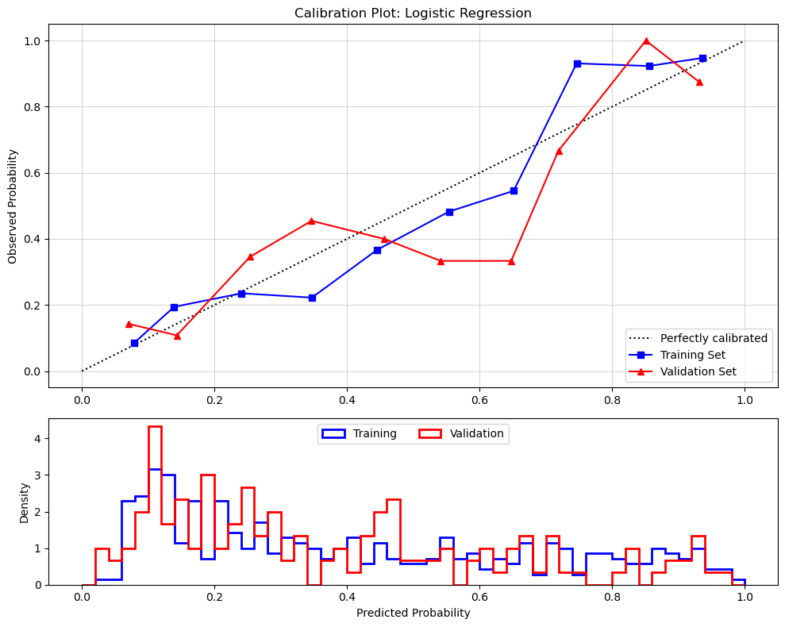

Figure S2. Loss curve of the neural network model
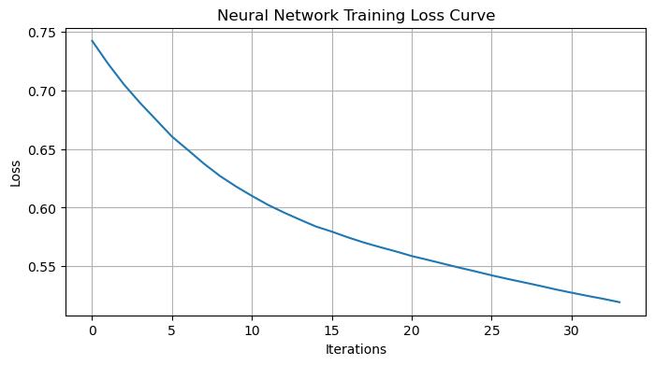

Figure S3. Calibration curve of the neural network model
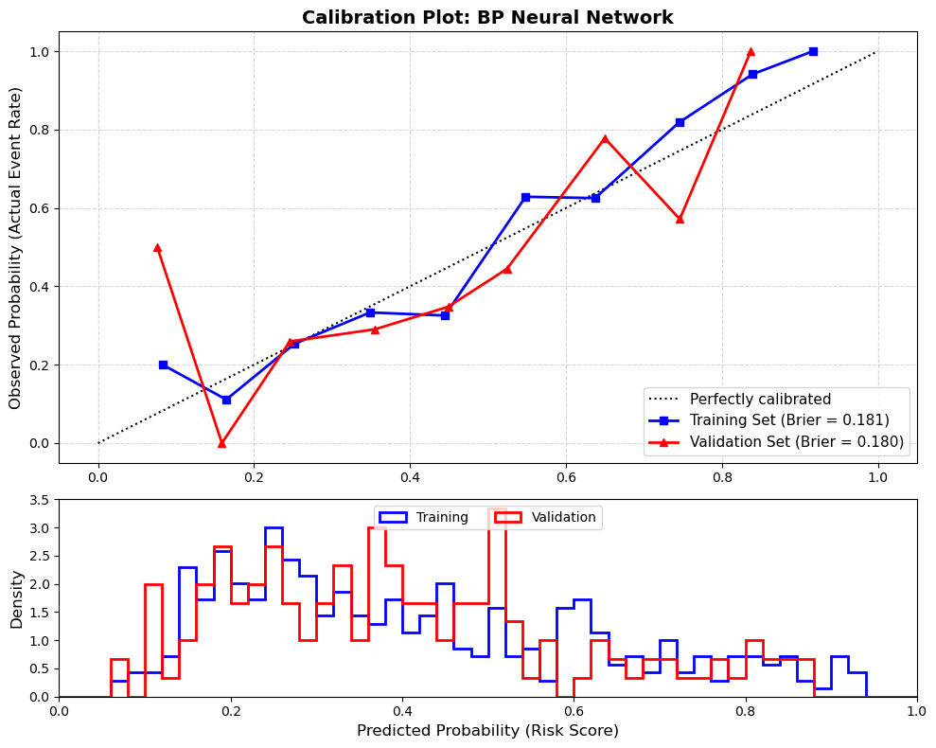
Figure S4. Calibration curve of the classification and regression tree model
