Information flow causality reveals evolving land–atmosphere coupling dynamics during compound dry–hot events

Yikui Zhang^{1,2,3*}, Daniel Hagan⁴, Diego G. Miralles⁴, Klaus Goergen^{1,2}, Stefan Kollet^{1,2,3}

(1) Agrosphäre (IBG-3), Institute of Bio- and Geosciences, Forschungszentrum Jülich, Germany
(2) Centre for High-Performance Scientific Computing in Terrestrial Systems, Geoverbund ABC/J, Jülich, Germany
(3) Meteorological Institute, University of Bonn, Bonn, Germany
(4) Hydro-Climate Extremes Lab (H-CEL), Ghent University, Ghent 9000, Belgium

*Correspondence: yik.zhang@fz-juelich.de.

Supplementary Information
A. Liang-Kleeman Information flow rate calculation
Explanations on $\frac{Cov(X_{1},\dot{X_{1}})}{σ_{X_{1}}^{2}}$ in Eq. 1 and Eq. 2:
Given a linear relationship between $X_{1}$ and $\dot{X_{1}}$:
(1)

Where:
$X_{1}$ is the independent variable
$\dot{X_{1}}$ is the dependent variable (tendency)
$β$ is the regression coefficient
$ε$ is the residual, assumed to satisfy $E\left[X_{1}ε\right]=0$ (uncorrelated with $X_{1}$)

The least-squares estimate minimizes the mean-squared residual:
(2)
Taking the derivative with respect to $β$ and setting it to zero:
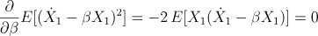 (3)
Solving for $β$:
(4)
Rearranging:
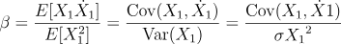 (5)
Thus, the ratio $\frac{Cov(X_{1},\dot{X_{1}})}{σ_{X_{1}}^{2}}$ is simply the regression slope of $\dot{X_{1}}$ on $X_{1}$, which represents how much $X_{1}$’s current deviation explains its future rate of change

B. Additional information flow analysis results

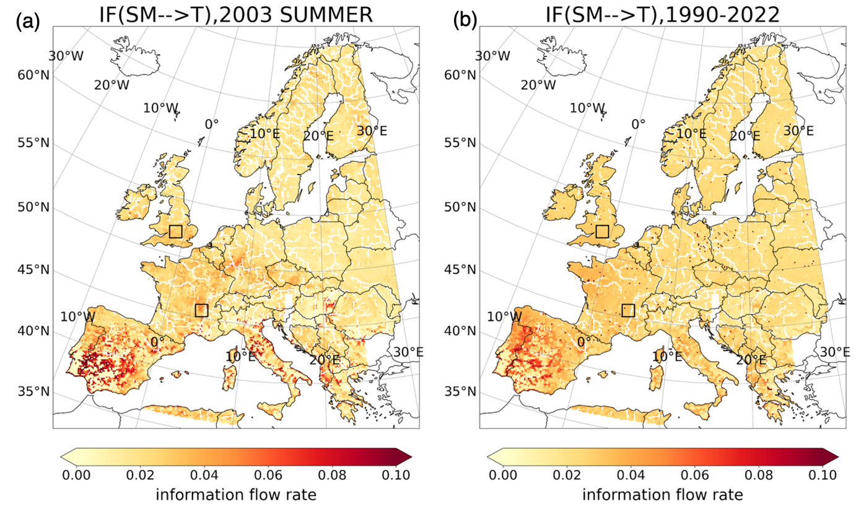
Figure B1. Maps for time averaged IF(SM→T) over the entire analysis domain in 2003 summer (a) and over 1990-2022 (b). The two black boxes indicate the two selected domains in FR and BI. The Unit of IF is in nats/h.

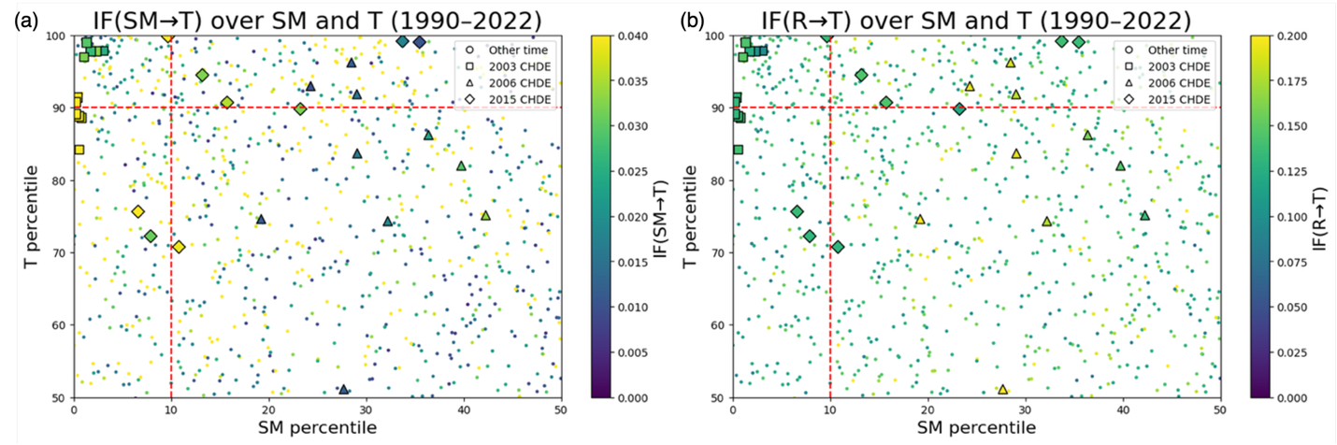
Figure B2. Scatter plots of daily SM→T (a) and R→T (b) from 1990 to 2022 within the domains of Iberian Peninsula (IP). The x- and y-axes represent soil moisture (SM) and temperature (T) percentiles, respectively. For better visualization, only top 50% percentile of T and lower percentile of SM are plotted. Each marker represents the average value at a daily time scale and the colorbar represents the magnitude of SM→T. Squares, triangles, and diamonds represent the same CDHE days as in France during the 2003, 2006, and 2015 CDHEs. All other days are shown as small dots. Dashed lines mark the SM < 10th percentile and T > 90th percentile thresholds. The unit of IF is in nats/h.

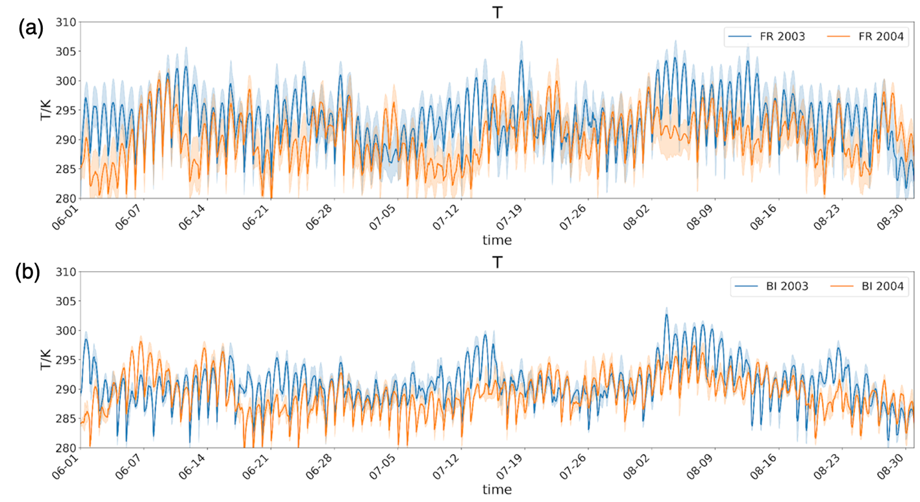

Figure B3. Domain-averaged hourly time series of 2-meter temperature (T) in a 10*10 grid domain in as in Figure 3, in 2003 (blue) and 2004 (orange) summer. (a). France (FR); (b). British Isle (BI). The red dashed box highlights the 2003 CDHE period and the shaded area represents the confidence interval over the 10*10 domain.

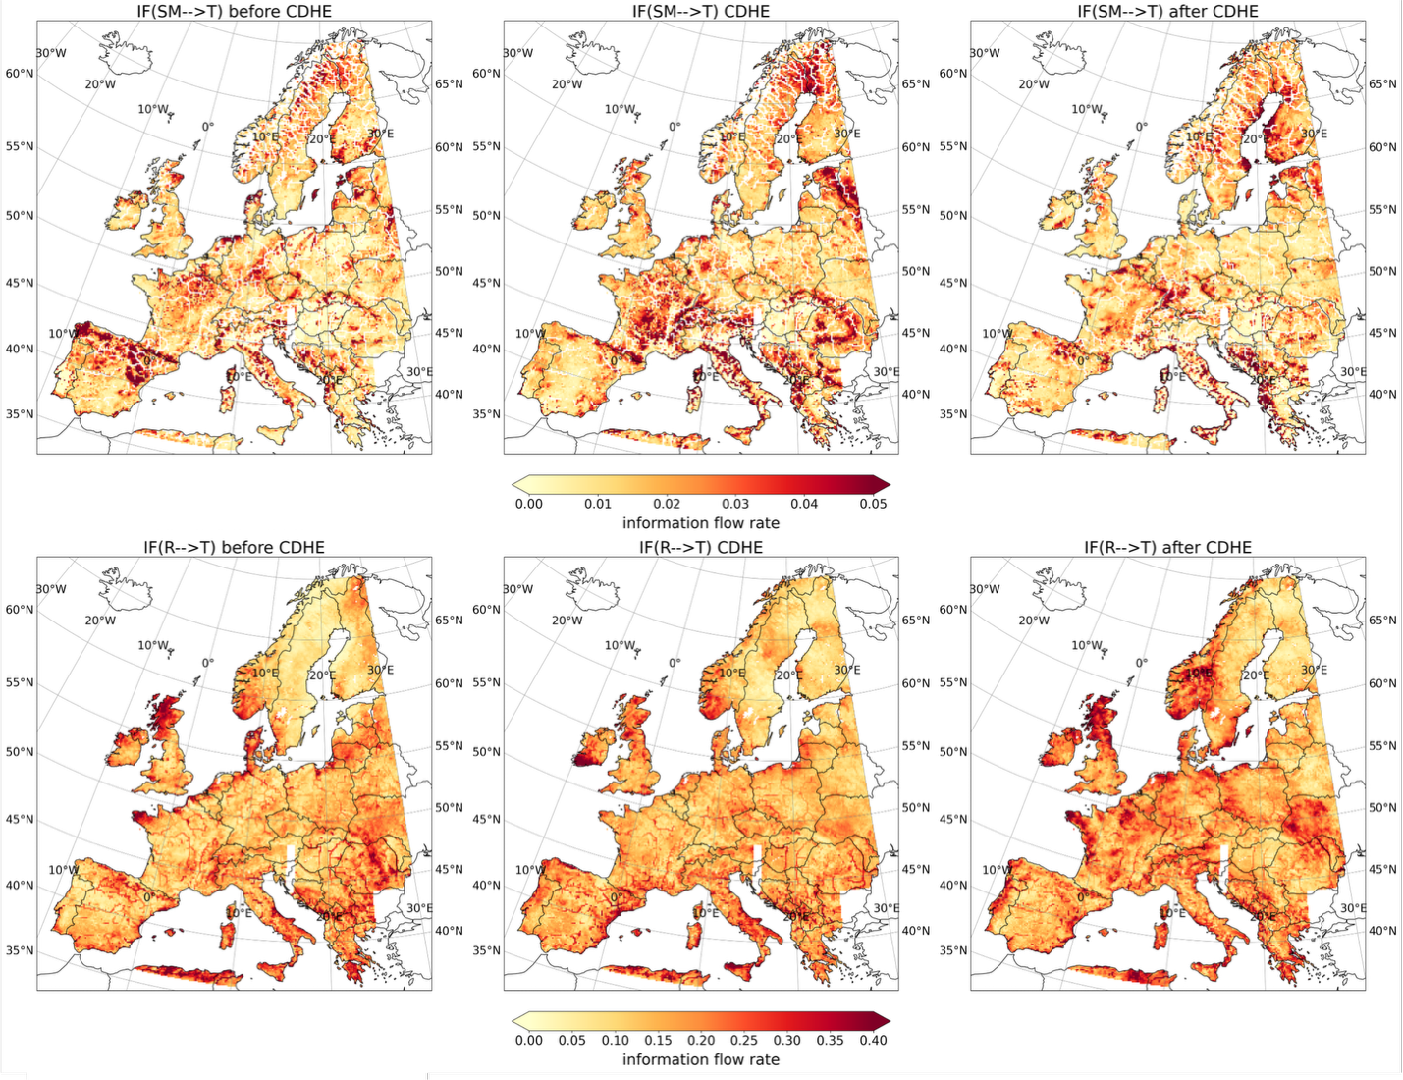

Figure B4. Maps for time-averaged information flow rate over the entire analysis domain. The CDHE period ranges from July 19th to July 27th, 2006 over France. The `before CDHE` period ranges one week before July 19th, 2006. The `after CDHE` period ranges one week after July 27th, 2006. The first row represents the changes in SM–>T and the second row show the variability of R–>T over the 2006 CDHE. The unit of IF is in nats/h. Note that the information flow is calculated at the grid-cell level, and the resulting IF rate maps are shown only for the eight PRUDENCE regions.

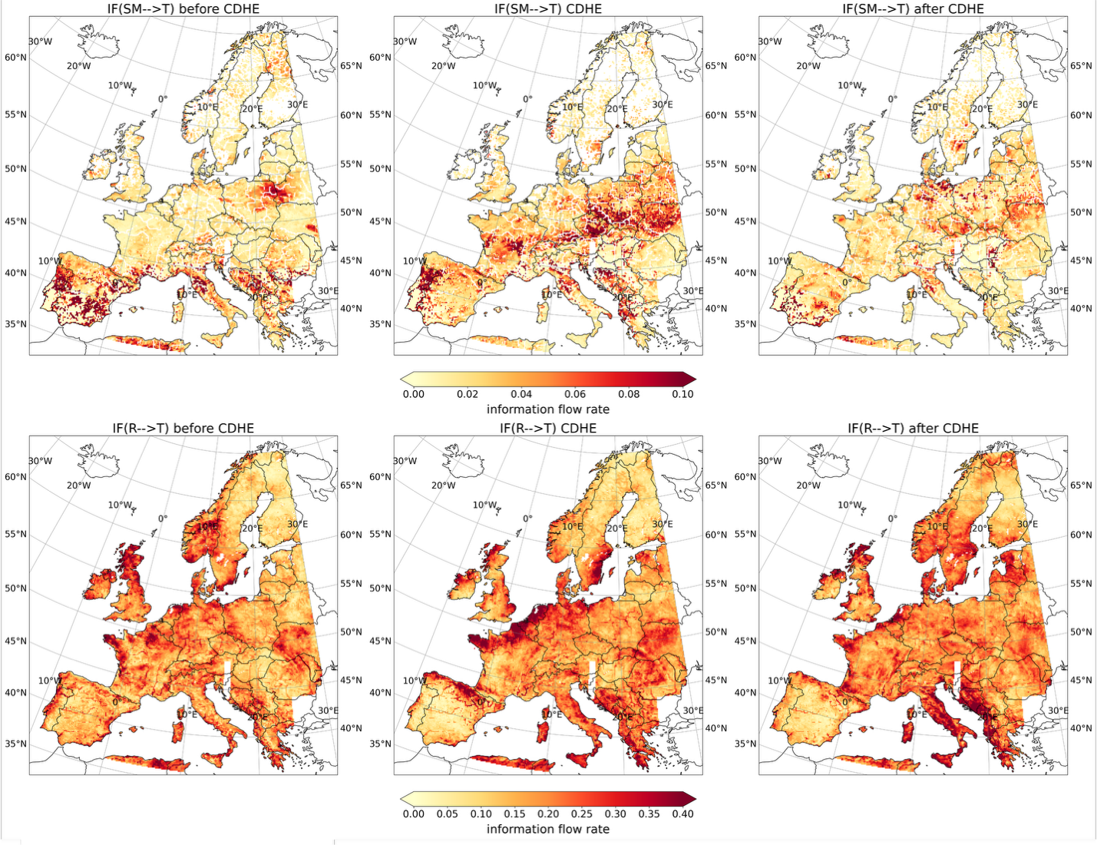
Figure B5. Maps for time-averaged information flow rate over the entire analysis domain. The CDHE period ranges from August 4th to 14th, 2015 over France. The `before CDHE` period ranges one week before August 4th, 2015. The `after CDHE` period ranges one week after August 14th, 2015. The first row represents the changes in SM→T and the second row show the variability of R→T over the 2015 CDHE. The unit of IF is in nats/h. Note that the information flow is calculated at the grid-cell level, and the resulting IF rate maps are shown only for the eight PRUDENCE regions.

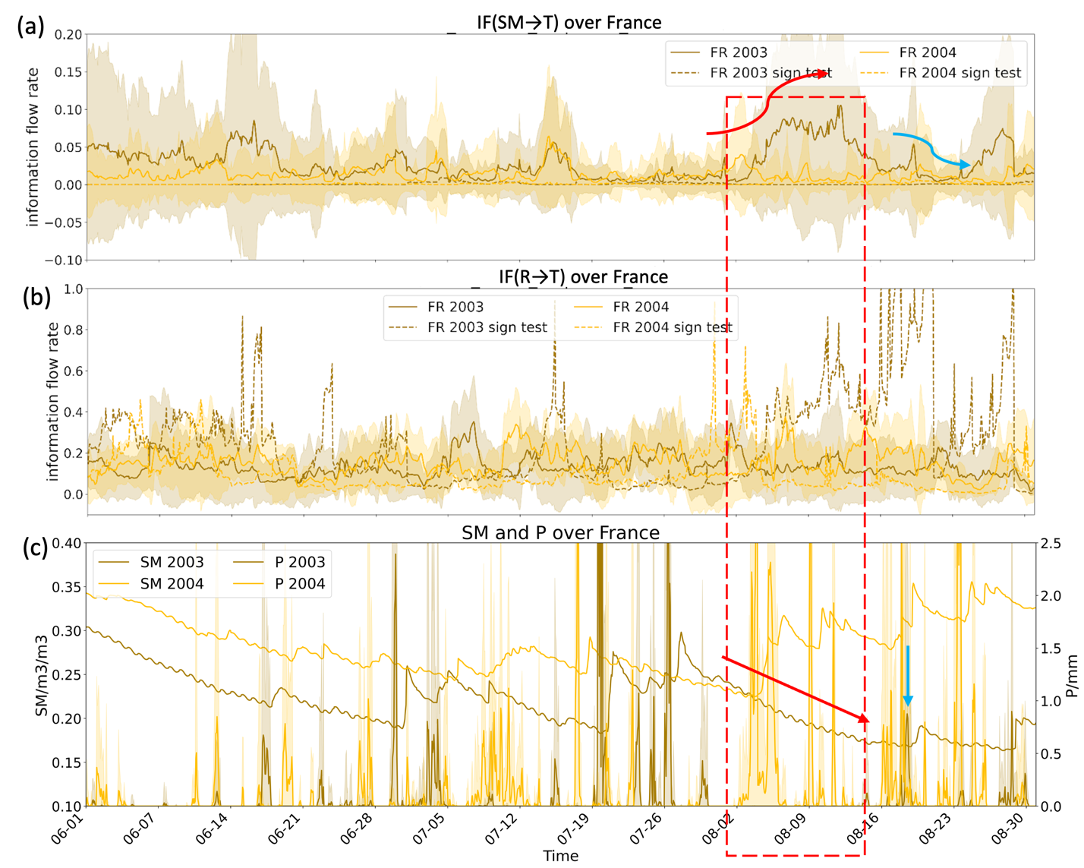
Figure B6. Time series of information flow and hydroclimatic variables over France (FR) during summer for 2003 and 2004. The top panel shows IF(SM→T), and the middle panel shows IF(R→T). Solid lines represent the estimated information flow rates, while shaded envelopes indicate the associated uncertainty range derived from the Fisher information matrix. Dashed lines denote statistically significant information flow values based on the significance test, indicating periods when the inferred information flow is significantly different from zero. The bottom panel shows domain-averaged surface soil water content (SM; left axis) and total precipitation (P; right axis) for the same years. This figure highlights the temporal evolution and statistical significance of the diagnosed land–atmosphere coupling pathways during contrasting hydroclimatic conditions.

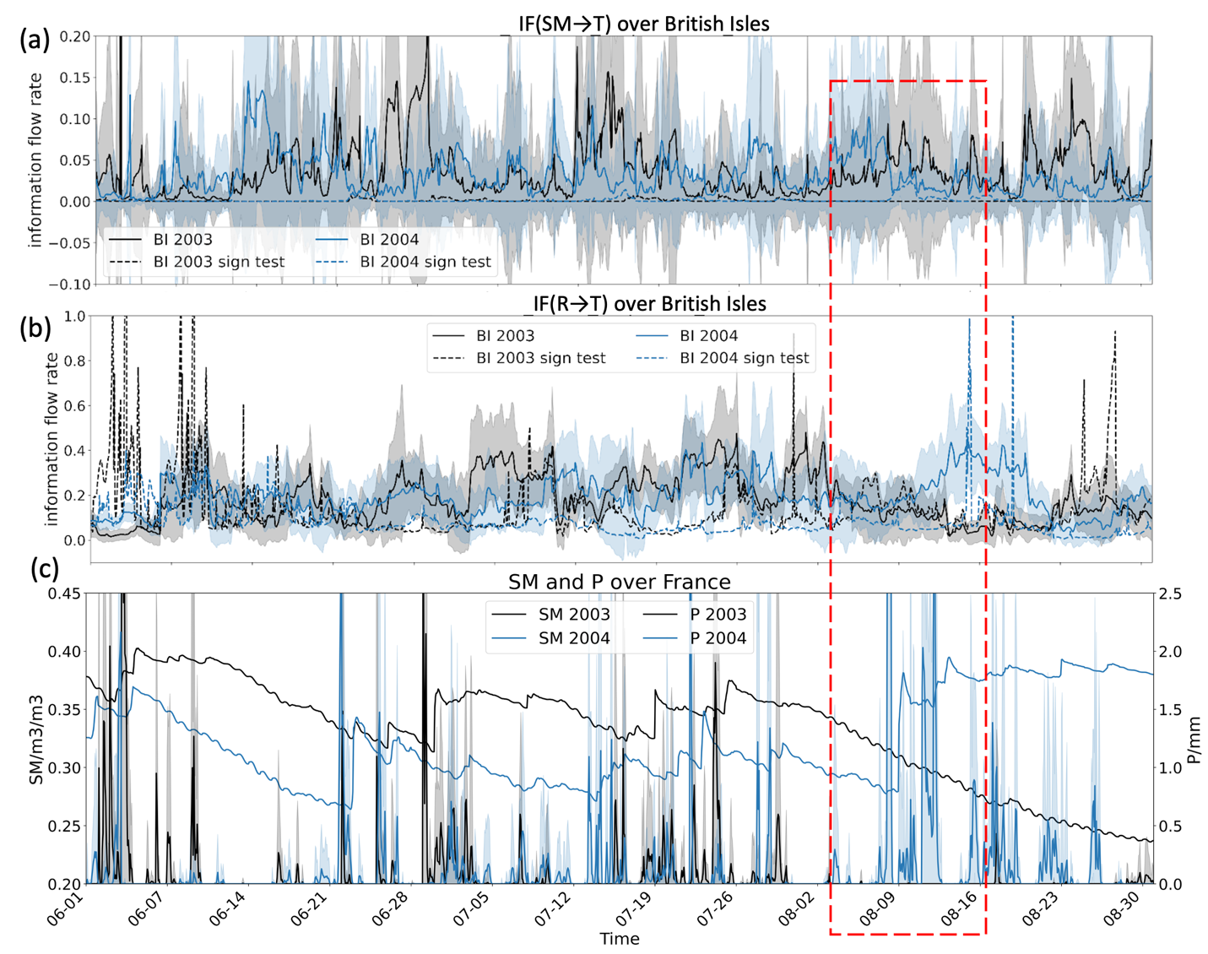
Figure B7. Same as Figure B6 but for BI.

