Supplementary Table 1. Assessment of missing data rates for clinical variables in the MIMIC-IV and eICU-CRD cohorts.
Variable Category | Specific Variables | MIMIC-IV Missing Rate (%) | eICU-CRD Missing Rate (%)
Laboratory Findings (Hepatic & Inflammatory) | TBil | 42.89 | 27.15
 | ALT | 42.34 | 26.22
 | AST | 41.82 | 25.14
 | Neut | 35.11 | 33.64
 | LY | 35.08 | 23.82
Laboratory Findings (Metabolic & Renal) | Lac | 24.19 | 42.61
 | AG | 4.34 | 22.51
 | BUN | 2.35 | 0.77
 | Cr | 2.16 | 0.77
 | HCO₃ | 2.72 | 1.86
Laboratory Findings (Electrolytes & CBC) | Na | 7.16 | 0.62
 | K | 6.96 | 1.24
 | Cl | 2.02 | 1.31
 | WBC | 2.08 | 1.01
 | Hb | 1.79 | 1.47
 | Plt | 0.95 | 2.09
 | INR | 2.61 | 25.14
Vital Signs & Respiratory | SBP | 0.02 | 29.78
 | DBP | 0.02 | 29.62
 | SpO₂ | 0 | 29.31
 | RR | 0 | 21.66
 | HR | 0 | 17.17
 | PaCO₂ | 4.83 | 13.23
 | pH | 4.82 | 12.45
 | PaO₂ | 4.8 | 12.06
Fluid Balance | Net Fluid Balance | 8.56 | 7.04
 | Total Input | 8.24 | 7.04
 | Total Output | 0.57 | 7.04
Demographics & Scores | Weight | 11.48 | 0.46
 | Gender | 0 | 0.15
 | APS III Score | 0 | 6.11
 | SOFA Score | 0.09 | 0
Complete Variables (0% Missing) | Age, Hospital Mortality, Diabetes, Renal Disease, CHF, Severe Liver Disease, COPD, Vasoactive Drug | 0 | 0

Supplementary Table S2. Complete list of clinical variables included in the Gaussian Mixture Model (GMM) clustering.
Variable Category | Specific Variables Included | Missing Data Handling | Outlier Handling
Demographics (3) | Age, Gender, Weight | Complete / Imputed (MICE) | Winsorized (1st-99th)
Comorbidities (5) | CHF, COPD, Diabetes, Severe Liver Disease, Renal Disease | Complete (Binary variables) | N/A
Vital Signs (5) | HR, RR, SpO₂, SBP, DBP | Imputed (MICE) | Winsorized (1st-99th)
Blood Gas (3) | PaO₂, PaCO₂, pH | Imputed (MICE) | Winsorized (1st-99th)
Laboratory (17) | Lac, BUN, Cr, Na, K, Cl, HCO₃, AG, Hb, Plt, LY, Neut, INR, ALT, AST, TBil , WBC | Imputed (MICE) | Winsorized (1st-99th)
Excluded Variables (Potential Bias/Leakage) | Total Fluid Input, Total Fluid Output, Net Fluid Balance, Vasoactive Drug Use, SOFA, APS III, Stay ID, Survival Days, Hospital Mortality, Phenotype | Excluded from GMM to prevent circularity and treatment-related confounding | N/A

Supplementary Table S3. Robustness of the "Cryptic Shock" phenotype across alternative clustering methodologies and data handling scenarios.
Cohort | MIMIC-IV | eICU-CRD
Primary (GMM k=2) | 2.24 (2.02–2.48) | p<0.001 | 1.39 (1.13–1.71) | p=0.002
k-means | 2.55 (2.30–2.82) | p<0.001 | 1.54 (1.26–1.88) | p<0.001
Hierarchical | 2.12 (1.91–2.35) | p<0.001 | 1.79 (1.04–3.06) | p=0.034
GMM (k=3) | 1.95 (1.68–2.27) | p<0.001 | 1.55 (1.14–2.10) | p=0.005

Notes: All hazard ratios (HR) for in-hospital mortality were adjusted for age, gender, and baseline SOFA score. For the k=3 sensitivity analysis, the target patient cluster expressing the distinct macro/micro-hemodynamic dissociation was compared against the combined remaining clusters

Supplementary Table S4. Sensitivity Analysis of the Independent Prognostic Association Between Clinical Phenotypes and In-Hospital Mortality Using APS III Score Adjustment.
Cohort | Adjusted HR (95% CI) | p-value
MIMIC-IV (Derivation) | 1.60 (1.44–1.79) | <0.001
eICU-CRD (Validation) | 1.16 (0.94–1.44) | 0.158
Notes: 1. Multivariable Analysis: Hazard ratios (HR) were calculated using multivariable Cox proportional hazards models adjusted for age, gender, comorbidities, and the Acute Physiology Score III (APS III).2. Rationale: The APS III score was utilized as a more comprehensive and granular alternative to the SOFA score to address potential algorithmic underestimation of severity in the MIMIC-IV database (due to missing initial FiO₂ and GCS documentation).3.Interpretation: Phenotype B remained a highly significant independent predictor of mortality in the derivation cohort (p<0.001). In the validation cohort, while the independent prognostic effect was partially attenuated after adjusting for the multi-parameter APS III score (p=0.158), the consistent directional trend (HR > 1.0) and the significant improvements in reclassification indices (NRI/IDI) reported in the main text collectively underscore the robust incremental value of the phenotypic classification beyond traditional severity scoring systems.

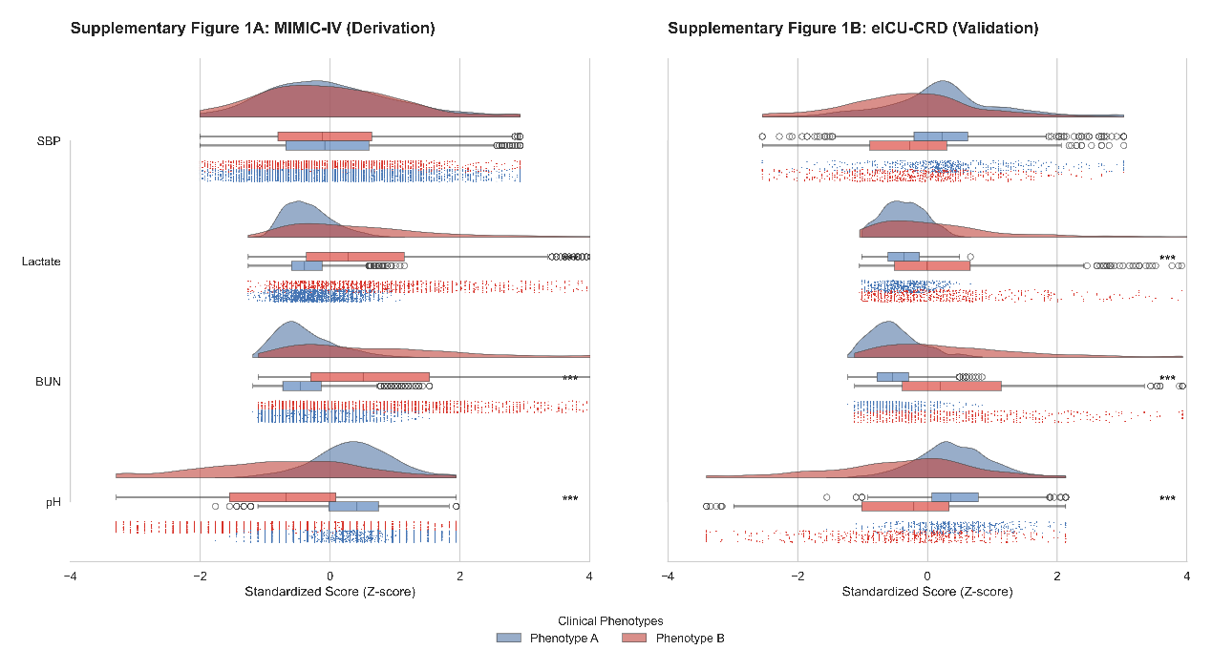
Supplementary Figure 1. Detailed Raincloud Plots of Phenotype Feature Distributions and Inter-Cohort Consistency.
Legend: This comprehensive visualization combines density plots (clouds), individual patient data points (rain), and boxplots to provide a transparent view of the underlying data for (A) MIMIC-IV and (B) eICU-CRD. The connected point plots (lines) track the transition of medians between phenotypes across variables, emphasizing the consistent "metabolic-respiratory shift" that defines the Cryptic Shock phenotype. The tight alignment of these patterns across both independent databases demonstrates the high reproducibility and data-level stability of the machine learning-derived clusters.

