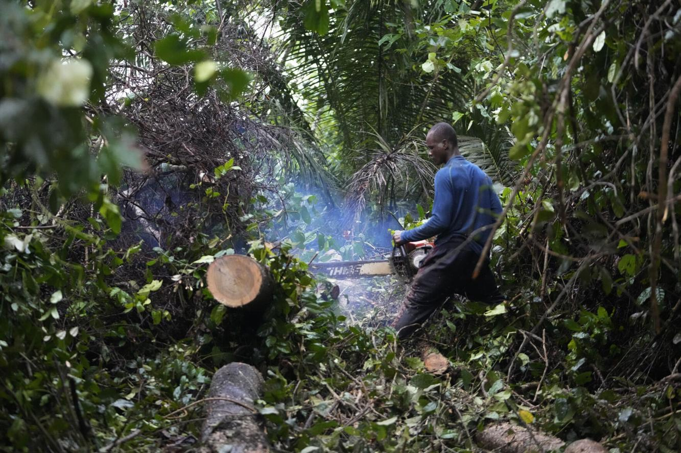
Plate 1: Uncoordinated logging in the study area (source: Author 2017)

