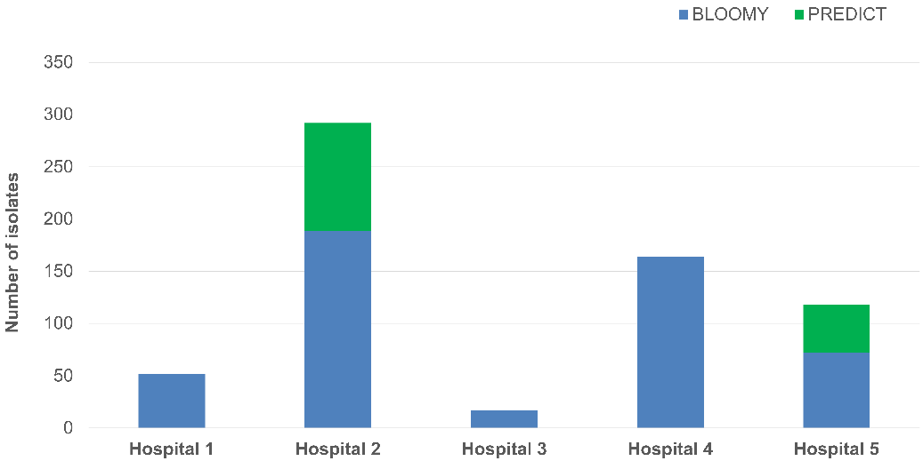

Supplementary Fig. 1: Number of isolates analyzed for each study site. Hospital 1 (n=52), Hospital 2 (n=292), Hospital 3 (n=17), Hospital 4 (n=164) and Hospital 5 (n=118) for BLOOMY (blue) and PREDICT (green) study phase.

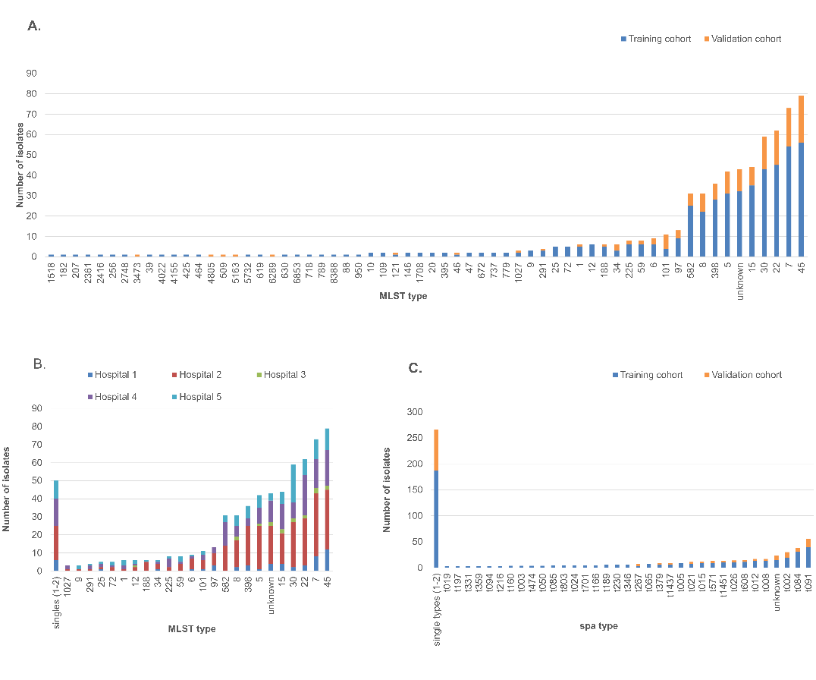

Supplementary Fig. 2: Distribution of MLST (A-B) and spa (C) types. A. Training vs. validation cohort. B. Total cohort with illustration of study site (n=643). C. Training vs. validation cohort. Overall, 61 distinct MLST types and 232 spa types were identified. Numbers are displayed as total amount of isolates.

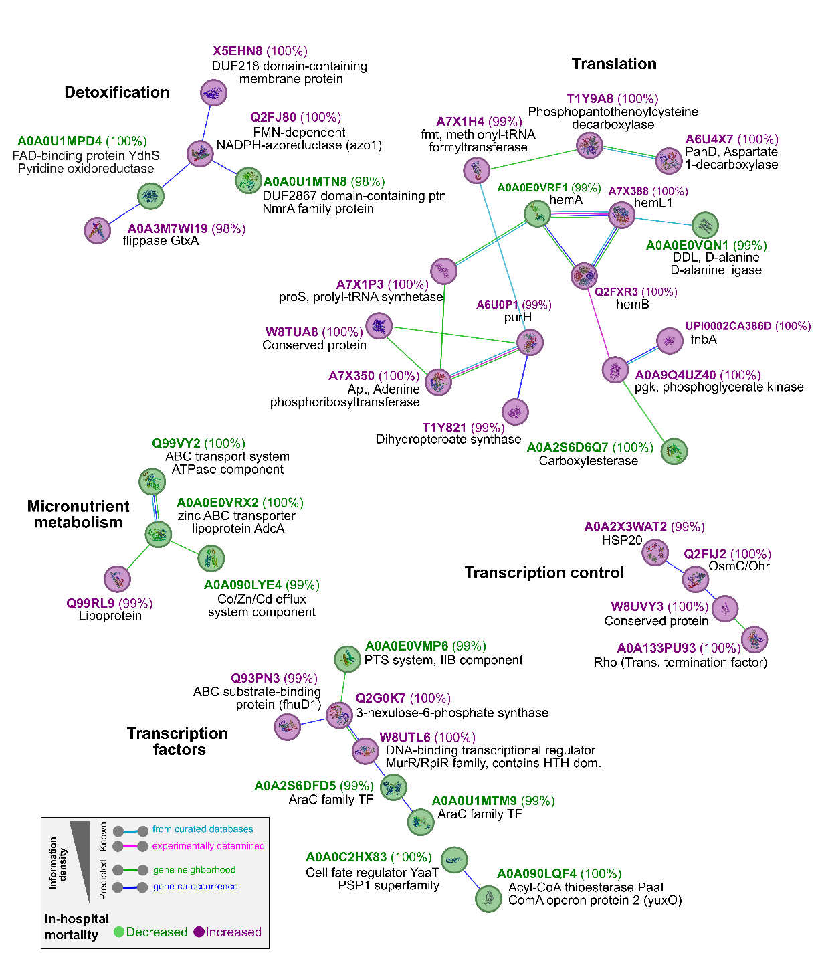

Supplementary Fig. 3: Functional network analysis using the STRING database. UniRef100 traits formed five networks based on associations in curated databases, experimentally determined functional connections, gene neighborhood, and co-occurrence across genomes, suggesting a similar regulatory background. Colors of nodes represent their associated influence on in-hospital mortality (purple = increased in-hospital mortality; green = decreased in-hospital mortality). Percentage values in brackets indicate the amino acid identity to the closest homologue found in the database.

Supplementary Table 1: Patient demographics and S. aureus specific features. Displayed are absolute and relative numbers of epidemiological and clinical parameters and limits of 95% confidence intervals (CI). Numbers are shown for the total cohort as well as the training and validation cohort. Level of significance assessing the distribution of features between the training and validation cohort was calculated by Chi Square test or t-test. Non-significant p values (p>0.05) display homogeneity between the two cohorts.

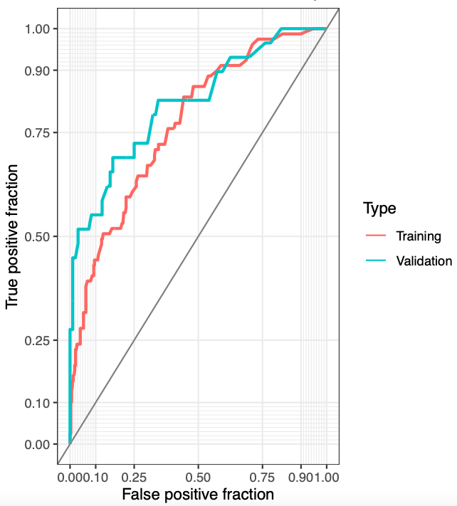
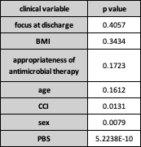
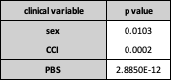
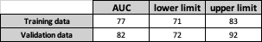
B.
A.
D.
C.

Supplementary Table 2: Performance of clinical parameters on in-hospital mortality prediction in a multiple logistic regression analysis. Significance is assumed for p≤0.05. A. Analysis of variance (ANOVA) of all incorporated confounding clinical parameters. B. Analysis of variance (ANOVA) of significant clinical parameters. C. AUC (area under the curve) results from ANOVA incorporating PBS (Pitt bacteremia score), CCI (Charlson comorbidity index) and sex. D. ROC (Receiver Operating Characteristic) curve from training (red) and validation data (blue) from ANOVA, incorporating PBS, CCI and sex as decisive clinical parameters.

Supplementary Table 3: Full list of significantly associated traits on in-hospital mortality in S. aureus bacteremia, including their abundance, type of association, their trait associated in-hospital mortality rate, suggested site of action, rank achieved in the Scoary2 pipeline and clustering with other traits in the absence/presence matrix.

Supplementary Table 4: Output of the Scoary2 analytic pipeline after incorporating the same input used for the training cohort in model A and feeding the maximum likelihood tree of the analyzed cohort for phylogenetic background correction. Significant UniRef100 factors identified in Scoary2 (represented by p≤0.05 in fq*ep) are colored in orange, 77 significant UniRef100 trait of our statistical model are colored in blue.

Supplementary Table 5: Absence-presence matrix of UniRef100 traits across the study isolates. Columns are sorted traits associated with increased in-hospital mortality (left, red headings) and decreased in-hospital mortality (right, green headings). From left to right, traits associated with increased in-hospital mortality are arranged in ascending abundance, and traits associated with decreased in-hospital mortality in descending abundance. Arrows indicate the top 10 traits. The second spreadsheet displays contig localization of traits with start and end nucleotide.

Supplementary Table 6: Clinical metadata used for the analysis. The second spreadsheet lists the field names with their respective meaning. (NA = information not available)

