Supplementary Material
Contents
Supplementary Tables 3
Supplementary Table 1. Classification of World Health Organization Members States according to WHO Regions and subregional clusters adopted for the WHO foodborne disease estimates 2026 edition. 3
Supplementary Table 2. List of 42 hazards included in the World Health Organization foodborne disease estimates 2026 edition. 5
Supplementary Table 3. Overview of blocked pathways (B) and foods for 21 diarrhoeal disease and invasive enteric disease and intoxication hazards included in the structure expert judgement for the World Health Organization attribution of foodborne hazards to transmission pathways and foods 6
Supplementary Table 4. Overview of blocked pathways (B) and foods for seven parasitic hazards included in the structure expert judgement for the World Health Organization attribution of foodborne hazards to transmission pathways and foods 8
Supplementary Table 5. Criteria for selection of experts for the structure expert judgement for the World Health Organization attribution of foodborne hazards to transmission pathways and foods 10
Supplementary Table 6. Number of expert assessments per hazard and sub-region for the World Health Organization attribution of foodborne hazards to transmission pathways and foods 11
Supplementary Figures 13
Supplementary Figure S1. Attributions (median, 2.5th and 97.5th percentiles) to transmission pathways to foods for 29 hazards for the African Region. 13
Supplementary Figure S2. Attributions (median, 2.5th and 97.5th percentiles) to transmission pathways to foods for 29 hazards for the Region of the Americas. 15
Supplementary Figure S3. Attributions (median, 2.5th and 97.5th percentiles) to transmission pathways to foods for 29 hazards for the South-East Asia Region. 17
Supplementary Figure 4. Detailed attributions (median, 2.5th and 97.5th percentiles) to transmission pathways to foods for 29 hazards for the European Region. 19
Supplementary Figure S5. Attributions (median, 2.5th and 97.5th percentiles) to transmission pathways to foods for 29 hazards for the Eastern Mediterranean Region. 21
Supplementary Figure S6. Attributions (median, 2.5th and 97.5th percentiles) to transmission pathways to foods for 29 hazards for the Western Pacific Region. 23
Supplementary Figure 8. Estimated attribution proportion to main pathways (mean and 95% Confidence Interval) in FERG 2015 (Hald et al., 2016) and FERG 2026 for parasites 33
Supplementary Figure 9. Estimated attribution proportion to main pathways in FERG 2015 (median and 95% Confidence Interval) (Hald et al., 2016) and FERG 2026 (mean and 95% Confidence Interval) for lead 35
Supplementary Figures 10. Estimated attribution to food categories in FERG 2026 and estimated in previous source attribution studies (mean and 95% Confidence Intervals). 36

Supplementary Tables

Supplementary Table 1. Classification of World Health Organization Members States according to WHO Regions and subregional clusters adopted for the WHO foodborne disease estimates 2026 edition.
Region | Subregional cluster | Countries
AFR | AB | Botswana, Equatorial Guinea, Gabon, Mauritius, Namibia, Seychelles, South Africa
AFR | C | Algeria, Angola, Benin, Cameroon, Cabo Verde, Comoros, Congo, Côte d’Ivoire, Eswatini, Ghana, Guinea, Kenya, Lesotho, Mauritania, Nigeria, São Tomé and Príncipe, Senegal, United Republic of Tanzania, Zambia, Zimbabwe
AFR | D | Burkina Faso, Burundi, Central African Republic, Chad, Democratic Republic of Congo, Eritrea, Ethiopia, Gambia, Guinea-Bissau, Liberia, Madagascar, Malawi, Mali, Mozambique, Niger, Rwanda, Sierra Leone, South Sudan, Togo, Uganda
AMR | A | Antigua and Barbuda, Bahamas, Barbados, Canada, Chile, Guyana, Panama, Saint Kitts and Nevis, Trinidad and Tobago, United States of America, Uruguay
AMR | B | Argentina, Belize, Brazil, Colombia, Costa Rica, Cuba, Dominica, Dominican Republic, Ecuador, El Salvador, Grenada, Guatemala, Jamaica, Mexico, Paraguay, Peru, Saint Lucia, Saint Vincent and the Grenadines, Suriname
AMR | C | Bolivia (Plurinational State of), Haiti, Honduras, Nicaragua, Venezuela (Bolivarian Republic of)
SEAR | B | Indonesia, Maldives, Thailand
SEAR | CD | Bangladesh, Bhutan, India, Myanmar, Nepal, Democratic People's Republic of Korea, Sri Lanka, Timor-Leste
EUR | A | Andorra, Austria, Belgium, Croatia, Cyprus, Czechia, Denmark, Estonia, Finland, France, Germany, Greece, Hungary, Iceland, Ireland, Israel, Italy, Latvia, Lithuania, Luxembourg, Malta, Monaco, Netherlands (Kingdom of the), Norway, Poland, Portugal, Romania, San Marino, Slovakia, Slovenia, Spain, Sweden, Switzerland, United Kingdom of Great Britain and Northern Ireland
EUR | B | Albania, Armenia, Azerbaijan, Belarus, Bosnia and Herzegovina, Bulgaria, Georgia, Kazakhstan, Montenegro, North Macedonia, Republic of Moldova, Russian Federation, Serbia, Türkiye, Turkmenistan
EUR | C | Kyrgyzstan, Tajikistan, Ukraine, Uzbekistan
EMR | A | Bahrain, Kuwait, Oman, Qatar, Saudi Arabia, United Arab Emirates
EMR | BC | Djibouti, Egypt, Iran (Islamic Republic of), Iraq, Jordan, Lebanon, Libya, Morocco, Pakistan, Tunisia
EMR | D | Afghanistan, Somalia, Sudan, Syrian Arab Republic, Yemen
WPR | A | Australia, Brunei Darussalam, Cook Islands, Japan, Nauru, New Zealand, Niue, Singapore, Republic of Korea
WPR | B | China, Fiji, Malaysia, Marshall Islands, Palau, Tonga, Tuvalu
WPR | C | Cambodia, Kiribati, Lao People's Democratic Republic, Micronesia (Federated States of), Mongolia, Papua New Guinea, Philippines, Samoa, Solomon Islands, Vanuatu, Viet Nam
AFR=African Region; AMR=Region of the Americas; SEAR=South-East Asia Region; EUR=European Region; EMR=Eastern Mediterranean Region; WPR=Western Pacific Region.

Supplementary Table 2. List of 42 hazards included in the World Health Organization foodborne disease estimates 2026 edition.
Diarrhoeal disease hazards | Invasive enteric disease  and intoxication hazards | Invasive parasitic disease hazards | Chemical hazards
Viruses  1. Norovirus  2 Rotavirus *  Bacteria  3. Campylobacter jejuni/ coli  4. Enteroaggregative E. coli *  5. Enteropathogenic E. coli  6. Enterotoxigenic E. coli  7. Shiga-toxin producing E. coli  8. Non-typhoidal Salmonella enterica (diarrhoeal) ‡  9. Shigella spp.  10. Vibrio cholerae  Protozoa  11. Cryptosporidium spp.  12. Cyclospora cayetanensis *  13. Entamoeba histolytica  14. Giardia duodenalis | Viruses  15. Hepatitis A virus  Bacteria  16. Brucella spp.  17. Listeria monocytogenes  18. Mycobacterium bovis/ caprae/ orygis  8. Non-typhoidal Salmonella enterica (invasive) ‡  19. Salmonella Paratyphi  20. Salmonella Typhi  21. Clostridium botulinum | Protozoa  22.Toxoplasma gondii  23. Trypanosoma cruzi *  Cestodes  24. Echinococcus granulosus  25. Echinococcus multilocularis  26. Taenia solium  Nematodes  27. Ascaris spp.  28. Trichinella spp.  Trematodes  29. Clonorchis sinensis  30. Fasciola spp. & Fasciolopsis buski  31. Minute intestinal flukes §  32. Opisthorchis viverrini/ Opisthorchis felineus  33. Paragonimus spp. | Organic pollutants  34. Dioxin  Toxins and allergens  35. Aflatoxin B1  36. Aflatoxin M1 *  37 . Cassava cyanide  38. Peanut allergens  Metals  39. Inorganic arsenic *  40. Cadmium *  41. Lead *  42. Methylmercury *
* Hazard estimated for the first time
† This hazard includes other thermotolerant species.
‡ Salmonellosis and invasive samonellosis are counted as a single hazard causing two diseases.
§ Includes Echinostoma spp., Heterophyes spp., Metagonimus spp. and other foodborne intestinal trematode species.

Supplementary Table 3. Overview of blocked pathways (B) and foods for 21 diarrhoeal disease and invasive enteric disease and intoxication hazards included in the structure expert judgement for the World Health Organization attribution of foodborne hazards to transmission pathways and foods
 | Brucella spp. | Campylobacter spp. | Clostridium botulinum | Cryptosporidium spp. | Cyclospora | Enteropathogenic E.coli (EPEC) | Enterotoxigenic  E.coli (ETEC) | Enteroaggregative  E.coli (EAEC) | Giardia spp. | Hepatitis A virus | Listeria monocytogenes | Mycobacterium  bovis/caprae/orygis | Norovirus | Rotavirus | Salmonella enterica Typhi | Salmonella enterica  Paratyphi A | Non-typhoidal  Salmonella enterica | Shiga toxin-producing  E.coli (STEC) | Shigella spp. | Vibrio cholerae | Entamoeba histolytica
Major pathways
Food
Contact with animals (domestic or wild) |  |  | B |  |  |  |  |  |  |  |  |  | B | B | B | B |  |  | B |  | B
Water |  |  | B
Soil |  |  | B
Human contact | B |  | B |  |  |  |  |  |  |  | B
Other (e.g. airborne/pollution, occupational) |  |  | B |  |  |  |  |  |  |  | B
Foods categories
Beef |  |  |  |  |  |  |  |  |  |  |  | B
Dairy
Small ruminants |  |  |  |  |  |  |  |  |  |  |  | B
Pigs' meat* |  |  |  |  |  |  |  |  |  |  |  | B
Eggs | B | B | B | B | B | B | B | B | B | B |  | B | B | B | B | B |  | B | B | B | B
Poultry meat | B |  |  |  |  |  |  |  |  |  |  | B
Game |  |  |  |  |  |  |  |  |  |  |  | B
Fruits and nuts | B |  |  |  |  |  |  |  |  |  |  | B
Vegetables | B |  |  |  |  |  |  |  |  |  |  | B
Grains and beans | B |  |  | B | B |  |  |  | B | B |  | B | B | B | B | B |  |  |  | B | B
Oils and sugar | B |  | B | B | B |  |  |  | B | B |  | B | B | B | B | B |  |  |  | B | B
Finfish | B |  |  |  | B |  |  |  |  |  |  | B
Shellfish | B |  |  |  |  |  |  |  |  |  |  | B
Seaweed | B |  |  |  |  |  |  |  |  |  |  | B
*Pig’s meat was excluded from the source attribution for all hazards in the Eastern Mediterranean sub-regions due to absent or negligible pork consumption in the region (Source: Meat: OECD-FAO Agricultural Outlook 2018-2027 | OECD)

Supplementary Table 4. Overview of blocked pathways (B) and foods for seven parasitic hazards included in the structure expert judgement for the World Health Organization attribution of foodborne hazards to transmission pathways and foods
 | Toxoplama gondii | Fasciola & Fasciolopsis | Echinococcus multilocularis | Echinococcus granulosus | Trichinella spp. | Trypanosoma cruzi | Ascaris lumbricoides
Major pathways
Food
Contact with animals (domestic or wild) |  | B |  |  | B |  | B
Water |  |  |  |  | B | B | B
Soil |  | B |  |  | B | B
Human contact |  | B | B | B | B |  | B
Vector borne | B | B | B | B | B |  | B
Other (e.g. airborne/pollution, occupational) | B | B | B | B | B |  | B
Specific foods | B | B | B | B | B | B | B
Beef |  | B | B | B | B | B | B
Dairy |  | B | B | B | B | B | B
Small ruminants |  | B | B | B | B | B | B
Pigs' Meat* |  | B | B | B |  | B | B
Eggs | B | B | B | B | B | B | B
Poultry Meat |  | B | B | B | B | B | B
Game |  | B | B | B |  |  | B
Fruits and Nuts |  | B |  |  | B
Vegetables |  |  |  |  | B
Grains and Beans | B | B | B | B | B | B | B
Oils and sugar | B | B | B | B | B | B | B
Finfish | B | B | B | B | B | B | B
Shellfish |  | B | B | B | B | B | B
Seaweed | B | B | B | B | B | B | B
*Pig’s meat was excluded from the source attribution for all hazards in the Eastern Mediterranean sub-regions due to absent or negligible pork consumption in the region (Source: Meat: OECD-FAO Agricultural Outlook 2018-2027 | OECD)

Supplementary Table 5. Criteria for selection of experts for the structure expert judgement for the World Health Organization attribution of foodborne hazards to transmission pathways and foods
Criteria | Academic | Governmental
Relevance of university degree* | None (2 points); BSc or equivalent (4 points); MSc or equivalent (6 points); PhD/doctoral or equivalent (8 points); postdoctoral or equivalent (10 points) | None (2 points); BSc or equivalent (4 points); MSc or equivalent (6 points); PhD/doctoral or equivalent (8 points); postdoctoral or equivalent (10 points)
Years of experience on call topic | 1-3 (2 points); 3-6 (4 points); 6-10 (6 points); 10-15 (8 points); >15 (10 points) | 1-3 (2 points); 3-6 (4 points); 6-10 (6 points); 10-15 (8 points); >15 (10 points)
Relevant publications of reports on hazard(s)/region(s) | <10 (2 points); 11-20 (4 points); 21-30 (6 points); 31-40 (8 points); >40 (10 points) | Not applicable
Level of seniority (position held) | Not applicable | Trainee/intern (2 points); junior/assistant (4 points); officer/investigator (6 points); senior officer/PI (8 points); director/head of lab/service (10 points)
*We did not consider candidates with no university degree

Supplementary Table 6. Number of expert assessments per hazard and sub-region for the World Health Organization attribution of foodborne hazards to transmission pathways and foods
 | AFR AB | AFR C | AFR D | AMR A | AMR B | AMR C | SEAR B | SEAR CD | EUR A | EUR B | EUR C | EMR A | EMR BC | EMR D | WPR A | WPR B | WPR C
Enterics diseases (diarrhoeal diseases)
Campylobacter spp. | 5 | 4 | 2 | 18 | 8 | 4 | 4 | 4 | 22 | 4 | 3 | 6 | 3 | 1 | 5 | 3 | 2
Cryptosporidium spp. | 3 | 3 | 2 | 11 | 4 | 4 | 4 | 5 | 12 | 7 | 3 | 2 | 2 | 2 | 3 | 2 | 2
Cyclospora | 1 | 2 | 1 | 6 | 3 | 3 | 2 | 2 | 4 | 5 | 2 | 1 | 1 | 1 | 2 | 1 | 1
Entamoeba histolytica | 4 | 3 | 3 | 5 | 3 | 3 | 2 | 4 | 4 | 5 | 3 | 2 | 2 | 2 | 2 | 2 | 2
Enteroaggregative E.coli | 1 | 4 | 1 | 5 | 2 | 1 | 2 | 3 | 4 | 1 | 1 | 3 | 2 | 0 | 1 | 1 | 0
Enteropathogenic E.coli | 4 | 6 | 4 | 9 | 3 | 1 | 3 | 4 | 5 | 1 | 0 | 3 | 4 | 0 | 2 | 2 | 0
Enterotoxigenic E.coli | 2 | 4 | 1 | 6 | 5 | 2 | 3 | 4 | 5 | 1 | 0 | 3 | 4 | 0 | 2 | 2 | 0
Giardia spp. | 3 | 3 | 2 | 6 | 3 | 3 | 3 | 2 | 9 | 5 | 3 | 3 | 3 | 2 | 4 | 2 | 2
Norovirus | 4 | 4 | 4 | 14 | 5 | 5 | 5 | 4 | 13 | 5 | 3 | 5 | 4 | 3 | 8 | 4 | 3
Rotavirus | 3 | 3 | 2 | 6 | 2 | 2 | 1 | 1 | 7 | 2 | 1 | 3 | 1 | 1 | 2 | 2 | 1
Non-typhoidal Salmonella enterica | 4 | 5 | 4 | 15 | 8 | 2 | 4 | 4 | 12 | 4 | 2 | 4 | 5 | 1 | 7 | 3 | 2
Shigella spp. | 1 | 2 | 1 | 10 | 1 | 1 | 0 | 1 | 5 | 0 | 0 | 1 | 2 | 0 | 0 | 1 | 0
Shiga toxin-producing E.coli (STEC) | 2 | 3 | 2 | 14 | 4 | 2 | 1 | 1 | 12 | 2 | 1 | 5 | 3 | 0 | 3 | 2 | 0
Vibrio cholerae | 2 | 2 | 2 | 7 | 2 | 2 | 3 | 1 | 4 | 1 | 1 | 4 | 4 | 1 | 2 | 2 | 1
Enteric Diseases (invasive and intoxications)
Brucella spp. | 3 | 1 | 3 | 7 | 3 | 1 | 2 | 2 | 5 | 4 | 1 | 2 | 2 | 1 | 2 | 0 | 0
Clostridium botulinum | 2 | 2 | 2 | 8 | 4 | 2 | 3 | 3 | 7 | 3 | 2 | 5 | 2 | 1 | 3 | 1 | 1
Hepatitis A virus | 2 | 2 | 1 | 11 | 3 | 2 | 1 | 1 | 6 | 1 | 1 | 6 | 5 | 2 | 4 | 2 | 1
Listeria monocytogenes | 3 | 3 | 1 | 14 | 6 | 3 | 2 | 3 | 15 | 4 | 2 | 6 | 3 | 1 | 4 | 3 | 1
Mycobacterium bovis/caprae/orygis | 3 | 5 | 5 | 5 | 3 | 0 | 0 | 2 | 4 | 2 | 0 | 1 | 1 | 0 | 1 | 0 | 0
Salmonella enterica Paratyphi A | 3 | 2 | 2 | 5 | 3 | 1 |  |  | 3 | 2 | 0 |  |  |  | 1 | 0 | 0
Salmonella enterica Typhi | 4 | 2 | 3 | 6 | 3 | 1 |  |  | 4 | 2 | 0 |  |  |  | 1 | 0 | 0
Parasitic Diseases
Ascaris lumbricoides | 4 | 4 | 3 | 3 | 3 | 3 |  |  | 6 | 6 | 3 |  |  |  | 3 | 2 | 2
Echinococcus granulosus | 3 | 3 | 3 | 4 | 4 | 3 |  |  | 7 | 6 | 2 |  |  |  | 2 | 2 | 2
Echinococcus multilocularis |  |  |  | 4 |  |  |  |  | 9 | 6 | 3 |  |  |  | 2 | 2 | 2
Fasciola spp. | 1 | 2 | 1 | 1 | 1 | 1 |  |  | 5 | 4 | 1 |  |  |  | 1 | 1 | 1
Toxoplasma gondii | 3 | 3 | 2 | 5 | 3 | 3 |  |  | 10 | 5 | 2 |  |  |  | 3 | 1 | 1
Trichinella spp. | 1 | 1 | 1 | 8 | 3 | 2 |  |  | 7 | 5 | 2 |  |  |  | 1 | 1 | 1
Trypanosoma cruzi |  |  |  | 3 | 6 | 4
Chemicals and Toxins
Lead | 2 | 2 | 1 | 5 | 1 | 1 |  |  | 5 | 2 | 2 |  |  |  | 4 | 6 | 2

Supplementary Figures

Supplementary Figure S1. Attributions (median, 2.5th and 97.5th percentiles) to transmission pathways to foods for 29 hazards for the African Region.
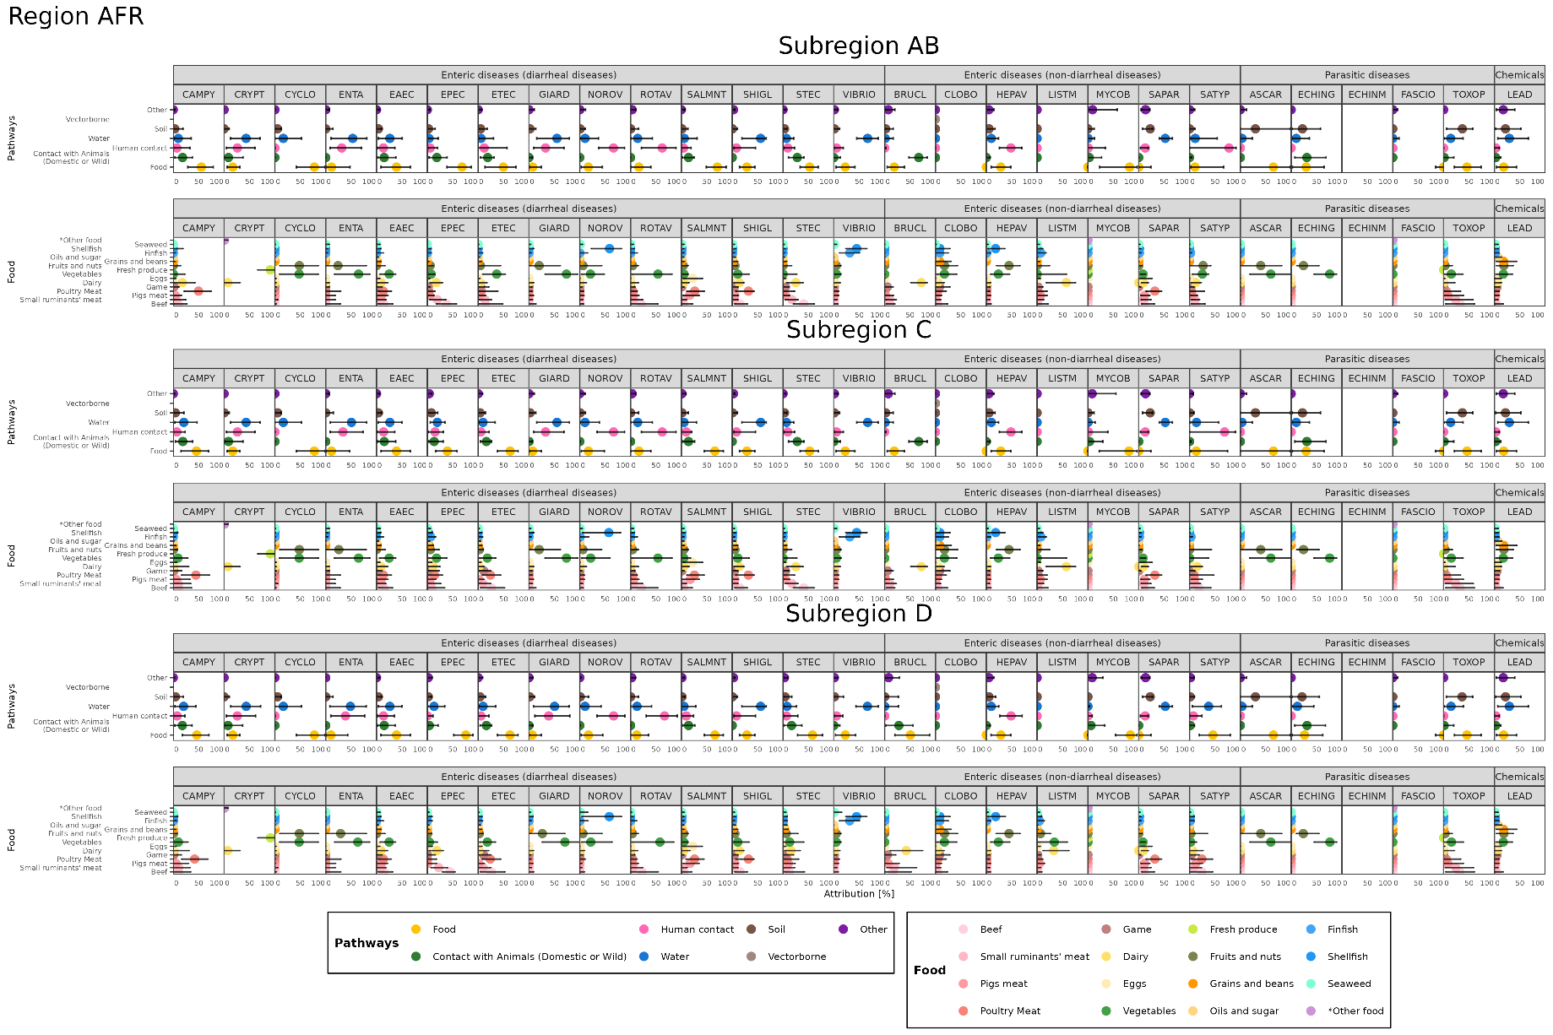
Transmission “vector-borne” is applicable only to T. cruzi in the American Region. The category “other food” in the food groups applies only to Cryptosporidium and includes all remaining food groups except “dairy” and “fresh produce”. Where estimated, “fresh produce” applies only to Cryptosporidium and Fasciola/Fasciolopsis, and includes both “vegetables” and “fruits and nuts”. Pathway-level attribution estimates for T. gondii and E. granulosus were obtained from Hald et al. (2B16b) and Torgerson et al. (2B2B), respectively. For food-level attribution estimates for these parasites (not shown in this picture), we refer to Hoffmann et al. (2B17) and Torgerson et al. (2B2B), respectively. CAMPY = Campylobacter, CRYPT = Cryptosporidium; CYCLO = Cyclospora; ENTA = Entamoeba histolytica; EAEC = Enteroaggregative E. Coli; EPEC = Enteropathogenic E. coli; ETEC = Enterotoxigenic E. coli; GIARD = Giardia; NOROV = Norovirus; ROTAV = Rotavirus; SALMNT = Non-typhoidal Salmonella enterica; SHIGL = Shigella; STEC = Shiga toxin-producing E. coli; VIBRIO = Vibrio cholerae; BRUCL = Brucella; CLOBO = Clostridium botulinum; HEPAV = Hepatitis A virus; LISTM = Listeria monocytogenes; MYCOB = Mycobacterium bovis/caprae/orygis; SAPAR = Salmonella Paratyphi; SATYP = Salmonella Typhi; ASCAR = Ascaris; ECHING = Echinococcus granulosus; ECHINM = Echinococcus multilocularis; FASCIO = Fasciola & Fasciolopsis; TOXOP = Toxoplasma gondii; LEAD = Lead.

Supplementary Figure S2. Attributions (median, 2.5th and 97.5th percentiles) to transmission pathways to foods for 29 hazards for the Region of the Americas.
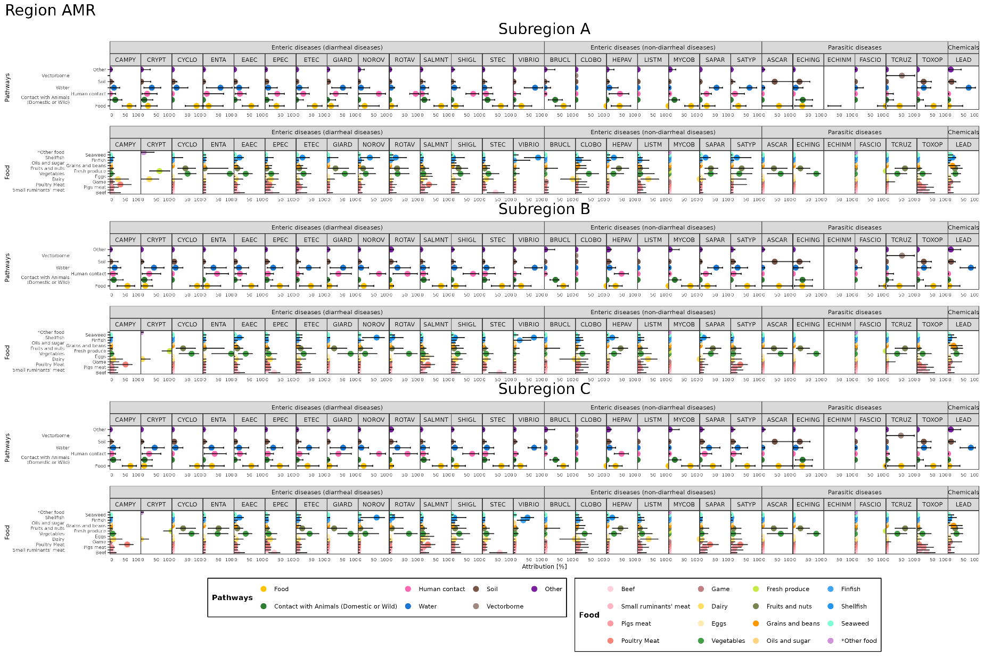
The category “other food” in the food groups applies only to Cryptosporidium and includes all remaining food groups except “dairy” and “fresh produce”. Where estimated, “fresh produce” applies only to Cryptosporidium and Fasciola/Fasciolopsis, and includes both “vegetables” and “fruits and nuts”. Pathway-level attribution estimates for T. gondii and E. granulosus were obtained from Hald et al. (2B16b) and Torgerson et al. (2B2B), respectively. For food-level attribution estimates for these parasites (not shown in this picture), we refer to Hoffmann et al. (2B17) and Torgerson et al. (2B2B), respectively. CAMPY = Campylobacter, CRYPT = Cryptosporidium; CYCLO = Cyclospora; ENTA = Entamoeba histolytica; EAEC = Enteroaggregative E. Coli; EPEC = Enteropathogenic E. coli; ETEC = Enterotoxigenic E. coli; GIARD = Giardia; NOROV = Norovirus; ROTAV = Rotavirus; SALMNT = Non-typhoidal Salmonella enterica; SHIGL = Shigella; STEC = Shiga toxin-producing E. coli; VIBRIO = Vibrio cholerae; BRUCL = Brucella; CLOBO = Clostridium botulinum; HEPAV = Hepatitis A virus; LISTM = Listeria monocytogenes; MYCOB = Mycobacterium bovis/caprae/orygis; SAPAR = Salmonella Paratyphi; SATYP = Salmonella Typhi; ASCAR = Ascaris; ECHING = Echinococcus granulosus; ECHINM = Echinococcus multilocularis; FASCIO = Fasciola & Fasciolopsis; TOXOP = Toxoplasma gondii; LEAD = Lead.

Supplementary Figure S3. Attributions (median, 2.5th and 97.5th percentiles) to transmission pathways to foods for 29 hazards for the South-East Asia Region.
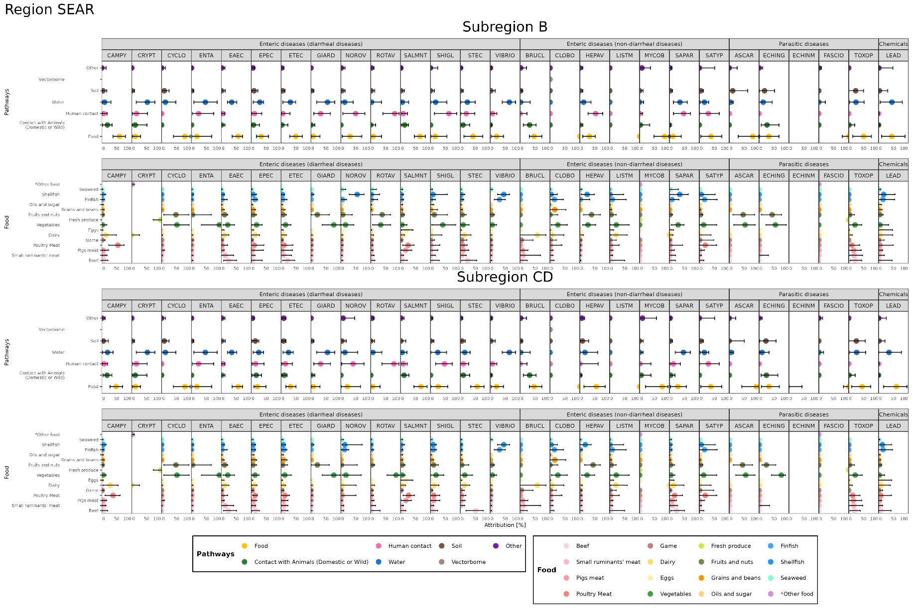

Transmission “vector-borne” is applicable only to T. cruzi in the Region of Americas. The category “other food” in the food groups applies only to Cryptosporidium and includes all remaining food groups except “dairy” and “fresh produce”. Where estimated, “fresh produce” applies only to Cryptosporidium and Fasciola/Fasciolopsis, and includes both “vegetables” and “fruits and nuts”. Pathway-level attribution estimates for T. gondii and E. granulosus were obtained from Hald et al. (2B16b) and Torgerson et al. (2B2B), respectively. For food-level attribution estimates for these parasites (not shown in this picture), we refer to Hoffmann et al. (2B17) and Torgerson et al. (2B2B), respectively. CAMPY = Campylobacter, CRYPT = Cryptosporidium; CYCLO = Cyclospora; ENTA = Entamoeba histolytica; EAEC = Enteroaggregative E. Coli; EPEC = Enteropathogenic E. coli; ETEC = Enterotoxigenic E. coli; GIARD = Giardia; NOROV = Norovirus; ROTAV = Rotavirus; SALMNT = Non-typhoidal Salmonella enterica; SHIGL = Shigella; STEC = Shiga toxin-producing E. coli; VIBRIO = Vibrio cholerae; BRUCL = Brucella; CLOBO = Clostridium botulinum; HEPAV = Hepatitis A virus; LISTM = Listeria monocytogenes; MYCOB = Mycobacterium bovis/caprae/orygis; SAPAR = Salmonella Paratyphi; SATYP = Salmonella Typhi; ASCAR = Ascaris; ECHING = Echinococcus granulosus; ECHINM = Echinococcus multilocularis; FASCIO = Fasciola & Fasciolopsis; TOXOP = Toxoplasma gondii; LEAD = Lead.

Supplementary Figure 4. Detailed attributions (median, 2.5th and 97.5th percentiles) to transmission pathways to foods for 29 hazards for the European Region.
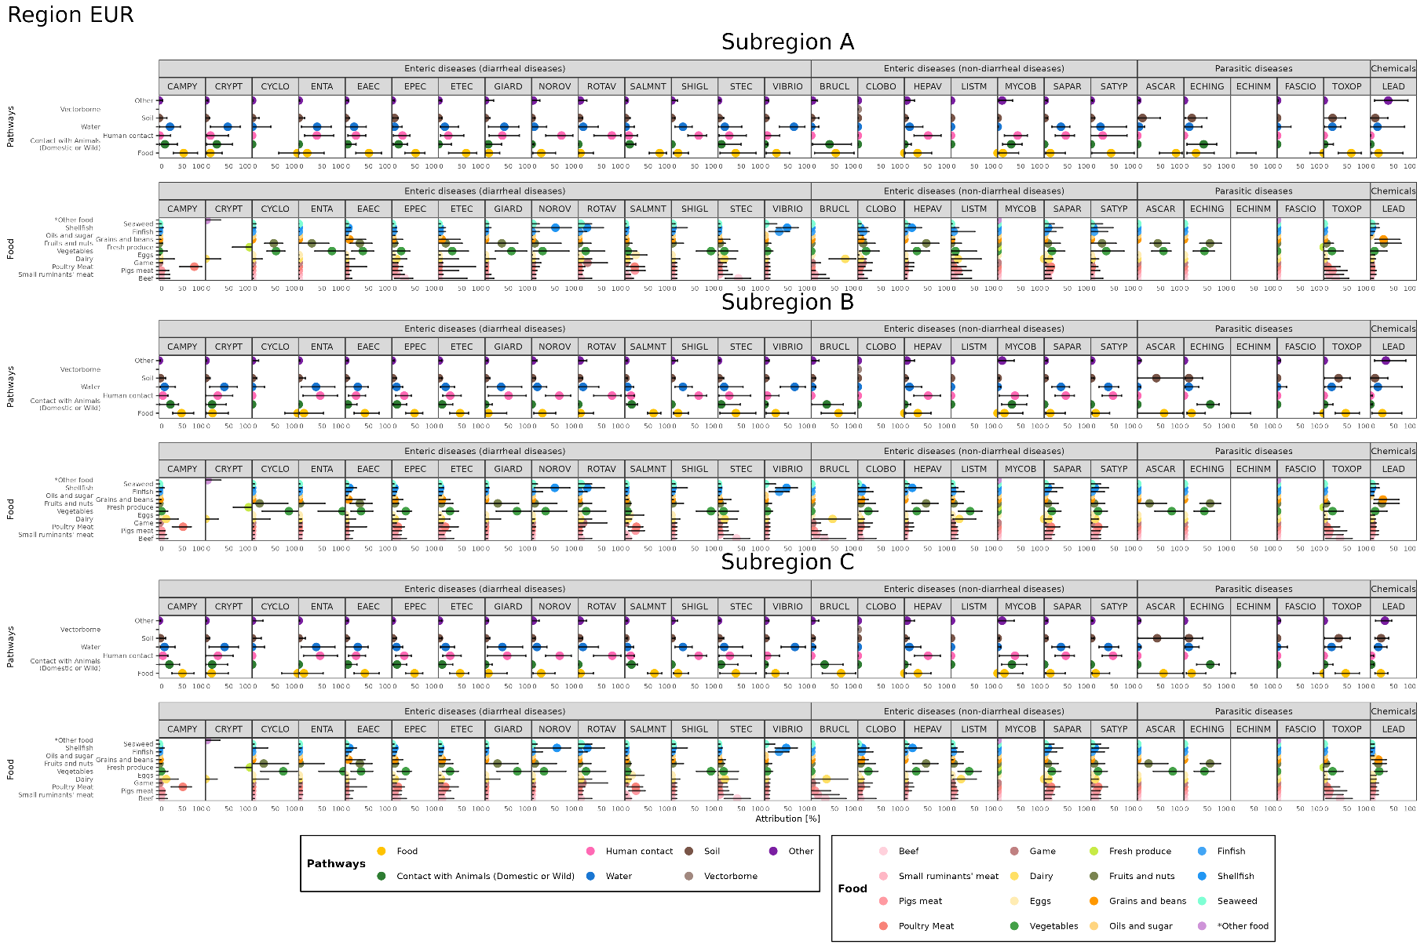
Transmission “vector-borne” is applicable only to T. cruzi in the Region of Americas. The category “other food” in the food groups applies only to Cryptosporidium and includes all remaining food groups except “dairy” and “fresh produce”. Where estimated, “fresh produce” applies only to Cryptosporidium and Fasciola/Fasciolopsis, and includes both “vegetables” and “fruits and nuts”. Pathway-level attribution estimates for T. gondii and E. granulosus were obtained from Hald et al. (2B16b) and Torgerson et al. (2B2B), respectively. For food-level attribution estimates for these parasites (not shown in this picture), we refer to Hoffmann et al. (2B17) and Torgerson et al. (2B2B), respectively. CAMPY = Campylobacter, CRYPT = Cryptosporidium; CYCLO = Cyclospora; ENTA = Entamoeba histolytica; EAEC = Enteroaggregative E. Coli; EPEC = Enteropathogenic E. coli; ETEC = Enterotoxigenic E. coli; GIARD = Giardia; NOROV = Norovirus; ROTAV = Rotavirus; SALMNT = Non-typhoidal Salmonella enterica; SHIGL = Shigella; STEC = Shiga toxin-producing E. coli; VIBRIO = Vibrio cholerae; BRUCL = Brucella; CLOBO = Clostridium botulinum; HEPAV = Hepatitis A virus; LISTM = Listeria monocytogenes; MYCOB = Mycobacterium bovis/caprae/orygis; SAPAR = Salmonella Paratyphi; SATYP = Salmonella Typhi; ASCAR = Ascaris; ECHING = Echinococcus granulosus; ECHINM = Echinococcus multilocularis; FASCIO = Fasciola & Fasciolopsis; TOXOP = Toxoplasma gondii; LEAD = Lead.

Supplementary Figure S5. Attributions (median, 2.5th and 97.5th percentiles) to transmission pathways to foods for 29 hazards for the Eastern Mediterranean Region.
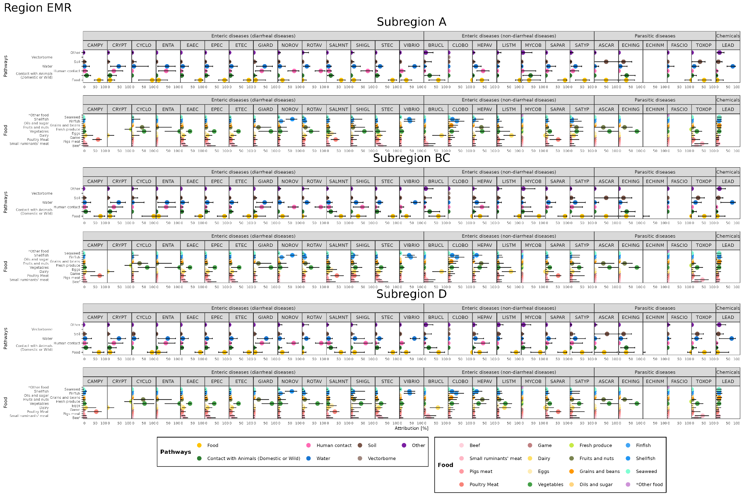
Transmission “vector-borne” is applicable only to T. cruzi in the Region of Americas. The category “other food” in the food groups applies only to Cryptosporidium and includes all remaining food groups except “dairy” and “fresh produce”. Where estimated, “fresh produce” applies only to Cryptosporidium and Fasciola/Fasciolopsis, and includes both “vegetables” and “fruits and nuts”. Pathway-level attribution estimates for T. gondii and E. granulosus were obtained from Hald et al. (2B16b) and Torgerson et al. (2B2B), respectively. For food-level attribution estimates for these parasites (not shown in this picture), we refer to Hoffmann et al. (2B17) and Torgerson et al. (2B2B), respectively. CAMPY = Campylobacter, CRYPT = Cryptosporidium; CYCLO = Cyclospora; ENTA = Entamoeba histolytica; EAEC = Enteroaggregative E. Coli; EPEC = Enteropathogenic E. coli; ETEC = Enterotoxigenic E. coli; GIARD = Giardia; NOROV = Norovirus; ROTAV = Rotavirus; SALMNT = Non-typhoidal Salmonella enterica; SHIGL = Shigella; STEC = Shiga toxin-producing E. coli; VIBRIO = Vibrio cholerae; BRUCL = Brucella; CLOBO = Clostridium botulinum; HEPAV = Hepatitis A virus; LISTM = Listeria monocytogenes; MYCOB = Mycobacterium bovis/caprae/orygis; SAPAR = Salmonella Paratyphi; SATYP = Salmonella Typhi; ASCAR = Ascaris; ECHING = Echinococcus granulosus; ECHINM = Echinococcus multilocularis; FASCIO = Fasciola & Fasciolopsis; TOXOP = Toxoplasma gondii; LEAD = Lead.

Supplementary Figure S6. Attributions (median, 2.5th and 97.5th percentiles) to transmission pathways to foods for 29 hazards for the Western Pacific Region.
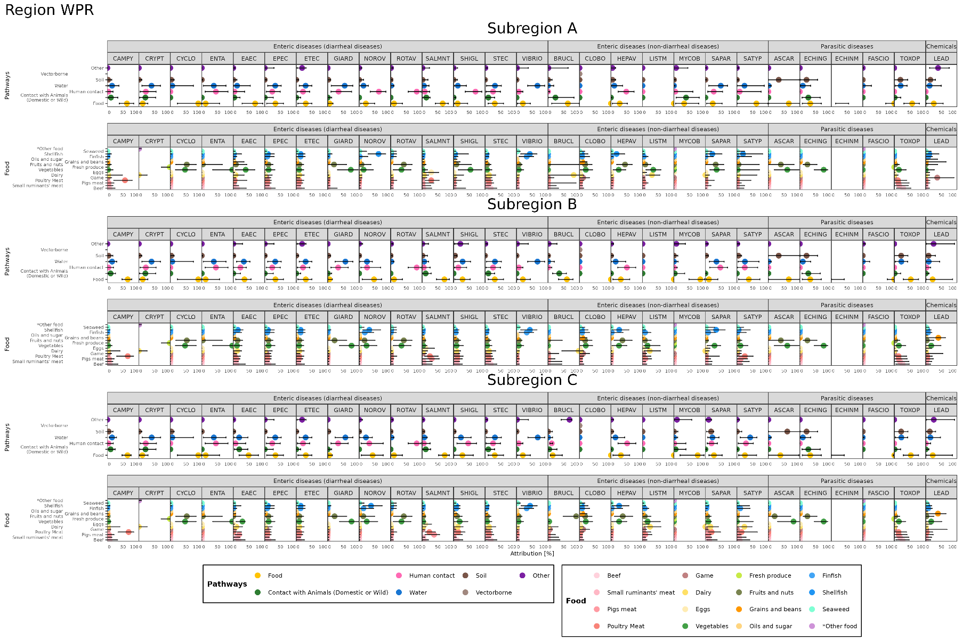
Transmission “vector-borne” is applicable only to T. cruzi in the Region of Americas. The category “other food” in the food groups applies only to Cryptosporidium and includes all remaining food groups except “dairy” and “fresh produce”. Where estimated, “fresh produce” applies only to Cryptosporidium and Fasciola/Fasciolopsis, and includes both “vegetables” and “fruits and nuts”. Pathway-level attribution estimates for T. gondii and E. granulosus were obtained from Hald et al. (2B16b) and Torgerson et al. (2B2B), respectively. For food-level attribution estimates for these parasites (not shown in this picture), we refer to Hoffmann et al. (2B17) and Torgerson et al. (2B2B), respectively. CAMPY = Campylobacter, CRYPT = Cryptosporidium; CYCLO = Cyclospora; ENTA = Entamoeba histolytica; EAEC = Enteroaggregative E. Coli; EPEC = Enteropathogenic E. coli; ETEC = Enterotoxigenic E. coli; GIARD = Giardia; NOROV = Norovirus; ROTAV = Rotavirus; SALMNT = Non-typhoidal Salmonella enterica; SHIGL = Shigella; STEC = Shiga toxin-producing E. coli; VIBRIO = Vibrio cholerae; BRUCL = Brucella; CLOBO = Clostridium botulinum; HEPAV = Hepatitis A virus; LISTM = Listeria monocytogenes; MYCOB = Mycobacterium bovis/caprae/orygis; SAPAR = Salmonella Paratyphi; SATYP = Salmonella Typhi; ASCAR = Ascaris; ECHING = Echinococcus granulosus; ECHINM = Echinococcus multilocularis; FASCIO = Fasciola & Fasciolopsis; TOXOP = Toxoplasma gondii; LEAD = Lead.

Supplementary Figures S7. Estimated attribution proportion to main pathways in FERG 2015 (median and 95% Confidence Interval) (Hald et al., 2016) and FERG 2026 (mean and 95% Confidence Interval) for nine enteric hazards. 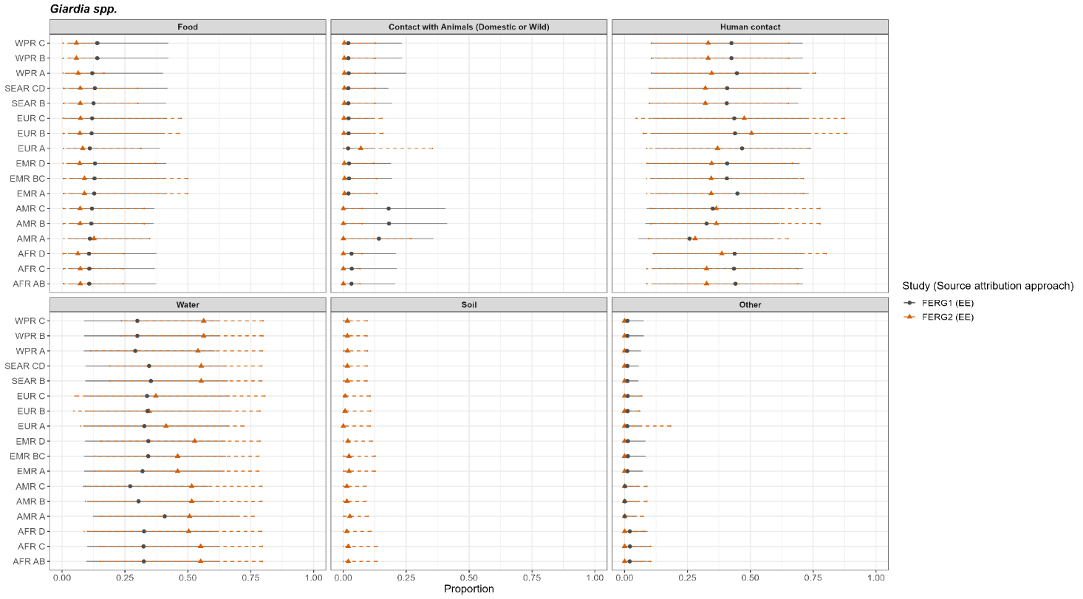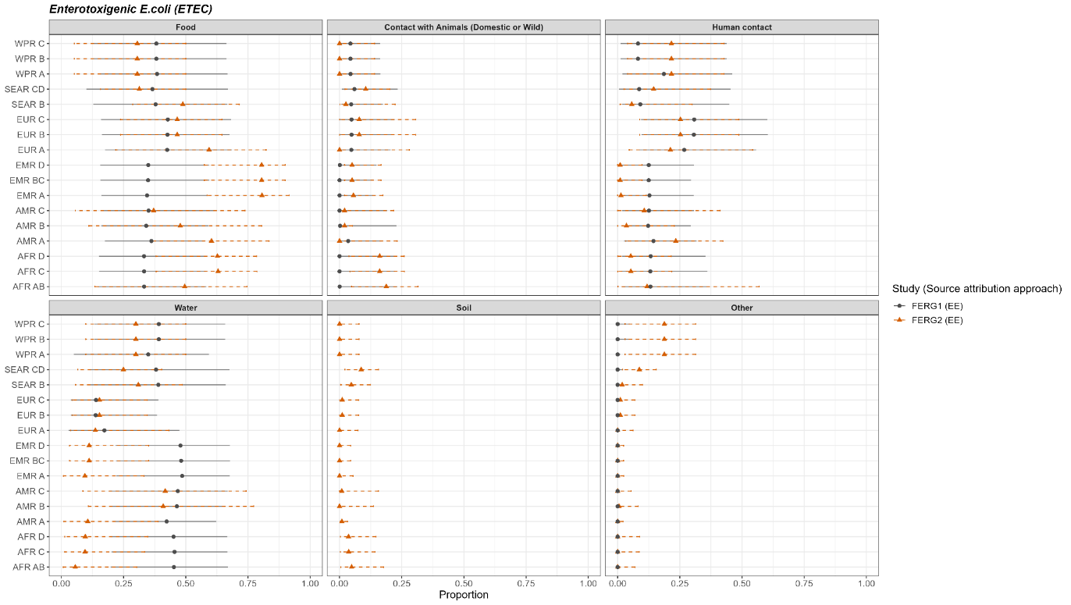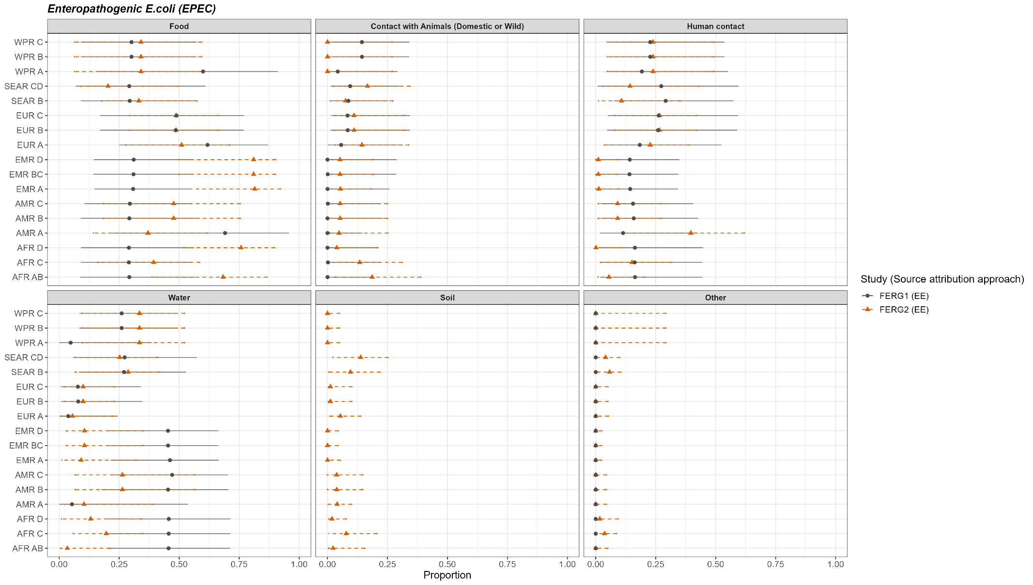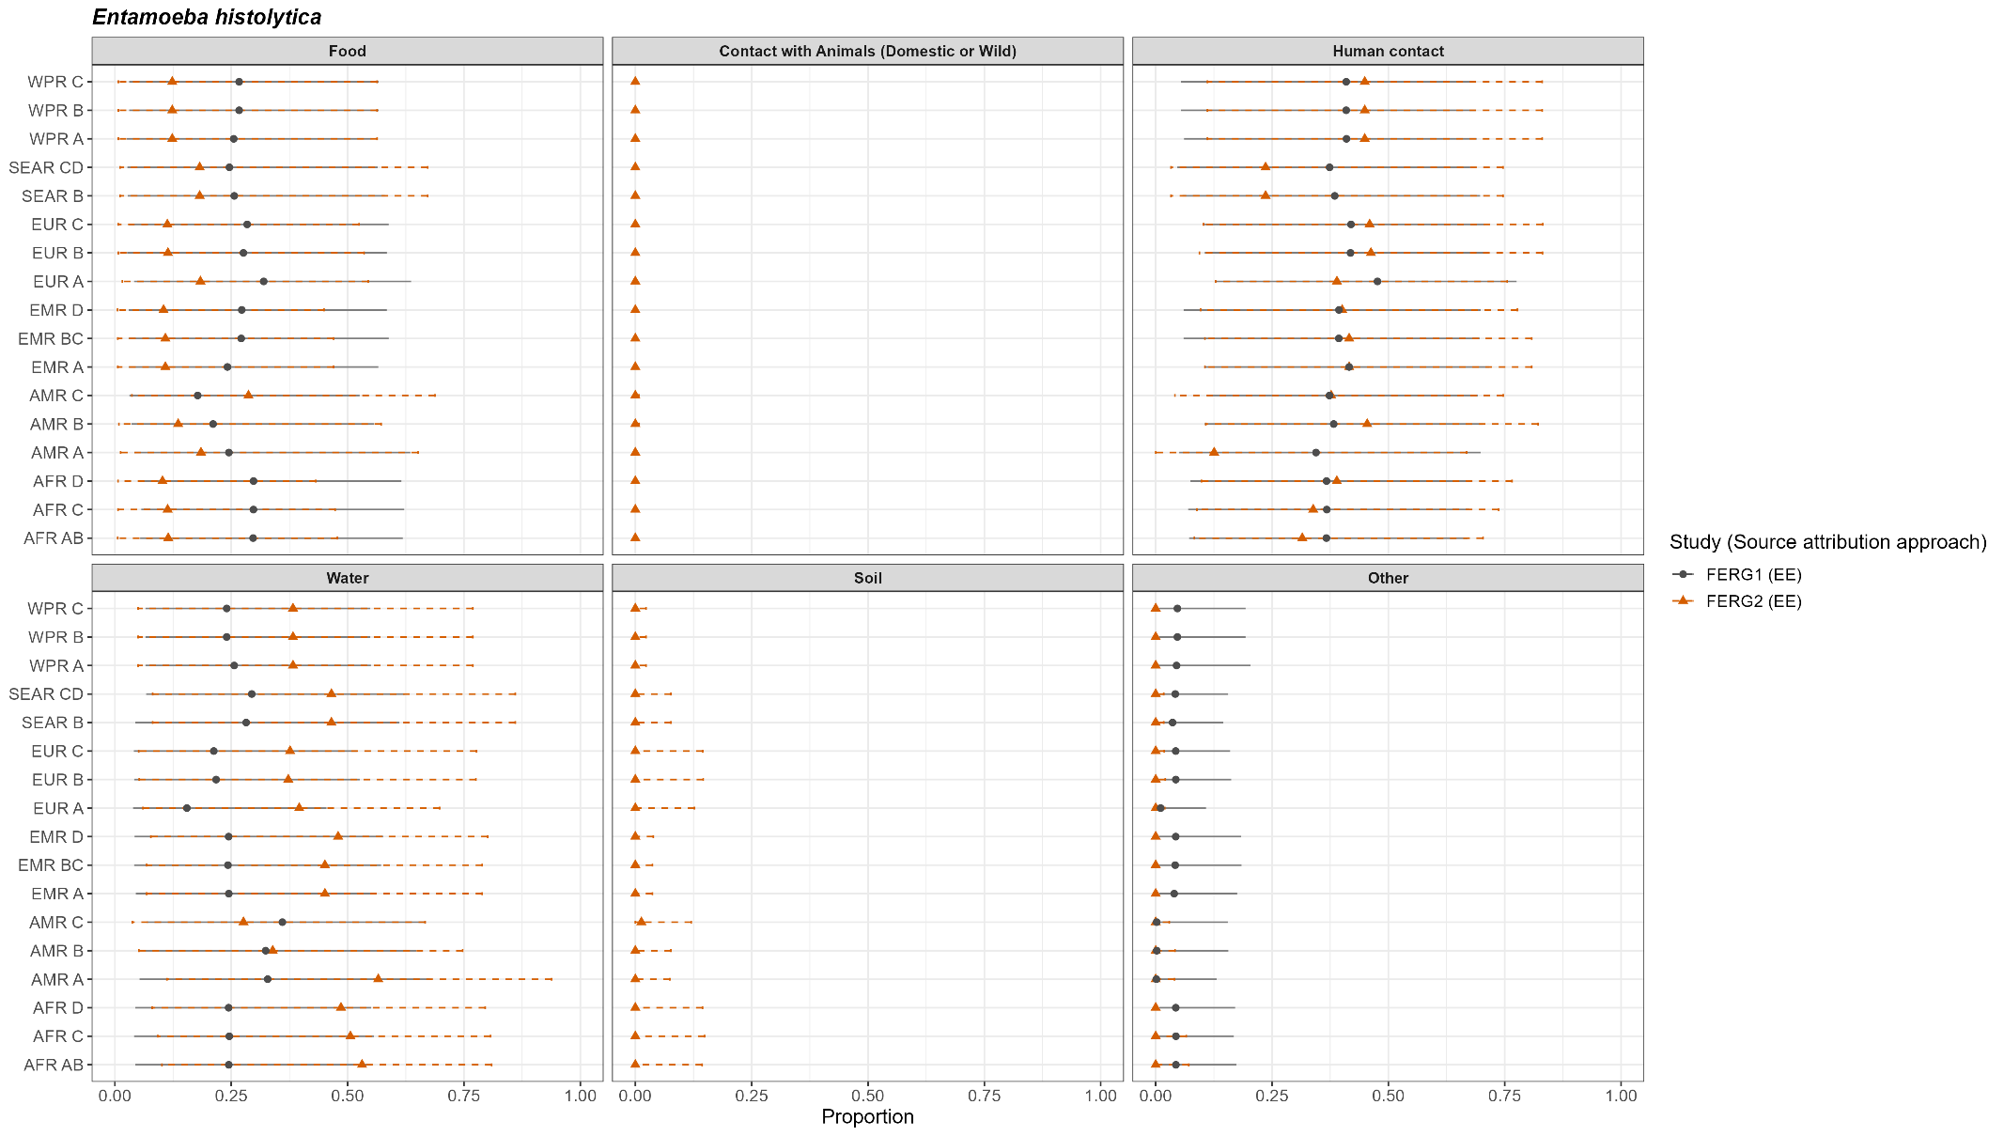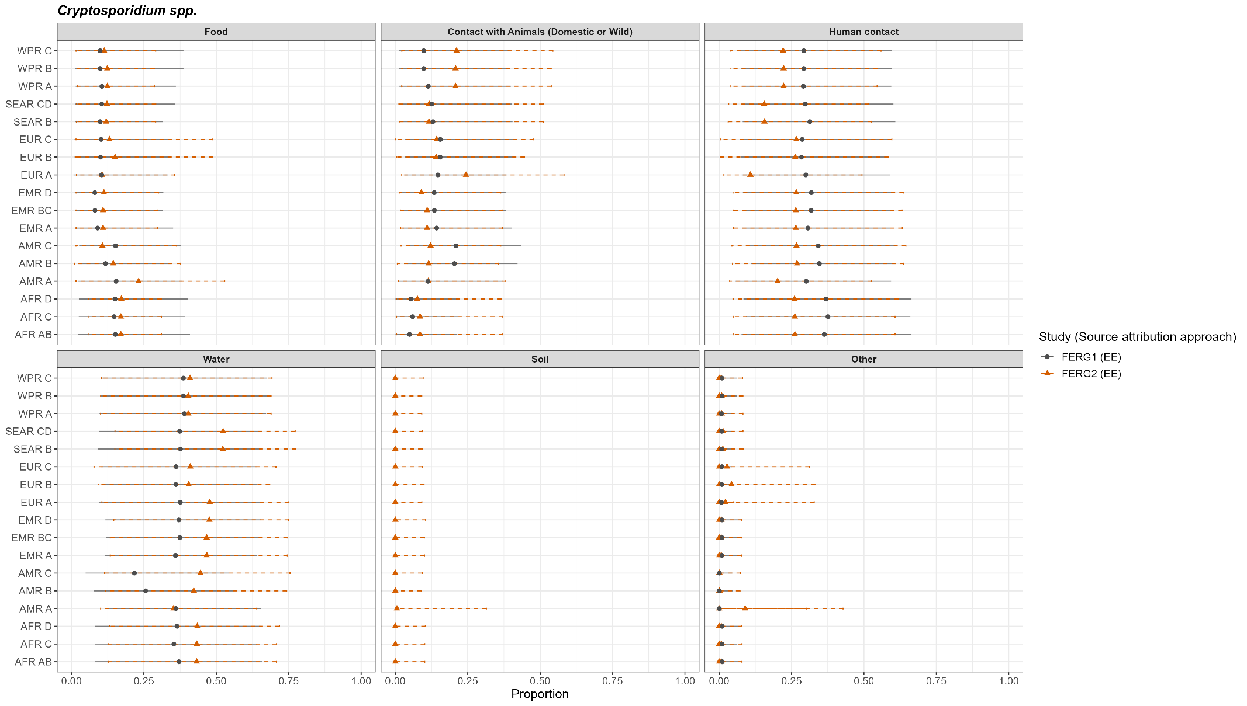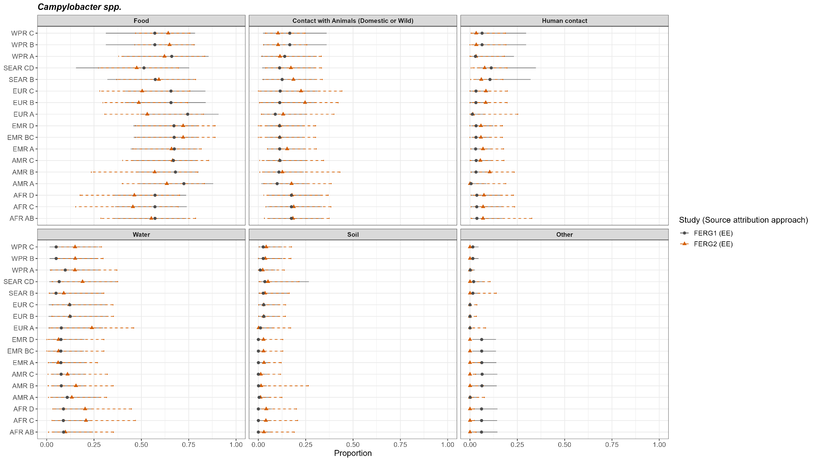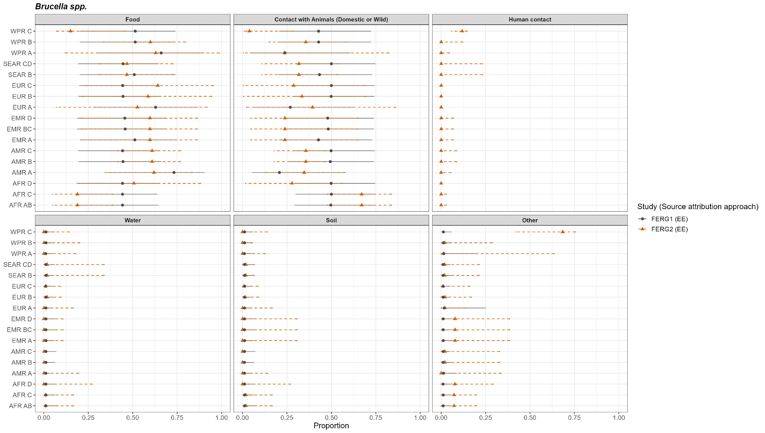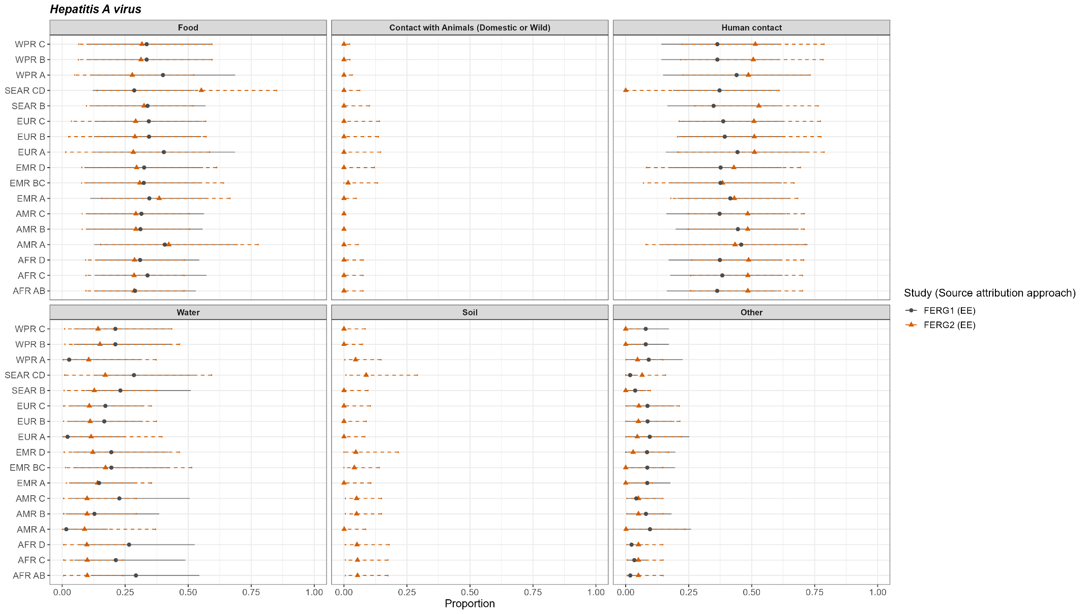

Supplementary Figure 8. Estimated attribution proportion to main pathways (mean and 95% Confidence Interval) in FERG 2015 (Hald et al., 2016) and FERG 2026 for parasites
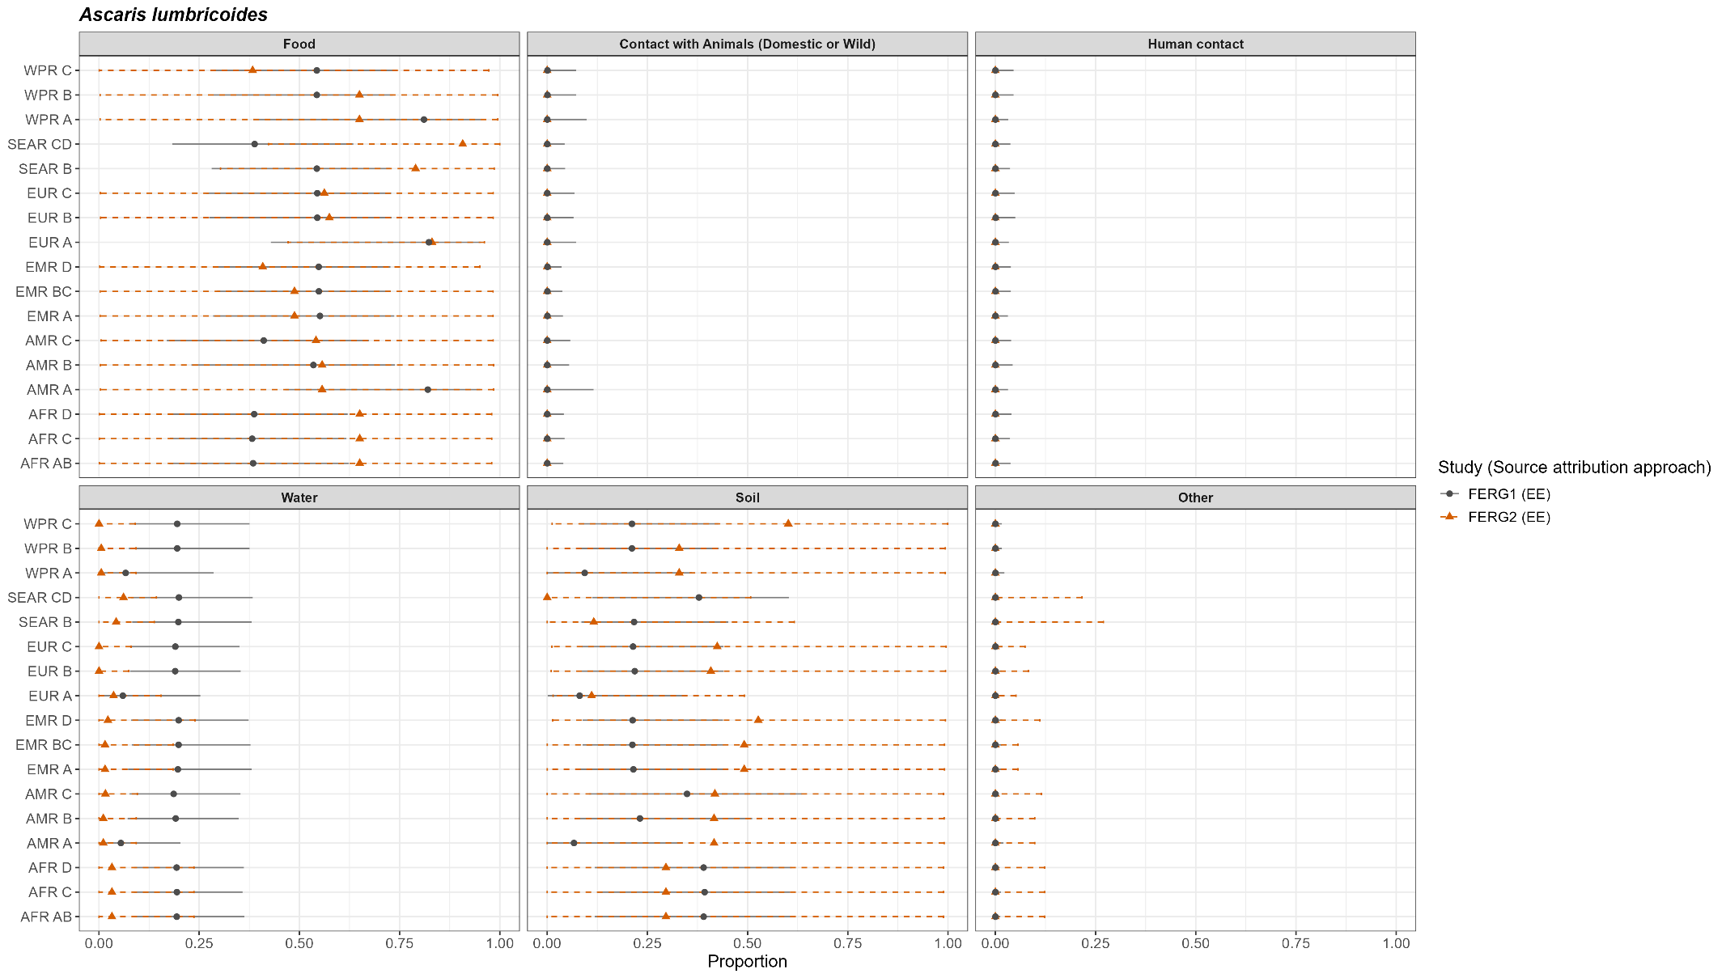
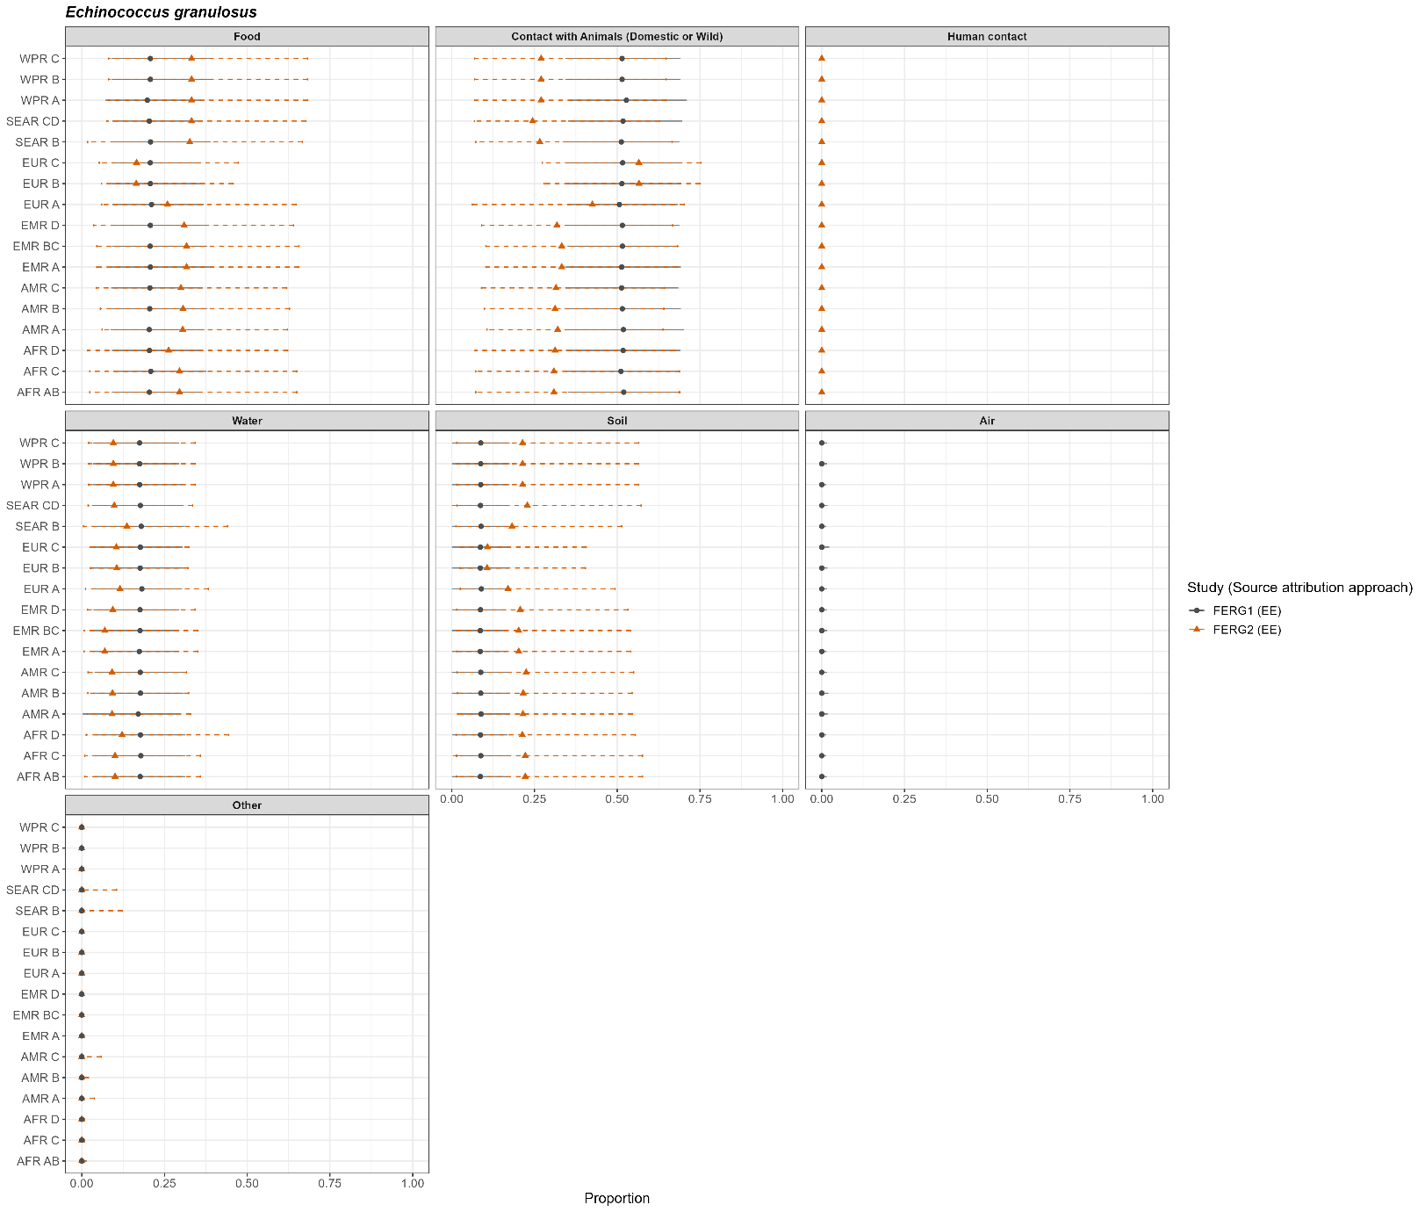

Supplementary Figure 9. Estimated attribution proportion to main pathways in FERG 2015 (median and 95% Confidence Interval) (Hald et al., 2016) and FERG 2026 (mean and 95% Confidence Interval) for lead
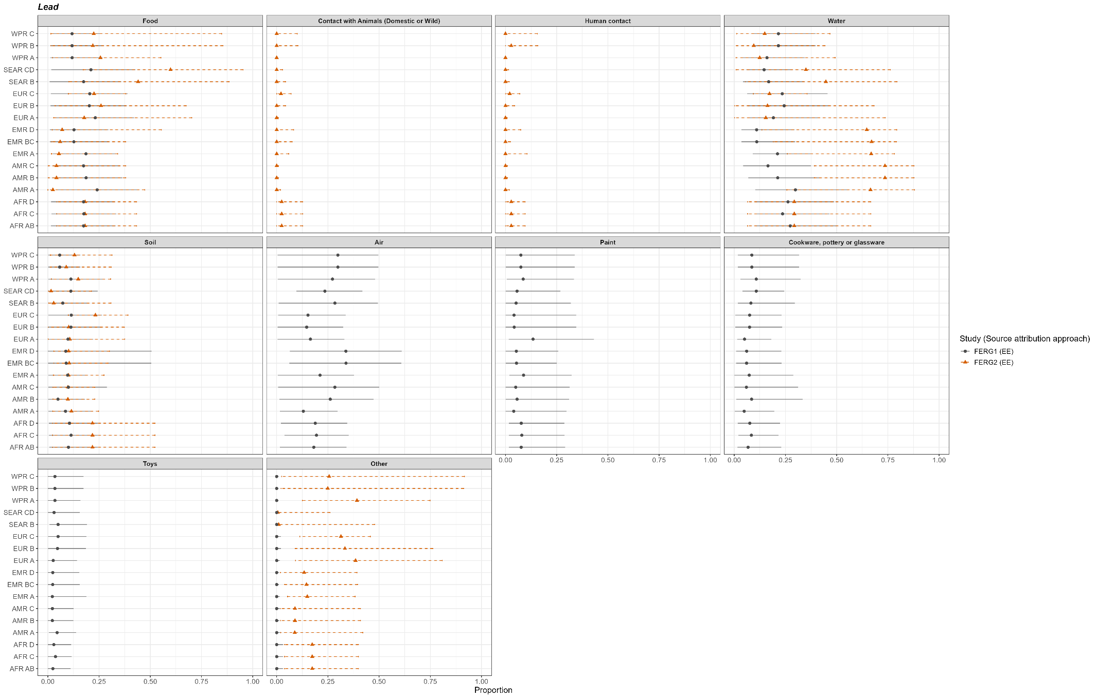

Supplementary Figures 10. Estimated attribution to food categories in FERG 2026 and estimated in previous source attribution studies (mean and 95% Confidence Intervals).
Estimates extracted from Davydova et al., 20251. Data is available through the Zenodo repository https://doi.org/10.5281/zenodo.14720777 under the Creative Commons Attribution 4.0 International license.
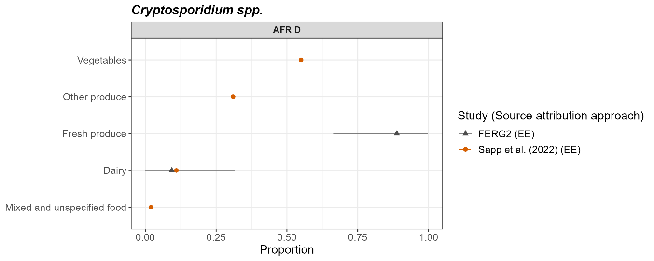
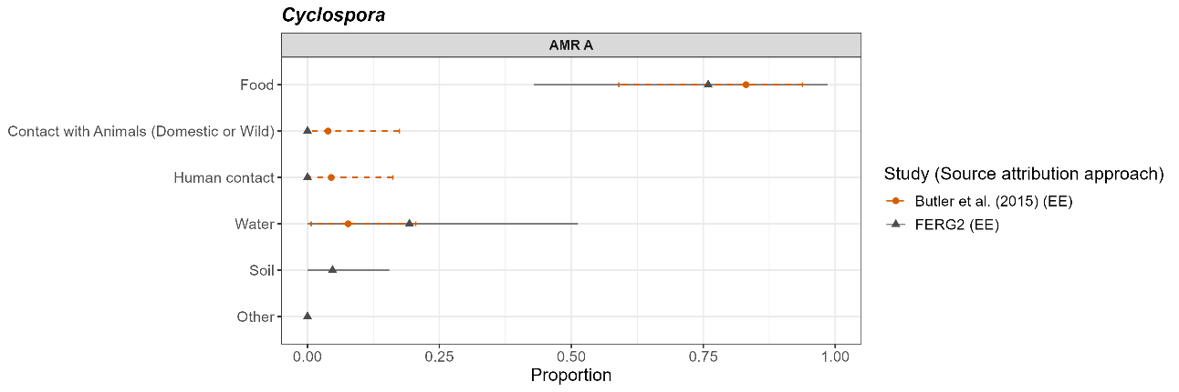
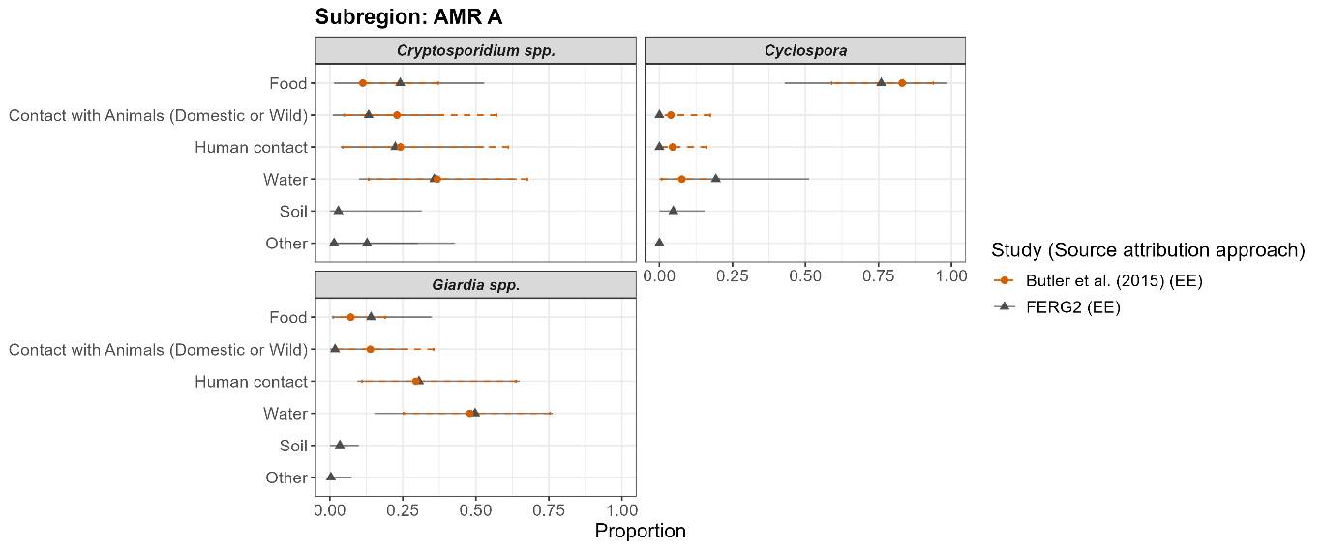
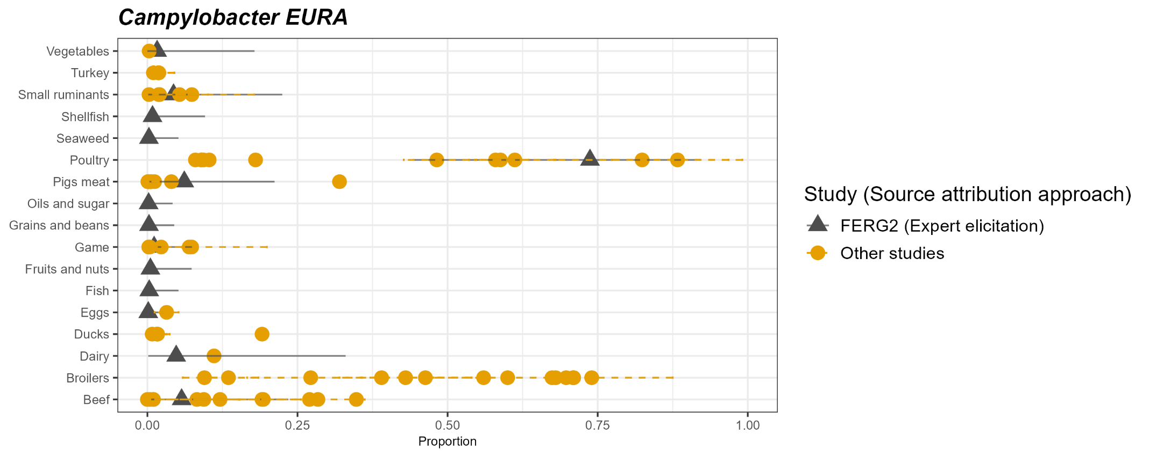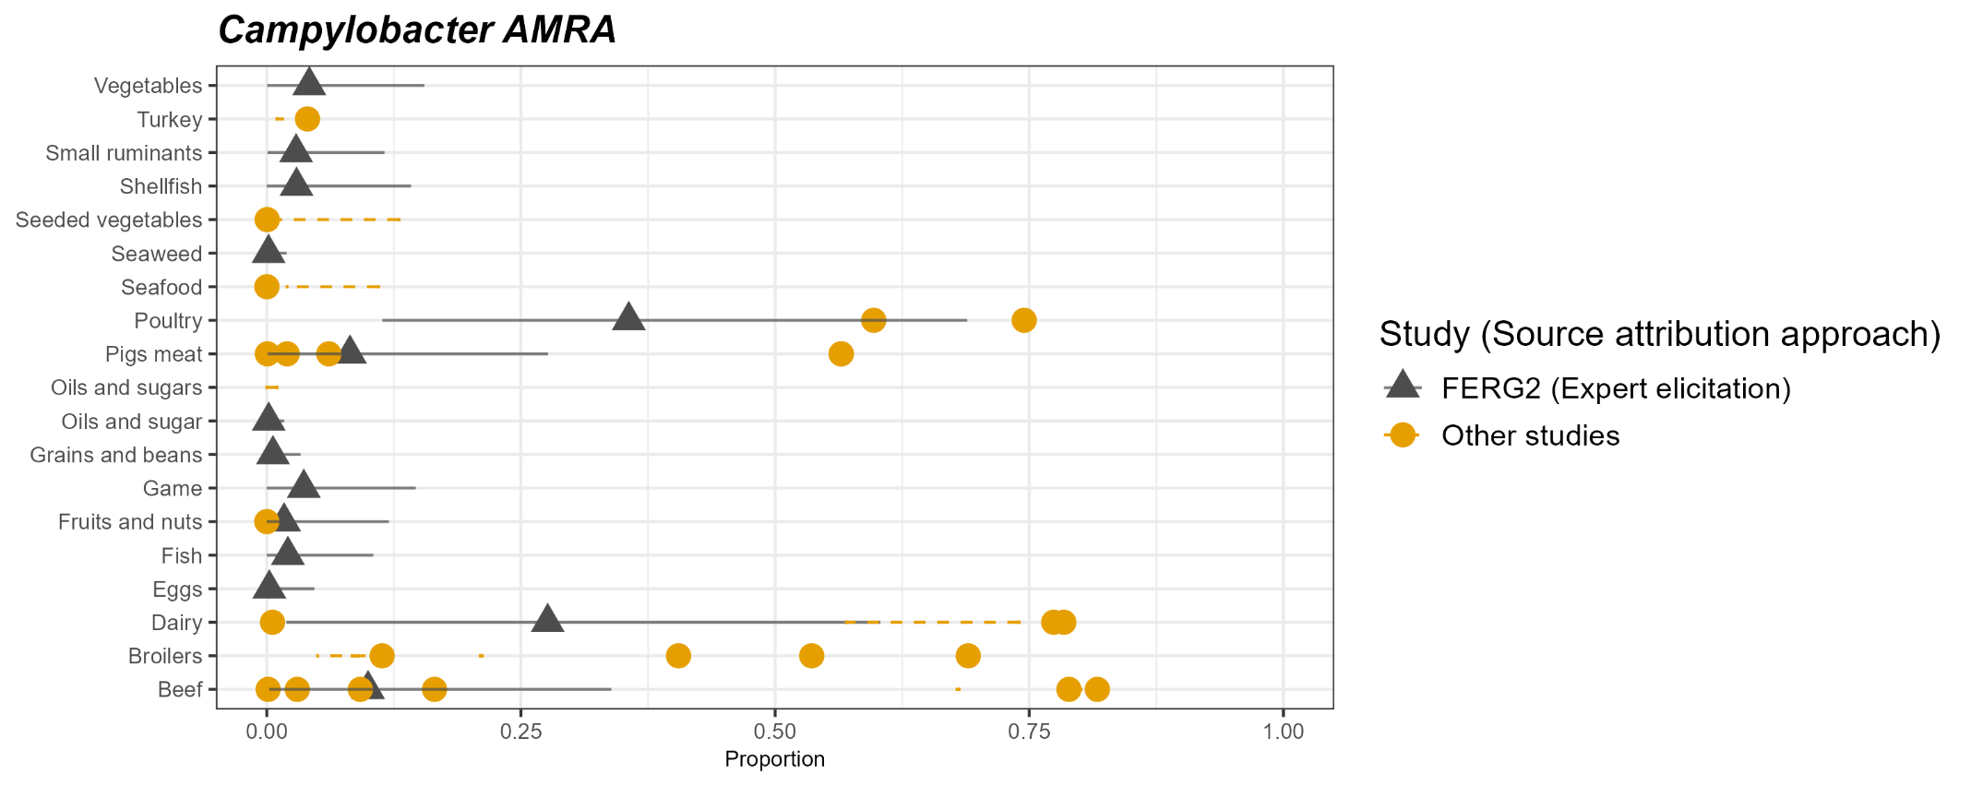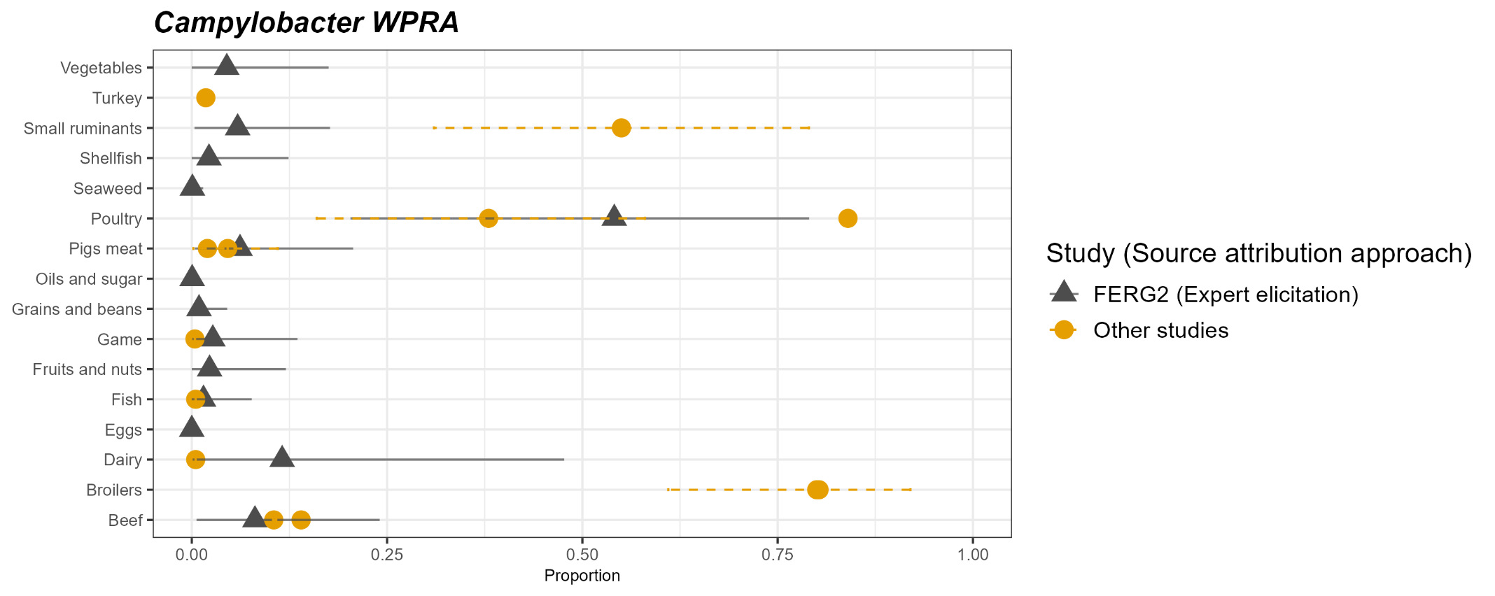

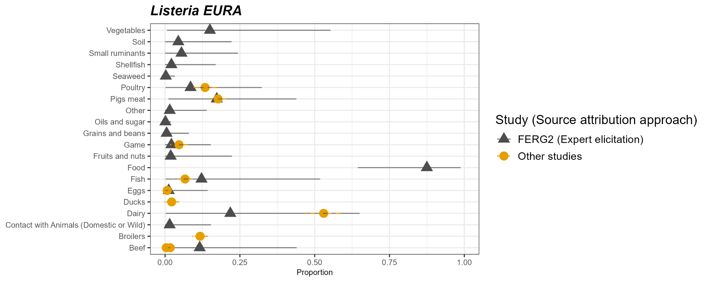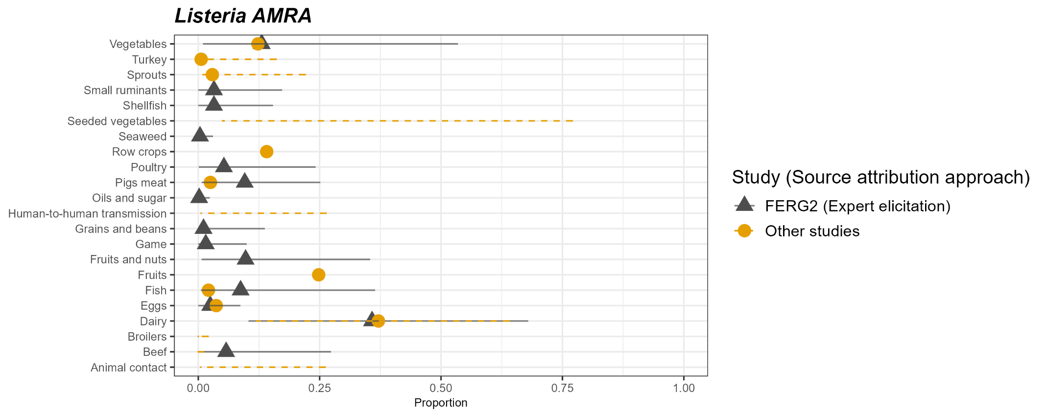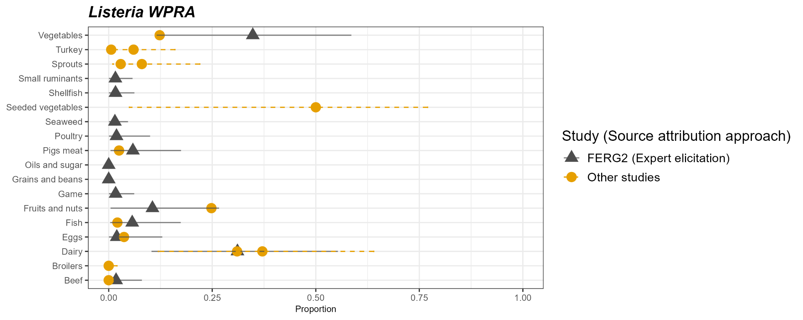

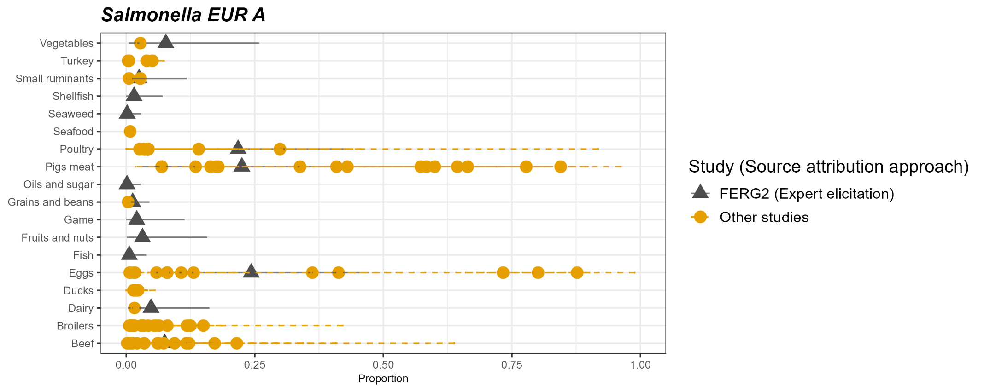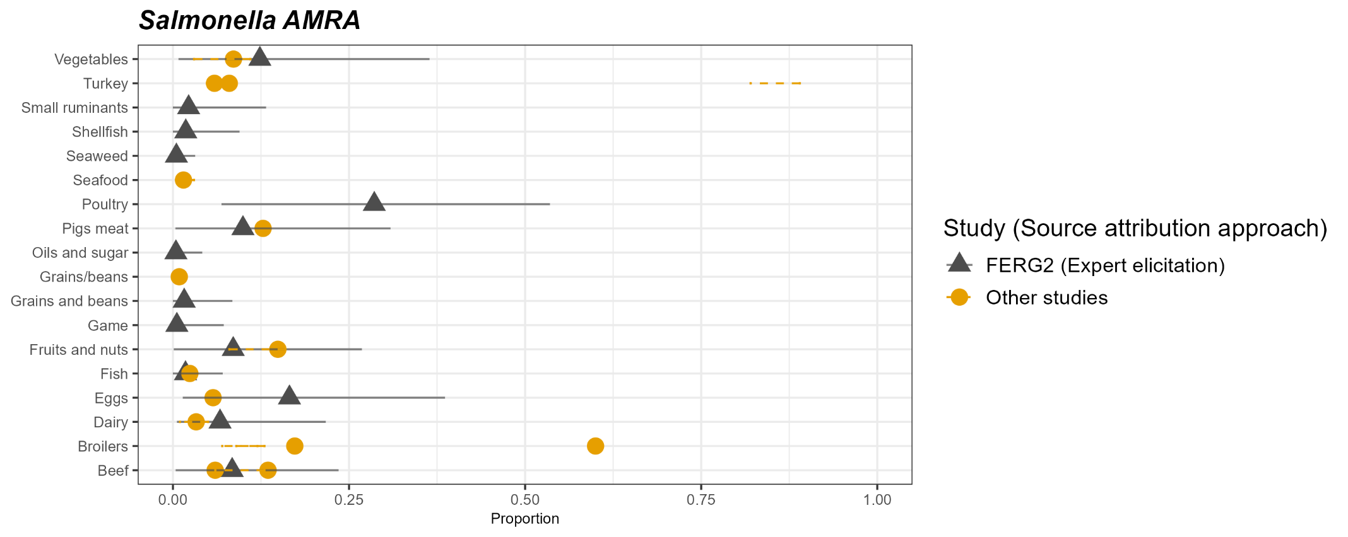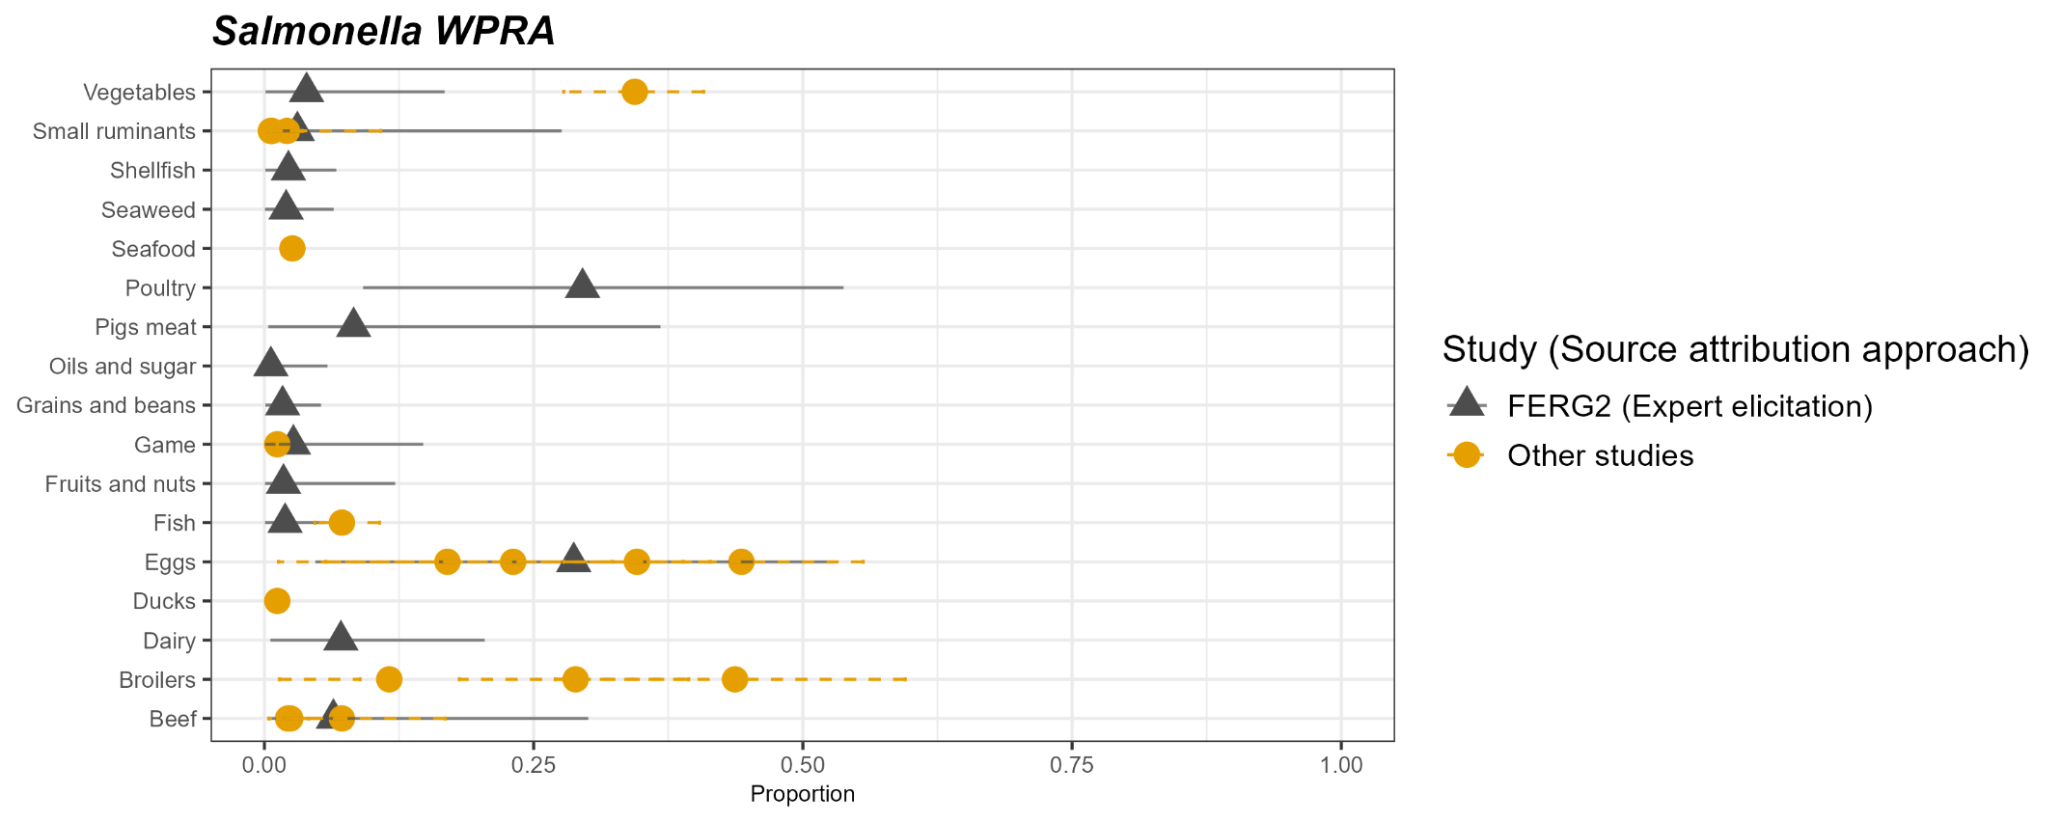

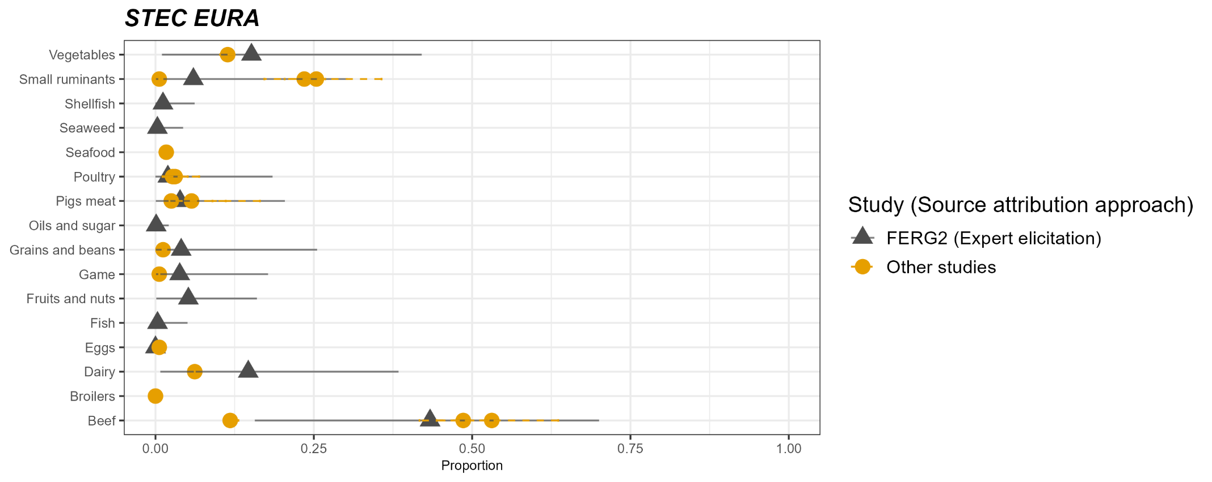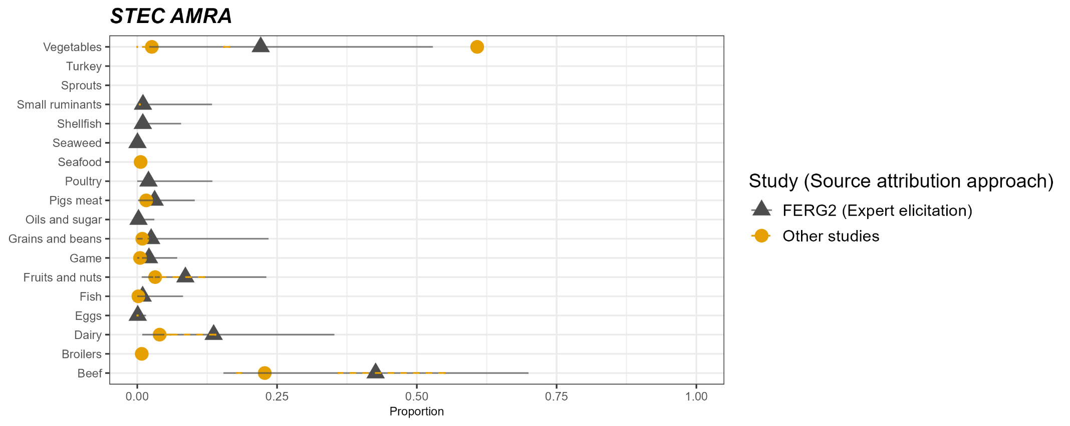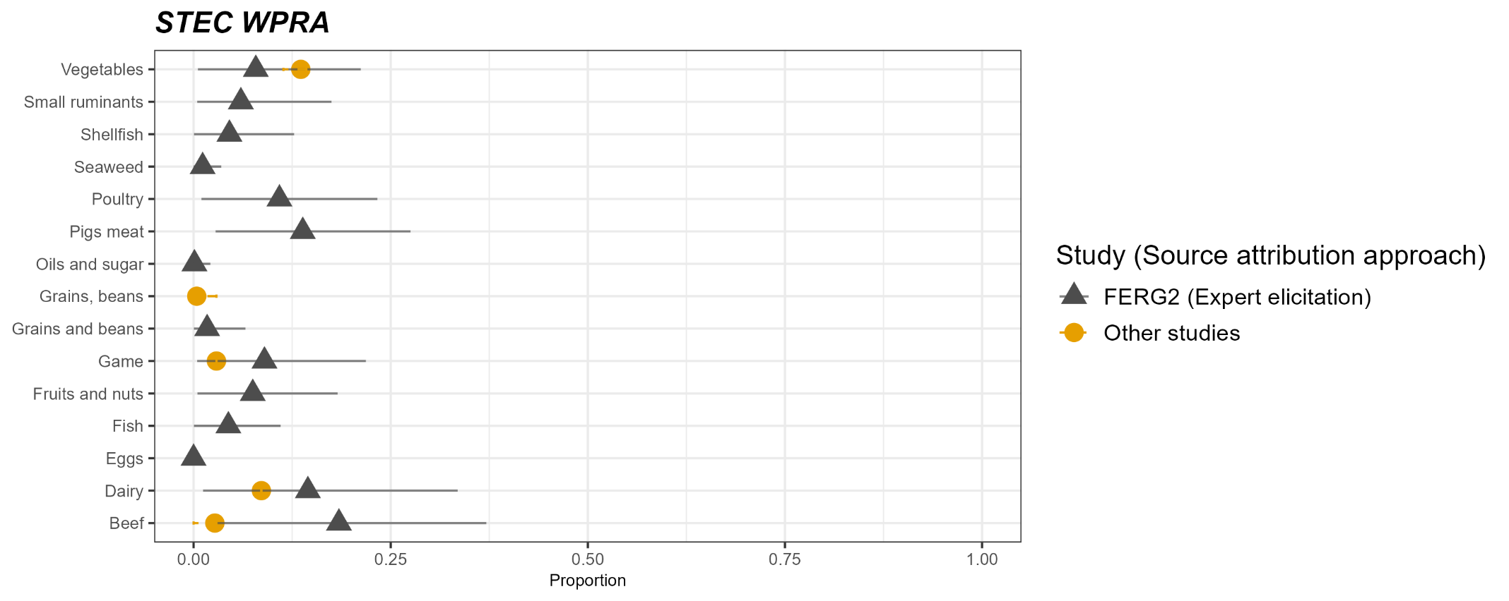

1. Davydova, A. et al. Source attribution studies of foodborne pathogens, 2010–2023: a review and collection of estimates. Food Microbiol. 131, 104812 (2025).

