Supplementary Information

Novel Chalcone-derived Pyrazoles as Potential Therapeutic Agents for the Treatment of Non-small Cell Lung Cancer
Natalia Maciejewska^{1*}, Mateusz Olszewski¹, Jakub Jurasz¹, Marcin Serocki³, Maria Dzierzynska², Katarzyna Cekala², Ewa Wieczerzak², Maciej Baginski¹

¹ Faculty of Chemistry, Gdansk University of Technology, Gabriela Narutowicza 11/12, 80-233 Gdansk, Poland
² Faculty of Chemistry, University of Gdansk, Wita Stwosza 63, 80-308 Gdansk, Poland
³Ryvu Therapeutics, Leona Henryka Sternbacha 2, 30-394 Krakow, Poland

*Corresponding authors: natalia.maciejewska@pg.edu.pl
Biological evaluation
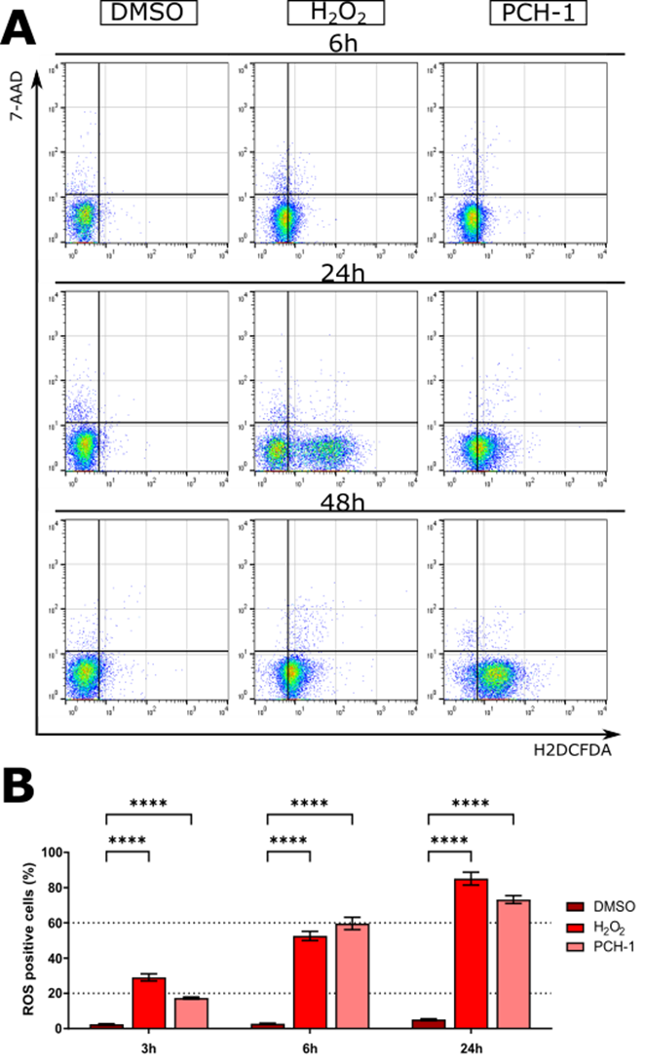
Figure S1. Flow cytometry analyses of ROS level after treatment A-549 cells with PCH-1.
A. Representative dot plots after labeling with H2DCFDA/PI; B. The quantitation of the analysis is presented in a graph bar. Data represent the mean ± SEM of three independent experiments. Statistical differences were analyzed by one-way ANOVA and post hoc Dunnett`s test. ** p<0.001, *** p<0.0001, **** p< 0.00001.

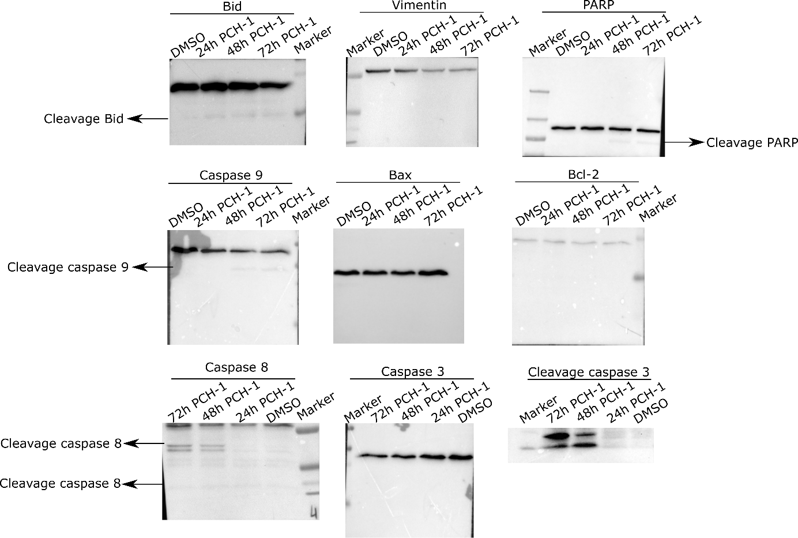
Figure S2. Full length western blot presented in Figure 8 of the main article.

Methods
Table S1 List of antibodies used in Western Blot
Antibody name | Company | Dilution
Anti-Caspase-3 (#9662)  Anti-Cleavage caspase-3 (#9661) | Cell Signaling  Cell Signaling | 1:1000  1:1000
Anti-Caspase-9 (#9502) | Cell Signaling | 1:1000
Anti-Caspase-8 (1C12) (#9746) | Cell Signaling | 1:1000
Anti-PARP (#9542) | Cell Signaling | 1:1000
Anti-Bcl-2 (#4223) | Cell Signaling | 1:1000
Anti-BID (#2002) | Cell Signaling | 1:1000
Anti-Bax (#2772) | Cell Signaling | 1:1000
Anti-Telomerase reverse  transcriptase antibody [Y182] (ab32020) | Cell Signaling | 1:1000
Anti-Vimentin (#5741) | Cell Signaling | 1:1000
Anti-N-cadherin (610920) | BD Transduction Laboratories | 1:250
Anti-actin (sc-1616) | Santa Cruz | 1:100
Anti-mouse-HRP (715-035-150) | Jacson ImmunoResearch Labs | 1:10000
Anti-rabbit-HRP (711-035-152) | Jacson ImmunoResearch Labs | 1:10000
Anti-goat-HRP (705-036-147) | Jacson ImmunoResearch Labs | 1:10000

