Supplementary Online Content
Supplementary Table 1. Variables included in the neonatal sleep questionnaire.
Supplementary Table 1 Maternal and Neonatal Characteristics and Sleep-Related Variables Assessed in the Questionnaire
Supplementary Table 2. Maternal and Neonatal Characteristics and Sleep-Related Variables Assessed in the Questionnaire
Supplementary Figure 1-1. Unadjusted comparisons of sleep outcomes between the exclusive breastfeeding group and the mixed-feeding group using the Mann–Whitney U test.
Supplementary Figure 1-2. Unadjusted comparisons of sleep outcomes between the exclusive breastfeeding group and the exclusive formula-feeding group using the Mann–Whitney U test.
Supplementary Figure 1-3. Unadjusted comparisons of sleep outcomes between the exclusive formula-feeding group and the mixed-feeding group using the Mann–Whitney U test.
Supplementary Figure S2. Graphical visualization of group differences in daytime sleep duration based on overlap-weighted univariate and multivariable regression analyses.
Supplementary Figure S3 Association between feeding patterns and nighttime sleep duration.
Supplementary Figure S4 Association between feeding patterns and time required to soothe infants to sleep.
Supplementary Figure S5 Association between feeding patterns and duration of nighttime wakefulness.
Supplementary Figure S6 Association between feeding patterns and difficulty in soothing infants to sleep.
Supplementary Figure S7 Association between feeding patterns and frequency of nighttime awakenings.
This supplementary material has been provided by the authors to give readers additional information about their work.

Supplementary Table 1
Variable | Construct | Measurement | Coding
Exposure
group | feeding pattern | 1 = Exclusive breastfeeding: fed only human milk without any formula;  2 = Exclusive formula feeding: fed only commercial formula without any breast milk;  3 = Mixed feeding: fed both breast milk and formula during the same period. | 1 = exclusive breastfeeding,  2 = exclusive formula feeding,  3 = mixed feeding
Covariates
age_m | Maternal age | Maternal age at the time of survey, reported in completed years. | Numeric (years)
edu | Maternal education level | Maternal educational attainment, self-reported by the caregiver at the time of survey. | 1 = Junior high school or below  2 = Senior high school or technical secondary school  3 = Junior college (associate degree)  4 = Bachelor’s degree  5 = Postgraduate degree or above
Delivery-related variables
mode | Mode of delivery | Mode of delivery at the current birth, as reported by the mother. | 1 = Vaginal delivery  2 = Cesarean section
freq | Parity | Parity, defined as the number of times the mother has given birth prior to or including the current delivery, as reported by the mother. | 1 = Primiparous (first birth)  2 = Multiparous (second birth)  3 = Multiparous (third birth or higher)
early_birth | Preterm birth status | Preterm birth status of the infant, defined based on gestational age at birth as reported by the caregiver or obtained from medical records. | 1 = Yes (preterm birth)  2 = No (term birth)
Neonatal variables
age_b | Postnatal age (days) | Infant’s postnatal age at the time of questionnaire completion, calculated as the number of days since birth. | Continuous variable (days).
sex | Sex | Infant sex, as reported by the caregiver. | 1 = Male  2 = Female
weight | Birth weight | Birth weight at delivery, as reported by the caregiver or medical record. | Continuous variable (grams)
Outcomes
night | nighttime sleep duration | Total nighttime sleep duration between 7:00 pm and 7:00 am, calculated by combining reported hours and minutes. | Continuous variable (hours).
day | daytime sleep duration | Total daytime sleep duration between 7:00 am and 7:00 pm, calculated by combining reported hours and minutes. | Continuous variable (hours).
trick_hard | Difficulty soothing the infant to sleep | Caregiver-reported perceived difficulty in soothing the infant to sleep before bedtime. | 1 = Very difficult  2 = Difficult  3 = Moderate  4 = Easy  5 = Very easy
tricktime |  | Caregiver-reported time typically required to soothe the infant to sleep in the evening, calculated by combining reported hours and minutes. | Continuous variable, recorded as total duration (hours).
wake | Frequency of nighttime awakenings | Caregiver-reported number of times the infant awakened during the nighttime period. | Continuous variable, recorded as number of awakenings (counts).
waketime | duration of nighttime wakefulness | Total duration of time the infant remained awake during the nighttime period, calculated by combining reported hours and minutes. | Continuous variable, recorded in hours
Supplementary Table 1. Variables included in the neonatal sleep questionnaire.
The final questionnaire comprised four dimensions and 21 items covering maternal and neonatal characteristics, feeding patterns, infant sleep duration, and sleep-related behaviors. Variables relevant to the present analysis are detailed in this table.

Supplementary Table 2 Demographics
Demographic parameters |  |  |  | Exclusive breastfeeding | Exclusive formula feeding  Exclusive formula feeding | Mixed feeding | p
 |  |  |  | (n=139) N (％) , Median(IQR) | (n=88) N (％) , Median(IQR) | (n=407) N (％) , Median(IQR)
Maternal age (years) |  |  |  | 30 (26–33) | 30 (27–33) | 30 (27–33) | 0.6515ª
Infant age (days) |  |  |  | 4 (3–5) | 3 (3–4) | 4 (3–5) | 0.0229*ª
Infant weight (g) |  |  |  | 3380 (3120–3700) | 3350 (3000–3625) | 3340 (3050–3600) | 0.5376ª
Infant sex |  | male |  | 78 (56.12%) | 44 (50.00%) | 212 (52.09%) | 0.6161^{b}
 |  | female |  | 61 (43.88%) | 44 (50.00%) | 195 (47.91%) | 0.6161^{b}
Mode of delivery |  | Vaginal delivery |  | 66 (47.48%) | 40 (45.45%) | 194 (47.67%) | 0.9306^{b}
 |  | Cesarean section |  | 73 (52.52%) | 48 (54.55%) | 213 (52.33%) | 0.9306^{b}
preterm birth rate |  |  |  | 9（6.5%） | 6（6.8%） | 22（5.4%） | 0.821ª
Number of deliveries |  | 1 |  | 89 (64.03%) | 63 (71.59%) | 282 (69.29%) | 0.443^{b}
 |  | 2 |  | 37 (26.62%) | 18 (20.45%) | 102 (25.06%) | 0.443^{b}
 |  | ≥3 |  | 13 (9.35%) | 7 (7.95%) | 23 (5.65%) | 0.443^{b}
Maternal education level |  | Junior high school or below |  | 30 (21.58%) | 13 (14.77%) | 45 (11.06%) | 0.0092*^{b}
 |  | High school |  | 20 (14.39%) | 13 (14.77%) | 82 (20.15%) | 0.0092*^{b}
 |  | Junior college |  | 25 (17.99%) | 28 (31.82%) | 98 (24.08%) | 0.0092*^{b}
 |  | Bachelor’s degree |  | 61 (43.88%) | 33 (37.50%) | 161 (39.56%) | 0.0092*^{b}
 |  | Master’s degree or above |  | 3 (2.16%) | 1 (1.14%) | 21 (5.16%) | 0.0092*^{b}
Maternal occupation |  | Agriculture, forestry,  animal husbandry, and fishery |  | 1 (0.72%) | 1 (1.14%) | 2 (0.49%) | 0.6574^{b}
 |  | Manual worker |  | 18 (12.95%) | 5 (5.68%) | 38 (9.34%) | 0.6574^{b}
 |  | Professional and technical personnel |  | 41 (29.50%) | 20 (22.73%) | 102 (25.06%) | 0.6574^{b}
 |  | Administrative staff |  | 16 (11.51%) | 10 (11.36%) | 42 (10.32%) | 0.6574^{b}
 |  | Freelancer |  | 25 (17.99%) | 24 (27.27%) | 86 (21.13%) | 0.6574^{b}
 |  | Homemaker |  | 14 (10.07%) | 5 (5.68%) | 39 (9.58%) | 0.6574^{b}
 |  | Unemployed |  | 13 (9.35%) | 11 (12.50%) | 53 (13.02%) | 0.6574^{b}
 |  | Other |  | 11 (7.91%) | 12 (13.64%) | 45 (11.06%) | 0.6574^{b}
Breastfeeding Difficulty Rate |  |  |  | 9（6.5％） | / | 60（14.7％） | 0.011*^{d}
Future feeding intention |  | Exclusive breastfeeding |  | 126 (90.6%) | 12 (13.6%) | 156 (38.3%) | <.0001*^{c}
 |  | Exclusive formula feeding |  | 1 (0.72%) | 52 (59.1%) | 5 (1.23%) | <.0001*^{c}
 |  | Mixed feeding |  | 12 (8.63%) | 24 (27.3%) | 246 (60.44%) | <.0001*^{c}
a. Kruskal-Wallis test
b. Chi-square test
c. Fisher’s exact test
d.Mann–Whitney test
IQR inter quartile range (quartile1(Q1) and quartile3 (Q3))

Supplementary Table 2.Maternal and Neonatal Characteristics and Sleep-Related Variables Assessed in the Questionnaire

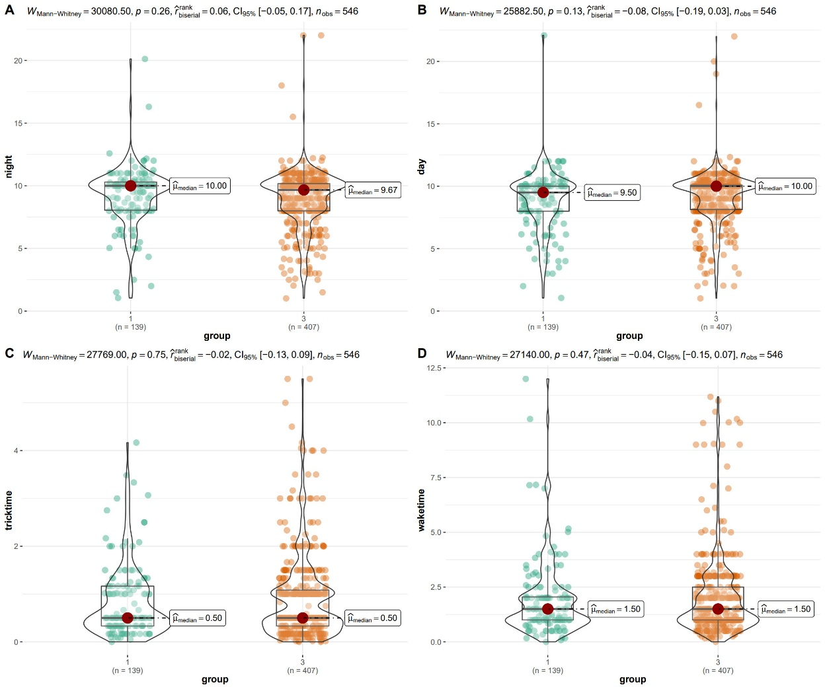
Supplementary Figure 1-1.Unadjusted comparisons of sleep outcomes between the exclusive breastfeeding group and the mixed-feeding group using the Mann–Whitney U test.
Violin plots illustrate group differences in
(A) daytime sleep duration,
(B) nighttime sleep duration,
(C) time required to soothe infants to sleep (tricktime), and
(D) duration of nighttime wakefulness (waketime).
Median values are indicated, and Mann–Whitney U statistics, rank-biserial effect sizes, and 95% confidence intervals are displayed for each comparison.

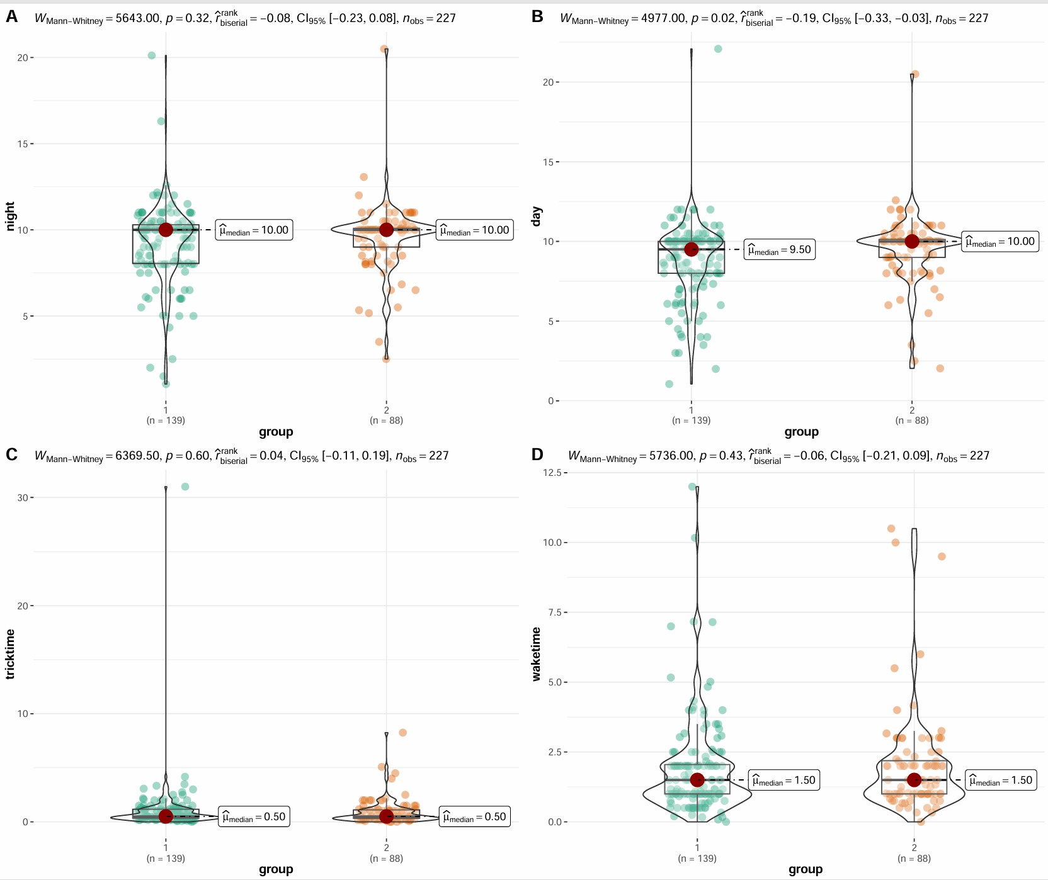
Supplementary Figure 1-2. Unadjusted comparisons of sleep outcomes between the exclusive breastfeeding group and the exclusive formula-feeding group using the Mann–Whitney U test.
Violin plots illustrate group differences in
(A) daytime sleep duration,
(B) nighttime sleep duration,
(C) time required to soothe infants to sleep (tricktime), and
(D) duration of nighttime wakefulness (waketime).
Median values are shown, with corresponding Mann–Whitney U statistics, rank-biserial effect sizes, and 95% confidence intervals reported for each outcome.

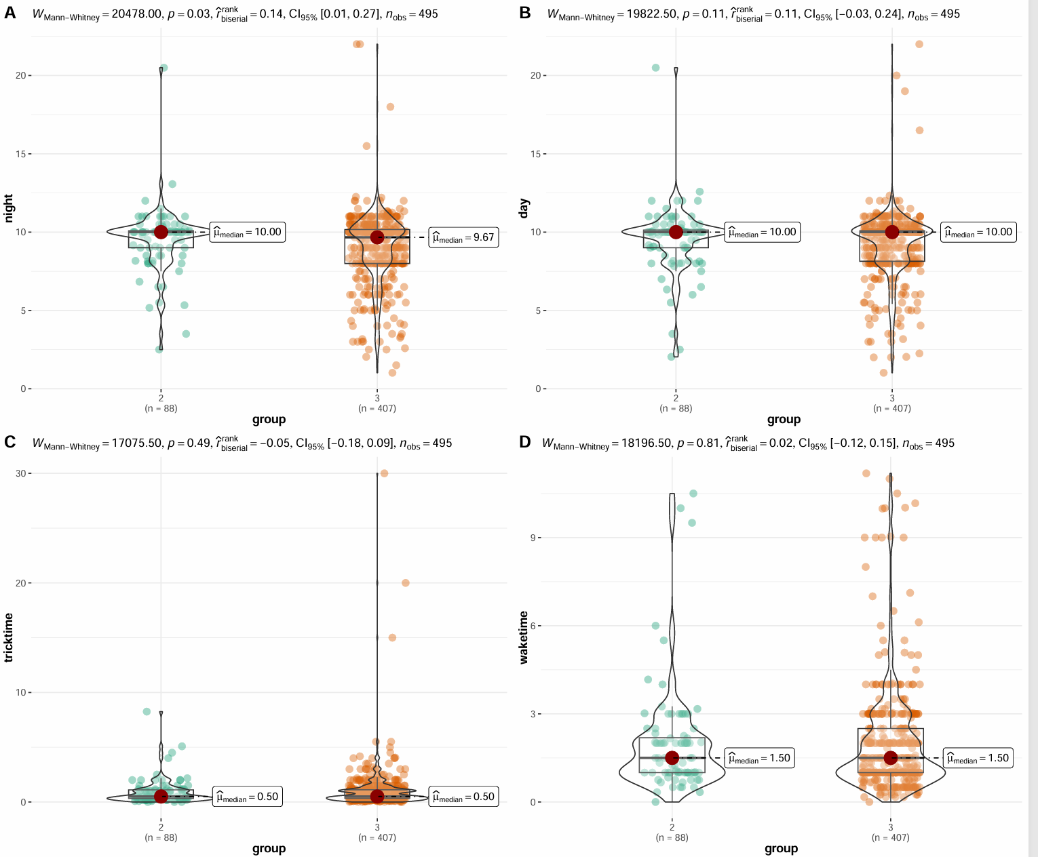
Supplementary Figure 1-3. Unadjusted comparisons of sleep outcomes between the exclusive formula-feeding group and the mixed-feeding group using the Mann–Whitney U test.
Violin plots depict group differences in
(A) daytime sleep duration,
(B) nighttime sleep duration,
(C) time required to soothe infants to sleep (tricktime), and
(D) duration of nighttime wakefulness (waketime).
Median values are marked, and Mann–Whitney U statistics with rank-biserial effect sizes and 95% confidence intervals are provided

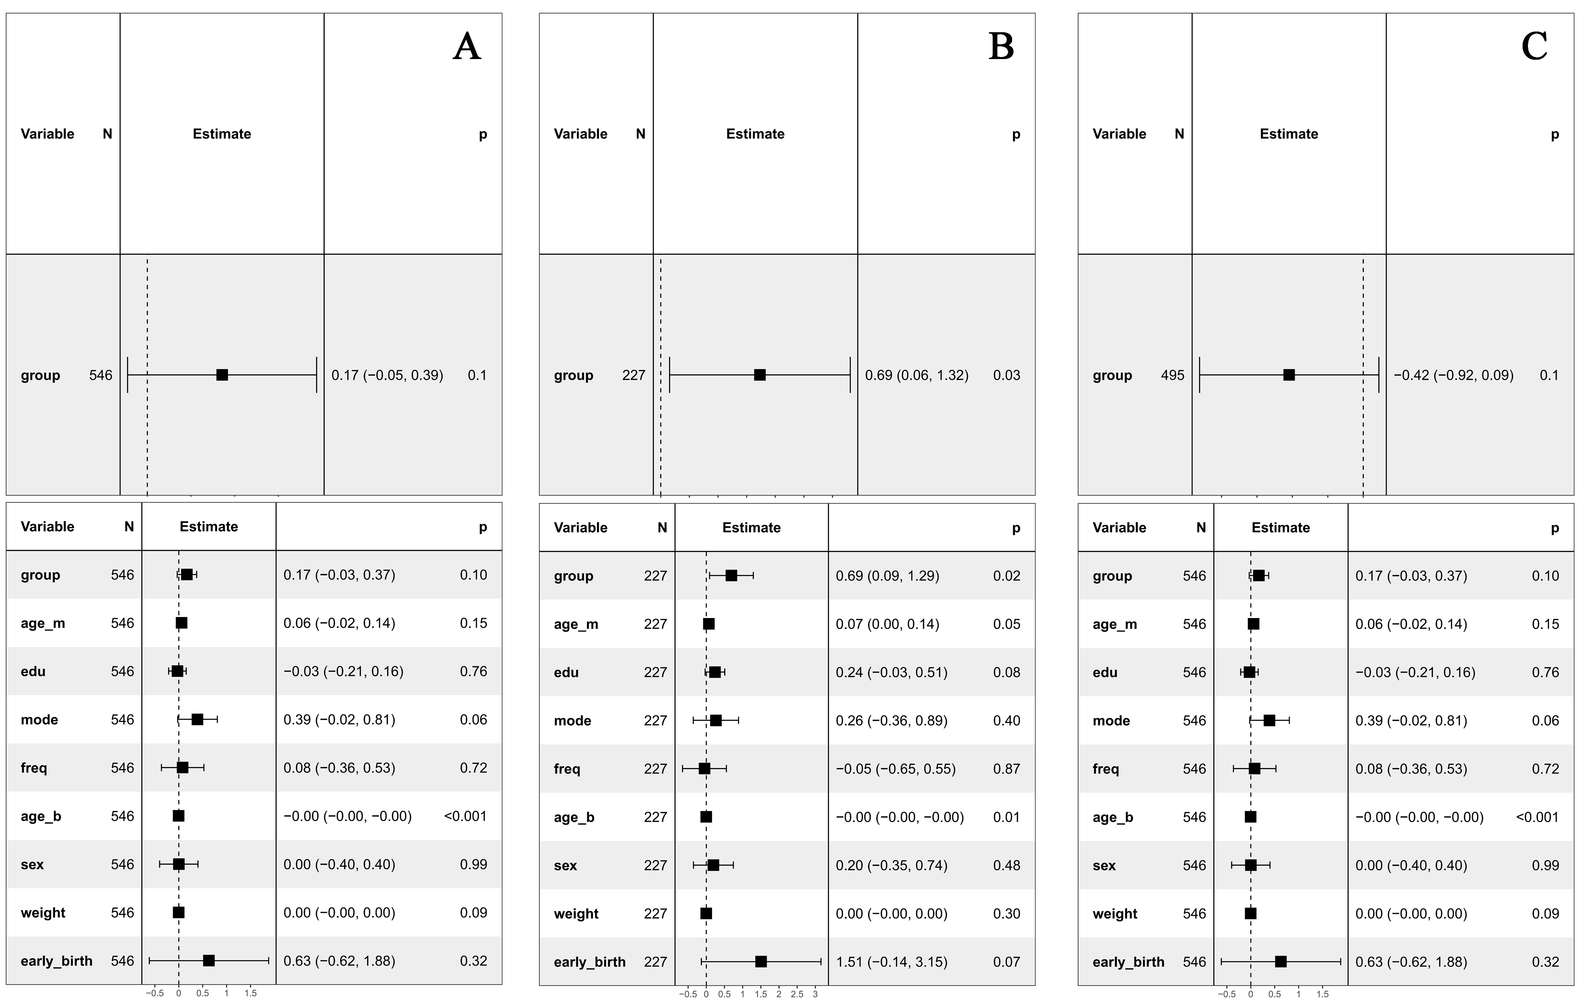Supplementary Figure S2. Graphical visualization of group differences in daytime sleep duration based on overlap-weighted univariate and multivariable regression analyses. Panel A compares exclusively breastfed infants with mixed-fed infants; Panel B compares exclusively breastfed infants with exclusively formula-fed infants; Panel C compares exclusively formula-fed infants with mixed-fed infants. Estimates are presented as adjusted mean differences with 95% confidence intervals.

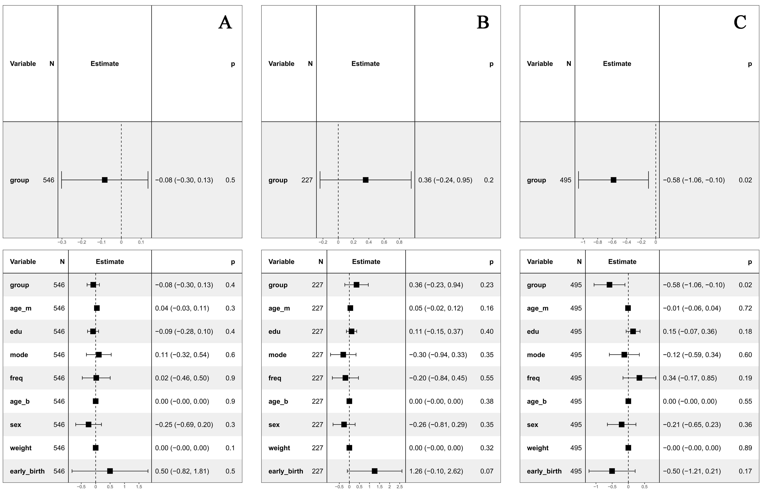
Supplementary Figure S3 Association between feeding patterns and nighttime sleep duration. Overlap-weighted univariate and multivariable regression analyses examining differences in nighttime sleep duration across feeding patterns. Panel A compares exclusively breastfed infants with mixed-fed infants; Panel B compares exclusively breastfed infants with exclusively formula-fed infants; Panel C compares exclusively formula-fed infants with mixed-fed infants. Estimates are presented as adjusted mean differences with 95% confidence intervals.

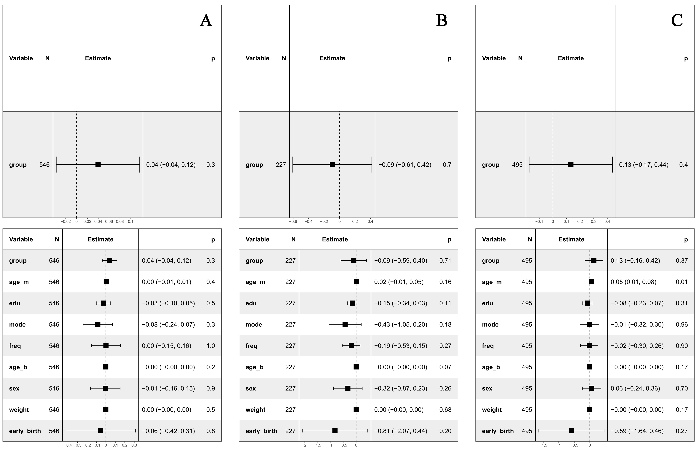
Supplementary Figure S4 Association between feeding patterns and time required to soothe infants to sleep. Overlap-weighted univariate and multivariable regression estimates for time required to soothe infants to sleep across feeding patterns. Panel A compares exclusively breastfed infants with mixed-fed infants; Panel B compares exclusively breastfed infants with exclusively formula-fed infants; Panel C compares exclusively formula-fed infants with mixed-fed infants. Estimates are presented as adjusted mean differences with 95% confidence intervals.

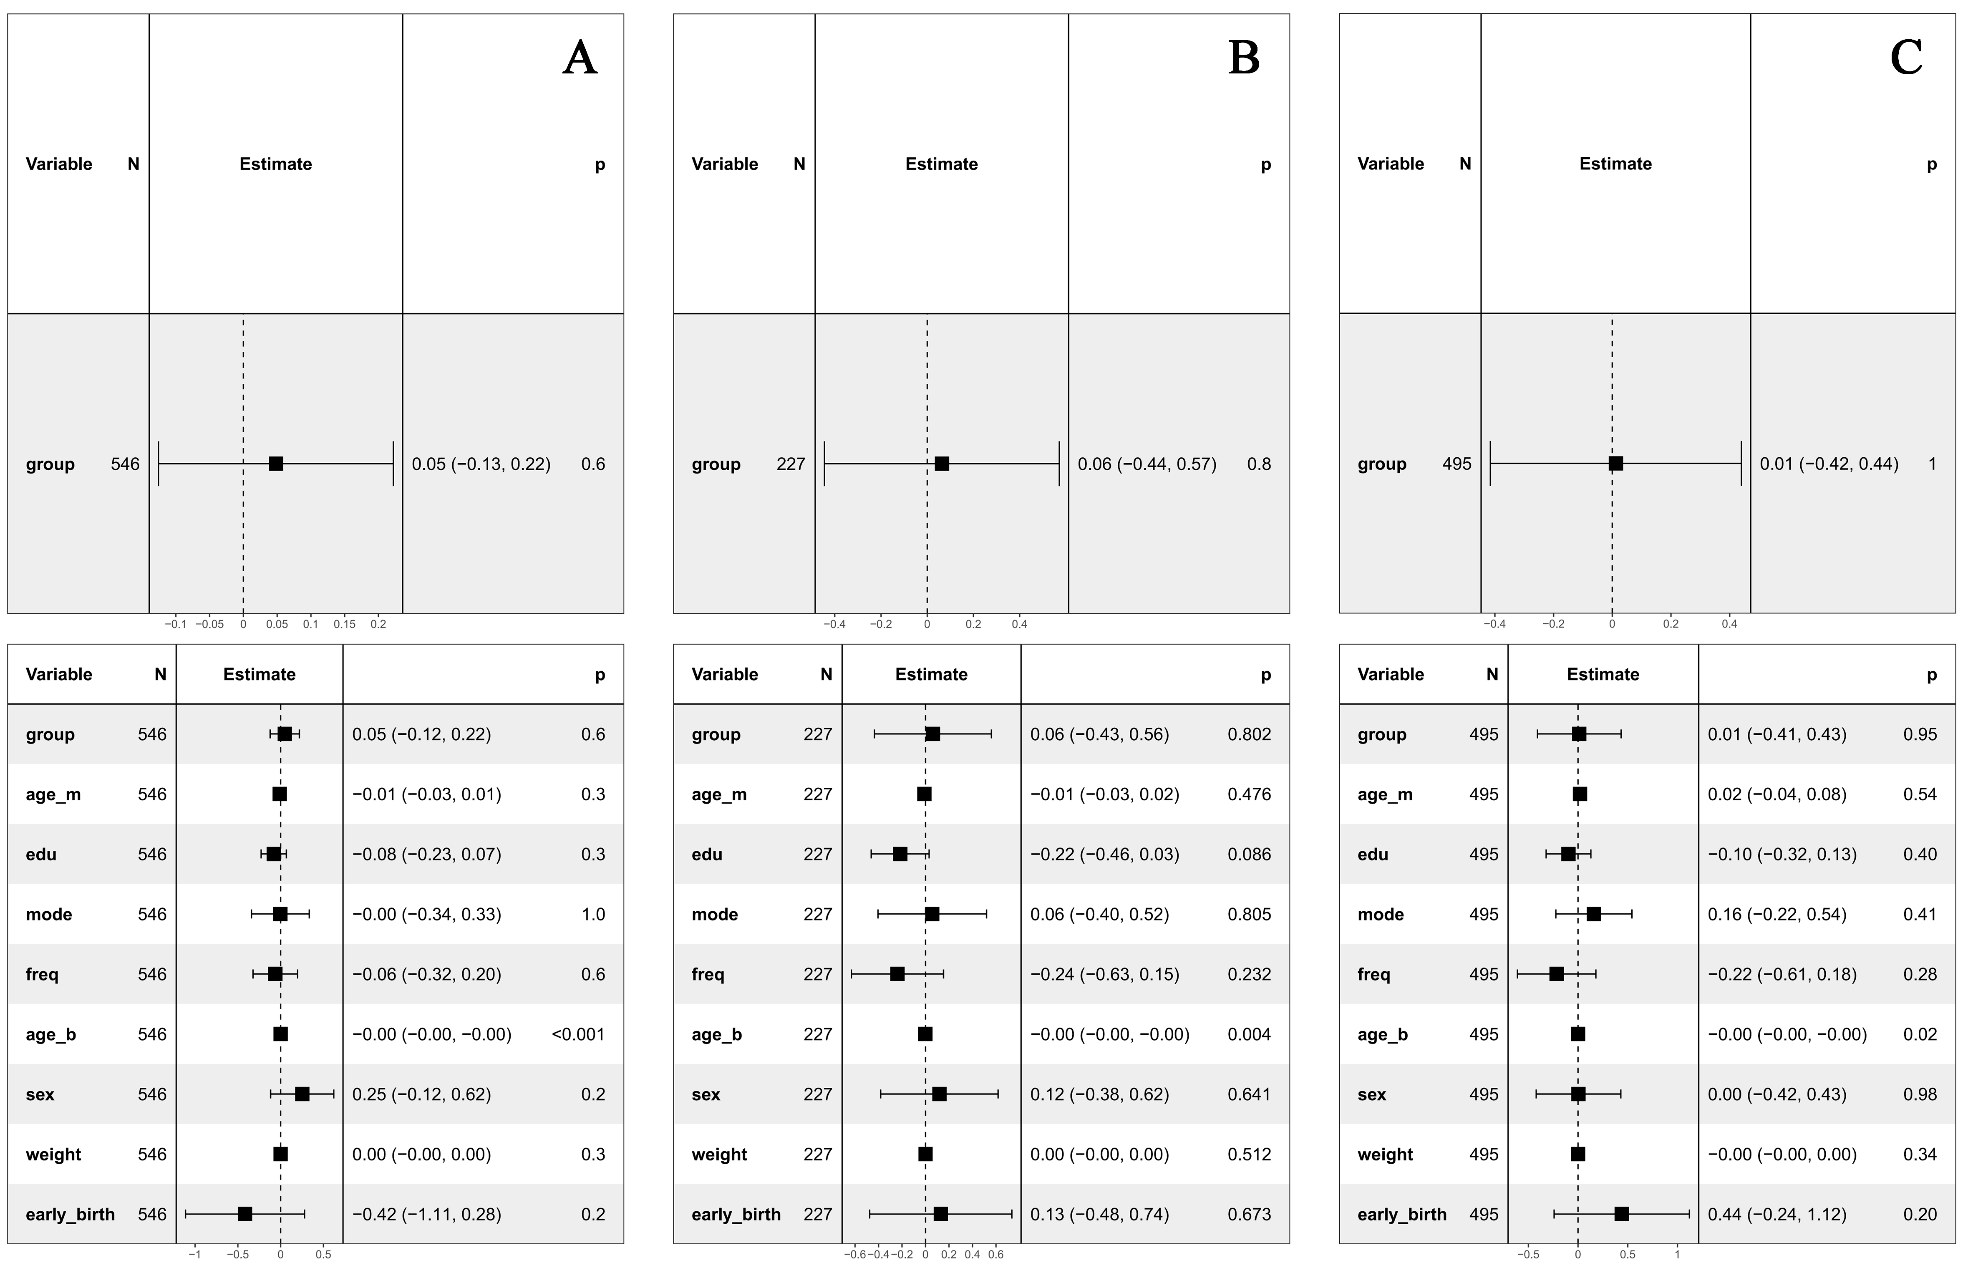
Supplementary Figure S5 Association between feeding patterns and duration of nighttime wakefulness. Overlap-weighted univariate and multivariable regression analyses assessing differences in nighttime wakefulness duration across feeding patterns. Panel A compares exclusively breastfed infants with mixed-fed infants; Panel B compares exclusively breastfed infants with exclusively formula-fed infants; Panel C compares exclusively formula-fed infants with mixed-fed infants. Estimates are presented as adjusted mean differences with 95% confidence intervals.

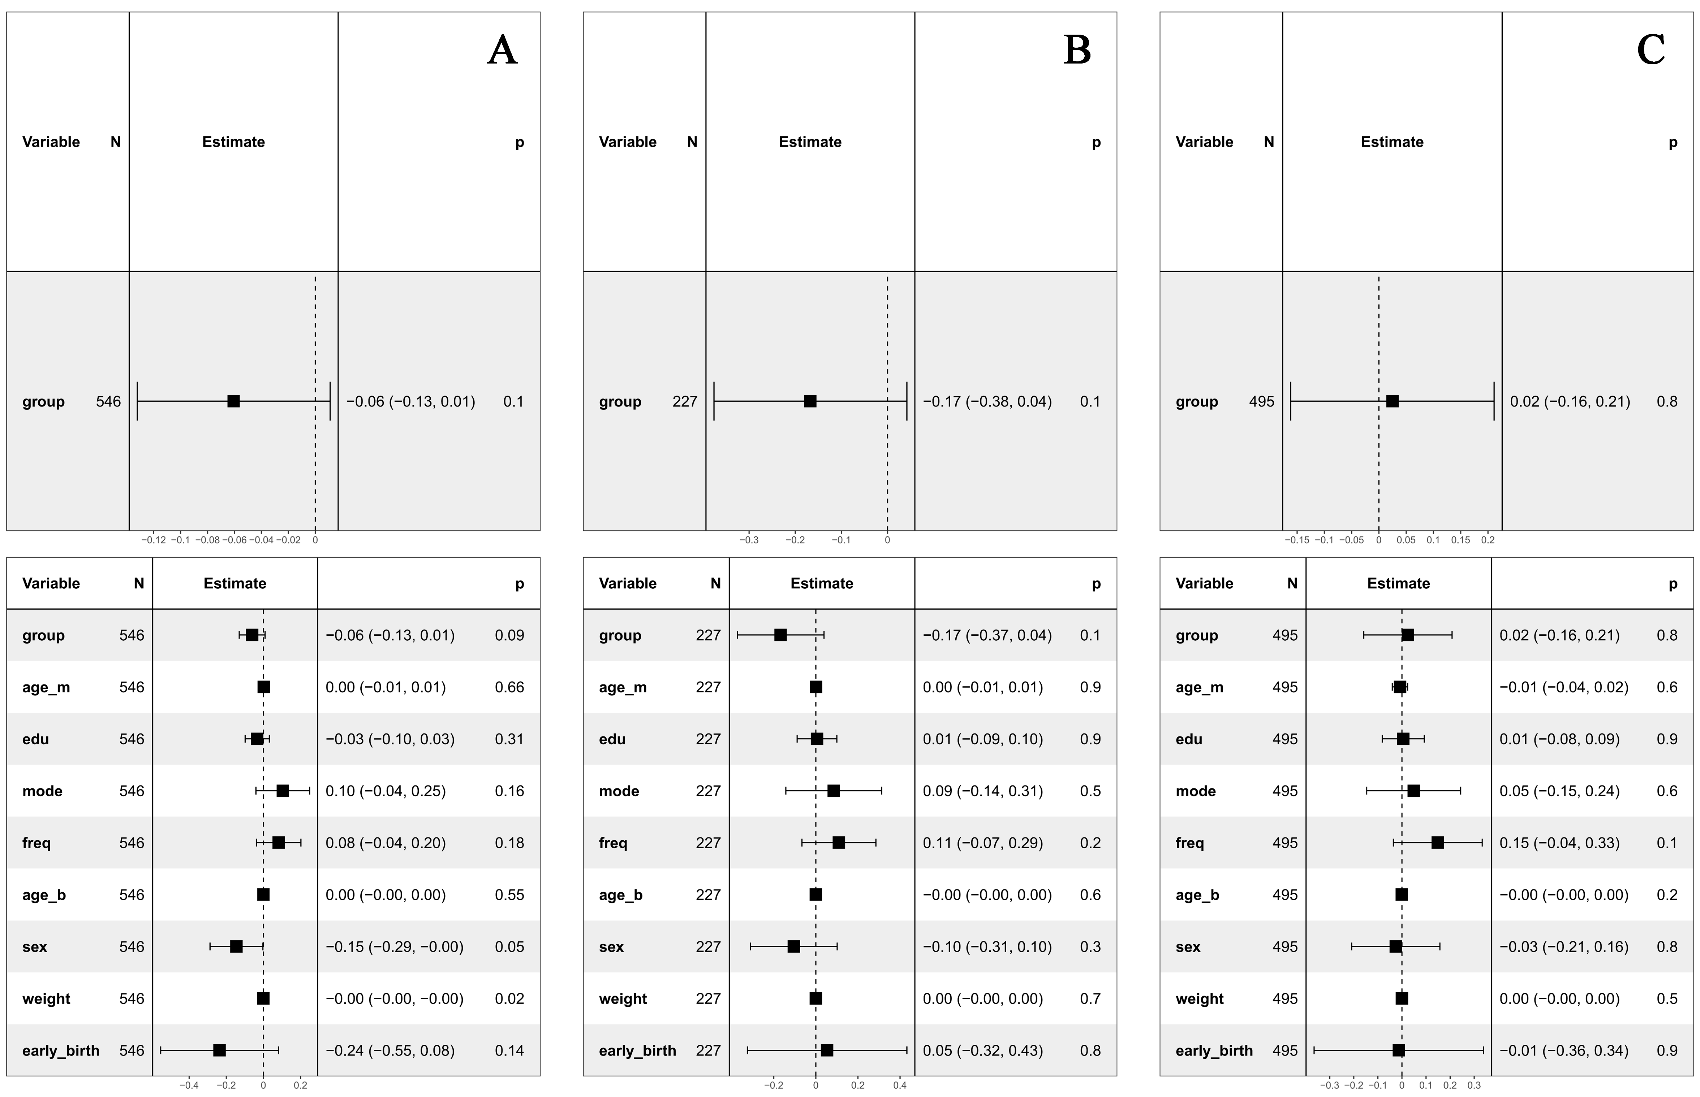
Supplementary Figure S6 Association between feeding patterns and difficulty in soothing infants to sleep. Overlap-weighted univariate and multivariable regression estimates for difficulty in soothing infants to sleep across feeding patterns. Panel A compares exclusively breastfed infants with mixed-fed infants; Panel B compares exclusively breastfed infants with exclusively formula-fed infants; Panel C compares exclusively formula-fed infants with mixed-fed infants. Estimates are presented as adjusted mean differences with 95% confidence intervals.

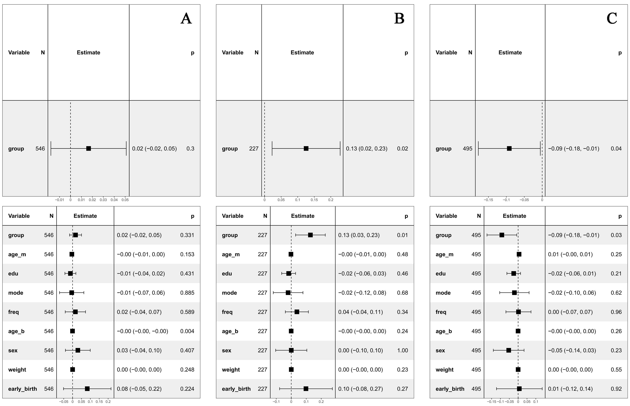
Supplementary Figure S7 Association between feeding patterns and frequency of nighttime awakenings. Overlap-weighted univariate and multivariable regression analyses evaluating differences in nighttime awakening frequency across feeding patterns. Panel A compares exclusively breastfed infants with mixed-fed infants; Panel B compares exclusively breastfed infants with exclusively formula-fed infants; Panel C compares exclusively formula-fed infants with mixed-fed infants. Estimates are presented as adjusted mean differences with 95% confidence intervals.

