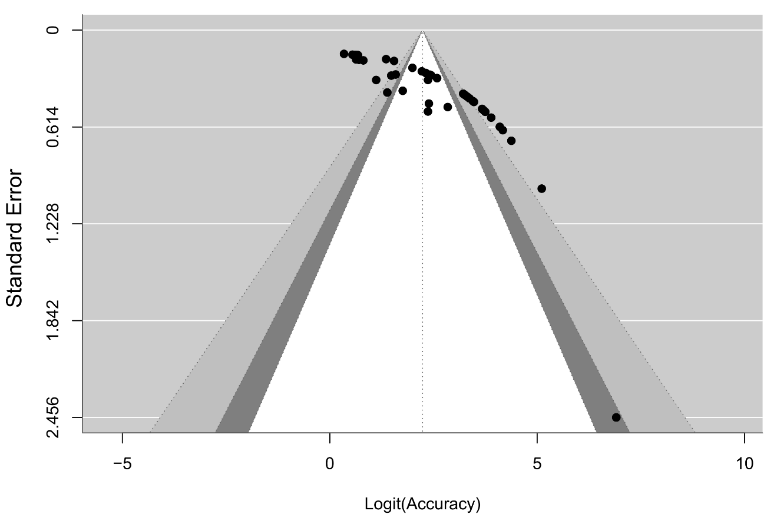
Figure S1: Funnel plot of Pooled Accuracy
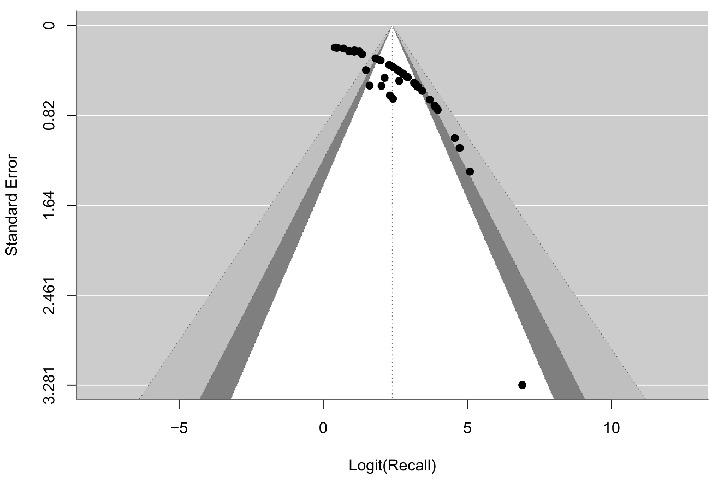
Figure S2: Funnel plot of Pooled Recall

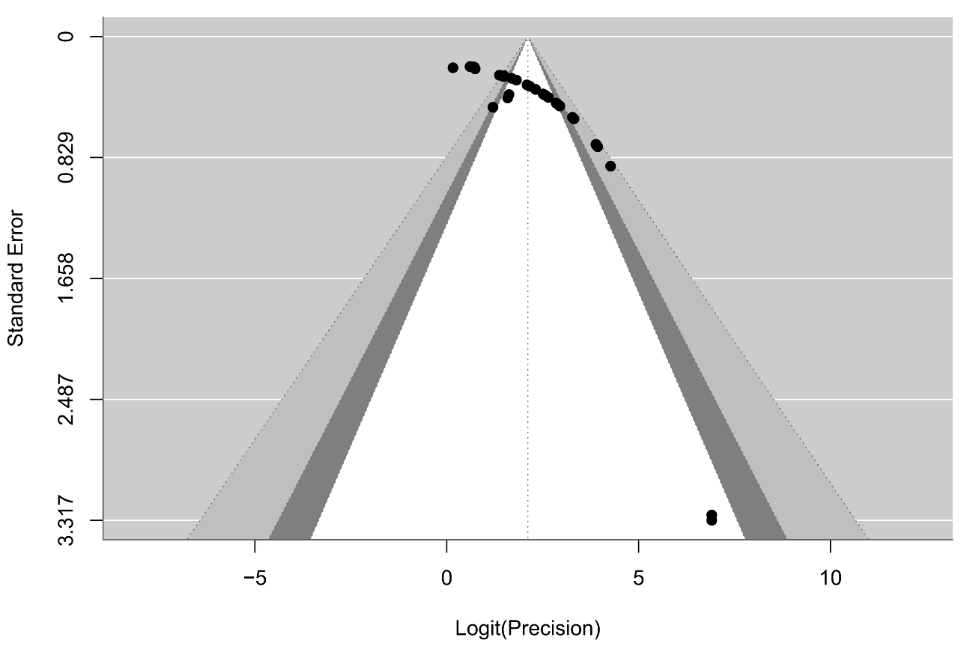
Figure S3: Funnel plot of Pooled Precision

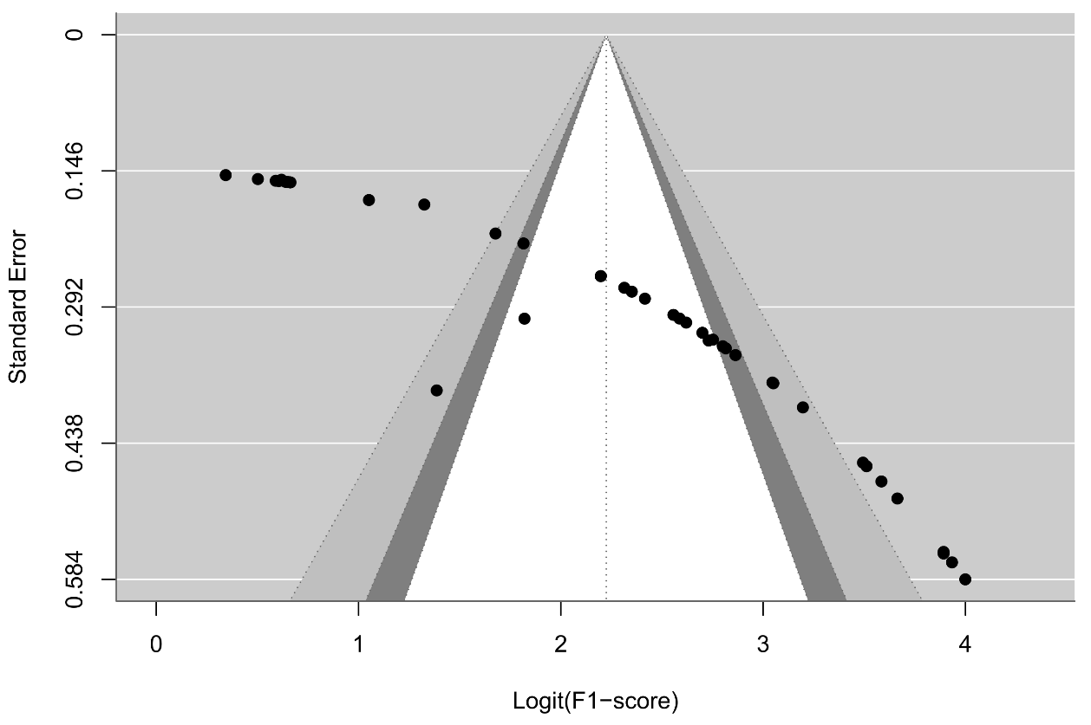
Figure S4: Funnel plot of Pooled F1-score

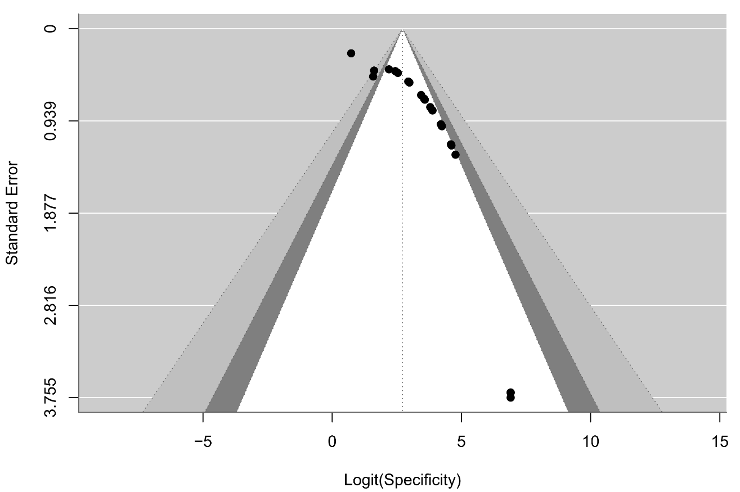
Figure S5: Funnel plot of Pooled Specificity

