Supplementary Information

Predicting Carbon Deposition on Rh-Based Catalysts in Ethanol Oxidative Steam Reforming
Hao Liu^{1,2,3}, Xue Han^{2,*}, HaoZhe Feng^{1,2,3}, Haoyu Li^{1,2,3}, Qinghe Yu²

1.National Engineering Research Center of Nonferrous Metals Materials and Products for New Energy, China GRINM Group Co., Ltd., Beijing 100088, China；
2. GRIMAT Engineering Institute Co., Ltd., Beijing 101407, China；
3. General Research Institute for Nonferrous Metals, Beijing 100088, China
Corresponding authors:
*GRIMAT Engineering Institute Co., Ltd., Beijing 104107, China
E-mail addresses: hanxuehit@126.com (X. Han)

S1 N₂ adsorption-desorption characterization
The BET surface area, average pore size and total pore volume of catalysts are shown in Table S1, and the pore size distribution of these samples are shown in Figure S1. 1%Rh/TiO₂ and 1%Rh/MgO get obviously higher surface area comparing to 1%Rh/ZrO₂, 1%Rh/CeO₂ and 1%Rh/ZnO; while 1%Rh/ZnO and 1%Rh/MgO catalysts have no typical pore size distribution mode, which is very different from 1% Rh/ZrO₂, 1%Rh/CeO₂ and 1%Rh/TiO₂. Considering ammonia produced by urea decomposition is a weak alkaline precipitant, the formation process of strong alkaline ZnO and MgO supports and weak alkaline TiO₂, CeO₂ and ZrO₂ supports should have a certain difference. Hence, although 1%Rh/TiO₂ and 1%Rh/MgO have similar larger specific surface area, their pore structures are great difference.

Table 1 Physical properties of the samples
Catalyst | Surface area（m²·g⁻¹） | Pore diameter（nm） | Pore volume（cm³·g⁻¹） | Crystallite size（nm）
1%Rh/MgO | 119 | 21.4 | 0.632 | 13.2
1%Rh/ZnO | 27.7 | 26.4 | 0.184 | 32.7
1%Rh/TiO₂ | 121 | 10.2 | 0.309 | 11.8
1%Rh/ZrO₂ | 53.7 | 4.87 | 0.065 | 15.2
1%Rh/CeO₂ | 28.4 | 6.32 | 0.045 | 20.6

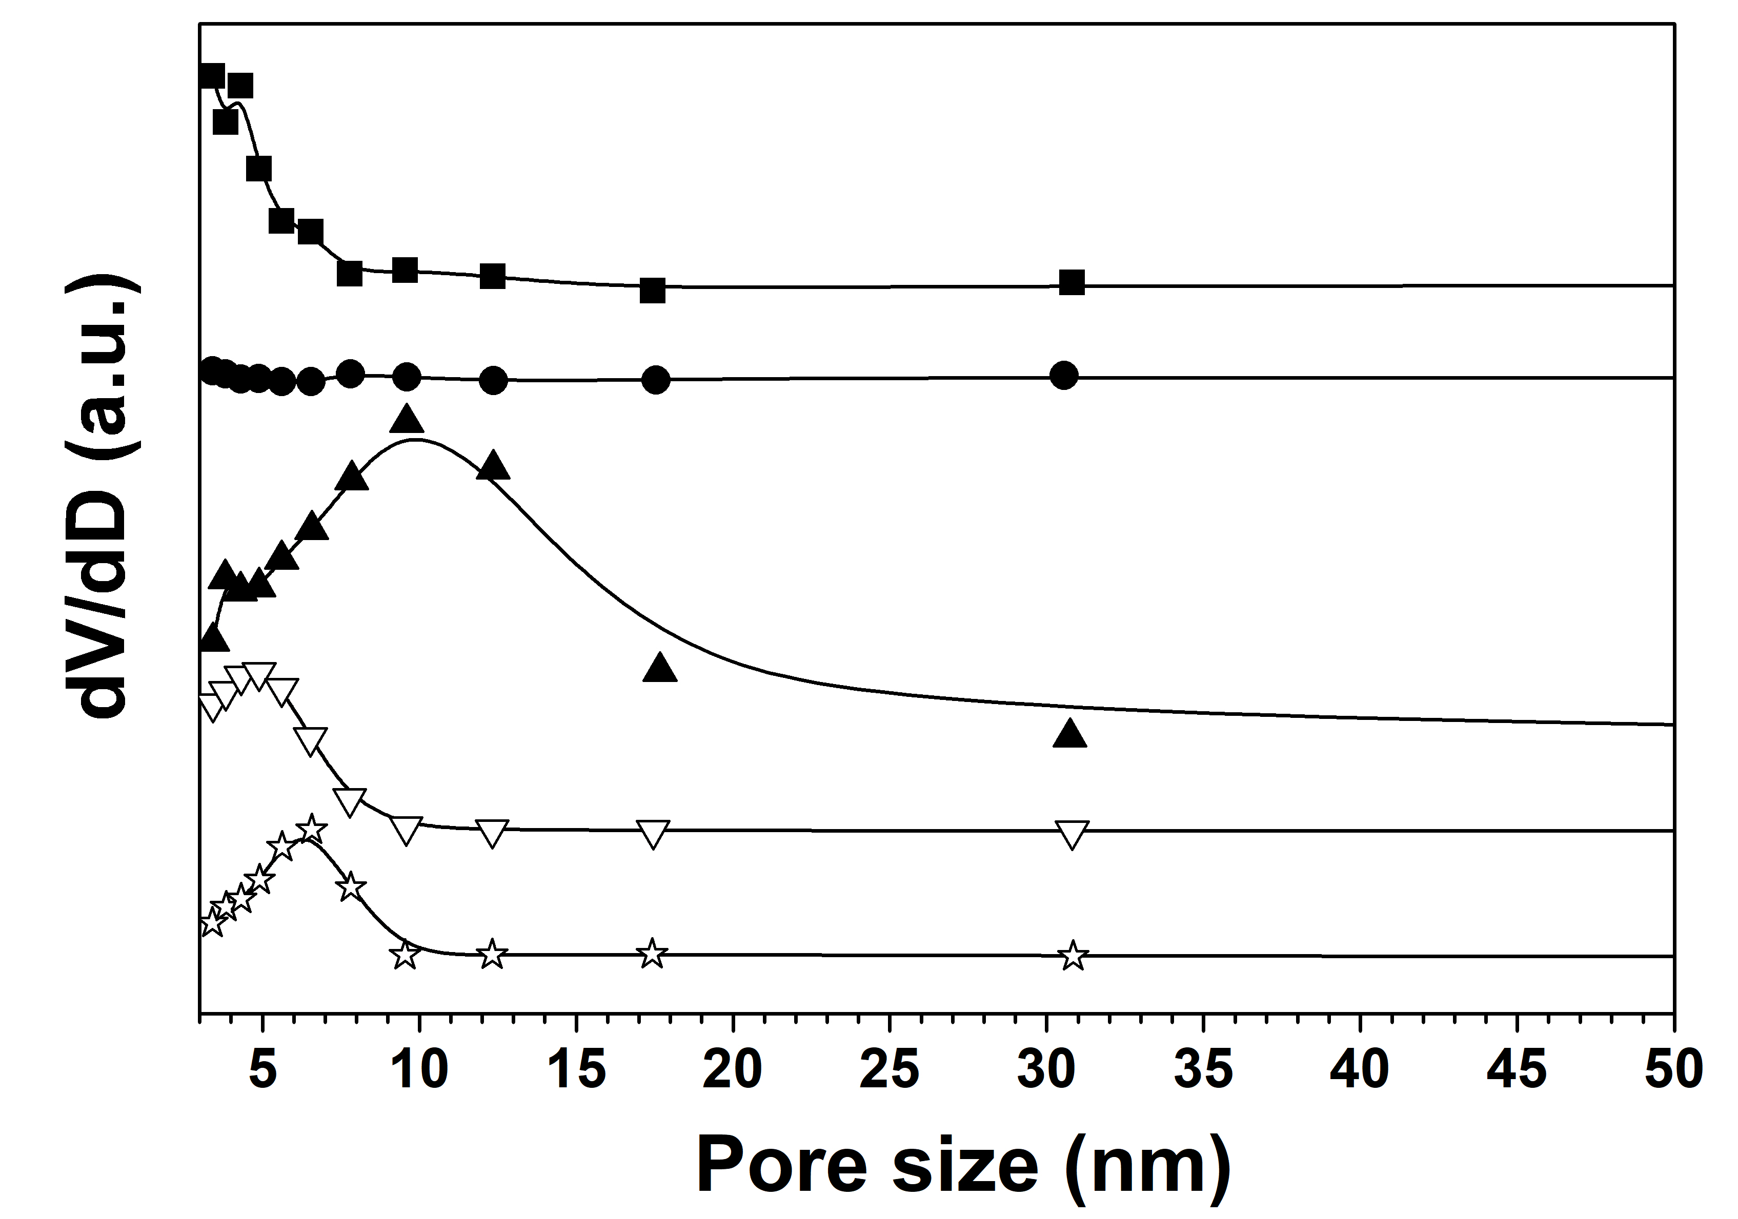
Figure S1. BJH pore size distribution of metal oxides supported Rh catalysts. Pore size distribution curves of 1%Rh/MgO (■), 1%Rh/ZnO (●), 1%Rh/TiO₂ (▲), 1%Rh/ZrO₂ (▽), and 1%Rh/CeO₂ (☆) catalysts prepared by urea homogeneous precipitation method. Measurements were conducted using N₂ adsorption–desorption isotherms at −196 °C.

