Supplementary Materials
for
Childhood trauma burden and reduced longitudinal variability in standardized reading speech among school-aged youth: a multi-wave observational study
Enze Zhu, Xizhe Zhang
Nanjing Brain Hospital, Nanjing Medical University, Nanjing 210029, China
School of Biomedical Engineering and Informatics, Nanjing Medical University, Nanjing 210029, China
Correspondence: Xizhe Zhang, zhangxizhe@njmu.edu.cn
Supplementary Methods
Acoustic features were extracted from repeated standardized reading speech with an automated pipeline based on openSMILE. Longitudinal variability was operationalized at the participant-by-feature level and analysed with feature-wise regressions and follow-up variance models.
Supplementary Table S1. Full list of acoustic features
See Table S1 above (99 features).
Feature name | Domain | Brief interpretation | Units/scale | Quality proxy (Y/N) | Variance follow-up (Y/N)
F0semitoneFrom27.5Hz_sma3nz_amean | Prosody (F0) | Mean fundamental frequency (semitones re 27.5 Hz) | semitones | N | Y
F0semitoneFrom27.5Hz_sma3nz_meanFallingSlope | Prosody (F0) | Mean slope of F0 falling contours | semitones/s | N | N
F0semitoneFrom27.5Hz_sma3nz_meanRisingSlope | Prosody (F0) | Mean slope of F0 rising contours | semitones/s | N | Y
F0semitoneFrom27.5Hz_sma3nz_pctlrange0-2 | Prosody (F0) | F0 range (0th–2nd percentile) | semitones | N | N
F0semitoneFrom27.5Hz_sma3nz_percentile20.0 | Prosody (F0) | 20th percentile of F0 | semitones | N | N
F0semitoneFrom27.5Hz_sma3nz_percentile50.0 | Prosody (F0) | Median F0 | semitones | N | N
F0semitoneFrom27.5Hz_sma3nz_percentile80.0 | Prosody (F0) | 80th percentile of F0 | semitones | N | N
F0semitoneFrom27.5Hz_sma3nz_stddevFallingSlope | Prosody (F0) | Std. dev. of F0 falling slopes | semitones/s | N | N
F0semitoneFrom27.5Hz_sma3nz_stddevNorm | Prosody (F0) | Coefficient of variation of F0 | ratio | N | Y
F0semitoneFrom27.5Hz_sma3nz_stddevRisingSlope | Prosody (F0) | Std. dev. of F0 rising slopes | semitones/s | N | N
F1amplitudeLogRelF0_sma3nz_amean | Formant | Mean log amplitude of F1 relative to F0 | log ratio | N | Y
F1amplitudeLogRelF0_sma3nz_stddevNorm | Formant | CV of F1 log amplitude rel. F0 | ratio | N | N
F1bandwidth_sma3nz_amean | Formant | Mean 1st formant bandwidth | Hz | N | N
F1bandwidth_sma3nz_stddevNorm | Formant | CV of 1st formant bandwidth | ratio | N | N
F1frequency_sma3nz_amean | Formant | Mean 1st formant frequency | Hz | N | N
F1frequency_sma3nz_stddevNorm | Formant | CV of 1st formant frequency | ratio | N | N
F2amplitudeLogRelF0_sma3nz_amean | Formant | Mean log amplitude of F2 relative to F0 | log ratio | N | Y
F2amplitudeLogRelF0_sma3nz_stddevNorm | Formant | CV of F2 log amplitude rel. F0 | ratio | N | N
F2bandwidth_sma3nz_amean | Formant | Mean 2nd formant bandwidth | Hz | N | N
F2bandwidth_sma3nz_stddevNorm | Formant | CV of 2nd formant bandwidth | ratio | N | N
F2frequency_sma3nz_amean | Formant | Mean 2nd formant frequency | Hz | N | N
F2frequency_sma3nz_stddevNorm | Formant | CV of 2nd formant frequency | ratio | N | Y
F3amplitudeLogRelF0_sma3nz_amean | Formant | Mean log amplitude of F3 relative to F0 | log ratio | N | Y
F3amplitudeLogRelF0_sma3nz_stddevNorm | Formant | CV of F3 log amplitude rel. F0 | ratio | N | Y
F3bandwidth_sma3nz_amean | Formant | Mean 3rd formant bandwidth | Hz | N | N
F3bandwidth_sma3nz_stddevNorm | Formant | CV of 3rd formant bandwidth | ratio | N | Y
F3frequency_sma3nz_amean | Formant | Mean 3rd formant frequency | Hz | N | N
F3frequency_sma3nz_stddevNorm | Formant | CV of 3rd formant frequency | ratio | N | N
HNRdBACF_sma3nz_amean | Voice quality | Mean harmonics-to-noise ratio (autocorrelation) | dB | N | N
HNRdBACF_sma3nz_stddevNorm | Voice quality | Coefficient of variation of HNR | ratio | N | Y
MeanUnvoicedSegmentLength | Temporal | Mean duration of unvoiced segments | s | N | N
MeanVoicedSegmentLengthSec | Temporal | Mean duration of voiced segments | s | N | N
StddevUnvoicedSegmentLength | Temporal | Std. dev. of unvoiced segment durations | s | N | N
StddevVoicedSegmentLengthSec | Temporal | Std. dev. of voiced segment durations | s | N | N
VoicedSegmentsPerSec | Temporal | Rate of voiced segments per second | Hz | N | N
alphaRatioUV_sma3nz_amean | Spectral | Mean alpha ratio for unvoiced segments | dB | N | Y
alphaRatioV_sma3nz_amean | Spectral | Mean alpha ratio for voiced segments (50–1000 Hz vs 1–5 kHz) | dB | N | N
alphaRatioV_sma3nz_stddevNorm | Spectral | CV of voiced alpha ratio | ratio | N | N
equivalentSoundLevel_dBp | Loudness | Equivalent sound pressure level | dB | N | Y
flu_leading_silence_sec | Fluency | Duration of silence before speech onset | s | Y | Y
flu_max_pause_sec | Fluency | Maximum within-speech pause duration | s | N | Y
flu_mean_pause_sec | Fluency | Mean duration of within-speech pauses | s | N | N
flu_mean_speech_seg_sec | Fluency | Mean duration of speech segments between pauses | s | N | N
flu_median_pause_sec | Fluency | Median duration of within-speech pauses | s | N | N
flu_pause_count | Fluency | Number of pauses (silence >= 200 ms within speech) | count | N | N
flu_pause_rate_per_min | Fluency | Pause rate (pauses per minute of trimmed audio) | pauses/min | N | Y
flu_speech_ratio | Fluency | Proportion of trimmed duration containing speech | ratio [0,1] | Y | Y
flu_total_duration_sec | Fluency | Total audio file duration | s | Y | N
flu_trailing_silence_sec | Fluency | Duration of silence after speech offset | s | Y | Y
flu_trimmed_duration_sec | Fluency | Duration after leading/trailing silence removal | s | N | N
hammarbergIndexUV_sma3nz_amean | Spectral | Mean Hammarberg index for unvoiced segments | dB | N | Y
hammarbergIndexV_sma3nz_amean | Spectral | Mean Hammarberg index for voiced segments (0–2 kHz vs 2–5 kHz) | dB | N | N
hammarbergIndexV_sma3nz_stddevNorm | Spectral | CV of voiced Hammarberg index | ratio | N | Y
jitterLocal_sma3nz_amean | Voice quality | Mean local jitter (pitch perturbation) | ratio | N | N
jitterLocal_sma3nz_stddevNorm | Voice quality | Coefficient of variation of local jitter | ratio | N | N
logRelF0-H1-A3_sma3nz_amean | Voice quality | Mean log ratio of 1st harmonic to 3rd formant amplitude | log ratio | N | N
logRelF0-H1-A3_sma3nz_stddevNorm | Voice quality | CV of H1–A3 | ratio | N | Y
logRelF0-H1-H2_sma3nz_amean | Voice quality | Mean log ratio of 1st to 2nd harmonic amplitude (H1–H2) | log ratio | N | N
logRelF0-H1-H2_sma3nz_stddevNorm | Voice quality | CV of H1–H2 | ratio | N | N
loudnessPeaksPerSec | Loudness | Rate of loudness peaks per second | Hz | N | N
loudness_sma3_amean | Loudness | Mean perceived loudness | sone (approx.) | Y | N
loudness_sma3_meanFallingSlope | Loudness | Mean slope of loudness falling contours | sone/s | N | N
loudness_sma3_meanRisingSlope | Loudness | Mean slope of loudness rising contours | sone/s | N | N
loudness_sma3_pctlrange0-2 | Loudness | Loudness range (0th–2nd percentile) | sone | N | N
loudness_sma3_percentile20.0 | Loudness | 20th percentile of loudness | sone | N | N
loudness_sma3_percentile50.0 | Loudness | Median loudness | sone | N | N
loudness_sma3_percentile80.0 | Loudness | 80th percentile of loudness | sone | N | N
loudness_sma3_stddevFallingSlope | Loudness | Std. dev. of loudness falling slopes | sone/s | N | N
loudness_sma3_stddevNorm | Loudness | Coefficient of variation of loudness | ratio | N | Y
loudness_sma3_stddevRisingSlope | Loudness | Std. dev. of loudness rising slopes | sone/s | N | N
mfcc1V_sma3nz_amean | MFCC | Mean MFCC-1 for voiced segments | arbitrary | N | N
mfcc1V_sma3nz_stddevNorm | MFCC | CV of voiced MFCC-1 | ratio | N | N
mfcc1_sma3_amean | MFCC | Mean MFCC-1 (overall spectral shape) | arbitrary | N | N
mfcc1_sma3_stddevNorm | MFCC | CV of MFCC-1 | ratio | N | N
mfcc2V_sma3nz_amean | MFCC | Mean MFCC-2 for voiced segments | arbitrary | N | N
mfcc2V_sma3nz_stddevNorm | MFCC | CV of voiced MFCC-2 | ratio | N | N
mfcc2_sma3_amean | MFCC | Mean MFCC-2 (spectral tilt) | arbitrary | N | N
mfcc2_sma3_stddevNorm | MFCC | CV of MFCC-2 | ratio | N | N
mfcc3V_sma3nz_amean | MFCC | Mean MFCC-3 for voiced segments | arbitrary | N | N
mfcc3V_sma3nz_stddevNorm | MFCC | CV of voiced MFCC-3 | ratio | N | N
mfcc3_sma3_amean | MFCC | Mean MFCC-3 | arbitrary | N | N
mfcc3_sma3_stddevNorm | MFCC | CV of MFCC-3 | ratio | N | N
mfcc4V_sma3nz_amean | MFCC | Mean MFCC-4 for voiced segments | arbitrary | N | N
mfcc4V_sma3nz_stddevNorm | MFCC | CV of voiced MFCC-4 | ratio | N | N
mfcc4_sma3_amean | MFCC | Mean MFCC-4 | arbitrary | N | N
mfcc4_sma3_stddevNorm | MFCC | CV of MFCC-4 | ratio | N | N
shimmerLocaldB_sma3nz_amean | Voice quality | Mean local shimmer (amplitude perturbation) | dB | N | N
shimmerLocaldB_sma3nz_stddevNorm | Voice quality | Coefficient of variation of local shimmer | ratio | N | N
slopeUV0-500_sma3nz_amean | Spectral | Mean spectral slope 0–500 Hz for unvoiced segments | dB/Hz | N | Y
slopeUV500-1500_sma3nz_amean | Spectral | Mean spectral slope 500–1500 Hz for unvoiced segments | dB/Hz | N | N
slopeV0-500_sma3nz_amean | Spectral | Mean spectral slope 0–500 Hz for voiced segments | dB/Hz | N | Y
slopeV0-500_sma3nz_stddevNorm | Spectral | CV of voiced spectral slope 0–500 Hz | ratio | N | Y
slopeV500-1500_sma3nz_amean | Spectral | Mean spectral slope 500–1500 Hz for voiced segments | dB/Hz | N | N
slopeV500-1500_sma3nz_stddevNorm | Spectral | CV of voiced spectral slope 500–1500 Hz | ratio | N | N
spectralFluxUV_sma3nz_amean | Spectral | Mean spectral flux for unvoiced segments | arbitrary | N | N
spectralFluxV_sma3nz_amean | Spectral | Mean spectral flux for voiced segments | arbitrary | N | N
spectralFluxV_sma3nz_stddevNorm | Spectral | CV of voiced spectral flux | ratio | N | N
spectralFlux_sma3_amean | Spectral | Mean spectral flux (whole spectrum) | arbitrary | N | N
spectralFlux_sma3_stddevNorm | Spectral | CV of spectral flux | ratio | N | Y

Supplementary Table S2. Alternative CTQ operationalizations
The main manuscript used the first available four-subscale CTQ total score as the primary exposure.
CTQ operationalization | Sample size | Coefficient correlation vs primary CTQ | Mean absolute beta difference | Interpretation
First available CTQ (primary) | 4906 | 1.000 | 0.000 | Reference specification
Baseline-only CTQ | 4906 | 0.993 | 0.013 | Near-identical results; 83 significant in Model A, TOP20 overlap 90%
Across-wave mean CTQ | 4906 | 0.991 | 0.006 | Near-identical results; 79 significant in Model A, TOP20 overlap 90%

Supplementary Table S3. Alternative DASS summaries
The symptom-adjusted model in the main manuscript used participant-specific across-wave mean depression, anxiety, and stress scores from the DASS-21.
DASS summary | Coefficient correlation vs primary symptom-adjusted model | Mean absolute beta difference | Interpretation
Across-wave mean DASS (primary) | 1.000 | 0.000 | Reference specification
First-available DASS | 0.991 | 0.002 | Near-identical; 79 significant features
Baseline DASS | 0.990 | 0.015 | Slightly more features significant (82); directionally concordant

Supplementary Table S4. Extended robustness analyses
The main manuscript presents a compact robustness summary.
Analysis | Main numerical result | Additional notes
Alternative IIV estimators | SD: 79; MAD: 73; IQR: 77; CV: 73; detrended SD: 79 | 52 features significant across all five estimators
3-wave-only sample | 77 significant features; coefficient correlation with full sample = 0.942 | 77 significant features; coefficient correlation with full sample r = 0.942; TOP20 overlap = 14/20 (70%); mean absolute beta = 0.071
Wave-combination control | Coefficient correlation = 0.993; mean absolute beta change = 0.018 | Mean absolute beta change = 0.018; all TOP20 features remain significant; 4 wave patterns tested
School fixed effects | 89 significant features; coefficient correlation = 0.546 | Substantial pattern shift; interpret cautiously
Recording-quality adjustment | 63/94 non-quality features remained significant; coefficient correlation = 0.807 | Fluency and pause features attenuated most clearly
ICC stratification | 13/16 features with ICC ≥ 0.50; 66/83 with ICC < 0.50 remained significant | Do not equate low ICC with purely meaningful variability
Explicit variance modelling | 7/25 representative features showed significant negative CTQ effects on residual variance | See Table S5 for detailed feature-level outputs

Supplementary Table S5. Full explicit variance follow-up
See Table S5 above. Seven of the 25 representative features showed significant negative CTQ effects on residual variance (FDR q < 0.05), confirming that higher childhood trauma exposure is associated with reduced across-wave variance in these acoustic parameters.
Feature | Domain | Wave-level beta | Residual-variance beta | 95% CI | p value | q value | n
flu_speech_ratio | Fluency | 0.2848 | -0.4033 | [-0.4429, -0.3638] | 5.42e-132 | 3.79e-131 | 4903
flu_trailing_silence_sec | Fluency | -0.1797 | -0.4865 | [-0.5342, -0.4388] | 1.02e-123 | 3.56e-123 | 4906
alphaRatioUV_sma3nz_amean | Spectral | 0.0642 | -0.4013 | [-0.4406, -0.3619] | 9.98e-122 | 2.33e-121 | 4904
logRelF0-H1-A3_sma3nz_stddevNorm | Voice quality | -0.1437 | -0.3945 | [-0.4332, -0.3558] | 3.70e-78 | 6.48e-78 | 4904
loudness_sma3_stddevNorm | Loudness | 0.0634 | -0.3207 | [-0.3521, -0.2893] | 3.87e-70 | 5.42e-70 | 4904
F3amplitudeLogRelF0_sma3nz_amean | Formant | 0.3898 | -0.1693 | [-0.1859, -0.1527] | 1.76e-26 | 2.06e-26 | 4904
F0semitoneFrom27.5Hz_sma3nz_amean | Prosody (F0) | -0.2206 | -0.2127 | [-0.2336, -0.1919] | 9.08e-26 | 9.08e-26 | 4904

Supplementary reporting notes
openSMILE version: 2.6.0 (Python binding via the opensmile package). Feature set: eGeMAPSv02 (extended Geneva Minimalistic Acoustic Parameter Set v02), functionals level. Platform: Ubuntu Linux, Python 3.10, Conda environment. Eleven additional fluency/pause proxy features were computed using librosa (v0.10+) based on energy-based speech/silence segmentation (top_db=30, min_silence=200ms).
Feature extraction failure rate: across the 14,280 audio-available recordings, fewer than 0.1% of recordings yielded missing values for any single eGeMAPSv02 feature. Within the analytic sample (N = 4,906 participants with >= 2 recordings), the effective sample size per feature ranged from 4,903 to 4,906 due to sporadic extraction failures. No systematic differences in failure rates across waves or schools were observed.
Winsorization was applied at the recording level (long-format) prior to computing participant-level IIV metrics. Each acoustic feature was winsorized at the 1st and 99th percentiles within the full longitudinal dataset. This step preserved the total sample size (no observations were dropped) and was performed identically across all waves.
All recordings were collected using standardized Android tablets provided by the research team as part of a school-based screening program. Audio files were stored in MP3 or M4A format and converted to WAV (16 kHz, 16-bit mono) before feature extraction. Device model, original audio format, and signal-to-noise ratio metadata were not retained in the analytic dataset. This limitation is acknowledged in the main manuscript (Discussion, Limitations section).
Analysis scripts and the complete data processing pipeline are organized under the project directory ctq_vocal_rigidity_project_extended/. The main analysis is orchestrated by run_all.py and config.yaml. Feature extraction code is available in ext_feature/src/features.py. Supplementary robustness and sensitivity analyses are in revise1/scripts/ and revise2/scripts/. A complete data dictionary is available upon request from the corresponding author.
Supplementary Figures
Figure S1. Distribution of the first-available four-subscale CTQ sum score in the analytic sample. The distribution shows a marked floor concentration at the minimum score (CTQ = 20), indicating limited support for a fully linear exposure–response interpretation across the full score range.
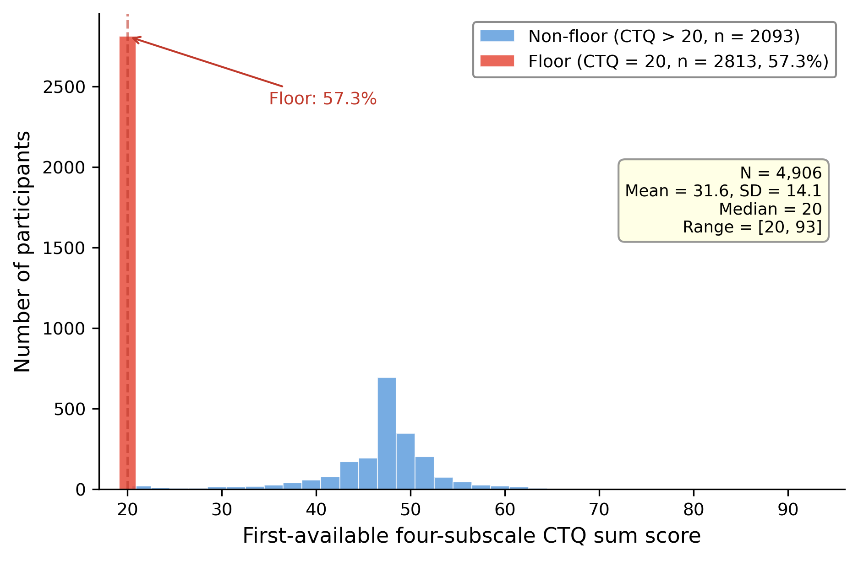
Figure S2. Distribution of intraclass correlation coefficients (ICCs) across the 99 acoustic features. Most features showed low-to-moderate repeatability across waves. This distribution is presented to contextualize the longitudinal variability findings rather than to validate them. Lower ICC values should not be interpreted as evidence of meaningful within-person variability per se, because lower repeatability may also reflect measurement noise.
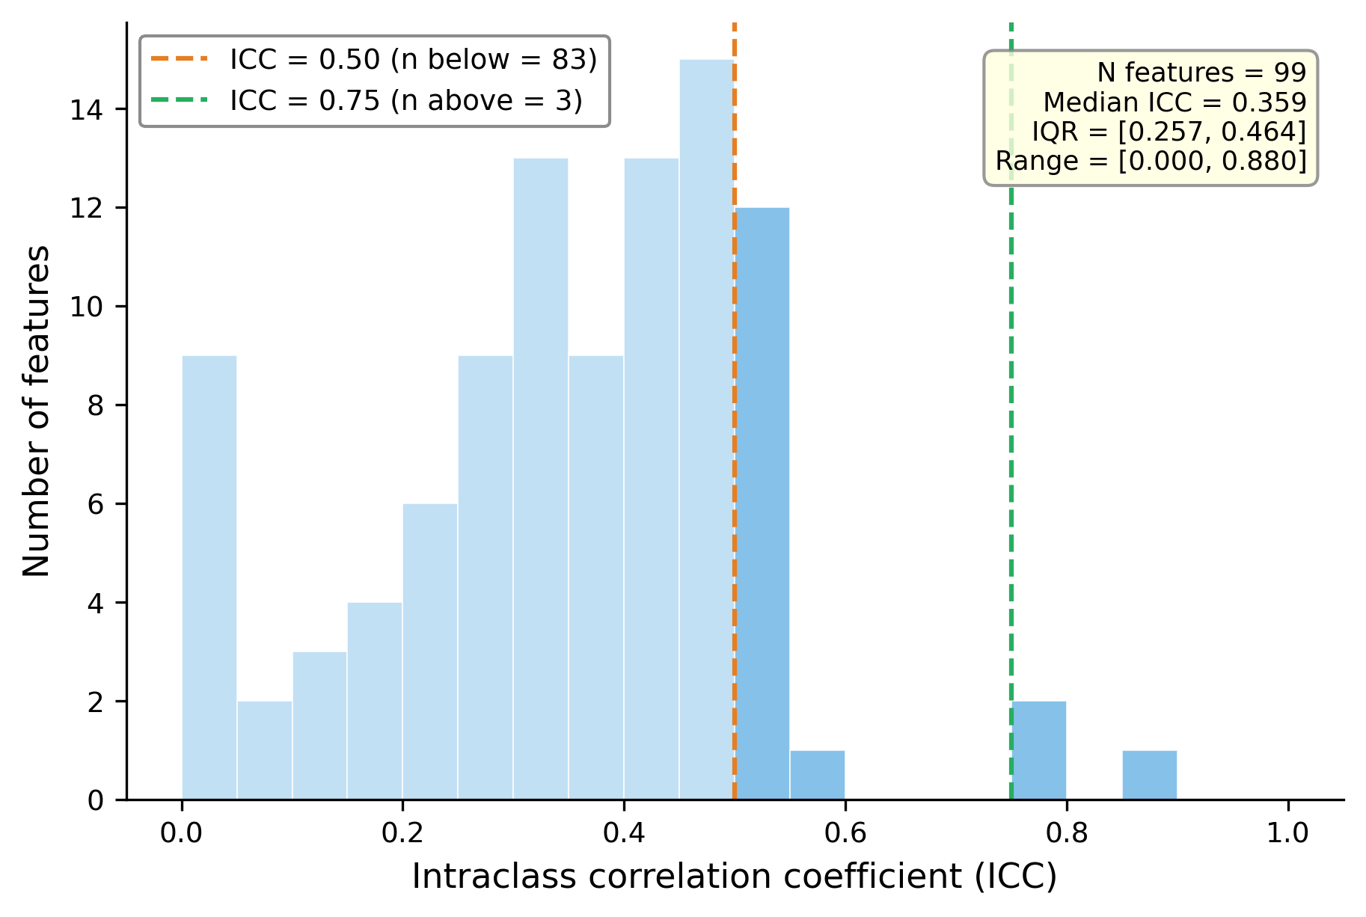
Figure S3. Full forest plot of feature-wise CTQ associations in the SD-based symptom-adjusted analysis (Model B). The plot shows standardized CTQ coefficients and 95% confidence intervals for all 99 acoustic features in the SD-based symptom-adjusted model. Dark markers indicate FDR-significant associations (q < 0.05), and light markers indicate non-significant associations..
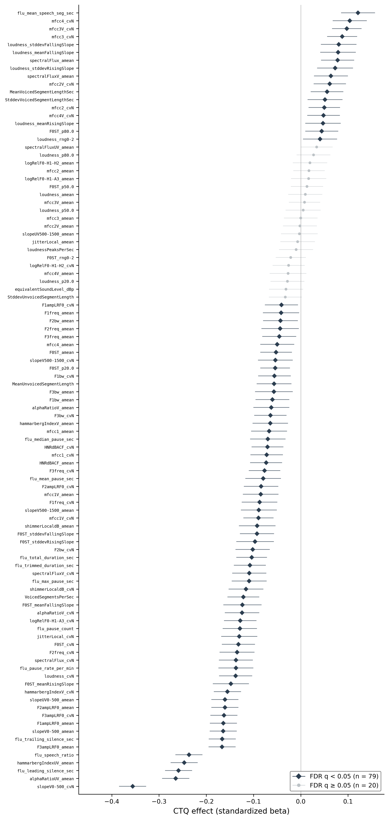
Figure S4. Concordance of CTQ coefficients across alternative IIV estimators relative to the SD-based primary analysis. Each panel compares feature-wise CTQ coefficients derived from the SD-based primary analysis with those derived from an alternative IIV estimator (MAD, IQR, CV, or detrended SD). Spearman’s rho is reported in each panel and should match the corresponding values reported in the main manuscript.
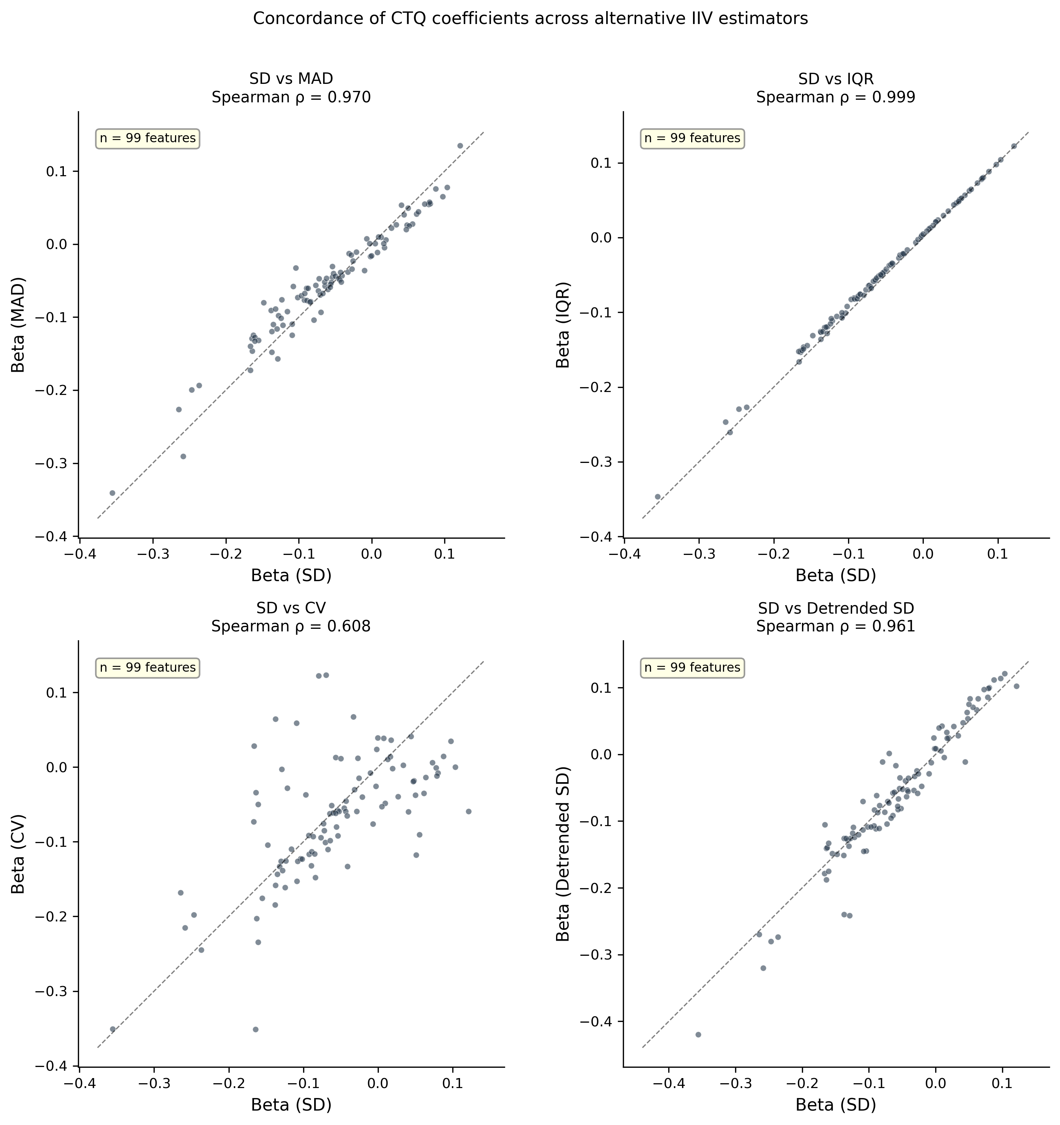
Figure S5. Supplementary plots for the explicit variance follow-up analyses. Panel A shows residual-variance beta estimates and 95% confidence intervals for the seven FDR-significant features identified in the explicit variance follow-up analysis. Panel B shows the relation between mean-level CTQ effects and residual-variance CTQ effects across the same features. These plots are intended to illustrate the direction and relative magnitude of the variance-related findings reported numerically in Supplementary Table S5.
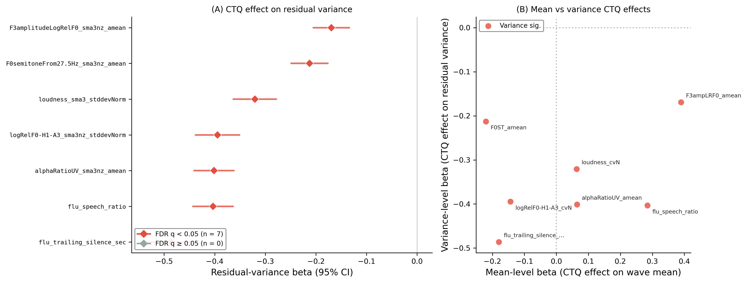
Supplementary table and figure legends
Table S1. Full list of the 99 acoustic features used in the present study.
Table S2. Detailed sensitivity results for alternative CTQ operationalizations.
Table S3. Detailed sensitivity results for alternative DASS summaries.
Table S4. Extended numerical results for prespecified robustness analyses.
Table S5. Full feature-level outputs from the explicit variance follow-up analysis.
Figure S1. Distribution of the first available CTQ score in the analytic sample.
Figure S2. Intraclass correlation coefficients across the 99 acoustic features.
Figure S3. Full forest plot of feature-wise CTQ associations in the SD-based symptom-adjusted analysis (Model B).
Figure S4. Concordance of CTQ coefficients across alternative IIV estimators.
Figure S5. Supplementary plots for the explicit variance follow-up analyses.

