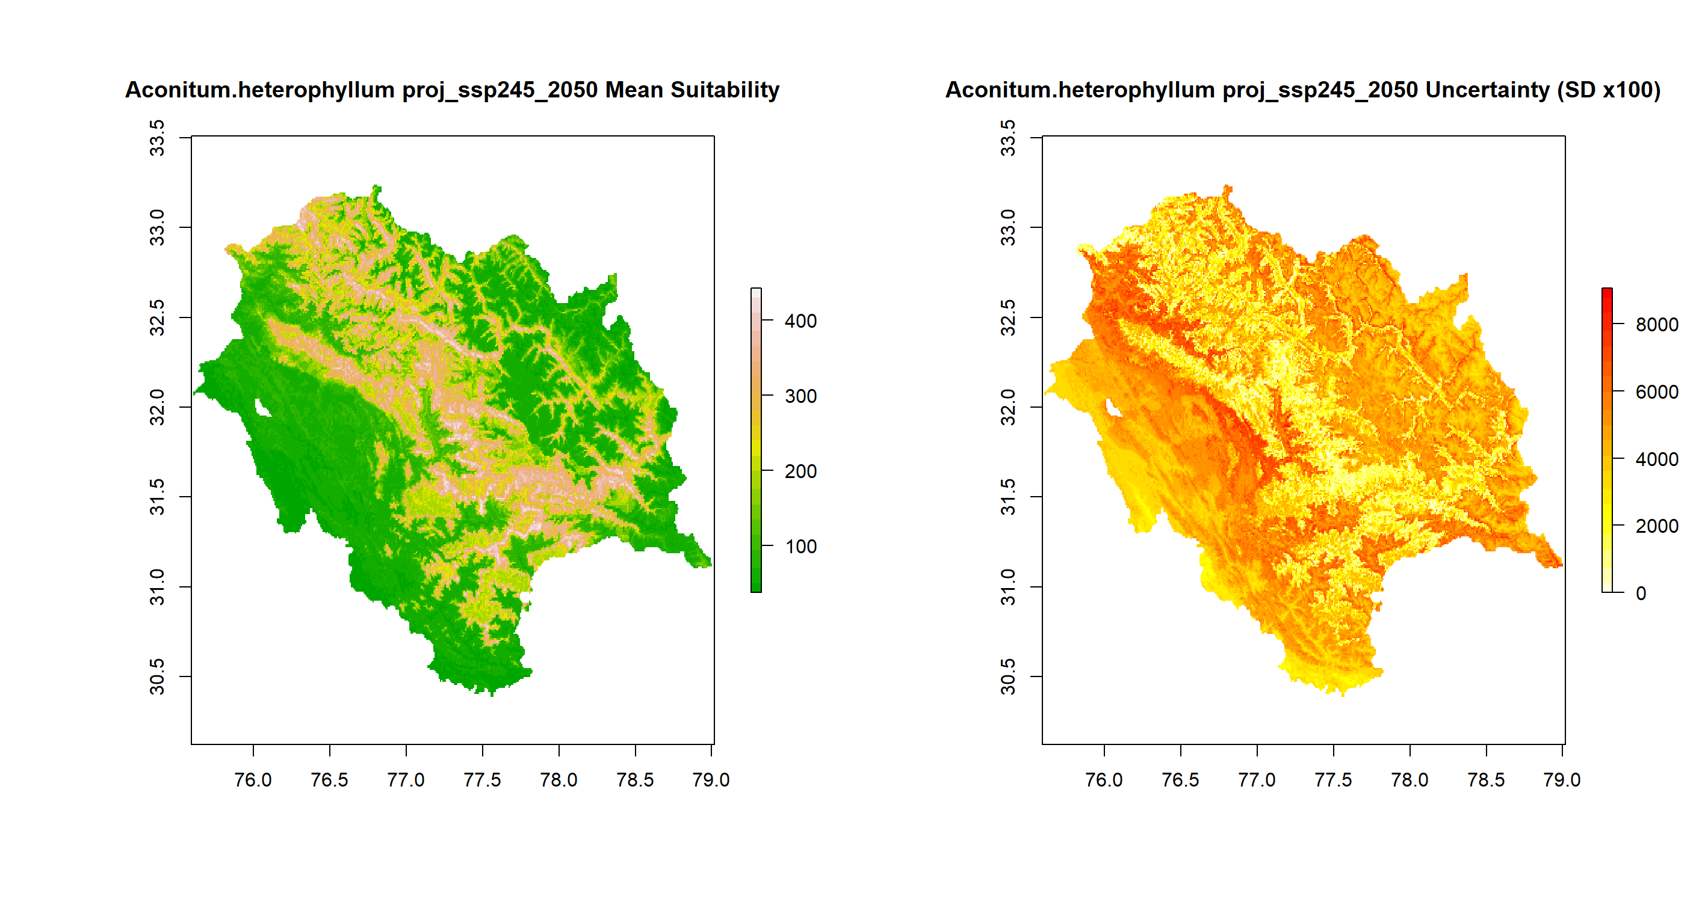
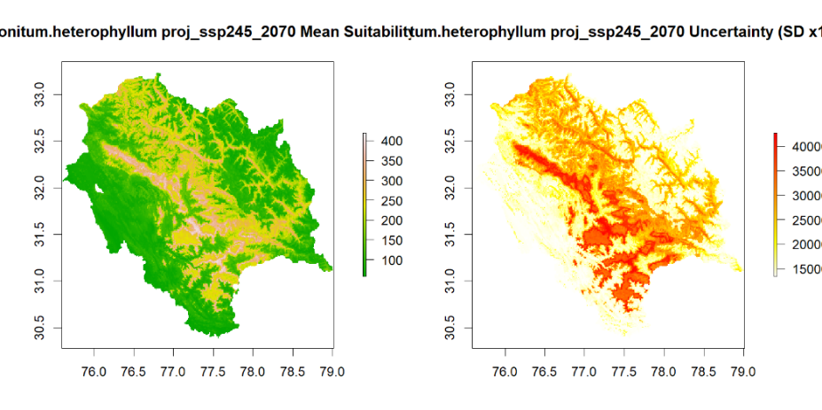
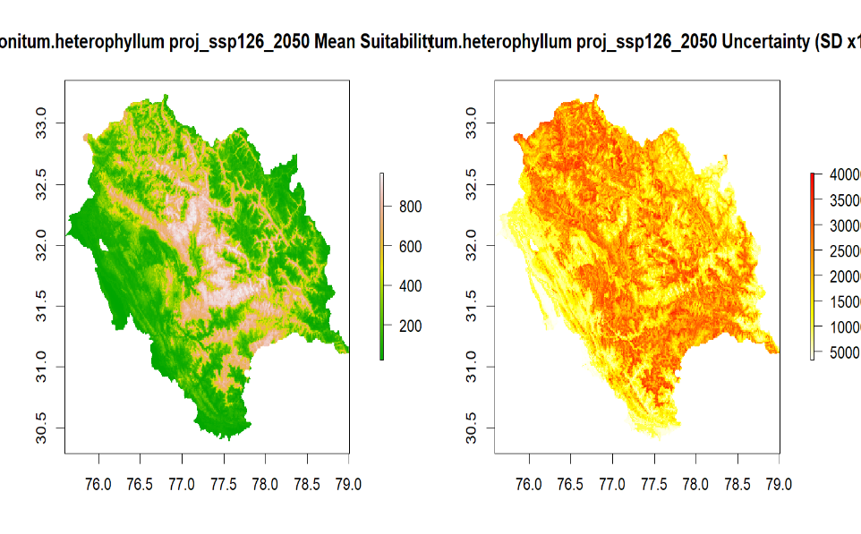
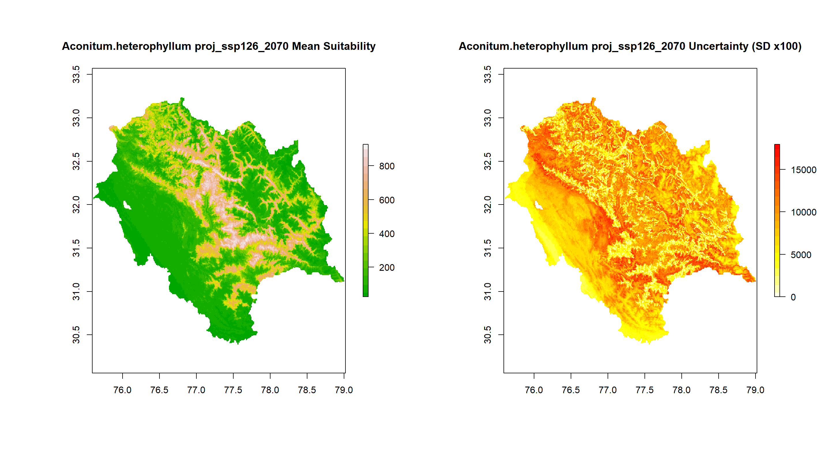
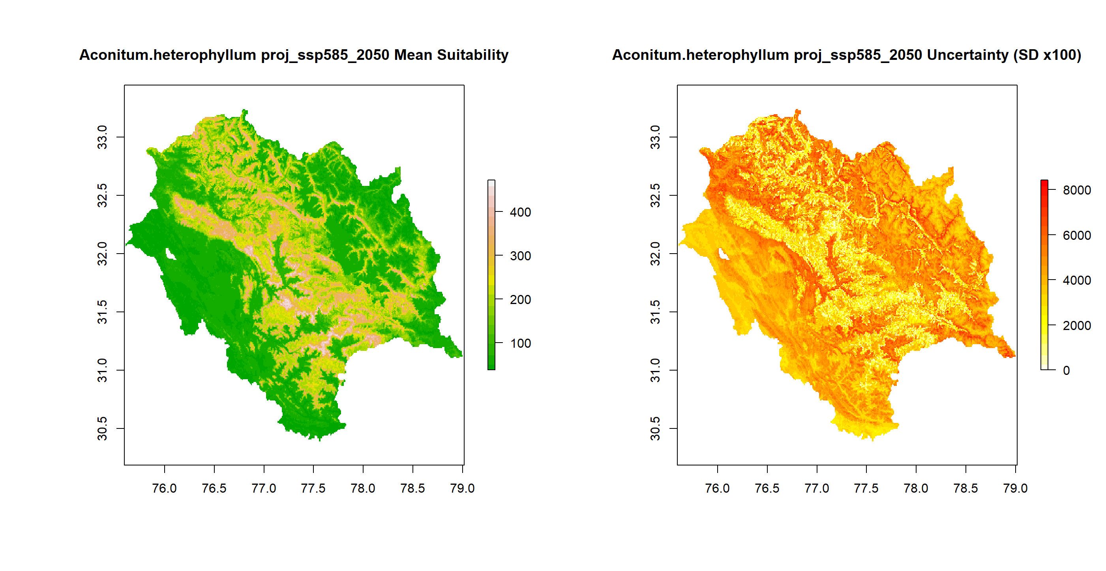
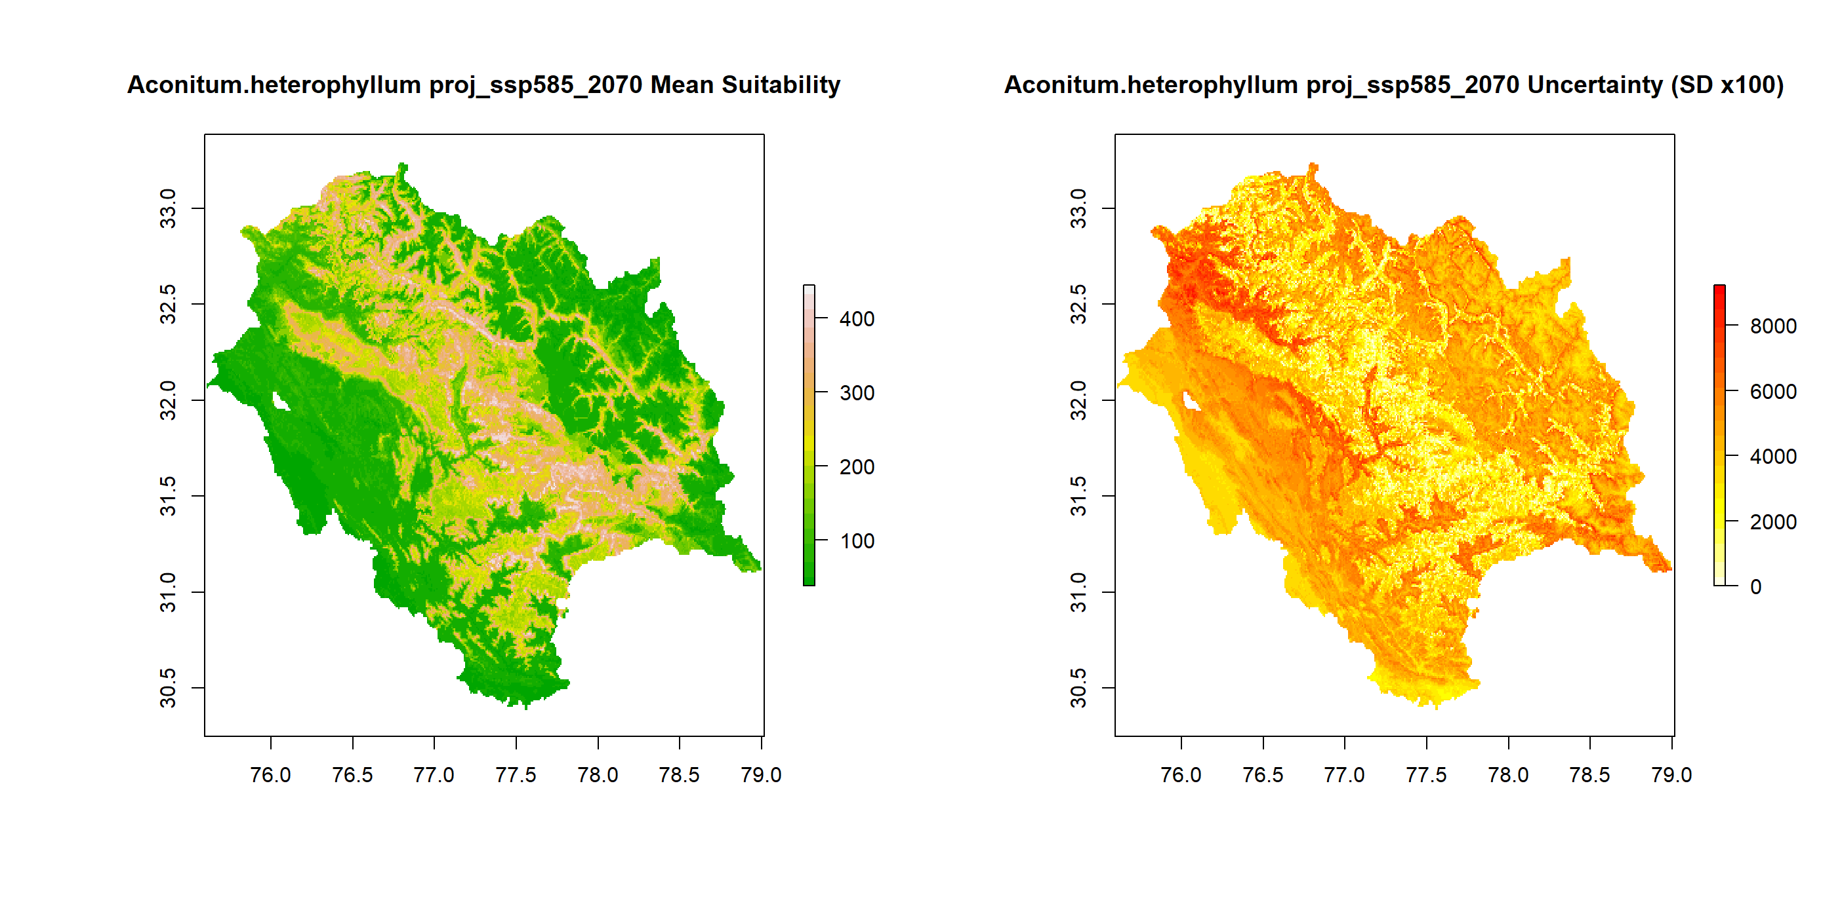
Fig. 12(a) A. heterophyllum mean suitability maps and Uncertainty maps under SSP126, 245 and 585 in 2050 and 2070
2050
2070
SSP126
SSP245
SSP585
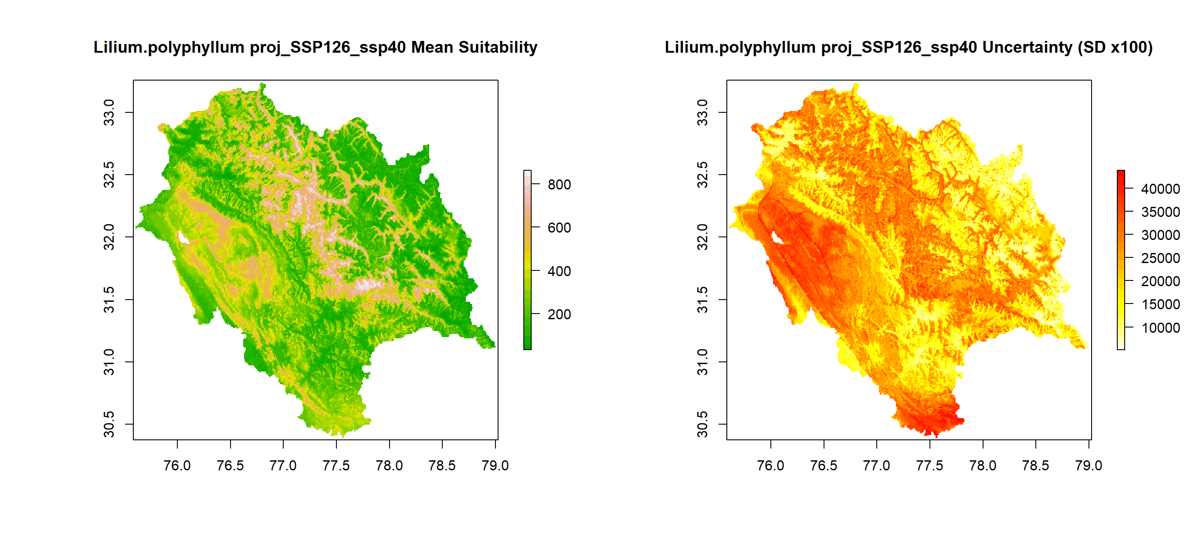
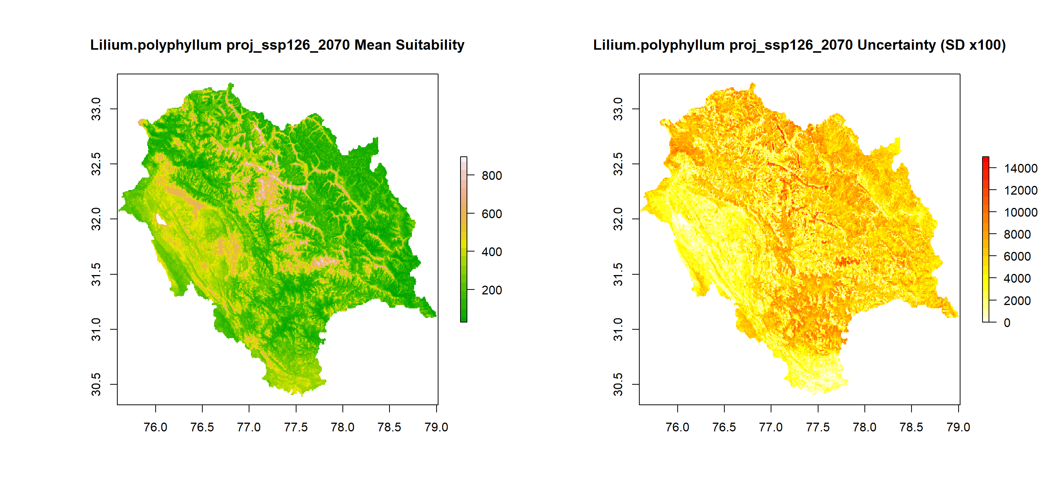
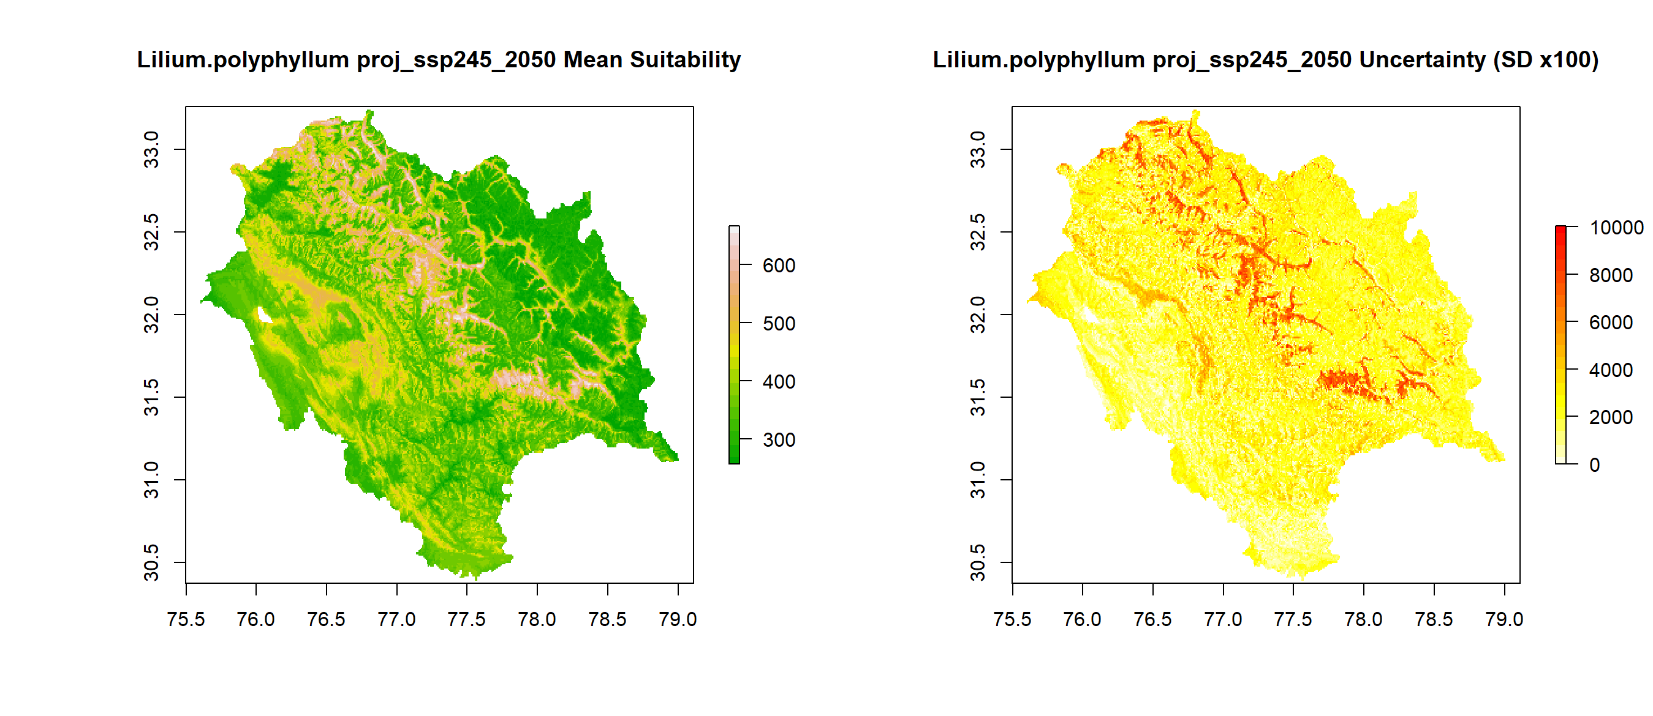
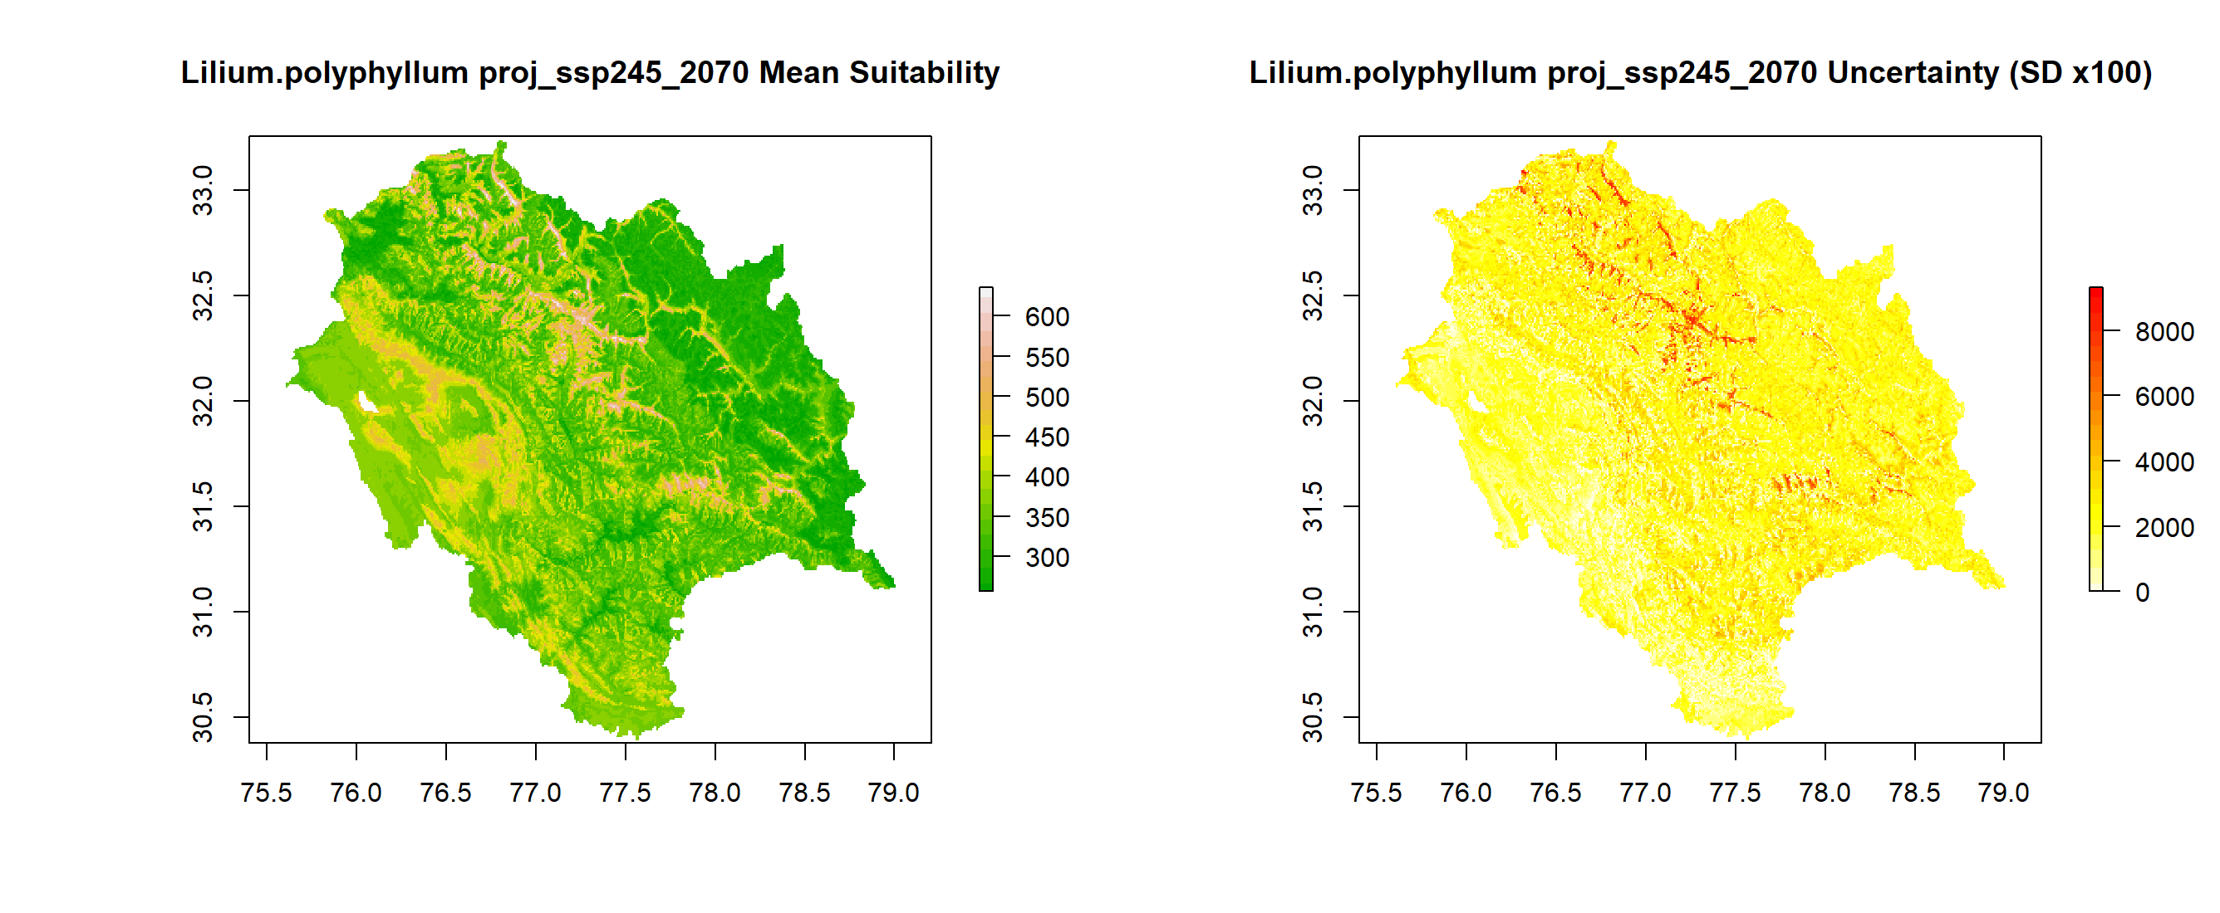
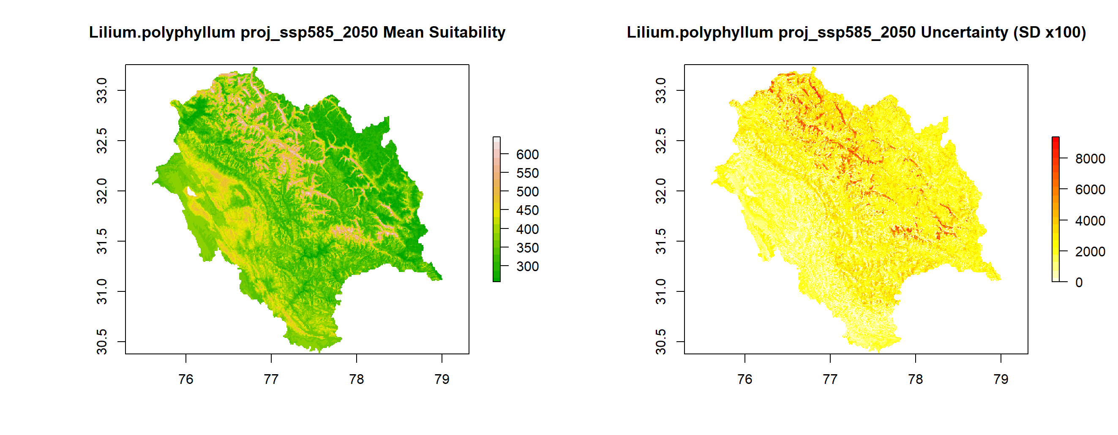
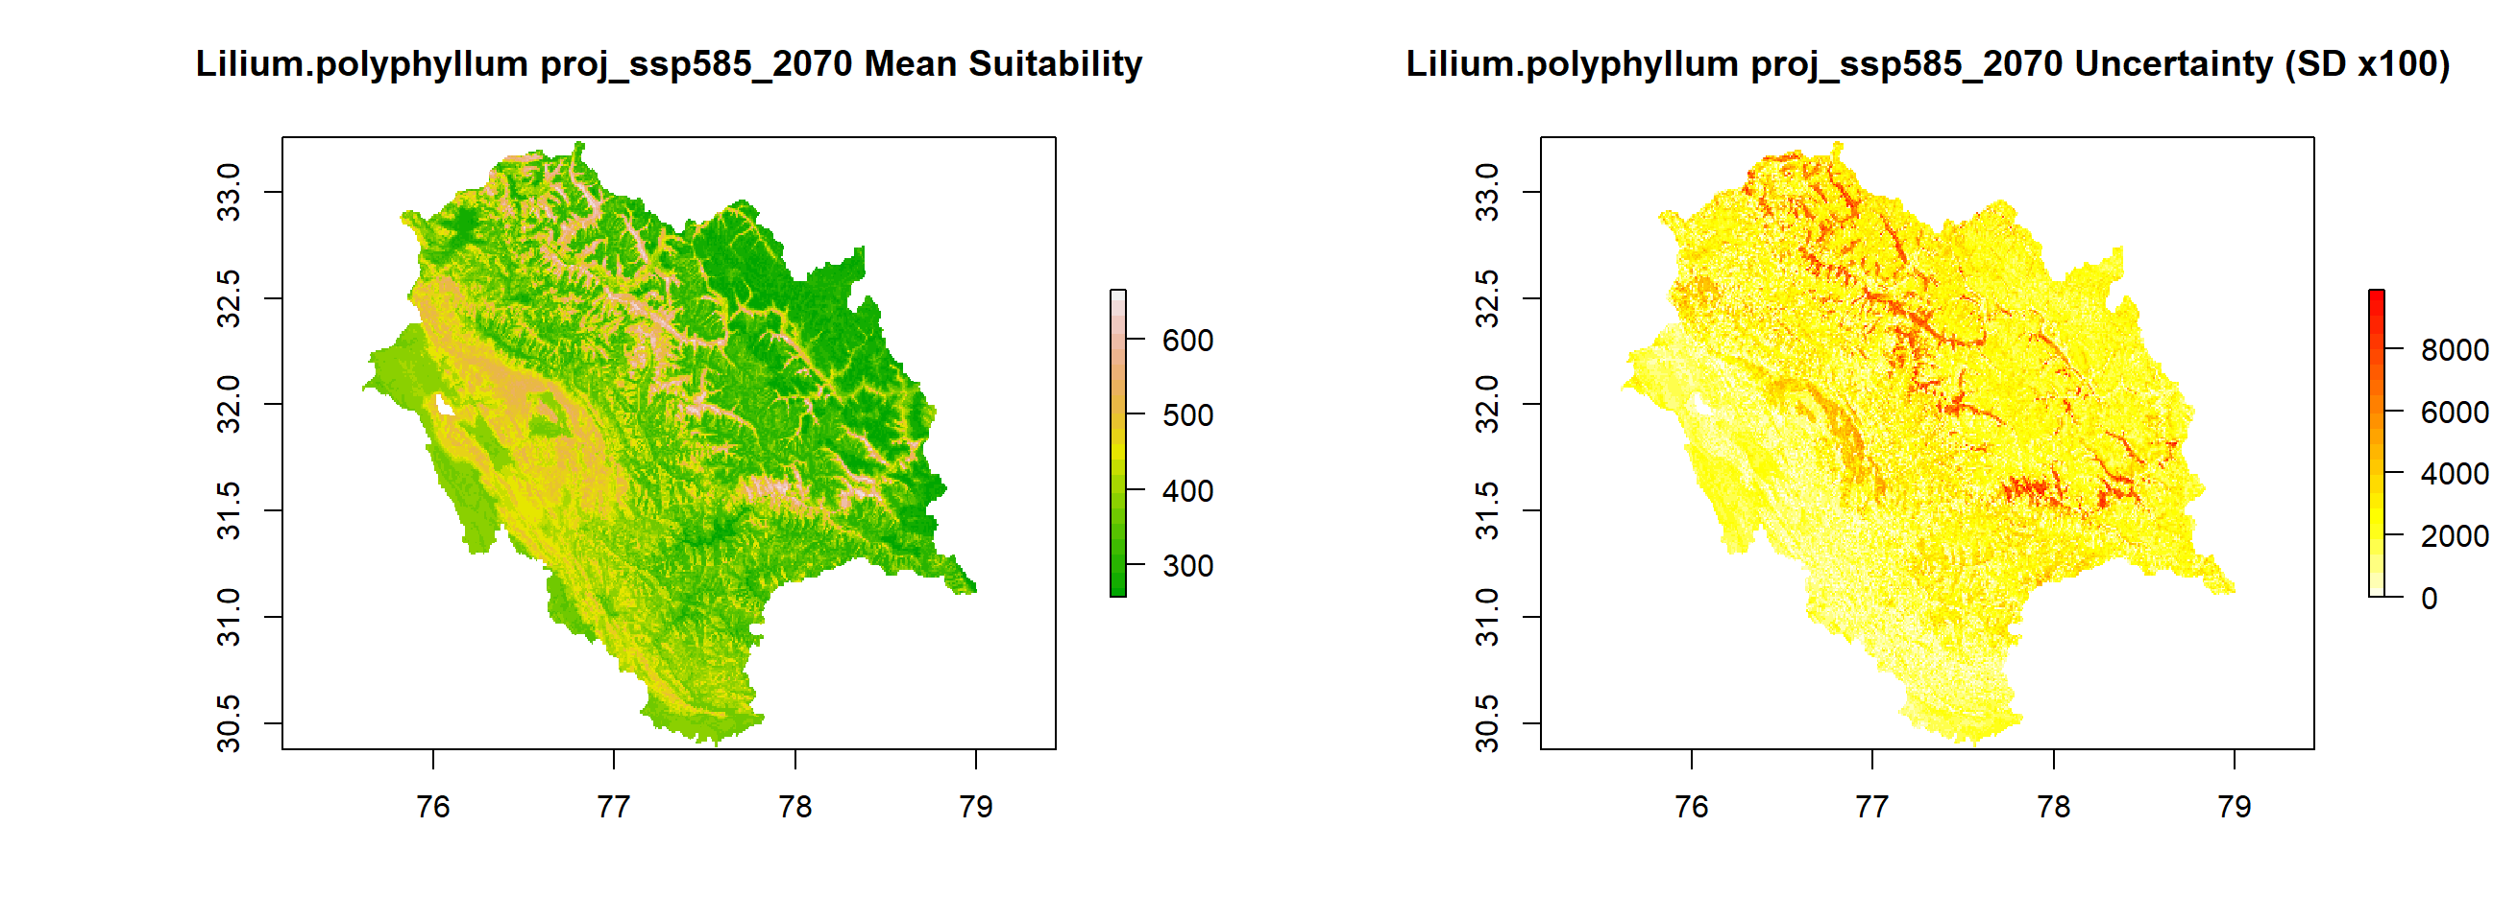
Fig. 12(b) L. polyphyllum mean suitability maps and Uncertainty maps under SSP126, 245 and 585 in 2050 and 2070
2050
2070
SSP126
SSP245
SSP585

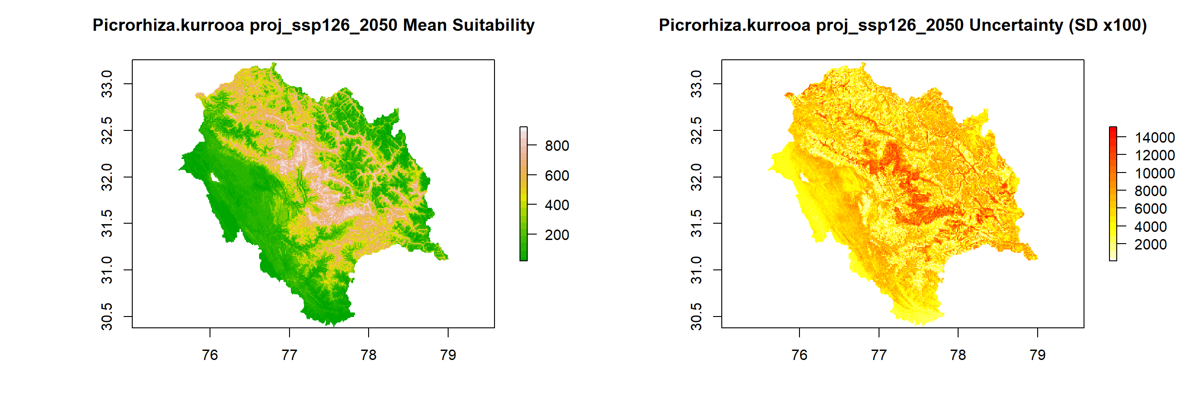
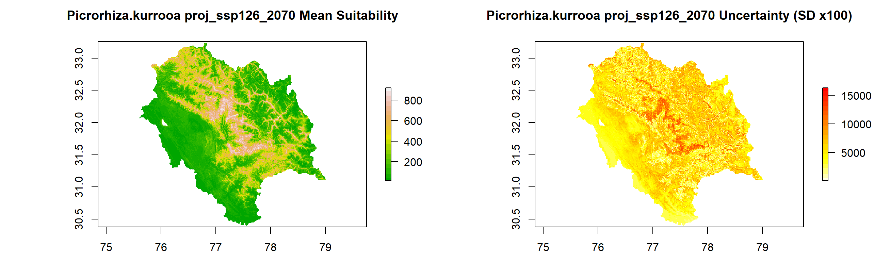
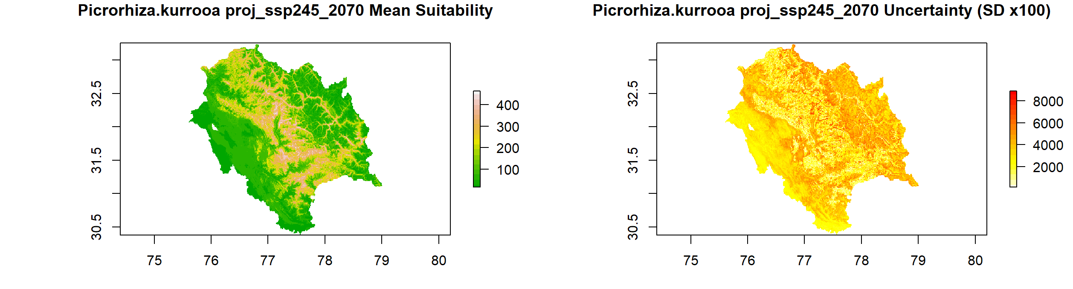
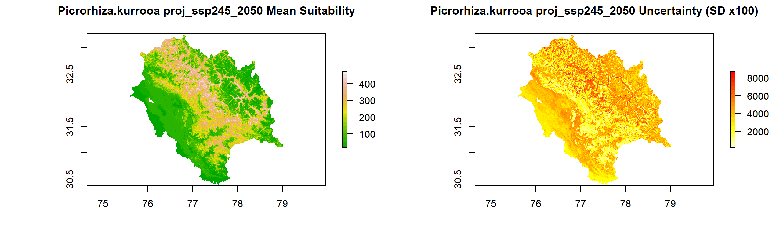
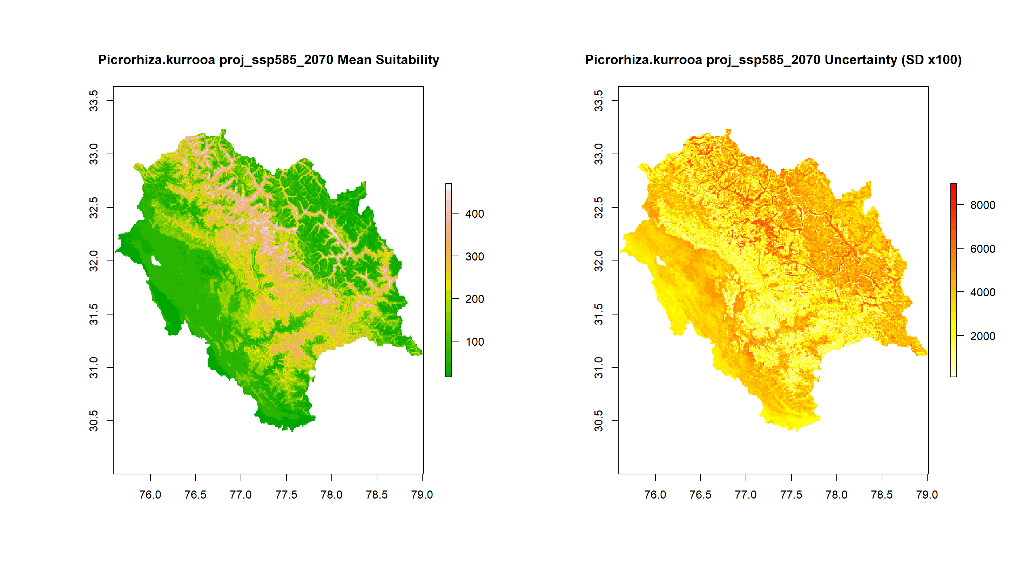
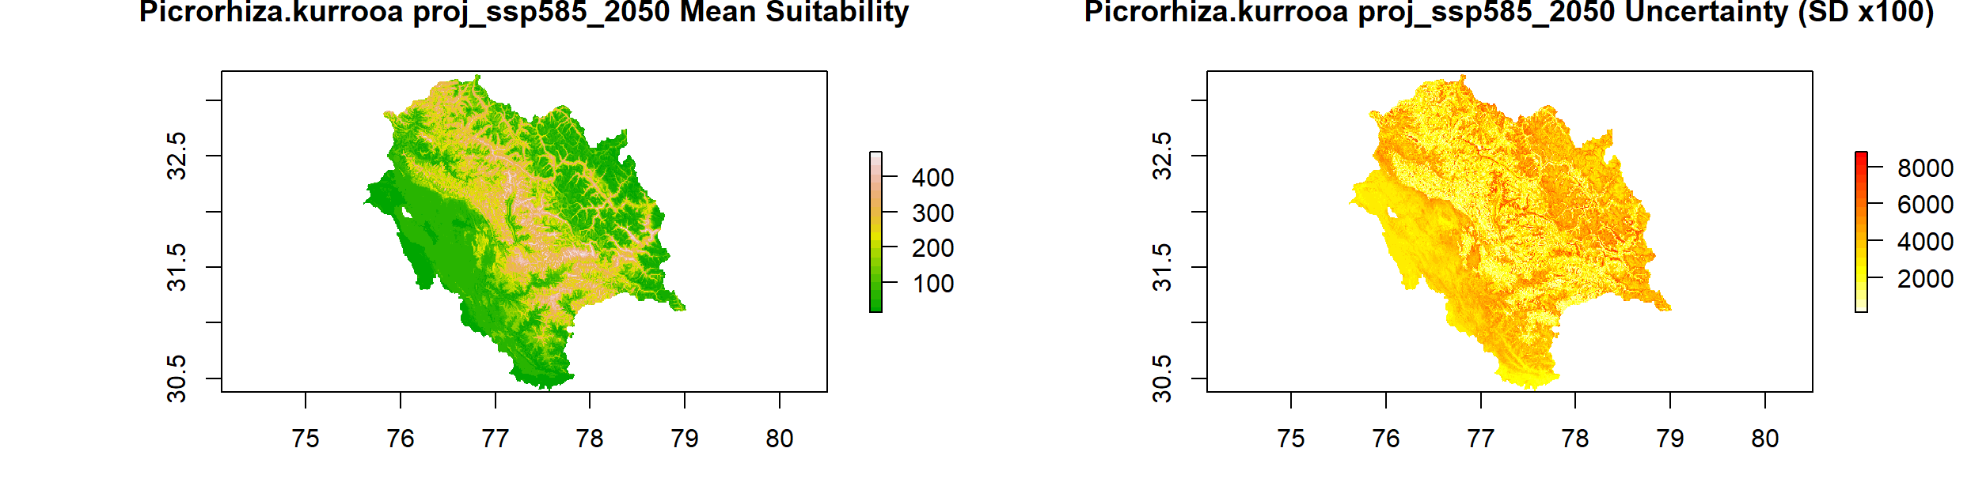
2050
2070
SSP126
SSP245
SSP585

Fig. 12(c) P. Kurroa mean suitability maps and Uncertainty maps under SSP126, 245 and 585 in 2050 and 2070

Table. 2 Current and future distribution of Aconitum heterophyllum, Lilium polyphyllum and Picrorhiza kurroa in each district of Himachal Pradesh under the low, medium and high suitable habitats
Species | District | Suitability | Current | SSP126 |  | SSP245 |  | SSP585
Species | District | Suitability | 2025 | 2050 | 2070 | 2050 | 2070 | 2050 | 2070
Lilium polyphyllum | Lahaul & Spiti | Unsuitable | 4509.54 | 6165.18 | 8527.61 | 1017.707 | 1208.89 | 1264.95 | 1068.02
Lilium polyphyllum | Lahaul & Spiti | Low | 2402.93 | 4403.59 | 3557.66 | 8523.295 | 8781.31 | 7457.43 | 8833.06
Lilium polyphyllum | Lahaul & Spiti | Medium | 3339.20 | 1382.10 | 719.44 | 695.720 | 769.03 | 865.34 | 669.85
Lilium polyphyllum | Lahaul & Spiti | High | 3298.12 | 1553.15 | 699.31 | 3267.299 | 2744.79 | 3916.30 | 2933.09
Lilium polyphyllum | Lahaul & Spiti | Total Suitable Area | 9040.25 | 7338.84 | 4976.41 | 12486.31 | 12295.13 | 12239.07 | 12436.00
Lilium polyphyllum | Shimla | Unsuitable | 1802.82 | 2563.67 | 2845.41 | 627.442 | 700.75 | 697.88 | 616.66
Lilium polyphyllum | Shimla | Low | 789.36 | 2224.44 | 2058.41 | 3278.080 | 2790.79 | 2671.48 | 3009.28
Lilium polyphyllum | Shimla | Medium | 878.38 | 81.22 | 56.06 | 338.517 | 436.26 | 449.92 | 388.11
Lilium polyphyllum | Shimla | High | 1645.32 | 203.40 | 112.84 | 828.684 | 1144.92 | 1253.45 | 1058.67
Lilium polyphyllum | Shimla | Total Suitable Area | 3313.06 | 2509.05 | 2227.31 | 4445.28 | 4371.97 | 4374.85 | 4456.06
Lilium polyphyllum | Chamba | Unsuitable | 2311.42 | 2506.17 | 3347.80 | 694.283 | 785.56 | 721.59 | 780.53
Lilium polyphyllum | Chamba | Low | 643.69 | 3199.74 | 2606.08 | 2276.903 | 2918.00 | 2384.71 | 2281.22
Lilium polyphyllum | Chamba | Medium | 1630.38 | 387.39 | 247.96 | 547.664 | 490.89 | 536.88 | 504.54
Lilium polyphyllum | Chamba | High | 1793.48 | 278.86 | 170.34 | 2853.316 | 2177.72 | 2728.98 | 2805.88
Lilium polyphyllum | Chamba | Total Suitable Area | 4067.55 | 3865.99 | 3024.37 | 5677.88 | 5586.61 | 5650.57 | 5591.64
Lilium polyphyllum | Hamirpur | Unsuitable | 111.43 | 0.00 | 0.00 | 51.748 | 32.34 | 24.44 | 7.19
Lilium polyphyllum | Hamirpur | Low | 47.93 | 777.65 | 1026.33 | 350.016 | 91.28 | 98.46 | 32.34
Lilium polyphyllum | Hamirpur | Medium | 960.55 | 191.90 | 61.81 | 45.998 | 51.03 | 37.37 | 11.50
Lilium polyphyllum | Hamirpur | High | 2.49 | 148.06 | 29.47 | 669.847 | 942.96 | 957.33 | 1066.58
Lilium polyphyllum | Hamirpur | Total Suitable Area | 1010.97 | 1117.61 | 1117.61 | 1065.86 | 1085.27 | 1093.17 | 1110.42
Lilium polyphyllum | Kinnaur | Unsuitable | 2327.61 | 3438.35 | 4179.35 | 436.981 | 644.69 | 674.16 | 551.26
Lilium polyphyllum | Kinnaur | Low | 963.66 | 1859.33 | 1688.99 | 4109.638 | 4123.29 | 3599.35 | 3947.21
Lilium polyphyllum | Kinnaur | Medium | 850.99 | 447.76 | 227.12 | 279.582 | 334.20 | 389.55 | 319.83
Lilium polyphyllum | Kinnaur | High | 2152.68 | 502.38 | 152.37 | 1421.627 | 1145.64 | 1584.78 | 1429.53
Lilium polyphyllum | Kinnaur | Total Suitable Area | 3967.33 | 2809.47 | 2068.47 | 5810.85 | 5603.14 | 5573.67 | 5696.57
Lilium polyphyllum | Una | Unsuitable | 755.74 | 129.37 | 310.49 | 40.248 | 94.15 | 80.50 | 112.12
Lilium polyphyllum | Una | Low | 103.34 | 1264.95 | 1159.29 | 1247.697 | 278.14 | 245.08 | 306.17
Lilium polyphyllum | Una | Medium | 603.85 | 62.53 | 12.94 | 25.874 | 69.72 | 81.93 | 99.90
Lilium polyphyllum | Una | High | 41.09 | 28.03 | 2.16 | 171.055 | 1042.86 | 1077.36 | 966.68
Lilium polyphyllum | Una | Total Suitable Area | 748.27 | 1355.50 | 1174.39 | 1444.63 | 1390.72 | 1404.38 | 1372.75
Lilium polyphyllum | Bilaspur | Unsuitable | 955.57 | 107.09 | 155.96 | 107.089 | 98.46 | 67.56 | 9.34
Lilium polyphyllum | Bilaspur | Low | 148.78 | 875.40 | 901.99 | 560.601 | 431.95 | 210.58 | 56.06
Lilium polyphyllum | Bilaspur | Medium | 36.73 | 108.53 | 65.40 | 89.840 | 89.12 | 70.43 | 19.41
Lilium polyphyllum | Bilaspur | High | 0.00 | 51.03 | 18.69 | 384.515 | 522.51 | 793.47 | 1057.24
Lilium polyphyllum | Bilaspur | Total Suitable Area | 185.51 | 1034.96 | 986.08 | 1034.96 | 1043.58 | 1074.49 | 1132.70
Lilium polyphyllum | Kangra | Unsuitable | 1739.32 | 541.91 | 893.37 | 382.359 | 411.83 | 479.39 | 340.67
Lilium polyphyllum | Kangra | Low | 468.76 | 3648.94 | 3957.99 | 2750.540 | 1101.08 | 1584.78 | 916.37
Lilium polyphyllum | Kangra | Medium | 2383.63 | 595.82 | 384.51 | 268.082 | 299.71 | 299.71 | 250.83
Lilium polyphyllum | Kangra | High | 1021.56 | 825.09 | 375.89 | 2210.781 | 3799.15 | 3247.89 | 4103.89
Lilium polyphyllum | Kangra | Total Suitable Area | 3873.95 | 5069.85 | 4718.39 | 5229.40 | 5199.94 | 5132.38 | 5271.09
Lilium polyphyllum | Kullu | Unsuitable | 319.98 | 1367.72 | 1947.01 | 534.727 | 693.56 | 641.82 | 664.82
Lilium polyphyllum | Kullu | Low | 593.89 | 1832.73 | 2090.76 | 2227.312 | 2399.09 | 2121.66 | 2550.74
Lilium polyphyllum | Kullu | Medium | 1187.15 | 871.09 | 717.28 | 339.236 | 403.20 | 413.98 | 389.55
Lilium polyphyllum | Kullu | High | 3410.17 | 1442.47 | 758.97 | 2412.741 | 2018.16 | 2336.56 | 1908.92
Lilium polyphyllum | Kullu | Total Suitable Area | 5191.20 | 4146.29 | 3567.00 | 4979.29 | 4820.45 | 4872.20 | 4849.20
Lilium polyphyllum | Mandi | Unsuitable | 2537.40 | 1062.99 | 1047.17 | 477.230 | 454.23 | 470.04 | 354.33
Lilium polyphyllum | Mandi | Low | 742.05 | 2532.05 | 2557.92 | 1471.938 | 1124.80 | 1208.17 | 768.31
Lilium polyphyllum | Mandi | Medium | 423.94 | 206.27 | 213.46 | 287.488 | 307.61 | 309.77 | 269.52
Lilium polyphyllum | Mandi | High | 252.12 | 155.24 | 137.99 | 1719.896 | 2069.91 | 1968.57 | 2564.39
Lilium polyphyllum | Mandi | Total Suitable Area | 1418.10 | 2893.56 | 2909.38 | 3479.32 | 3502.32 | 3486.51 | 3602.22
Lilium polyphyllum | Sirmaur | Unsuitable | 973.62 | 503.10 | 487.29 | 283.894 | 314.08 | 245.80 | 240.05
Lilium polyphyllum | Sirmaur | Low | 305.66 | 2094.35 | 2174.13 | 1671.742 | 959.49 | 624.57 | 835.15
Lilium polyphyllum | Sirmaur | Medium | 1385.73 | 81.93 | 44.56 | 180.399 | 222.80 | 208.43 | 196.21
Lilium polyphyllum | Sirmaur | High | 90.27 | 37.37 | 10.78 | 580.725 | 1220.39 | 1637.96 | 1445.34
Lilium polyphyllum | Sirmaur | Total Suitable Area | 1781.66 | 2213.66 | 2229.47 | 2432.87 | 2402.68 | 2470.96 | 2476.71
Lilium polyphyllum | Solan | Unsuitable | 1746.17 | 628.16 | 759.69 | 176.805 | 145.90 | 120.03 | 55.34
Lilium polyphyllum | Solan | Low | 150.65 | 1126.95 | 1014.83 | 1076.642 | 840.90 | 551.26 | 442.73
Lilium polyphyllum | Solan | Medium | 3.11 | 95.59 | 80.50 | 127.213 | 118.59 | 106.37 | 78.34
Lilium polyphyllum | Solan | High | 0.00 | 31.62 | 27.31 | 501.666 | 776.94 | 1104.67 | 1305.91
Lilium polyphyllum | Solan | Total Suitable Area | 153.76 | 1254.17 | 1122.64 | 1705.52 | 1736.43 | 1762.30 | 1826.98
Aconitum heterophyllum | Lahaul & Spiti | Unsuitable | 5671.96 | 4074.65 | 6729.37 | 5944.53 | 6944.53 | 6452.66 | 6535.32
Aconitum heterophyllum | Lahaul & Spiti | Low | 142.70 | 3499.74 | 3429.01 | 3416.07 | 3016.07 | 4486.97 | 3072.53
Aconitum heterophyllum | Lahaul & Spiti | Medium | 4937.42 | 1685.19 | 1161.45 | 1432.41 | 1422.41 | 1240.51 | 1415.16
Aconitum heterophyllum | Lahaul & Spiti | High | 2813.36 | 4243.53 | 2184.19 | 2711.01 | 2211.01 | 1323.88 | 2481.02
Aconitum heterophyllum | Lahaul & Spiti | Total Suitable Area | 7893.48 | 9428.46 | 6774.65 | 7559.49 | 6649.49 | 7051.36 | 6968.70
Aconitum heterophyllum | Shimla | Unsuitable | 1285.04 | 771.09 | 1783.14 | 1001.89 | 1101.89 | 1106.11 | 725.91
Aconitum heterophyllum | Shimla | Low | 0.00 | 1047.77 | 1696.18 | 1726.36 | 1426.36 | 1898.86 | 1995.88
Aconitum heterophyllum | Shimla | Medium | 1448.79 | 498.73 | 566.35 | 799.93 | 699.93 | 826.53 | 836.59
Aconitum heterophyllum | Shimla | High | 2380.60 | 2755.96 | 1027.05 | 1544.53 | 1244.53 | 1241.23 | 1514.34
Aconitum heterophyllum | Shimla | Total Suitable Area | 3829.39 | 4302.45 | 3289.58 | 4070.83 | 3370.83 | 3966.61 | 4346.82
Aconitum heterophyllum | Chamba | Unsuitable | 2176.30 | 735.16 | 2249.59 | 766.87 | 866.87 | 1863.64 | 588.63
Aconitum heterophyllum | Chamba | Low | 122.42 | 2589.23 | 3446.26 | 2407.71 | 2007.71 | 2910.10 | 3218.43
Aconitum heterophyllum | Chamba | Medium | 2632.46 | 1039.14 | 396.01 | 1092.45 | 1000.45 | 652.60 | 1035.67
Aconitum heterophyllum | Chamba | High | 1463.60 | 2007.86 | 280.30 | 2105.13 | 2005.13 | 945.83 | 1529.44
Aconitum heterophyllum | Chamba | Total Suitable Area | 4218.49 | 5636.24 | 4122.58 | 5605.29 | 5013.29 | 4508.53 | 5783.54
Aconitum heterophyllum | Hamirpur | Unsuitable | 1124.41 | 740.19 | 1117.61 | 1103.95 | 1003.95 | 1116.17 | 1057.96
Aconitum heterophyllum | Hamirpur | Low | 0.00 | 378.00 | 0.00 | 13.66 | 10.66 | 1.44 | 59.65
Aconitum heterophyllum | Hamirpur | Medium | 0.00 | 0.00 | 0.00 | 0.00 | 0.00 | 0.00 | 0.00
Aconitum heterophyllum | Hamirpur | High | 0.00 | 0.00 | 0.00 | 0.00 | 0.00 | 0.00 | 0.00
Aconitum heterophyllum | Hamirpur | Total Suitable Area | 0.00 | 378.00 | 0.00 | 13.66 | 10.66 | 1.44 | 59.65
Aconitum heterophyllum | Kinnaur | Unsuitable | 2215.29 | 1970.49 | 2967.59 | 2419.21 | 3419.21 | 2480.30 | 2136.03
Aconitum heterophyllum | Kinnaur | Low | 0.00 | 1334.50 | 1416.60 | 1300.88 | 1000.88 | 2215.09 | 1453.97
Aconitum heterophyllum | Kinnaur | Medium | 2272.21 | 648.21 | 568.51 | 615.22 | 315.22 | 683.50 | 622.41
Aconitum heterophyllum | Kinnaur | High | 1812.94 | 2293.16 | 1295.13 | 1912.51 | 1812.51 | 868.93 | 2035.41
Aconitum heterophyllum | Kinnaur | Total Suitable Area | 4085.15 | 4275.86 | 3280.24 | 3828.62 | 3128.62 | 3767.53 | 4111.79
Aconitum heterophyllum | Una | Unsuitable | 1504.15 | 1451.64 | 1484.87 | 1484.16 | 2484.16 | 1478.41 | 1464.75
Aconitum heterophyllum | Una | Low | 0.00 | 34.49 | 0.00 | 0.72 | 0.52 | 6.47 | 14.37
Aconitum heterophyllum | Una | Medium | 0.00 | 0.00 | 0.00 | 0.00 | 0.00 | 0.00 | 3.59
Aconitum heterophyllum | Una | High | 0.00 | 0.00 | 0.00 | 0.00 | 0.00 | 0.00 | 2.16
Aconitum heterophyllum | Una | Total Suitable Area | 0.00 | 34.49 | 0.00 | 0.72 | 0.52 | 6.47 | 20.12
Aconitum heterophyllum | Bilaspur | Unsuitable | 1156.38 | 804.87 | 1141.33 | 1121.20 | 1221.20 | 1103.23 | 1006.93
Aconitum heterophyllum | Bilaspur | Low | 0.00 | 327.70 | 0.72 | 17.25 | 14.25 | 31.62 | 97.75
Aconitum heterophyllum | Bilaspur | Medium | 0.00 | 4.31 | 0.00 | 1.44 | 1.41 | 5.03 | 24.44
Aconitum heterophyllum | Bilaspur | High | 0.00 | 4.31 | 0.00 | 2.16 | 1.12 | 2.16 | 12.94
Aconitum heterophyllum | Bilaspur | Total Suitable Area | 0.00 | 336.32 | 0.72 | 20.84 | 16.77 | 38.81 | 135.12
Aconitum heterophyllum | Kangra | Unsuitable | 4422.00 | 3109.52 | 4345.38 | 3671.94 | 4671.94 | 3837.96 | 3555.51
Aconitum heterophyllum | Kangra | Low | 24.95 | 1070.76 | 585.76 | 804.97 | 604.97 | 835.87 | 856.71
Aconitum heterophyllum | Kangra | Medium | 351.67 | 190.44 | 208.43 | 329.89 | 229.89 | 282.46 | 323.42
Aconitum heterophyllum | Kangra | High | 860.07 | 1243.23 | 472.20 | 804.97 | 504.97 | 655.47 | 876.12
Aconitum heterophyllum | Kangra | Total Suitable Area | 1236.70 | 2504.43 | 1266.38 | 1939.82 | 1339.82 | 1773.80 | 2056.26
Aconitum heterophyllum | Kullu | Unsuitable | 867.87 | 377.28 | 1174.39 | 495.20 | 699.20 | 733.81 | 294.67
Aconitum heterophyllum | Kullu | Low | 8.58 | 748.10 | 1307.35 | 1500.69 | 1400.69 | 2149.69 | 1754.39
Aconitum heterophyllum | Kullu | Medium | 948.18 | 405.31 | 534.73 | 918.52 | 718.52 | 928.59 | 950.87
Aconitum heterophyllum | Kullu | High | 3702.29 | 3981.94 | 2497.55 | 2599.61 | 2199.61 | 1701.93 | 2514.08
Aconitum heterophyllum | Kullu | Total Suitable Area | 4659.05 | 5135.35 | 4339.63 | 5018.82 | 4318.82 | 4780.20 | 5219.34
Aconitum heterophyllum | Mandi | Unsuitable | 2337.71 | 570.59 | 2308.53 | 1182.29 | 1582.29 | 1406.53 | 774.78
Aconitum heterophyllum | Mandi | Low | 17.15 | 1213.05 | 985.36 | 1557.47 | 1357.47 | 1180.14 | 1714.86
Aconitum heterophyllum | Mandi | Medium | 929.47 | 470.70 | 258.74 | 436.26 | 400.26 | 511.01 | 614.51
Aconitum heterophyllum | Mandi | High | 680.73 | 1701.72 | 403.92 | 780.53 | 711.53 | 858.87 | 852.40
Aconitum heterophyllum | Mandi | Total Suitable Area | 1627.35 | 3385.48 | 1648.02 | 2774.26 | 2469.26 | 2550.02 | 3181.77
Aconitum heterophyllum | Sirmaur | Unsuitable | 2650.40 | 2250.76 | 2560.80 | 2318.59 | 2518.59 | 2216.53 | 1996.60
Aconitum heterophyllum | Sirmaur | Low | 0.00 | 263.02 | 140.15 | 212.74 | 199.74 | 264.49 | 369.42
Aconitum heterophyllum | Sirmaur | Medium | 79.54 | 48.15 | 12.22 | 79.06 | 69.06 | 115.71 | 189.74
Aconitum heterophyllum | Sirmaur | High | 31.97 | 155.22 | 3.59 | 106.37 | 99.37 | 120.03 | 160.99
Aconitum heterophyllum | Sirmaur | Total Suitable Area | 111.51 | 466.39 | 155.96 | 398.17 | 368.17 | 500.23 | 720.16
Aconitum heterophyllum | Solan | Unsuitable | 1877.66 | 1080.82 | 1854.30 | 1691.15 | 1891.15 | 1571.12 | 1347.60
Aconitum heterophyllum | Solan | Low | 0.00 | 633.83 | 28.03 | 120.03 | 98.03 | 165.31 | 227.12
Aconitum heterophyllum | Solan | Medium | 26.51 | 87.67 | 0.00 | 36.65 | 16.65 | 73.31 | 158.12
Aconitum heterophyllum | Solan | High | 0.00 | 80.49 | 0.00 | 34.50 | 24.50 | 72.59 | 149.49
Aconitum heterophyllum | Solan | Total Suitable Area | 26.51 | 801.99 | 28.03 | 191.18 | 139.18 | 311.21 | 534.73
Picrorhiza Kurrooa | Lahaul & Spiti | Unsuitable | 1544.47 | 5471.61 | 6974.45 | 5942.37 | 7264.10 | 6364.98 | 6278.01
Picrorhiza Kurrooa | Lahaul & Spiti | Low | 3029.81 | 4630.71 | 3972.36 | 3216.99 | 3913.43 | 4308.72 | 3316.89
Picrorhiza Kurrooa | Lahaul & Spiti | Medium | 4014.02 | 1639.40 | 1308.07 | 1400.07 | 1186.61 | 1476.25 | 1319.57
Picrorhiza Kurrooa | Lahaul & Spiti | High | 4961.49 | 1762.30 | 1249.13 | 2944.59 | 1139.89 | 1354.07 | 2589.55
Picrorhiza Kurrooa | Lahaul & Spiti | Total Suitable Area | 12005.32 | 8032.41 | 6529.57 | 7561.65 | 6239.92 | 7139.04 | 7226.01
Picrorhiza Kurrooa | Shimla | Unsuitable | 285.11 | 1230.45 | 1840.64 | 830.84 | 1078.08 | 927.15 | 710.09
Picrorhiza Kurrooa | Shimla | Low | 706.56 | 2479.58 | 2519.83 | 2228.03 | 2023.20 | 2036.85 | 2511.92
Picrorhiza Kurrooa | Shimla | Medium | 2659.41 | 712.97 | 403.20 | 935.05 | 812.15 | 835.15 | 896.24
Picrorhiza Kurrooa | Shimla | High | 1464.79 | 649.72 | 309.05 | 1078.80 | 1159.29 | 1273.57 | 954.46
Picrorhiza Kurrooa | Shimla | Total Suitable Area | 4830.76 | 3842.27 | 3232.08 | 4241.88 | 3994.64 | 4145.57 | 4362.63
Picrorhiza Kurrooa | Chamba | Unsuitable | 1688.90 | 2044.04 | 2589.55 | 1437.44 | 2320.03 | 1481.28 | 1814.05
Picrorhiza Kurrooa | Chamba | Low | 1452.34 | 2670.76 | 2701.67 | 2296.31 | 2991.31 | 3201.18 | 2708.14
Picrorhiza Kurrooa | Chamba | Medium | 1697.61 | 1026.33 | 718.00 | 931.46 | 685.66 | 981.77 | 869.65
Picrorhiza Kurrooa | Chamba | High | 1540.12 | 631.04 | 362.95 | 1706.96 | 375.17 | 707.94 | 980.33
Picrorhiza Kurrooa | Chamba | Total Suitable Area | 4690.07 | 4328.13 | 3782.62 | 4934.73 | 4052.14 | 4890.89 | 4558.12
Picrorhiza Kurrooa | Hamirpur | Unsuitable | 1122.41 | 1117.61 | 1117.61 | 1117.61 | 1117.61 | 1117.61 | 1093.17
Picrorhiza Kurrooa | Hamirpur | Low | 0.00 | 0.00 | 0.00 | 0.00 | 0.00 | 0.00 | 24.44
Picrorhiza Kurrooa | Hamirpur | Medium | 0.00 | 0.00 | 0.00 | 0.00 | 0.00 | 0.00 | 0.00
Picrorhiza Kurrooa | Hamirpur | High | 0.00 | 0.00 | 0.00 | 0.00 | 0.00 | 0.00 | 0.00
Picrorhiza Kurrooa | Hamirpur | Total Suitable Area | 0.00 | 0.00 | 0.00 | 0.00 | 0.00 | 0.00 | 24.44
Picrorhiza Kurrooa | Kinnaur | Unsuitable | 1074.47 | 2209.34 | 2736.17 | 2073.51 | 2603.92 | 2346.62 | 1893.83
Picrorhiza Kurrooa | Kinnaur | Low | 1358.96 | 2137.47 | 2409.15 | 2054.10 | 2281.93 | 2087.16 | 2406.27
Picrorhiza Kurrooa | Kinnaur | Medium | 2394.84 | 794.90 | 647.57 | 724.47 | 636.07 | 687.81 | 829.40
Picrorhiza Kurrooa | Kinnaur | High | 1466.66 | 1106.11 | 454.95 | 1395.75 | 725.91 | 1126.23 | 1118.33
Picrorhiza Kurrooa | Kinnaur | Total Suitable Area | 5220.46 | 4038.48 | 3511.66 | 4174.32 | 3643.91 | 3901.21 | 4354.00
Picrorhiza Kurrooa | Una | Unsuitable | 1504.01 | 1484.87 | 1484.87 | 1484.87 | 1484.87 | 1482.72 | 1469.06
Picrorhiza Kurrooa | Una | Low | 0.00 | 0.00 | 0.00 | 0.00 | 0.00 | 2.16 | 15.81
Picrorhiza Kurrooa | Una | Medium | 0.00 | 0.00 | 0.00 | 0.00 | 0.00 | 0.00 | 0.00
Picrorhiza Kurrooa | Una | High | 0.00 | 0.00 | 0.00 | 0.00 | 0.00 | 0.00 | 0.00
Picrorhiza Kurrooa | Una | Total Suitable Area | 0.00 | 0.00 | 0.00 | 0.00 | 0.00 | 2.16 | 15.81
Picrorhiza Kurrooa | Bilaspur | Unsuitable | 1141.08 | 1141.33 | 1142.05 | 1129.83 | 1136.30 | 1117.61 | 1055.08
Picrorhiza Kurrooa | Bilaspur | Low | 0.00 | 0.72 | 0.00 | 12.22 | 5.75 | 24.44 | 86.97
Picrorhiza Kurrooa | Bilaspur | Medium | 0.00 | 0.00 | 0.00 | 0.00 | 0.00 | 0.00 | 0.00
Picrorhiza Kurrooa | Bilaspur | High | 0.00 | 0.00 | 0.00 | 0.00 | 0.00 | 0.00 | 0.00
Picrorhiza Kurrooa | Bilaspur | Total Suitable Area | 0.00 | 0.72 | 0.00 | 12.22 | 5.75 | 24.44 | 86.97
Picrorhiza Kurrooa | Kangra | Unsuitable | 4254.31 | 4287.16 | 4375.56 | 3949.36 | 4026.99 | 3858.80 | 3843.71
Picrorhiza Kurrooa | Kangra | Low | 282.00 | 423.33 | 471.48 | 687.10 | 836.59 | 986.80 | 974.58
Picrorhiza Kurrooa | Kangra | Medium | 351.10 | 301.14 | 307.61 | 356.48 | 390.26 | 449.92 | 360.08
Picrorhiza Kurrooa | Kangra | High | 725.86 | 600.13 | 457.11 | 618.82 | 357.92 | 316.24 | 433.39
Picrorhiza Kurrooa | Kangra | Total Suitable Area | 1358.96 | 1324.60 | 1236.20 | 1662.40 | 1584.78 | 1752.96 | 1768.05
Picrorhiza Kurrooa | Kullu | Unsuitable | 64.74 | 733.09 | 1216.07 | 488.73 | 838.03 | 472.20 | 396.73
Picrorhiza Kurrooa | Kullu | Low | 670.46 | 1347.60 | 1453.25 | 1524.40 | 1777.39 | 1707.68 | 1796.80
Picrorhiza Kurrooa | Kullu | Medium | 1566.26 | 716.56 | 787.00 | 1119.05 | 986.80 | 1003.33 | 1254.88
Picrorhiza Kurrooa | Kullu | High | 3209.72 | 2716.76 | 2057.69 | 2381.84 | 1911.79 | 2330.81 | 2065.60
Picrorhiza Kurrooa | Kullu | Total Suitable Area | 5446.44 | 4780.92 | 4297.94 | 5025.29 | 4675.99 | 5041.82 | 5117.28
Picrorhiza Kurrooa | Mandi | Unsuitable | 1965.30 | 1824.11 | 2504.74 | 1535.18 | 1483.44 | 1224.70 | 1112.58
Picrorhiza Kurrooa | Mandi | Low | 815.50 | 1671.02 | 1114.73 | 1714.15 | 1554.59 | 1805.42 | 2330.09
Picrorhiza Kurrooa | Mandi | Medium | 835.42 | 224.96 | 150.93 | 321.99 | 304.74 | 324.86 | 252.27
Picrorhiza Kurrooa | Mandi | High | 339.27 | 236.46 | 186.15 | 385.23 | 613.79 | 601.57 | 261.61
Picrorhiza Kurrooa | Mandi | Total Suitable Area | 1990.20 | 2132.44 | 1451.81 | 2421.37 | 2473.11 | 2731.85 | 2843.97
Picrorhiza Kurrooa | Sirmaur | Unsuitable | 2225.51 | 2598.89 | 2646.33 | 2358.84 | 2419.21 | 2329.37 | 2138.91
Picrorhiza Kurrooa | Sirmaur | Low | 374.76 | 115.00 | 68.28 | 342.83 | 260.90 | 370.14 | 577.13
Picrorhiza Kurrooa | Sirmaur | Medium | 154.39 | 2.87 | 2.16 | 10.06 | 21.56 | 9.34 | 0.72
Picrorhiza Kurrooa | Sirmaur | High | 0.62 | 0.00 | 0.00 | 5.03 | 15.09 | 7.91 | 0.00
Picrorhiza Kurrooa | Sirmaur | Total Suitable Area | 529.77 | 117.87 | 70.43 | 357.92 | 297.55 | 387.39 | 577.85
Picrorhiza Kurrooa | Solan | Unsuitable | 1700.10 | 1806.86 | 1865.80 | 1668.15 | 1756.55 | 1655.93 | 1432.41
Picrorhiza Kurrooa | Solan | Low | 169.95 | 75.47 | 16.53 | 214.18 | 125.78 | 226.40 | 449.92
Picrorhiza Kurrooa | Solan | Medium | 29.88 | 0.00 | 0.00 | 0.00 | 0.00 | 0.00 | 0.00
Picrorhiza Kurrooa | Solan | High | 0.00 | 0.00 | 0.00 | 0.00 | 0.00 | 0.00 | 0.00
Picrorhiza Kurrooa | Solan | Total Suitable Area | 199.83 | 75.47 | 16.53 | 214.18 | 125.78 | 226.40 | 449.92

Table 3. Centroid shift and change in Bearing degrees for all the three species calculated on the basis of change in latitudes and longitudes and Schoener D index.
Species | SSP | Year | Area (km²) | Centroid  longitude | Centroid latitude | Shift  (km) | Bearing  degrees | Schoener D | Current Area (km²) | Current Centroid longitude | Current  Centroid latitude
A. heterophyllum | SSP126 | 2050 | 20952929.64 | 77.28779309 | 31.93334907 | 11.57 | -125.001 | 0.55749671 | 15444375 | 77.38809 | 31.99328
A. heterophyllum | SSP126 | 2070 | 88869.07145 | 77.29174266 | 31.97248714 | 9.39 | -104.185 | 0.543524 | 15444375 | 77.38809 | 31.99328
A. heterophyllum | SSP245 | 2050 | 99868.79242 | 77.26647286 | 31.97902267 | 11.60 | -97.801 | 0.508476 | 15444375 | 77.38809 | 31.99328
A. heterophyllum | SSP245 | 2070 | 99868.79242 | 77.26647286 | 31.97902267 | 11.60 | -97.801 | 0.508476 | 15444375 | 77.38809 | 31.99328
A. heterophyllum | SSP585 | 2050 | 92956.17777 | 77.27576868 | 31.95129107 | 11.59 | -113.651 | 0.496031 | 15444375 | 77.38809 | 31.99328
A. heterophyllum | SSP585 | 2070 | 101202.382 | 77.26841481 | 31.95364413 | 12.13 | -111.202 | 0.489072 | 15444375 | 77.38809 | 31.99328
L. polyphyllum | ssp126 | 2050 | 97101.73 | 77.17866 | 31.92989 | 16.69629 | -139.123 | 0.586554 | 20675880 | 77.2942 | 32.04379
L. polyphyllum | ssp126 | 2070 | 88819.31 | 77.16745 | 31.90621 | 19.39827 | -141.824 | 0.56203 | 20675880 | 77.2942 | 32.04379
L. polyphyllum | ssp245 | 2050 | 131555.3 | 77.216 | 31.93714 | 13.94593 | -147.978 | 0.560729 | 20675880 | 77.2942 | 32.04379
L. polyphyllum | ssp245 | 2070 | 134642.8 | 77.19493 | 31.91498 | 17.0893 | -146.673 | 0.535048 | 20675880 | 77.2942 | 32.04379
L. polyphyllum | ssp585 | 2050 | 137794.3 | 77.20341 | 31.91644 | 16.5239 | -148.69 | 0.543831 | 20675880 | 77.2942 | 32.04379
L. polyphyllum | ssp585 | 2070 | 137229.1 | 77.18691 | 31.91279 | 17.71638 | -145.053 | 0.528566 | 20675880 | 77.2942 | 32.04379
P. kurrooa | ssp126 | 2050 | 92339.54 | 77.30045 | 31.97449 | 13.40195 | -129.925 | 0.503475 | 17218614 | 77.40919 | 32.0521
P. kurrooa | ssp126 | 2070 | 85150.19 | 77.28722 | 31.97366 | 14.43746 | -127.011 | 0.502977 | 17218614 | 77.40919 | 32.0521
P. kurrooa | ssp245 | 2050 | 96971.39 | 77.28252 | 31.98202 | 14.26847 | -122.963 | 0.475527 | 17218614 | 77.40919 | 32.0521
P. kurrooa | ssp245 | 2070 | 89270.77 | 77.28826 | 31.94668 | 16.34651 | -135.618 | 0.478529 | 17218614 | 77.40919 | 32.0521
P. kurrooa | ssp585 | 2050 | 93860.12 | 77.28419 | 31.95751 | 15.79577 | -131.574 | 0.472394 | 17218614 | 77.40919 | 32.0521
P. kurrooa | ssp585 | 2070 | 95675.62 | 77.2915 | 31.95925 | 15.15426 | -132.764 | 0.467589 | 17218614 | 77.40919 | 32.0521

