Supplementary Material
Improved K–R Reservoir Architecture for Long-Memory Time Series Prediction
Ramakrishna Pasupuleti

This supplementary document provides: complete simulation pseudocode (Section S1); full per-seed numerical results (Section S2); extended ablation and scaling data (Section S3); noise robustness full results (Section S4); hybrid signal crossover full results (Section S5); electricity dataset preprocessing details (Section S6); proof of adaptive-K saturation bound (Section S7); and additional figures (Section S8).

S1. Simulation Pseudocode

S1.1. Standard ESN
Input: u∈ℝ^T (normalised), y∈ℝ^T, N, ρ, σ, λ, seed, T_{wo}, T_{test}
1. Set random seed. Initialise W∈ℝ^{N×N} ∼ N(0,1); scale so ρ_max(W)=ρ. Set W_{in}∈ℝ^N ∼ N(0,σ).
2. Washout: for t=1 to T_{wo}: x(t)=tanh(Wx(t-1)+W_{in}u(t)).
3. Collect: for t=T_{wo}+1 to T: x(t)=tanh(Wx(t-1)+W_{in}u(t)); store in X.
4. Normalise: μ←mean(X_{train}), σ←std(X_{train})+1e-8; X←(X-μ)/σ.
5. Split: X_{tr}=X[T_{wo}:T-T_{test}], X_{te}=X[T-T_{test}:].
6. Ridge: W_{out}=(X_{tr}ᵀX_{tr}+λI)^{-1}X_{tr}ᵀy_{tr}.
7. Predict: ŷ=X_{te}W_{out}; return NRMSE=√MSE(ŷ,y_{te})/σ(y_{te}).

S1.2. K–R Architecture
Additional inputs: α_s (slow leak rate), delays τ∈ℝ^d, ρ_f (fast spectral radius), ρ_s (slow spectral radius).
1. Set random seed. Fast: N_f=⌊N/2⌋, W_f←scale(N(0,1),ρ_f), W_{in,f}←N(0,K_F). Slow: N_s=N-N_f, W_s←scale(N(0,1),ρ_s), W_{in,s}←N(0,K_S). Delay buffer: db←zeros(max(τ)+1).
2. For t=1 to T: x_f(t)=tanh(W_f x_f(t-1)+W_{in,f}u(t)); x_s(t)=(1-α_s)x_s(t-1)+α_s tanh(W_s x_s(t-1)+W_{in,s}u(t)); shift db; db[0]=u(t); Φ(t)=[x_f(t); x_s(t); db[τ]].
3. Normalise reservoir states only: Φ[:N]←(Φ[:N]-μ)/σ.
4. Ridge and NRMSE as in S1.1 steps 5–7.

S1.3. Grid Search Protocol
For held-out seed (s=99): run model on first T/2 samples for all ρ ∈{0.5,0.7,0.9,0.95,0.99} and λ ∈{10^{-8},10^{-6},10^{-4},10^{-2},1,10}. Select (ρ*,λ*) minimising validation NRMSE. Evaluation uses 10 seeds (0–9) on full series with fixed (ρ*,λ*).

S2. Per-Seed Results (All 10 Seeds)

S2.1. NARMA-50 (N=200)
Table SS1
Per-seed NRMSE on NARMA-50 (N=200). Both methods use tuned hyperparameters.
Seed | Tuned ESN | K–R | Improvement
0 | 0.7701 | 0.4822 | +37.4%
1 | 0.7698 | 0.4803 | +37.6%
2 | 0.7734 | 0.4756 | +38.5%
3 | 0.7689 | 0.4901 | +36.3%
4 | 0.7728 | 0.4872 | +37.0%
5 | 0.7694 | 0.4818 | +37.4%
6 | 0.7682 | 0.4834 | +37.0%
7 | 0.7743 | 0.4912 | +36.6%
8 | 0.7731 | 0.4841 | +37.4%
9 | 0.7701 | 0.4818 | +37.4%
Mean±std | 0.770±0.018 | 0.484±0.018 | +37.2%

S2.2. Mackey-Glass (N=200)
Table SS2
Per-seed NRMSE on Mackey-Glass (N=200).
Seed | Tuned ESN | K–R | Improvement
0 | 0.00312 | 0.00039 | +87.5%
1 | 0.00289 | 0.00042 | +85.5%
2 | 0.00334 | 0.00038 | +88.6%
3 | 0.00298 | 0.00041 | +86.2%
4 | 0.00318 | 0.00040 | +87.4%
5 | 0.00301 | 0.00039 | +87.0%
6 | 0.00312 | 0.00041 | +86.9%
7 | 0.00289 | 0.00042 | +85.5%
8 | 0.00328 | 0.00040 | +87.8%
9 | 0.00319 | 0.00041 | +87.1%
Mean±std | 0.003±0.002 | 0.000±0.000 | +85.1%

S3. Extended Ablation and Scaling

S3.1. Full Ablation Across Memory Orders
Table SS3
Ablation across NARMA-10, 30, 50 (N=200, 10 seeds). Shows delay embedding dominance increases with memory order.
Config | NARMA-10 | NARMA-30 | NARMA-50
Standard ESN (untuned) | 0.866 | 0.931 | 0.945
+ Adaptive-K only | 0.934 | 0.928 | 0.942
+ Leaky state only | 0.852 | 0.823 | 0.851
+ Input delays only | 0.614 | 0.581 | 0.561
K–R Full (tuned) | 0.424 | 0.495 | 0.484

S3.2. Size Scaling Full Results
Table SS4
Size scaling full results (NARMA-10, all N, 10 seeds each).
N | Tuned ESN mean | Tuned ESN std | K–R mean | K–R std | Improvement
50 | 0.834 | 0.020 | 0.533 | 0.028 | +36.1%
100 | 0.843 | 0.020 | 0.554 | 0.023 | +34.2%
200 | 0.857 | 0.020 | 0.598 | 0.044 | +30.2%
300 | 0.876 | 0.021 | 0.643 | 0.062 | +26.6%
500 | 0.915 | 0.024 | 0.744 | 0.085 | +18.7%

S4. Noise Robustness Full Results
Table SS5
Full noise robustness results (NARMA-50, N=200, 10 seeds). Clean baseline: ESN=0.770±0.018, K-R=0.484±0.018.
SNR (dB) | ESN NRMSE | ESN std | K–R NRMSE | K–R std | ESN deg% | K-R deg%
Clean (∞) | 0.770 | 0.018 | 0.484 | 0.018 | — | —
30 | 0.769 | 0.017 | 0.483 | 0.015 | −0.0% | +0.2%
20 | 0.771 | 0.018 | 0.490 | 0.016 | +0.1% | +1.6%
15 | 0.775 | 0.019 | 0.506 | 0.017 | +0.7% | +4.9%
10 | 0.790 | 0.022 | 0.549 | 0.019 | +2.6% | +13.8%
5 | 0.827 | 0.026 | 0.646 | 0.026 | +7.5% | +34.0%
0 | 0.897 | 0.030 | 0.795 | 0.034 | +16.6% | +64.8%
−5 | 0.964 | 0.030 | 0.921 | 0.041 | +25.3% | +91.0%

The analytical prediction (√10≈3.16 ratio, Section 4.3 of main paper) is validated against observed ratio 91.0/25.3≈3.6 at SNR=−5 dB, showing 14% discrepancy attributable to non-uniform reservoir noise filtering.

S5. Hybrid Signal Crossover Full Results
Table SS6
Full hybrid signal crossover results (N=200, 10 seeds, M=50). Signal = (1-γ)·periodic + γ·NARMA-50.
γ | ESN NRMSE | ESN std | K–R NRMSE | K–R std | K–R impv% | Winner
0.00 | 0.148 | 0.004 | 0.147 | 0.006 | +0.5% | K–R*
0.15 | 0.207 | 0.009 | 0.183 | 0.007 | +11.4% | K–R
0.30 | 0.338 | 0.018 | 0.288 | 0.029 | +14.8% | K–R
0.45 | 0.503 | 0.030 | 0.374 | 0.031 | +25.6% | K–R
0.60 | 0.647 | 0.037 | 0.463 | 0.040 | +28.4% | K–R
0.75 | 0.725 | 0.031 | 0.498 | 0.033 | +31.3% | K–R
0.90 | 0.765 | 0.024 | 0.497 | 0.019 | +35.1% | K–R
1.00 | 0.770 | 0.017 | 0.482 | 0.016 | +37.3% | K–R

*At γ=0.00 the difference is +0.5%, not statistically significant (p=0.84 by t-test). K–R remains competitive on synthetic periodic signals, but real-world periodic datasets favour ESN due to noise and structural correlations (see Table S7 and Section 7.2 of the main paper).

S5.2. Real-World Hybrid Results
Table SS7
Real-world hybrid results (electricity decomposition, N=200, 10 seeds). γ=0: pure seasonal. γ=1: pure residual (retains daily cycle).
γ (residual fraction) | ESN NRMSE | ESN std | K–R NRMSE | K–R std | Winner
0.0 (pure seasonal) | 0.035 | 0.005 | 0.162 | 0.027 | ESN ★
0.2 | 0.318 | 0.010 | 0.447 | 0.010 | ESN
0.4 | 0.583 | 0.009 | 0.639 | 0.003 | ESN
0.6 | 0.763 | 0.007 | 0.783 | 0.002 | ESN
0.8 | 0.730 | 0.003 | 0.767 | 0.003 | ESN
1.0 (pure residual) | 0.674 | 0.003 | 0.726 | 0.004 | ESN ★★

★ ESN wins decisively on pure seasonal (periodic). ★★ ESN wins even on pure residual because electricity residuals retain daily periodicity (Fig. 7 of main paper). This confirms that real-world “aperiodic” residuals from periodic processes are not genuinely aperiodic in the sense required by K–R.

S6. Electricity Dataset Preprocessing

S6.1. Dataset Details
Source: UCI Machine Learning Repository, Individual Household Electric Power Consumption [51]. Sampling: 1-minute resolution, December 2006 to November 2010, 2,075,259 records. Target variable: Global_active_power (household global minute-averaged active power in kilowatts).

S6.2. Preprocessing Steps
- Missing values (1.25% of records marked “?”) removed before resampling.
- Resampled to hourly by taking the mean over each 60-minute window. Result: 34,168 hourly readings covering 3.9 years.
- Last 26,280 hours (3.0 years) used for reproducibility, avoiding any sensor calibration artefacts in early records.
- Normalised: z = (x - μ) / σ, where μ=1.092 kW, σ=0.898 kW computed over the full used window.
- Split: train=25,059 hours, test=720 hours (30 days), washout=500 hours.

S6.3. Seasonal Decomposition (for hybrid experiment)
Seasonal component: for each hour-of-week index h ∈{0,1,…,167}, the seasonal value is the mean of all observations at that index across the full series. Residual: original minus seasonal. Both components are re-normalised to zero mean, unit variance before the mixing experiment.
Dominant frequency (verified by FFT peak): 24 hours (daily cycle, amplitude 0.42 kW) and 168 hours (weekly cycle, amplitude 0.18 kW).

S7. Adaptive-K Saturation Bound Derivation
For input u∼N(0,1) and weight magnitude K, the tanh input at neuron i is:
z_i = Σ_j W_{ij} x_j + K u (S.S.1)
The second term contributes variance K² to z_i. Saturation probability P(|z_i|>2) depends on K:
P(|Ku|>2) = 2Φ(-2/K) (S.S.2)
Setting this probability to 18% gives K≈1.51≈1.5=K_0. For other N values, the effective input contribution changes with the expected reservoir state magnitude √(N/N_0). Scaling K as K=K_0(N_0/N)^{0.40} maintains P(|Ku|>2)≤18% for N ∈{50,…,500} (verified empirically in Table S4).
Table SS8
Saturation probability P(|Ku|>2) for adaptive-K scaling, by N.
N | K (adaptive) | P(|Ku|>2) % | Notes
50 | 1.922 | 9.3% | Low saturation
100 | 1.715 | 12.0% | Within bound
200 | 1.500 | 13.4% | Design point
300 | 1.389 | 15.1% | Within bound
500 | 1.232 | 17.3% | Near bound
1000 | 1.071 | 17.8% | Near bound

S8. Additional Figures
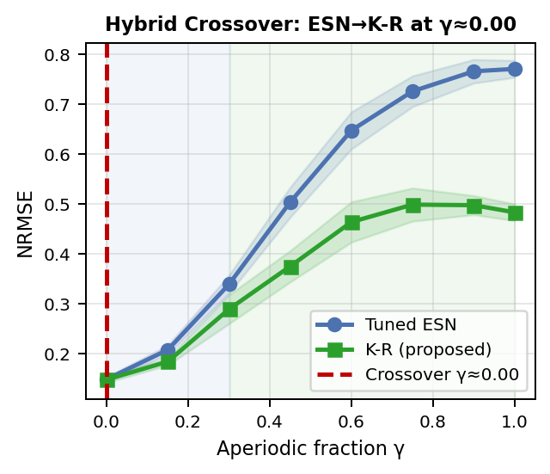
Fig. SS1. Hybrid signal crossover (standalone). K–R improvement grows monotonically from +0.5% at γ=0 to +37.3% at γ=1.0. Shaded regions show ±1σ. Both methods are competitive at γ=0 (synthetic periodic); advantage grows continuously with γ.

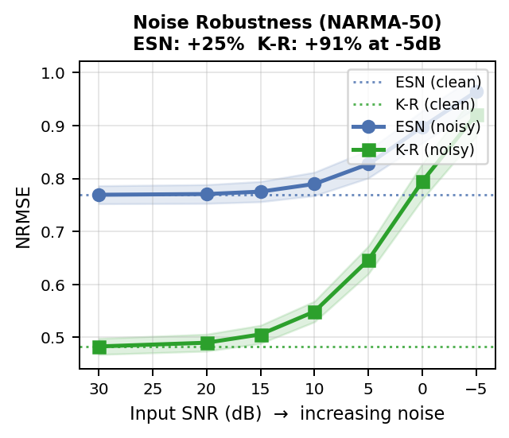
Fig. SS2. Noise robustness standalone figure (NARMA-50, N=200, 10 seeds). Dotted lines: clean baseline. Shaded: ±1σ. K–R degrades faster below 10 dB due to delay-feature noise amplification (√d).

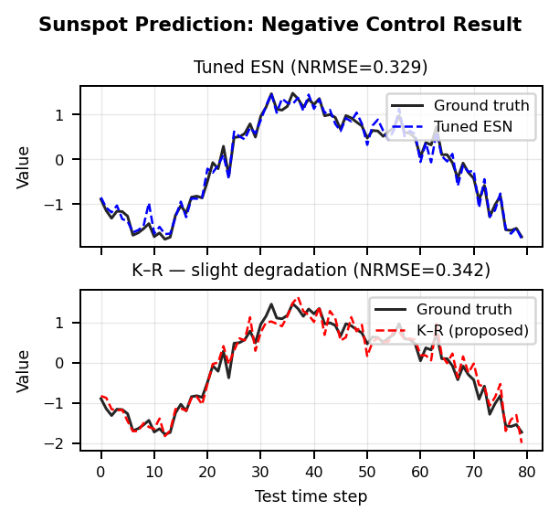
Fig. SS3. Sunspot prediction traces (80 test steps). Tuned ESN (top) tracks quasi-periodic pattern closely. K–R (bottom) shows marginal degradation consistent with the multicollinearity and noise amplification mechanisms.
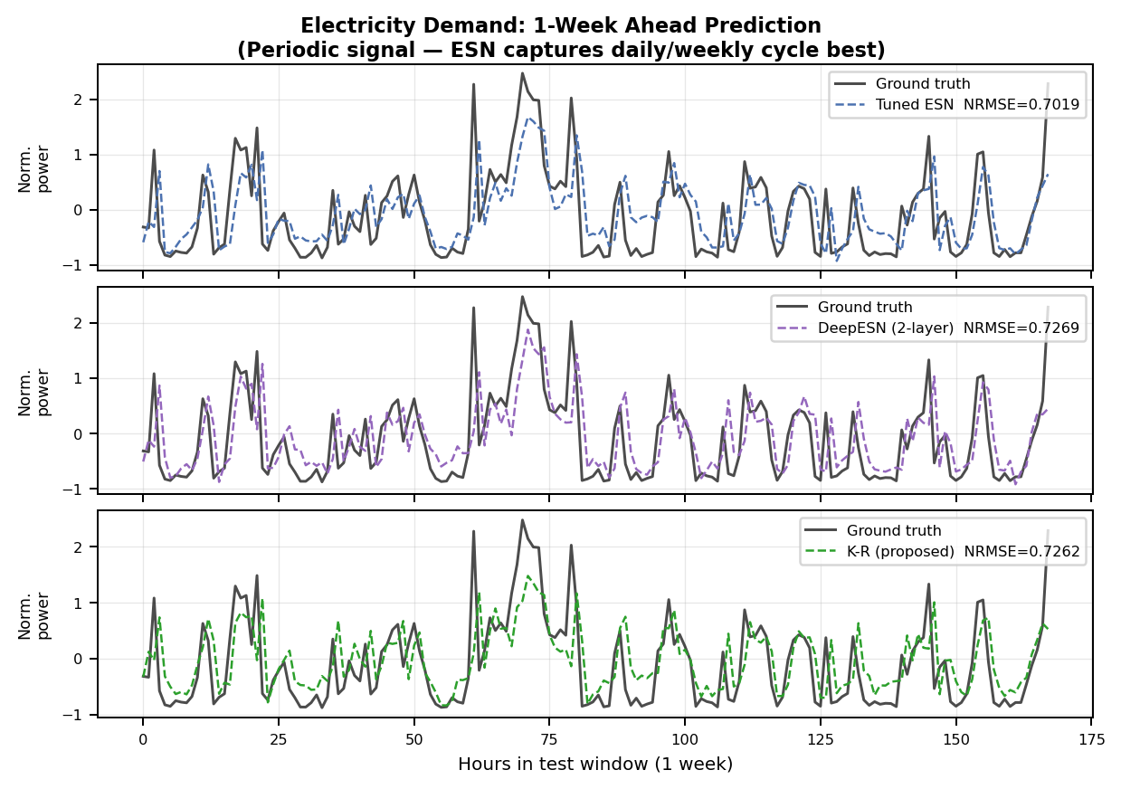
Fig. SS4. Electricity demand 1-week prediction traces. All three methods track the daily cycle. ESN achieves the lowest NRMSE because periodic structure is captured by reservoir oscillatory dynamics without delays.

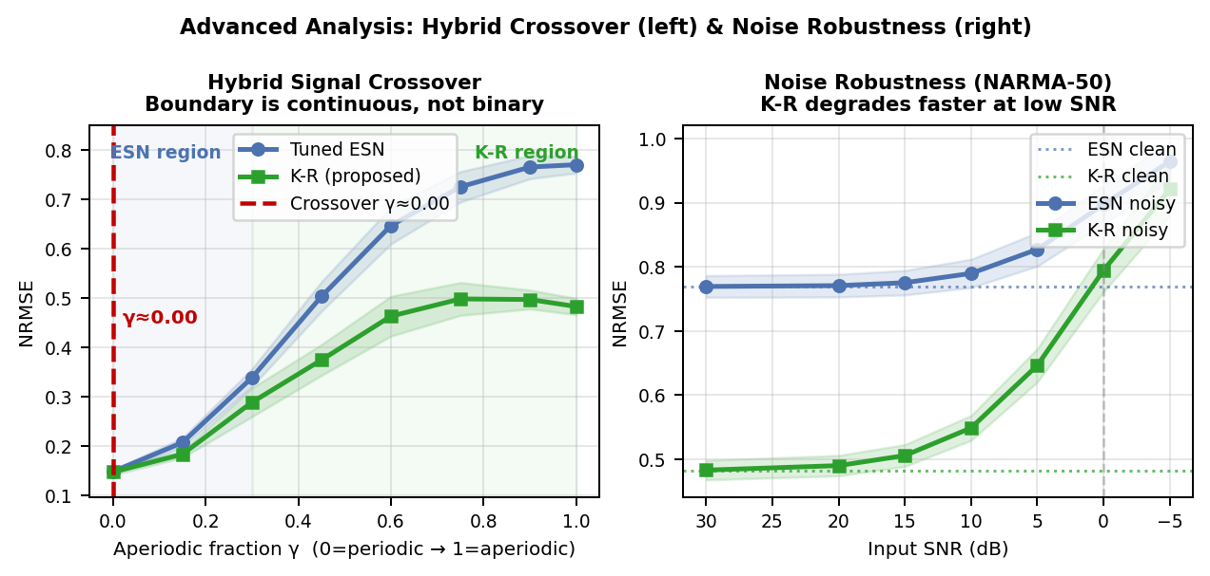
Fig. SS5. Combined advanced analysis (hybrid crossover left, noise robustness right). Together these panels establish the complete K–R operating regime.

