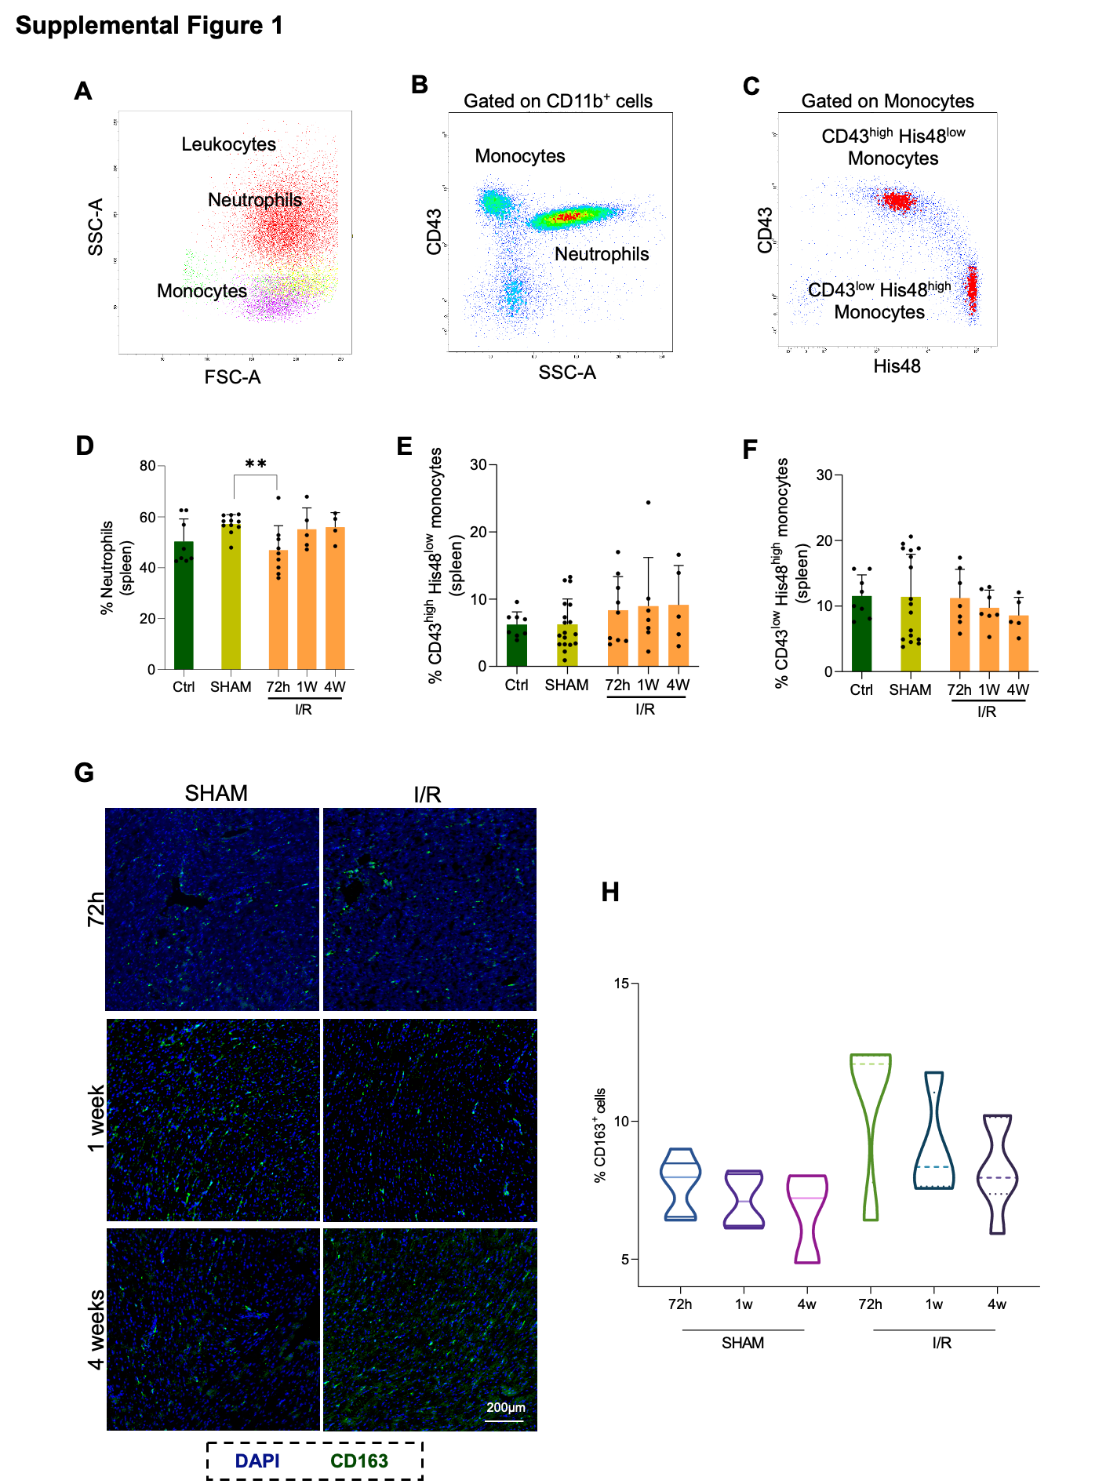
Supplemental Figure 1. Inflammatory cell subsets in spleen and myocardium in rats after I/R intervention. Dot plots with the flow cytometry strategy (A-C). Leukocytes gated on SSC and FSC, neutrophils (in red) and monocytes (in purple) (A). Monocytes and neutrophils gated in CD11b⁺ cells (B). CD43^{high} His48^{low} and CD43^{low} His48^{high} subtypes gated on monocytes (C). Bar graphs show levels of neutrophils (D), CD43^{high} His48^{low} (E) and CD43^{low} His48^{high} (F) monocytes in the spleen from control (dark green, n=9-11), SHAM (blue, n=4-10) and I/R (orange, n=5-10) rats at 72h, 1 and 4 weeks after the interventions. Immunofluorescence staining of CD163⁺ macrophages in SHAM and I/R rats (G) and CD163⁺ cell percentage (H) in the middle papillary region of hearts of SHAM (n=3-14) and I/R (n=5-16) rats at 72h, 1 and 4 weeks after the intervention. Nuclei are stained with DAPI (blue). Data are represented as mean ± S.D. ** indicate significance at p < 0.01. Group comparisons were performed using Kruskal-Wallis test with multiple comparisons for D-E graphs, and ordinary one-way ANOVA with multiple comparisons for C and H graphs. I/R: ischemia and reperfusion.

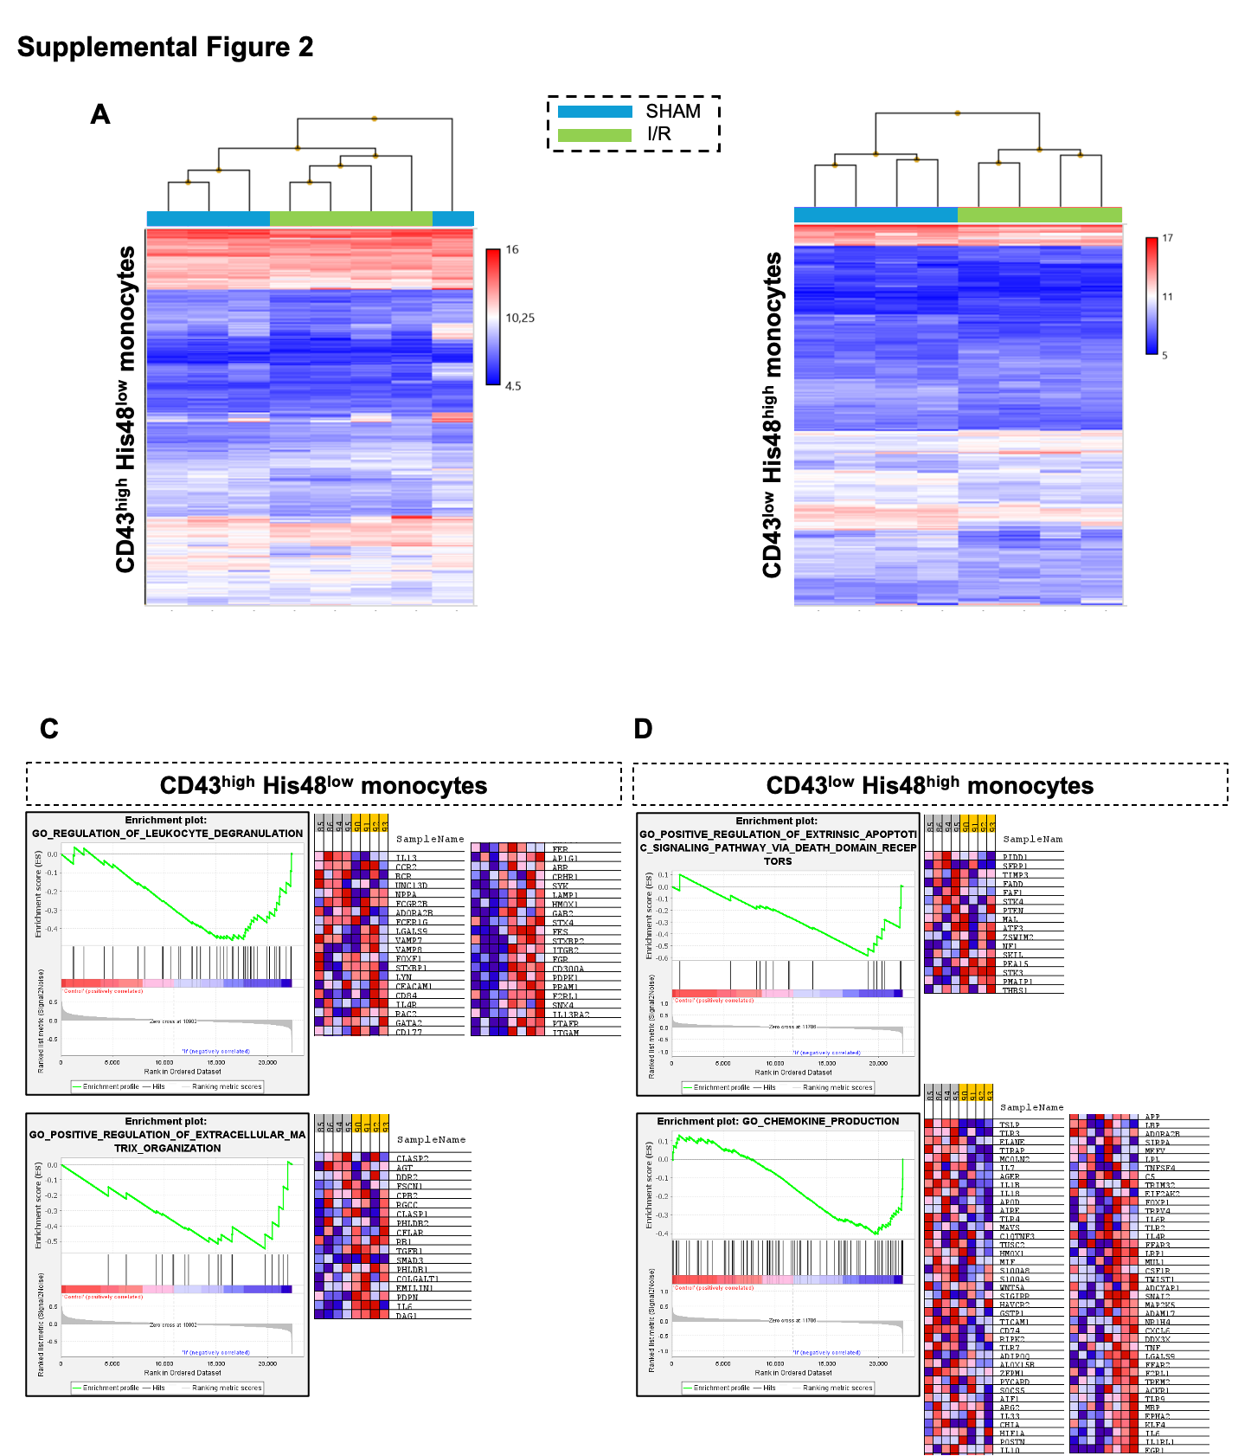
Supplemental Figure 2. Gene Array and gene enrichment analysis of sorted monocytes in SHAM and I/R rats. Hierarchical clustered sample heat-map plots of –2.0 > fold change > 2.0 value of genes (A) in CD43^{high} His48^{low} (left side) and CD43^{low} His48^{high} (right side) monocytes from SHAM (blue, n=4) and I/R (green, n=4) rats 24h after the intervention. Examples of enrichment analysis in CD43^{high} His48^{low} (C) and CD43^{low} His48^{high} (D) monocytes. I/R: ischemia and reperfusion.

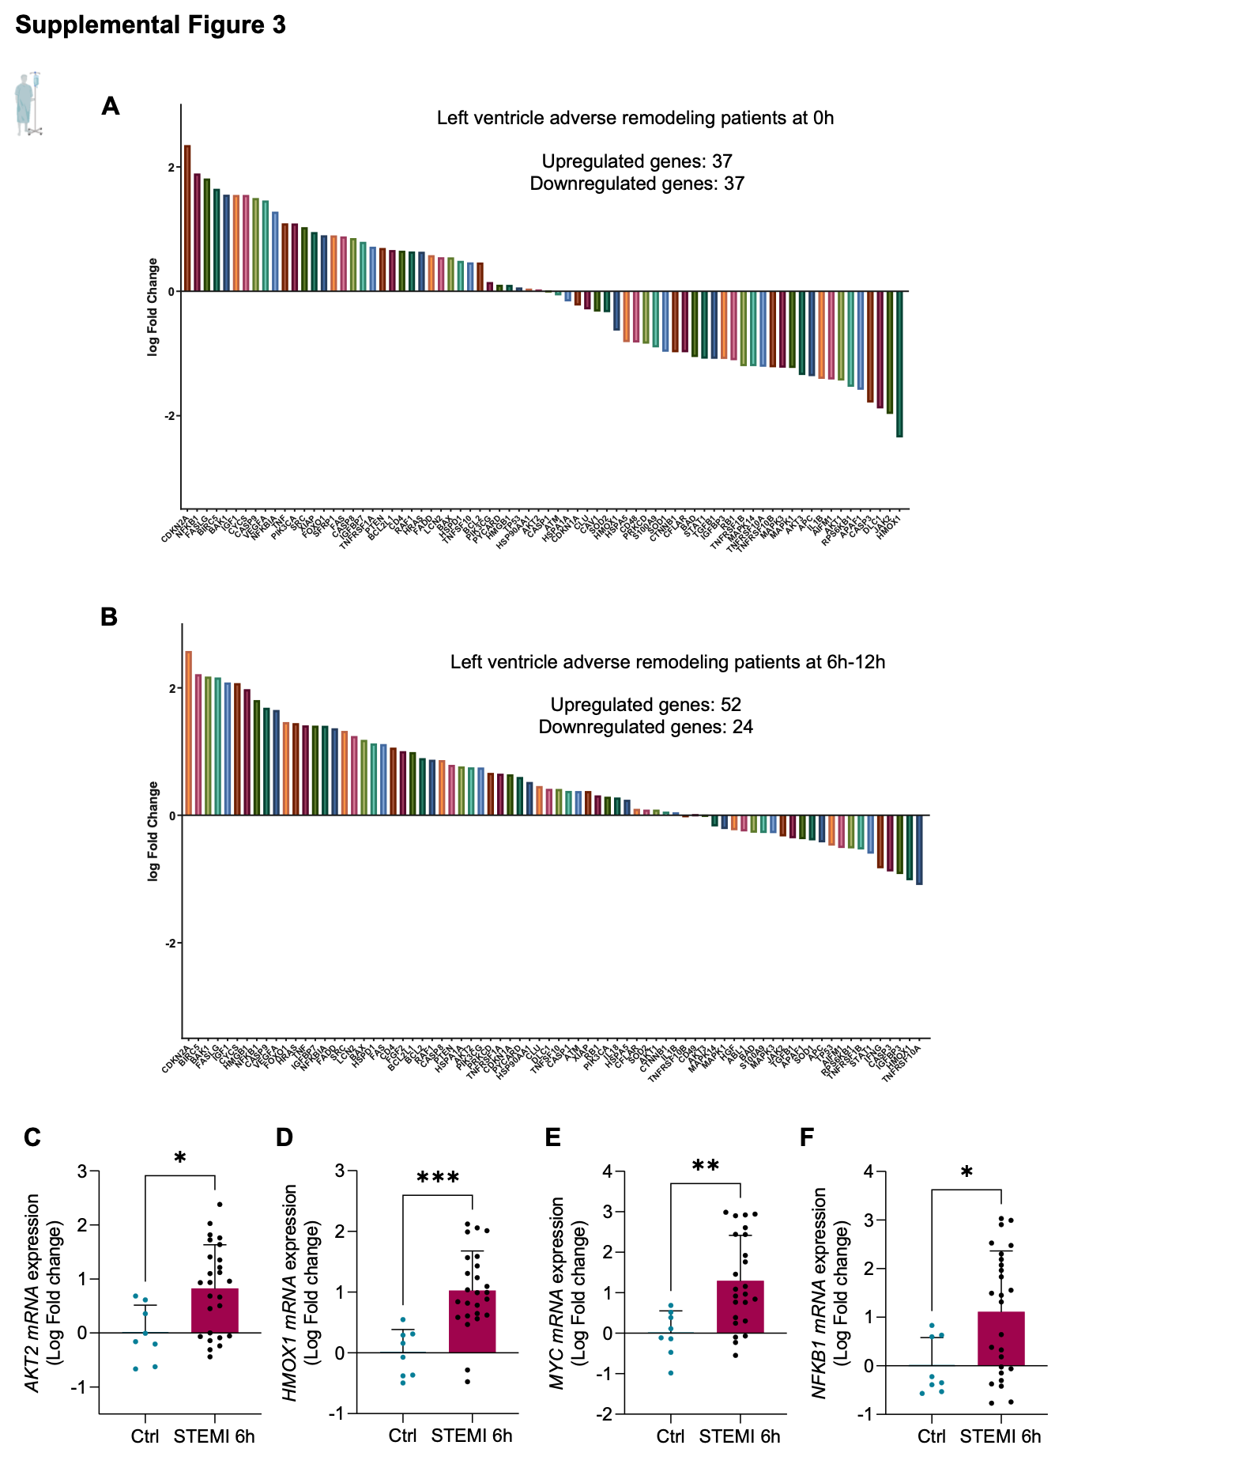
Supplemental Figure 3. Fibrotic and apoptotic genes in STEMI patients. Upregulated and downregulated genes from Prime PCR, in left ventricle adverse remodeling patients after STEMI at 0h (before revascularization, n=4) (A) and 6-12h (after revascularization, n=4) (B). Data are normalized to healthy controls (n=4). Gene expression (AKT2, C; HMOX1, D; MYC, E; NFKB1, F) in healthy controls (n=8) and STEMI patients (n= 25) 6h after revascularization. Gene's relative expression was calculated using the 2^{−ΔΔCt} method after normalization to the internal control 18S. Data are relative expression of mean of fold change ± S.D. (*), (**) and (***) indicate significance at p < 0.05, p < 0.01 and p<0.001 respectively. Differences between two groups were assessed using the unpaired t-test for C- E graphs, and Mann-Whitney test for F graph. STEMI: ST-elevation myocardial infarction. AKT2: AKT serine/threonine kinase 2. HMOX1: Heme oxygenase 1. MYC: myc proto-oncogen, BHLH transcription factor. NFKB1: Nuclear factor Kappa B subunit 1.

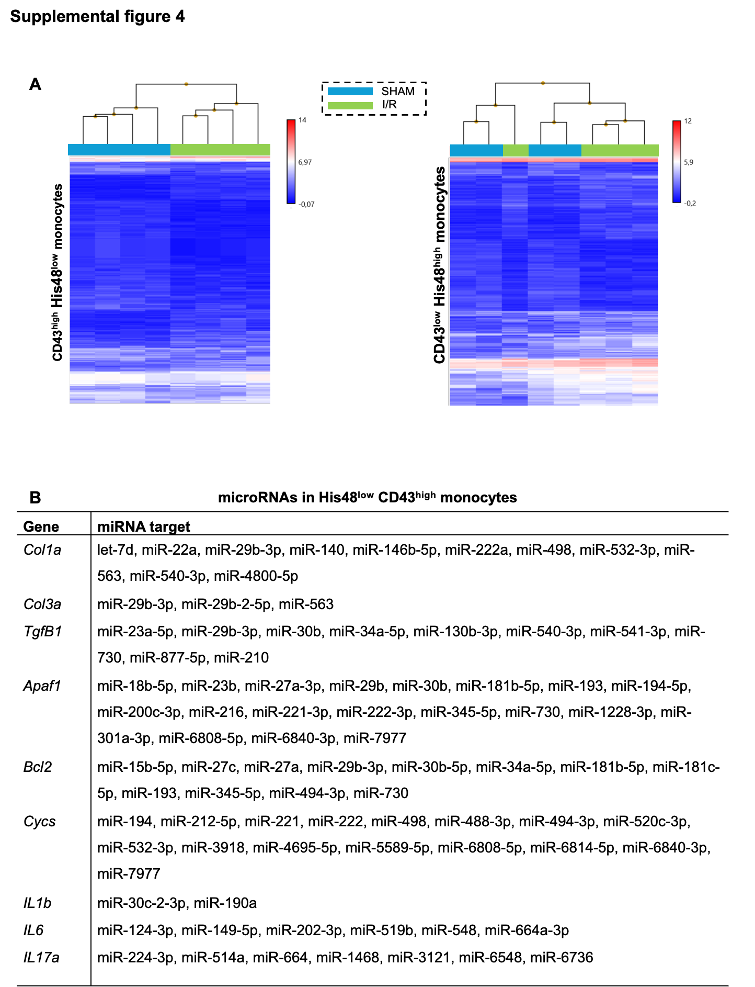
Supplemental Figure 4. microRNAs hierarchical clusters in sorted monocytes and their regulated genes in SHAM and I/R rats. Hierarchical clustered sample heat-map plots of –2.0 > fold change > 2.0 value of genes (A) in CD43^{high} His48^{low} (left side) and CD43^{low} His48^{high} (right side) monocytes from SHAM (blue, n=4) and I/R (green, n=4) 24h after the I/R intervention. (B) In silico study of microRNAs in CD43^{low} His48^{high} monocytes, regulating apoptotic and fibrotic genes studied in the cardiac populations. I/R: ischemia and reperfusion. Col1a: collagen type 1a; Col3a: collagen type 3a; Tgfβ1: transforming growth factor beta 1; Apaf1: apoptotic protease activating factor-1; Bcl2: B-cell lymphoma 2; Cycs: cytochrome c somatic; IL1β: interleukin 1 beta; IL6: interleukin 6; IL17a: interleukin 17a; miR: microRNA.

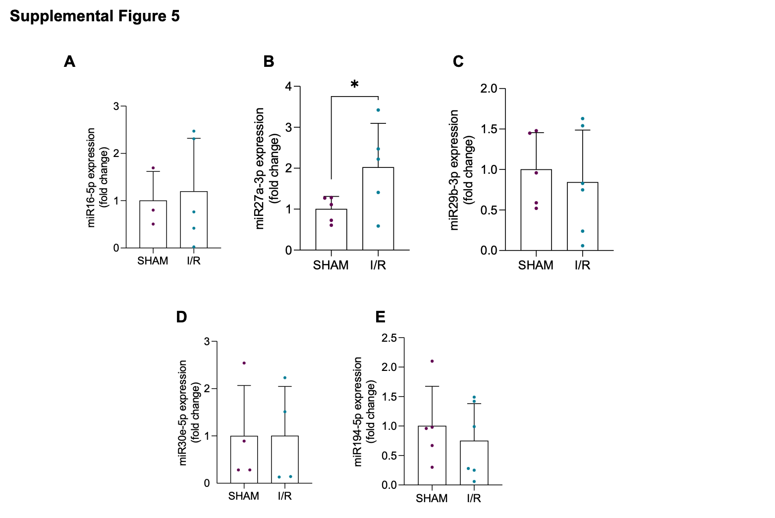
Supplemental Figure 5. microRNAs validation in sorted CD43^{low} His48^{high} monocytes. MicroRNAs validation of miR-16-5p (A), miR-27a-3p (B), miR-29b-3p (C), miR-30e-5p (F), miR-194-5p (D) and miR-194-5p (E) by RT-qPCR in CD43^{low} His48^{high} monocytes of SHAM (purple dots, n=4-5) and I/R (blue dots, n= 4-5) rats 24h after the I/R intervention. miRNA's relative expression was calculated using the 2^{−ΔΔCt} method after normalization to the internal control U6. Data are relative expression of mean of fold change ± S.D. (*) indicate significance at p < 0.05. Differences between two groups were assessed using the unpaired t-test. I/R: ischemia and reperfusion; miR: microRNA.

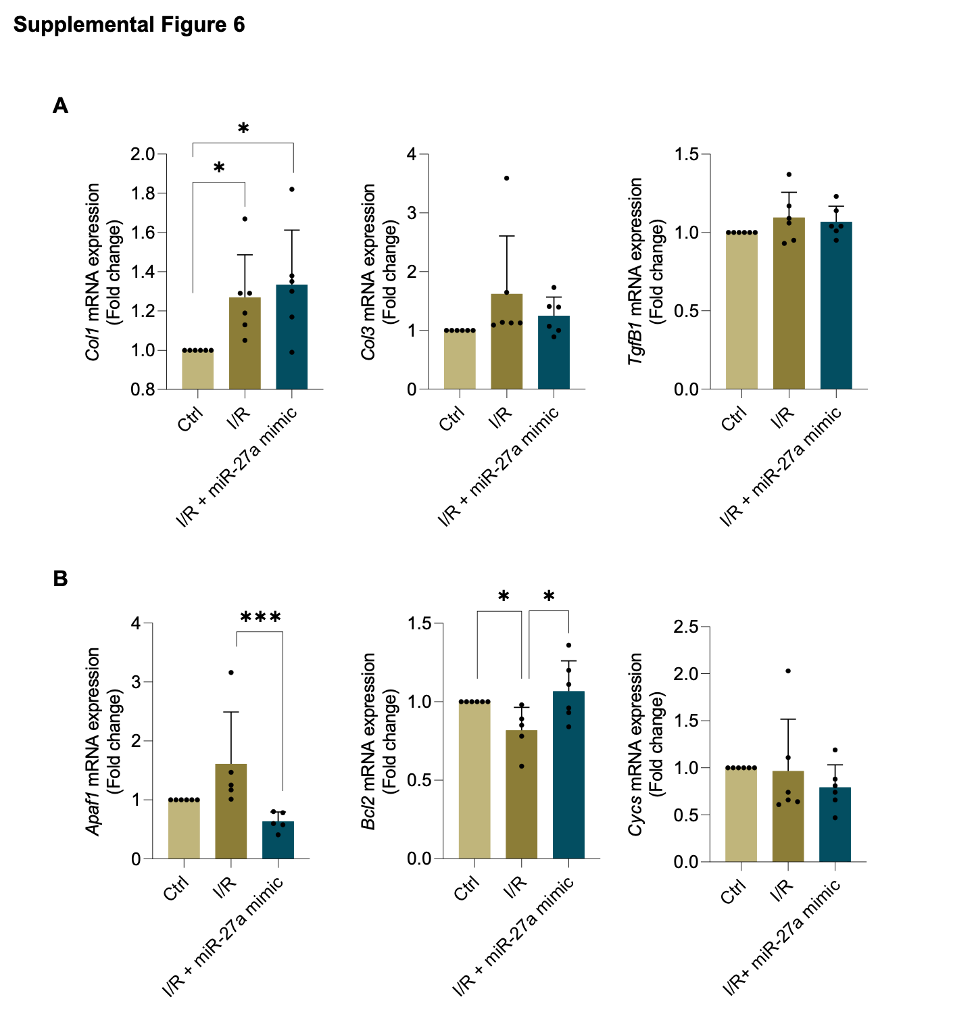
Supplemental Figure 6. miR-27a mimic regulation of fibrotic and apoptotic genes in cardiomyocytes of rats. Quantification of mRNA expression of fibrotic (Col1, Col3, Tgfβ1) (A) and apoptotic genes (Cycs, Apaf1, Bcl2) (B) by RT-qPCR in NRVMs (n=6) when transfected with scramble (light beige for controls and dark beige for I/R) and miR-27a mimic (dark blue for I/R). Gene's relative expression was calculated using the 2^{−ΔΔCt} method after normalization to the internal control 18S. Data are relative expression of mean of fold change ± S.D. (*) and (***) indicate significance at p < 0.05 and p < 0.001, respectively. Group comparisons were performed using ordinary one-way ANOVA with multiple comparisons for Col1, Tgfβ1 and Bcl2 graphs, and Kruskal-Wallis test with multiple comparisons for Col3, Apaf1 and Cycs graphs. Col1: collagen type 1; Col3: collagen type 3A; Tgfβ1: transforming growth factor beta 1; Apaf1: apoptotic protease activating factor-1; Bcl2: B-cell lymphoma 2; Cycs: cytochrome c somatic; miR: microRNA. I/R: ischemia and reperfusion; miR: microRNA.

Supplemental Material.
Prime PCR
Supplemental Table 1. List of genes in Apoptosis and inflammation Prime PCR.
ABL1 | FASLG | PIK3CG
AIFM1 | FGF2 | PRKCD
AKT1 | FGFR2 | PTEN
AKT2 | FOXO1 | PYCARD
AKT3 | HGF | RAF1
APAF1 | HMGB1 | RB1
APC | HMOX1 | RPS6KB1
ATM | HRAS | S100A9
BAD | HSP90AA1 | SFRP1
BAK1 | HSPA1A | SOD1
BAX | HSPA5 | SOD2
BCL2 | HSPD1 | SRC
BCL2L1 | IFNG | STAT1
BIRC5 | IGF1 | TGFB1
CASP1 | IGFBP3 | TNF
CASP3 | IGFBP7 | TNFRSF10A
CASP8 | IL17A | TNFRSF10B
CASP9 | IL18 | TNFRSF1A
CAV1 | IL1B | TNFRSF1B
CD4 | JAK2 | TNFSF10
CD44 | LCN2 | TP53
CDKN1A | MAPK1 | TP63
CDKN2A | MAPK14 | VEGFA
CFLAR | MAPK3 | XIAP
CLU | MAPK8 | TBP
CTNNB1 | MCL1 | GAPDH
CYCS | MDM2 | HPRT1
DLC1 | MYC | gDNA
ERBB3 | NFKB1 | PCR
ERBB4 | NFKBIA | RQ1
FADD | NGF | RQ2
FAS | PIK3CA | RT

Human AKT2 Forward | CATCCTCATGGAAGAGATCCGC
Human AKT2 Reverse | GAGGAAGAACCTGTGCTCCATG
Human HMOX1 Forward | CCAGGCAGAGAATGCTGAGTTC
Human HMOX1 Reverse | AAGACTGGGCTCTCCTTGTTGC
Human MYC Forward | TCAAGAGGCGAACACCAAC
Human MYC Reverse | GGCCTTTTCATTGTTTTCCA
Human NFKB1 Forward | GCAGCACTACTTCTTGACCACC
Human NFKB1 Reverse | TCTGCTCCTGAGCATTGACGTC
Rat Col1 Forward | TTCACCTACAGCACGCTTGT
Rat Col1 Reverse | TTTGGGATGGAGGGAGTTTAC
Rat Col3 Forward | GGTCACTTTCACTGGTTGACGA
Rat Col3 Reverse | TTGAATATCAAACACGCAAGGC
Rat Tgfβ1 Forward | ATTCCTGGCGTTACCTTGG
Rat Tgfβ1 Reverse | AGCCCTGTATTCCGTCTCCT
Rat Apaf1 Forward | TCCAGCGGCAAGGACACAGACG
Rat Apaf1 Reverse | CAACCGCGTGCAAAGATTCTGCA
Rat Bcl2 Forward | TTCGGGATGGAGTAAACTGG
Rat Bcl2 Reverse | AAGGCTCTAGGTGGTCATTCAG
Rat Cycs Forward | CAAAAGTGTGCCCAGTGCCA
Rat Cycs Reverse | CAGCAGCCTGGCCTGTCTTC
18S Forward | AACGAGACTCTGGCATGCTAA
18S Reverse | GCCACTTGTCCCTCTAAGAAGT
Supplemental Table 2. List of forward and reverse primers.

